Abstract
This dissertation examines the connection between Adverse Childhood Experiences (ACEs) and offending behaviour in South Wales, through a comprehensive study of existing literature and a mixed-methods approach, the review establishes a crucial link between ACEs and criminal behaviour. The findings highlight the negative influence of early traumatic experiences on people's life, with memories increasing the likelihood of criminal behaviour. Furthermore, the study emphasises the need for a multi-sectoral response to ACEs, highlighting the interconnection of many frameworks such as healthcare, education, and policing. Recommendations include bringing issues to light, using injury-informed techniques, and helping individuals affected by it affected by ACEs. Overall, the review contributes to understanding the confusing aspects of childhood adversity and its implications for society, urging for purposeful efforts to prevent and address ACEs for a more secure and healthier environment for all people.
is there a correlation between ACEs and the likelihood of offending behaviour?
Offending Behaviours
Nilupa Begum (2114298)

Acknowledgements

I would like to start by expressing my deepest gratitude to my supervisor, Mike Durke, for his invaluable guidance, support, and encouragement throughout the entire process of researching and writing this dissertation. Also making time for our 1 to 1 when I had questions about my dissertation or when I needed guidance and giving feedback pushed me to reach new heights for which I’m truly grateful.
I would like to express my heartfelt appreciation to my family. Mom, Dad, and my siblings, thank you for always believing in me and supporting me every step of the way. Your love, encouragement, and constant belief in my abilities have been my biggest motivation throughout this journey. I am forever grateful for your support and for being my rock.
To my amazing friends, thank you for being there for me through thick and thin. Your words of encouragement, late-night study sessions, and endless cups of coffee have made this journey so much more enjoyable. Your friendship has been a constant source of strength and laughter, and I am incredibly lucky to have you by my side.
Lastly, I want to thank all the individuals who have supported me in ways big and small, whether it was offering a listening ear, providing research resources, or simply cheering me on. Your belief in me has meant the world, and I am humbled by your presence in my life.

Declarations

This work has not previously been accepted in substance for any degree and is not being concurrently submitted in candidature for any degree.
STATEMENT 1
This dissertation is being submitted in partial fulfilment of the requirements for the degree of BA/BSc.
STATEMENT 2
This dissertation is the result of my own independent work/investigation, except where otherwise stated.
Other sources are acknowledged in the Reference Section.
STATEMENT 3
I hereby give consent for my dissertation, if accepted, to be available for photocopying and for interlibrary loan, and for the title and summary to be made available to outside organisations.
STATEMENT 4
I hereby give consent for my dissertation, if accepted, to be available on the university’s IT system to those who have consent to use the system.

Student’s Name: Nilupa Begum
Signed: N Begum
Date: 07/5/2024
Contents

Acknowledgements 1
Declarations 2
Chapter One: Introduction 4
1.1 Background 4
1.2 Aims and Objectives 6
1.3 Research method and timescale 7
1.4 Chapter Outline 8
Chapter Two: Literature Review 9
2.1 Current Understanding of ACEs and Their Impact 9
2.1.2 Nature of Aces on Their Impact 10
2.2 Analysis Of Whether Aces Lead To A Greater Likelihood Of Antisocial And Criminal Behaviour 13
2.3 Critical Evaluation Of How An Understanding Of Aces Can Lead To Proactive Approaches To Prevention Of Aces And The Reduction Of Negative Outcomes 16
Chapter Three: Methodology 18
3.1 Research Union 18
3.1.1 Research Philosophy 18
3.1.2 Research Approach 19
3.2 Methodological Choice 20
3.3 Data Collection 21
3.4 Research Strategy 21
3.5 Sampling 22
3.6 Limitations and Potential Hurdles 22
Chapter Four: Data Analysis 24
4.1 Findings Analysis 32
4.2 Informed Assent and Socioeconomics 32
4.3 Awareness of ACEs 33
4.5 Awareness of Local Area Resources 34
4.6 Course of Action with Study Objectives 35
Conclusion 36
Reference List 39
Appendix 1 45

Chapter One: Introduction

1.1 Background

According to Public Health Wales (2023), Adverse Childhood Experiences (ACEs) are stressful occurrences, particularly in early childhood, that have a negative impact on people's health and well-being which could lead to anti-social behaviour in the future. According to Public Health Scotland (2021), a survey on ACEs was carried out on adults in Wales, and the results showed that those with four or more ACEs are more likely to be in prison at least once in their life, have heart disease, constantly visit the general practitioner (GPs) have type two diabetes, committed violence in the last 12 months, taking parts in behaviours that are health-harming such as high-risk drinking, smoking, and drug usage. Exposure of children to stressful and traumatic situations can have long-term effects on their ability to learn, think, and interact with others.
This dissertation will answer the following question ‘ Is there a correlation between Adverse Childhood Experiences (ACEs) and the likelihood of offending behaviour in South Wales’? This topic is relevant as this question addresses an important and socially significant subject. Understanding the relationship between childhood abuse, unpleasant experiences, and adolescent criminal behaviour is critical for establishing effective prevention and intervention strategies. It has implications for both public policy and individual and community well-being. Conducting a dissertation on ACEs can help to expand our understanding of a critical issue, offering opportunities to contribute to the field, for instance, influencing policies and ultimately improving the well-being of individuals who have experienced childhood adversity (Webster,2022).
ACEs as a dissertation topic can provide a variety of benefits, both in terms of personal and professional development and contribution to the field of study. Here are some key benefits of choosing ACEs as a dissertation topic: addressing a critical social issue, ACEs are a significant public health concern. Researching on ACEs can contribute to a better understanding of the prevalence, causes, and consequences of childhood adversity. Contribution to knowledge, informing policy and interventions, practical applications, awareness, and advocacy. The purpose of this study is to look at the relationship between ACEs and criminal behaviour, identify if there’s any correlation between the two and how to address these issues. Furthermore, this topic is important as many people are unaware of why certain adolescents commit crimes therefore, this research will demonstrate how adversity is often associated with negative outcomes. The purpose of this study is to investigate and understand the potential relationship between two key factors: ACEs and adolescent criminal behaviours. This includes examining the negative effects of incidents from childhood on children's brain development, immune systems, and stress response systems. This research also has the potential to raise awareness of ACEs that children may have suffered in the past, but their experience might have been disregarded by their parents, teachers, friends, or any public services, which could have been due to a lack of education and understanding in this area (Genevieve, 2019).
It is important to understand ACEs as the current view of the literature shows that ACEs are linked to health problems, mental illness, and substance misuse in adulthood. Preventing ACEs can help children to have a better future, by doing so will decrease health issues like depression, cancer, and asthma in adulthood. Reduce behaviours like smoking, drinking, or selling drugs. With the benefit of increasing education and employment potential (Matjasko et al, 2022). Stopping ACEs from one generation to another. According to the Centers for Disease Control and Prevention (2021), 1 in 6 adults has experienced four or more ACEs. 5 out of 10 causes of death are associated with ACEs. To prevent ACEs from occurring it is essential to identify the existing gaps which include understanding how to identify and assess risk in children who have encountered ACEs, as well as the development and, most crucially, evaluation of intervention (Chizimba, 2021).
this dissertation will look at awareness and understanding of ACEs, as many people may not understand what ACEs are and how exposure to ACEs can have long-term effects, for example, risk of health problems, and criminal or anti-social behaviour (CDC, 2021). Conducting a study on ACEs is crucial for improving public health, addressing social issues, and providing better support and opportunities for individuals who have experienced childhood adversity. As well as raise awareness about ACEs as many individuals may not be aware of the symptoms of ACEs or may not be aware that they are experiencing them.
Research on the correlation between ACEs and criminal behaviour is important as it helps us understand the impact of traumatic experiences on individuals and how they can influence their behaviour later in life. This dissertation research will contribute to the existing knowledge and help create strategies to prevent and address these issues. The current literature review has shown a strong correlation between ACEs and various negative outcomes, including criminal behaviour. The study of ACEs helps us understand the long-term effects of childhood trauma and develop interventions to support individuals affected by ACEs (Leitch, 2017). It’s an important area of research with significant implications for public health and social welfare. Raising awareness has serval benefits. Firstly, it helps to reduce stigma and shame around childhood trauma. Increasing awareness can create more supportive and understanding environments for those who have experienced ACEs. It can also help to inform policymakers and professionals in various fields, such as education and healthcare, about the importance of trauma-informed care. Ultimately, raising awareness can lead to better prevention, intervention, and support systems for individuals (CDC, 2023).

1.2 Aims and Objectives
This study aims to examine the relationship between ACEs and criminal behaviour. It will be addressed by answering the following 3 objectives.
1. Explore the current understanding of ACEs.
2. Examine the current criminal behaviour and if there’s any link between ACEs and crimes.
3. Identify if the current intervention and prevention help reduce ACEs.

1.3 Research method and timescale

This dissertation will conduct a primary research questionnaire, using both quantitative and qualitative methods. The target sample for this research will be any individual over the age of 18 in South Wales. This will be carried out online via social media where the link will be attached. The purpose of the survey is to find out if people are aware of, knowledgeable about, and affected by ACEs. This survey will assist with what they understand or already know about ACEs. If they know the 10 examples of ACEs. As well as if the questionnaire helped to expand their knowledge and if they learned anything new from it.
in order to finish the dissertation on time the draft chapter deadline was set out to reduce stress and balance out the dissertation along with other assignments. For example, the draft introduction deadline is due 10th November 2023, the Literature review is due 8th November 2023, the Methodology is due 9th February 2024, the findings due 22nd March 2024, the conclusion is due 19th April and the final deadline is due 7th May 2024. This allows enough time to finish each chapter without rushing, allowing enough time to focus on other assignments as well as not falling off track. This ensures I have plenty of time to amend any chapter if necessary.

1.4 Chapter outline

The following chapters will be included in the dissertation:
Chapter 2 Literature Review - Outlining the research and critically analysing current literature about ACEs, understanding of ACEs, examples of cases prevention and intervention, if it’s successful or not, and Bandura's social learning theory.
Chapter 3 Methodology - This chapter outlines the framework and methodology, including the sample that was utilised, the ethical considerations that were made, the sample used, and how the data was collected and analysed.
Chapter 4 Findings – this chapter critically examines the results of the study about the literature review and the dissertation questions and concludes to see if the findings support the question of whether there is any correlation between ACEs and criminal behaviour.
Chapter 5 Conclusion - This chapter summarises the overall study and, based on the findings of the study, will indicate if there is any link between criminal behaviours and ACEs.

Chapter Two: Literature Review

To understand the relationship between ACEs and criminal behaviour in adolescents and young adults, this chapter will include the current understanding of ACEs, an overview of all current literature on ACEs stating whether negative events in childhood lead to negative behaviour in later life, and finally the effectiveness of preventions.

2.1 Current Understanding of ACEs and Their Impact

Despite the way that there is certainly not a conventional definition for ACEs, it’s pivotal to grasp how they’re characterised (Parliament, 2018). The expression “adversity” alludes to the difficult circumstances and experiences that an individual has experienced. As indicated by Youthful Personalities (2023), ACEs are exceedingly unpleasant or even horrifying situations or events that occur during childhood or adolescence. Any young person who encounters a traumatic occurrence in their lives between the ages of 0 and 17 could be traumatised (Gilgoff et al, 2020). The expression “ACEs” was made by Drs. Vincent Felitti and Robert Anda (Felitti, 2019). First Pro exploration was directed in 1995 as a team with Kaiser Permanente and the CDC. The ACEs, which included 10 afflictions, were grouped into three classes: misuse, disregard, and brokenness in the home. Living with a drunkard, seeing homegrown maltreatment, encountering physical, sexual, or psychological mistreatment, living with somebody who has been imprisoned, living with somebody who has a serious dysfunctional behaviour, and, lastly, losing a parent to separation, demise, or abandonment are the most common instances of Adverse Childhood Experiences (ACEs) (Manchester College, 2023). People who have had ACEs are bound to have psychological well-being issues, take part in unsafe exercises, and experience the ill effects of constant diseases. chronic drug use, uneasiness, melancholy, and inconvenience shaping sound connections (Sanderson et al, 2021).
The ACE investigation of Dr. Nadine Burke-Harris is widely perceived. ACEs, according to her definition, are horrible childhood experiences that may fundamentally damage an individual's well-being and prosperity later in life. As a component of the Pro Review, scientists Vincent Felitti and Robert Anda previously fostered the idea of ACEs during the 1990s. This further examination upholds the laid-out meaning of ACEs (ACEs mindful, 2022). Dr Nadine Burke-Harris has helped people understand and cope with the effects of ACEs. She emphasises how childhood harm is linked to a variety of physical and psychological health difficulties, such as drug usage, heart disease, diabetes, and depression. Dr. Burke-Harris is well-known in both clinical and community settings for her commitment to raising awareness of ACEs and advancing injury-informed treatment. Her research has improved our understanding of the long-term effects of childhood adversity, as well as the importance of prevention strategies and support for people who have been injured. She highlights the need to have an appropriate carer so that children can experience childhood in a safe environment (The Burke Establishment, 2019).

2.1.2 Nature of Aces on Their Impact

The adverse consequences of those with ACEs could affect a singular’s prosperity. Adults with ACEs may promote toxic pressure or engage in high-risk activities, such as illegal drug use and addiction, all of which may have a negative impact on their achievement as adults (CDC, 2020). People may also experience despair, and when their children meet the ultimate consequences of their parents' experiences, they may also develop these challenges.
(CDC, 2020). Since ACEs might be shown by seeing guardians act, they won’t be guaranteed to have to have the greatest effect. Early experiences give the basis for well-being and improvement and hugely affect life course results, which explains why promoting a healthy lifestyle is so important. The relationship between happy, productive, and healthy adult lives and favourable early experiences, such as loving and caring parents and safe, libertarian environments (Struck et al., 2021).
As per the latest exploration audit, ACEs are connected to unfortunate grown-up results for both mental and actual well-being. The proof base and examination needs are right now inadequate for specific data. These include developing and, essentially, evaluating mediations and determining ways to identify and evaluate risk in children who have experienced ACEs. There are still unanswered questions regarding the existence of sensitive childhood phases, the function of protective or harsh elements, the relationship between natural cycles and causes, and the overall risk that adverse childhood experiences (ACEs) will have particular negative outcomes (Steptoe et al, 2019).
It is vital to understand that, as far as conceivable wrongdoers, anyone in a child's environment has the potential to cause harm. Guardians or other relatives, carers, professors, or even classmates may be the ones committing these crimes. Because of their concerns and bad experiences, the wrongdoers may inflict harm to the child on purpose or by accident. Not all individuals who have experienced ACEs continue to carry out violations; rather, a pattern of harm may occur within families or networks (Habitats for Disease Control and Counteraction 2023).
ACEs might cause a great many symptoms, both mental and physical. Individuals might turn out to be more powerless against diseases like malignant growth, stoutness, and cardiovascular issues because of their actual qualities. Mentally, ACEs have been connected to psychological well-being conditions including wretchedness, nervousness, and PTSD (post-horrendous pressure problem). Besides, there is a connection between ACEs and poor mental turn of events, inconvenience learning, and behavioural issues. Youngsters who have gone through ACEs might experience difficulty controlling their feelings, experience difficulty building solid connections, and have connection issues (Manchester College, 2023). Pregnancy-related liquor and medication use is one of the essential drivers of that. The youngster’s actual well-being is one of the primary concerns. For instance, fatal liquor range problems (FASD) are a gathering of diseases that might result from pre-birth liquor openness (PAE). It could have impeded, teratogenic outcomes on a singular’s turn of events and well-being that are both short- and long-haul. Liquor, which is known to be poisonous, may harm an embryo by causing a range of neurological and physiological problems that can lead to deep-rooted behavioural disorders as well as other concerns. The main goals of late exploration have been to identify the mechanisms that contribute to alcohol's temporary negative effects on health and disease propensity as well as the systems that impede its rapid teratogenic effects on catastrophic events (Chung, 2021). The proof connecting PAE to ACEs is inadequate, despite the way that PAE is an extreme issue for kids.
13,494 people who have gone through a standardised clinical assessment were the subjects of a survey conducted by Felitti et al. (1998). The investigation focused on seven types of negative childhood experiences: living with drug addicts, individuals who were insane or self-destructive, and those who were jailed. From then on, each Pro classification was matched to a range of 0-7 classifications of adult risk conduct, diseases, and medical conditions. As per the discoveries, the greater part of the members referenced somewhere around one sort of openness all through their childhood, and 25% referenced two classes. They found a reviewed connection between all grown-up well-being risk behaviours and diseases being scrutinised and the quantity of childhood openness classes. Individuals who had at least four classifications of childhood openness had four to multiple times higher well-being gambles for liquor abuse, chronic drug use, sorrow, and self-destruction endeavours; a 2-to 4-crease increase in smoking, unfortunate self-evaluated well-being, 50 sexual accomplices, and physically communicated disease; and a 1.4-to 1.6-overlay increase in actual latency and serious stoutness contrasted with the people who had none.
As per one investigation, there is a measured relationship between the number of classes of negative childhood openings and grown-up issues like malignant growth, ischemic coronary illness, breaks, and liver disease. Individuals who were presented with an extensive variety of negative childhood experiences were sure to confront numerous factors that jeopardised their prosperity later on. There were major areas of strength between the seven classifications associated with negative childhood experiences (Felittie et al, 1998). This shows that the specialists found an extremely huge, assessed connection between the level of childhood receptiveness to mishandling or brokenness in the family and a couple of hazard factors for what is probable the most widely recognised grown-up reasons for mortality and hazard factors that could prompt foe of social behaviours.
Although (Felittie et al., 1998) researched serious areas of strength for offers that negative childhood experiences might make extreme and getting through impacts. In any case, a central question emerges: Is there an association between early difficulty and criminal behaviour as individuals develop from childhood to adolescence and adulthood? Researching this connection widens our insight into ACEs and emphasises the requirement for early intercession to stop and reduce the adverse consequences of these circumstances.

2.2 Analysis Of Whether Aces Lead To A Greater Likelihood Of Antisocial And Criminal Behaviour

The effect of ACEs on human turn of events and later-life well-being has been the subject of extraordinary exploration throughout recent years. The noteworthy Habitats for Disease Control-Kaiser Pro review, driven by Felitti et al. (1998), which analysed the effect of ACEs on grown-up well-being results, might be connected to the developing corpus of examination. The investigation of children's misuse and withdrawn direct has gathered more examination information, hypothetical consideration, and conversation than a few other criminological worries. The absolute most huge criminological ideas argue that early life openness to harmful and conflicting nurturing might make children act improperly, increasing the probability of introverted lead. (2020, Connolly). This exploration shows that there is persuading proof connecting hostility to social directly to ACEs. As per the general strain hypothesis, long-haul openness to unpleasant improvements, (for example, close to home, physical, verbal, or sexual maltreatment) increases a youngster’s gamble of acting improperly to manage the pressure, especially if the kid battles to get a handle on their feelings, like fury. Agnew (1992). The Overall Hypothesis of Wrongdoing (1990) by Gottfredson and Hirschi states that children who lack nurturing, especially before the age of eight, which should show them productive profound motivation control, may have lower levels of self-control and act more impulsively than rationally, increasing the likelihood of criminal and/or delinquent culpability.

The continuous discussion in writing on the advancement of reserved behaviours after adverse childhood experiences (ACEs) is around nature versus support contention (Ports et al., 2020). Although the research stresses the substantial role that acquired propensities play in shaping activities, normal factors, such as adverse childhood experiences (ACEs), also play an important part. The significant investigation by Adrian Raine features how natural and hereditary factors associate to incline individuals toward saved perspectives. Understanding the collaborations among qualities and ecological factors is significant, as shown by Raine’s examination (Sheffler et al., 2020), particularly in separated locales of the mind, for example, the prefrontal cortex, which is connected to detached behaviours. The quality explanation might be adjusted by ACEs and other normal factors, which thusly influence behavioural results. Furthermore, longitudinal twin exams provide insightful data on the relative roles that hereditary characteristics and climate play in the advancement of held behaviour. These tests exhibit that. Although acquired factors have an important role in the constancy of direct throughout time, the overall climate also has an impact, however less significant. According to meta-examinations, the level of variation made sense of by genetic elements differs depending on the individual's formative phase—measures shift from 32% to 60% in children and 49% in adults (Finkelhor, 2020). Social learning speculations feature the role of environmental factors, especially steady and definite lead, in shaping behaviour, as shown by Albert Bandura’s renowned Bobo doll examination. Bandura’s examination features the role that social environment plays in improving aggressive tendencies by showing how being responsive to forceful activity might prompt the impersonation of comparative behaviour.
Longitudinal twin research on behavioural difficulties and introverted personality revealed that inherited variables were primarily responsible for soundness across time. The twins in the examination were followed for quite a long time. Moreover, three studies indicated that the shared environment did not affect the strength associated with maturing. In this case, there is a shortage of exploration of patterns of antisocial behaviour in later adulthood — that is, past the age of 24 — (Wesseldijk, 2018). Whether or not hereditary and natural impacts contrast in males and females (i.e., quantitative gender contrasts) and whether the equivalent or various qualities are involved (i.e., subjective sex contrasts) is further highlighted by gender differences in the prevalence of direct and aggressive character issues. According to twin studies, there are subjective sex differences in reserved direct and behaviours. (Wesseldijk, 2018). Twin examinations make it conceivable to assess the impacts of shared, hereditary, and individual ecological factors on behavioural contrasts and dependability over time. Cross-sectional examinations on behaviours and reserved character troubles were completed in most twin exploration studies. As per one meta-examination of this exploration, hereditary factors represent somewhere in the range of 32 and 60% fluctuation in kids, 45 and half variety in young people, and 49% variety in grown-ups. As per gauges, the common climate — likewise alluded to as the “normal” family climate — contributes somewhere in the range of 10% and 20% throughout growing up, 10% and 17% during adolescence, and 14% during adulthood. As per Wesseldijk (2018), particular natural factors represent the rest of the variety in twin exploration that isn’t brought about by hereditary qualities or a common climate.
How does investigating ACEs and solitary habits reveal the collaboration between inherited tendencies and environmental circumstances that impact our understanding of individual outcomes? What implications does this complex relationship have for mediations aimed at reducing the negative effects of ACEs? By examining these concerns, will help to gain a better knowledge of the complex relationship between inherited weaknesses and environmental pressures, as well as appropriate interventions to address behavioural changes. Understanding these components is vital for introducing flexibility in Pro impacted individuals and trying explicit answers to promote positive results and decrease negative outcomes. (Crandall et al., 2019).

2.3 Critical Evaluation Of How An Understanding Of Aces Can Lead To Proactive Approaches To Prevention Of Aces And The Reduction Of Negative Outcomes

Various examinations, similar to those led by Felitti et al. (1998), have shown a high relationship between adverse childhood experiences (ACEs) and adverse results such as psychological well-being issues, constant disease, and withdrawn behaviours. Understanding the prevalence and effects of ACEs is crucial for effective preventive interventions. Early detection and intervention is a proactive method (Walsh et al., 2019). By identifying risk factors associated with ACEs, such as parental medication abuse or aggressive behaviours at home, medical professionals as well as teachers can intervene at the correct time to provide support and resources to at-risk children and families (Burke-Harris, 2019). Furthermore, presenting injury-informed treatment solutions in medical and educational contexts to support those affected by ACEs may reduce the risk of negative outcomes. ACEs are caused by underlying causes such as poverty and social wrongdoing, which should be addressed as part of prevention efforts. ACEs can be avoided and their impact on individuals and networks may be reduced via agreements aimed at reducing financial imbalances and facilitating access to assets (Habitats for Disease Control and Avoidance, 2023). Additionally, community-based initiatives that support and educate families could better educate parents and other carers to provide their children with loving environments, hence reducing the prevalence of ACEs (Steptoe et al, 2019).
Essentially, preventive approaches must take into account the exchange of injury between ages. People who have experienced ACEs can influence similar experiences in their families. Family treatment and nurturing programmes are two examples of interventions that target both guardians and children and might alter the pattern of injury and produce better results for people in the future (CDC, 2020). Understanding ACEs is essential for coming up with proactive methodologies for forestalling and lessening adverse results. Key strategies for reducing the influence of ACEs and increasing flexibility in individuals and networks include early detection, injury-informed treatment, addressing foundational issues, and focusing on transmission between generations (Narayan et al., 2022). Using these methods could aim to create a more stable and secure atmosphere for all those who have been impacted by childhood trauma.

Chapter Three: Methodology

The main purpose of this chapter is to assess and identify the appropriate research design, data collection method, technique and approaches adapted to the study. This chapter will evaluate and justify the use of selected research design and data analysis techniques in the context of the topic of investigation. In addition, the chapter will also address the research onion based on which the whole research methodology for the study will be guided. The chapter will also indicate the limitations which may arise in the study.

3.1 Research Union

Research Onion framework was created by Saunders et al. (2018), as it's known for the technique. Research onion is a technique framework separated into pieces that allows researchers to select and justify their methodologies within a research endeavour. It is comprised of a few levels that start the research cycle. An onion's layers include the research system, research philosophy, information collection strategies, and information analysis techniques, with the research rationale serving as the focal part. Each layer influences and shapes the ones that follow it, ensuring a powerful and rigorous research process (Thomas, 2022). Using the Research Onion model, this study adds to the collection of information nearby by providing a fastidious and very coordinated procedure to investigate the connection between adverse childhood experiences (ACEs) and antisocial behaviour.

3.1.1 Research Philosophy

Interpretivist philosophy emphasises the importance of understanding the subjective experiences and meanings that individuals attach to their actions and interactions. When surveying the correlation between Adverse Childhood Experiences (ACEs) and anti-social behaviour, an interpretive approach would focus on uncovering the nuanced perspectives and interpretations of the participants rather than solely relying on statistical analysis (Alharahsheh and Pius, 2020). Interpretivist philosophy guides the researcher to approach the survey with an open mind, recognising that ACEs and anti-social behaviour are complex phenomena influenced by individual perceptions, experiences, and social contexts. The researcher acknowledges that the meanings attributed to ACEs and anti-social behaviour can vary among participants and that these meanings shape their responses. Using interpretive principles, the researcher may employ qualitative methods such as open-ended questions, interviews, or focus groups to allow participants to express their experiences and perspectives in their own words. This approach enables the researcher to delve deeper into the underlying reasons and motivations behind the observed correlations, rather than simply quantifying relationships through numerical data.
By embracing interpretivism, the researcher recognises the importance of context and acknowledges the role of subjective interpretation in shaping social phenomena. This philosophical stance encourages reflexivity, prompting the researcher to critically reflect on their own biases and assumptions throughout the research process. Ultimately, by adopting an interpretive perspective, the researcher aims to gain a richer and more holistic understanding of the correlation between ACEs and anti-social behaviour, informed by the lived experiences and interpretations of the participants themselves (Alharahsheh and Pius, 2020).

3.1.2 Research Approach

The current survey utilised an inductive research philosophy. Inductive reasoning will commence with examining and studying the details of the world until some complex concepts are abstracted. The inductive approach, on the contrary, involves exploring a topic first where an investigator is engaging in the process of generating empirical generalisations and revealing certain variables. It is done at the early of the study (Kumari et al., 2023). No hypothesis can be identified at the first stage of the research. There is no knowledge concerning the type and nature of the research findings until the study is completed. Analysis of collected data will be carried out and the hypothesis will be validated. The report describes likely truths arising out of the mod which is issued currently and that are focused on the demerits of ACEs and antisocial behaviour. This approach generates new ideas and hypotheses that then become a starting point for creating novel interventions and programs. This technique gives birth to truly creative thinking and unique points of view that the deductive method would not have been pays as much attention to (Newman and Gough, 2020). In general, there is a preference for inductive principle in the scientific study, which is based on empirical data to evidence or validate pre-existing views on the link between ACEs and antisocial behaviour, hence enriching the knowledge base of the issue.

3.2 Methodological Choice

This particular study is qualitative and quantitative. To test the hypothesis and to arrive at a conclusion, quantitative research uses numbers and mathematical data to statistics (Verma et al., 2024). This plan was decided to empower objective analysis and correlation by unequivocally measuring factors associated with antisocial behaviour and adverse childhood experiences (ACEs). Using a quantitative technique, the researcher can determine the prevalence of ACEs and the severity of antisocial behaviour, and track down potential associations between the two factors, given the interesting emphasis of this concentrate on examining the connection between ACEs and antisocial behaviour. Besides, a deliberate and repeatable framework for information gathering and analysis is given by quantitative research procedures like surveys and statistical analysis, which work on the legitimacy and dependability of discoveries (Mishra and Alok, 2022). According to Creswell (2007), a mixed-method study combines qualitative and quantitative methods of data collection and analysis within a single research project. The reason for this is approach allows policy researchers to comprehensively understand complex phenomena both qualitatively and quantitatively, enabling them to provide explanations using numerical data, charts, and basic statistical analyses.

3.3 Data Collection

Primary data are immediate, original records that the researcher has assembled determined to accomplish a certain objective. Members of the review who are straightforwardly involved in the research will give primary data to this analysis. This study's primary technique for collecting data is an open and closed question. Closed-question surveys include the appropriation of standardised questionnaires with predetermined reaction choices to gather quantitative data (Pandey and Pandey, 2021). An example of a closed question would be ‘Were you aware of ACEs?’ which requires participants to answer either a ‘yes’, or ‘no’. whereas through open questions participants will be able to express their own opinions. Google Forms will be used to create a survey. The benefit of using Google Forms is that it is easy to access and time efficient as it automatically generates responses into pie charts which will be utilised in the data analysis chapter for the findings.

3.4 Research Strategy

A survey design involves data collection from a sample of participants at a specific time and a given moment to focus on the correlation between factors (Coker, 2022). This system was selected precisely because it enabled the collection of data on antisocial behaviour and ACEs (Adverse Childhood Experiences. A researcher may circulate surveys or questionnaires to the target population at specific intervals. They may be able to get a picture of the commonness and seriousness of ACEs and antisocial behaviour in the populace they are focusing on (Terrell, 2021). Experts should probably adopt the survey approach for analysing the connection between ACEs and antisocial conduct by inspecting information from several population meetings (Varena et al., 2021). An advantage of online surveys is that the internet provides access to groups or individuals who would be difficult to access in person as well as time efficient as the survey can reach thousands of people within a short period (Wright, 2005). Another advantage of online surveys is modern technology and smartphone as it is easier to get access to target participants therefore will get more responses than paper-based surveys. According to the Office for National Statistics (2022), 90% of private households in the UK had a home computer, and 93% of households had access to a cell phone therefore a better chance of a good response rate.

3.5 Sampling

This research will utilise the non-probability convenience sampling method which means the participants will self-select to take part in the study.

3.6 Limitations and Potential Hurdles

Due to social appeal bias, social media members may either underreport or overreport ACEs or antisocial behaviour, which can force self-report biases in synopsis data and research method discrepancies (Ocaña-Fernández and Fuster-Guillén, 2021). One possible weakness of the study is the occurrence of sampling bias. Because the survey will be distributed via social media channels, the sample will be mainly comprised of people who have access to these platforms and are online when the questionnaire is posted as well as elderly people who may not have access to smart smartphones, the internet or social media. Furthermore, as observed by Andrade (2020), online surveys are frequently completed by people who have a specific interest in the issue, which might result in an uneven and potentially biased data collection process as it’s not generalised to the whole population. Different factors, such as validation scales for ACEs and antisocial measures will be used to reduce biases and to provide data sources. In addition to longitudinal studies or blended systems as part of a comprehensive approach to overcome the shortcomings of survey and self-reporting techniques (Kumari et al.,2023). The orderly plans for data collecting and analysis, the commitment to well-known research methods, and the receptiveness with which the study’s limitations and potential biases are included in the research’s consistency and credibility. The audit stresses reliable methodology and hits the core problems to strengthen its validity and reliability.
(see appendix 1 survey question attached)

Chapter Four: Data Analysis

The findings of this investigation present an assessment of survey results relating to Adverse Childhood Experiences (ACEs) and their suggestions. Through an exploration of informed assent, awareness of Pros, view of prevalence, and information on local area resources, this segment reveals insight into key elements of public comprehension and commitment to ACEs. By breaking down the survey information related to pertinent writing, one expects to give a comprehensive comprehension of the findings' importance inside the setting of the study objectives. These findings offer important experiences into the intricacies surrounding ACEs, including moral contemplations, awareness holes, and admittance to help administrations. Through a nuanced investigation, this segment adds to how one might interpret the connection between childhood adversity and its ramifications, illuminating procedures for intercession, prevention, and strategy improvement.

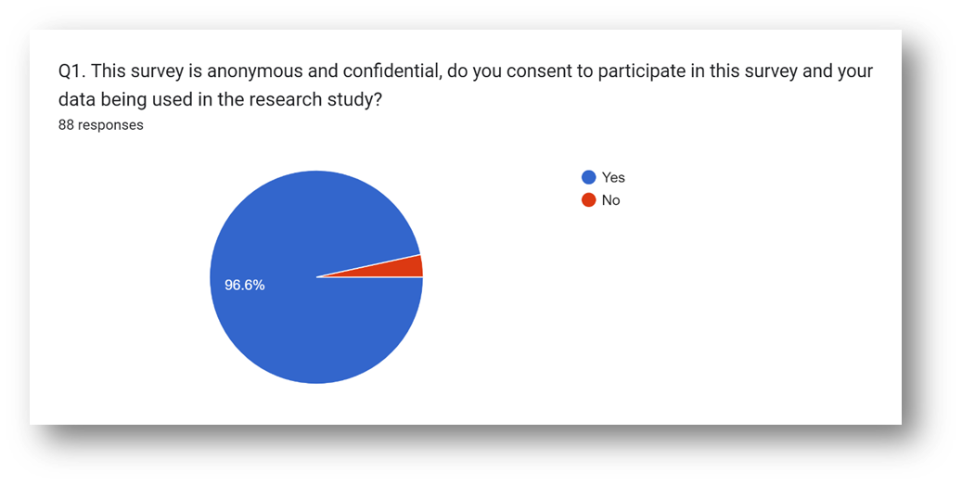

This result (Q1) shows the results of a survey question about informed consent to participate in a research study. In total, 88 people responded to the question. Of those who responded, 96.6% said yes (85 people) and 3.4% said no (3 people). Those who did not show consent were not included in the process.
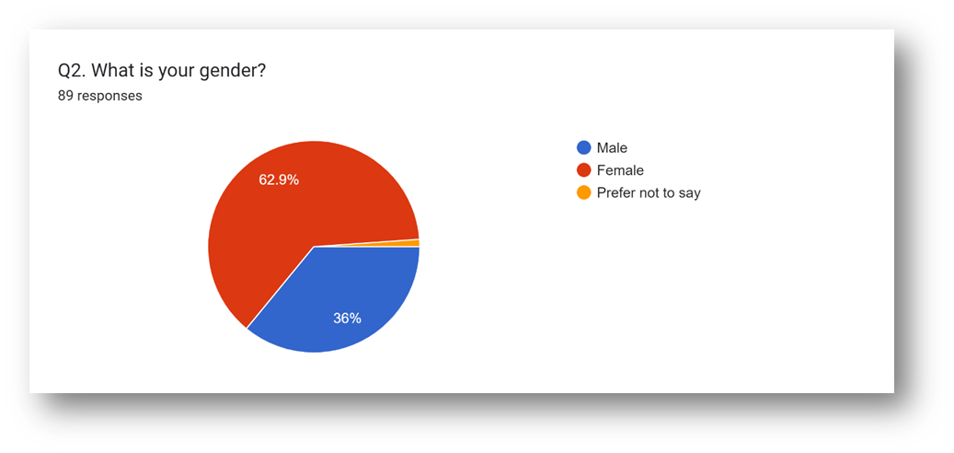

Q2 shows the gender distribution of 89 survey respondents.
It is important to note that the sample size is relatively small, so the results may not be generalisable to a larger population. However, the chart does show that a majority of the respondents who answered the question identified as male.

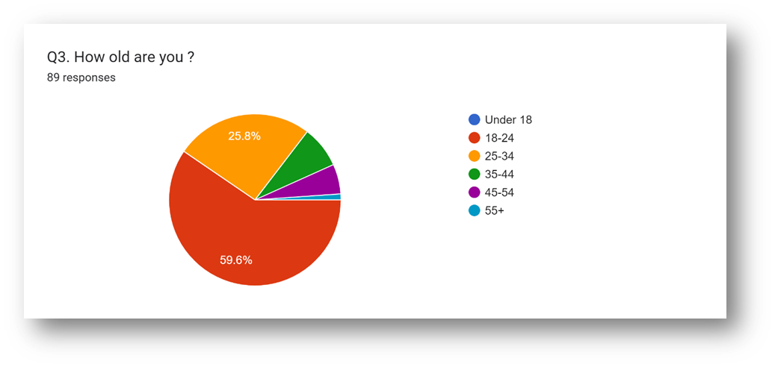
It is important to consider that the survey does not capture data for a significant portion (40.4%) of the respondents. This could potentially divert the results depending on the age demographics of those who did not answer the question. For instance, if older age groups were less likely to respond to the question, the pie chart would overrepresent the younger demographics.

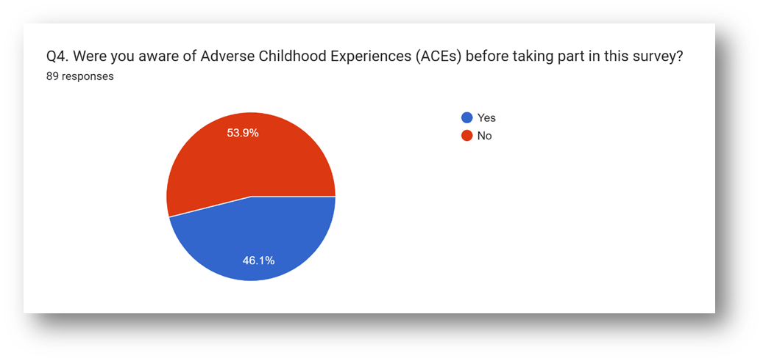
The pie chart shows the distribution of responses to a survey question about people’s awareness of Adverse Childhood Experiences (ACEs) before taking part in the survey. There were 89 total respondents. Just over half of the respondents (53.9%, or 48 people) said they were aware of ACEs before taking the survey. That means almost half (46.1%, or 41 people) were not aware of ACEs before the survey.

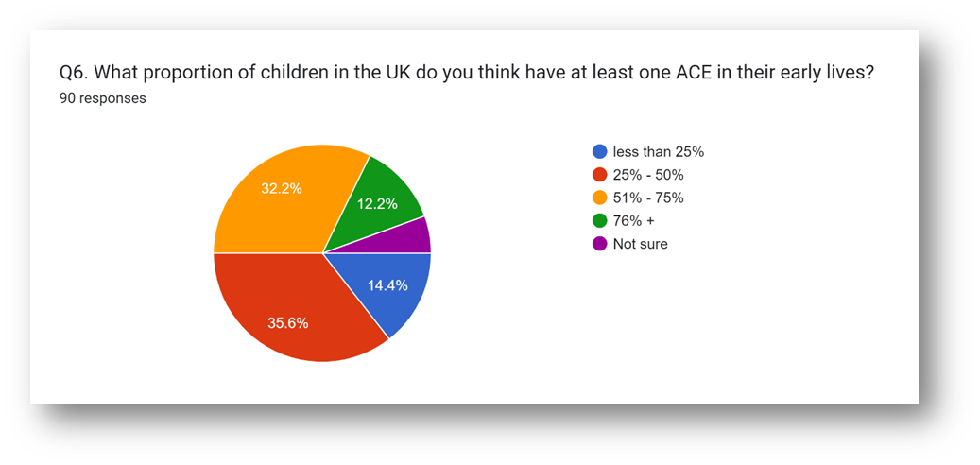
Q6 depicts the public perception of Adverse Childhood Experiences (ACEs) prevalence in the UK. A significant portion (35.6%) believe that over half (51-75%) of children have experienced at least one ACE. Interestingly, 14.4% are unsure, highlighting a potential knowledge gap about ACEs. While the chart offers valuable insight into public perception, it's crucial to remember this data is based on opinions, not concrete evidence of actual ACE rates.
The pie chart reveals that awareness of Adverse Childhood Experiences (ACEs) is divided nearly equally among the 89 people who responded to the survey question. Over half, 53.9% (48 people), said they were aware of ACEs before participating in the survey. This suggests that a significant portion of the population has some knowledge about ACEs. However, a nearly equal number, 46.1% (41 people), were not aware of ACEs before the survey. This highlights a potential knowledge gap about ACEs in a substantial portion of the population.

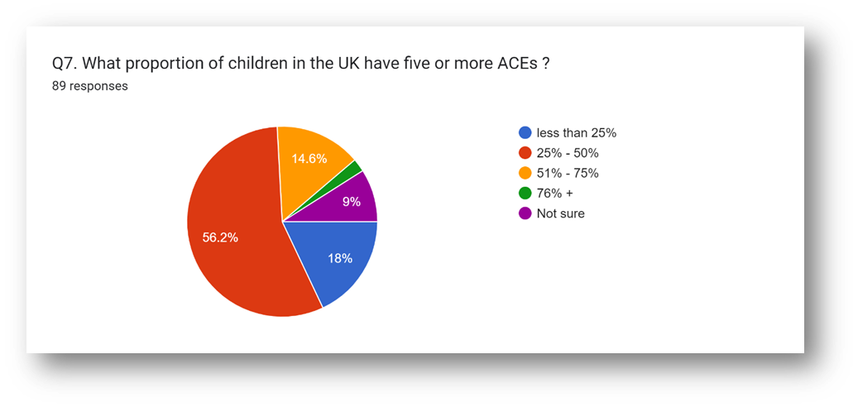
Q7 shows the results of a survey question about awareness of community resources for individuals affected by Adverse Childhood Experiences (ACEs). A total of 89 people responded to the question.

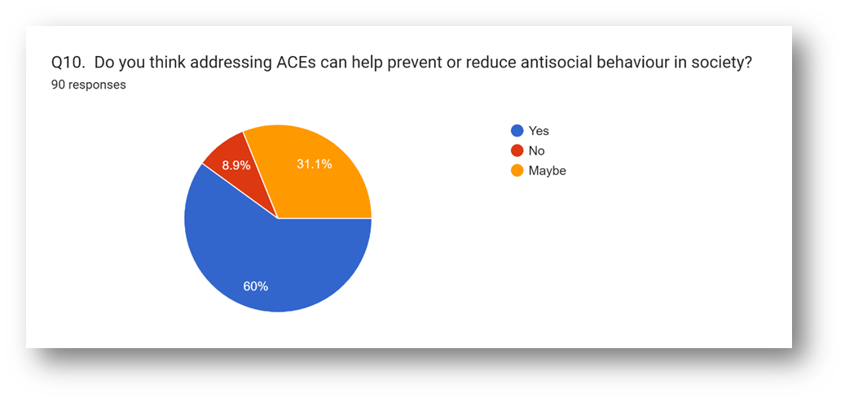
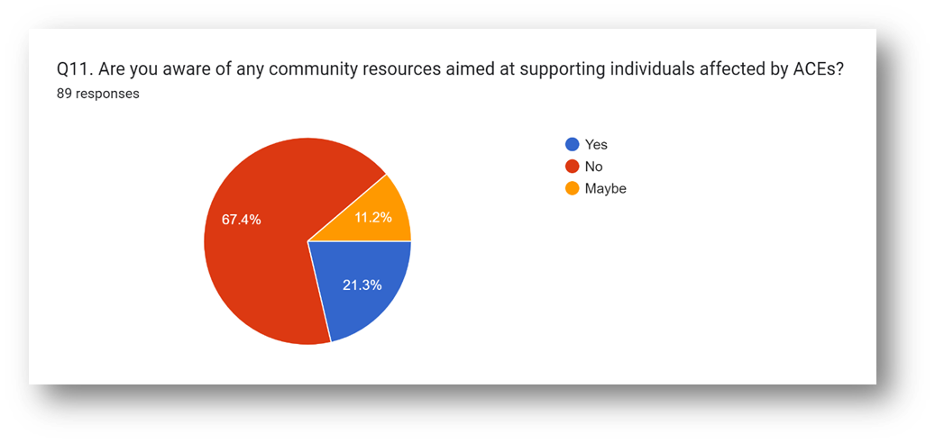

Q11 indicates that a significant majority (67.4%, or 60 people) are aware of resources available in their community to help those impacted by ACEs. This suggests that there may be successful outreach programs informing the community about available resources. However, a sizeable minority (21.3%, or 19 people) were not aware of such resources. There is also a small group (11.2%, or 10 people) who are unsure about the availability of resources.
Overall, the pie chart suggests that there is some awareness about community resources for people affected by ACEs. However, there is also a gap in knowledge among a significant minority of the population. Considering the limitations of the data, further research to understand the demographics of those who are unaware and the reach of outreach programs could be beneficial.

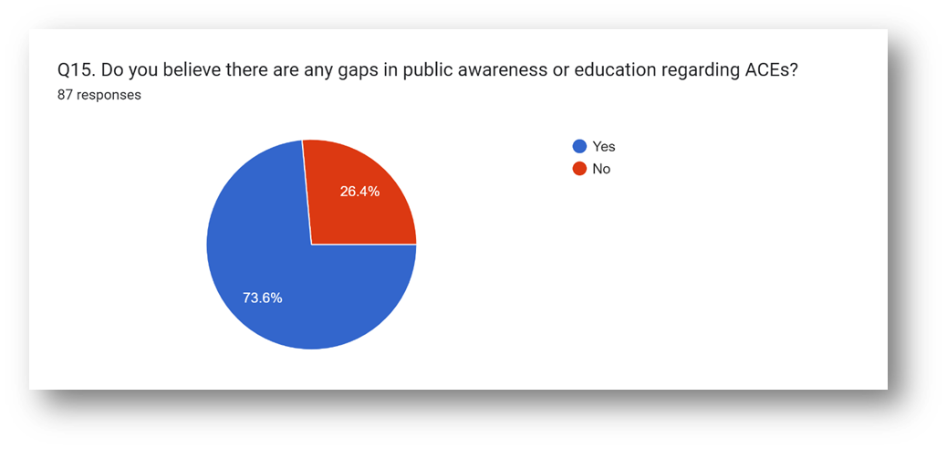
According to the pie chart (Q15), the largest percentage of respondents (35.6%) believe that over half (51-75%) of children in the UK have at least one ACE in their early lives (Boulier & Blair, 2018). However, it is important to note that this data is based on people’s perceptions rather than factual data
Here’s a more detailed breakdown of the findings:
• A significant portion of respondents (35.6%) believe that a majority of children (51-75%) experience at least one ACE before adulthood.
• Over a third (32.2%) believe that less than a quarter (under 25%) of children experience ACEs.
• Nearly one in seven (14.4%) are unsure about the prevalence of ACEs in early childhood.

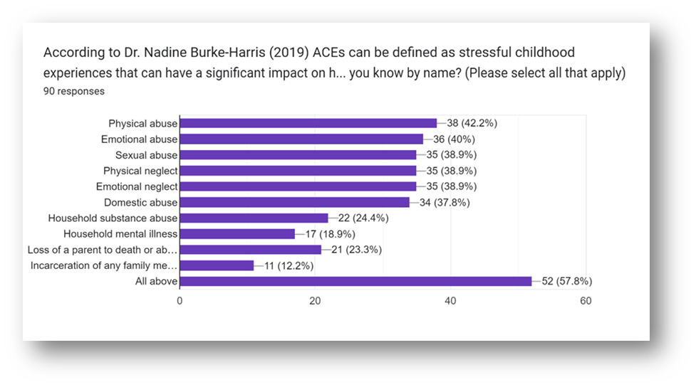

The graph shows the number of respondents who reported experiencing each type of ACE, as well as the percentage of respondents who reported experiencing each type of ACE.
Here is a breakdown of the results shown in the graph:
• Physical abuse: 38 respondents (42.2%)
• Emotional abuse: 36 respondents (40%)
• Sexual abuse: 35 respondents (38.9%)
• Physical neglect: 35 respondents (38.9%)
• Emotional neglect: 35 respondents (38.9%)
• Domestic violence: 34 respondents (37.8%)
• Household substance abuse: 22 respondents (24.4%)
• Household mental illness: 17 respondents (18.9%)
• Loss of a parent to death or abandonment: 21 respondents (23.3%)
• Incarceration of a household member: 11 respondents (12.2%)

4.1 Findings Analysis

The findings from the survey information offer huge knowledge into different parts of Adverse Childhood Experiences (ACEs) and their suggestions for research and practice. This comprehensive investigation expects to dig further into the findings, giving extra settings and explanations upheld by important writing.

4.2 Informed Assent and Socioeconomics

The survey's high pace of informed assent, with 96.6% of respondents consenting to partake in the research study, thinks about emphatically the moral lead of the study. Informed assent is a major moral rule in research, ensuring that members figure out the reason, procedures, and expected dangers of the survey before deliberately consenting to participate (Beauchamp and Childress, 2019). Most members consenting to the study propose that they comprehended the furnished data and were OK with their investment.
Recognising the restrictions inborn in the absence of segment data about respondents is significant. Without this segment information, it is trying to evaluate whether certain groups might be overrepresented or underrepresented in the example, which could affect the generalisability of the findings (Bowling, 2014). For example, studies have shown that variables like age, orientation, financial status, and instructive level can impact people's eagerness to partake in research (Fry and Dwyer, 2001; Galea and Tracy, 2007). Subsequently, understanding the segment structure of the example is fundamental for interpreting the findings precisely and making legitimate derivations about the more extensive populace.

4.3 Awareness of ACEs

The survey findings uncover degrees of awareness concerning ACEs among respondents. While over a portion of the respondents (53.9%) knew about the Pros before taking part in the survey, a critical extent (46.1%) didn't know about ACEs. This features a potential information gap inside the populace concerning the effect of childhood adversity on well-being and prosperity.
The significance of bringing issues to light about ACEs couldn't possibly be more significant, as it assumes a pivotal part in preventive endeavours and mediation techniques (Felitti et al., 1998; Hughes et al., 2017). Research shows that expanded awareness of Pros can prompt superior distinguishing proof, early intercession, and backing for people impacted by childhood adversity (Anda et al., 2006; Lanier et al., 2018). Besides, state-funded schooling efforts and preparing programs focusing on medical care ACEs, teachers, and social specialist organisations can add to a more comprehensive comprehension of Pros and their suggestions for individual and local area well-being (Merrick et al., 2017; Cronholm et al., 2015).
The survey findings concerning the impression of Pro prevalence among respondents offer important bits of knowledge into public awareness and perspectives toward childhood adversity. A critical extent of respondents (35.6%) accepts that over portion of children in the UK have experienced something like one Pro in their initial lives. This insight underscores the widespread acknowledgement of the prevalence of Pros and their possible effect on people and networks.
View of Pro prevalence can impact public strategy, resource assignment, and intercession techniques pointed toward addressing childhood adversity (Evans et al., 2013; Gershoff et al., 2012). In any case, it is fundamental to perceive that discernments may not necessarily line up with experimental information on Pro prevalence (Taylor et al., 2019). Disparities among saw and genuine prevalence rates can result in misguided approach choices and lacking resource designation, underscoring the requirement for exact information on ACEs (Taylor et al., 2019; Javdani et al., 2014).

4.5 Awareness of Local Area Resources

The survey findings concerning awareness of communities for individuals influenced by ACEs give experiences into the availability and transparency of help organisations (Giano et al. 2020). While 67.4% of respondents had some awareness of open resources, a striking degree (21.3%) had hardly any insight into such resources. This finding underscores the meaning of additional induction to information about help organizations and resources for individuals affected by childhood adversity (Anda et al. 2020).
Induction into communities is critical for directing the horrific outcomes of ACEs and promoting resilience among affected individuals (Bethell et al., 2019; Dube et al., 2003). Regardless, limits like restricted awareness, shame, and hidden aberrations can hinder permission to these resources, particularly for limited people (Shonkoff et al., 2012; Nurius et al., 2015). As such, attempts to update awareness, decline shame, and address hidden limits are central to ensuring unprejudiced induction to help organisations for all individuals affected by ACEs (Finkelhor, 2020).

4.6 Course of Action with Study Objectives

The survey findings change personally with the study objectives, particularly in sorting out the association among ACEs and the likelihood of at-fault lead (Boulier and Blair, 2018). The high speed of informed consent reflects moral examinations central to coordinating research on fragile subjects like ACEs. Additionally, the survey gives critical pieces of information about public awareness, observations, and permission to resources associated with Stars, which are essential for enlightening prevention and intervention techniques (Gilgoff et al. 2020).
By addressing these objectives, the study means to add to the field and effect courses of action highlighted further fostering the success of individuals affected by childhood adversity (Briggs et al. 2021). Comprehending the complex relationship between ACEs, social determinants of affluence, and unfavourable outcomes such as disruptive behaviour is essential for developing appropriate interventions and promoting resilience in vulnerable populations (Tooth et al., 2017; Baglivio et al., 2014). Likewise, by addressing the underlying causes of childhood adversity and its associated outcomes, the study can shed insight on advocacy efforts and resource distribution decisions by revealing knowledge gaps regarding awareness and access to resources (Narayan et al. 2021).
Therefore, the survey findings give significant knowledge into different parts of ACEs (Pros) and their suggestions for research and practice (Jones et al. 2020). By addressing the study objectives and featuring key findings, this examination adds to how one might interpret the perplexing connection between childhood adversity and its implications, at last, illuminating endeavours to help people and networks impacted by ACEs (Jones et al. 2020). To address the primary causes of early adversity and promote resilience among vulnerable populations, it is anticipated that research, advocacy, and strategic efforts would continue to be pursued.

Conclusion

This dissertation set out to explore the correlation between ACEs and the probability of offending behaviour in South Wales. Through an exploration of existing literature, a strategy using both quantitative and qualitative procedures, and an examination of findings, this study intended to reveal knowledge into this huge social issue.
The results of this study show an essential association between criminal behaviour and ACEs in South Wales. Examining ACEs and their effects on people's lives makes it evident that traumatic early experiences can manifest in a variety of cynical ways, bringing up guilt for previous violations (Alhowaymel et al. 2021). The research maintains the possibility that ACEs are hindering to individual well-being as well as have greater implications for social welfare, including expanded paces of detainment, ailments, and threatening to social behaviours (Alhowaymel et al. 2021).
Reflecting on the study, it is evident that understanding ACEs is not only essential but also necessary for developing effective preventative and intervention strategies. The literature review investigated numerous aspects of ACEs, providing information on their prevalence, important causes, and clear effects on persons' mental well-being (Anda et al. 2006). By combining current data, the study highlighted the pressing need for comprehensive approaches to managing ACEs, emphasising the importance of early diagnostic confirmation, intervention, and ongoing support.

The research gathered many viewpoints and experiences through a combination of quantitative summaries and qualitative questions, improving our comprehension of how ACEs appear throughout the community (Anda et al. 2006). This critical process not only separated evidence of common ACEs, but also shed light on the complex patterns that these events have on people's life, such as their stress management strategies, resilience components, and recovery routes.
Furthermore, the research inspired significant reflection on the complexities of addressing ACEs within a social context. It emphasised the importance of integrating many institutions, including as healthcare, education, and law enforcement, in effectively treating childhood adversity. This realisation highlights the significance of working together across disciplines and comprehensive approaches to supporting people affected by ACEs, which include both urgent interventions and long-term strategies targeted at promoting resilience and facilitating positive outcomes.
The compelling need for a comprehensive response to ACEs is shown by the combination of experimental results and literature reviews. Through comprehending the complicated relationship of factors that lead to childhood adversity, one can develop specific strategies that target the root causes and reduce their long-lasting effects (Anda et al. 2020). It may move closer to creating a truly sustaining and strong environment for everyone, where childhood harm is acknowledged, addressed, and ultimately prevented, by persistent research, activism, and collaboration. The lack of understanding of ACEs is another important finding of this dissertation. In a survey, participants were asked if they were aware of ACEs before to participating in this study, and 46.1% of respondents indicated they were not. This demonstrates how little people know about it. Thus, this issue could be resolved by introducing programmes regarding ACEs.

In light of the findings of this review, a few recommendations can be made to address the issue of ACEs and their correlation with criminal behaviour. First of all, there is a requirement for expanded mindfulness and training about ACEs among the overall population, experts, and policymakers (Anda et al. 2020). This incorporates carrying out injury-informed approaches in different settings, like schools, medical services facilities, and law enforcement frameworks. The interventions should also focus on providing resources and assistance to individuals who have suffered from ACEs, with a specific focus on early detection and prevention.
This research fundamentally contributes to the developing group of information on ACEs and their significant effect on people and society. By clarifying the connection between childhood injury and ensuing commitment to criminal behaviour, this study stresses the extreme need to address ACEs as a basic general well-being and social issue (Anda et al. 2020). Additionally, the findings of this research hold suggestions for strategy improvement, mediation projects, and advocacy endeavours pointed toward preventing and improving the impacts of ACEs. By illuminating proof-based arrangements and mediations, this research helps individuals from other fields to adopt injury-informed methods and use specific methodologies to assist those affected by ACEs. Finally, this contribution increases our aggregate understanding of ACEs and emphasises the fundamentals of purposeful effort to break the pattern of adversity and advance positive consequences for people and networks (Anda et al. 2020).
This dissertation has given significant knowledge into the connection between ACEs and offending behaviour in South Wales. By addressing the research question, summarising key findings, making recommendations, and featuring the contribution to the field, This study contributes to a better understanding of the complex relationship between early hardship and criminality. Moving forward, genuine efforts must be made to address ACEs holistically, with a focus on prevention, intervention, and support for those affected. Finally, by addressing ACEs, one can work towards creating a more secure and better climate for all people, ensuring that every child has the opportunity to thrive and reach their full potential.

Reference List

ACEs aware (2022). Healing from Toxic Stress with Dr. Nadine Burke Harris. Available at: https://www.acesaware.org/blog/healing-from-toxic-stress-with-dr-nadine-burke-harris/(Accessed: 7 November 2023).
Agnew R. (1992). Foundation for a general strain theory of crime and delinquency. Criminology, 30, pp.47–88. Available at: https://doi.org/10.1111/j.1745-9125.1992.tb01093.x
Alharahsheh, HH., and Pius, A.(2020) ' A Review of key paradigms: positivism VS interpretivism', Global Academic Journal of Humanities and Social Sciences , 2(3), pp 39-43. Available at: https://gajrc.com/media/articles/GAJHSS_23_39-43_VMGJbOK.pdf (Accessed: 19 March 2024).
Alhowaymel, F., Kalmakis, K., & Jacelon, C. (2021). Developing the concept of adverse childhood experiences: A global perspective. Journal of Pediatric Nursing, 56, 18-23.
Anda, R. F., Felitti, V. J., Bremner, J. D., Walker, J. D., Whitfield, C., Perry, B. D., ... & Giles, W. H. (2006). The enduring effects of abuse and related adverse experiences in childhood: A convergence of evidence from neurobiology and epidemiology. European archives of psychiatry and clinical neuroscience, 256(3), 174-186.
Anda, R. F., Porter, L. E., & Brown, D. W. (2020). Inside the adverse childhood experience score: Strengths, limitations, and misapplications. American Journal of Preventive Medicine, 59(2), 293-295.
Andrade, C.(2020) ‘The Limitations of Online Surveys’. Indian Journal of Psychological Medicine. pp 575-576, 42(6).Available at:10.1177/0253717620957496.
Baglivio, M. T., Wolff, K. T., Piquero, A. R., Bilchik, S., Jackowski, K., Greenwald, M. A., & Epps, N. (2014). Maltreatment, child welfare, and recidivism in a sample of deep-end crossover youth. Journal of Youth and Adolescence, 43(5), 782-796.
Baldwin, J. R., Caspi, A., Meehan, A. J., Ambler, A., Arseneault, L., Fisher, H. L., ... & Danese, A. (2021). Population vs individual prediction of poor health from results of adverse childhood experiences screening. JAMA pediatrics, 175(4), 385-393.
Beauchamp, T. L., & Childress, J. F. (2019). Principles of biomedical ethics. Oxford University Press.
Bethell, C. D., Newacheck, P., Hawes, E., & Halfon, N. (2014). Adverse childhood experiences: Assessing the impact on health and school engagement and the mitigating role of resilience. Health Affairs, 33(12), 210
Boullier, M., & Blair, M. (2018). Adverse childhood experiences. Paediatrics and Child Health, 28(3), 132-137.
Briggs, E. C., Amaya-Jackson, L., Putnam, K. T., & Putnam, F. W. (2021). All adverse childhood experiences are not equal: The contribution of synergy to adverse childhood experience scores. American Psychologist, 76(2), 243.
Bryant, D. J., Oo, M., & Damian, A. J. (2020). The rise of adverse childhood experiences during the COVID-19 pandemic. Psychological Trauma: Theory, Research, Practice, and Policy, 12(S1), S193.
Centers for Disease Control and Prevention - CDC (2021) Adverse Childhood Experiences (ACEs) preventing early trauma to improve adult health. Available at: https://www.cdc.gov/vitalsigns/aces/index.html (Accessed: 7 November 2023).
Centers for Disease Control and Prevention- CDC (2020). Adverse childhood experiences (ACEs). https://www.cdc.gov/violenceprevention/childabuseandneglect/acestudy/index.html
Centers for Disease Control and Prevention-CDC (2023) Fast Facts: Preventing Adverse Childhood Experiences. Available at: https://www.cdc.gov/violenceprevention/aces/fastfact.html#:~:text=Raising%20awareness%20of%20ACEs%20can,%2C%20depression%2C%20or%20suicidal%20thoughts. (Accessed: 9 November 2023).
Chizimba, B. (2021) Assessing the knowledge and skills gap for Adverse Childhood Experiences (ACEs) and trauma-informed practice in children and young people’s services across the education, health, care and voluntary sector', Sage Journal, 45,1. Available at: https://doi.org/10.1177/0308575921995439
Chowdhury, M. (2014) ‘Interpretivism in Aiding Our Understanding of the Contemporary Social World’. Open Journal of Philosophy, 4(3), 432-438. doi: 10.4236/ojpp.2014.43047.
Chung, DD., Pinson, MR., Bhenderu, LS., Lai, MS., Patel, RA. and Miranda, RC. (2021) ‘ Toxic and Teratogenic Effects of Prenatal Alcohol Exposure on Fetal Development, Adolescence, and Adulthood’, International Journal of Molecular Science, 22(16):8785 . Available at: 10.3390/ijms22168785
Coker, D. C. (2022). A Thematic Analysis of the Structure of Delimitations in the Dissertation. International Journal of Doctoral Studies, 17.
Connolly, E. J. (2020). Further Evaluating the Relationship Between Adverse Childhood Experiences, Antisocial Behavior, and Violent Victimization: A Sibling-Comparison Analysis. Youth Violence and Juvenile Justice, 18(1), pp.3-23. Available at: https://doi.org/10.1177/1541204019833145
Crandall, A., Miller, J. R., Cheung, A., Novilla, L. K., Glade, R., Novilla, M. L. B., ... & Hanson, C. L. (2019). ACEs and counter-ACEs: How positive and negative childhood experiences influence adult health. Child abuse & neglect, 96, 104089.
Creswell, JM. (2007) 'Chapter 18 - Mixed-Method Research: Introduction and Application', Handbook of Educational Policy, pp 455-472 Available at: https://doi.org/10.1016/B978-012174698-8/50045-X
Dubey, U. K. B., & Kothari, D. P. (2022). Research methodology: Techniques and trends. Chapman and Hall/CRC.
Felitti, V. (2019). Origins of the ACE study. American Journal of Preventive Medicine, 56(6), 787-789

Felitti, V., Anda., R., Nordenberg, D., Williamson, D., Spitz, A., Edwards, V., Koss, M., & Marks, J. (1998). Relationship of childhood abuse and household dysfunction to many of the leading causes of death in adults: The adverse childhood experiences study. American Journal of Preventive Medicine, 14(4), 245-258. https://doi.org/10.1016/s0749-3797(98)00017-8
Finkelhor, D. (2020). Trends in adverse childhood experiences (ACEs) in the United States. Child abuse & neglect, 108, 104641.
Finkelhor, D. (2020). Trends in adverse childhood experiences (ACEs) in the United States. Child abuse & neglect, 108, 104641.
Genevieve, S. (2019) 'Knowledge and awareness of Adverse Childhood Experiences (ACEs) in the public service workforce in Wales: a national survey', Public Health Wales, p 17. Available at: https://phw.nhs.wales/news/new-survey-shows-both-good-welsh-public-sector-awareness-of-adverse-childhood-experiences-aces-and-opportunities-for-improvement/knowledge-and-awareness-of-adverse-childhood-experiences-in-the-public-service-workforce-in-wales/ (Accessed: 16 October 2023).
Giano, Z., Wheeler, D. L., & Hubach, R. D. (2020). The frequencies and disparities of adverse childhood experiences in the US. BMC public health, 20, 1-12.
Gilgoff, R., Singh, L., Koita, K., Gentile, B, and Marques, SS. (2020). Adverse Childhood Experiences, Outcomes, and Interventions. ‘Pediatr Clin North Am’,67(2), pp259-273 . Available at: 10.1016/j.pcl.2019.12.001
Gilgoff, R., Singh, L., Koita, K., Gentile, B., & Marques, S. S. (2020). Adverse childhood experiences, outcomes, and interventions. Pediatric Clinics, 67(2), 259-273.
Goddard, A. (2021). Adverse childhood experiences and trauma-informed care. Journal of Pediatric Health Care, 35(2), 145-155.
Gottfredson M. R., Hirschi T. (1990). A general theory of crime. Palo Alto, CA: Stanford University Press. Available at: https://doi.org/10.1515/9781503621794
Hughes, K., Ford, K., Bellis, M. A., Glendinning, F., Harrison, E., & Passmore, J. (2021). Health and financial costs of adverse childhood experiences in 28 European countries: a systematic review and meta-analysis. The Lancet Public Health, 6(11), e848-e857.
Jones, C. M., Merrick, M. T., & Houry, D. E. (2020). Identifying and preventing adverse childhood experiences: implications for clinical practice. Jama, 323(1), 25-26.
Kumari, S. K. V., Lavanya, K., Vidhya, V., Premila, G. A. D. J. S., & Lawrence, B. (2023). Research methodology (Vol. 1). Darshan Publishers.
Leitch, L. (2017) 'Action steps using ACEs and trauma-informed care: a resilience model', Health and Justice, 5(5) p1. Available at: https://link.springer.com/article/10.1186/s40352-017-0050-5.(Accessed: 9 November 2023)
Leza, L., Siria, S., López-Goñi, J. J., & Fernandez-Montalvo, J. (2021). Adverse childhood experiences (ACEs) and substance use disorder (SUD): a scoping review. Drug and alcohol dependence, 221, 108563.
Loveday, S., Hall, T., Constable, L., Paton, K., Sanci, L., Goldfeld, S., & Hiscock, H. (2022). Screening for adverse childhood experiences in children: a systematic review. Pediatrics, 149(2), e2021051884.
Manchester University (2023) Adverse Childhood Experiences (ACEs) and Attachment. Available at: https://mft.nhs.uk/rmch/services/camhs/young-people/adverse-childhood-experiences-aces-and-attachment/ (Accessed: 30 November).
Matjasko, JL., Herbst, JH. and Estefan, LF. (2022) ' Preventing Adverse Childhood Experiences: The Role of Etiological, Evaluation, and Implementation Research',Am J Prev Med ,(6 Suppl 1):p6-15 . Available at: 10.1016/j.amepre.2021.10.024
Mishra, S. B., & Alok, S. (2022). Handbook of research methodology. Educreation publishing.
Narayan, A. J., Lieberman, A. F., & Masten, A. S. (2021). Intergenerational transmission and prevention of adverse childhood experiences (ACEs). Clinical psychology review, 85, 101997.
Narayan, A. J., Lieberman, A. F., & Masten, A. S. (2021). Intergenerational transmission and prevention of adverse childhood experiences (ACEs). Clinical psychology review, 85, 101997.
Newman, M., & Gough, D. (2020). Systematic reviews in educational research: Methodology, perspectives and application. Systematic reviews in educational research: Methodology, perspectives and application, 3-22.
Ocaña-Fernández, Y., &amp; Fuster-Guillén, D. (2021). The bibliographical review as a research methodology. Revista Tempos e Espaços em Educação, 14(33), e15614-e15614.
Office for National Statistic (2022) Available at: https://www.ons.gov.uk/aboutus/transparencyandgovernance/freedomofinformationfoi/percentageofhomesandindividualswithtechnologicalequipment (Accessed: 15 March 2024).
Pandey, P., & Pandey, M. M. (2021). Research methodology tools and techniques. Bridge Center.
Parliament (2018). Evidence-based early years intervention. Available at: https://publications.parliament.uk/pa/cm201719/cmselect/cmsctech/506/50605.htm (Accessed: 30 November 2023).
Ports, K. A., Ford, D. C., Merrick, M. T., & Guinn, A. S. (2020). ACEs: Definitions, measurement, and prevalence. In Adverse childhood experiences (pp. 17-34). Academic Press.
Public Health Scotland (2021) Adverse Childhood Experience (ACEs). Available at:https://www.healthscotland.scot/population-groups/children/adverse-childhood-experiences aces/overview-of-aces (Accessed: 7 November 2023).
Public Health Wales (2023) Adverse Childhood Experiences. Available at: https://phw.nhs.wales/topics/adverse-childhood-experiences/ (Accessed: 16 October 2023).
Raine, A. (2008) ‘From Genes to Brain to Antisocial Behavior’, Current Directions in Psychological Science, 17(5). Available at: https://doi.org/10.1111/j.1467-8721.2008.00599.x
Sanderson, M., Mouton, CP., Cook, M., Liu, J., Blot, WJ. and Hargreaves, MK.(2021) ‘Adverse Childhood Experiences and Chronic Disease Risk in the Southern Community Cohort Study’, J Health Care Poor Underserved, 32(3) pp.1384-1402 Available at: 10.1353/hpu.2021.0139
Schroeder, K., Schuler, B. R., Kobulsky, J. M., & Sarwer, D. B. (2021). The association between adverse childhood experiences and childhood obesity: a systematic review. Obesity Reviews, 22(7), e13204.
Sheffler, J. L., Stanley, I., & Sachs-Ericsson, N. (2020). ACEs and mental health outcomes. In Adverse childhood experiences (pp. 47-69). Academic Press.
Steptoe, A., Marteau, T., Fonagy, P. and Abel, K.(2019). ‘ACEs: Evidence, Gaps, Evaluation, and Future Priorities’, Social Policy and Society,18(3), pp415-424 Available at: https://doi.org/10.1017/S1474746419000149
Struck, S., ATufescu, AS., Asmundson, A., Asmundson, G. and Afifi, T. (2021) ‘Adverse childhood experiences (ACEs) research: A bibliometric analysis of publication trends over the first 20 years’, Child Abuse & Neglect, 112, Available at: https://www.sciencedirect.com/science/article/pii/S0145213420305500(Accessed: 7 December 2023).
Struck, S., Stewart-Tufescu, A., Asmundson, A. J., Asmundson, G. G., & Afifi, T. O. (2021). Adverse childhood experiences (ACEs) research: A bibliometric analysis of publication trends over the first 20 years. Child Abuse & Neglect, 112, 104895.
Terrell, S. R. (2022). Writing a proposal for your dissertation: Guidelines and examples. Guilford Publications.
The Burke Foundation (2019). Adverse Childhood Experiences (ACEs). Available at: https://burkefoundation.org/what-drives-us/adverse-childhood-experiences-aces/ (Accessed: 7 November 2023).
Thomas, C. G. (2021). Research methodology and scientific writing. Thrissur: Springer.
Ullrich, C., Stürmlinger, A., Wensing, M., & Krug, K. (2020). Qualitative research methods in medical dissertations: an observational methodological study on prevalence and reporting quality of dissertation abstracts in a German university. BMC Medical Research Methodology, 20, 1-9.
Varela, M., Lopes, P., & Rodrigues, R. (2020, June). Research in Business Sciences: A Study of Master's Dissertation Methodologies in Management Based on Case Studies. In ECRM 2020 20th European Conference on Research Methodology for Business and Management Studies: ECRM 2020 (p. 292). Academic Conferences and publishing limited.
Varela, M., Lopes, P., & Rodrigues, R. (2021). Rigour in the management case study method: A study on Master's dissertations. Electronic Journal of Business Research Methods, 19(1), pp1-13.
Verma, R., Verma, S., & Abhishek, K. (2024). Research Methodology. Booksclinic Publishing.
Walsh, D., McCartney, G., Smith, M., & Armour, G. (2019). Relationship between childhood socioeconomic position and adverse childhood experiences (ACEs): a systematic review. J Epidemiol Community Health, 73(12), 1087-1093.
Webster, EM.(2022) 'The impact of Adverse Childhood Experiences on Health and Development in Young Children', Global Pediatr Health. Available at: https://www.ncbi.nlm.nih.gov/pmc/articles/PMC8882933/
Wesseldijk, LW., Bartels, M., Vink, JM,. Beijsterveldt, CEM., Ligthart, L., Boomsma. DI. and Middeldorp. (2018) ‘Genetic and environmental influences on conduct and antisocial personality problems in childhood, adolescence, and adulthood’, European Child & Adolescent Psychiatry, 27, pp. 1123-1232. Available at: https://doi.org/10.1007/s00787-017-1014-y
Wright, KB. (2005) 'Researching Internet-Based Populations: Advantages and Disadvantages of Online Survey Research, Online Questionnaire Authoring Software Packages, and Web Survey Services', Journal of Computer-Mediated Communication, 10 (3). Available at: https://doi.org/10.1111/j.1083-6101.2005.tb00259.x
Young Minds (2023) Understanding trauma and adversity. Available at: https://www.youngminds.org.uk/professional/resources/understanding-trauma-and-adversity/

Appendix 1

Is there a correlation between Adverse Childhood Experiences (ACEs) and the likelihood of offending behaviour in England and Wales?
My name is Nilupa Begum, and I am currently studying in my final year for a bachelor’s degree in Criminology and Policing in University of Wales Trinity Saint David. The aim of my dissertation is to explore the relationship between ACEs and the potential impact of engaging in offending behaviour. This survey aims to find out participant's views and general knowledge of ACEs. This survey is anonymous and confidential and should take 5-7 minutes to complete. To take part in this survey you must be over 18. If you agree to participate then please ensure you answer ‘yes’ to the first question. For any questions email me on 2114298@student.uwtsd.ac.uk

Thank you for your time.

Q1. This survey is anonymous and confidential, do you consent to participate in this survey and your data being used in the research study?
- Yes
- No

Q2. What is your gender?
- Female
- Male
- Prefer not to say

Q3. How old are you?
- Under 18
- 18- 24
- 25-34
- 35-44
- 45-54
- 55+

Q4. Were you aware of Adverse Childhood Experiences (ACEs) before taking part in this survey?
- Yes
- No

According to Dr. Nadine Burke-Harris (2019) ACEs can be defined as stressful childhood experiences that can have a significant impact on health and well-being later in life.

Q5. How many ACEs do you know by name? (Please select all that apply)
- Physical abuse
- Emotional abuse
- Sexual abuse
- Physical neglect
- Emotional neglect
- Domestic abuse
- Household substance abuse
- Household mental illness
- Loss of a parent to death or abandonment by parental divorce
- Incarceration of any family member for a crime
- All of above

Q6. What proportion of children in the UK do you think have at least one ACE in their early lives?
- Less than 25%
- 25-50%
- 51-75%
- 76%+
- Not sure

Q8. Do you think there is a link between negative experiences in childhood and the likelihood that children might step towards anti-social and criminal behaviour as adults?
- Yes
- No
- Maybe

Q9. What do you think are the long-term effects of ACEs on individuals?
Type your answer here ………………………………………………………

Q10. Do you think addressing ACEs can help prevent or reduce antisocial behaviour in society?
- Yes
- No
- Maybe

Q11. Are you aware of any community resources aimed at supporting individuals affected by ACEs?
- Yes
- No
- Maybe

Q12. What strategies or interventions do you think are effective in addressing the effects of ACEs?
Type your answer here …………………………………………………………………………….

Q13. How do you think awareness and understanding of ACEs can contribute to public health initiatives?
Type your answer here …………………………………………………………………………….

Q14. Could you give examples of any anti-social behaviour a person with ACEs might commit?
Type your answer here …………………………………………………………………………….

Q15. Do you believe there are any gaps in public awareness or education regarding ACEs?
- Yes
- No
If answered yes please explain what the gaps are?
Type your answer here …………………………………………………………………………….

