

Assignment Title:
Experimental Data Analysis

Module:
Data Analysis and Visualisation

Module code: ACCB4002

Student: Irina Tupca (2112902)

Lecturer: Koushik Modak

Date of submitted: 06 May 2022

Table of Contents
List of figures 2
Introduction 2
Description of the dataset 3
Visualisation of the dataset 3
Appropriate hypotheses for the analysis 3
T-test: Paired Two Sample for Means. 3
Selection of T-test: Paired Two Sample for Means 4
Technique and process for presenting the result 4
Testing hypotheses at different levels of significance: 4
1. p = 0,10 4
2. p=0.01 5
3. p=0.02 6
Outliers in the dataset 7
Outliers and their impact: 7
Factors affecting Hypotheses testing 7
Results 7
Conclusion 7
References 7

List of figures

- Figure 1 Visualization of the dataset
- Figure 2. Test for p = 0.10
- Figure 3. Test for p = 0.01
- Figure 4. Test for p = 0.02
- Figure 5. The existence of outliers

Introduction

Description of the dataset

The generated data set shows that the results of class tests (marked out of 20) of children learning mathematical concepts in a local primary school. The data set contains 40 children from year 5 from a local primary school. The school received a math learning app from a local online learning app development company. The production company wants to analyse the use of the application as a learning tool by comparing the test score before using the application with the test score after using the application.
Initial results show children's achievements when using traditional materials to help them learn and the second set shows the results obtained when children use a new online application to help them study. The data of these children are analysed to find out whether the company should continue to develop this application or not.
Hypotheses are made on several dataset.

Visualisation of the dataset

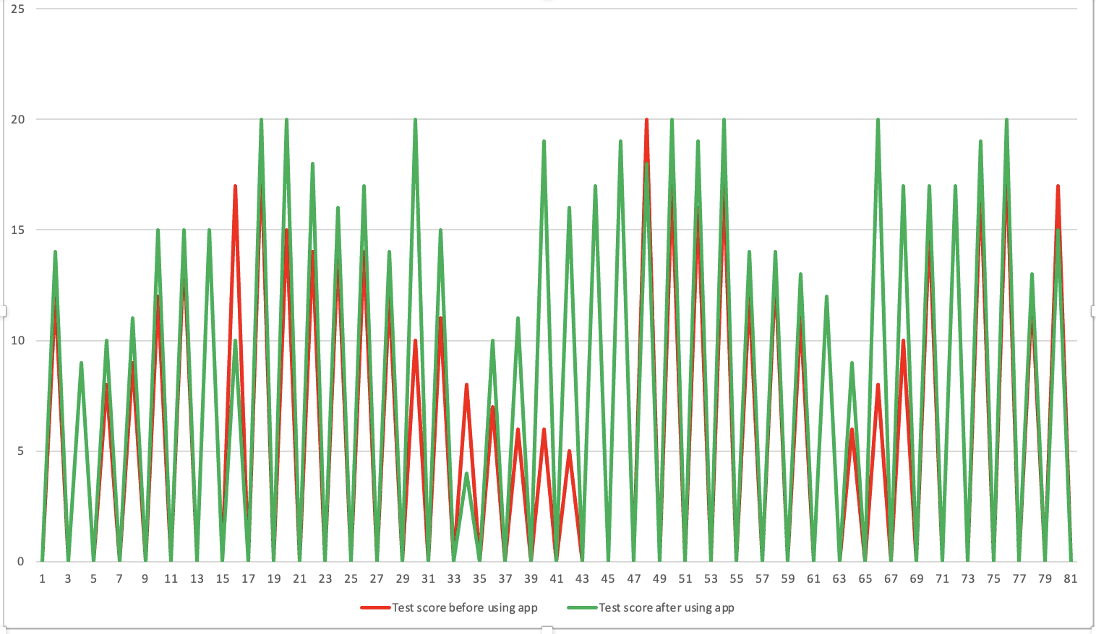

Figure 1. Visualization of the dataset
The bar chart shows the test scores before and after using the application of 40 primary school students. And it can be observed the comparison of the data according to the periods specified above.

Appropriate hypotheses for the analysis

Null and alternative hypotheses are two mutually exclusive statements about a population.
The null hypothesis assumes that that a population parameter(such as the mean, the standard deviation, and so on) is equal to a hypothetical value. The symbol for the null hypothesis is H0.
Instead, the alternative hypothesis assumes that a population parameter is smaller, larger, or different from the hypothetical value in the null hypothesis. The symbol for the alternative hypothesis is H1. The alternative hypothesis can be either one-tail and two-tail. One-tail alternative hypothesis (also known as directional hypothesis) is used to determine whether the population parameter differs from the hypothetical value in a certain direction. Two-tail alternative hypothesis (also known as nondirectional hypothesis) used to determine whether the population parameter differs from the hypothetical value in either direction.
The t-test is one of the commonly used statistical test. It is used to find out if the means of two samples differ to a statistically significant degree.
There three types of t-Tests:
- Paired t-test is used if the groups come from a single population. The paired t-test statistics value can be calculated using the following formula:
t = $\frac{m}{s/{\sqrt{n}}}$
where,
- m is the mean differences.
- n is the sample size.
- s is the standard deviation of the differences.
- Independent t-test is used if the groups come from two different populations. The independent t-test statistics value can be calculated using the formula below:
t = $\frac{m}{\sqrt{\frac{S_{A}^{2}}{n_{A}}+\frac{S_{B}^{2}}{n_{B}}}}$
where,
  - m is the mean differences.
  - n is the sample size of the two populations.
  - S is the estimates of the variances of the two populations.
- One-sample t-test is used if there is a group that is compared to a standard value. The one-sample t-test statistics value can be calculated using the formula below:
t = $\frac{m-μ}{s/{\sqrt{n}}}$
where,
  - m is mean of the population.
  - $μ$ is a theoretical value.
  - s is the standard deviation.
  - n is the size of the set of values.

T-test: Paired Sample for Means.

The pair sample test is a statistical procedure used when it is necessary to determine whether the mean difference between two sets of observations is zero. In a paired sample test, each subject is measured twice, resulting in pairs of observations. Common applications of the paired sample test include case-control studies or repeated measures projects.

Selection of T-test: Paired Sample for Means

In given exercise, we study a group (40 students) to compare the group over time (before using the application and after using the application). Respectively we will use a paired T-test. We have two sets of scores, one pre-test scores before using the app and one post-test scores after using the app. The scores are matches, not independent. In this case it is the differences in the scores that are important rather than the scores themselves.
tobt = $\frac{\overline{D}}{{{SD}_{D}}/{\sqrt{n}}}$
where,
- $\overline{D}$ is the mean of the differences between the two measurements.
- ${SD}_{D}$ is the standard deviation of the differences.
- $n$ is the number of pairs.
The data analysis is done in MS-Excel where the sample data are selected for the group and then the hypothesis is calculated and tested.
State the hypotheses:
- H0 ${:μ}_{1}$ = $μ_{2}$
- H1 ${:μ}_{1}$ $≠$ $μ_{2}$

Technique and process for presenting the result
Respectively according to these hypotheses, they can be calculated.

Testing hypotheses at different levels of significance:

p = 0.10
- Cells B5 = 12.75 and C5 = 15.3 contain the mean of each sample, Test score before using app = Beginning and Test score after using app = End.
m = $\frac{sums of the test scores}{number of items}$
- Cells B6= 16.81 and C6 = 15.29 contain the variance of each sample.
formula
- Cells B7 and C7 contain the number of observations in each sample (40).
- Cell B8 = 0.54 contains the Pearson Correlation which indicates that the two variables are quite closely correlated.
- Cell B9 = 0 contains our entry for the Hypothesized Mean Difference.
- Cells B10 contains the degrees of freedom, 40 – 1.
- Cell B11 = - 4.15 contains the result of the actual t-test. We will compare this value with the t-Critical two-tail statistic:
- The t-Statistic (- 4.15) is smaller than t Critical two-tail (1.68) and t Critical one-tail (1.30), the value of null hypotheses cannot be rejected, and that data must support the null hypotheses, and Students Test scores before using app and after using app can be considered equal.
- The P-value for two-tail (0.000172) is smaller than the value of alpha (0.10), that means the null hypotheses can be rejected. Our data sample supports the hypothesis that population averages are different. Specifically, the Post-test average is higher than the Pre-test average.
- If we compare P-value for one-tail (8.62) and P-value for two-tail (0.00017), that mean the data of P-value for one-tail cannot reject the null hypothesis, but the data of P-value for two-tail can reject the null hypothesis.

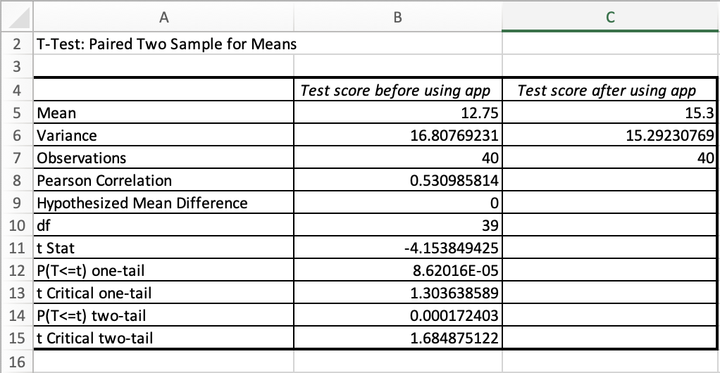

Figure 2. Test for p = 0.10

My reflection au impact compares tcritical one tail
Tcritical two tail, p

p=0.01

For the value of 0.01 the same technique is used and represents the following result:
- The t-Statistic (- 4.15) is smaller than t Critical two-tail (2.71) so the value of null hypotheses cannot be rejected, and the null hypotheses is performed.
- The P-value for two-tail (0.000172) is smaller than the value of alpha (0.01), then the null hypotheses can be rejected.

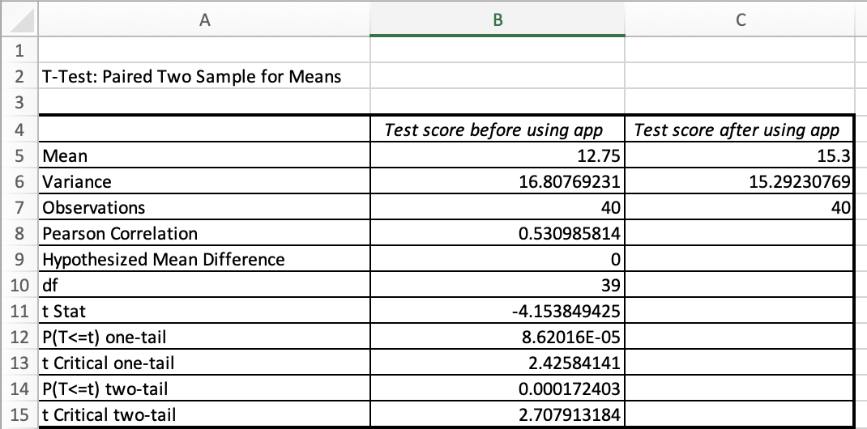

Figure 3. Test for p = 0.01

p=0.02

For the value of 0.02 the same technique is used and represents the following result:
- The t-Statistic (- 4.15) is smaller than t Critical two-tail (2.43) so the value of null hypotheses cannot be rejected, so the null hypotheses is not avoided.
- The P-value for two-tail (0.000172) is smaller than the value of alpha (0.02), then the null hypotheses can be rejected.

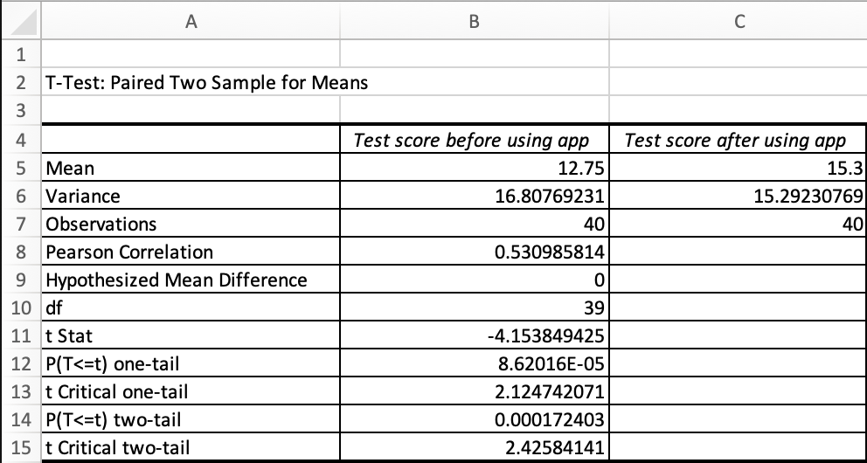

Figure 4. Test for p = 0.02

Results

Overall analyses of whole t test
Also, in some cases, statisticians choose ⍺ = 0.01. Reducing the critical value from 0.05 to 0.01 decreases the chance of a false positive (called a Type I error), but it also makes it more difficult to reject the null hypothesis. Therefore, with a critical value of 0.01, the results are more trustworthy but also more difficult to obtain.
- p_value > 0.1: No evidence
- p_value between 0.05 and 0.1: Weak evidence
- p_value between 0.01 and 0.05: Evidence
- p_value between 0.001 and 0.01: Strong evidence
- p_value < 0.001: Very strong evidence

Outliers in the dataset

Outliers and their impact:

Outliers are rare values that appear far from most data. Outliers can influence the results and lead to incorrect conclusions if not treated properly. One way to treat outliers is to simply remove them. However, deleting data points can introduce other types of bias into results and lead to the loss of critical information.

In our exercise, there is no outliers as all the values are under 4-20 and no unusual value. Mean and standard deviation are also significant changes, there is no big difference between mean and standard deviations. Respectively, no aberrant values were found in our exercise.

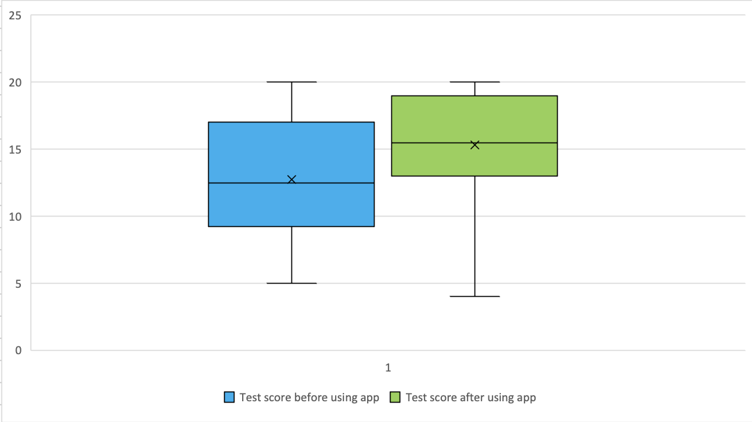

Figure 5. The existence of outliers

In we have outliers, cut them, and create a new t test
If, aberrant values are found, they can be treated by several methods:
- Sort the dataset to find outliers: By filtering the data, you can discover significant effects that are simply "hidden" by outliers. This means that you can find the highest and lowest values in the dataset, that is, the abnormally high or low values have been leaked.
- Using Z score test: It is one of the most used methods for detecting outliers. Measures the number of standard deviations of the observation from the mean value.
- Make data charts in MS Excel: Charts like scatter charts, histograms, or boxplots can easily show data that is different by placing them elsewhere.
- Finding outliers with hypothesis tests:
If the p-value for this test is less than your significance level, you can reject the null and conclude that one of the values is an outlier.

Factors affecting Hypotheses testing

example
The hypothesis test is affected by three factors.

- Sample size (n). The other things being equal, the larger the sample size, the greater the power of the test. Ci cit e mai mare este mai aproape auna de alta
- Significance level (α). The lower the significance level, the lower the power of the test. If you reduce the significance level (for example, from 0.05 to 0.01), the acceptance region becomes larger. As a result, you are less likely to reject the null hypothesis. This means that you are less likely to reject the null hypothesis when it is false, so you are more likely to make a type II error. In short, the power of the test is reduced when you reduce the level of significance; and vice versa.
- The "true" value of the tested parameter. The greater the difference between the "true" value of a parameter and the value specified in the null hypothesis, the greater the power of the test. That is, the larger the effect size, the greater the power of the test.

Conclusion

References

- Bevans, Rebecca. “An Introduction to T-Tests | Definitions, Formula and Examples.” Scribbr, 31 Jan. 2020, www.scribbr.com/statistics/t-test/.
- Birkett, Alex. “How to Deal with Outliers in Your Data.” CXL, 24 Aug. 2019, cxl.com/blog/outliers/.
- Glen, Stephanie. “T Test (Student’s T-Test): Definition and Examples.” Statistics How To, 2020, www.statisticshowto.com/probability-and-statistics/t-test/.
- Stat Trek. “Power of Hypothesis Test.” Stattrek.com, stattrek.com/hypothesis-test/power-of-test.aspx.
- “T-Test: Paired Two Sample for Means.” Solver, 16 May 2016, www.solver.com/t-test-paired-two-sample-means.

