Assesment1
Software Development
Submit Date:29.04.2022
Student name:(2030117)dENIS gORI
M00NE

Table of Contents
What is a variable and why are they important in writing programs? 2
Explain what an if/else statement is, how and why they are used. 2
Explain why loops are needed in a program and when you might use a for and a while loop. 8
Conclusion 10
References 10

What is a variable and why are they important in writing programs?
What is a variable?
A Python variable is a name for an object that acts as a pointer or reference. Once an object has been assigned to a variable, you may refer to it by its name. On the other hand, the data is still contained within the object.
Why are they important?
Numeric numbers, characters, character strings, and memory locations are examples of variables. In computer programming, variables are significant because they allow programmers to design flexible programmes. Instead of simply entering data into a programme, a programmer may utilise variables to represent it.
A variable can have a short name (such as x and y) or a longer name (such as age, carname, or total volume).
Variables in Python have the following rules:
- A variable name must start with a letter or the underscore character;
- A variable name must not start with a number;
- A variable name can only contain alphanumeric letters and underscores (A-z, 0-9, and_);
- Case matters when naming variables (age, Age, and AGE are three separate variables);

Explain what an if/else statement is, how and why they are used.
The if-else condition is used to execute both the true and false parts of a condition. The if block code is run if the condition is true, and the else block code is executed if the condition is false.if a)statement
In most computer languages, the conditional statement is one of the most commonly used. It decides if certain assertions are required to be implemented. If the operator checks for a condition, the if block's code will be executed if the condition is true; if the condition is false, the if block's code will not be executed.
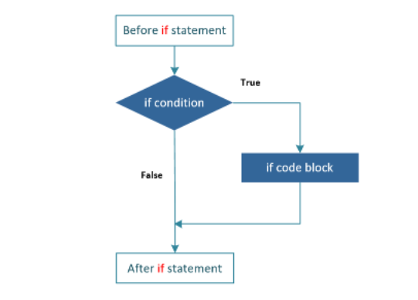
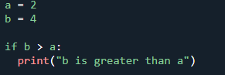
b is greater than a
In this example, we use two variables, a and b, to test whether b is greater than a as part of the if statement. Because a is 2 and b is 4, we know that 4 is greater than 2, thus we print "b is greater than a" on the screen.
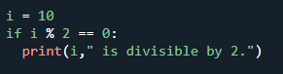
10 is divisible by 2

- If-else statement
If a condition is true, the expressions within the if block should be executed; if the condition is false, the else block should be executed, according to the operator. The else block will only be executed if the condition becomes false; you will take action in this block if the condition is false. The if-else operator analyses the Boolean expression and executes the code block in the if block if the condition is TRUE; if

the condition is FALSE, the else block's code block is run.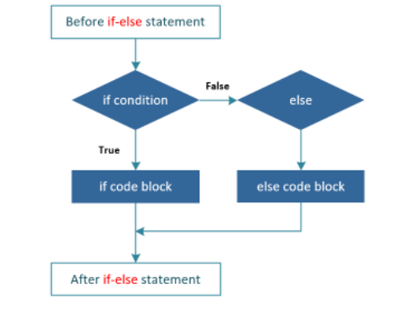
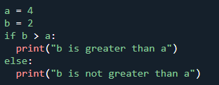
b is not greater than a
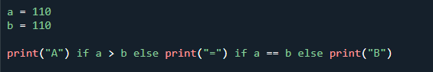
=

if-else program that broadcasts the name and age:
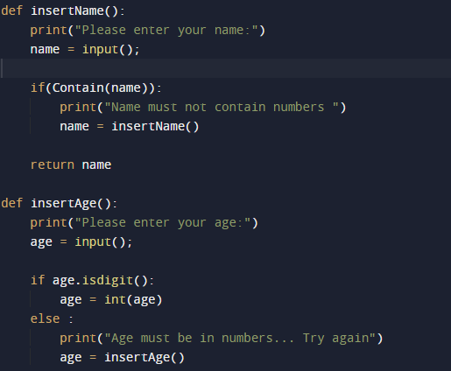
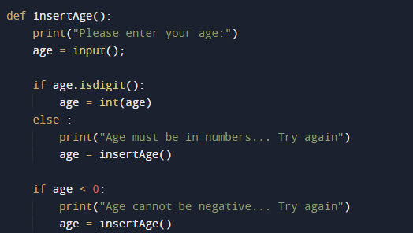
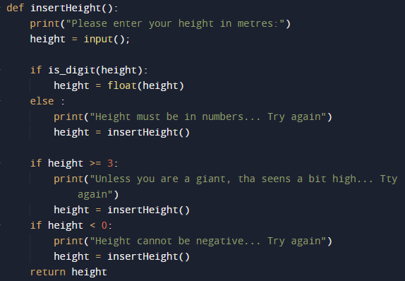
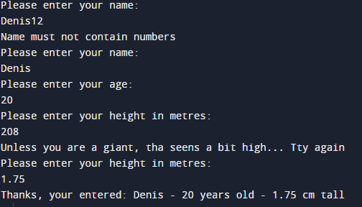
The output is:
C:\Users\user\Python\main1.py

In the above program it is possible to broadcast the name, age and height. Here we use if-else to broadcast this data correctly. If we enter the name with numbers it warns us to use only letters, so with age it warns us to use only numbers, in the same way it works at height where we can not put data with negative or exaggeratedly high.

c) elif statement
Elif is an acronym meaning "else if." It allows us to check for several expressions at once. If the if condition is False, the condition of the next elif block is examined, and so on. If all of the requirements are False, the body of else is executed. If the supplied condition evaluates to True, the elif block is performed.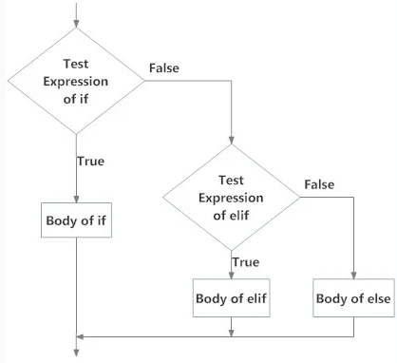

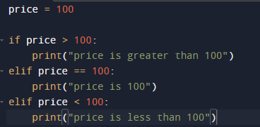
price is 100

In the example above, the elif conditions are applied after the if condition. Python will evaluate the if condition and execute the elif block with the True expression if it returns False. The first elif block is run if more than one elif condition is True.

Explain why loops are needed in a program and when you might use a for and a while loop.
Loops are programming structures that repeat a segment of code until the desired result is accomplished a predefined number of times. Repetitive actions are common in programming, and loops are essential for saving time and decreasing errors.
a) “for” loop
The for loop is a conditional iterative statement in programming that is used to check for particular criteria and then run a block of code continuously as long as those conditions are fulfilled.
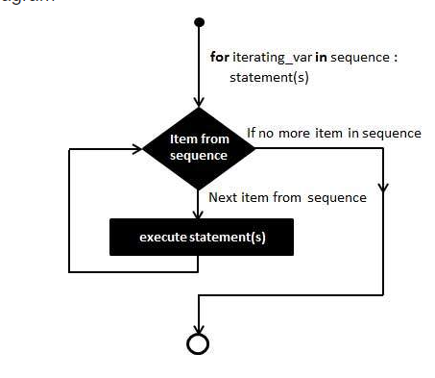
There is example with 3 cycle loops using for.
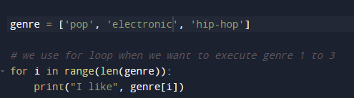
I like pop
I like electronic
I like hip-hop
b) “while” loop
While Loop in Python is a programming construct that is used to execute a set of statements until a condition is met. The line immediately following the loop is executed when the condition in the programme turns false.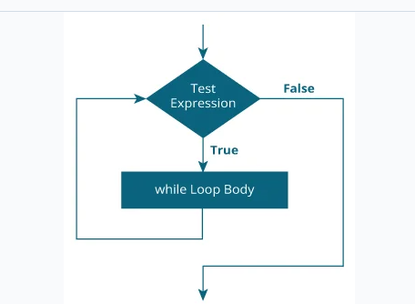

There is examples for with “while” loop:
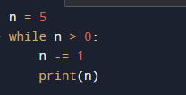
4
3
2
1
0

In this case, here's what's going on:

n is initially set to 5. The term n > 0 is true in the while statement header on line 2, therefore the loop body executes. Line 3 decrements n by 1 to 4 before writing it inside the loop body. When the loop's body is finished, the programme returns to line 2 at the beginning of the loop, where the expression is re-evaluated. The body executes once again since it is still true, and the number 3 is printed. This procedure is continued until the value of n equals zero. The expression is false when tested at that point, and the loop stops. The execution of the loop body would resume at the next statement, but there isn't one in this case.

Conclusion

In conclusion I can say that the work was difficult but I managed to do the work, I followed every step of the scenario and with the help of lessons and information provided by the teacher I managed to do all the work on time and without problems

References

[1] | G. v. R. (Guido), Pyton Manual, 1995-01-01.
[2] | C. S. Ong, Pattern for Python, 2000.
[3] | J. Z. &. M. L. R. Bakdash, Repeated measures correlation, 2017.
[4] | P. Berens, A MATLAB toolbox for circular statistics, 2009.
[5] | J. N. S. P. L. S. D. M. R. D. &. I. G. Rouder, Bayesian, 2009.

