Title page

Name - Shzanur Rahman

Student I.D number- 1815228

Programme - BA (Hons) Leadership and Management Skills for the Workplace

Module – Leading and implementing workplace change

Module code – BMSW6103

Assignment title – Change management portfolio

Lecturer – Prof Dennis Pepple

Table of Contents

Title page 1
Table of Contents 2
Introduction 3
Critical evaluation of the meaning of organisation power and politics 4
What is power 4
What are politics 4
Relevant data/debate about power and politics in organisation 6
Power 6
Politics 6
Critical identification of the stakeholders 8
Salience model 8
Power interest matrix model 11
How each stakeholder analysis relates or explains each other 13
Reflecting on Thomas Kilmann’s Conflict resolution model 15
Dispute resolutions discussion 16
Conclusion 17
Recommendations 18
References 19

Introduction

The post office has been a part of UK heritage since the 1600’s, being a part of the royal mail, growing to a point where it is not only nationally, but also internationally recognised as the mailing service of the United Kingdom.
“Until the 1969 Post Office Act, the Post Office was department of central government.” (Comber et al., 2009)
In the past 2 decades, shares have been sold of the post office to employees and Unions, also, the Royal mail PLC which was is a huge partner of the post office became its own separate company as a Ltd company.
Due to this, there has been disputes over a pay freeze placed on employees for 2 years, and a 2% rise in the year of 2023, the Communication Workers Union (CWU) has been angered by this and has organised a one day strike across their 114 branches which is due to happen on a Saturday.
“Walkouts by employees without union approval or authorization are uniformly condemned by legal tribunals and commentators, but there has been little investigation into the causes, and hence possible justification, for such walkouts.” (Atleson, J.B., 1973)
In this report we will critically evaluate the meaning of power and politics in an organisational environment.
Also will be debated with the relevant date as back up is what power and politics is happening in this particular case.
Also a critical identification of stakeholders will be conducted, this will be done by using 2 models, one of which is the salience model and the other will be the power interest matrix model, then will be a discussion on how both stakeholder analysis models relate to one another.
Thomas Kilmann’s Conflict resolution model will also be deeply discussed and how it relates in this case.
Dispute resolutions discussion will also be conducted and finally a conclusion on the findings and then my personal recommendations.
There will also be numerous references to accompany this report.

Critical evaluation of the meaning of organisation power and politics

What is power

“The social sciences often conflate power and ‘politics’ in and around organizations. So it is important to make an analytical distinction between the two concepts.” Fleming, P. and Spicer, A., 2014.
Power in laymen terms is when a person has the right or authority to make final decisions, or to make changes as they see fit, power is also when one is answerable to by others.
In an organisation, power is a hierarchy which is made up of owners, CEO, directors, board members, these positions in any company hold the most power overall, below are managers, supervisors and lastly the floor staff/assistants.
Owners most usually provide the company with financial power, which also makes them the most at risk in losing out if the company does not succeed, owners of an organisation seldom are to be seen or heard by their employees, except for their appointed CEO who keeps them in the know regarding losses and profits, owners will also demand results, with results and financial targets being met.
However, it can be said that owners often deflect responsibilities a little too much to their CEO’s in order to avoid criticism, such as misconduct within their organisations isn’t dealt with accordingly or simply ignored, eventually when a problem or complaint becomes too loud, owners will intervene by simply holding the CEO responsible, thus disciplining him /her by opening an internal investigation and in the worst case scenario, firing them.
In the case assigned, the owners are faced with a tough decision, risk losing one day of takings, leaving the door open for future strikes, however, what the owners have on their side is that out of over 11,000 post offices, its only 114 that are closing their stores for one day, also there are nearby post offices, usually within walking distance around the UK, another positive for the owners is that they have agreed to a 2% increase in the next 2 years.

What are politics

“While “no politics at work” has long been a standard policy among corporations around the world, there is a heated debate regarding whether firms consider individual political views when hiring or more broadly when managing their workforce.” (Colonnelli et al, 2022)
To define politics, it is when a group of people, each in different groups and beliefs govern power amongst their group over the general public, or in a business environment, to act as the governing body, ensuring that regulations are well maintained, disputes are taken into consideration with changes made with votes democratically.
In relation to the case of the post office strikes, the politics involved is that there is a divide, as we already know, only 114 out of the 11,000 post offices have closed their branches for the day, but have been also required to place notices in plain view for their customers, directing them where the nearest open post office there is, in this situation, the post office has already agreed to increase the pay to increase by 2% in 2023, but the 114 crown post offices have decided to strike for one day, separating themselves from the majority of the branches that have had to accept the pay freeze until 2023, this could be seen as a political move as on one hand they are a part of the post office family, yet they are taking extreme actions by going on strike, without consideration for their colleagues that will have more workload on them, also alienating themselves by doing this.

Relevant data/debate about power and politics in organisation

Power

As mentioned above, there is both power play and politics within the post office organisation, from both sides, here we will delve deeper into this.
The power is mainly being asserted by the post office organisation, as they are staying strong in their stance that there will be a pay freeze until 2023, which will then be increased by 2% they are refusing to negotiate with the 114 crown post offices, as they hold strength in numbers in regards to having over 11,000 branches, this is further demonstrated in the statement which is telling their customers where their nearest open post offices can be found, also included with a website link where open stores can be located.

Politics

“In some organizations, people adopt a competitive and self-serving style. They band together into small groups and are inattentive, perhaps even destructive, to the needs of others. This organization would be political.” (Cropanzano et al, 1997)
In this situation, the politics is predominantly coming from the crown post offices, as we know, only 114 post offices are going on strike for one day due to the freeze on pay, but seeing as there is an agreement in place that pay will increase by 2% in 2023, one could argue there was not a need to go ahead with this strike.
Power and politics has definitely manifested itself in this case, as the post office is using their position of power to freeze pay and only increase it by a small percentage at a time when it will suit them, which is understandable as from 2020 they have been faced with losses due to the pandemic, furthermore they are not interfering with the 114 branches closing for a strike for one day, even with the potential losses of sales and damage to their reputation.
Whilst the post office are choosing to assert their power, the CWU have definitely turned this political, I say this because even though they are less than a quarter of the post offices in this country, the decision to close 114 stores cannot be taken lightly, this will cause friction from the majority of post offices, as they are still operating and will be facing a more busier day than usual at their branches, also customers will have to re plan their journey to use the services, it is understandable they will not be entirely happy with the inconvenience.
Also, the image of the post office, which was founded in 1986, has been a pride of Britain for decades, helping people to stay connected, whether be in personal relationships, official or courts. Undoubtedly this will have a negative impact on their image, as the public, who may not know the intricate details of the strike, may think staff are not being paid correctly, are being unfairly treated and also because their services will be slightly slower than usual.
Overall, the remaining 11,000 branches won’t be very much affected by this, only the few who are nearby to the closed offices will have to deal with a day of busier periods, with some aggravated customers.
Moral may also be affected within the organisation, as the 114 branches and staff have essentially gone their own way in order to get a pay rise, individualising themselves from the other 11,000 branches, the remaining branches and their workers may also be low on moral due to this as they may wonder if they are losing out on a pay increase.

Critical identification of the stakeholders

Salience model

Stapel says, this model assumes that
Self-constructive emphasis is an important determinant of whether stranger-to-self effects follow the principles
self-improvement, imitation or complementarity. Stapel et al, 2006.
The salience model which was created in order to help one understand the profile of the stakeholders, what this model does is identify and analyse the requirements the stakeholders, which is similar to the power interest grid, the main difference is the power interest grid has 4 parameters, the salience model has 3 parameters.
Number 1 is power, the stakeholder’s ability to influence the outcome of a deliverable project.
It was said that the higher the amassed weighting of esteem circles a partner takes portion within, the higher its power with regard to the central organization. (Hein et al, 2017)
Number 2 is legitimacy, which means the stakeholders authority or the level of involvement in the project.
And number 3 is urgency, basically this is the stakeholder’s expectation of the response time, basically how fast you need to act in order to meet the stakeholder’s deadline.
The first 2 points, power and legitimacy is also what the power interest grid consists of, however, the urgency part is different and is not included in the power interest grid.

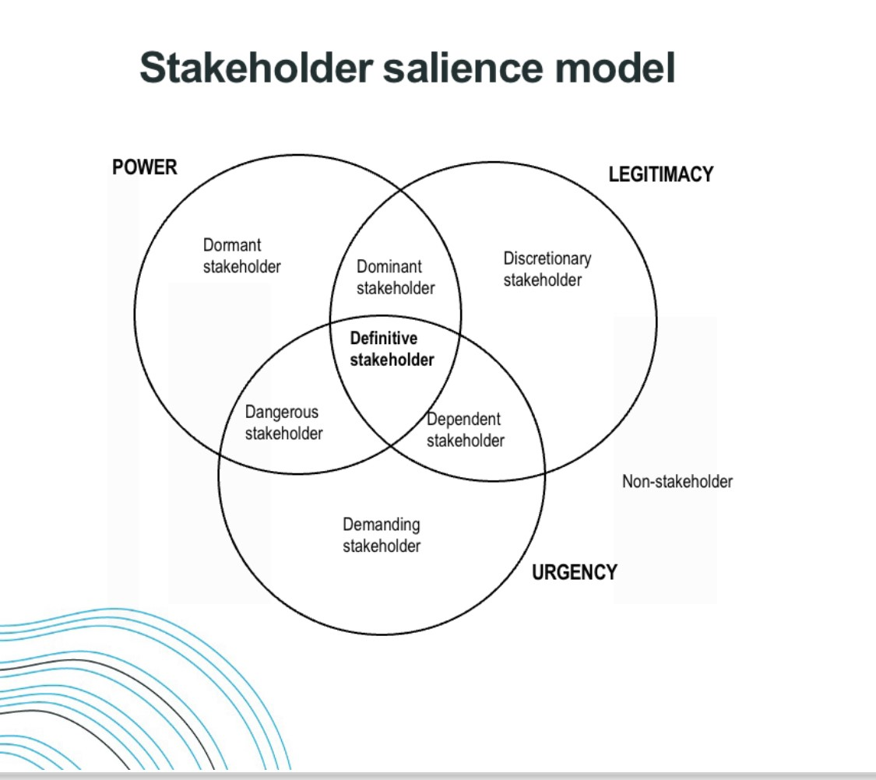
Royal mail PLC
Banks
Bureau de exchange
Staff –
Managers and employees
Local community
customers
Local politician
Ministry of defence
Government
Royal mail PLC
Banks
Local community

“One of the primary goals of stakeholder theory is to explain and predict how organizations function with respect to stakeholder influences” (Mitchell et al, 2017)
As the above salience model shows, there is 3 circles which consists of power, legitimacy and urgency, within the circles are 7 types of stakeholders. This diagram helps us to place each stakeholder into where they fit within the Venn diagram.
Above is the salience model with the stakeholders aligned to the relevant intersection circles, lets now explain why each stakeholder has been in each section, in this part the goal is to understand what each stakeholders needs and wants are from this organisation, also what power they hold.
Local politician
The local politician has been placed as a dormant stakeholder, this is due to the post office being a majority government owned, even though they have their own post office Ltd board, which holds responsibility for the operations, therefore the local politician holds a high degree of power as stakeholder to share their views, yet he or she lacks the legitimacy or urgency to do so, hence power goes without being used.
Ministry of defence
In this situation and the post office stakeholders, the ministry of defence is also a dormant stake holder as it is their responsibility to promote UK prosperity and for a civil society, so they also hold high importance of power, but again, are lacking the urgency unless it is considered a high emergency.
Government
As the government essentially owns the post offices, they are in the dangerous circle because they can at any time decide to intervene with the power they hold.
Royal mail PLC
Also a dangerous stakeholder is the royal mail PLC, as they are an independent company from the post office since 1 April 2012, they initially had a 10 year inter-business agreement.
Banks
Another dangerous stakeholder are the banks that provide their services within post office branches, postal banking provide some services such as cashing cheques, paying bills and even offering small loans.
Local community
The local community is a demanding stakeholder in this as they expect branches to be open and fully functioning to meet their needs, they are also one of the most important stakeholders as without them, branches would not be able to run.
Royal mail PLC
Royal mail PLC is also dominant stakeholder as they are a partner to the post office, so if the post office fail to deliver on their terms and contractual obligation, action could be taken, both internally and in a court of law.
Banks
Making a 2nd appearance in this diagram are banks, as they offer their services to post offices for their clients to use sort of like a sub branch, they can decide to withdraw their services in order to keep their namesake at high standards.
Bureau de exchange
A discretionary stakeholder in the post office, as they offer currencies in over 60 currencies, the Bureau de exchange is its own business who offer their services to post offices and many other chains of supermarkets and similar stores, hence they are discretionary stakeholders as they are a not owners but rather partners with the post office.
Staff –
Managers and employees
Placed in the definitive circle, due to being the people who run day to day operations of their respective stores, they are also on the payroll so they understandably hold a high degree if importance as without them, branches would not be able to open such as the 114 branches that will be closed due to the 1 day strike.
Local community customers
Customers are also definitive stakeholders, this is because without them, businesses and stores would not be able to operate financially, also as customers have the right to complain, they are considered one of, if not the most important people of a business, because they are the ones who are impacted most by the quality of service they receive.

Power interest matrix model

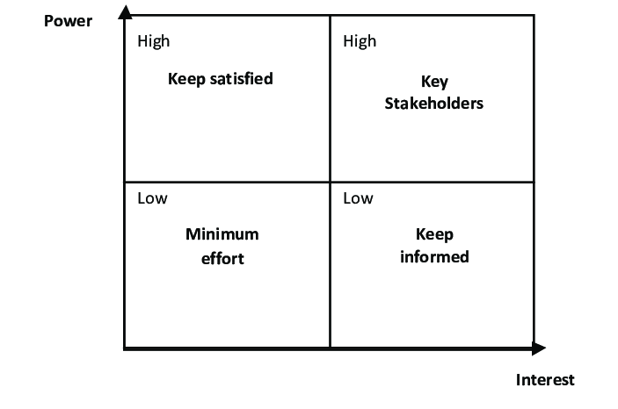
“Many projects and programmes adopt the power-interest matrix in an attempt to codify and order the process for identifying stakeholders; yet this approach privileges a certain type of stakeholder at the expense of many others who are needed to make the project successful.” Horton, L. and Pilkington, A., 2014.
Above we can see a power interest matrix model, this model helps us to align each stakeholders importance and also their interest of the business they are partnered with, in this case the post office, lets now place each stakeholder with explanation of why they are where they are in this grid.
Local politician
In regards to the post office, the local politician has high power but low interest as a stakeholder, this is because the post office is government owns, so the politician may take issues to his or her counsel if needs be to assert changes, however the interest is low as the post office is of little use.
Ministry of defence
Once again the power would be high but interest low, as the ministry of defence are a part of the government, they can intervene at any point if they feel necessary, the interest is low as the post office generally doesn’t affect them.
“The Ministry of Defence (MOD) as we know it today was created in 1964.” (Plan, D.C., 2016)
Government
Similar to the above, the power the government hold as a stakeholder in the post office will be high, as it is essentially their business, but their interest will also be high due to the income revenues and reputation of the running’s of the post office is directly the responsibility of the government.
Royal mail PLC
“To assess the intrinsic value of Royal Mail, the main valuation model was the Discounted Cash Flow (DCF) and the multiple valuation as a relative model to corroborate the principal.” (Duarte, F.M.F., 2019)
Having both high power and high interest, royal mail mail PLC has a vested business interest in the post office as they are their main distributer, they are both as important to one another, as without one, the other will face significant losses in revenue, therefore royal mail can demand changes, better quality of service from the post office.
Banks
As banks offer many post offices their services as a sort of sub branch, they hold low interest and high power, as without the banks services, the post office will suffer financial loss, so will the banks, but this would be less than what the post offices would, as banks have their own branches and online services so their services are still accessible to their clients.
Bureau de exchange
In this instance, this stakeholder is considered as having low interest and low power, as currency exchange is fairly easy to find, whether in supermarkets, local travel agencies or even online, so for these reasons the Bureau de exchange have little influence over the post office.
Local community customers
This stakeholder is arguably the single most important one out of all, purely because the local community customers are depended on by their nearest post office, as without them, the post office sales would drop almost completely. Each post office must value their local community as realistically, seldom would people travel to a different area to use the post office services due to there being a post office nearby, and for this reason the local customers have high power and also high interest.
“In the public sector, one of the key concerns is delivering quality services especially the customer-contact counter staff. As front-liners, the quality of services provided by the public service staff will have a tremendous influence on the public’s perceptions of the quality of the public service.” (Voon et al., 2012)
Staff - managers and employees
Are both of high in the high interest and high power, as both the post office need them in order for their branches to run and operate, but the employees also depend on the organisation to be employed and receiving wages.

How each stakeholder analysis relates or explains each other

The salience model as we saw has 3 main sections, power, legitimacy and urgency, within these are more intersections which consist of.
- Dormant stakeholders: They have some power, but it's not very urgent or legitimate. As a project manager, you should be aware of them, but there is no need for major communication or involvement.

“If the only attribute present is power, such stakeholders are called dormant stakeholders.” (Elias et al., 2002)

- Discretionary stakeholders: They are legitimate, but they have no power or urgency. Their communication style may involve asking for specific details, but they don't need a lot of attention other than regular project updates.

- Demanding stakeholders: These people always seem to think that their work needs your immediate attention. If you spend too much time and effort with these stakeholders, you won't earn as many project miles. There are other important people you should keep in the loop, but you should not neglect your relationships with them.

- Dominant stakeholders: In this case, power and legitimacy overlap. The stakeholders with the most legitimacy and authority have a say in what happens in an organization. Communication and involvement are always important in any relationship.

- Dangerous stakeholders: These stakeholders have a dangerous mix of power and urgency. The power and urgency of the project necessitate the involvement of these resources, even though they are not directly involved in the project. As project manager, it is important to meet their needs and keep them engaged and satisfied.

It was said that stakeholders who hold power and urgency but little to no power will at times use aggressive and even violent methods to fulfil their needs. (De Vries et al., 2003)

- Dependant stakeholders: They are legitimate and have the urgency, but they do not have the power to address the full range of issues. Keep them updated on what they can do to help you when you need to be successful in complicated environments.

- Definitive stakeholders: The most important component of this model is where power, urgency, and legitimacy intersect. Keeping stakeholders in the loop is always important, and as a project manager, you need to be especially attentive to them.

We also used the power interest matrix mode, this is similar to the salience model with the main difference being that there are 4 components, these are as follows.

- High power – High interest: These stakeholders are likely to be the decision makers and have the greatest influence on the success of the project. You need to keep your stakeholders close to manage their expectations.

- High power – Low Interest: These stakeholders need to be kept informed of what is happening in the project. Although they may not care about the outcome, they generate power. These stakeholders should be treated with caution because they may use their power in a negative way if they are not satisfied.

- Low power – High interest: Keep these people appropriately informed and speak to them to ensure no major issues arise. These people can often be very helpful in the specifics of your project.

- Low power – low interest: Monitor these people, but don't waste your time and energy on over-communication.

Both models are very good in terms of identifying who the stakeholders are, how much power each holds and how much interest they have in the business they have stakes in, where the models fall short of is identifying what weakness each stakeholder poses in the business, whilst they all bring many positives, there is also negatives that each owner will bring to the table, and in any organisation, it is important to know both sides of the coin to further ensure the growth and success.
Both models can be related to one another if you look at them both side by side, for example, in the salience model we have dormant stakeholders, the local politician and the ministry of defence, if we compare them in the power interest grid they also have high power, but low interest in the post office as a business.
The government, Royal mail PLC and banks in the salience model are placed under the dangerous stakeholder section, in the power interest matrix they are all of high power and high interest except for the banks, who are of low interest, the reasoning for this has already been explained on page 9. Both royal mail plc and banks have also been placed as dominant stakeholders, this is due to the power they both hold, as explained in the power matrix.
The local community has been placed in the demanding part in the salience model, local community customers has also been placed in the definitive part, as they are essentially the same stakeholders in the post office, therefore are of high interest and high power in the power interest matrix.
Bureau de exchange in the salience model has been put in the discretionary stakeholder intersection, in the matrix model they are considered to be of low power and low interest.
Staff – managers and employees are in the definitive section in the salience model, so in the power matrix are considered to be of high power and also high interest.

Reflecting on Thomas Kilmann’s Conflict resolution model

“The Thomas-Kilmann Conflict Mode Instrument (TKI) assesses an individual’s behavior in conflict situations—that is, situations in which the concerns of two people appear to be incompatible.” (Thomas, K.W., 2008)
Kenneth Thomas and Ralph Kilmann created this model in the 1970’s, with the belief that each of us individually have our own way of managing conflict, this model makes the claim that there are 2 methods when deciding how to manage conflict, one being assertiveness and the other being cooperativeness. To be assertive when dealing with conflict is to prioritise your own interests, to be cooperative in the face of conflict means to prioritise others needs first.
Avoiding = sidestepping the conflict, this is when there is an ongoing issue or dispute, but rather than addressing things, the people who are responsible to resolve conflict i.e stakeholders, managers or supervisors choose to ignore the ongoing problems, this could be due to a number of reasons, maybe they are uncomfortable in these situations, or do not have the ability to reason with more than one person with different views, but I firmly believe this approach is not good for anybody, as the issues remain ongoing therefore the conflict will most likely continue to brew and eventually come to a boiling point, this will also affect employees morale, affecting the customers experience.
Accommodating = trying to satisfy the other person’s concerns at expense of your own, in this approach, coming to a resolution is key, even if that means at the expense of the person who’s trying to mediate, agreeing fully or almost fully to the people who are having conflicts, this is somewhat a good approach, however, simply agreeing to end others conflict even if it comes at a cost to yourself isn’t always the right decision, as this way leaves little room to negotiate so that everyone can find the end resolution they are content with.
“The opposite of "competing"; A self-sacrificing approach wherein an individual is unassertive and cooperative to the point that the person's own concerns are to satisfy the other party in the conflict” (Watt, W.M., 1994)
Compromising = trying to find an acceptable settlement that only partially satisfies both people’s concerns, this is similar to the accommodating approach, however, in this we try to resolve as many issues from all parties involved in conflict, but once again, because we will only partly resolve the issues, there will be lingering conflict beneath the surface so not everyone will be fully satisfied.
Competing = trying to satisfy your concerns at the expense of others, this is the complete opposite of the accommodating approach, in this style, the stakeholder or manager is solely interested in their own benefit, which means that they will most likely not end the conflict, but find a way in which the ongoing issues are quietened and made sure that nothing gets in their way.
Collaborating = trying to find a win-win solution which completely satisfies all parties concerned, in this approach the end goal is to end all conflicts and appease everyone’s demands, including your own, this is quite possibly the most difficult approach as you are trying to please multiple people or groups who are having different views on what would make them happy, whilst the end result will be satisfying as it will bring a better working environment, the most challenging part is that this may take some time and you will need to work around everyone to ensure their needs have been met.

Dispute resolutions discussion

The disputes in this case is fairly clear cut and open, one of these is the Members of the Communication Workers Union (CWU) are unsatisfied that there is a pay freeze for 2 years, from 2021 – 2022.
Another dispute is from the union is that in 2023 there is only a 2% increase after a 2 year freeze
And finally from the post office there is a dispute of the 114 branches being closed for one day on a Saturday due to the strike.
So to reiterate and relate these disputes with Kilmanns model, it seems the post office stakeholders have chosen to use the compromising approach, as they have placed a 2 year freeze on pay, this will make sure the company’s employees overheads will remain the same as it cannot be raised, unless it is raised discretionally. The post office stakeholders have also agreed on raising the pay for employees at 2% only after the 2 years of pay freeze. At a glance this seems to be an accommodating approach by the stakeholders, however this is the post office attempting to resolve all issues whilst making sure they themselves are the priority.
Another reason I have stated that the approach from the post office is compromising is because at the end of the 2 year freeze, the post office may make a number of their employees, there could be many reasons for this, such as, loss of revenue, or a drop in demand, new technology may be brought in as well in which case less people are needed. So the company can decide to make any employee redundant by proving that their job no longer exists. Other fair reasons to make staff redundant can be based on the employee’s performance, their attendance, punctuality and even their disciplinary history.
For example, employees who have been made redundant has been the subject of more investigation in Great Britain, the most of any labour market behaviour. (Norman, R., 2001)
So as we can see, in the 2 years before the 2% increase, circumstances may change drastically so the current crop of employees are not guaranteed their 2% pay rise as there is a risk of redundancy.
Whilst the stakeholders of the post office have decided to take the approach that they have, it is my belief that this dispute would have better been resolved if the stakeholders had they taken the collaborating approach.
As mentioned earlier, this approach is made to be a win-win end result for all parties affected, so there is a desire to make sure that everyone has got what they wanted, this approach may have took longer to accomplish a resolution but as we already know, there has been a 2 year pay freeze which would have given enough time for the Union and the post office stakeholders to come to a better result which would have not only have kept everyone happy, but also most likely have avoided the one day strike by the 114 branches.

Conclusion

So to conclude what has been covered in this change management portfolio, critical evaluation of the meaning of organisation power and politics was first, with a critical analysis of what is power, how it is beneficial and the opposite, also discussed was how power played a role in this case.
“These two assumptions, while not inherently wrong, are somewhat misplaced given the political realities of many contexts on the front line of adaptation to climate change. The long tradition of political ecology and vulnerability studies has already thoroughly undermined the first assumption by showing that biophysical change is always mediated through a variety of social and political mechanisms.” (Nightingale, A.J., 2017)
What is politics was also discussed, a brief explanation of how politics plays in life and also how it plays into this particular dispute within the post office.
In the next section, power and politics was discussed with more focus on the case at hand, we debated with relevant data on the power that is being asserted by the parties involved with the post office pay dispute.
We then moved onto critically identify the stakeholders, this was done by using the salience model in which each stakeholder was placed into their category of the type of stakeholder they are.
We then used the power interest matrix model to determine which stakeholder had more interest and power, with both models we also deeply analysed critically about their stake, how much power each of them hold and also how much interest they have in the organisation, further explaining how each analysis relates and or explains the other.
Then a reflection on the Thomas Kilmann’s Conflict resolution model was done, in which a critical analysis on each approach was explained.
“Within this two-dimensional model, Thomas and Kilmann (1974) have developed a popular framework that accounts for five styles of handling conflict: competing, collaborating, avoiding, accommodating, and compromising.” (Brahnam., et al, 2005)
And finally was a dispute resolutions discussion, outlining each issue in this case, we then related which approach from the Killmann model is being used and which approach may have been used.

Recommendations

Turning now as to what could be recommended, the use of the Killmann model may significantly help resolve the current disputes staining the post office’s image and moral, whilst it is a small fraction of the 11,000 branches, the conflict would be better resolved by using the approach of collaborating, stakeholders and the CWU must be more open to discussion and find a middle ground where they each are satisfied with the end result.
“The concept of collaboration implies that there is collective action to a purpose, and that this action involves organisations who are otherwise at competition with one another. In fact, collaboration has been defined as the “formal institutionalised relationships among existing networks of institutions, interests and/or individual stakeholders” (Atorough, P. and Martin, A., 2012)
If the stakeholders want to avoid any more future strikes or negative media coverage, it is highly recommended that meetings are held, with the 2 year pay freeze removed and a more ongoing discussions held whilst they are negotiating how to resolve their issues.

References

Atleson, J.B., 1973. Work group behavior and wildcat strikes: The causes and functions of industrial civil disobedience. Ohio St. LJ, 34, p.751.
Atorough, P. and Martin, A., 2012. The politics of destination marketing: Assessing stakeholder interaction choice orientations toward a DMO formation, using the Thomas‐Kilmann Conflict Mode Instrument. Journal of Place Management and Development.
Brahnam, S.D., Margavio, T.M., Hignite, M.A., Barrier, T.B. and Chin, J.M., 2005. A gender‐based categorization for conflict resolution. Journal of management development.
Colonnelli, E., Neto, V.P. and Teso, E., 2022. Politics at work (No. w30182). National Bureau of Economic Research.
Comber, A., Brunsdon, C., Hardy, J. and Radburn, R., 2009. Using a GIS—Based network analysis and optimisation routines to evaluate service provision: A case study of the UK post office. Applied Spatial Analysis and Policy, 2(1), pp.47-64.
Cropanzano, R., Howes, J.C., Grandey, A.A. and Toth, P., 1997. The relationship of organizational politics and support to work behaviors, attitudes, and stress. Journal of Organizational Behavior: The International Journal of Industrial, Occupational and Organizational Psychology and Behavior, 18(2), pp.159-180.
De Vries, H., Verheul, H. and Willemse, H., 2003, December. Stakeholder identification in IT standardization processes. In Proceedings of the Workshop on Standard Making: A Critical Research Frontier for Information Systems. Seattle, WA (pp. 12-14).
Duarte, F.M.F., 2019. Equity Research-Royal Mail PLC (Doctoral dissertation, Universidade de Lisboa (Portugal)).
Elias, A.A., Cavana, R.Y. and Jackson, L.S., 2002. Stakeholder analysis for R&D project management. R&D Management, 32(4), pp.301-310.
Fleming, P. and Spicer, A., 2014. Power in management and organization science. Academy of Management Annals, 8(1), pp.237-298.
Hein, A.M., Jankovic, M., Feng, W., Farel, R., Yune, J.H. and Yannou, B., 2017. Stakeholder power in industrial symbioses: A stakeholder value network approach. Journal of Cleaner Production, 148, pp.923-933.
Horton, L. and Pilkington, A., 2014. Rolling back from the power/interest matrix: a new approach for role based stakeholder engagement in projects.
Mitchell, R.K., Lee, J.H. and Agle, B.R., 2017. Stakeholder prioritization work: The role of stakeholder salience in stakeholder research. In Stakeholder management. Emerald Publishing Limited.
Nightingale, A.J., 2017. Power and politics in climate change adaptation efforts: Struggles over authority and recognition in the context of political instability. Geoforum, 84, pp.11-20.
Norman, R., 2001. Practical reasons and the redundancy of motives. Ethical Theory and Moral Practice, 4(1), pp.3-22.
Plan, D.C., 2016. Ministry of Defence. Wellington, November.
Stapel, D.A. and Van der Zee, K.I., 2006. The self salience model of other-to-self effects: Integrating principles of self-enhancement, complementarity, and imitation. Journal of personality and social psychology, 90(2), p.258.
Thomas, K.W., 2008. Thomas-kilmann conflict mode. TKI Profile and Interpretive Report, 1(11).
Voon, B.H., Douglas, A. and Singh, B., 2012. Serving the local community customers: Evidence from multi-cultural Malaysia. International Journal of Business and Society, 13(3), p.293.
Watt, W.M., 1994. Conflict Management: Using the Thomas-Kilmann Conflict Mode Instrument To Assess Levels of Learning in the Classroom.

