Appendix 1 - Observation schedule

Name of child:- Pupil A Class:- Year 7

Date of observation:-04/02/2020 Time:-14.00

Lesson/Subject:- History/ attacking a castle

Name of observer:-
Task:- Does the provision of differentiation by task have an impact on the amount of pupil engagement in the classroom?

 | Comments
Confidence when given task to complete (e.g Did the pupil carry out the task promptly) | Task was carried out promptly – no questioning
Confidence giving answers in the classroom (e.g When feeding back answers in the classroom environment) | Very confident – hands up to answer questions  Overall very confident for both tasks and giving feedback
Amount of time on task  (Was the child distracted at any point, lack of engagement etc.) | Very engaged with task, tasks were completed quickly with no distractions or any help required from the teacher
Was additional help required | Only to help with cutting and sticking activity into books
Level of challenge  Was the differentiated work provided, the right level for the child | Differentiated work perhaps was not challenging enough for this pupil. Completed very quickly, did not spend much thinking time. Closed ended questions did not allow room for extended answers.
Working independently | Worked independently for tasks.
Behaviours (e.g talk related to task, talk not related to task, listening to teacher,  Attempting to draw attention etc.) | Off task talk when completed work.

Observation schedule

Name of child:- Pupil B Class:- year 7

Date of observation:- 04/02/2020 Time:-14.00

Lesson/Subject:- History/Attacking a castle

Name of observer:-
Task:- Does the provision of differentiation by task have an impact on the amount of pupil engagement in the classroom?

 | Comments
Confidence when given task to complete (e.g Did the pupil carry out the task promptly) | Carried out task when encouraged by teacher. Teacher had to give additional instructions for carrying out the task
Confidence giving answers in the classroom (e.g When feeding back answers in the classroom environment) | Very confident, hands up to answer questions. Gave good explanations for answers.
Amount of time on task  (Was the child distracted at any point, lack of engagement etc.) | Distracted when teacher was giving instructions which meant the teacher had to provide additional instructions.
Was additional help required | Additional help was given by the teachers questioning to encourage pupil to fully explain answers.
Level of challenge  Was the differentiated work provided, the right level for the child | Level of challenge was suitable for this child however description questions did not allow for pupil to think creatively.
Working independently | Worked independently for most of the lesson, did require some encouragement at times to complete tasks.
Behaviours (e.g talk related to task, talk not related to task, listening to teacher,  Attempting to draw attention etc.) | Attempted to avoid work at times, encouragement by the teacher got pupil back on task. Some minor off task talk with Pupil A.

Observation schedule

Name of child:- Pupil C Class:- year 7

Date of observation:- 04/02/2020 Time:-14.00

Lesson/Subject:- History/Attacking castles

Name of observer:-
Task:- Does the provision of differentiation by task have an impact on the amount of pupil engagement in the classroom?
 | Comments
Confidence when given task to complete (e.g Did the pupil carry out the task promptly) | Questioning when carrying out activity. Seemed sure of what was required but lacked confidence.
Confidence giving answers in the classroom (e.g When feeding back answers in the classroom environment) | Reluctant at first, did not put hands up to volunteer answers but when questioned directly was able to provide answers with some scaffolding from the teacher. A lack of confidence in pupils knowledge and a reluctance to answer wrong in front of class.
Amount of time on task  (Was the child distracted at any point, lack of engagement etc.) | Engaged in tasks, took a while to complete but all tasks were completed.
Was additional help required | Additional help to cut/stick in activities into books.  Encouragement to complete tasks.
Level of challenge  Was the differentiated work provided, the right level for the child | Level of challenge was appropriate for this pupil, lack of self-confidence was a factor in the pupil completing the work. The work was do-able, so the pupil was able to do it. Level of challenge could have been more with more teacher assistance.
Working independently | Worked alone throughout
Behaviours (e.g talk related to task, talk not related to task, listening to teacher,  Attempting to draw attention etc.) | Did not talk to any other pupil in the class.

Observation schedule

Name of child:- Pupil D Class:- year 7

Date of observation:- 03/02/2020 Time:- 12.20

Lesson/Subject:- Maths/Revision

Name of observer:-
Task:- Does the provision of differentiation by task have an impact on the amount of pupil engagement in the classroom?

 | Comments
Confidence when given task to complete (e.g Did the pupil carry out the task promptly) | Very quick to ask for help, carried out tasks when encouraged, showed lack of resilience
Confidence giving answers in the classroom (e.g When feeding back answers in the classroom environment) | Did not show teacher own work, sent her partner to check if the answers were correct.
Amount of time on task  (Was the child distracted at any point, lack of engagement etc.) | Very easily distracted, fussy, playing with hair and attempting to distract other pupils.
Was additional help required | Yes, teacher provided additional explanations for tasks, pupil was able to carry out the task promptly after this but lacked motivation to carry on working through the booklet.
Level of challenge  Was the differentiated work provided, the right level for the child | The first page of the booklet seemed too easy. The rest of the booklet was appropriate however due to working in pairs it was difficult to know whether pupil understood the tasks or just copied her neighbour.
Working independently | Very reliant on partner.
Behaviours (e.g talk related to task, talk not related to task, listening to teacher,  Attempting to draw attention etc.) | Lots of off task talk, not self motivated, does what is asked, will not move onto the next task until asked to do so.

Observation schedule

Name of child:- Pupil E Class:- 7

Date of observation:- 03/02/2020 Time:-12.20

Lesson/Subject:- Maths/Revision

Name of observer:-
Task:- Does the provision of differentiation by task have an impact on the amount of pupil engagement in the classroom?
 | Comments
Confidence when given task to complete (e.g Did the pupil carry out the task promptly) | Carried out all tasks promptly, did not need additional instructions
Confidence giving answers in the classroom (e.g When feeding back answers in the classroom environment) | Very confident taking book for marking.
Amount of time on task  (Was the child distracted at any point, lack of engagement etc.) | On task all lesson, willing to ask for extensions which were provided
Was additional help required | No
Level of challenge  Was the differentiated work provided, the right level for the child | Completed the booklet very quickly and easily, answers were always correct. Moved onto extension work with more than half the lesson to go. Level of challenge was not high enough for this pupil
Working independently | Worked well in a pair, the leader of the two.
Behaviours (e.g talk related to task, talk not related to task, listening to teacher,  Attempting to draw attention etc.) | Confident and happy with her work. Not distracted by other pupils, willingness to help her partner, very focused. All tasks including extensions were completed promptly and easily. A very hard working capable pupil.

Observation schedule

Name of child:- Pupil F Class:- 7

Date of observation:- 03/02/93 Time:-12.20

Lesson/Subject:- Maths/Revision

Name of observer:-
Task:- Does the provision of differentiation by task have an impact on the amount of pupil engagement in the classroom?

 | Comments
Confidence when given task to complete (e.g Did the pupil carry out the task promptly) | Attempted task willingly and promptly
Confidence giving answers in the classroom (e.g When feeding back answers in the classroom environment) | Confident to show answers for marking
Amount of time on task  (Was the child distracted at any point, lack of engagement etc.) | Pupil was on task for majority of the lesson. A few moments of disengagement quickly had attention brought back by TA.
Was additional help required | Yes- teaching assistant present throughout
Level of challenge  Was the differentiated work provided, the right level for the child | Booklet was of an appropriate level of challenge, took pupil all lesson to complete, needed the help of number charts throughout.
Working independently | Worked closely with the TA.
Behaviours (e.g talk related to task, talk not related to task, listening to teacher,  Attempting to draw attention etc.) | Easily distracted, short attention span, lack of resilience and motivation. Quick to give up if ‘too hard’ although easy to get back on task with encouragement from teacher and TA.

Appendix 2
Focus Group Interview Questions

- Do you feel confident about the work you have completed today?

Pupil A – yes I liked the topics and found it interesting to learn all the different ways you could attack a castle.
Pupil B – I think I understood the lesson, some of the weapons were confusing because they were similar like the ladder and siege tower and the catapults, I can’t remember their names.
Pupil C – I enjoyed the lesson and learnt a lot

- How did you find the worksheet that was provided to you?

Pupil A – the worksheet was good, I understood the activities and I felt confident that I could complete them all. I finished my work quickly, more quicker than my friends.
Pupil B – the worksheet was good as it had lots of pictures and not much writing. I am slow reading so not having to read many words is good for me.
Pupil C – I liked the worksheet. It was easy to understand and finish.

- Do you feel like you engaged more with the lesson today? E.g – Did you feel like the lesson was productive?

Pupil A- I really enjoyed todays lesson. I felt I learnt a lot. The tasks were easy to complete so when I gave my answers in front of the class I didn’t feel shy or worried they were wrong.
Pupil B – Most lessons I don’t like to answer questions, but today I didn’t mind so much, the support that you gave me when I was completing my work gave me confidence to answer your questions as you told me I had the answer right earlier on.
Pupil C – I don’t really like speaking in front of the class. I try to get out of answering questions if I can. When you directed a question as me I didn’t know what the answer was but you reassured me I had the right answer on my sheet I just needed to look. I looked and I had the answer, then I didn’t mind telling you infront of everyone.

- Is there anything else you would like to be provided to you in order to help you complete the work?

Pupil A- Writing frames are always helpful, I feel like I can write long answers, I just struggle with how to word them and structure them.
Pupil B – maybe showing me someone else’s work from another class so I can see how it is all meant to be laid out.
Pupil C- just more help from you.

- Did you feel confident in providing answers in front of the rest of the class?

Pupil A – yes
Pupil B – yes
Pupil C- not so much but in the end I didn’t mind.

- Would you like tasks to be set in this way for all topics? E.g – Providing scaffolds (Additional detail) on worksheets.

Pupil A- I think it might get boring if they were all like this, doing the same type of work every lesson. I like it when we do different things like group work, I like seeing what my friends have said.
Pupil B – Yes, I don’t like it when we are left to get on with a question and it is hard to answer. I prefer smaller tasks like this and when we check our answers as a group.
Pupil C- Yes, it helped me do all my work today, which I never really do. I feel good after this lesson, most lessons I don’t feel good because I’m worried that I’ll get told off for not doing enough work but when it’s like this and I can do it I know I won’t get told off.

- Would you like this approach to be taken throughout other subjects in school?

Pupil A – it is like this in some other subjects, in maths we get different questions, but sometimes when we go through answers as a class it’s not the same questions we have had so I don’t get to give my answers. I liked that it was the same questions so I felt I was doing the same work as the others.
Pupil B – Yes, I liked how the worksheet was set out so I could understand what I needed to do.
Pupil C – We get different work in some subjects but not in all of them. It would help me with my work if I had worksheets for all subjects that I felt I could do. A lot of time the work is just too hard, or there’s too much writing on a sheet and I don’t like reading lots of stuff.

- Did you feel distracted at any point whilst the task was being completed?

Pupil A- not really. I got a bit bored when I had finished though but I had finished everything
Pupil B – yes, sometimes I find it hard to concentrate, especially if my friends have already finished their work.
Pupil C – No, I don’t really get distracted much.

Appendix 3
Reflection
Gibbs Reflective Model

Description  What happened? | - Three case pupils were confident in completing the differentiated task they were given. The instructions for the task were the same as the rest of the class. They understood the instructions and completed the tasks promptly and confidently.  - All pupils were engaged with the tasks, there was little off-task talk.  - Pupils required additional help to complete basic tasks such as cutting and sticking, although the main body of learning was independent.
Feelings  What were you thinking and feeling? | - I was pleased with the attitude of the three case pupils towards their work for this lesson. They were engaged and motivated to complete their work and confident to answer questions and participate in classroom discussions.  - I thought that for Pupil A, the level of challenge was not high enough, the work was completed very quickly and I felt that the style of the differentiated worksheets perhaps limited her scope of ability for this lesson.  - I thought that the differentiated sheets improved the level of student engagement within the classroom, compared to previous lessons the three case pupils demonstrated a better attitude to learning.
Evaluation  What was good and bad about the experience? | Good  - Three case pupils worked well for the lesson, all work was completed and they showed a high level of motivation and self- esteem.  - The worksheets provided a suitable level of challenge for most pupils.  - The use of differentiation in the form of worksheets did have a positive effect on student engagement with the lesson. They were do-able, so they got done.  Bad  - Last lesson on a Friday, pupils were very fussy, an activity that required cutting and pasting proved to be very time consuming meaning the final activity could not be completed. A lot of time was spent helping pupils cut and stick in their books, this was valuable time and attention that could have been used to help pupils meet learning objectives, deepen or broaden knowledge.  - The level of challenge was not appropriate for one pupil, level of challenge needs to be increased.  - Closed ended questions did not allow pupils to work to their maximum capabilities.
Analysis  What sense can you make of the situation? | - Differentiation by task does have a positive impact on student engagement and motivation. When students are set work that is do- able they are more likely to complete the work, and be confident when answering questions on the work.  - However, this may place students in the comfort zone of learning, which provides low challenge and low learning.  - If students were placed in the struggle zone of learning but received alternative differentiation strategies, the level of learning could increase.
Conclusion  What else could you have done? | - Worksheets could have been different for each three pupils that met their individual needs.  - More challenging tasks could have been given, pupils may have been able to complete more challenging tasks with more teacher support rather than complete easier tasks with less teacher support  - Pupils could have had activities which allowed them to work in groups  - Alter the seating plan; not have all ALN pupils sat together, whilst this makes it easier to provide support for 1 table, there is value is MAT pupils being able to offer support and guidance.
Action plan  If it arose again what would you do? | - A better structured method of data collection and measurement.  - Carry out a DIRT lesson with the pupils where no differentiation strategies were used, record findings then compare results with a lesson where differentiation strategies were used.  - Construct differentiated worksheets for each individual pupils rather than as a group.  - Consider other methods of differentiation, for example teacher/peer support.  - Measure positive outcomes over time

Appendix 4
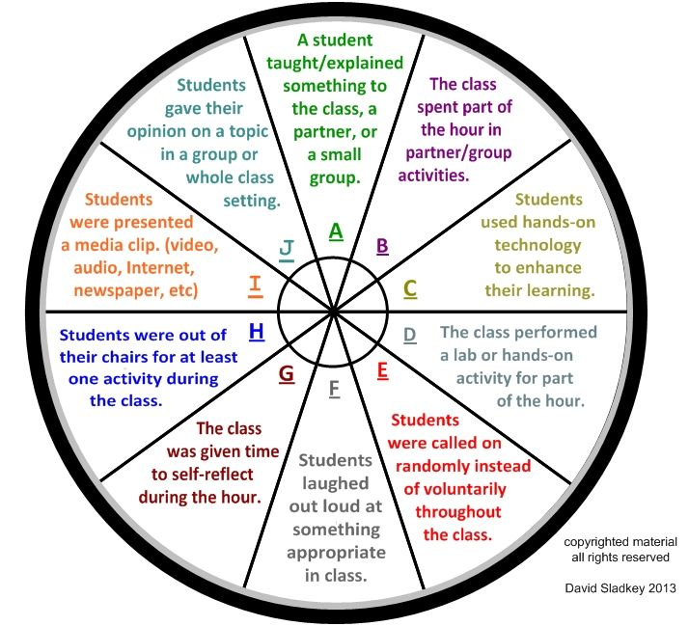

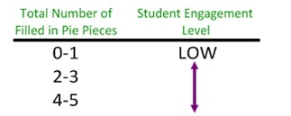
Name: Pupil C

Score:2
Name: Pupil B

Score:3
Name: Pupil A

Score:3

