Name: Nicoleta Angheluta
Student Number: 1914622
Module Title: Global Business Environment
Assignment Title: Covid 19 and its effects on Mini Cooper
Module Lecturer’s Name: Nadeem Mirza

Table of Contents
Introduction 3
1) Critically analyze the changes that the company have made in the last few months in light of the COVID 19 Pandemic. 4
2) Explain the extent to which you think these changes are sustainable. If you think they are not sustainable, would you recommend any other changes? 8
Conclusion 10
Reference list 11

Introduction
Due to globalisation, businesses are, affected by several factors. These factors affect the company either internally or externally. These factors can affect the business either positively or negatively. Various approaches can be uses to access the internal and external factors of a company. The use of PESTEL and SWOT analysis will be done to access the internal and external factors affecting Mini Cooper cars. Further, in this report, sustainable strategies will be recommended for the company. Mini Cooper is a British automobile company. Mini Cooper cars were founded in the year 1969. Bayerische Motoren Werke AG is the owner of the company.

PESTEL approach is used for accessing the external factors of a company. This approach accesses six different external factors, which are political, economic, social, technological, environmental and legal.
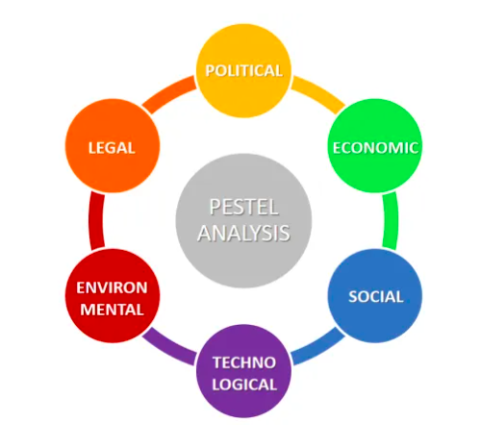
Figure 1: PESTEL analysis
(Source: Portice and Reicher, 2018)
Political: The political system of the United Kingdom is very stable. A stable political environment helps a business to operate smoothly and with very fewer government restrictions (Jones, 2015). However, due to the covid-19 pandemic, the UK government imposed several laws that hindered the business operation of Mini Cooper cars (mcguirewoods.com, 2020). Since the government had imposed a country-wide lockdown the business operations of Mini Cooper cars were slowed down. The company workers were not able to go to work because and the business was not able to get raw material to build a new card. However, to get the economy rolling the UK government allowed people to go to work with proper safety equipment. This helped the company to resume its operations.
Economic: The inflation rate of the United Kingdom has decreased from 0.9% in October to 0.6%in November (Ons.gov.uk, 2020). The inflation rate is directly proportional to the buying power of the customers. Hence, due to the decrease in the inflation rate the buying power of people has increased. This positive news for the company as the company will be able to sell more cars if the buying power of people increases. The United Kingdom is an economically stable country. Due to the covid-19 pandemic, the stock market has been affected negatively due to which business was facing problems to survive (mckinsey.com, 2020). However, due to the measures taken by the UK government, the economy of the country was back on track.
Social: Most of the people in the United Kingdom belong to the high-income group. Since, these people belong to the high-income group, the market share of Mini Cooper automatically increase (Wagner, 2020). Most people in the UK prefer driving the car to their work instead of taking a bus or train. Understanding their customers can help mini cooper to sell more cars. The young generation prefers buying cars, which are considerably small and looks stylish (David, 2019). This car perfectly suits the criteria and through effective marketing strategy, the company can target many customer groups.
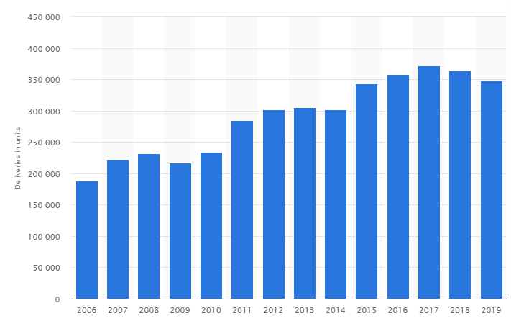
Figure 2: Deliveries of BMW MINI cars
(Source: Warger, 2020)
Technological: The United Kingdom is one of the most technologically advanced countries. The country provides all kind of technological benefits for manufacturing companies by providing them with advanced technological equipment. Mini Cooper is a subsidiary and people expect some extra features from the car company (miniusa.com, 2020). The company produces automatic cars that are easier for customers to drive. Mini Cooper is a hybrid car also has features like Wi-Fi and Bluetooth connectivity (mini.co.uk, 2020).
Environmental: The biggest problem Mini Cooper faces is to produce cars that produce less amount of CO2 from its exhaust. The change in climate condition is severe and environmentalist is pushing companies to innovate to reduce the amount of CO2 emissions (Press.bmwgroup.com, 2020). Mini Copper is looking forward to creating cars that run on electricity. The 2020 Mini Cooper SE is an electric vehicle developed by the company that runs on electricity with a battery capacity of 28.9KWh. The company also produces a hybrid model of Mini Cooper that produces less amount of CO2 (Harvey, 2020).
Legal: In order to operate smoothly without any government interruption Mini Cooper has to follow several laws such as labour safety law, environmental law, employment law, tax law, anti-trust laws, licensing, and so on (natlawreview.com, 2020). These laws are different in every country and Mini Cooper has to abide with each one of them to operate smoothly. The Mini Cooper car company adheres to a variety of copyright laws related to its vehicles. It is more challenging because the company has to comply with the laws that help a company to produce and sell the vehicles in each region. Any changes to these laws can stop or completely stop the performance and development of new technologies by BMW.
Porter’s five forces
Porter’s five forces analysis is an approach that helps a company to tackle the various threats of a company. This approach defines five different threats that can affect the company. The five force include,
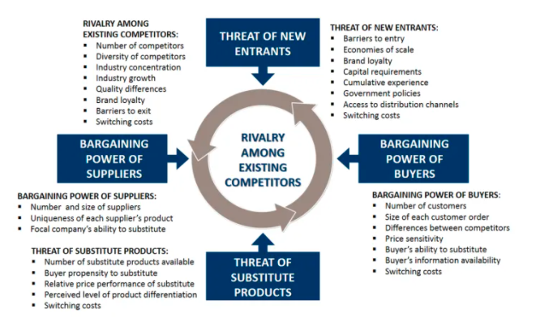
Figure 2: Porter’s five forces analysis
(Source: Thomas, 2019)
The threat of new entrants: Mini Cooper faces less threat from new entrants in the market. This is because it is very difficult for new entrants to compete in the automobile industry. In order to compete with mini cooper, the new entrant in the market will require enormous amounts of investment, capital, advanced robots, mechanical and AI equipment along with highly skills engineers and labours. The industry has heavy competition and it is very difficult for new entrants to compete with Mini Cooper (Thomas, 2019).
Bargaining power of supplier: Suppliers of raw materials play a very significant role for car manufacturing companies. The main raw material used by mini cooper to manufacture cars is metal sheets, copper wires, metals of different composition and thermal conditions, and so on. In order to get raw material at a cheaper price, the company has to maintain a healthy relationship with the suppliers (Mathooko and Ogutu, 2015). However, due to the covid-19 pandemic, the company has to pay extra amounts for raw material.
The threat of substitution: Mini Cooper faces high threat from substitute products produced by other car companies. Tesla is the largest producer of electric cars and provides better features and mileage compared to Mini Cooper. In order to compete against Tesla Mini Cooper will have to improve their features and innovate to provide better mileage on a single charge (DEBORD, 2020).
Bargaining power of buyers: Customers hold the bargaining power. Customers hold the power to pressure the company into reducing their prices. Due to the covid-19 pandemic, the bargaining power of buyers increased and the company forced to bring down its prices to sell the cars in its stock (Varelas and Georgopoulos, 2017). Customers also have a lot of bargaining power when they purchase products in large amounts forcing the company to bring down its prices.
Competitive rivalry: Mini Cooper also faces threats from rival companies. The automobile industry is very huge and Mini Cooper has to compete with hundreds of companies that produce hybrid and electric cars.
Product life cycle
The product life cycle strategy consists of four different stages, which include introduction, growth, maturity and decline. The product introduction strategy has four different stages, which are rapid skimming, slows skimming, rapid penetration and slow penetration. Out of these four strategies, Mini Cooper follows rapid penetration strategy, which involves launching a product at a low price but with significant promotion. Mini Cooper provides luxurious cars at a low price and hence follows a rapid penetration strategy. Mini Cooper’s growth strategy involves improving product quality, entering new market segments, adding new product and new features to existing products, and entering new markets. Mini Cooper follows product growth strategies to improve its sales.
The product maturity strategy of Mini Cooper includes market and product modification. Mini Cooper follows market modification strategy by entering new markets in different countries. Mini Cooper has redefined its target market by targeting young individuals and professionals in the UK by providing them with luxurious products at very low prices (Bremner, 2017). Product modification strategy of Mini Cooper involves modifying its cars by adding new and essential features such as automatic parking, WiFi connectivity, and so on (Volberg, 2019). The basic model of Mini Cooper was very famous when it launched. However, after many years passed people preferred buying new products and Mini Cooper has to reduce its distribution and promotional expenditure.
Mini Cooper has developed a car that runs on electricity and thus avoiding pollution. The Mini Cooper SE developed by the company is an electrically powered vehicle and the vehicle is all about carbon emission-free mobility (Harvey, 2020). The combined fuel emission of the Mini Cooper SE is, 0.01/100Km and the combined power consumption is 16.8-14.8 kWh/100 km and the combined CO2emission is 0g/Km. This Mini Cooper model is not yet in the rest of the world. The company had planned an international media launch of the vehicle model in 2020 in Florida, United States. The company has taken several measures to reduce the carbon emissions produced by cars. However, it is difficult for an automotive company to reduce carbon emissions while manufacturing different parts of the cars.
The Mini Cooper group is also trying to develop cars that run on hydrogen by the year 2030-2035. Hydrogen is zero emissions and it is abundantly available on earth. This makes sense because by using fuel and that is abundantly available and it has zero emissions. This technology can reduce pollution by an enormous amount. However, it is very difficult to build a fuel tank that has zero leakages. This is where Mini Cooper faces difficulty, because if any amount of Hydrogen leaks, it can result in an explosion. The company has promised to bring hydrogen-powered vehicles by 2035 (Bmwgroup.com, 2012).
The company has invested more than € 171 million since 2006 to take a measure that can reduce environmental hazards. These measures include taking action to reduce resource consumption, avoiding wastage of raw material, lowering greenhouse gas emissions. The company is aiming for the use of 100% renewable energy sources for its operations. It is also aiming to optimise energy efficiency and digitalisation possibilities. Data analytics is very important for Mini Cooper to manage various things such as minimising waste and scrapped parts and by predictive maintenance of machinery. The company has already offset carbon emissions for most of its car models and looks forward to achieving the same for all the car models by the year 2021. Mini Cooper already lowered carbon emissions by 70% since the year 2006 and the goal is to further reduce harmful gas emissions by 90% in the year 2021 (Press.bmwgroup.com, 2020).
An automotive industry takes up a lot of electrical power to complete its operations. If the company does not use renewable sources of energy for its operation it may use up natural sources for power generation. Using natural sources of power generation results into emission of harmful gases and it pollutes the environment. It is recommended that Mini Cooper build an infrastructure that allows the company to make use of renewable energy sources such as wind-mill, power from Dams, solar energy, and so on. The company must also make provisions for automatic parking and driving system. Technology is constantly evolving and the company can make its vehicle safer to drive by providing an automated driving system. Automated driving vehicles consist of cameras, which can detect people and vehicles to avoid accidents. This system can also allow users to put the car on autopilot mode and people can drive their cars to their homes without handling the steering wheel.

Conclusion
Due to the covid-19 pandemic, the sales and operation of Mini Cooper is affected. The PESTEL analysis was useful to understand how the external factors during the covid-19 pandemic affected the company. Porter's five forces analysis is useful for understanding the threats for the company and hoe the company can tackle them to maintain a competitive edge in the industry. The product life cycle strategy of Mini Cooper helps the company to understand what measures it needs to take for product introduction, growth, maturity and decline. The company has also taken several measures to protect the environment through its sustainability approach.

Reference list
Bmwgroup.com. 2012. Group-Wide Environmental Protection. [online] Available at: <https://www.bmwgroup.com/en/responsibility/group-wide-environmental-protection.html> [Accessed 24 December 2020].
Bremner, R., 2017. Insight: how Mini is growing up as a brand [online] Available at: <https://www.autocar.co.uk/car-news/industry/insight-how-mini-growing-brand> [Accessed 24 December 2020].
David, J., 2019. PESTEL analysis of the UK. Retrieved October, 30, p.2019.
Debord, M., 2020. The MINI Cooper Electric beats the Tesla Model 3 on just one point — but it's a crucial one [online] Available at: <https://www.businessinsider.in/thelife/news/the-mini-cooper-electric-beats-the-tesla-model-3-on-just-one-point-x2014-but-itaposs-a-crucial-one/slidelist/77891122.cms> [Accessed 24 December 2020].
Harvey, F., 2020. Electric cars produce less CO2 than petrol vehicles, study confirms Available at: < https://www.theguardian.com/environment/2020/mar/23/electric-cars-produce-less-co2-than-petrol-vehicles-study-confirms> [Accessed 24 December 2020].
https://www.miniusa.com. 2020. PREMIUM TECHNOLOGY IN ITS PLACE. AT YOUR FINGERTIPS. [online] Available at: <https://www.miniusa.com/why-mini/why-mini/mini-technology.html> [Accessed 24 December 2020].
Jones, R., 2015. The UK’s political system is dying, but digital technology offers an alternative [online] Available at: <https://www.theguardian.com/media-network/2015/apr/01/uk-political-system-digital-technology> [Accessed 24 December 2020].
Mathooko, F.M. and Ogutu, M., 2015. Porter’s five competitive forces framework and other factors that influence the choice of response strategies adopted by public universities in Kenya. International Journal of Educational Management.
mcguirewoods.com, 2020. UK Guidance on Application of Competition Law to Business Cooperation in Response to COVID-19 [online] Available at: < https://www.mcguirewoods.com/client-resources/Alerts/2020/4/uk-guidance-on-application-of-competition-law-to-business-cooperation-in-response-to-covid-19 > [Accessed 24 December 2020].
mckinsey.com, 2020. COVID-19: Implications for business [online] Available at: <https://www.mckinsey.com/business-functions/risk/our-insights/covid-19-implications-for-business#> [Accessed 24 December 2020].
mini.co.uk, 2020. MINI CONNECTED. [online] Available at: <https://www.mini.co.uk/en_GB/home/owners/mini-connected.html > [Accessed 24 December 2020].
natlawreview.com, 2020. January Update: Key Developments in UK and EU Environment, Safety and Health Law, Procedure and Policy [online] Available at: <https://www.natlawreview.com/article/january-update-key-developments-uk-and-eu-environment-safety-and-health-law> [Accessed 24 December 2020].
Ons.gov.uk. 2020. Inflation And Price Indices - Office For National Statistics. [online] Available at: <https://www.ons.gov.uk/economy/inflationandpriceindices#:~:text=Consumer%20price%20inflation%2C%20UK%3A%20November%202020&text=The%20Consumer%20Prices%20Index%20including,from%200.9%25%20in%20October%202020.> [Accessed 23 December 2020].
Portice, J. and Reicher, S., 2018. Arguments for European disintegration: A mobilization analysis of anti‐immigration speeches by UK political leaders. Political Psychology, 39(6), pp.1357-1372.
Press.bmwgroup.com. 2020. Consistently Sustainable: Media Presentation Of The New MINI Electric Is Designed To Be CO2 Neutral.. [online] Available at: <https://www.press.bmwgroup.com/global/article/detail/T0304444EN/consistently-sustainable:-media-presentation-of-the-new-mini-electric-is-designed-to-be-co2-neutral?language=en> [Accessed 24 December 2020].
Press.bmwgroup.com. 2020. Sustainable Mobility for Everyone: MINI ELECTRIC Shows the Way. [online] Available at: <https://www.press.bmwgroup.com/global/article/detail/T0305041EN/sustainable-mobility-for-everyone:-mini-electric-shows-the-way?language=en> [Accessed 24 December 2020].
Thomas, D., 2019. Five reasons the car industry is struggling [online] Available at: <https://www.bbc.com/news/business-48545733> [Accessed 24 December 2020].
Ulubeyli, S., Kazancı, O., Kazaz, A. and Arslan, V., 2019. Strategic Factors Affecting Green Building Industry: A Macro-Environmental Analysis Using PESTEL Framework. Sakarya Üniversitesi Fen Bilimleri Enstitüsü Dergisi, 23(6), pp.1042-1055.
Varelas, S. and Georgopoulos, N., 2017. Porter’s competitive forces in the modern globalized hospitality sector–the case of a Greek tourism destination. J Tour Res, 18, pp.121-131.
Volberg, G., 2019. Environmental Report MINI Cooper SE. [online] Bmwgroup.com. Available at: <https://www.bmwgroup.com/content/dam/grpw/websites/bmwgroup_com/responsibility/downloads/en/2020/Environmental-report_MINI-Cooper-SE.pdf> [Accessed 24 December 2020].
Wagner, I., 2020. Worldwide deliveries of BMW MINI cars from FY 2007 to FY 2019 [online] Available at: <https://www.statista.com/statistics/267245/worldwide-sales-volume-of-mini-automobiles-since-2006/> [Accessed 24 December 2020].

