



BSc (Hons) Applied Computing

2024/25



LEVEL 6 ASSESSMENT SPECIFICATION

Student name: | Joachim Manlongat | Student ID number: | 119187
Programme: | BSc Software Engineering
Module: | Socket Programming and Concurrency
Module code: | ACCA6028 | Contribution to Overall Module Assessment (%): | 50%
Lecturer: | Dr Tim Bashford | Internal Verifier: | Dr Mike Dacey
Assignment Title: | Socket Programming and Concurrency Report | Word count (or equivalent): | 3000
Submission deadline: |  | Return date of provisional marks & written feedback:
Submission method: | All written assessments, where practical and possible, must be submitted via Turnitin unless otherwise instructed by the Lecturer. (Please DO NOT put this assessment specification into Turnitin or it will match many similarities with other students’ submissions.)  Alternative submission method (if applicable):  Late submission of the assessment will result in a late penalty mark:  Work which is submitted up to 1 week late will be capped at 40% for the first attempt and will be awarded a mark of 0% for re-assessment. Late submission penalties may be lifted only if there is an approved extenuating circumstances claim.  Work submitted more than 1 week late will be considered as a non-submission and will not be marked. The work may be considered as a submission for reassessment if offered by an Examining Board or if there is an approved extenuating circumstances claim.
Academic honesty / referencing: | Academic honesty is required. In the main body of your submission you must give credit to authors on whose research and ideas your work is based. Append to your submission a reference list that indicates the books, articles, etc. that you have used, cited or quoted in order to complete this assessment.

Socket Programming and Concurrency – Assignment 1
Joachim Manlongat / 119187

Contents
Transmission Control Protocol (TCP) 6
Three-Way Handshake 6
Two Generals Problem 8
Maximum Transmission Unit (MTU) 9
Protocol Data Unit (PDU) and IP Fragmentation 9
PDU OSI 10
PDU Layers in OSI 10
Synchronous and Asynchronous in Networking 11
Synchronous transmission 11
Asynchronous transmission 12
The meaning of interoperability for networked applications and how it is best achieved. 13
How can it be best achieved? 13
Syntactic Interoperability 13
Semantic Interoperability 13
References 14

Transmission Control Protocol (TCP)
The TCP is a protocol suite and standard for communication and data transferring by enabling on both ends of the communication with reliability. It ensures that the data being transferred is reliable between endpoints such as a computer-to-computer or any hardware with a network connection that applies to a TCP/IP protocol through the network. [3] The TCP allows for the transferring of information that passed in both ends simultaneously. This means that computer systems that communicate over TCP can send and receive data at the same time. [2]
The protocol has a primary function to transport data in the form of packets as the basic unit of data transmission. Often limited, the segments can also contain control information 1,500 bytes. [4] This is to determine the maximum size of each packet in any transmission and avoid uneven packets. The benefit of it is the data that can be transferred to another system with the same protocol. [1] As most networks use TCP/IP as the network protocol, or set of rules for communication between devices, and the rules of TCP/IP require information to be split into packets that contain both a segment of data to be transferred and the address where the data is to be sent. [1]

Three-Way Handshake
The process of the TCP connection is established in three steps. The Three-Way Handshake is a sequence of three TCP segments that pass through an exchange between server and client over a TCP/IP network to establish a connection on both end (end-to-end) connection over the network. [5]
Both endpoints must have a unique IP address (IPv4 or IPv6) and have it assigned and enabled to the desired port for registration. [7] The IP address serves its purpose as an identifier with the port and its number to allow the computer to read and assign connections to the client and server. With IPv4 shown to have its constraints with number count of addresses possible, IPv6 offers a vast scalable address space with more reliable and efficient routing. [6]
The Three-way handshake is designed so that two computers that want to pass on information back-to-back can negotiate the parameters of the connection before sending and transmitting data. [8]
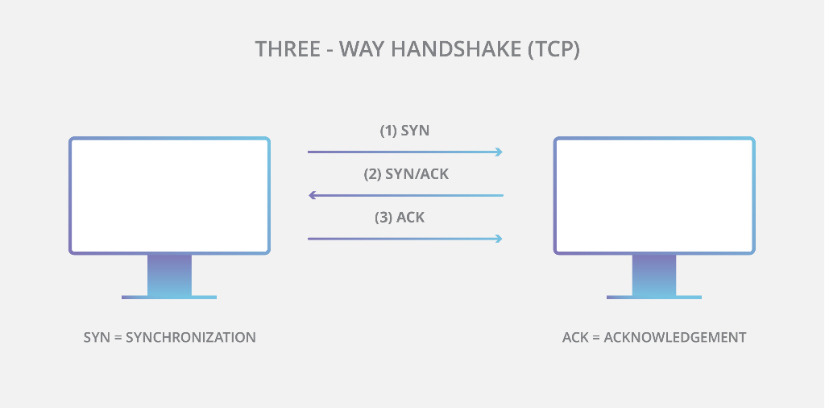

The process of the Three-way Handshake is broken down into three steps:
- Synchronise (SYN)
- Synchronise- Acknowledge (SYN-ACK)
- Acknowledge (ACK)
The first or initiating computer starts by sending a synchronised packet over to the receiving computer. The packet is set to ask the receiving computer is open for inquiry or availability. [9]
If in the case that the receiving computer has available ports open for the client and can be accepted for the connection, it acknowledges the statement by the first computer by sending back a synchronised-acknowledge packet to the first computer with the first packet also sent back with some changes. [9]
The first computer as the client then sends an acknowledge packet back to the receiving computer. The acknowledge packet is the acknowledgement of the receipt received by the receiving computer from the last action. The packet is set to the receiving computer packet that is also changed. Once the procedure finishes, the connection establishes, and data transmission can begin. [8] [9]

Two Generals Problem
The reference of the problem is the concept of the surrounding issue of an unsolvable problem in distributed systems and highlights the claimed impossible action to be taken notice of achieving perfect agreement or connection between two parties over an unreliable link up or network, such as the internet or any network that can lose messages. [12] [13] Two Generals has an issue that of surrounding the distributed systems and networks by achieving a consensus with the full certainty that it is impossible when there is any possibility that messages can be lost. [12] [14] This problem occurring is a fundamental understanding of the challenges with distribution that lead to further exploration in algorithms and systems designed to achieve consensus under practical conditions. [14]
The concept of Two Generals is the agreement between the communication. As with the TCP, in relation to communication, the scenario of which two endpoints (computers) communicate. [15] The underlying challenge is the presence of unreliability of the channel and the potential instability between two computers. It does not resolve the TGP due to the uncertainties in the communication and distribution of both computers or systems. [15] The TCP approach is to ensure that data are delivered despite errors although successful and to be acknowledged, even though perfect certainty is not always achieved. [13]
As TCP uses the Three-Way Handshake to negate such factor by retrying until success. [11] with the procedure taking place between two computers to establish a connection and reliability between those two ends of the communication before the actual data gets transferred and secured. [8] In terms of reliability, TCP follows a sequence and acknowledgements before transferring data. In the case that data is damaged, lost or duplicated, it must recover that data. TCP achieves the reliability by the Three-way handshake. [10] If the first computer fails to send a message to the receiving computer, that data is then retransmitted until it is successful. The process may take time however, The time-out value is dynamically determined for each connection, based on round-trip time. [9] [10]

Maximum Transmission Unit (MTU)
In networking, the MTU is an overall measurement by representing the largest available data packet that a TCP device will accept and communicate. [16] The size of the MTU also refers to the maximum amount of data that can be transmitted in a single network without fragmentation and with the benefit of optimisation with the performance of a network. [20]
The impact of MTU is the allowance of max bytes for the system to send packets of the same caliber in order to reach the same network without fragmentation. The large packets greatly reduce the process. [17] If the packets are larger that succeeds then the data becomes fragmented. The packets are then split into smaller segments to fit the network’s requirements. Fragmentation also takes extra time that can slow the process of data transfer significantly. [21] An MTU is based on the physical properties of the device used such as a desktop or a dedicated server. [18]

Protocol Data Unit (PDU) and IP Fragmentation
The PDU is a unit of information that is sent by a protocol based on the OSI model. [PSU1] They are a type of network data that is encapsulated to communicate information between other protocols. The PDU can be in single or multiple frames. [23]
The PDU is structured containing a header with control information such as addresses and the data to be transmitted from one device to another. The size of the PDU can have a significant impact on network performance. [22] Larger PDU can make use of the efficiency by reducing overhead, as fewer PDUs are needed to transmit a given amount of data. However, excessively larger PDUs past the threshold can lead to increased delay and overbearing fragmentation issues. [23]
Fragmentation is ideal when transferring PDU towards different TCP/IP devices over different networks. If the PDU is too big for the path, it is then broken down which makes it easier to send and keep the flow of data consistent, even with different hardware constraints. [26] IP packets can be as big as 65535 bytes, for it to have packets fit into various networks, it is split into smaller packets. [25]
MTU is measured in bytes, and the standard for it can carry up to 1500 bytes (if it’s the Ethernet or 1400 through Wi-Fi) per transfer at best to ensure reliability and prevention of fragmentation. [16] [21] The use of large MTU sizes allows the system to send fewer packets of larger size to reach towards the same network through. The large packets also greatly reduce the processing required in the operating system, assuming the workload allows large messages to be sent. [17] In networking, MTU is a measurement that represent the largest data packet that a machine with network connection will accept. [16]
In the network layer of the OSI Model, fragmentation may occur by breaking down large packets into smaller packets to make ends meet with the MTU of the network. Fragmentation allows the transport layer to ignore the issue which is then sent to the network layer to break down and reduce the oversized packet and return to its size once the destination reaches. [25]
The broken-down packets retract into its initial size once it reaches the destination of the network. While the method for IP Fragmentation split to reach the limit of the MTU for efficiency, the benefit of the split also has its drawbacks which could lead to threats and vulnerabilities. [26] It can be seen as having a negative impact on efficiency. The break down if in the case of losing fragments leads to having to retransmit all of the fragments that make up that damaged packet. [23] Another issue with fragmentation is the unpredicting action of course of it happening. It’s difficult to know what the actual MTU size would be from one end of the network to another, and not all networks handle fragmentation as well which then causes more fragments, productivity and time. [24]

PDU OSI
The PDU is the term used to refer to the entities created at each layer of the OSI Model or the TCP IP Suite as each layer's information is referred to as a PDU, together alongside data, it contains protocol-specific control information. [39] With each layer the PDU may transfer by encapsulating or decapsulating to each layer. The PDU is given a different name at each layer. [38]
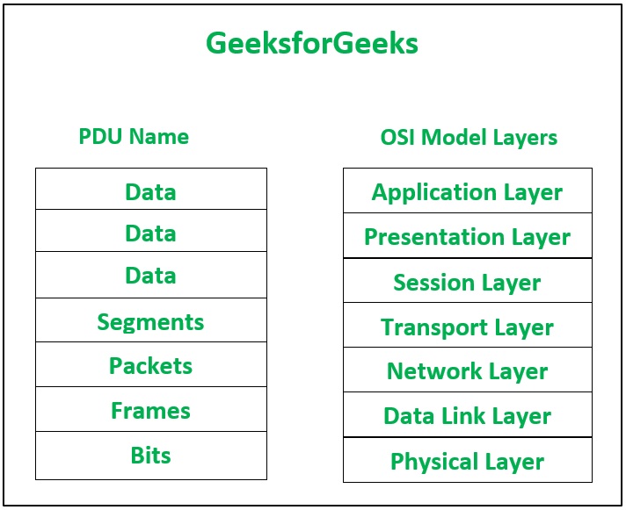[39]

PDU Layers in OSI
In the OSI model, PDU Is a term that is used in networking and telecommunications to refer to the data unit that's transmitted of information that gets passed around in a network. [22] The layer of the OSI model has a PDU of the following:
At Layer 4: Transport => Segment
At Layer 3: Network => Packet
At Layer 2: Data Link => Frame
At Layer 1: Physical => Bit

Synchronous and Asynchronous in Networking
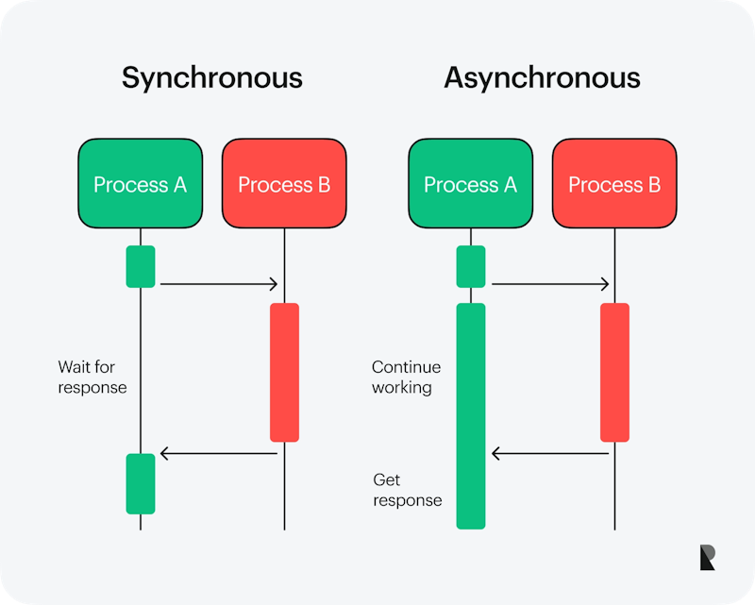[29]

Synchronous transmission
Synchronous is a technique that executes around communication that depends on one another to complete the task with connected systems communicating in real time. [31] By sending large data as frame with a stop and start bit of each character, it is then transmitted continuously. [33] Synchronous follows a strict set of sequences, with the tasks performed one at a time, in order. While one task is being performed, data is sent continuously without stop between the bytes being transferred. [28] Synchronous is used to describe a continuous and set timed transfer of data blocks where the connections are transferred in large packets from another location to the next. Once transmitted, the sender and receiver are synchronised.
The synchronous model is often led to being costly, as it takes a constant before moving on to the next although the trade-off is that it leads to a better result. Due to the blocking technique of synchronous, the execution for programming limits the overall speed. [33] Followed by the responsiveness, the entire application run is being held if a synchronous task takes a long time to complete. [29]

Asynchronous transmission
Asynchronous networking is provided by non-blocking service requests. [27] The applications can request asynchronous call when a connection might be established or when data is sent in character or in 8-bits a time. It might also be sent or received, unbeknownst to the receiver. [28] The send and receive for the transmission does not require a clock whereas the synchronous transmission however does. With asynchronous, it is a concurrent technique that enables the application to start a task that proceed a prolonged time while able to multitask with other events while the application is still running. [32] The technique is a benefit in that Asynchronous is a non-blocking architecture, the feature is so that an execution of one task isn't dependent on another task being executed with tasks run simultaneously and independently. [31] Asynchronous can send updated data between client and server that can be an overall better user experience for the user. Opposite to synchronous, it avoids blocking and endorses the improvement of concurrency by allowing the full use of its resources to run tasks with scalability. [29]
The issue with Asynchronous are the possible errors to run due to the timing. This causes problems, such as the size of data and overall speed of transfer is slower than synchronous. In addition to the higher latency due to the processing time and arrival of data to become available. The extra data is required with the start and stop bit, with the communication increasing overall size of the transmitted data to be time consuming. From an asynchronous standpoint providing the issues with multiple calls from tasks, patterns and difficulty in reading or sending. [33]

The meaning of interoperability for networked applications and how it is best achieved.
Interoperability allows each system on a network to communicate to another system by sending or receiving data such as messages, images and other media. [35] Interoperability also refers to the extent of which a software system, devices, apps or other endpoint can freely connect and communicate with other entities in a coordinated manner without effort from the end user. [34]
In networking, the interoperability for networked applications is understanding the ability of various networking systems to communicate and work together efficiently. As these devices vary towards different software and hardware, the interoperability would allow them to exchange data and perform functions regardless of platform and without most of the incompatibility issues. [36]
The network infrastructure and its interoperability are also the ability of different networks or applications to work or communicate together without additional tools. For example, most devices use TCP/IP to communicate to the network. The suite is available for all operating systems, computers, and supported devices that utilise the internet. The reliability and availability of devices that apply TCP/IP as the standards allows these devices to communicate and become compatible with one another. [40]

How can it be best achieved?
Acknowledging the interoperability can further improve networking and its scalability. When networks can integrate among another endpoint, they become more robust. [36] By applying standards and protocols, it can reduce dependency and complexity If one component fails, others can overtake and reduce downtime. Additionally, it allows organisations to scale their networks more efficiently, adding new devices and systems as needed without compatibility concerns. [41] For data exchange, the various types of interoperability have been a standard through the use of communication of protocols.

Syntactic Interoperability
Syntactics refers to systems using compatible file formats and protocols. The example of file formats such as JSON, XML and SQL has the ability to store data and communicate with objects of different platforms to exchange data using common communication protocols and ensuring that the data format is consistent and can be interpreted by both devices such as computers communicating to one another. [42]

Semantic Interoperability
Semantics refers to the ability of the computers to interpret and share data seamlessly especially when consistently structured and encoded. This interoperability type also focuses on the structure of the data exchange, how it is ensured that the data format used has remained consistent and that it can be interpreted by both systems in a network. [42]

References
[1] whatismyipaddress. What is a TCP/IP Packet and How Does It Work? No Date Found. [Accessed on 16/05/25] Available from: https://whatismyipaddress.com/tcp-ip
[2] IONOS. TCP (Transmission Control Protocol) – The transmission protocol explained. 2020. [Accessed on 16/05/25] Available from: https://www.ionos.co.uk/digitalguide/server/know-how/introduction-to-tcp/
[3] K Yasar and B Lutkevich. Transmission Control Protocol (TCP). No Date Found. [Accessed on 16/05/25] Available from: https://www.techtarget.com/searchnetworking/definition/TCP
[4] IBM. TCP Maximum Segment Size tuning. 2025. [Accessed on 16/05/25] Available from: https://www.ibm.com/docs/sv/aix/7.1.0?topic=tuning-tcp-maximum-segment-size
[5] geeksforgeeks. TCP 3-Way Handshake Process. 2024. [Accessed on 16/05/25] Available from: https://www.geeksforgeeks.org/tcp-3-way-handshake-process/
[6] IBM. How TCP/IP uses networks: TCP/IP addresses. 2021. [Accessed on 16/05/25] Available from: https://www.ibm.com/docs/en/zos/2.4.0?topic=networks-how-tcpip-uses-tcpip-addresses
[7] IONOS. TCP (Transmission Control Protocol) – The transmission protocol explained. 2020. [Accessed on 16/05/25] Available from: https://www.ionos.co.uk/digitalguide/server/know-how/introduction-to-tcp/
[8] mdn web docs. TCP handshake No Date Found. [Accessed on 16/05/25] Available from: https://developer.mozilla.org/en-US/docs/Glossary/TCP_handshake
[9] coursera. What Is a Three-Way Handshake? 2024. [Accessed on 16/05/25] Available from: https://www.coursera.org/articles/three-way-handshake
[10] IBM. Transmission Control Protocol. 2024. [Accessed on 16/05/25] Available from: https://www.ibm.com/docs/en/aix/7.1.0?topic=protocols-transmission-control-protocol
[11] geeksforgeeks. TCP 3-Way Handshake Process. 2024. [Accessed on 16/05/25] Available from: https://www.geeksforgeeks.org/tcp-3-way-handshake-process/
[12] mwhittaker. Two Generals and Time Machines. No Date Found. [Accessed on 16/05/25] Available from: https://mwhittaker.github.io/blog/two_generals_and_time_machines/
[13] Design Gurus. What is the Two Generals' Problem? No Date Found. [Accessed on 16/05/25] Available from: https://www.designgurus.io/answers/detail/what-is-the-two-generals-problem
[14] A Gelenler. What is the Two Generals' Problem? 2024. [Accessed on 16/05/25] Available from: https://medium.com/@ali.gelenler/two-generals-problem-and-idempotency-4d28f4b07694
[15] P Pandey. The Two Generals problem in TCP. 2024. [Accessed on 16/05/25] Available from: https://www.scaler.in/the-two-generals-problem-in-tcp/
[16] Cloudflare. What is MTU? No Date Found. [Accessed on 14/04/25] Available from: https://www.cloudflare.com/en-gb/learning/network-layer/what-is-mtu/
[17] IBM. MTU Size performance impacts. 2025. [Accessed on 14/04/25] Available from: https://www.ibm.com/docs/en/aix/7.2?topic=tuning-mtu-size-performance-impacts
[18] okta. What Is MTU (Maximum Transmission Unit)? 2024. [Accessed on 16/05/25] Available from: https://www.okta.com/uk/identity-101/mtu/
[19] Exascale. What is MTU (maximum transmission unit) in networking? 2024. [Accessed on 16/05/25] Available from: https://www.exascale.co.uk/blog/what-is-mtu-maximum-transmission-unit/
[20] Pure Storage. What Is MTU Size and How Do You Calculate It? 2023. [Accessed on 16/05/25] Available from: https://blog.purestorage.com/purely-educational/what-is-mtu-size-and-how-do-you-calculate-it/
[21] R Gargan. What Is MTU Size? Effects on Speed and Network Efficiency. 2025. [Accessed on 16/05/25] Available from: https://www.netmaker.io/resources/mtu-size
[22] Lenovo. What is PDU? No Date Found. [Accessed on 16/05/25] Available from: https://www.lenovo.com/us/en/glossary/what-is-pdu/
[23] professormesser. Protocol Data Units – CompTIA Network+ N10-007 – 1.3. 2018. [Accessed on 16/05/25] Available from: https://www.professormesser.com/professor-messer-archives/n10-007/protocol-data-units/
[24] G Mazonaite. Understanding IP Fragmentation Attack: A Complete Guide for Network Security. 2024. [Accessed on 16/05/25] Available from: https://www.mysteriumvpn.com/blog/ip-fragmentation
[25] S Iveson. IP Fragmentation in Detail. 2019 [Accessed on 16/05/25] Available from: https://packetpushers.net/blog/ip-fragmentation-in-detail/
[26] J Sheehan. Understand IP Fragmentation: A Newbie Guide. 2025. [Accessed on 16/05/25] Available from: https://synchronet.net/ip-fragmentation/
[27] oracle. Asynchronous Networking. No Date Found. [Accessed on 16/05/25] Available from: https://docs.oracle.com/cd/E19455-01/806-1017/6jab5di32/index.html
[28] geeksforgeeks. Difference Between Synchronous and Asynchronous Transmission. 2024. [Accessed on 16/05/25] Available from: https://www.geeksforgeeks.org/difference-between-synchronous-and-asynchronous-transmission/
[29] Ramotion. Synchronous vs. Asynchronous: Core Differences. 2023. [Accessed on 16/05/25] Available from: https://www.ramotion.com/blog/synchronous-vs-asynchronous-programming/#section-synchronous-vs-asynchronous-core-differences
[30] microfocus Understanding Synchronous and Asynchronous Communication. No Date Found. [Accessed on 16/05/25] Available from: https://www.microfocus.com/documentation/silk-performer/205/en/silkperformer-205-webhelp-en/GUID-6CC17B5B-71B7-4703-B9E6-C81835A5335A.html
[31] D Bevans. Asynchronous vs. Synchronous Programming: Key Similarities and Differences. 2024. [Accessed on 16/05/25] Available from: https://www.mendix.com/blog/asynchronous-vs-synchronous-programming/
[32] mdn web docs. Introducing asynchronous JavaScript. No Date Found. [Accessed on 16/05/25] Available from: https://developer.mozilla.org/en-US/docs/Learn_web_development/Extensions/Async_JS/Introducing
[33] G Lau. Synchronous And Asynchronous Data Transmission: The Differences And How to Use Them. 2023. [Accessed on 16/05/25] Available from: https://www.computer.org/publications/tech-news/trends/synchronous-asynchronous-data-transmission
[34] S Lewis. Interoperability. 2023. [Accessed on 16/05/25] Available from: https://www.techtarget.com/searchapparchitecture/definition/interoperability
[35] M Lindquist. What Is Interoperability? 2024. [Accessed on 16/05/25] Available from: https://www.oracle.com/uk/interoperability/
[36] Howard. What is Interoperability in Networking? 2024. [Accessed on 16/05/25] Available from: https://community.fs.com/article/what-is-interoperability-in-networking.html
[37] S Burrell. Understanding Interoperability: The Key to Seamless Telecom Networks. 2025. [Accessed on 16/05/25] Available from: https://wraycastle.com/blogs/knowledge-base/understanding-interoperability-the-key-to-seamless-telecom-networks
[38] C M. Kozierok. Data Encapsulation, Protocol Data Units (PDUs) and Service Data Units (SDUs) 2004. [Accessed on 16/05/25] Available from: http://www.tcpipguide.com/TCPIPGuide_2-0_s2.pdf
[39] geeksforgeeks Protocol Data Unit (PDU). 2022. Available from: https://www.geeksforgeeks.org/protocol-data-unit-pdu/
[40] telecoms. How Interoperability Will Define Network Infrastructure in 2025. [Accessed on 16/05/25] Available from: https://www.telecoms.com/network-software/how-interoperability-will-define-network-infrastructure-in-2025
[41] S Nag. Future of Interoperability and the Evolving Trends. 2024. Available from: https://calsoftinc.com/blogs/2024/01/future-of-interoperability-and-the-evolving-trends.html
[42] HIMSS UTAH. Understanding the Three Levels of Interoperability: Foundational, Structural, and Semantic. 2024. Available from: https://utahhimss.org/blog/id/9

