University of Wales Trinity Saint David
School of Engineering



Computational Methods
ACMA6012

2D Transient Heat Equation Solved with the
Explicit Finite Difference Method

Cori-James Davies (1303441)
02/02/26

Table of Contents
1 Introduction 1
2 Governing Equation 2
3 Explicit Finite Difference Formulation 4
3.1 Introduction to Finite Difference Approximations 4
3.2 Spatial and Temporal Discretisation 4
3.3 Explicit Finite Difference Scheme 5
3.4 Stability Criterion 5
4 Initial Conditions, Boundary Conditions and Analytical Solution 6
5 Code Details and Explanations 7
6 Validation of the Numerical Model 13
7 Sensitivity Analysis 16
7.1 Grid Spacing Sensitivity 16
7.2 Time Step Sensitivity 17
7.3 Convergence Tolerance Sensitivity 19
8 Limitations of the Numerical Model 21
9 Suggested Improvements and Future Developments 22
10 Conclusions 23
11 References 24
12 Appendix 26
12.1 MATLAB Code 26

Table of Figures
Figure 1: Two-dimensional heat diffusion equation (Lienhard and Lienhard, 2020). 2
Figure 2: thermal diffusivity (Incropera et al., 2017). 2
Figure 3: Taylor series expansion of the temperature function T(x+h) (Burden et al., 2016) 4
Figure 4: Central difference approximation for the second derivative. 4
Figure 5: Explicit finite difference scheme for the two-dimensional heat equation (Smith, 1985). 5
Figure 6: Definition of the Fourier number for the explicit finite difference scheme (Incropera et al., 2017). 5
Figure 7: Fourier Number 5
Figure 8 Initial and boundary conditions: 6
Figure 9: MATLAB lines 1-11 7
Figure 10: MATLAB lines 13 - 41 7
Figure 11: MATLAB lines 42-71 8
Figure 12: MATLAB lines 73-74 8
Figure 13: MATLAB lines 76-78 8
Figure 14: MATLAB lines 80-88 9
Figure 15: MATLAB lines 90-95 9
Figure 16:MATLAB lines 95-108 9
Figure 17: MATLAB lines 110-124 10
Figure 18: MATLAB lines 126-133 10
Figure 19: MATLAB lines 135-142 10
Figure 20: MATLAB lines 144 - 153 11
Figure 21: MATLAB lines 155-157 11
Figure 22: MATLAB lines 159-190 11
Figure 23: Stability condition for the explicit finite difference method. 13
Figure 24: Numerical steady-state temperature distribution 14
Figure 25: Analytical steady-state temperature distribution for the same geometry and boundary conditions 14
Figure 26: Absolute difference between the numerical and analytical solutions 15
Figure 27: Grid Spacing Graph 17
Figure 28: Time Step Graph 18
Figure 29: Tolerance Graph 20

Introduction
Modeling transient heat conduction is crucial in various engineering fields, especially where changes in temperature affect material strength, system performance, or safety. In many real-world situations, analytical solutions often only work for simplified shapes and boundary conditions. This limitation means that numerical techniques are typically needed to tackle more complex problems effectively.
This report investigates the numerical solution of the two-dimensional transient heat conduction equation using the Explicit Finite Difference Method (EFDM). The method is implemented in MATLAB to simulate heat diffusion within a rectangular plate subjected to prescribed thermal boundary conditions and a uniform initial temperature. Due to the conditional stability of explicit schemes, particular attention is given to time-step selection and numerical convergence criteria.
The primary objectives of this study are to develop and implement the EFDM formulation, validate the numerical solution by comparing it with an analytical steady-state benchmark, and quantitatively assess numerical accuracy using appropriate error metrics. Additionally, a sensitivity analysis is conducted to examine the effects of spatial discretisation, time step size, and convergence tolerance on the model's behavior. We also critically evaluate the limitations of the adopted numerical approach and propose potential improvements.

Governing Equation
Heat conduction in solids is governed by the heat diffusion equation, which describes the spatial and temporal evolution of temperature arising from thermal gradients within a material. Lienhard and Lienhard (2020) demonstrate that this equation is obtained by combining Fourier’s law of heat conduction with the principle of energy conservation, under the assumptions of a homogeneous and isotropic medium with constant thermophysical properties.
Fourier’s law relates the heat flux vector to the negative temperature gradient, indicating that heat flows from regions of higher temperature to regions of lower temperature. When this relationship is applied to a differential control volume and coupled with the conservation of energy, the transient heat diffusion equation is obtained.
Figure 1 presents the governing equation for two-dimensional heat conduction in a domain with no internal heat generation.
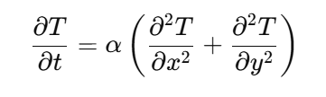
Figure 1: Two-dimensional heat diffusion equation (Lienhard and Lienhard, 2020).
Where:
$T$= temperature
$t$ = time
$x$,$y$ = spatial coordinates
$a$ = thermal diffusivity.
Thermal diffusivity is defined as Figure 2:
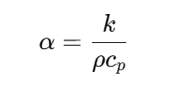
Figure 2: thermal diffusivity (Incropera et al., 2017).
Where:
$a$ = thermal diffusivity
$k$ = thermal conductivity
$p$ = density
c_{p} = specific heat capacity.

Thermal diffusivity characterises the rate at which thermal disturbances propagate through a material and is a key parameter governing transient thermal response (Incropera et al., 2017). The heat equation is a second-order parabolic partial differential equation frequently used in engineering analysis, including applications such as electronic thermal management, materials processing, and energy systems.
However, analytical solutions exist only for a limited set of idealised geometries and boundary conditions. As a result, numerical techniques such as the finite difference method are widely adopted for solving practical transient heat transfer problems involving complex boundary constraints, including the configuration considered in this study (Smith, 1985).

Explicit Finite Difference Formulation

Introduction to Finite Difference Approximations
The finite difference method approximates derivatives using algebraic expressions derived from Taylor series expansions. For a sufficiently smooth temperature function $T$ ($x$), $a$ Taylor series expansion about a point $x$ is illustrated in Figure 3 (Burden et al., 2016):
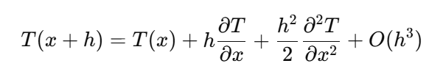
Figure 3: Taylor series expansion of the temperature function T(x+h) (Burden et al., 2016)

Expanding the Taylor series about $x+h$ yields a forward Taylor expansion, while expanding about $x-h$ produces a backward Taylor expansion. By combining these two expansions and eliminating the first-derivative terms, a central difference approximation for the second derivative is obtained, as illustrated in Figure 4.
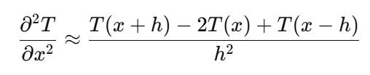
Figure 4: Central difference approximation for the second derivative.

The central difference scheme is second-order accurate in space, with a truncation error of order $O(h^{2}).$ This truncation error arises from neglecting higher-order terms in the Taylor series and represents a fundamental source of numerical error in finite difference approximations (Burden et al., 2016).

Spatial and Temporal Discretisation
The spatial domain is discretised into a uniform Cartesian grid with spacing $h$ in both the $x$ and $y$ directions. Each grid node is defined by indices $\left(i and j\right).$ Time is discretised into uniform increments $Δt$ and the temperature at node $\left(i,j\right)$at time level $n$ is denoted by $T\frac{n}{i,j}$.
The choice of grid spacing directly influences numerical accuracy and computational cost. Finer grids reduce spatial discretisation error but increase the number of nodes and, consequently, the computational effort required. Similarly, smaller time steps improve temporal resolution but increase the number of iterations needed to reach a given physical time (Smith, 1985).

Explicit Finite Difference Scheme
Applying a forward difference approximation to the temporal derivative and central difference approximations to the spatial derivatives yields the explicit finite difference formulation illustrated in Figure 5:
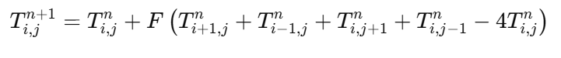
Figure 5: Explicit finite difference scheme for the two-dimensional heat equation (Smith, 1985).

Where the Fourier number $F$ is defined as illustrated in Figure 6:
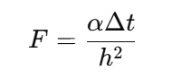
Figure 6: Definition of the Fourier number for the explicit finite difference scheme (Incropera et al., 2017).

The Fourier number represents the ratio of diffusive heat transport over a single time step to the thermal energy stored within a grid cell. Physically, it indicates the distance over which heat diffuses relative to the grid spacing during one time increment (Incropera et al., 2017).

Stability Criterion
The explicit finite difference method (EFDM) is conditionally stable. Von Neumann stability analysis demonstrates that, for a two-dimensional diffusion problem, numerical stability is ensured only when the Fourier number satisfies the condition:
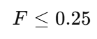
Figure 7: Fourier Number

If this stability condition is violated, numerical errors grow exponentially with time, leading to divergence or non-physical oscillatory solutions (Smith, 1985). This stability restriction necessitates the use of very small time steps, particularly for refined spatial grids, and therefore constitutes a significant limitation of explicit finite difference schemes (Özişik et al., 2017).

Initial Conditions, Boundary Conditions and Analytical Solution
The numerical model considers an aluminium plate initially at a uniform temperature of 0°C. This initial condition, shown in Figure 8, represents a physically realistic scenario in which the plate is in thermal equilibrium with its surroundings before the application of external heating. At the start of the simulation $(T=0)$, the temperature at all interior nodes is therefore set to zero.
Mixed boundary conditions are imposed on the computational domain. A prescribed constant temperature $T0$ is applied along the north boundary, representing an external heat source. The east and south boundaries are maintained at 0°C.
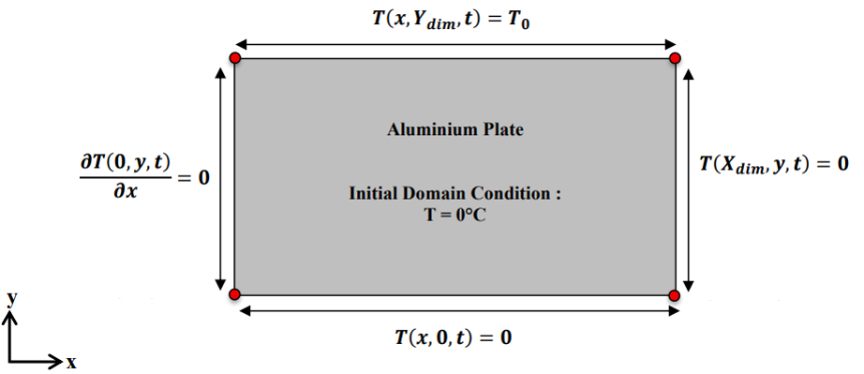
Figure 8 Initial and boundary conditions:
At thermal equilibrium, the transient term vanishes, and the governing heat equation reduces to a steady-state diffusion problem described by Laplace’s equation. For the present combination of boundary conditions, an analytical solution exists and can be obtained using the method of separation of variables, in which the temperature field is expressed as a Fourier series satisfying the imposed boundary conditions (Daileda, 2012).
The availability of an analytical solution provides a rigorous benchmark against which the numerical results may be validated. By comparing the numerical temperature distribution at equilibrium with the corresponding analytical solution, discretisation errors can be quantified and the accuracy of the explicit finite difference implementation assessed. Validation against analytical solutions is widely recommended in numerical heat transfer studies to establish model reliability prior to undertaking further parametric or sensitivity analyses (Smith, 1985).

Code Details and Explanations
The MATLAB model follows a structured approach focused on numerical stability, physical consistency, and validation, comprising parameter initialisation, explicit time integration, analytical benchmarking, and error quantification.
The cleaning command, material properties and geometric parameters are defined at the start of the script (Figure 9).
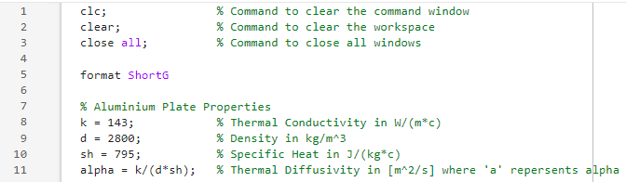
Figure 9: MATLAB lines 1-11

User input is validated to ensure physically meaningful plate dimensions and a uniform spatial discretisation, with checks that the chosen grid spacing exactly divides the domain (Figure 10). This guarantees a structured mesh suitable for the finite difference formulation.
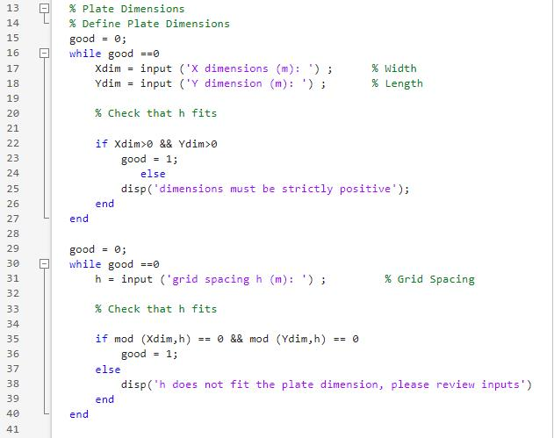
Figure 10: MATLAB lines 13 - 41

The temperature field is initialised to a uniform value, representing a quiescent initial condition, and Dirichlet boundary conditions are applied directly to the boundary nodes (Figure 11). The time step is constrained using the explicit scheme stability criterion, ensuring the Fourier number remains within the stable limit. Invalid time step selections are rejected before execution, preventing unstable simulations.
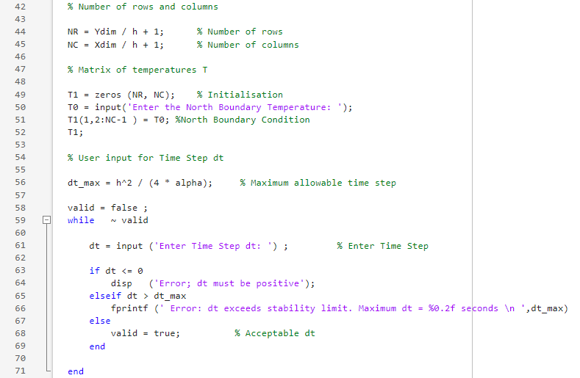
Figure 11: MATLAB lines 42-71

Boundary values are preserved throughout the simulation, while a separate temperature matrix stores updated values at each time step (Figure 12).
Figure 12: MATLAB lines 73-74

Steady state is detected using a convergence criterion based on the maximum absolute change between successive temperature fields (Figure 13), providing a practical numerical definition of equilibrium.
Figure 13: MATLAB lines 76-78

Time integration is performed using an explicit finite difference update applied to all interior nodes (Figure 14).
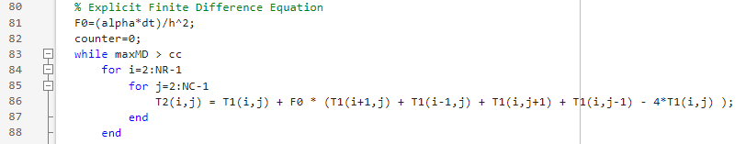
Figure 14: MATLAB lines 80-88

Figure 15 shows the convergence check and time advancement. Calculating the maximum absolute difference between successive temperature fields to measure the change in the solution. This process repeats until the convergence criterion is met, allowing the steady-state temperature distribution to be obtained.
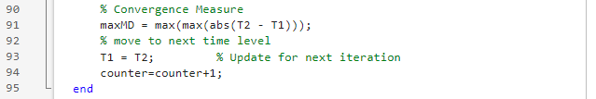
Figure 15: MATLAB lines 90-95

Once convergence is achieved, the total simulation time required to reach steady state is calculated and reported in an appropriate unit to improve physical interpretability (Figure 16).
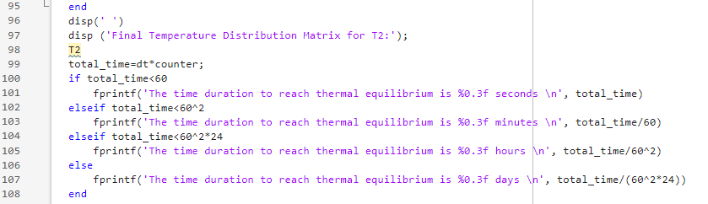
Figure 16:MATLAB lines 95-108

Validation is carried out by computing an analytical steady-state solution based on a Fourier series representation (Figure 17).

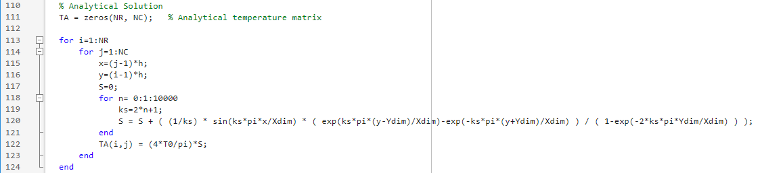
Figure 17: MATLAB lines 110-124

Only the required odd harmonics are retained to ensure convergence while maintaining computational efficiency. The analytical solution is reoriented to match the numerical grid prior to comparison (Figure 18).
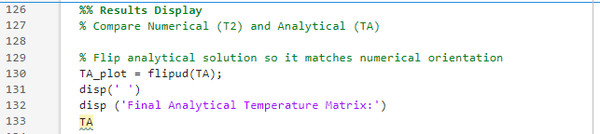
Figure 18: MATLAB lines 126-133

Quantitative validation is achieved by evaluating the absolute error between numerical and analytical temperatures at each grid point (Figure 19).
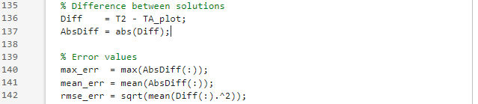
Figure 19: MATLAB lines 135-142
The maximum, mean, and root mean square errors (RMSE) are computed and reported, providing measures of worst-case deviation, overall bias, and global accuracy (Figure 20).

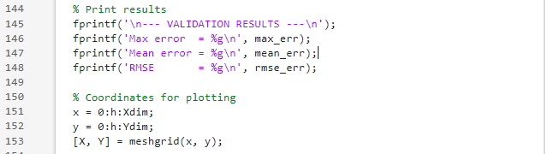
Figure 20: MATLAB lines 144 - 153

Contour plots of the numerical and analytical solutions, and the absolute error, are generated on consistent scales to allow direct visual comparison (Figures 21 and 22).
Figure 21: MATLAB lines 155-157
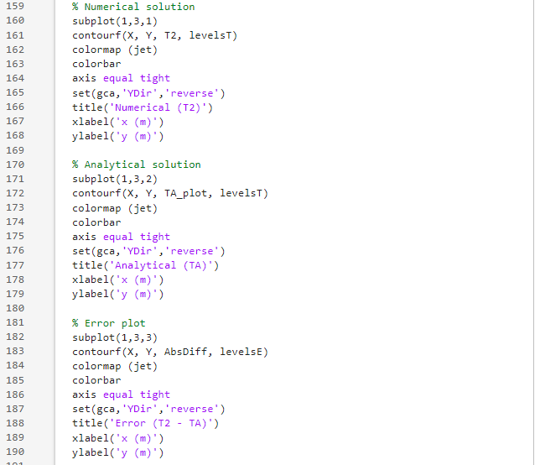
Figure 22: MATLAB lines 159-190
Overall, the implementation demonstrates a stable and verifiable numerical solution to the two-dimensional steady-state heat conduction problem. The combination of enforced stability, convergence monitoring, analytical benchmarking, and quantitative error metrics provides confidence in the accuracy and robustness of the model.

Validation of the Numerical Model
The numerical solution obtained using the explicit finite difference method was validated through comparison with the analytical steady-state solution of the two-dimensional heat conduction equation. This validation was carried out to assess the accuracy and reliability of the numerical scheme, as well as to confirm the correct implementation of the governing equation and spatial discretisation.
The computational domain consisted of a rectangular plate of dimensions X = 1m and Y = 0.5 m. Whilst using a uniform grid spacing h = 0.02 m. The north boundary of the plate was maintained at a constant temperature of T0 = 100°C, while the remaining boundaries (East, South and West) were held at 0°C.
Time integration was performed using an explicit finite-difference scheme until steady-state conditions were reached. At steady state, the governing heat conduction equation reduces to the two-dimensional Laplace equation.
For numerical stability, the time step is restricted by the explicit finite difference stability criterion, given in Figure 23, which relates the time step size to the spatial discretisation and thermal diffusivity.
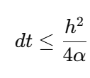
Figure 23: Stability condition for the explicit finite difference method.

An initial trial value of 𝑑𝑡 = 9 s was rejected by the algorithm as exceeding the stability limit, demonstrating correct enforcement of the stability condition. A revised value of 𝑑𝑡 = 1.5 s was subsequently adopted for all validation runs, ensuring stable and monotonic convergence to the steady-state solution.
Figure 24 presents the numerical steady-state temperature distribution, while Figure 25 shows the corresponding analytical solution for the same geometry and boundary conditions. The two solutions exhibit identical qualitative behaviour, with the highest temperatures occurring along the heated upper boundary and a smooth decay towards the remaining boundaries. Symmetry about the vertical centreline of the domain is preserved in each case, indicating correct implementation of the boundary conditions and confirming the absence of directional bias in the numerical formulation.
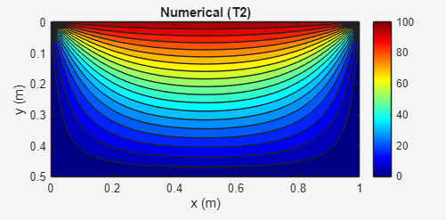

Figure 24: Numerical steady-state temperature distribution

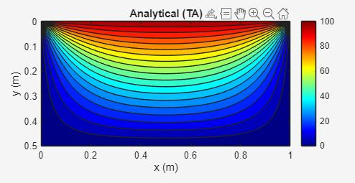

Figure 25: Analytical steady-state temperature distribution for the same geometry and boundary conditions

Figure 26 illustrates the absolute difference between the numerical and analytical solutions across the computational domain. The error remains small throughout the plate and is concentrated primarily in the interior region, while being minimal near the boundaries where temperatures are prescribed exactly. The smooth and continuous nature of the error distribution indicates that the discrepancy is dominated by spatial discretisation error rather than numerical instability or lack of convergence.

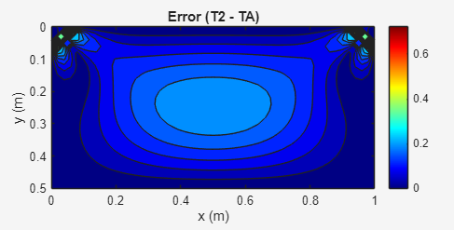
Figure 26: Absolute difference between the numerical and analytical solutions

The maximum absolute error is less than 1°C, over a temperature range of 100°C, corresponding to a relative error of less than 1%. This level of accuracy is consistent with expectations for a second-order spatial discretisation scheme applied to a finite-resolution grid. Furthermore, the absence of oscillatory behaviour or irregular patterns in the error field confirms that the numerical solution has converged correctly to the steady-state regime.
Overall, the strong agreement between the numerical and analytical solutions demonstrates that the implemented finite difference model provides an accurate approximation of the governing heat conduction equation under the prescribed boundary conditions. These results therefore validate the correctness of the numerical formulation, stability control, and convergence procedure employed in this study.

Sensitivity Analysis
To assess the code’s sensitivity, a detailed analysis is required. This will involve running multiple simulations across the three following primary adjustable parameters: Grid Spacing (h), Time Step (t), and Tolerance (Convergence Criteria).
Grid convergence assessment is a standard requirement in numerical heat transfer studies to ensure that observed trends are not artefacts of discretisation (Roache, 1994).

Grid Spacing Sensitivity
Celik and Rodi (1988) note that grid sensitivity analysis is essential to distinguish numerical artefacts from true physical responses, and that refining a grid beyond the point of convergence yields little additional accuracy at a high computational cost.
Table 1 shows how changing the grid spacing affects the predicted thermal equilibrium time, while keeping the time step and tolerance constant.
Table 1: Grid Spacing Analysis
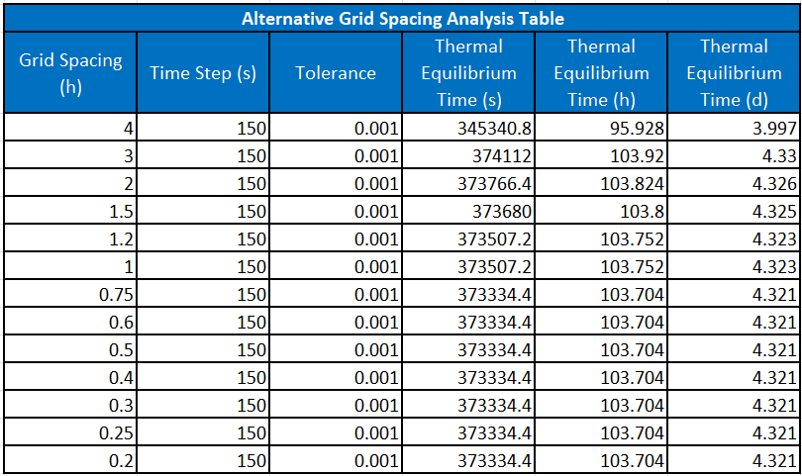
At the coarsest grid spacing (h = 4), the predicted equilibrium time is significantly lower (approximately 96 h), indicating reduced accuracy. As the grid spacing is decreased, the equilibrium time increases and subsequently stabilises at approximately 104 h (≈ 4.32 days) for h ≤ 1.
Using Figure 27, this trend is evident: the curve decreases at h = 4 but becomes nearly flat for smaller grid spacings. This plateau indicates that the solution has converged and is no longer sensitive to grid size. This behaviour is typical of finite difference schemes, where truncation error decreases as grid spacing is reduced (Chapra and Canale, 2015).
This behaviour is consistent with recent grid convergence studies, which show that beyond a certain refinement level, further mesh reduction produces diminishing changes in solution metrics, indicating near grid-independent behaviour (Roache, 1994).

Figure 27: Grid Spacing Graph

Overall, the results indicate that when the grid spacing is reduced below 2m, the equilibrium time converges to approximately 3.73 × 10⁵ s (≈ 103.7 h, ≈ 4.32 days). Further refinement beyond this point produces no meaningful change in the result, demonstrating that grid independence has been achieved. This confirms that the numerical solution is no longer sensitive to spatial resolution and that the discretisation error has been minimised.

7.2 Time Step Sensitivity
Versteeg and Malalasekera (2007) explain that time step sensitivity analysis is a key aspect of transient numerical modelling, as the choice of time step can significantly affect both stability and accuracy. They note that excessively large time steps can smear transient behaviour, while overly small steps increase computational cost without substantial benefit.
Table 2 shows the effect of time step size on the predicted thermal equilibrium time, with grid spacing (h = 0.75) and tolerance held constant. As the time step increases from 25 s to 2000 s, the equilibrium time rises from approximately 4.32 × 10⁵ s to 9.26 × 10⁵ s, demonstrating strong sensitivity to temporal discretisation and indicating that larger time steps introduce significant numerical error.
Table 2: Time Step Analysis
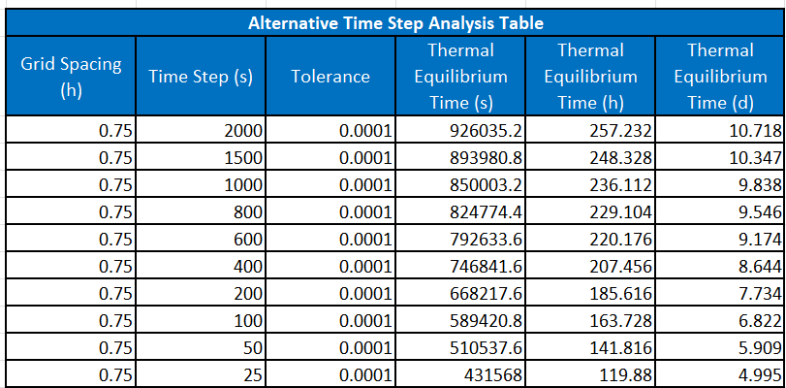

This trend is evident in Figure 28, where the equilibrium time increases monotonically with time step. At smaller time steps (below about 100 s), the curve begins to flatten, indicating convergence towards a stable solution. This behaviour is typical of time-marching schemes, where reducing the time step decreases temporal discretisation error and improves accuracy (Ferziger and Perić, 2002).

Figure 28: Time Step Graph
Overall, the results confirm that reducing the time step improves accuracy, with convergence towards approximately 4.3 × 10⁵ s (≈ 4.3 days). This demonstrates that a sufficiently small time step is required to achieve temporal convergence and minimise discretisation error, consistent with established numerical heat transfer theory (Incropera et al., 2017).

7.3 Convergence Tolerance Sensitivity
Butt (2010) states that convergence tolerance controls when an iterative solution is considered converged. If the tolerance is too large, the solution may terminate early and become inaccurate, while excessively small tolerances increase computational cost without significant accuracy gains.
Table 3 shows the effect of convergence tolerance on the predicted thermal equilibrium time, with grid spacing (h = 1) and time step (500 s) held constant. As the tolerance is reduced from 0.1 to 0.000001, the equilibrium time increases substantially from approximately 5.55 × 10⁴ s to 1.30 × 10⁶ s. This indicates strong sensitivity of the solution to the convergence criterion and demonstrates that loose tolerances significantly underestimate the equilibrium time.
Table 3: Tolerance Analysis Table
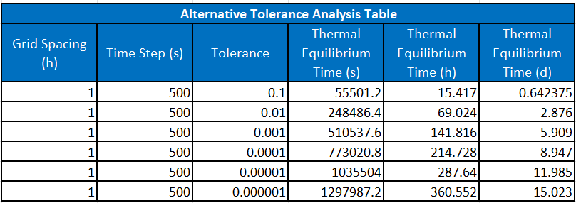

This trend is evident in Figure 29, where the thermal equilibrium time increases monotonically as the tolerance is reduced. At higher tolerance values (≥ 0.01), the equilibrium time is much lower, suggesting premature convergence. As the tolerance is reduced below 0.001, the curve begins to flatten, indicating convergence towards a stable solution. This behaviour is characteristic of iterative schemes, in which tighter convergence criteria reduce the residual error and improve solution accuracy (Saad, 2003).

Figure 29: Tolerance Graph

Overall, the results confirm that reducing the convergence tolerance improves solution accuracy, with convergence towards approximately 1.3 × 10⁶ s (≈ 15.0 days). This demonstrates that a sufficiently small tolerance is required to ensure numerical convergence and minimise residual error, consistent with established numerical heat transfer and iterative solution theory (Patankar, 1980).

Limitations of the Numerical Model
Özişik et al. (2017) describe conditional stability as a fundamental limitation of explicit finite difference schemes, requiring the time step to satisfy a restrictive criterion that scales with the square of the spatial grid spacing. In practice, this implies that grid refinement necessitates proportionally smaller time steps to maintain stability, significantly increasing computational cost and limiting the scalability of the Explicit Finite Difference Method (EFDM).
Burden et al. (2016) show that explicit schemes are first-order accurate in time and second-order accurate in space. As a result, truncation errors may dominate the numerical solution if temporal discretisation is not sufficiently refined, requiring reductions in the time step alongside spatial refinement to preserve accuracy. The same authors also note that round-off error can accumulate over many iterations due to finite-precision arithmetic, particularly for long transient simulations or when stringent convergence tolerances are applied.
Patankar (1980) emphasises that defining thermal equilibrium using a fixed numerical tolerance does not necessarily correspond to a physically meaningful steady state, such as one defined by global energy balance or boundary heat-flux continuity. Consequently, the predicted equilibrium time in the present model is sensitive to the chosen tolerance value and reflects an algorithmic rather than purely physical criterion. Furthermore, as discussed by Versteeg and Malalasekera (2007), the use of a structured Cartesian grid limits applicability to simple geometries and homogeneous materials, restricting the suitability of the EFDM for more complex engineering problems.

Suggested Improvements and Future Developments
The proposed improvements address key limitations of the numerical model and reflect established best practice in computational heat transfer, particularly with respect to the use of explicit finite difference schemes.
Zhang et al. (2021) demonstrate that the primary limitation of explicit schemes arises from conditional stability. Replacing the EFDM with an unconditionally stable formulation, such as an implicit or Crank–Nicolson scheme, would permit larger time steps while maintaining numerical stability and improving computational efficiency. For two-dimensional transient problems, Alternating Direction Implicit (ADI) methods provide an effective balance between stability and computational cost.
Saad (2003) notes that convergence criteria based solely on fixed numerical tolerances may reflect algorithmic settings rather than physical behaviour. Adopting physics-based measures, such as residual monitoring, global energy balance, or boundary heat flux evaluation, would therefore provide a more physically meaningful definition of steady state and reduce sensitivity to arbitrarily chosen tolerance values.
Versteeg and Malalasekera (2007) highlight that structured Cartesian grids and pointwise discretisation restrict applicability to simple geometries and homogeneous materials. To extend the model to more realistic engineering problems, alternative approaches such as the finite volume, finite element, or boundary element methods could be employed, offering greater geometric flexibility and improved conservation properties. Computational efficiency and scalability could also be enhanced through vectorisation and clearer boundary condition handling (LeVeque, 2007).

Conclusions
This report presented the development and application of an Explicit Finite Difference Method (EFDM), implemented in MATLAB, to solve the two-dimensional transient heat conduction equation on a rectangular domain. The primary objectives were to formulate the governing equations numerically, implement a stable and accurate computational model, validate the solution against an analytical steady-state benchmark, and evaluate sensitivity to key discretisation parameters.
The numerical results show strong agreement with the analytical steady-state temperature distribution, with low global error measures confirming the correct implementation of the spatial discretisation, time integration scheme, and boundary conditions. Sensitivity analyses indicate that reducing the spatial grid spacing and time step improves numerical accuracy and solution smoothness, albeit at the expense of increased computational cost, highlighting the conditional stability constraints inherent to explicit schemes. The equilibrium tolerance study further demonstrates that the predicted time to steady state depends on the chosen numerical criterion, suggesting that equilibrium detection is partly algorithmic rather than purely physical.
Overall, the model offers a reliable and transparent framework for simulating transient heat diffusion in simple geometries and for illustrating the fundamental trade-offs between stability, accuracy, and computational efficiency. While well suited to educational and introductory engineering applications, future developments could include unconditionally stable time integration schemes and physics-based convergence criteria to enhance robustness, efficiency, and physical realism.

References
Burden, R.L., Faires, J.D. and Burden, A.M. (2016) Numerical Analysis. 10th edn. Boston, MA: Cengage Learning.
Butt, R. (2010) Introduction to Numerical Analysis Using MATLAB. Sudbury, MA: Jones and Bartlett Publishers.
Celik, I.B. and Rodi, W. (1988) ‘Sensitivity of CFD predictions to near‐wall grid resolution’, Journal of Fluids Engineering, 110(2), pp. 152–156.
Chapra, S.C. and Canale, R.P. (2015) Numerical Methods for Engineers. 7th edn. New York: McGraw-Hill Education.
Daileda, R.C. (2012) The Two-Dimensional Heat Equation. San Antonio, TX: Trinity University.
Ferziger, J.H. and Perić, M. (2002) Computational Methods for Fluid Dynamics. 3rd edn. Berlin: Springer.
Incropera, F.P., DeWitt, D.P., Bergman, T.L. and Lavine, A.S. (2017) Fundamentals of Heat and Mass Transfer. 7th edn. Hoboken, NJ: John Wiley & Sons.
LeVeque, R.J. (2007) Finite Difference Methods for Ordinary and Partial Differential Equations: Steady-State and Time-Dependent Problems. Philadelphia: SIAM.
Lienhard, J.H. and Lienhard, J.H. (2020) A Heat Transfer Textbook. 5th edn. Mineola, NY: Dover Publications.
Özişik, M. N., Orlande, H. R. B., Colaço, M. J. & Cotta, R. M. (2017). Finite Difference Methods in Heat Transfer (2nd ed.). CRC Press.
Patankar, S.V. (1980) Numerical Heat Transfer and Fluid Flow. New York: Hemisphere Publishing Corporation.
Roache, P.J. (1994) ‘Perspective: A method for uniform reporting of grid refinement studies’, Journal of Fluids Engineering, 116(3), pp. 405–413. Available at: https://asmedigitalcollection.asme.org/fluidsengineering/article/116/3/405/140367/Perspective-A-Method-for-Uniform-Reporting-of (Accessed: 23 January 2026).
Saad, Y. (2003) Iterative Methods for Sparse Linear Systems. 2nd edn. Philadelphia: SIAM.
Smith, G.D. (1985) Numerical Solution of Partial Differential Equations: Finite Difference Methods. 3rd edn. Oxford: Oxford University Press.
Versteeg, H.K. and Malalasekera, W. (2007) An Introduction to Computational Fluid Dynamics: The Finite Volume Method. 2nd edn. Harlow: Pearson Education.
Zhang, Y., Wang, S. and Li, H. (2021) ‘Stability and accuracy analysis of explicit finite difference schemes for transient heat conduction problems’, Applied Thermal Engineering, 190, 116742. https://doi.org/10.1016/j.applthermaleng.2021.116742

Appendix

MATLAB Code
clc; % Command to clear the command window
clear; % Command to clear the workspace
close all; % Command to close all windows

format ShortG

% Aluminium Plate Properties
k = 143; % Thermal Conductivity in W/(m*c)
d = 2800; % Density in kg/m^3
sh = 795; % Specific Heat in J/(kg*c)
alpha = k/(d*sh); % Thermal Diffusivity in [m^2/s] where 'a' repersents alpha

% Plate Dimensions
% Define Plate Dimensions
good = 0;
while good ==0
Xdim = input ('X dimensions (m): ') ; % Width
Ydim = input ('Y dimension (m): ') ; % Length

% Check that h fits

if Xdim>0 && Ydim>0
good = 1;
else
disp('dimensions must be strictly positive');
end
end

good = 0;
while good ==0
h = input ('grid spacing h (m): ') ; % Grid Spacing

% Check that h fits

if mod (Xdim,h) == 0 && mod (Ydim,h) == 0
good = 1;
else
disp('h does not fit the plate dimension, please review inputs')
end
end

% Number of rows and columns

NR = Ydim / h + 1; % Number of rows
NC = Xdim / h + 1; % Number of columns

% Matrix of temperatures T

T1 = zeros (NR, NC); % Initialisation
T0 = input('Enter the North Boundary Temperature: ');
T1(1,2:NC-1 ) = T0; %North Boundary Condition
T1;

% User input for Time Step dt

dt_max = h^2 / (4 * alpha); % Maximum allowable time step

valid = false ;
while ~ valid

dt = input ('Enter Time Step dt: ') ; % Enter Time Step

if dt <= 0
disp ('Error; dt must be positive');
elseif dt > dt_max
fprintf ('Error: dt exceeds stability limit. Maximum dt = %0.2f seconds \n ',dt_max)
else
valid = true; % Acceptable dt
end

end

% Matrix of temperatures T2 (initialisation)
T2 = T1; % Copy T1 so all boundary values are the same

% Convergence criterion
cc = 0.01;
maxMD = cc+1;

% Explicit Finite Difference Equation
F0=(alpha*dt)/h^2;
counter=0;
while maxMD > cc
for i=2:NR-1
for j=2:NC-1
T2(i,j) = T1(i,j) + F0 * (T1(i+1,j) + T1(i-1,j) + T1(i,j+1) + T1(i,j-1) - 4*T1(i,j) );
end
end

% Convergence Measure
maxMD = max(max(abs(T2 - T1)));
% move to next time level
T1 = T2; % Update for next iteration
counter=counter+1;
end
disp(' ')
disp ('Final Temperature Distribution Matrix for T2:');
T2
total_time=dt*counter;
if total_time<60
fprintf('The time duration to reach thermal equilibrium is %0.3f seconds \n', total_time)
elseif total_time<60^2
fprintf('The time duration to reach thermal equilibrium is %0.3f minutes \n', total_time/60)
elseif total_time<60^2*24
fprintf('The time duration to reach thermal equilibrium is %0.3f hours \n', total_time/60^2)
else
fprintf('The time duration to reach thermal equilibrium is %0.3f days \n', total_time/(60^2*24))
end

% Analytical Solution
TA = zeros(NR, NC); % Analytical temperature matrix

for i=1:NR
for j=1:NC
x=(j-1)*h;
y=(i-1)*h;
S=0;
for n= 0:1:10000
ks=2*n+1;
S = S + ( (1/ks) * sin(ks*pi*x/Xdim) * ( exp(ks*pi*(y-Ydim)/Xdim)-exp(-ks*pi*(y+Ydim)/Xdim) ) / ( 1-exp(-2*ks*pi*Ydim/Xdim) ) );
end
TA(i,j) = (4*T0/pi)*S;
end
end

%% Results Display
% Compare Numerical (T2) and Analytical (TA)

% Flip analytical solution so it matches numerical orientation
TA_plot = flipud(TA);
disp(' ')
disp ('Final Analytical Temperature Matrix:')
TA

% Difference between solutions
Diff = T2 - TA_plot;
AbsDiff = abs(Diff);

% Error values
max_err = max(AbsDiff(:));
mean_err = mean(AbsDiff(:));
rmse_err = sqrt(mean(Diff(:).^2));

% Print results
fprintf('\n--- VALIDATION RESULTS ---\n');
fprintf('Max error = %g\n', max_err);
fprintf('Mean error = %g\n', mean_err);
fprintf('RMSE = %g\n', rmse_err);

% Coordinates for plotting
x = 0:h:Xdim;
y = 0:h:Ydim;
[X, Y] = meshgrid(x, y);

% Contour levels
levelsT = linspace(min(T2(:)), max(T2(:)), 20);
levelsE = linspace(0, max_err, 20);

% Numerical solution
subplot(1,3,1)
contourf(X, Y, T2, levelsT)
colormap (jet)
colorbar
axis equal tight
set(gca,'YDir','reverse')
title('Numerical (T2)')
xlabel('x (m)')
ylabel('y (m)')

% Analytical solution
subplot(1,3,2)
contourf(X, Y, TA_plot, levelsT)
colormap (jet)
colorbar
axis equal tight
set(gca,'YDir','reverse')
title('Analytical (TA)')
xlabel('x (m)')
ylabel('y (m)')

% Error plot
subplot(1,3,3)
contourf(X, Y, AbsDiff, levelsE)
colormap (jet)
colorbar
axis equal tight
set(gca,'YDir','reverse')
title('Error (T2 - TA)')
xlabel('x (m)')
ylabel('y (m)')

