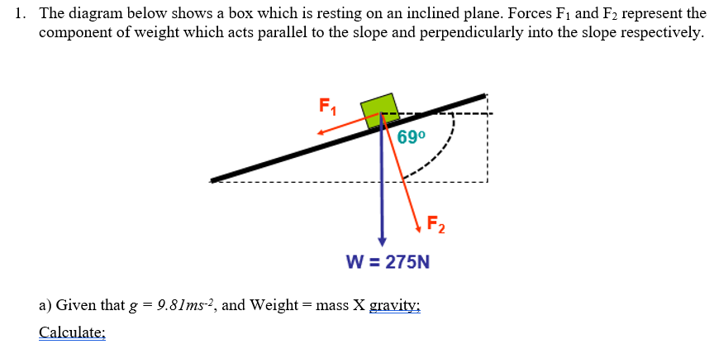
- The Magnitude of Friction;
90 – 69 = 21, 275 sin(21) = 98.55118612 = 98.55N 2dp
- The angle between the direction of the force of frictional and the vertical;
90 degrees
- The normal Reaction between the box and the plane;
275 sin(69) = 256.7346173 = 256.73N 2dp

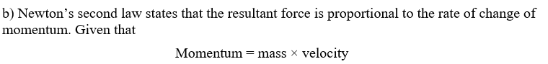
- Write out the above statement mathematically.
Momentum = Kg x m/$s^{-1}$
- Kgm/$s^{-1}$

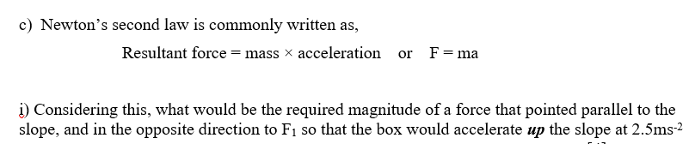
Weight / gravity = mass, 275/ 9.81 = 28.03261978
Mass x acceleration = resultant force, 28.03261978 x 2.5 = 70.08154944
Force required = 70.08N 2dp

- What would be the change in momentum between the moment just before the box began to move up the slope and when its velocity reached 7.5ms⁻¹

change in momentum = 70.08 / 7.5 = 9.344 Kgm/$s^{-1}$

- Using the statement given in b) What resultant force would be required to increase the velocity of a 5kg box from rest to 12.5ms⁻¹ in 3.2s.
$$a=\frac{v-u}{t}$$
Acceleration = ( final velocity – initial velocity) / time
$$\frac{12.5-0}{3⋅2}=3.90625$$
Resultant force = mass x acceleration, 3.90625 x 5 = 19.53125, = 19.53N 2dp
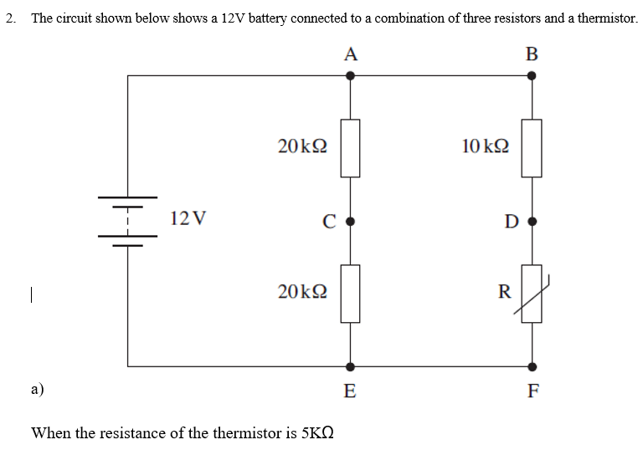
- Calculate the total resistance of the circuit.
20 + 20 = 40, 10 + 5 = 15

$\frac{1}{40}+\frac{1}{15}=$ 10.91KΩ 2dp
- Calculate the current leaving the battery.
12 / 10.9 = 1.1A
- Calculate the power used by each of the three resistors and the thermistor.

Power = Voltage x Current
Current = Voltage / Resistance
AC) Current = 12v / 20000Ω , power = 12 x (12/20000), power = 9/125
AC used 0.072 watts of power.
CE) Current = 12v / 20000Ω , power = 12 x (12/20000), power = 9/125
CE used 0.072 watts of Power.
BD) Current = 12v / 10000Ω, power = 12 x (12/10000), power = 9/625
BD used 0.0144 watts of power.
DF) Current = 12v / 5000Ω, power = 12x (12/5000), power = 18/625
DF used 0.0288 watts of power.

b) A voltmeter is used to measure the potential difference (PD) between points on the circuit. What PD would you expect to see between points:
V = I x R
- V = 1.0994 x 20000, PD = 21988v – 12v = 21976v
- V = 1.0994 x 20000, PD= 21988v – 21988v = 0v

Q3 a) The product of the distance from the initial point to the point of application as well as the force that’s perpendicular to the line of motion of the component
b)
i) Force X; 48mm x 250N = 12Nm
ii) Y = 250N x 27mm = 6.75Nm
- F= K x X, K = F/X
250/15 = 3.2Nm, Therefor the spring constant is 3.2 Newton Metres
- 250nm x 42mm = 10500 = 10.5Nm
c) i) Power = Energy / Time , Watts = Joules / Seconds
ii) 12/2.2= 5.45W
- 3200/12 = 266.66
266 Squeezes

