Cloud-Based Web Services
  - Name: Sarann Strange

Student Number: 1701763

University of wales Trinity saint David

Stream: B.Sc. Software engineering

Assignment code:
Lecturer:

Table of Contents
1 Table of Contents 1
2 Table of figures 2
3 Introduction 3
4 Investigation 4
4.1 Cloud computing 4
4.1.1 Public cloud services, Private clouds, and Hybrid clouds 6
4.1.2 software-as-a-service (SaaS), platform-as-a-service(PaaS), Infrastructure as-a-service (IaaS) 7
4.1.3 Cost 9
4.2 Node.js and Docker 10
4.2.1 Virtualisation and Containerisation 11
4.2.2 Evaluate Development. 12
5 Conclusion 20
6 References 21
7 Appendices 22

Table of figures
Figure 1 Visual example of SaaS, PaaS, IaaS 8
Figure 2 Folder structure for project 12
Figure 3 Node.js Packages installed 13
Figure 4 Creating docker Container 13
Figure 5 Docker container running 14
Figure 6 connection to the web service running in the container 14
Figure 7 Login for adminer database 15
Figure 8 insert method inside the webservice 16
Figure 9 select method inside the webservice 16
Figure 10 webservice showing information from the database 17
Figure 11 index html on webserver 17
Figure 12 inserting and saving user data 18
Figure 13 readstudentspage.html 19

Introduction
This report includes an explanation and an analysis on cloud services. What its used for, how it works, its drawback, costs the different versions that are available such as public cloud services, private clouds, and hybrid clouds and an in depth look into software-as-a-service (SaaS), platform-as-a-service(PaaS), Infrastructure as-a-service (IaaS).
A discussion on Node.js and Docker what they are and how they work along with a discussion on virtualisation and containerisation.
Then finally a discussion and an evaluation on the development that was done during this module.

Investigation

Cloud computing
Cloud computing refers to an array of computers all working together and sharing resources over the internet. Different devices connect to the computers to access resources, data and applications that are not stored on the individual device themselves but over the cloud. Cloud computing is used for a variety of reasons such as the storage and back-up of data, testing and building applications, software on demand, virtual desktops, streaming audio and video, front-end web applications and for the analysis of gathered data [1][2].
Cloud computing allows businesses to pay to access a pre-designed and built computing infrastructures that they do not have to manage, control, update, replace or fix themselves. There are many benefits from utilising cloud computing such as scalability, speed, reliability, performance, accessibility on a global scale, cost, and security. When businesses or individuals pay for cloud storage, they are paying to access a portion of the Hard Disk Drive (HDD) space, the electricity to run the HDD and the bandwidth that allows them to access the cloud computer service [3][4].
Businesses and individuals using cloud computing can choose a cloud computing service that suits their needs as and when they need it and typically pay for the cloud services that they use. This allows a level of scalability were the cost of the service correlates to what is being used and what is needed at different periods for the business, this can fluctuate where the need increases during peak levels of activity for the business and lowers depending on the month, time, or day. This flexibility allows businesses to lower costs of cloud services freely and as needed, in comparison to a company running their own servers that they pay for entirely and all at once even if they are using the entire HDD space or not. The business would need to pre-emptively buy additional storage and improve their servers, risking overreaching investing in hardware that they do not require or underreaching making a bad experience for consumers [5][6][7].
Cloud computing provides robust data protection from theft, hardware issues and natural disasters such as, but not limited to, flooding, earthquakes, hurricanes, and fire because the data stored on the cloud is backed up and securely stored in multiple locations separate from one another. If a disaster strikes one data centre, businesses and consumers would not experience down time as they have constant access to said data and resources. This structure and stability ensure businesses do not loose custom or any data stored on the cloud [8][9].
Latency refers to the delayed responses of web applications to the actions that a user has made when interacting with said web application, different cloud computing services have servers across the globe, this enables a user to access the data or services locally no matter their location which reduces latency issues [7].
The speed of cloud computing is typically more reliable than the speed that a business can acquire when implementing their own solution. This is due to the cloud computing infrastructure that has been invested in by the companies that own the cloud services. Some cloud computing services increase the security for a business or user as they provide security features such as role-based access control (RBAC), multi-layered security, encryption of data, firewalls, and identity management. Making cloud computing a very attractive option for online based businesses [10].

Public cloud services, Private clouds, and Hybrid clouds
The different types of cloud environments include private cloud service, public cloud services, and hybrid cloud service.
The public cloud services involve an accessibility through a web-browser over the internet to the public or businesses. This cloud service is operated by a third party such as Amazon (AWS), google (GCP) or Microsoft Azure and the users of the service can share the same storage areas or access resources from the same hardware while not themselves having access to the data that other users have stored [11][12].
Private clouds involve a cloud-based infrastructure that was set up and designed exclusively for an individual organisation or business, only individuals working within the business are given permission to access the private cloud-based services. Amazon virtual private cloud (VPC), google virtual Private Cloud are some of the private clouds available. Although these services are private, they are vulnerable to hackers through social engineering. This is when individuals working for a business are personally targeted by hackers, being exploited, and manipulated to reveal passwords, user identities and other information that enable hackers to access private data. Access breaches are another vulnerability due to poor access control mechanisms. Access control mechanisms dictate what applications and clients have access to. If it is not designed, maintained, and monitored correctly certain individuals may have access to data or important servers that they should not have access to [13][14][15].
The hybrid cloud mixes aspects of the private and public clouds, allowing businesses a level of scalability and saving on expenses as less sensitive data in a hybrid are stored by a public cloud, while the confidential and private data are stored on the private cloud that cannot be accede directly through the internet [16][17][18].

software-as-a-service (SaaS), platform-as-a-service(PaaS), Infrastructure as-a-service (IaaS)
SaaS this is when a business or an individual use the cloud to access software and use it remotely through the internet. Office 365 such as word and PowerPoint online, educational websites that offer classes such as Pluralsight and video streaming websites such as Netflix are examples of SaaS. SaaS is paid for either annually or on a monthly billing cycle the costs for various SaaS software vary. SaaS provides the end user a level of freedoms as they do not have to download, install, maintain, or update the software that they use or ensure that they have the latest version or that their systems capable of running the software [19][20].
The drawbacks of SaaS include vendor lock-in. This is when a vendor makes it difficult for a user as they become dependent on a single vendor for certain products and services whether it be through costs, difficulty in switching or migrating data to another vendor, a business wanting to maintain order and avoid interruptions to the normal workflow or a company integrating a third-party software into their everyday working environment, making it difficult to de-couple the software from the everyday processes of the business. Vendor lock-in can be a bad thing because the quality of a service could decline making the software worse or difficult to use. The third-party vendor could go out of business or change the functionality of the product that they are providing making it useless for the business. Finally, the price could change drastically making it expensive [21][22][23].
Data security can be an issue with SaaS as data is being transferred over the internet, especially private or confidential data that is required for the backend data centres to function it can be compromised.
There is a lack of customization when it comes to SaaS applications so functionality can be limited to whatever the vendor of the application offers. Users are also at the whims of the vendor if they choose to make changes to the functionality. Users run the risk of performance issues and down time when using SaaS application when maintenance occurs it could be unplanned, and the users may find themselves unable to access resources. The performance of SaaS can be impacted by a variety of issues such as hackers, denial of service attacks, and network issues [24].

PaaS is used for development purposes as it enables developers to build and maintain applications. Application hosting environments allow developers to run, test, build and deploy applications within an environment that allows for it by hosting environments that provide OS’s, execution environments and databases. Effectively PaaS as a service is providing a fully functional environment that allows a developer to create, design and program freely without having to worry about hardware requirements [14][25][26].
The drawbacks of PaaS also include vendor lock-in along with data security issues. The integration of data from an on-sight data store and a cloud-based data-store may be difficult. This difficulty arises when a pre-existing services and infrastructure that uses a legacy IT system are still in use and the business wishes to use the cloud, as these older systems are not always built to be used with the cloud [27][28].

IaaS is when a business outsources the equipment for storage, networking, and monitoring computers. This involves a business paying for access to servers and must manage applications that are stored on the hardware themselves, ensuring that they are up to date, they must maintain middleware, the data that is stored and the OS platform. The cost of IaaS varies based on the amount of resources that the company uses. Examples of popular IaaS are Microsoft Azure, Google Compute Engine (GCE) and Amazon Web Services (AWS) [29][30].
All the different things discussed above provide individuals and businesses with the freedom to access hardware, software, and anything else they may need as and when they need it allowing a level of flexibility.
The issues with IaaS include security issues because of virtual machines, system vulnerabilities or insider threat. Because IaaS is basically only including the servers and storage and data centres but not the OS, development tools or applications the users of the IaaS may need more training to utilise the IaaS infrastructure as they have to manage data such as its back-up, its up-dating, its continuity and security [31][32].
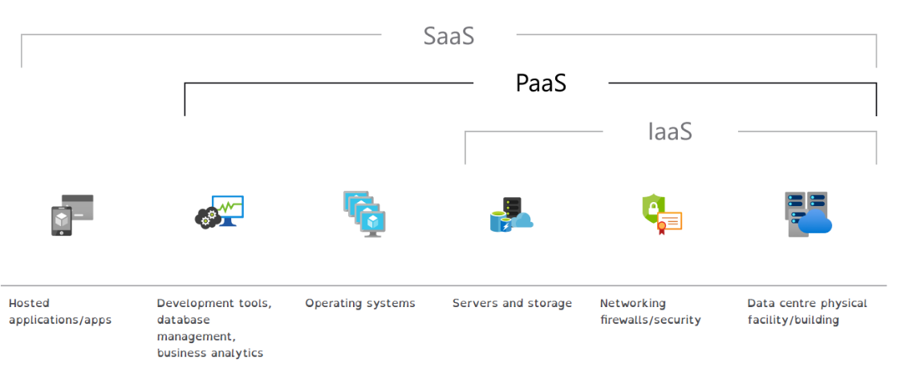
Figure 1 Visual example of SaaS, PaaS, IaaS

[25]

Cost
The cost of cloud computing can vary greatly not only on the amount of data that you wish to store, or the accessibility of data but on the cloud services that is being used, the service provider chosen and the tier of service that is chosen with that service provider. The three main service providers chosen as a base line for this project include Amazon web services, Microsoft Azure and Google Cloud.
For instance, cloud storage costs vary from the amount of storage that is required which is calculated based on the storage in price per gigabytes (GB) per month or price per terabytes (TB) per month. As an example, the prices of just the storage for the three service providers are £0.0448 per used GB per month for Microsoft Azure [33], $0.022 per GB per month for Amazon web services [34], and $0.020 per GB per month for Google Cloud [35]. But then there are additional costs such as network connections and operations this raises the costs even more.
Network costs are calculate based on how much data is transferred in or out of the cloud service per month. AWS does not charge for data transfer into their service, but they charge $0.05-$0.09 per GB per month based on the usage with an additional charge for overseas transfer ranging between $0.01-$0.02 per GB per month for data retrieval [34]. Google cloud charges £0.01 per GB per month for data retrieval within the US. Overseas data retrieval can be liable to varying costs [35]. AWS is the same as google cloud for data transfer in, as it is free. Microsoft Azure charges £0.0075 per GB per month for data retrieval with additional costs for overseas transfer [33]. They also do not charge for data transfer in.
The operations are classified as A or B, but they can have different naming conventions between services. The class A operations are the CREATE, UPDATE, DELETE database operations. The class B operations are the READ operations. The service providers charge per 10,000 operations per month for any of the specific classes of operations.
AWS charges $0.05 per 10,000 class A operations per month and $0.004 per 10,000 class B operations per month.
Google cloud charges $0.05 per 10,000 class A operations per month and $0.004 per 10,000 class B operations per month [35].
Microsoft Azure charges $0.0373 per 10,000 class A operations per month and $0.0075 per 10,000 class B operations per month [33].
Based on the prices researched it is important to not only look at the initial storage price but all the additional operation prices as well as the add on prices as they can greatly increases the costs of the cloud service. It is also important to check if there are additional costs for certain countries as they can have costs added on once again cutting in the budget of a business wishing to use cloud services. A business before setting up their business with a cloud provider must question the number of operations that they expect and again choose a vendor accordingly. For instance the storage of google is cheaper than the others but Microsoft Azure has better pricing for network speed and operations.

Node.js and Docker
Node.js and Docker allow for the development, testing, running, and shipping of applications.
Node.js is a runtime environment (this is basically where an application or program is executed) that uses JavaScript and is cross platform (meaning it can run on Linux, Microsoft windows or other platforms like the ones mentioned). Node.js is used to make server-side applications that run web applications outside of a client’s browser. The applications that Node.js can be used to make include video-streaming websites, online messaging application and single page applications [36][37][38].
Docker is an open software platform that makes things quicker like development, managing, running, testing, and getting the application out. It packages an application into containers which has its own framework, libraries and software that gets the application out and lets the application run on different machines with different versions of software and OS’s. Docker can get the application out in a variety of ways like over a cloud provider, through a local data centre or even both making it a hybrid [39][40].
The reason Docker is so good is because it lets different application run even if they have different requirements and makes development faster and more streamlined because it lets developers and different people work together all at the same time in lots of different ways like on their own personal system, virtual machines, or physical machines run over a data centre. Buggs can be fixed freely, and all the different developers can easily just go look at the containers and even run tests on the code either manually or automated [40].
People choose to use Docker because it can be cheaper and better if you have not got as many resources like good hardware. Docker occupies less memory space, has a shorter boot time, and lets developers run one docker with multiple containers that have everything the developers need in comparison to the virtual machines which are considered worse at all the mentioned things and does not have different containers.

Virtualisation and Containerisation
Virtualisation is the act of changing from physical IT equipment to software options. The physical IT equipment may include networking equipment, computer systems, and servers.
virtualisation allows business an alternative to a physical IT infrastructure that would require multiple isolated computers which all need to be maintained individually requiring a permanent member of staff who is fully trained and knowledgeable in that field. There is also a reduced cost in the initial purchasing and setup of equipment, as an individual would need to ensure that everything is up to specification and working as expected.
This form of virtualisation is known as virtual machines. Virtual machines are a virtual software of desktop computers that a business can access and use remotely that they would normally have within a building or office that they own, and their employees work from. They function in the way a typical computer would be expected to function, with the exception that they do not have a physical presence. They instead run virtually on a host server and are accessed remotely. They can be used for many different reasons ranging from a simple office machine that uses office 365, to a development environment [41][42].
There are many advantages to using virtual machines including the ability to run multiple operating systems, improved maintainability as software updates and management can be done at a single host location rather than individually on each machine.
The disadvantage of virtualization is that it can be less efficient than a physical machine as virtual machines must request access to hardware and software from the host machine. If there is a lack of power or the set up of the host machine is not efficient if multiple virtual machines [43].
Containerisation can be thought of as virtualisation for software instead of hardware. It is a process of creating environments for different applications that run-in isolation while having access to resources required. These environments are called containers they let applications run on different computing environments reliably and quickly.

Evaluate Development.
To use docker you must first compose the container, then once the container is composed it needs to be run. After that it can be connected to using the different ports. Then it can read the information and it connects to the database that has been created on adminer this is also running on docker. Docker can be used for hosting.

These are the folders found on a machine, within these folders there is a docker compose settings which initialise the docker container. It has two project folders one called node web service and one called node web server.
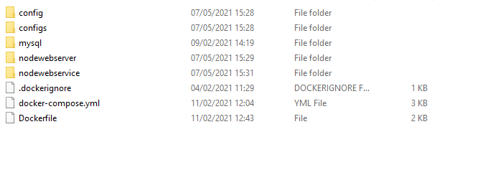
Figure 2 Folder structure for project

Docker runs the server which connects to the database which exists on an external server. The server contains information about the separate webpages.
These are the NPM or node.js packages modules that were installed to build and run the webservice that was made for this module.
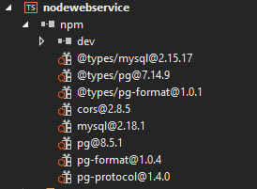
Figure 3 Node.js Packages installed

This is the setting up of the docker container, to run the server and the service.
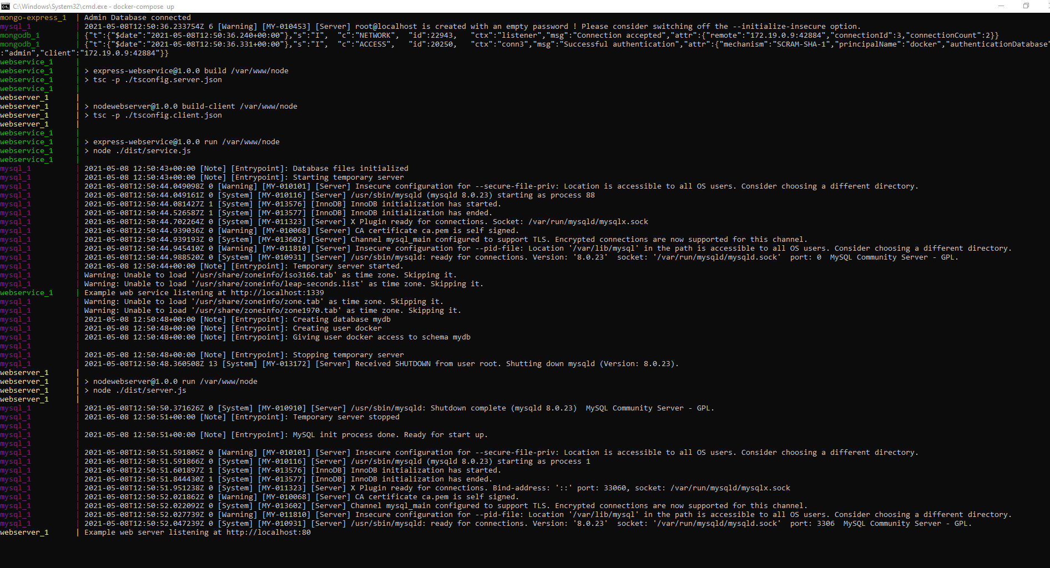
Figure 4 Creating docker Container

This is the container existing within docker. This is the container that is running the service and the server. The green indicates that the container is active.
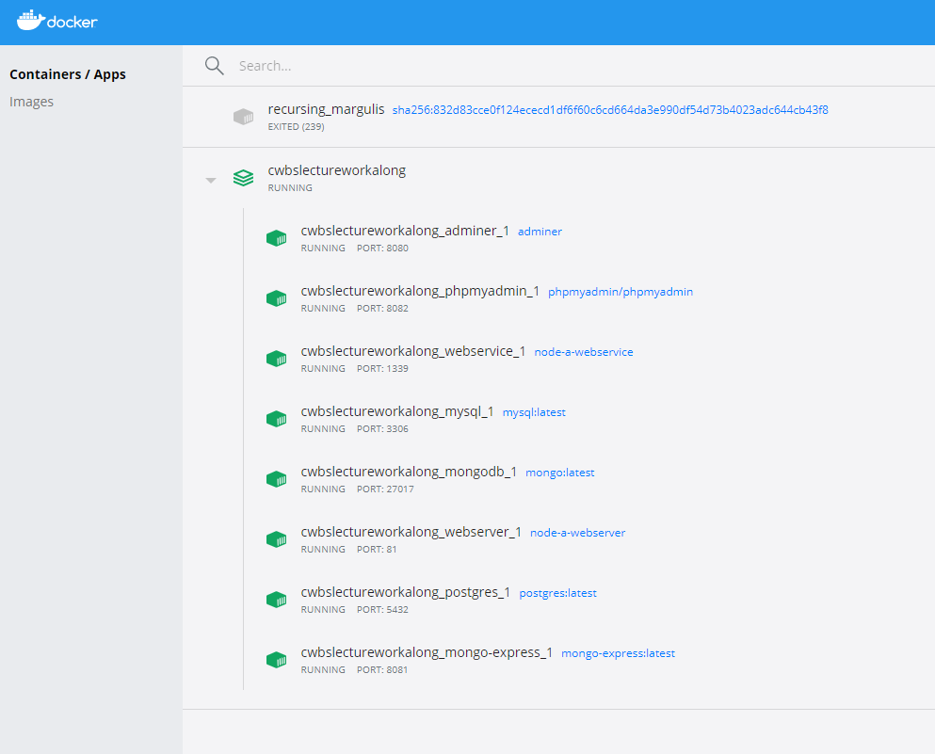
Figure 5 Docker container running

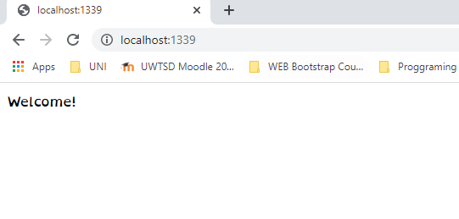
This is an example of the student gaining access to the webservice within docker while its running within docker.
Figure 6 connection to the web service running in the container
This is the login page to the postgres SQL database. This is also being run within the docker container.
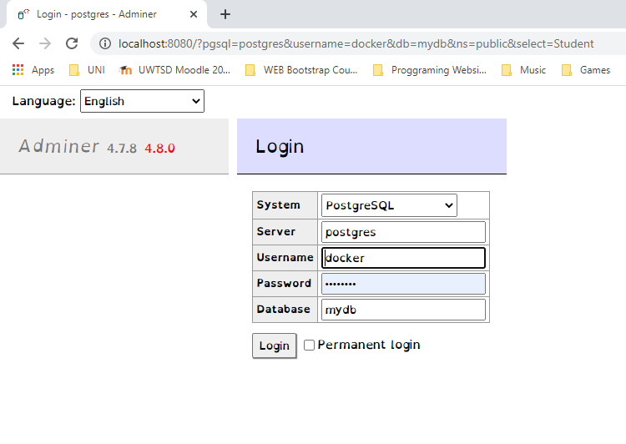
Figure 7 Login for adminer database
This is the insert method which puts data into the database from the webservice.
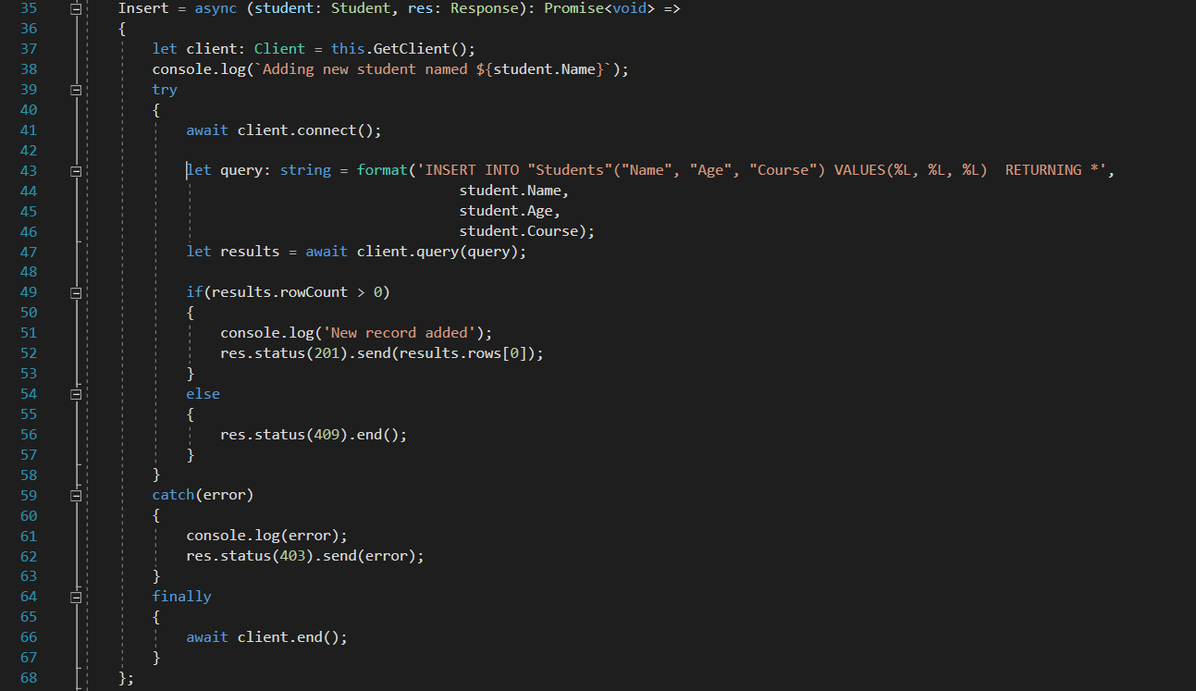
Line 43 composes the SQL query with the relevant data.
Figure 8 insert method inside the webservice

This is the select method that reads the data from the database to be displayed on the webservice. Line 78 shows the SQL query that’s selects all from the students table.

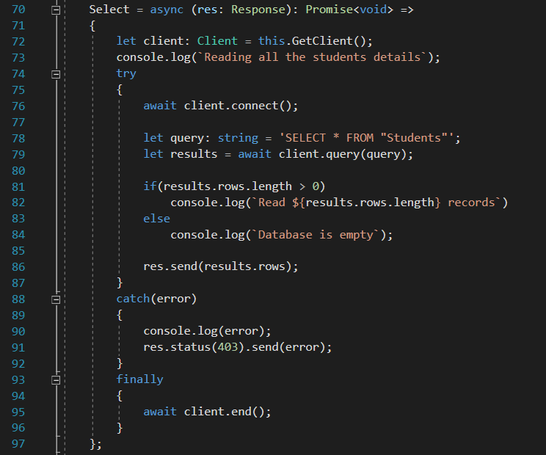
Figure 9 select method inside the webservice

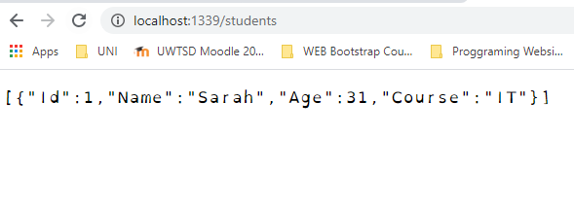
this is a manifestation of the previous select method shown in
Figure 10 webservice showing information from the database

This is the index html on the webserver this gives us links to other pages.
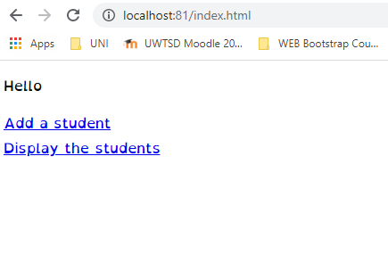
Figure 11 index html on webserver

this is the add student form and the inserted data being added to the database. The add student webpage is stored inside the server. The data is stored within the database.
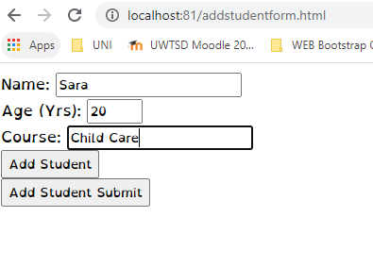
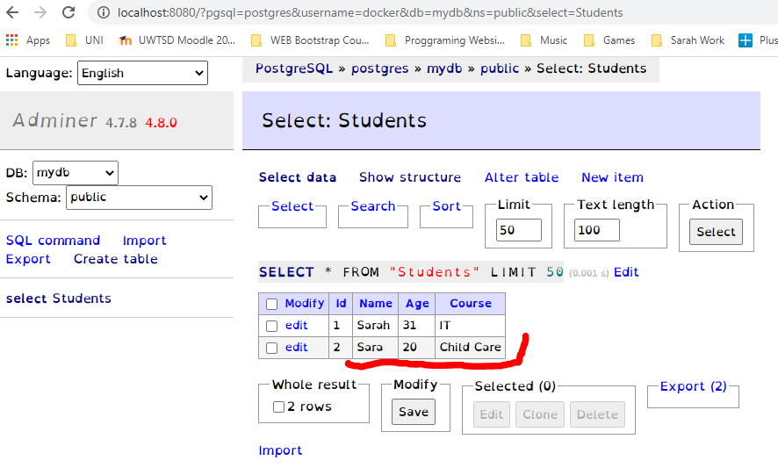
Figure 12 inserting and saving user data
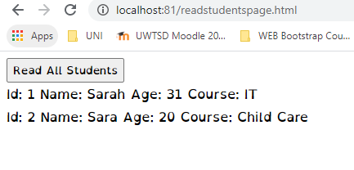
this is the read student page that displays the student data from the database onto the webpage that is controlled by the server.
Figure 13 readstudentspage.html

This is an effective way of setting up a docker container to run a server which can provide data from a database to a webservice. Rather than having separate machines running the server and the database and the service. Everything is contained within one environment rather than it being spread across multiple machines making docker a powerful tool within web development and web applications.

Conclusion
The report successfully covered the explanation and an analysis on cloud services explaining what its used for, how it works, its drawback, costs the different versions that are available such as public cloud services, private clouds, and hybrid clouds and an in-depth investigation into software-as-a-service (SaaS), platform-as-a-service (PaaS), Infrastructure as-a-service (IaaS) their drawbacks and their benefits.
Node.js is covered in reasonable detail and so is Docker the report provides a decent explanation on what they are and how they work along with a discussion on virtualisation and containerisation how they relate to Docker.
Then finally a discussion and an evaluation on the development that was done during this module.

References

[1] G. Pallis, “Cloud computing: The new frontier of internet computing,” IEEE Internet Computing, vol. 14, no. 5. pp. 70–73, Sep. 2010, doi: 10.1109/MIC.2010.113.
[2] T. Erl, Cloud computing. 2013.
[3] S. Marston, Z. Li, S. Bandyopadhyay, J. Zhang, and A. Ghalsasi, “Cloud computing - The business perspective,” Decis. Support Syst., vol. 51, no. 1, pp. 176–189, Apr. 2011, doi: 10.1016/j.dss.2010.12.006.
[4] Steve Ranger, “What is cloud computing? Everything you need to know about the cloud explained | ZDNet,” ZDNet, Dec. 13, 2018. https://www.zdnet.com/article/what-is-cloud-computing-everything-you-need-to-know-about-the-cloud/ (accessed May 11, 2021).
[5] T. C. I. for I. BCS, “Cloud Computing : Moving IT Out of the Office: EBSCOhost,” he Chartered Institute for IT, 2012. https://web-b-ebscohost-com.ezproxy.uwtsd.ac.uk/ehost/detail/detail?vid=0&sid=1b8e8f3b-ad91-4860-a239-0494357daa30%40pdc-v-sessmgr03&bdata=JnNpdGU9ZWhvc3QtbGl2ZQ%3D%3D#AN=452109&db=nlebk (accessed May 10, 2021).
[6] M. P. Ling Liu, “IEEE 4th International Conference on Cloud Computing,” Jul. 2011.
[7] V. Rajaraman, “Cloud computing,” Resonance, vol. 19, no. 3, pp. 242–258, Mar. 2014, doi: 10.1007/s12045-014-0030-1.
[8] A. Berl et al., “Energy-efficient cloud computing,” Comput. J., vol. 53, no. 7, pp. 1045–1051, Sep. 2010, doi: 10.1093/comjnl/bxp080.
[9] D. Zissis and D. Lekkas, “Addressing cloud computing security issues,” Futur. Gener. Comput. Syst., vol. 28, no. 3, pp. 583–592, Mar. 2012, doi: 10.1016/j.future.2010.12.006.
[10] M. Ali, S. U. Khan, and A. V. Vasilakos, “Security in cloud computing: Opportunities and challenges,” Inf. Sci. (Ny)., vol. 305, pp. 357–383, Jun. 2015, doi: 10.1016/j.ins.2015.01.025.
[11] Bilkisu Larai Muhammad-Bello; Masayoshi Aritsugi etal., “TCloud: A Transparent Framework for Public Cloud Service Comparison | IEEE Conference Publication | IEEE Xplore,” in IEEE, 2016, pp. 228–233, Accessed: May 11, 2021. [Online]. Available: https://ieeexplore-ieee-org.ezproxy.uwtsd.ac.uk/document/7881637.
[12] R. Pitchai, S. Jayashri, and J. Raja, “Searchable Encrypted Data File Sharing Method Using Public Cloud Service for Secure Storage in Cloud Computing,” Wirel. Pers. Commun., vol. 90, no. 2, pp. 947–960, Sep. 2016, doi: 10.1007/s11277-016-3273-1.
[13] Y. Laili, F. Tao, L. Zhang, Y. Cheng, Y. Luo, and B. R. Sarker, “A ranking chaos algorithm for dual scheduling of cloud service and computing resource in private cloud,” Comput. Ind., vol. 64, no. 4, pp. 448–463, May 2013, doi: 10.1016/j.compind.2013.02.008.
[14] F. Doelitzscher, A. Sulistio, C. Reich, H. Kuijs, and D. Wolf, “Private cloud for collaboration and e-Learning services: From IaaS to SaaS,” Comput. (Vienna/New York), vol. 91, no. 1, pp. 23–42, Jan. 2011, doi: 10.1007/s00607-010-0106-z.
[15] Microsoft Azure, “Private Cloud – Definition | Microsoft Azure,” Microsoft Azure, 2021. https://azure.microsoft.com/en-gb/overview/what-is-a-private-cloud/ (accessed May 11, 2021).
[16] C. Li, “Hybrid cloud service selection strategy: Model and application of campus,” Comput. Appl. Eng. Educ., vol. 23, no. 5, pp. 645–657, Sep. 2015, doi: 10.1002/cae.21634.
[17] K. K. Azumah, L. T. Sørensen, R. Montella, and S. Kosta, “Process mining-constrained scheduling in the hybrid cloud,” Concurr. Comput. , vol. 33, no. 4, p. e6025, Feb. 2021, doi: 10.1002/cpe.6025.
[18] P. Viotti, D. Dobre, and M. Vukolić, “Hybris: Robust hybrid cloud storage,” ACM Trans. Storage, vol. 13, no. 3, Sep. 2017, doi: 10.1145/3119896.
[19] A. Dutt, H. Jain, and S. Kumar, “Providing Software as a Service: a design decision(s) model,” Inf. Syst. E-bus. Manag., vol. 16, no. 2, pp. 327–356, May 2018, doi: 10.1007/s10257-017-0356-9.
[20] S. Lee, S. B. Park, and G. G. Lim, “Using balanced scorecards for the evaluation of ‘software-as-a- service,’” Inf. Manag., vol. 50, no. 7, pp. 553–561, Nov. 2013, doi: 10.1016/j.im.2013.07.006.
[21] S. H. Kim, S. Y. Jang, and K. H. Yang, “Analysis of the Determinants of Software-as-a-Service Adoption in Small Businesses: Risks, Benefits, and Organizational and Environmental Factors,” J. Small Bus. Manag., vol. 55, no. 2, pp. 303–325, Apr. 2017, doi: 10.1111/jsbm.12304.
[22] E. Loukis, M. Janssen, and I. Mintchev, “Determinants of software-as-a-service benefits and impact on firm performance,” Decis. Support Syst., vol. 117, pp. 38–47, Feb. 2019, doi: 10.1016/j.dss.2018.12.005.
[23] W. T. Tsai, X. Y. Bai, and Y. Huang, “Software-as-a-service (SaaS): Perspectives and challenges,” Sci. China Inf. Sci., vol. 57, no. 5, pp. 1–15, May 2014, doi: 10.1007/s11432-013-5050-z.
[24] D. Ma and A. Seidmann, “Analyzing software as a service with per-transaction charges,” Inf. Syst. Res., vol. 26, no. 2, pp. 360–378, 2015, doi: 10.1287/isre.2015.0571.
[25] microsoft Azure, “What is PaaS? Platform as a Service | Microsoft Azure,” microsoft Azure, 2021. https://azure.microsoft.com/en-gb/overview/what-is-paas/ (accessed Apr. 24, 2021).
[26] D. Beimborn, T. Miletzki, and S. Wenzel, “Platform as a Service (PaaS),” WIRTSCHAFTSINFORMATIK, vol. 53, no. 6, pp. 371–375, Dec. 2011, doi: 10.1007/s11576-011-0294-y.
[27] J. Anselmi, D. Ardagna, and M. Passacantando, “Generalized Nash equilibria for SaaS/PaaS Clouds,” Eur. J. Oper. Res., vol. 236, no. 1, pp. 326–339, Jul. 2014, doi: 10.1016/j.ejor.2013.12.007.
[28] M. Basyuni, W. Yuriswan, and Y. Bimantara, “Root development in mangrove plant Rhizophora mucronata under different shade intensities,” 2020, doi: 10.1088/1755-1315/452/1/012090.
[29] D. Gonzales, J. M. Kaplan, E. Saltzman, Z. Winkelman, and D. Woods, “Cloud-Trust-a Security Assessment Model for Infrastructure as a Service (IaaS) Clouds,” IEEE Trans. Cloud Comput., vol. 5, no. 3, pp. 523–536, Jul. 2017, doi: 10.1109/TCC.2015.2415794.
[30] S. S. Manvi and G. Krishna Shyam, “Resource management for Infrastructure as a Service (IaaS) in cloud computing: A survey,” Journal of Network and Computer Applications, vol. 41, no. 1. Academic Press, pp. 424–440, May 01, 2014, doi: 10.1016/j.jnca.2013.10.004.
[31] T. Voith, K. Oberle, M. Stein, E. Oliveros, G. Gallizo, and R. Kübert, “A path supervision framework - A key for service monitoring in Infrastructure as a Service (IaaS) platforms,” in Proceedings - 36th EUROMICRO Conference on Software Engineering and Advanced Applications, SEAA 2010, 2010, pp. 127–130, doi: 10.1109/SEAA.2010.42.
[32] R. Ghosh, F. Longo, V. K. Naik, and K. S. Trivedi, “Modeling and performance analysis of large scale IaaS clouds,” Futur. Gener. Comput. Syst., vol. 29, no. 5, pp. 1216–1234, Jul. 2013, doi: 10.1016/j.future.2012.06.005.
[33] Azure, “Azure Storage Blobs Pricing | Microsoft Azure,” Azure Microsoft , 2021. https://azure.microsoft.com/en-gb/pricing/details/storage/blobs/ (accessed Apr. 24, 2021).
[34] Amazon, “Amazon S3 Simple Storage Service Pricing - Amazon Web Services,” Amazon , 2021. https://aws.amazon.com/s3/pricing/ (accessed Apr. 24, 2021).
[35] google cloud, “Cloud Storage pricing | Google Cloud,” google cloud, 2021. https://cloud.google.com/storage/pricing (accessed Apr. 24, 2021).
[36] S. Tilkov and S. Vinoski, “Node.js: Using JavaScript to build high-performance network programs,” IEEE Internet Comput., vol. 14, no. 6, pp. 80–83, Nov. 2010, doi: 10.1109/MIC.2010.145.
[37] I. K. Chaniotis, K. I. D. Kyriakou, and N. D. Tselikas, “Is Node.js a viable option for building modern web applications? A performance evaluation study,” Computing, vol. 97, no. 10, pp. 1023–1044, Oct. 2015, doi: 10.1007/s00607-014-0394-9.
[38] K. I. D. Kyriakou, N. D. Tselikas, and G. M. Kapitsaki, “Enhancing C/C++ based OSS development and discoverability with CBRJS: A Rust/Node.js/WebAssembly framework for repackaging legacy codebases,” J. Syst. Softw., vol. 157, p. 110395, Nov. 2019, doi: 10.1016/j.jss.2019.110395.
[39] docker, “Empowering App Development for Developers | Docker,” docker, 2020. https://www.docker.com/ (accessed May 11, 2021).
[40] Steven J Vaughan Nichols, “What is Docker and why is it so darn popular? | ZDNet,” ZDNet, 2020. https://www.zdnet.com/article/what-is-docker-and-why-is-it-so-darn-popular/ (accessed May 11, 2021).
[41] “What is virtualization? | Opensource.com.” https://opensource.com/resources/virtualization (accessed May 11, 2021).
[42] Red Hat, “What is virtualization?,” Red Hat, 2021. https://www.redhat.com/en/topics/virtualization/what-is-virtualization (accessed May 11, 2021).
[43] ittana, “14 Advantages and Disadvantages of Virtualization – Vittana.org,” ittana, 2021. https://vittana.org/14-advantages-and-disadvantages-of-virtualization (accessed May 11, 2021).

Appendices

