Richard Jones - 1809132
rojones@gmail.com
PRograms in C and documentation
ACCA4017 – Gaynor Thomas

Abstract
The author will be producing documentation that will discuss and evidence the programming skills in C that the author covered during the Software Development module. The document will break down several requested aspects of programming that were worked on during the semester and provide working solutions to multiple exercises.

Table of Contents
Abstract 1
Table of Contents 2
Introduction 1
1. Programming types 2
1.1 What is a variable and why are they important in writing programs? 2
1.2 Explain why the for-loop can also be referred to as a counting-loop and give an example of when you would use it. 3
1.3 Explain what an array is, what their features are, and give an example of when you would use one. 4
1. Part B – Exercises (Implementation) 5
2.1 Exercise on utilising & declaring variables to contain different values. 5
2.1.1 Identifying the problem: 5
2.1.2 Annotated Code: 5
2.1.3 Testing: 6
2.2 Exercise on calculating areas and subtracting one from the other to calculate remaining area 7
2.2.1 Identifying the problem: 7
2.2.2 Annotated Code: 8
2.2.3 Testing: 9
2.3 Exercise on entering 5 product prices in to an array and calculating pre VAT price and post VAT price. 10
2.3.1 Identifying the problem 10
2.3.2 Annotated Code: 11
2.3.3 Testing: 11
2.4 Exercise to build a fruit machine and display a score based on scoring criteria. 13
2.4.1 Identifying the problem: 13
2.4.2 Annotated Code (Cumulative Scoring) 14
2.4.3 Annotated code (non-cumulative scoring) 16
2.4.4 Testing (Cumulative Scoring & Non-Cumulative Scoring) 17
3. References 19

Introduction
In this document the author will complete two requested sections. The first section will cover the understanding of 3 programming aspects of C. These include “Variables”, “For-Loop” and arrays, the author will expand upon what these terms stand for and give examples of what they are used for in C Programs. The seconds section will cover four programming exercises that have been set, as part of this the author will at first set out the exercise requirement, then provide coding to demonstrate a working solution along with testing documentation and further conclusions around the solution to the exercise that was set.

Programming types
Explanation of three aspects of programming, these include “Variables”, “For-Loop” and arrays. In this section all the previously mentioned programming terms will be expanded upon and real-world examples given to explain their uses.

What is a variable and why are they important in writing programs?
Variables in computer programming are values that can change within the execution of the program. They are usually stored data that can be initialised with a pre-populated value[1], and then at some point in the execution of the program can be altered via either a user input or other parts of the program execution. Some variable types include[2]:
- Char – Char is short for Character, it is a type of data store that typically holds one character. For example, in a program Char could be set to hold a character for grades in an exam. So, in the program Char would be set as “Char mygrade;” and the data entered further in the program as an example would be “mygrade=’A’”.

- Int – Int is short for Integer, as the name would suggest int is used to store integer data in a program. The integer must be a whole number though and decimals would not be correctly utilised. An example of such data storage would be storing someone’s age for example, this would look like “int myage” with the data stored then being defined as “myage=37”.

- Float – Float is a store of fractional integer data. Whereas in an “int” that data stored must be a whole number. The data stored in a float can be of a decimal nature. An example would be storing a temperature value, this could be stored as follows “float mytemp” with the data then being stored by “mytemp=20.1”.

Explain why the for-loop can also be referred to as a counting-loop and give an example of when you would use it.
A “for-loop” is a type of sequence within a program that is continually repeated until a certain condition is met[3]. In the defining of the loop there will be a “start” and “end” condition, along with an “update” condition as to what is required to be done within the process of the loop.
The reason it is often called a “counting-loop” is because the common use of a counter condition within the loop. An example of this would be by defining a for-loop with a piece of programming within it, when defining this loop the start could be an integer defined as “counter” starting at 1 for example, then an end to the loop could be defined by the integer “counter” as 13 for example. During this loop the update would be defined as “counter++” which would mean that for every go around the loop the defined integer “counter” would increase by one. The end of the loop would occur once the “counter” reaches 13. Below is an example of a program utilising a “for-loop”
#include <stdio.h>
void main()//main function - starting point for all programs

{
//Task to loop and count down in the song from 10 to 0 green bottles
int i; //counter for the "for" loop

for (i = 10;i >= 0;i--) //For Loop with counting

{
if (i != 1) //If integer is not equal to 1 then carry out this code
{
printf("%d green bottles standing on the wall\n", i); //Print on Screen
}
else //if it is 1 bottle then print the following "Bottle"
{
printf("%d green bottle standing on the wall\n", i); //Print on Screen
}
}
}

Explain what an array is, what their features are, and give an example of when you would use one.
An “array” is an example of being able to store structured data types. As mentioned previously data types can be “int” whole integers “char” characters or “float” fractioned integers, an array can then hold a collection of a specified data type[4]. For example we could define a data type integer as “int myarray[6];” the number in the brackets dictates the number of integers in this case that can be stored “6”. We would then need to define the data in each defined integer within the array, to continue the above example “myarray[0] = 1;” “myarray[1] = 2;” and so on. Below is an example of a program utilising an “array”.
#include <stdio.h>
void main()//main function - starting point for all programs

{
int mynumbers[7] = { 2,3,4,5,6,7,8 }; //define Array number
float myprices[4] = { 1.111,2.222,3.333,4.444 }; //initiate the individual myprices in the array
int i; // for the for loop

for (i = 0;i <= 6;i++) //For loop to print out the mynumbers array
{
printf("%d\n", mynumbers[i]); //Print on Screen
}

for (i = 0;i <= 3;i++) //For loop to print out the my prices array
{
printf("%.2f\n", myprices[i]); //Print on Screen
}
}

Part B – Exercises (Implementation)

2.1 Exercise on utilising & declaring variables to contain different values.

2.1.1 Identifying the problem:

- User is prompted to enter name
- Name entered is scanned and stored (char)
- Name is printed on screen
- User is prompted to enter age
- Age is scanned and stored (int)
- Age is printed on screen
- User is prompted to enter height
- Height is scanned and stored (float)
- Height is printed on screen

2.1.2 Annotated Code:
#include <stdio.h> //library or header file

void main()//main function - starting point for all programs
{
int age = 121; //initiated variable for age
float height; //variable for height capture
char myname[8] = { 'R','i','c','h','a','r','d' }; //initiated variable for name capture

printf("Hello , please enter your name: "); //Prompt user to enter their name
scanf(" %s", &myname); //Caputure Name, Extra space before %s
printf("Thank you for entering your name: %s \n", myname); //Thank user and print their name to confirm

while (age < 0 || age >120) //while loop for age capture barriers
{
printf("Now please enter you age: "); //Prompt user to enter their age
scanf("%d", &age); //Capture age
}

printf("Thank you for entering your age: %d \n", age); //Thank user and print age

printf("lastly, Please enter your height: "); //Prompt user to enter their height
scanf(" %f", &height);//Capture height with .2 decimal
printf("Thank you for entering you height: %.2f \n", height); //Thank user and print out their height
}

2.1.3 Testing:
- Test of code with expected data entries

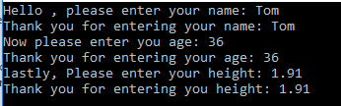

Result: Program ran as expected with correct outcome (Success).

- Test of code with age over and under boundaries set (<0 || >120) and then within boundary.

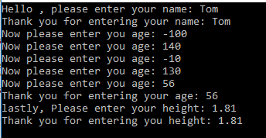

Result: Program ran and prompted user to enter age within boundary as expected (Success)

- Test of code with incorrect value types entered in Name (Numbers)

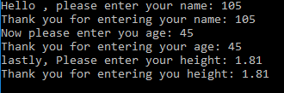

Result: Program ran and took the number entered as a correct entry, although this is a faulty output. (Failed)

- Test of code with incorrect value types entered in Age (Characters)

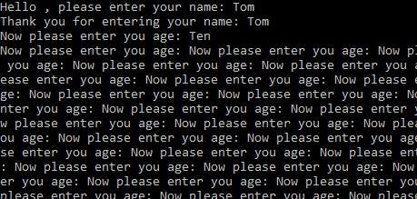

Result: Program failed, once character is entered in to age field the program kept repeating “Enter you age” request. (Failed)

- Test of code with incorrect value types entered in height (Characters)

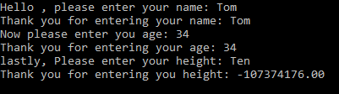

Result: Program failed, once character is entered in to age field then program outputting random numbers. (Failed)

2.2 Exercise on calculating areas and subtracting one from the other to calculate remaining area

2.2.1 Identifying the problem:

- User is prompted to enter radius length of circle
- Radius entered is scanned and stored (float)
- Circle area is calculated and is printed on screen
- User is prompted to enter base length of triangle
- Base entered is scanned and stored (float)
- User is prompted to enter height length of triangle
- Height entered is scanned and stored (float)
- Triangle area is calculated and is printed on screen
- Area of triangle is taken away from area of circle
- Remaining area is printed on screen

2.2.2 Annotated Code:
#include <stdio.h> //library or header file
#define PI 3.142 //defining pie

void main() //main function - starting point for all programs

{
float radius = -1, base = -1, height = -1, circlearea = 2, trianglearea = 100, remainingarea; //Define the variables for inputted measurements

while (circlearea < trianglearea)
{
radius = -1; //re-define the radius for while loop
base = -1; //re-define the base for while loop
height = -1; //re-define the height for while loop
while (radius < 0) //while loop to prevent a negative number entry
{
printf("please enter your radius of your circle: "); //ask user to enter radius of circle
scanf("%f", &radius); //capture user input
}
circlearea = PI * radius * radius; //sum to calculate circle area
printf("The area of the circle is: %.2f \n\n ", circlearea); //display circle area to user

while (base < 0) //while loop to prevent a negative number entry
{
printf("please enter the base length measurement of your Triangle: "); //ask user to input base of triangle
scanf("%f", &base); //capture user input
}

while (height < 0) //while loop to prevent a negative number entry
{
printf("please enter the height length measurement of your Triangle: "); //ask user to input height of triangle
scanf("%f", &height); //capture user input
}

trianglearea = (base * height) / 2; //sum to calculate area of triangle
printf("The area of the triangle is: %f \n\n", trianglearea); //display triangle area to user
}

remainingarea = circlearea - trianglearea; //Sum to calculate remaining area (Circle Area minus Triangle Area)
printf("The remaining area is: %.2f \n", remainingarea); //Display remaining area to user

}

2.2.3 Testing:
- Test of code with expected data entries

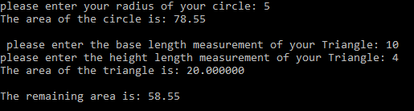

Result: Program ran as expected with correct outcome (Success).

- Test of code with minus entries added.

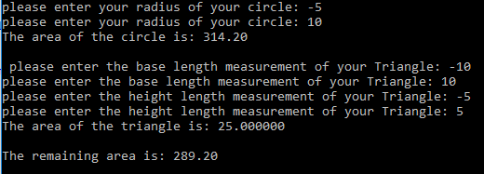

Result: Program ran as expected, as the while loops prevented negative number entry and re-prompted user for another value. (Success)

- Test of code with triangle area larger than circle area

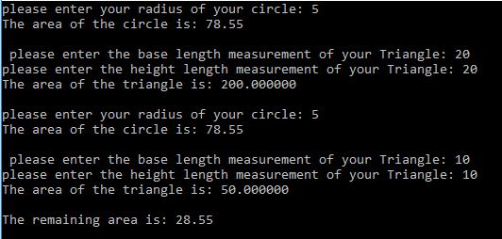

Result: Program ran as expected, the while loop prevents the remaining area being calculated while the triangle area is larger than circle area. (Success)
- Test of code with Characters entered in any of the data entry fields.
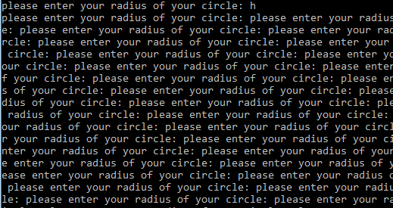

Result: Program failed when entering characters in to the float fields. Program kept repeating data entry prompt. (Failed)

2.3 Exercise on entering 5 product prices in to an array and calculating pre VAT price and post VAT price.

2.3.1 Identifying the problem

- User is prompted to enter the price for 5 items individually (Float)
- Entered price items are scanned and store in an array (Array)
- Entered price are added up from the array
- Total price is printed on the screen (float)
- Total price + 20% is calculated for price plus vat (float)
- Price plus vat is then printed on the screen

2.3.2 Annotated Code:
#include <stdio.h> //library or header file

void main() //main function - starting point for all programs

{
float totalprice = 0, priceplusvat = 0; //Float for Total Price and Total Price+Vat
float myprice[5]; //Array to capture 5 inputted prices
int i; //count for the array for loop

for (i = 0;i <= 4;i++) //For loop to capture the 5 inputted prices
{
while (myprice[i] < 0)
{
printf("Enter the price of your item: "); //ask user to enter price of item
scanf(" %f", &myprice[i]); //capture inputted price
}
}

for (i = 0; i <= 4; i++) //for loop to output captured price for SUM
{
totalprice += myprice[i]; //Sum to add all capture prices in the array
}

printf("Total price minus vat: %.2f \n", totalprice); //Display the total price minus VAT to the user

priceplusvat = totalprice + (totalprice * .2); //Sum to calculate total price + Vat
printf("Total price plus vat: %.2f", priceplusvat); //Display total price + vat to the user

}

2.3.3 Testing:
- Test of code with expected data entries
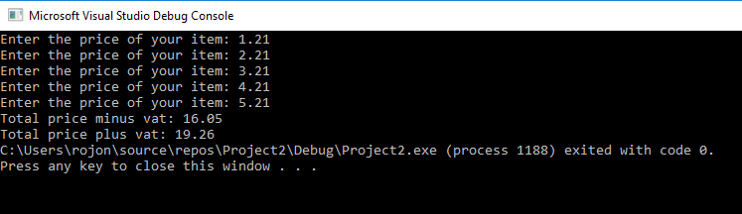

Result: Program ran as expected with correct outcome (Success).

- Test of code with minus entries added.

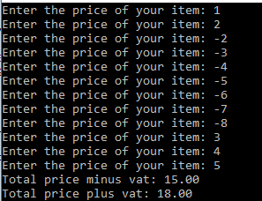

Result: Program ran as expected, as the while loops prevented negative number entry to store within the array, and re-prompted user for another value. (Success)

- Test of code with more than .2 decimal place.

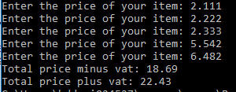

Result: The program executed as expected as there is no code to prevent the user from entering prices to higher decimal place, although the output it rounder out to .2 decimal place (Success, But improvement to code to prevent such input could be considered)

- Test of code with Characters entered in any of the data entry fields.

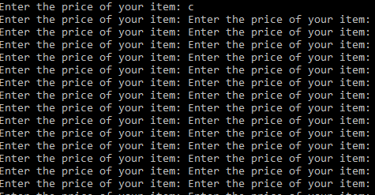

Result: Program failed when entering characters in to the float fields. Program kept repeating data entry prompt. (Failed).

Exercise to build a fruit machine and display a score based on scoring criteria.

Identifying the problem:

- User is prompted if they would like to spin, Y for Yes or N for No
- User reply captured (char)
- If user reply is Y for Yes 3 random numbers are displayed on same line or If user replies N for No the program will end (char)
- If user replied Y for the 3 random numbers will be matched for a win or no win
- If the 3 random numbers were 5 5 5 the user score would be 2000 (int)
- If the 3 random numbers were all the same (except 5 5 5) user score would be 20(int)
- If any 2 of the 3 random numbers were a 5 the user score would be 100(int)
- User score will increase in a cumulative fashion with each score (int)
- As well as cumulative user score a Win or No Win will be displayed before score.

There will also be a version that does not show the cumulative score but only the individual score per play

- User is prompted if they would like to spin, Y for Yes or N for No
- User reply captured (char)
- If user reply is Y for Yes 3 random numbers are displayed on same line or If user replies N for No the program will end (char)
- If user replied Y for the 3 random numbers will be matched for a win or no win
- If the 3 random numbers were 5 5 5 the user score would be 2000 (int)
- If the 3 random numbers were all the same (except 5 5 5) user score would be 20(int)
- If any 2 of the 3 random numbers were a 5 the user score would be 100(int)
- User score will show only the score for the latest spin (int)
- As well as single spin user score a Win or No Win will be displayed before score.

2.4.2 Annotated Code (Cumulative Scoring)
#include <stdio.h>
#include <stdlib.h>
#include <time.h>

void main()//main function - starting point for all programs

{

//Random Number Generator
int myrand1; //Random Number 1
int myrand2; //Random Number 2
int myrand3; //Random Number 3
int low = 1; //bottom of number range
int high = 5; //top of number range
int userscore = 0;//User Score fir Display
char reply;//Char for user input spin Y or N

printf("Spin? <y/n>: "); //ask user if they want to spin Y or N
scanf(" %c", &reply); //Capture user input

while (reply == 'y') //While loop to continue game on Y reply
{

srand(time(NULL)); //seed random with system clock

myrand1 = rand() % (high - low + 1) + low; //generate random number
myrand2 = rand() % (high - low + 1) + low; //generate random number
myrand3 = rand() % (high - low + 1) + low; //generate random number

printf("The random number is: %d %d %d \n", myrand1, myrand2, myrand3); //Display Random Numbers 1,2 & 3

if (myrand1 == 5 && myrand2 == 5 && myrand3 == 5) //If Random numbers are 5 5 5 then carry out following code
{
userscore = userscore + 2000; //userscore is previous userscore + 2000
printf("You win!!! %d \n", userscore); //print You win and user score
printf("Spin? <y/n>: "); //ask user if they want to spin Y or N
scanf(" %c", &reply); //Capture user input
}

else if (myrand1 == myrand2 && myrand2 == myrand3) //If Random numbers are the same then carry out following code
{
userscore = userscore + 20; //userscore is previous userscore + 20
printf("You win!!! %d \n", userscore); //print You win and user score
printf("Spin? <y/n>: "); //ask user if they want to spin Y or N
scanf(" %c", &reply); //Capture user input
}

else if (myrand1 == 5 && myrand2 == 5 || myrand1 == 5 && myrand3 == 5 || myrand2 == 5 && myrand3 == 5) // //If Random numbers have two 5's then carry out following code
{
userscore = userscore + 100; //userscore is previous userscore + 100
printf("You win!!! %d \n", userscore); //print You win and user score
printf("Spin? <y/n>: "); //ask user if they want to spin Y or N
scanf(" %c", &reply); //Capture user input
}

else
{
userscore = userscore + 0; //userscore is previous userscore + 0
printf("No Win!!! %d \n", userscore); //print No Win and user score
printf("Spin? <y/n>: "); //ask user if they want to spin Y or N
scanf(" %c", &reply); //Capture user input
}
}
printf("Thank you for playing, goodbye!"); //Print Thank you for playing, goodbye to user, end of program
}}

2.4.3 Annotated code (non-cumulative scoring)
#include <stdio.h>
#include <stdlib.h>
#include <time.h>

void main()//main function - starting point for all programs

{

//Random Number Generator
int myrand1; //Random Number 1
int myrand2; //Random Number 2
int myrand3; //Random Number 3
int low = 1; //bottom of number range
int high = 5; //top of number range
int userscore = 0;//User Score fir Display
char reply;//Char for user input spin Y or N

printf("Spin? <y/n>: "); //ask user if they want to spin Y or N
scanf(" %c", &reply); //Capture user input

while (reply == 'y') //While loop to continue game on Y reply
{

srand(time(NULL)); //seed random with system clock

myrand1 = rand() % (high - low + 1) + low; //generate random number
myrand2 = rand() % (high - low + 1) + low; //generate random number
myrand3 = rand() % (high - low + 1) + low; //generate random number

printf("The random number is: %d %d %d \n", myrand1, myrand2, myrand3); //Display Random Numbers 1,2 & 3

if (myrand1 == 5 && myrand2 == 5 && myrand3 == 5) //If Random numbers are 5 5 5 then carry out following code
{
userscore = 2000; //userscore is 2000
printf("You win!!! %d \n", userscore); //print You win and user score
printf("Spin? <y/n>: "); //ask user if they want to spin Y or N
scanf(" %c", &reply); //Capture user input
}

else if (myrand1 == myrand2 && myrand2 == myrand3) //If Random numbers are the same then carry out following code
{
userscore = 20; //userscore is 20
printf("You win!!! %d \n", userscore); //print You win and user score
printf("Spin? <y/n>: "); //ask user if they want to spin Y or N
scanf(" %c", &reply); //Capture user input
}

2.4.4 Testing (Cumulative Scoring & Non-Cumulative Scoring)
else if (myrand1 == 5 && myrand2 == 5 || myrand1 == 5 && myrand3 == 5 || myrand2 == 5 && myrand3 == 5) // //If Random numbers have two 5's then carry out following code
{
userscore = 100; //userscore is 100
printf("You win!!! %d \n", userscore); //print You win and user score
printf("Spin? <y/n>: "); //ask user if they want to spin Y or N
scanf(" %c", &reply); //Capture user input
}

else
{
userscore = 0; //userscore is 0
printf("No Win!!! %d \n", userscore); //print No Win and user score
printf("Spin? <y/n>: "); //ask user if they want to spin Y or N
scanf(" %c", &reply); //Capture user input
}
}
printf("Thank you for playing, goodbye!"); //Print Thank you for playing, goodbye to user, end of program
}

- Test of code with Y for Yes character entry and cumulative scoring
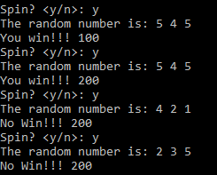

Result: Program ran as expected with cumulative scoring outcome (Success)

- Test of code with a Y for Yes character entry and non-cumulative scoring
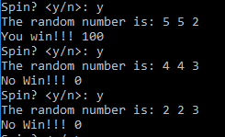

Result: Program ran as expected with non-cumulative scoring outcome (Success)
- Test of code with N for No character entry
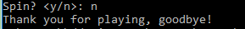

Result: Program ran as expected with ending and goodbye message (Success)

- Test of code with a number entered in Y/N Field.
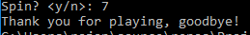

Result: Program ran as expected with ending in goodbye as a Y was not inputted despite it being a number. (Success, but improvement to code to prevent such input could be considered, and prompt user for another entry)

- Test of code with a character other than Y or N
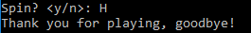

Result: Program ran as expected with ending in goodbye as a Y was not inputted despite it being a number. (Success, but improvement to code to prevent such input could be considered, and prompt user for another entry)

3. References

[1] M. Rouse, ‘What is variable? - Definition from WhatIs.com’, TechTarget.com, 2005. [Online]. Available: https://whatis.techtarget.com/definition/variable. [Accessed: 23-Jan-2019].
[2] tutorialspoint.com, ‘C Variables’. [Online]. Available: https://www.tutorialspoint.com/cprogramming/c_variables.htm. [Accessed: 23-Jan-2019].
[3] M. Rouse, ‘What is loop? - Definition from WhatIs.com’, techtarget.com, 2005. [Online]. Available: https://whatis.techtarget.com/definition/loop. [Accessed: 23-Jan-2019].
[4] V. Beal, ‘What is Array? Webopedia Definition’, webopedia.com. [Online]. Available: https://www.webopedia.com/TERM/A/array.html. [Accessed: 23-Jan-2019].

