Title of assignment
The evolving role of HR in the contemporary business world

Name: Owen Donovan

CIPD Membership Number

Date 09/01/2019

Word Count 4126

I declare that this assignment is my own work and that any information obtained from books and other sources have been appropriately referenced.

Signed Owen Donovan Date 09th January 2019

The evolving role of HR in the contemporary business world

Introduction
I hope you have all enjoyed your day learning about ‘The evolving role of HR in the contemporary business world’. Before exploring what is next it is important to understand how HR has got to the point we are at today and the journey it has been through. Human resource management has been in existence for many years with the earliest recorded text ‘The Farmers Almanac’ dating back almost 5000 years which included support for the supervision of farm labourers (Kramer, 1963). Modern HR management began as personnel management which was recognised at various times around the world with NCR opening a personal office in the 1890s in the USA which was more managerial focussed however roots of personnel management in the UK can be traced back to ‘welfare officers’ employed by Quaker owned companies in the early 1900s (Price, 2007). (Tyson, 1989) categorised personnel jobs into three categories ‘Clerk of Works’, ‘Contracts Managers’ and ‘Architects’ with more process and functional focussed roles and responsibilities leading at the time to be seen as lacking credibility and being marginalised by other managers (Price, 2007).
Human Resource Management and Strategic HRM was taught formally in 1981 when it was added to the list of available courses at Harvard Business School which supported additional credibility in its thinking. HRM in principle took a more proactive approach to People management rather than the more process driven personnel roles that previously existed. It recognised people as assets and costs that could be managed towards business objectives. It set out to manage people wider than just the work environment and geared organisations reward, learning and performance to support opportunities for individuals to maximise growth and improve commercial performance (Farnham, 2016) (Price, 2007). Additionally HRM practices were encouraged to be adopted by senior leaders in organisations with the support of HRM practitioners in a consultancy role to improve overall output which supported credibility within the field with Lengnick-Hall and Lengnick Hall identifying key reasons to implement the HRM approach.
- ‘HRM offers a broader range of solutions for complex organisational problems’
- ‘It ensures that an organisations people are considered as well as it financial and technological resources when objectives are set or capabilities assessed’
- ‘It forces the explicit consideration of the individuals who implement and comprise the strategy’
- Two way links are encouraged between formulation of strategy and its human resource implications’
(Price, 2007)

What forces shape HR and its agenda?
There is no one definitive model that depicts how HR functions are set up, this is ever changing due to the internal and external environment however there are a number of models demonstrating the various roles and influences of HR departments and its practitioners (Kew & Stedwick, 2014).
One widely used model is Ulrichs and later Ulrichs and Brockbank model (Kew & Stedwick, 2014) as shown below in figure 1 (Managing HR role David Ulrichs model, 2018).
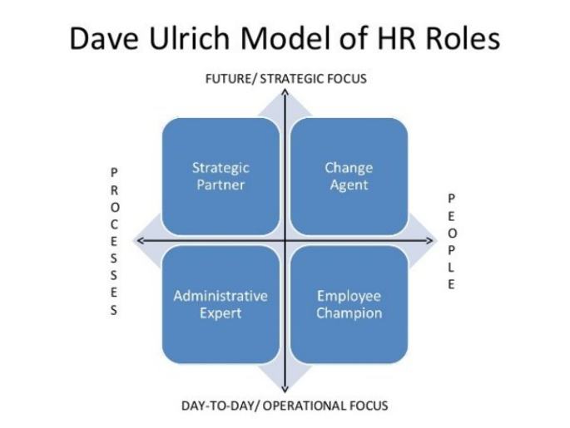
(Managing HR role David Ulrichs model, 2018) : Figure 1
The model splits roles into four sections comprising
Strategic/Business Partner – Support line management in a consultancy basis to ensure the organisations strategy is implemented, identify areas for improvement and support on more complex disciplinary, salary and incentive issues. This role has become more popular in recent years with senior leaders seeing increased value from the strategic views in this role (Kew & Stedwick, 2014) (Price, 2007).
Change Agent – Is a second strategic role concentrating more on engagement of employees when change is implemented and aligning the change to ensure the long term values of the organisation are inbuilt and are put into practice. (Kew & Stedwick, 2014) (Price, 2007)
Administrative Expert – Manages processes day to day and support businesses to ensure their policies for example ‘grievances, disciplinaries, equal opportunities and incentive arrangements’ (Kew & Stedwick, 2014) work as they should. One key acknowledgement of this role can be the lack of recognition received from others within the business with elements only coming to light when they go wrong. (Price, 2007)
Employee Champion – This role aims to give a voice to the employees of an organisation increasing their engagement and in return improving productivity and overall contribution.

From models to strategy
There is not one HR strategy that is the ‘holy grail’ to a successful business however there are 3 main strategies that have come to fruition since the introduction of HRM and organisations wanting to be able to quantify the impact and value of HRM (Kew & Stedwick, 2014)
Best Practice Approach
This aims at identifying the key elements of HR strategy that leads to an improved commercial return and is otherwise known as ‘high commitment’ or ‘high performance’ systems. The key factor is that no one single element will support sustained improvement rather a combination of set practices (Farnham, 2016) (Kew & Stedwick, 2014) and that this is universal regardless of the organisational setting or industry (Redmond & Wilkinson, 2009). One of the first best practice models is the Harvard model as described by (Beer, Spector, Lawrence, Quinn Mills, & Walton, 1985) which highlights six key elements as core to success which look like but are not excluded to ‘high job performance, problem-solving, innovation and cost effectiveness, matched by low levels of labour turnover, absence and grievances.’ (Farnham, 2016)
- Flexibility
- Selection Process
- Appraisal
- Learning and development of core employees
- Reward systems
- Participation and employee involvement
This has been the founding model from which other best practices have been drawn and built upon with research done in particular around what contributes to high levels of commitment consisting of the following elements (Kew & Stedwick, 2014)
- Employee Involvement
- Employee voice
- Harmonisation of Terms and Conditions
- Employee security
- Sophisticated recruitment and selection
- Extensive training and development
- Self managed teams
- Extensive systems of flexibility
- Performance related pay

Best Fit Approach
The counter argument to this is the best fit approach also known as the contingency model which argues that HR strategies must be aligned to the strategy of the organisation taking into account the culture and processes involved (HRMwordpress, 2016). (Armstrong, 2006) states best fit ‘is an idea that different HR strategies have to focus on the given needs of both the organization and its employees’.
The best fit approach aims to give companies more of a competitive edge and can align itself to a companies lifecycle with different HRM priorities at start up, growth, maturity and decline (Kew & Stedwick, 2014). The best fit approach can be extremely difficult to implement as it requires consideration for all of the key elements of a business, looking at the root of what makes a business successful can help HR build the right practices aligned to the business (Stratford, 2011). Lynda Gratton from the London business school also back this up describing 'signature processes' "which are idiosyncratic and unique to individual organisations [and] are the secret to sustainable competitive advantage".
Resource based view
Where as best fit can focus on external factors resource based view focuses purely on internal factors of an organisation viewing external factors as to volatile so applies HR strategy to the core competence of the business linked to the human capital approach (Kew & Stedwick, 2014). The focus is not solely on the behaviour of humans in a business but on the ‘skill, knowledge, attitudes and competencies which people bring to an organisation’ (Kew & Stedwick, 2014) and it is this that gives organisations their competitive edge. The RBV approach works best where resources vary across firms in similar sectors and where other firms are unable to gain resources to plug these gaps and it is this that will create the competitive advantage (Farnham, 2016). (Barney, 1991) picks out four key factors in determining if resource is gaining a sustained advantage where the resource must
- Be adding positive value to the firm
- Be unique or rare among competitors
- Be imperfectly inimitable
- Not able to be substituted with another resource by competing firms
RBV does have its critics with some arguing that you cannot completely ignore all external factors and the environment as it is there and can create constraints on a business which will impact the internal environment (Kew & Stedwick, 2014).
As well as looking at the strategies it is important to consider how they are implemented, vertical and horizontal integration are key concepts in how this is done. Vertical integration relates to HR linking with wider business strategies and external factors whereas horizontal integration is the fit between different internal HR policies and strategies and the degree to which these complement each other. The more a company can incorporate both vertical and horizontal integration into the HR framework the more effective the implementation of the HR strategy, however can be very difficult and requires commitment at all levels and excellent communication structures (Kew & Stedwick, 2014).
Insight and solutions
As discussed previously HRM and strategic HRM has provided greater credibility to the process of people management and a key element in enhancing this is the ability to demonstrate and add value through the provision of relevant MI which can shape strategic business decisions. (CIPD, 2018) describe it as ‘enabling HR teams to demonstrate the impact that HR policies and processes have on workforce and organisational performance, and can be used to demonstrate return-on-investment and social-return-on-investment for HR activity.’
Information gathered can be both quantitively illustrated through numbers such as total employees, absence rates, attrition rates or productivity or can be qualitative providing rich material with greater detail including partner engagement surveys, L&D outcomes and performance review feedback.
HR MI and analytics can also be used to support project work to understand success and incorporate further learning following the HR Analytics model as set out by (CIPD, 2018)
- Plan
- Define critical success factors
- Data audit
- Design the process
- Design the data collection strategy
- Data collection
- Analyse data
- Report data
- Evaluate

HR Business ethics and accountability
Ethics is described as ‘a set of principles often defined as a code that acts as a guide to conduct’ (Lawton, 1998). There have been a number high-profile cases recently that have brought business ethics to the forefront of organisational media with examples including Tesco, VW and Sports Direct demonstrating the impact a business can have when they do not act ethically. Most large corporate companies have a code of ethics with separate teams defining what ethics means to its organisation and guidance for implementation. Business ethics is becoming more important in the modern world with the reputational damage that can come from getting it wrong (Harrison, 2015). There is no universal model for business ethics however factors including religion, personal and cultural differences will all impact on ethical behaviour in the workplace (Farnham, 2016). The big debate is what part do HR play in the governance and implementation of business ethics, most belief that the responsibility sits with each individual within the organisation while HR act in the capacity of support guidance (Harrison, 2015).

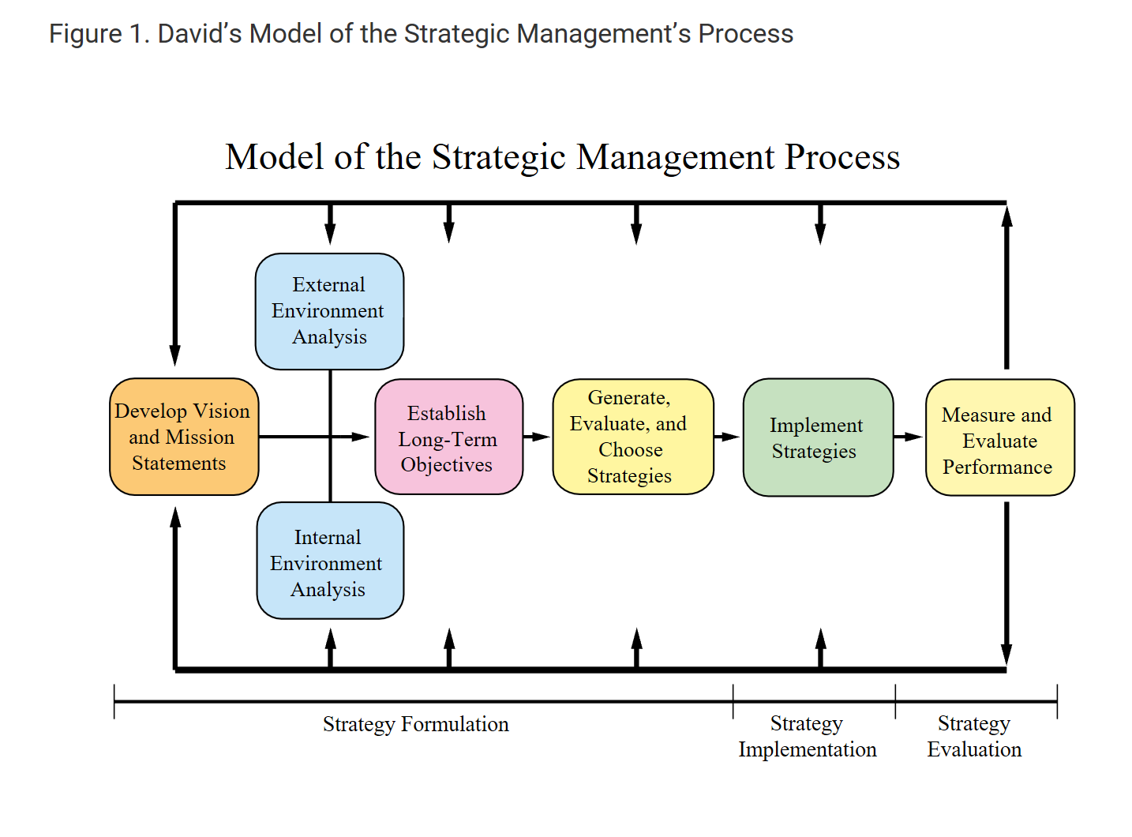
Figure 1 (Strategic Management Insight, 2013)
Stages of Strategic Management using the David model and HR role in each element
Strategy Formulation – Strategy formulation can be set at 3 generic levels within an organisation dependent on its size choosing between business level strategy, corporate level strategy and global level strategy. The key element is to understand what you are trying to achieve and is it aligned to the organisations vision and mission. Dependant on the aim various analysis models can be used including SWOT, PESTLE and Porters 5 forces which are explained later in further detail which will help to inform leaders in the strategy that has been decided (Strategic Management Insight, 2013). HR can provide valuable data to support existing skill sets within the workforce, identifying gaps and analysing potential costs to support recruitment through external benchmarking related to workforce planning (CIPD, 2017)
Strategy Implementation – Implementation relies more on leadership and management skills as opposed to analysis used heavily in the previous stage. (David, 2009) sets out 6 key factors required to achieve success during this phase
- Setting objectives
- Aligning policies to the objectives
- Allocating resources to strategically important areas
- Changing organizational structure to meet new strategy
- Managing resistance to change
- Introducing new reward system for performance results if needed
HR plays a significant role in supporting communication of the vision and goals across the business and upskilling the workforce to support skill gaps that may exist. Whilst looking at restructuring if required, HR will ensure all legal frameworks are followed and identify the potential cost implication of people strategies. The design of new reward structures aligned to the business objectives and visions is key to its success and HR can support the effective implementation of these across the estate (CIPD, 2017).
Strategy Evaluation - Evaluation must be monitored to be successful and aligned to the agreed goals set out during the formulation stage which will have agreed cost elements. Businesses must monitor both internal and external benchmarks and evaluate and adjust the tactics used rather than the strategy according to the results. It is important to evaluate the performance of the business with elements that are measurable and this is done in a time relevant manor to allow the business to change according to the results to achieve its goals (Strategic Management Insight, 2013). HR can support with both quantitative and qualitative data to understand the people impact of the change through Employee engagement surveys which can help to support future decisions. Combining performance or productivity data can also determine the success or failure of reward structures and allow them to be changed to support the initial goals (CIPD, 2017).
Most businesses can be split into three categories private sector, public sector and the third sector and all have different stakeholders to whom they are accountable
Private sector – the key element is they compete in an open market and are answerable to shareholders. They are also accountable to employees, suppliers, consumers and the local communities they exist in due to state governance. In more recent times public opinion has become a bigger factor with the introduction of social media and lobbying groups and needs to be taken into consideration when making decisions (Farnham, 2016).
Public sector – these are organisations created by the state and are accountable to the governing bodies they belong to but ultimately the public as this is where funding come from. Public sector accountability can be broadly divided into ‘legal, political, customer and professional’ (Rose & Lawton , 1999) with all public officials accountable to a political person and only able to act in what the law specifically states known as ultra vires (Farnham, 2016)
Third Sector – predominantly charity and voluntary organisations or community bodies and came together in 2005 to produce the charity governance code which sets out principles that should be adhered to including
- Organisational purpose
- Leadership
- Integrity
- Decision-making, risk and control
- Board effectiveness
- Diversity
- Openness and accountability
(Charity Governace Code, 2017)

Analysis Models
Three tools used to analyse business environment to shape strategies are shown in the diagram below fig 2
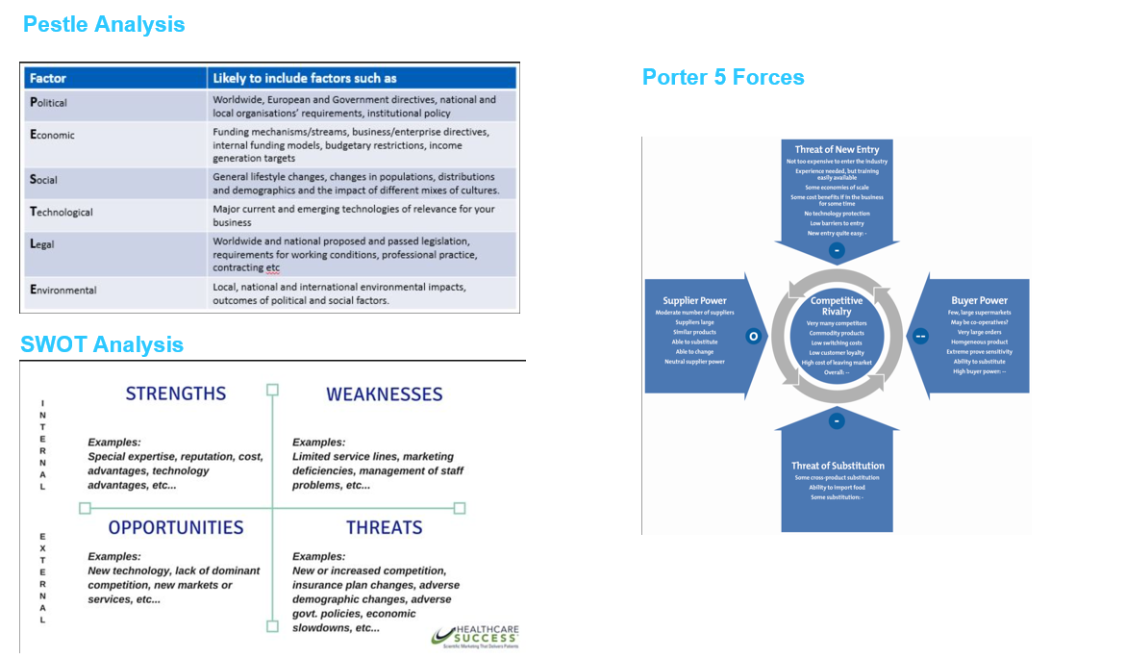
Fig 2 three models of business analysis tools (Mindtools team, 2019) (Spark rail, 2018) (Healthcare success, 2017)
Pestle Analysis
This allows an organisation to look at what external factors may impact on their business and build strategies to support growth and maintain a competitive edge. It can be used for Strategic planning, workforce planning, marketing planning and organisational change (CIPD, 2018).
SWOT Analysis
Is a simple framework allowing the Strengths, Opportunities, Weaknesses and Threats to be assessed for an organisation to support strategic planning looking at both internal and external factors that impact a business or project (CIPD, 2015)
Porters 5 Forces
Looks predominantly at competitors and the influences they can have on an organisation which will allow you to head of future threats and stay competitive in a market. Competitors can be Customers, suppliers, potential entrants, and substitute products to the one you supply and all can be considered when reviewing the strategy of the business (Porter, 1979)
Comparing the three tools
Tool | Advantages | Disadvantages
PESTLE | - It’s an easy framework to follow  - It supports greater awareness of the external environment  - Its develops external strategic thinking  - It allows businesses to spot future impacts and act early  - It allows business to highlight opportunities and fulfil potential | - Not all data sources are considered  - too much data may lead to ‘paralysis by analysis’.  - Needs to be done regularly to be effective.  - Not effective being carried out on your own  - Focuses mainly on external factors
SWOT | - It is a simple framework.  - It develops both Internal and external strategic thinking  - It enables a management team to focus on strengths and build opportunities.  - It can be flexible in its use  - It allows business to highlight opportunities and fulfil potential | - It is easy to not use enough data and make assumptions  - Needs to be done regularly to be effective  - Effective analysis requires multiple people with different viewpoints  - It is open to interpretation
Porters 5 Forces | - Helps evaluate current market environment  - Provides a strong point from which to understand areas of further research  - Is multi functional and can be used to understand how to stay ahead in the market alongside new strategy. | - The model was desined when markets were static and only provides a moment in time analysis so needs to be completed regularly.  - Non market forces are not considered in the model  - The model is predominately basedon the conception of competition and more basic market structures

Looking at 4 elements of PESTLE in detail and their impacts on businesses and HR functions
Political
Political influences can have a significant impact on a business with elements such as ‘Tax policy; environmental regulations; trade restriction/reform; tariffs and political stability’ all combining in decisions that are made (CIPD, 2018). Taking political instability as an example recently in Catalonia Sabadell bank moved their headquarters from inside Catalonia to Alicante due to the political instability in Spain around Catalonian independence and wanting to be able to operate freely within the European Union (Financial Times, 2017).
Sociological
Sociological influences such as ‘Cultural norms and expectations; health consciousness; population growth rates; age distribution; career attitudes and health and safety issues’ (CIPD, 2018). In western countries the population age is increasing in 1991 the age of the labour force over 65 was 1%,currently it is 6% and projected to be 9% by late 2029. Business and in particular HR strategies will need to look at how we retain expertise of staff and utilise skills to benefit new recruits alongside flexible working policies and phased retirement initiatives (Stats.gov, 2017).
Technology
Technology will have one of the biggest impacts on how we do business moving forward and includes elements such as robotics and Artificial Intelligence and the speed at which new technologies are emerging is ever increasing (CIPD, 2018). Technology has improved efficiency within business and different theories exist at present with some debating large wholesale job losses and others with a more moderate view citing some job loses but not on the same scale. One of the key roles of HR within this will be how technology and people can work together to mutually benefit business need whilst valuing all employees (CIPD, 2018) In a recent article describing technological growth in the USA over the last 100 years 90% of roles that were undertaken by humans are now automated with machinery, yet we have a lower unemployment rate now than then (Forbes, 2018)

Financial health
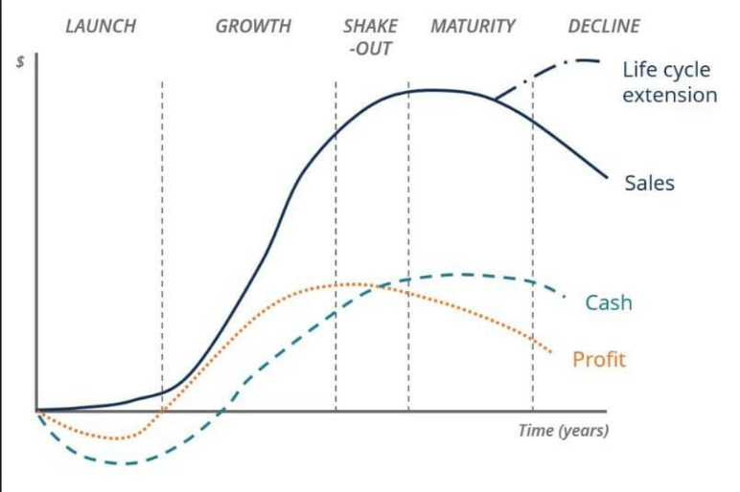
Fig 3 financial health model (Corporate finance Institute, 2016)
As shown above most businesses will go through a life cycle and the companies financial health within this will determine the business strategy and aligned to this the key roles HR will play with in it. In the initial growth stage if the financial health is strong HR policies will be based around recruitment and identifying appropriate talent and skills to support the growth. As the business builds towards maturity focus will move to the retention of staff with strategies around recognition and performance and if the financial health of the company declines the business and in turn HR will look towards cost saving measures and implementation within the business (Corporate finance Institute, 2016).

Evaluating business performance
Businesses use many methods to evaluate performance including
Key performance Indicators are a traditional method of measuring business performance and allow a business to understand how they are performing against pre-defined Indicators relevant to success. KPI have to be reported by companies in their end of year financial reporting as set out in the companies act 2006 giving reference to the financial performance of the company. KPI are often agreed by pre-defined measures in relation to a company’s strategy and are reviewed at set timeframes to understand progress and impact. Disadvantages of KPI are the inflexibility they can bring and if not reviewed regularly can slow reaction rates (Pricewaterhouse coopers, 2014).
Balance Scorecards are an advance of the traditional short term KPI measurement and a series of measures including KPIs brought together to provide greater cohesion between the ‘strategy elements of a business, vision, core values, operational elements, targets and initiatives (Strategy management balancedscorecard, 2018).’ The scorecard supports the communication of what a business is aiming to achieve aligned with the day to day operations of the business. It provides a balanced approach to a business and ensures a more rounded approach is taken by employees and allows progress against these to be measured and monitored. (Strategy management balancedscorecard, 2018)
Service level agreements (SLA) and service level management (SLM) are traditionally a way of agreeing how the relationship will work between two parties that enter into an agreement. The SLA is typically the agreement of how services will be provided and the level of service that has been agreed whereas the SLM involves the agreed monitoring and reporting on the agreement. This type of initiative is used where there is a service need that has to be delivered more so than a product (IT Governance, 2018)
HR role in business planning and change management
HR can play a key role in business planning and change management by being involved at the initial stage of development supporting key leaders with existing skillsets within the organisation and any gaps that are required to support outcomes being discussed. HR can also support in negotiating across functions and supporting in understanding the impact decisions will have across multiple business units. The final key element of support is the design and delivery of the communication of the proposed change as well as supporting people through the change faster to promote motivation and success (Rees & French, 2014). Within TSB HR support strategic decision making with a monthly people pack which supports decision making by providing FTE numbers, disciplinary, absence, salary, new starters, leavers, maternity and a glidepath a future attrition (TSB, 2019).

Sources of data to support planning
Attrition is defined as ‘a calculation of the number of individuals or items that vacate or move out of a larger, collective group over a specified time frame.’ (NGDATA, 2015) This is an important metric for a business to understand as it can support planning of key initiatives and will also drive priorities for a business and in particular HR. A high attrition rate will lead a business to understand further the reasons behind this with exit strategies key to this alongside ensuring appropriate recruitment is happening to ensure the business can achieve it key priorities (Sekar, 2018)
Understanding and the management of costs is extremely important within business both in terms of knowing historical costs of projects which will support in planning and sign off initiatives and the base for cost calculations. The monitoring of costs throughout a project or plan will ensure that the relative impact of the project is still relevant and allow elements to be re-evaluated as appropriate to understand success or failure. Relative costs throughout the business split into segments including design, analysis, people and development allow for standards to be drawn up through real life examples necessary to gain accurate cost predictions (Phillips & Phillips, 2012).
ACAS and new legislation are key sources required to be referenced in planning what is required in the future. An recent example being the requirement for any business with more than 250 employees to publish an annual report on the pay gap between the Chief executive and their average UK worker. It is also important that all internal policies are in adherence to new legislation and there is usually an implementation period which businesses have to plan and then implement the change. This also ensure that the business mitigate their exposure to any risk that could be created through non adherence (ACAS, 2019).
Office of National Statistics is a vital source of information useful as a credible source of data for businesses. They survey approx. 325,000 business with different survey with the information used by government sources and critically by businesses to identify any emerging trends in the market and alongside market performance and development. This will then support planning and setting of strategy and direction for a business from the external benchmarking that can take place (ONS, 2017)
What’s next
Having looked at how we have and currently operate it is also important to look forward particularly with the impact of technology and how this will impact HR and the role it plays. By 2020 35% of the UK workforce will be classed as millennials with research suggesting 35% of current roles could be automated within 20 years (CIPD, 2017). Technology will be able to support the removal of labour intensive mundane HR tasks digitalising processes particularly around recruitment however increasing the need for more strategic HRM activities to support growth and policies. Employee wellbeing will be key with the emergence of the gig economy it is more common for people to have more than 1 job at a time alongside the introduction of more short term contracts of employment. Ensuring this is aligned to business need will be key and HR will have a significant role to play in implementing this into the working models of organisations, designing contracts and reward strategies to support attaining the relevant talent to succeed (CIPD, 2017).

References
ACAS. (2019, Jan). Employment Law Update. Retrieved from ACAS: http://www.acas.org.uk/index.aspx?articleid=3909
Armstrong, M. (2006). A Handbook of Human Resouce Practice. Kogan Page.
Barney, J. (1991). Firm resources and sustainable competitive adavantage. Journal of Management, 99-129.
Beer, M., Spector, B., Lawrence, P., Quinn Mills, D., & Walton, R. (1985). Human Resource Management: a general managers perspective. Glencoe Illinois: Free Press.
Charity Governace Code. (2017). Charity Governance Code - About the Code. Retrieved from Charity Governance Code: https://www.charitygovernancecode.org/en/about-the-code-1/using-the-code
CIPD. (2015, October 15). SWOT Analysis. Retrieved from CIPD: https://www.cipd.co.uk/knowledge/strategy/organisational-development/swot-analysis-factsheet
CIPD. (2017, May 02). HR tech revolution: friend or foe? Retrieved from CIPD: https://www.cipd.co.uk/podcasts/hr-technology
CIPD. (2017, Nov 8). Strategic HRM. Retrieved from CIPD: https://www.cipd.co.uk/knowledge/strategy/hr/strategic-hrm-factsheet
CIPD. (2018, April 12). Emerging technology and the future of work. Retrieved from CIPD: https://www.cipd.co.uk/knowledge/work/technology/emerging-future-work-factsheet
CIPD. (2018, June 13). HR Analytics CIPD. Retrieved from CIPD: https://www.cipd.co.uk/knowledge/strategy/analytics/factsheet
CIPD. (2018, December 17). PESTLE Analysis. Retrieved from CIPD: https://www.cipd.co.uk/knowledge/strategy/organisational-development/pestle-analysis-factsheet
Corporate finance Institute. (2016). business life cycle. Retrieved from corporatefinanceinstitute: https://corporatefinanceinstitute.com/resources/knowledge/finance/business-life-cycle/
David, F. (2009). Strategic MAnagement Concepts and Cases. Prentence Hall. Retrieved from David, F.R. (2009). Strategic Management: Concepts and Cases. 12th ed. FT Prentice Hall, p. 36-37, 45-47, 93
Farnham, D. (2016). Human Resource Management in context. London: CIPD.
Financial Times. (2017, October 5th). Big bank to move headquarters out of Catalonia Financial Times. Retrieved from Financial Times: https://www.ft.com/content/daada4cc-a9b4-11e7-93c5-648314d2c72c
Forbes. (2018, January 18). Technology has already taken 905 of jobs. Retrieved from Forbes: https://www.forbes.com/sites/quora/2018/01/18/technology-has-already-taken-over-90-of-the-jobs-humans-used-to-do/#4e4ec9aa1bdd
Harrison, L. (2015, December 01). HR and Business Ethics CIPD. Retrieved from CIPD: https://www.cipd.co.uk/podcasts/hr-business-ethics
Healthcare success. (2017). Blog SWOT. Retrieved from Healthcare success: https://www.healthcaresuccess.com/blog/medical-advertising-agency/swot.html
HRMwordpress. (2016, March 8). Retrieved from WordPress: https://hrm024209.wordpress.com/2016/03/18/2/
IT Governance. (2018). SLA. Retrieved from IT Governance: https://www.itgovernance.co.uk/sla
Kew, J., & Stedwick, J. (2014). Human Resource Management in a busines context. London: CIPD.
Kramer. (1963). The Sumerians. Chicago: University of Chicago Press.
Lawton. (1998). Ethical Management for the public services. Buckingham: Open University Press.
Managing HR role David Ulrichs model. (2018, May 14). Retrieved from Mettle blog: https://blog.mettl.com/talent-hub/managing-hr-roles-david-ulrich-model
Mindtools team. (2019, Jan 03). Porters 5 forces. Retrieved from Mindtools: https://www.mindtools.com/pages/article/newTMC_08.htm
NGDATA. (2015, July 09). what is attrition rate. Retrieved from NGDATA: https://www.ngdata.com/what-is-attrition-rate/
ONS. (2017). about business surveys. Retrieved from Office National Statistics: https://www.ons.gov.uk/surveys/informationforbusinesses/aboutonsbusinesssurveys
Phillips, J., & Phillips, P. (2012, Feb 23). Proving the Value of HR: How and Why to Measure. ROI: SHRM. Retrieved from Society for Human Resource Management: https://www.shrm.org/resourcesandtools/hr-topics/behavioral-competencies/business-acumen/pages/measuring-hr-costs.aspx
Porter, M. (1979, March). How competitive forces shape strategy. Retrieved from Harvard Business Review: https://hbr.org/1979/03/how-competitive-forces-shape-strategy
Price, A. (2007). Human Resource Management in a business context. London: Thomas Learning.
Pricewaterhouse coopers. (2014). KPI. Retrieved from Price Waterhouse Coopers: https://www.pwc.com/gx/en/audit-services/corporate-reporting/assets/pdfs/uk_kpi_guide.pdf
Redmond, T., & Wilkinson, A. (2009). Contemporary human resource management. Prentice Hall- Financial times.
Rees, G., & French, R. (2014). Leading Managing and developing people. London: CIPD.
Rose, A., & Lawton , A. (1999). Public services management. Harlow: Prentice Hall.
Sekar, A. (2018, Nov 30). Use HR anylytics. Retrieved from analyticstraining: https://analyticstraining.com/use-hr-analytics/
Spark rail. (2018, December). Sparkrail Pestle Analysis. Retrieved from Sparkrail: https://www.sparkrail.org/Pages/HSPestle.aspx
Stats.gov. (2017, Dec 14). Labour force will grow and age. Retrieved from stats.govt.nz: https://www.stats.govt.nz/news/labour-force-will-grow-and-age
Strategic Management Insight. (2013, Feb 13). Strategic Planning Process. Retrieved from Strategic Management Insight: https://www.strategicmanagementinsight.com/topics/strategic-planning-process.html
Strategy management balancedscorecard. (2018, Jan 08). About the balance scorecard. Retrieved from balancedscorecard: https://www.balancedscorecard.org/BSC-Basics/About-the-Balanced-Scorecard
Stratford, H. (2011, August 22). Is best practice holding you back? Retrieved from HRmagazine: https://www.hrmagazine.co.uk/article-details/is-best-practice-holding-you-back
TSB. (2019, Jan). HR Monthly People Pack. Edinburgh: TSB Internal document.
Tyson. (1989). The Management of the Personnel Function. Journal of management studies, 523.

