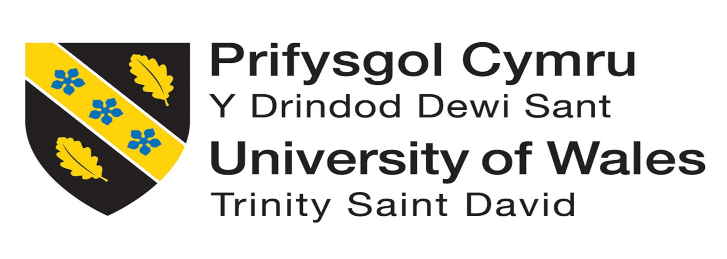

MODULE NAME: ORGANISATIONAL CULTURE
MODULE CODE: ( LCLM 5005_LON)
STUDENT NAME : JOHN SYLVESTER MENSAH
ASSIGNMENT TITLE : ASS1 INDIVIDUAL REPORT
LECTURER’S NAME : DR. RAMESES MANALANG

Table of Contents
Introduction 2
Identification of Organisational Culture of British Airways 3
Identified cultures of British Airways 4
How the Organisational Culture helps shape British Airways structure and decision-making 5
Relevant Framework, Models and Theories to British Airways 7
The Artefacts Level 8
The Espoused Values 8
Basics Underlying Assumptions Levels 9
Organisational Culture and adaptation to the external environment of the British Airways 10
Political Adaptation 10
Economic Adaptation 10
Sociocultural Adaptation 10
Technological Adaptation 11
Environmental Adaptation 11
Legal Adaptation 11
Evaluation of the impact of Organisational Culture on organisational performance of British Airways 12
Recommendations 13
Conclusion 13
References 14

Introduction
Cultural life is inevitable in societies as well as organisations and businesses. The way of life, particularly how people and group behaviour is actually matters in organisations and workplaces. However, culture is invisible but it is a powerful force that influences people socially, market and financial performances. Furthermore, culture can influence attitudes, employees behaviours and organisation effectiveness. According to Bellot (2011), organisational culture can be defined as “ a system of shared values, norms, rules, beliefs, and habits that are learned and internalized by members of an organization, which then become reflected in their behaviours”. Therefore, organisational culture plays an important role in workplace performance.
Additionally, this report is aimed to address the organisational culture in British Airways, how organisational culture could help British Airways in decision making and shaping its structure. Furthermore, Schein’s model of Organisational Culture will be used to explain what type of organisational culture is predominate in the British Airways and how external environment could influence British Airways workplace culture and its adaptation. The report will also seek to evaluate the impact of organisational culture on performance in the British airways. Therefore, recommendations of the organisational cultural behaviours could help to improve the functions within the organisation.

Identification of Organisational Culture of British Airways
British Airways is an aviation company in the United Kingdom which has become one of the global leading airline in the world. British Airways aim to connect people, places and different cultures coming together for over the years. To its credibility, British Airways determines with their entire team to provide exceptional service to it customers that they arrive their destinations safely. Moreover, as British Airways fly with British flag, it is their pride of having of long standing record of attention to sustainability in the world aviation and focusing on how impact their organisation could affect people, planet and responsibility (British Airways).

Identified cultures of British Airways
As world known aviation company in the world, there are existing culture in the organisation that may have an influence on the British Airways that would determine how decision are made and things are done in a particular way. The following are organisational culture of the British Airways identified. Firstly, culture of excellence is best describe as organisational culture of British Airways, whereby the employers are expecting the employees to deliver world class and high quality standard services to their customers. Secondly, open culture is also practice in British Airways which encourages new ideas of the employees for innovation that gives them room to express and try some new ideas relate to their roles and tasks. The open culture helps British Airways to embrace uniqueness and diversity of the organisation. Thirdly, safety and security culture which is the core fundamental ethos of British Airways because of the nature of business that deal which life of people. Every employee is to ensure that, they are responsible to maintaining safe environment and safety for the customers and staff as well. Last but not the least, is caring culture which British Airways lay emphasis on genuine customer care and value other staff (British Airways).
Therefore, these cultures identified in British Airways has evolved significantly over the years which has brought constant transformation and innovation of the organisation. Additionally, the culture which based on the core values of the company has also enhance the wellbeing of staff including diversity and inclusive, active colleagues support network and collaboration. Again, these values which are in the heart of British Airways identified helps the organisation focusing on professionalism and pride (Allaire and Firsirotu, 2026).

How the Organisational Culture helps shape British Airways structure and decision-making
Organisational Culture plays significant role in organisational structure of businesses which influence how they are structured and their decision-making. There are also some reasons organisational structure helps organisations to achieve like co-ordinating of different department in the organisation, creating flexibility in order to meet the demand of the changing environment which may have impact on the organisation. In addition to that, structure helps to provide the organisations a kind of framework and pattern of management such as social satisfaction of the staff in the organisation (Moravcevic and Ruzicic, 2023). However, there are two types of organisational structure which are traditional and organic. Therefore, traditional organisational structure consist of simple structure, functional structure and divisional structure whiles organic structure includes matrix structure (Module).
As looking in the British Airways as a chosen company of the assignment, will explore what type of organisational structure is conducted in the British Airways? Also how does it influence its decision-making? Ahmady, Mehrpour and Nikooravesh, (2016), stated that organisational structure “is the framework of the relations on jobs, systems, operating process, people and groups making efforts to achieve the goals. Organisational structure is a set of methods dividing the task to determined duties and coordinate them”. The organisational culture British Airways operating with is functional organisational culture which mainly emphasis on customer excellence service, safety and operational efficiency.
Having identify the organisational structure of British Airways as functional organisational structure and here is the detailed of how this structure works in the organisation. The functional organisational structure which British Airways use is mainly divided into various departments including Legal, Finance, Commercial, Safety and Security, Customer Service, Human Resources, Logistics, Digital Technology and Technical. All these departmental divisions are operating under the supervision of the CEO of the organisation, also it is the responsibility of every department to reporting to the CEO. Furthermore, the first level of the structure is Executive Leadership which hold position of making strategic and major decisions for the organisation relating to its operations like how British Airways function well worldwide. Following by the Chief Operation Officer who holds a position to ensure the operations and planning such as worldwide airports, maintenance, management, fleet and punctuality. The next level of organisational structure is Chief Commercial Officer, who is responsible of management of revenue of the company, commercial marketing including corporate sales, trade sales, agency sales and development of network (Alvesson, 2013).
Additionally, customer service are there to ensure customers satisfaction and safety. The Human Resources functions includes recruiting pilots, learning, training, people management, rewards and social affairs. With finance department, they manage all the payments and transactions for the company, payroll for the staff and supply and deliveries. However, the Technical Officer is responsible for the maintenance of aircrafts and documentations, whereas Digital and IT department manage the data engineering, protect the organisation from cyber-attacks, ensuring the business information systems that the organisation operates with are modernised and updates are available for effective services. Furthermore, the Safety and Security division are responsible for aviation security, health and safety of the customers and staff which requires strict control and regulatory compliance. The legal department responsible for compliance of the laws and regulations. Therefore, the functional structure of British Airways helps centralised strategic decision-making which come from the top (CEO), operational departmental make decision within their department based on the functionality and customer decision are decentralised to empower the workers. The below is the organisational structure chart of British Airways.

Source: (Microsoft office 356)

Relevant Framework, Model and Theory to British Airways
There are theories of Organisational Culture which influence organisations entity such as personality and characteristics, the shared values and beliefs and the assumptions of the behaviour of people, how they interact and decisions made in the organisation. It continues to demonstrate how work operation are carried out in a particular organisation. Furthermore, it reveals the system of communication patterns, rituals and type of leadership style (Hameli, 2024). In order to understand the organisational culture of British Airways, it is necessary to examine types of organisational Culture theories that are relevant to the organisation and these are including Hofstede’s Cultural Dimensions, Schein’s Three Levels of Organisational Culture, Johnson and Scholes’ Culture Web, Handy’s 4 Types of Culture and Deal and Kennedy’s Cultures (UWTSD Module).
Having carefully studied these five models, the Schein’s Three Levels of Organisational Culture would be the suitable theory to be used to examine the British Airways culture. Schein, (1980), argues in his theory that culture is very difficult organisational entity which could be changed, therefore, it cannot be examined in its totality. However, Schein’s model of Organisational Culture explains the three levels such as Artefacts, Espoused Values and Basic Underlying Assumptions. With these levels help one to understand what type of organisational Culture is being operating in an organisation and particularly of the British Airways. Schein’s theory is an appropriate model which seems to help to explain the organisational Culture of British Airways and using these three levels can help to explain the culture evolution and modern customer excellence in the British Airways organisational culture.

The Artefacts Level
First of all, the Artefacts level is the symbols such as logo of the British Airways with colours like “Red and Blue”, fly with British flag. It is also identifies the visible behaviours of the organisation like their uniforms which make them unique from other aviation companies. These make them observable in the British Airways aspect of their Culture. This Artefacts level has help British Airways especially manifested it strict departmental operations and organisational structure of leadership regarding decision-making from the top to bottom. Artefacts also show how British Airways use it customer services training programmes as visible symbol of giving assistance customers who are struggling to find their gates numbers, check in, etc. as the staff wear visible vest with inscription ‘We are Here to Help’. With the modern digitalisation has transformed British Airways operations on the their help desks which visibly displays their logo makes it easier to ensure that customers are able to find and access any help they need. Therefore, with the Artefacts level helps the British Airways organisation culture to collaborate effectively with its customers and providing satisfaction services (Obeng, Arhinful and Teneng, 2025).

The Espoused Values
The next to the Artefacts level is the Espoused Values whereby the culture of an organisation is based on the values and its beliefs. The values could also be the philosophy, principles and strategies of the organisation and as such, the British Airways emphasis strongly on customers excellence, safety and security which values life of people in order to ensure peace of mind when they fly with British Airways. Additionally, the maintenance department, engineers, logistics and pilots and all other relevant department do robust safety checks before they fly as it is the core value of British Airways. Furthermore, as British Airways value quality service, this level of Schein’s model helps them to use good corporate communication skills and engaging with all the stakeholders in the organisation. Therefore, the values reflect on British Airways aspirations and goals to achieve success of the organisation.

Basics Underlying Assumptions Levels
The final level of Schein’s model is essential for British Airways organisational culture which is based on the persistent belief of safety. However, this assumptions of aviation company is rooted in their culture in order to facilitate counter production for the organisation in all their operations of every department. Again, the market positioning also influence the company’s beliefs in operating efficiently to be competitive advantage in the aviation market. Even though, British Airways has strong assumption of putting people first, they also have belief for leadership. Therefore, the assumptions of the British Airways influences the culture in the organisation. The below diagram highlights Schein’s theory of organisational culture.

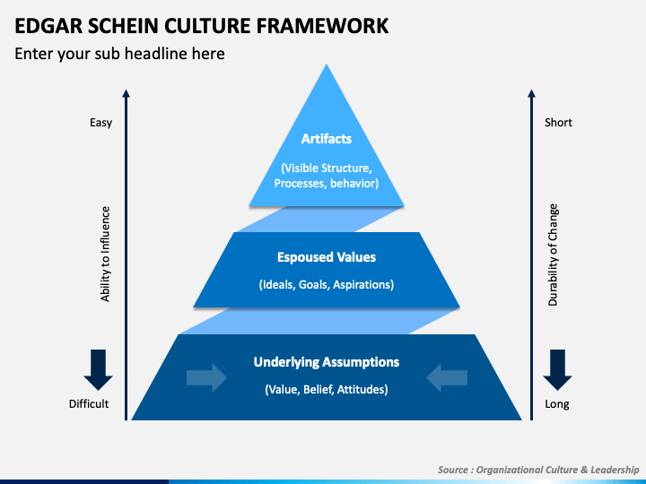
(online Pictures)
Source: UWTSD

Organisational Culture and adaptation to the external environment of the British Airways
Organisational Culture is essential to businesses on how they response to the external environmental factors that may affect the organisations operations in order to achieve success. For British Airways continue to be successful and staying in the markets of aviation in a competitive business world. It is necessary that the company must be able to adapt to the external market pressures through transformative strategies and modernised digitalisation that align with external macro-environmental factors which are identified in PESTEL analysis (Deal, etal., 2003).

Political Adaptation
British Airways needs to adapt strategically on the political aviation regulations, safety standards and international travel rules and policies which must align and comply to all these regulations. Moreover, British Airways supposed to align with United Kingdom, EU and World aviation regulations by complying with travellers immigration status of their destination countries. Therefore, British Airways should respond to political regulation by adjusting to routes with the strong capacity of complying with geographical conditions.

Economic Adaptation
As we are living in a uncertainty world, the economic factors could have impact on how organisations can perform effectively. These economic factors including inflation, prices of fuel on rise as result of conflicts of wars and global demand is a pressure on the British Airways to adapt economically. This could be strategically responded by modernising the fleet of their flights operations in order to reduce fuel cost effectiveness. The next economic adaptation which British Airways respond to market sales and in order to compete with their competitors, British Airways must develop dynamics of pricing and how to manage revenues to stay in the market. Therefore, adapting well with the external economic factors ensure British Airways to perform well and sustain organisation.

Sociocultural Adaptation
The social behaviour and expectations of the customer like their comfort, digital evolvement and speed has caused British Airways to respond to this external factor in a way that provide quality service socially. In light to the sociocultural factors, British Airways managed by expanding and upgrading the lounges areas in the airports for the social comfort of the passengers, also increasing the cabin seats for comfort seating. Additionally, they have adapted by enhancing the digital bookings, electronic tickets and booking pass experiences which promote speed in order to reduce waiting time during boarding.

Technological Adaptation
As technology is on the rapid development and introduction of AI has made the British Airways to transform its plans which includes developing IT systems with modern digital, new App and upgraded website to improve customers experiences that makes it easier and faster for them.

Environmental Adaptation
Environmental factors may have impact on British Airways operations and it is vital for the organisation to adapt and respond by strategizes its plans and goals. Therefore British Airways environmental adaptation is by operating with more efficient planes and everyday activities should embedded in sustainability target goal for the organisation.

Legal Adaptation
The legal adaptation of British Airways is very critical to the organisation as major of it operations are involved with people and their safety. Therefore, it is require that the organisation must comply with all the legal requirements and the laws and regulations in every geographical location they operate. Therefore, the below diagram explain the external factors that may have impacted an organisation.
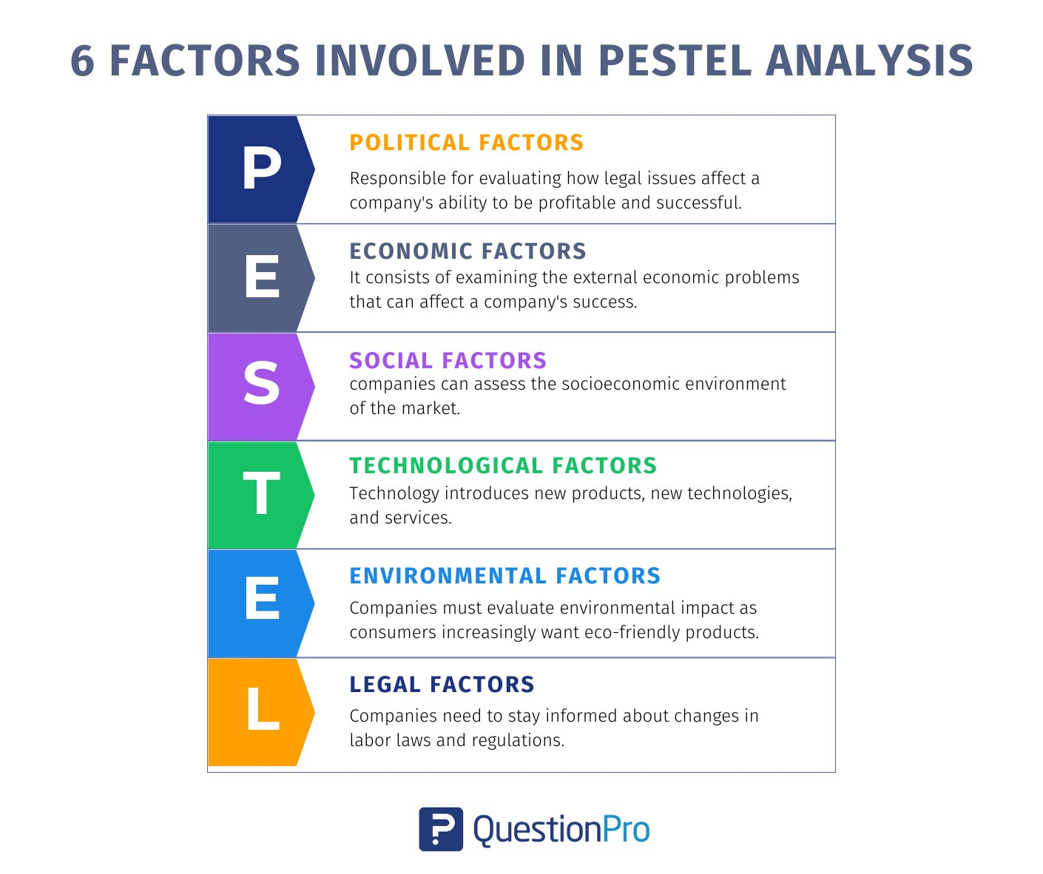
(Online Picture) Source: UWTSD

Evaluation of the impact of Organisational Culture on organisational performance of British Airways
Organisational Culture has impact on organisational performance. When the culture of an organisation is good it will definitely affect the performance of the company like an open culture promotes innovation and inclusion (Mullins, 2019). The organisational culture identified of British Airways in this report are customer excellence, openness, safety and security and caring cultures which impact the company’s performance. These culture has helped shaped the organisation performance of British Airways such as training the employees has transformed their behaviours which emphasis customer satisfaction, building confidence to express new ideas and innovation. Furthermore, it create an environment of safety and security which everyone is endeavour to ensure safety is provided in all the operations and the employees morale has increased by the improvement of good communication skills, training, good team-working and flexibility of operations. Evaluating the organisational culture of British Airways, it shows positive impact on it performance including higher customer satisfaction, better coordination which reduces conflict and the improvement of workers moral, quality services and flexibility in operations.

Recommendations
The recommendations of organisational culture of British Airways should be customer excellence and open culture which put people first that will empower the staff, promotes innovation and enhance trust.

Conclusion
To conclude, the performance of an organisation is much depend on the culture of the organisation. The organisational culture also determines the structure of the organisation which reflects the leadership style, operational functions, collaborations and engagement with all the stakeholders. However, if the organisational culture of British Airways is healthy and good, it will create an environment that facilitate growth, and contribute to company’s vision and mission, therefore, organisational culture is decisive force behind every organisations achievement.

References
Ahmady, A., G., Mehrpour, M., and Nikooravesh, A., (2016, par3), vol.230,(455-462), ‘Organisational Structure’, 3rd International Conference on New Challenges in Management and Organisation: Organisation and Leadership, Available at: https://doi.org/10.1016/j.sbspro.2016.09.057
Alvesson, M., (2013), Understanding organisational culture, 2nd Edition, Los Angeles: Sage Publications Ltd.
Allaire, Y. and Firsirotu, M., E., (2026), ‘Sage Journal’, Theories of Organisation Culture, vol.5(3), Available at: https://doi.org/10.1177/017084068400500301
Bellot, J. (2011) ‘Defining and assessing organizational culture’, Nursing forum (Hillsdale), 46(1), pp. 29–37. Available at: https://doi.org/10.1111/j.1744-6198.2010.00207.x.
British Airways, (n.d.), About British Airways, available at: https://www.britishairways.com/content/information/about-ba (Accessed on 11 July, 2026)
British Airways, ‘Our Culture’, available at: https://careers.ba.com/our-culture (Accessed on 11 July, 2026)
Deal, etal., (2003), Developing Culture Adaptability, 1st Edition, Greensboro: Centre for Creative Leadership
Hameli, K., (2024), ‘Foundation of Organisational Culture: A Comprehensive Review’, Journal of Balkan Economies and Management, vol.1(1), 53-66, Available at: https://doi.org/10.51331/bemA03
Hattangadi, V., (2020), ‘ResearchGate’, Edgar Schein’s Three Level of Organisational culture, vol.10(6), 112-118, Available at: https://www.researchgate.net/publication/392206304_Edgar_Schein's_three_levels_of_Organizational_Culture
Moravcevic, L., M., and Ruzicic, M., M., (2023), ‘CEEOL’, Organisational Structure and Organisational Culture- Impact on Innovative Behavior of the Organisation, Available at: https://www.ceeol.com/search/article-detail?id=1247528 (Accessed on 14th July, 2026)
Mullins, L., J., (2019), Organisational Behaviour in the Workplace, edn.12th , Harlow: Pearson Education, Limited
Obeng, H., A., Arhinful, R. and Teneng, R., C., (2025), ‘Sage Open’, Harmonizing Growth: Leadership Competencies’ Mediation in SMEs’ Organisational Culture and Structure Through Schein’s Model Available at: https://doi.org/10.1177/21582440251364954

