

Building a Sustainable Marketing Relationship BMSW5007
Individual Report

Name: Ciprian Grosu
Student number: 2209375

Executive Summary
This case study provides an overview of some critical strategic initiatives Tesco had used to grow sustainably after consistently flourishing within the consumer and retail sectors. Based on an analysis of current market position, competition, and other factors unique to the business, several findings can be concluded. According to analysis, Tesco is successfully providing a customer-centric approach by utilizing data analytics and technology to improve their overall shopping experience and build loyalty. Furthermore, Tesco's commitment to sustainability and corporate social responsibility efforts has struck a chord with consumers, enhancing both brand perception and long-term profitability. While clearly strong in several areas, the report highlights challenges including mounting competition from online retailers and shifts in consumer habits, suggesting changes Tesco must make to continue on its path of growth. ThereforeIf Tesco wants to get rid of these challenges, according to the report, they need to make more investment in digital development, increase their online presence and need to give more attention to sustainability and community involvement initiatives. Additionally, by incorporating these suggestions and further leveraging its existing advantages, Tesco will be able to strengthen positions in the market, enhance profitability, and sustain its ability to deliver value to both customers and stakeholders in the changing retail environment.

Table of Contents
1. Introduction 3
2. Task 1: Tesco Profile 3
3. Task 2: Impact of Data Collection, Analysis, and Evaluation on Sustainable Marketing 5
4. Task 3: Tesco’s Sustainable Marketing Strategy 8
4.1 STP 8
4.2 Porter's Generic Model 10
4.3 Ethical and Sustainability policies and practices 13
5. Task 4: Performance Evaluation and Areas for Improvement 16
6. Conclusion 18
References 19

1. Introduction
The report explores Tesco's intent to promote a sustainable customer relationship through strategic marketing. With this view of changing consumer preferences and becoming more ethical with practices concerning the environment, Tesco has been responsive and strengthened loyalty and relationships with customers by mitigating the undesirable outcomes associated with the environmental setup. Through an elaboration on the influence that the effects of data-driven marketing segmentation and pricing policy could exert on sustainability measures, it is traced how the business goals of Tesco have responded to the expectations of consumers. This analysis will examine Tesco's current performance and will seek to identify potential improvements for actionable recommendations in furthering Tesco's sustainable marketing relationships.

2. Task 1: Tesco Profile
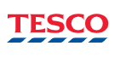
Figure 1: Company logo of Tesco
(Source: Tesco, 2024)
Tesco was owned by Jack Cohen in the year 1919 as a market stall in London (Tesco, 2021). The company then developed into one of the world's largest retailers with operations around Europe and Asia (Tesco PLC, 2024). As a grocery-retailing firm, the company spread its wings during the 1990s and 2000s through diversification in non-food sectors through electronics, clothing, financial services, and telecom (Wortmann, 2015).
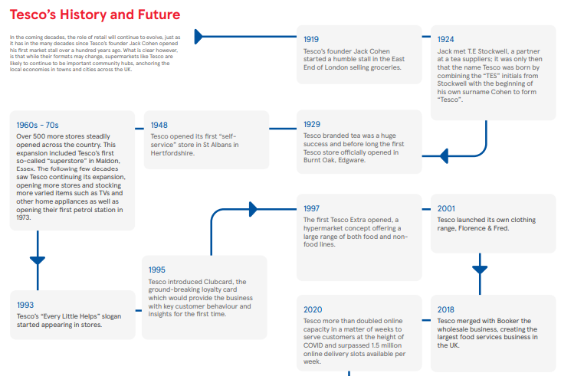
Figure 2: Company history of Tesco
(Source: Tesco, 2021)
Tesco accounts for approximately 27% of the UK grocery market as of 2023 (Tesco, 2023). Tesco has managed to sustain its market share even as it faces stiff competition from discounters Aldi and Lidl. Tesco group's operating profit for the fiscal year ending in February 2023 was at £2.63 billion, which indicates profitability in trying trading conditions (Bedford, 2024).
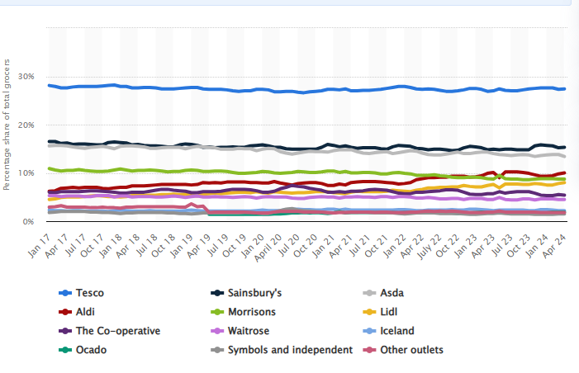
Figure 3: Tesco’s Market share in the Great Britain
(Source: Bedford, 2024)
Tesco PLC (2024) reported on their aim to be able to "serve customers, communities, and the planet a little better every day," indicating a commitment towards customer service and sustainability, which in turn will benefit the brand with strong loyalty from its customers and its competitive position in the retail arena.

3. Task 2: Impact of Data Collection, Analysis, and Evaluation on Sustainable Marketing
Data collection, analysis, and evaluation are very important aspects of forming and sustaining Tesco's marketing relationships. Through these, a retailer will be able to connect more with its customers, tailor their experience and make loyalty higher.
Data Collection
The Tesco firm collects most data through the Clubcard that are provided to the customers buying products over a certain worth. The Clubcard program has 20 million active users in the UK (Shiryaevskaya, 2023). Clubcard provides an opportunity to collect tremendous volumes of data on individual preferences and purchasing and shopping behaviours among customers.
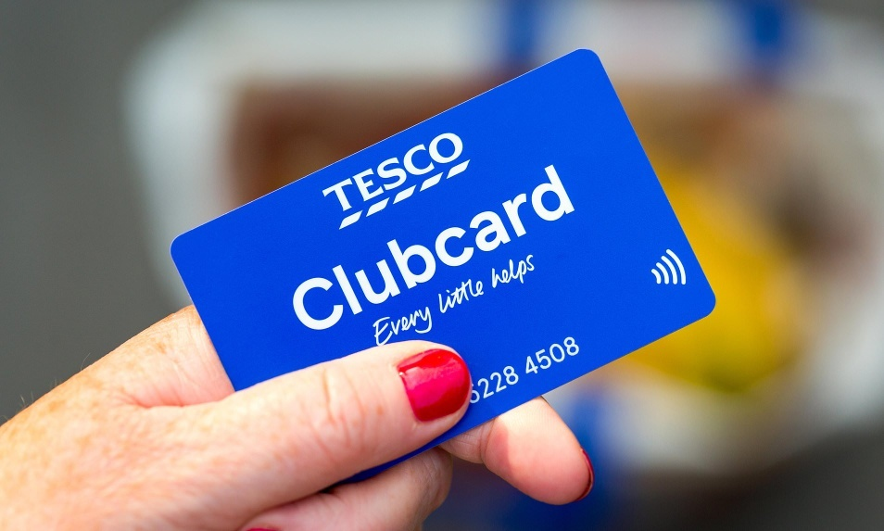
Figure 4: Clubcard strategy of Tesco
(Source: Shiryaevskaya, 2023)
Clubcard data and Tesco's website and mobile application online shopping behaviour reveal customer demographics, times they shop, preferred products, and response to promotions (Yawson and Yamoah, 2022). The detail of data collection serves as a foundation for Tesco's personal marketing approach and points out trends that are critical in the long-term handling of relationships with customers. For instance, data at Tesco has shown healthy food items and plant-based products have seen an upward trend in demand over the last few years.
Data Analysis
Advanced data analytics and AI help in spotting patterns, predicting customer requirements, and personalising marketing efforts. For example, Kang et al., (2024) reported that Tesco could predict when a customer is likely to run out of frequent items such as milk and bread using predictive analytics. Then Tesco uses this analysis to send targeted reminders or promotions to increase repeat business. Besides, data analysis, which reveals what is purchased with what else, further helps Tesco adapt in-store shelving and cross-promotional advertisement.
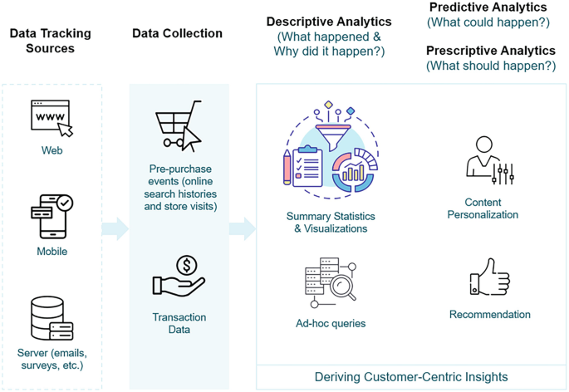
Figure 5: Analytical models for enhanced customer-centric services
(Source: Kang et al., 2024)
Since Tesco now knows what products are more than frequently purchased together, the store can put items next to one another or sell products together as a package; the convenience of shopping improves and so does the prospect of selling more (Nott, 2024). These factors have helped maintain customers over time by increasing consumer satisfaction and making shopping much more intuitive.
Data Evaluation
Marketing strategies are subject to scrutiny about their feasibility and sustainability. Tesco looks at customer retention rates, average basket sizes, and purchase frequencies for its regular checks of the KPIs (Neussner, 2021). Analysis of the data drawn from its Clubcard program and its other digital sources can also ascertain the way certain campaigns or promotions could have had effects on its customers. For instance, Tesco's "Clubcard Prices" where club members can benefit from offers on some of the goods has been very successful. In 2022, Tesco managed to note a 15% increase in usage of the clubs for such offers (Tesco Plc, 2022). A data-driven marketing approach supports the sustainability of customer relationships by continuously enhancing the value customers receive.
Babatunde et al., (2024) reported that personalised marketing, powered by Tesco's data analysis, fosters loyalty by offering relevant discounts, tailored product recommendations, and timely engagement, making customers feel understood and valued.

4. Task 3: Tesco’s Sustainable Marketing Strategy

4.1 STP
STP Analysis of Tesco is stated as below:
Segmentation:
Tesco segments its market based on demographics, psychographics, and behavioural. It categorises customers by age, income, lifestyle, buying pattern and shopping behaviour. For example, Tesco Finest targets premium customers who are looking for the best quality products, whereas, Tesco Everyday Value targets budget-conscious shoppers (Tesco, 2018). The behavioural segmentation is also highly significant, which is likely to be seen in case of Tesco's Clubcard loyalty program with over 20 million active users in the UK enables Tesco to segment based on purchase history, allowing them to have highly targeted promotions (Fleming, 2019).
Targeting:
Tesco uses differentiated targeting to reach several market segments. Tesco Express is a convenience-focused store in urban areas, while larger Tesco Extra stores appeal to families who like one-stop shopping. This diverse approach helps Tesco appeal to 27% of the UK grocery market, making it a market leader (Bedford, 2024).
Positioning:
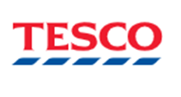
Reliability
High price, Less discounts
Un-reliable
Low Price, High discounts
Figure 6: Positioning Map
Tesco is positioned as a value-driven brand that provides good quality products at every price level. The "Every Little Helps" slogan points towards affordability and customer service (Tesco, 2021). This favours Tesco by sustaining its competitive advantage through a wide range of segments of customers.
Customer personal

Name: Sarah Johnson
Age: 56 years
Occupation: Marketing manager
Income: £45,000
Location- Suburban London
Family- Married with two children
Shopping habits
- Weekly grocery shopper
- Prefers Tesco for large shopping tips
Goals
- Finding quality products for family, saving time and earning rewards
Pain Points
- Juggling work-life balance and budgeting for family besides seeking convenience and value
Preferred channels
- Mobile apps and Clubcard for personalised discounts
Values
- Quality, convenience, family-oriented choices and eco-friendly options
Figure 7: Customer Persona

4.2 Porter's Generic Model
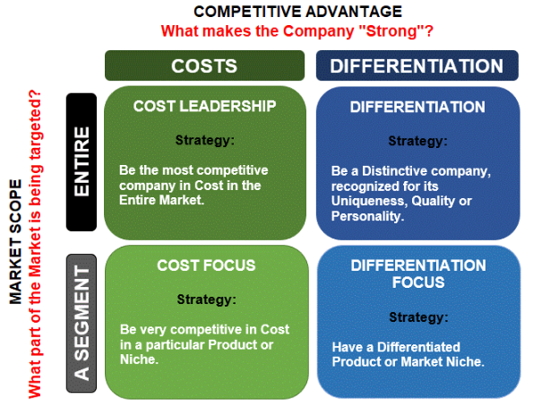
Figure 8: Porter’s Generic Model
(Source: Chauke, 2021)
Tesco has mainly adopted a Cost Leadership strategy for competitive advantage, in this case, by ensuring customer value for money (Shastri, 2023). Its supply chain optimisation and realisation of economies of scale means that Tesco maintains operational costs at the lowest levels without compromising on quality to stay competitive.
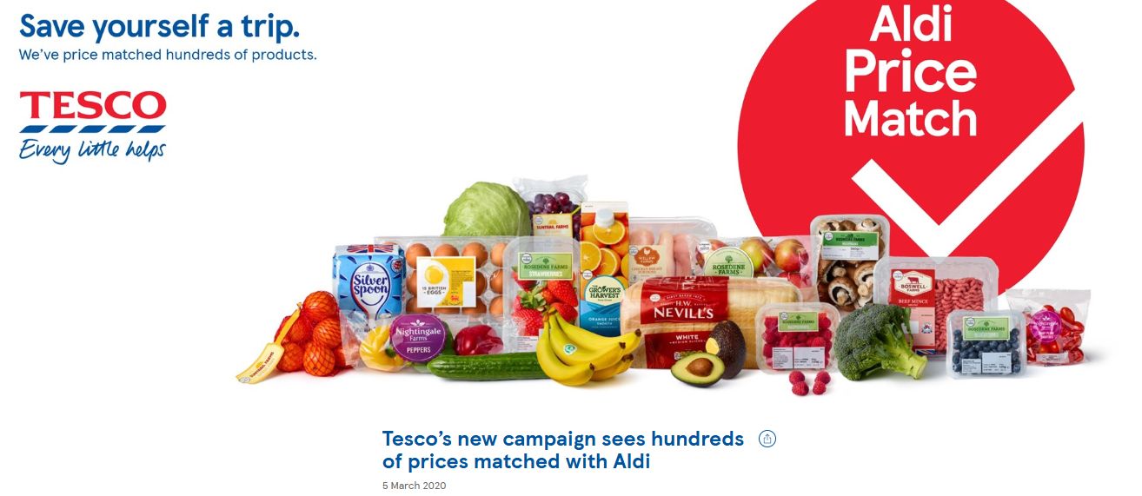
Figure 9: Evidence of Tesco’s ‘Aldi price match’ initiative
(Source: Tesco PLC, 2020)
For instance, Tesco's "Aldi Price Match" has successfully positioned the supermarket as a low-price rival to discount stores (Tesco PLC, 2020). Its price-sensitive customers come primarily during economic downturns; hence, customer loyalty increases.
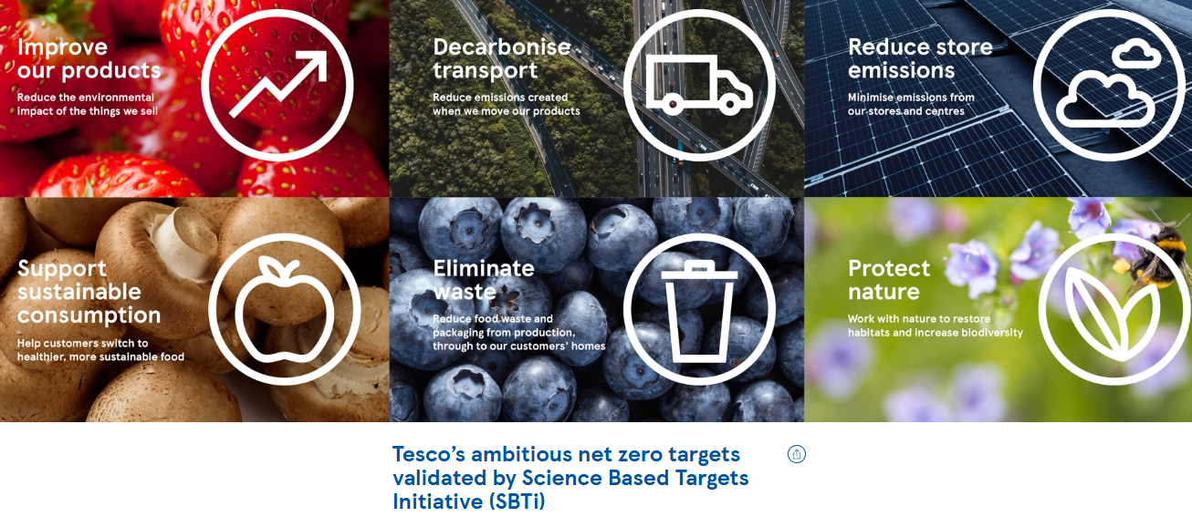
Figure 10: Evidence of Tesco’s net zero targets validated by SBTi
(Source: Tesco, 2023)
Alongside, Kar, Bansal and Mishra (2021) denoted that Tesco follows a Differentiation approach, focusing on quality, convenience, and sustainability that differentiate Tesco from its competitors. Its products, such as the Tesco Organic range, and measures to reduce packaging help Tesco appeal to green consumers. Furthermore, Tesco's ethical sourcing policies and target of achieving net-zero emissions by 2050 place the company in a different space in the market, resonating with consumers who view sustainability as paramount (Tesco, 2023). With cost efficiency combined with distinctive sustainable practices, Tesco maintains a competitive advantage by attracting assorted customers across the spectrum of market segments.

4.3 Ethical and Sustainability policies and practices
Tesco has ethics and sustainability policies that constitute its brand and operation strategy. Initially, as of the reports in Tesco (2023), the company has targeted, as a goal to be carbon neutral by 2035 through sources of renewable energy, minimising waste, and sustainable supply chains. Tesco already powers over 90% of its stores in the UK from renewable electricity and is committed to using 100% renewable electricity across all its chains by 2030 (Tesco Group, 2019). This implies that Tesco has reduced its carbon emissions by a quarter since 2019 in its supply chain.
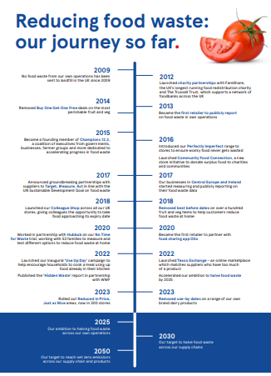
Figure 11: Tesco’s ‘No Time for Waste’ initiatives progress so far
(Source: Tesco, 2024)
As part of its effort to cut food waste, Tesco initiated a program called "No Time for Waste," under which unsold food products were donated to charities or sold at discounted prices (Tesco, 2024). Through this Tesco attained 45% food waste reduction as of 2023 (Nott and Quinn, 2024).
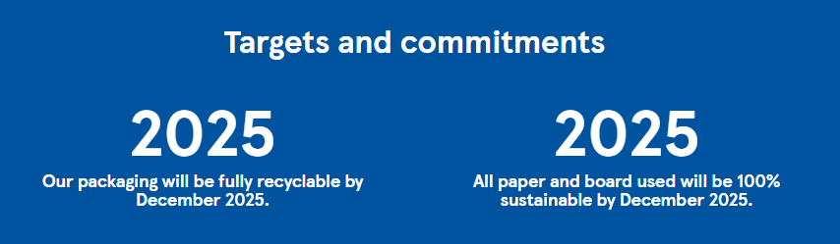
Figure 12: Tesco’s target and commitment to 100% recyclable packaging
(Source: Tesco Plc, 2024)
Alongside, Tesco has also agreed to use 100% recyclable packaging on private-label products by 2025, a target of over 70% complete (Tesco Plc, 2024). Tesco sources products from suppliers that maintain fair labour standards, especially with high-impact products such as tea, coffee, and cocoa (Tesco Plc, 2022). Hence, this policy supports the reputation of Tesco as well as the expectations of its customers about ethical and responsible practices.

5. Task 4: Performance Evaluation and Areas for Improvement
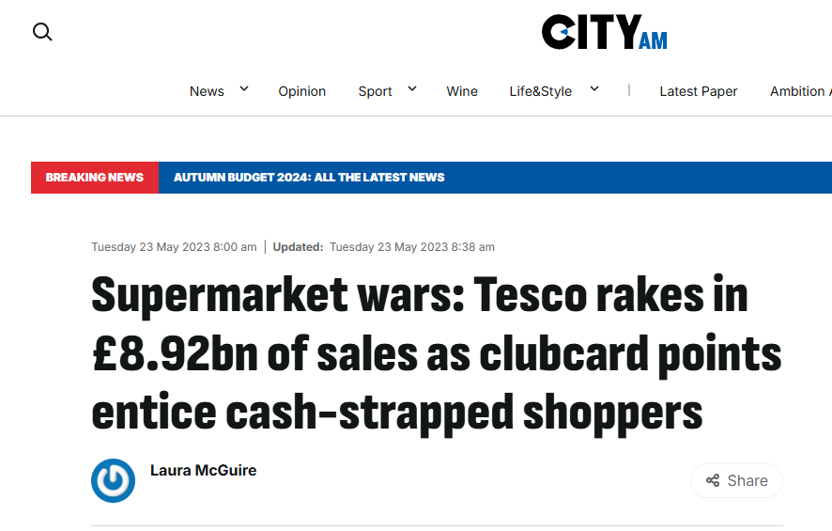
Figure 13: Evidence of Tesco’s Clubcard popularity
(Source: McGuire, 2023)
Tesco's sustainability marketing strategies have significantly enhanced the brand image and market position, mainly through customer and environmental-focused campaigns. One of the areas of performance where Tesco has excelled is through its loyalty program, the Clubcard, retaining customers and producing highly valuable information regarding shopping behaviour. According to McGuire (2023), Tesco generated £8.92 billion in sales through Clubcard points in 2023.
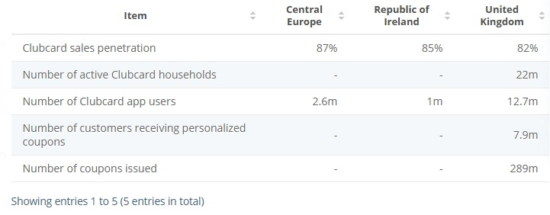
Figure 14: Tesco’s total number of members as of 2024
(Source: Statista, 2023)
As of recent achievements, Tesco has over 87% of Central Europe, 85% of ROI and 82% of the UK population as its Clubcard sales penetration, which is testimony to the success of the program in retaining and engaging customers (Statista, 2023).
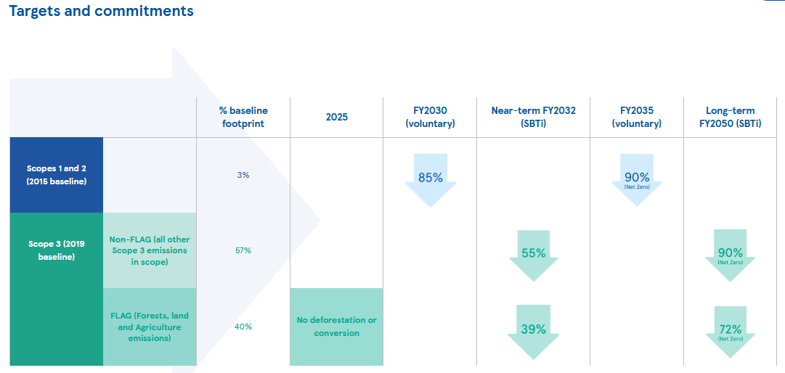
Figure 15: Tesco’s target and commitments towards the environment
(Source: Tesco, 2024b)
Another area Tesco has particularly excelled is environmental sustainability. The reports in Tesco (2024b) highlight that the company aims to eradicate carbon emissions in its operations by 2035 with an aim to attain a complete reduction of its supply chain by 2050. Recent measures taken include banning plastic packaging where the organisation has removed 2 billion plastic pieces for its business operations by 2023 (Tesco, 2023a). In addition, Tesco's energy-efficient designs for store buildings have contributed to reducing store emissions by 50% against 2015 (Tesco, 2024b).
Another area for improvement of Tesco is to improve its price strategy on sustainable products. The customers start to realise the importance of sustainability, but at the same time, the premium prices attached to sustainable products deter consumers from using them. According to a customer survey conducted in 2023, 45% of Tesco customers believe that green alternatives are unaffordable compared with similar conventional products (Tesco, 2024a). Tesco can improve its subsidy policy and achieve economies of scale by collaborative procurement with its suppliers to make sustainable products affordable for value-sensitive customers.

6. Conclusion
In conclusion, by focusing on sustainable marketing and customer relationship management, Tesco takes up the gauntlet of living up to these changing expectations of the customers. This is by ensuring that all data-driven approaches, from the Clubcard loyalty card to more efficient services, improve the provision made and increase customer satisfaction levels. Further, by being ethically responsible, sustainable, and minimisation of carbon emissions as well as reducing food waste, it cements its position within the marketplace. However, the price of sustainable products is a critical issue that needs to be addressed for the wide acceptance of the products. In general, Tesco's continuous efforts place it in a good position within a competitive environment, which ensures loyalty and promotes a sustainable future for the retail industry.

References
Babatunde, O., Odejide, N.O.A., Edunjobi, E. and Ogundipe, O. (2024) ‘The Role of AI in Marketing Personalization: a Theoretical Exploration of Consumer Engagement Strategies’, International Journal of Management & Entrepreneurship Research (Print), 6(3), pp. 936–949. Available at: https://doi.org/10.51594/ijmer.v6i3.964.
Bedford, E. (2024) Market share of grocery stores in Great Britain from January 2017 to April 2024, Statista. Statista. Available at: https://www.statista.com/statistics/280208/grocery-market-share-in-the-united-kingdom-uk/ (Accessed: 28 October 2024).
Bedford, E. (2024) Topic: Tesco PLC, www.statista.com. Statista. Available at: https://www.statista.com/topics/3807/tesco-plc/ (Accessed: 29 October 2024).
Chaucer, N.G. (2021) Master of Business Administration Strategic Analysis, Tools and Techniques (ST4S38-V1-26008) The case of Post Holdings buying Weetabix A critical strategic analysis of the current Strategic Change, Research Gate. Available at: https://www.researchgate.net/figure/Porters-generic-strategies-Consuunt-2021_fig1_355351264 (Accessed: 28 October 2024).
Fleming, M. (2019) How Tesco revolutionised loyalty with Clubcard: The Inside Story, Marketing Week. Available at: https://www.marketingweek.com/tesco-clubcard-loyalty/ (Accessed: 29 October 2024).
Kang, P.S., Wang, X., Son, J.Y. and Jat, M. (2024) ‘Analytics Models for Customer-Centric Service-Based Supply Chains’, Springer Briefs in Service Science. Springer, Cham. , pp. 35–55. Available at: https://doi.org/10.1007/978-3-031-63875-6_3.
Kar, S.K., Bansal, R. and Mishra, S. (2021) ‘Tesco: Entry and Expansion Strategy in India’, Emerging Economies Cases Journal, 3(1), p. 251660422110384.
McGuire, L. (2023) Tesco rakes in £8.92bn in sales as Clubcard points entice cash-strapped shoppers, CityAM. Available at: https://www.cityam.com/tesco-rakes-in-8-92bn-of-sales-as-clubcard-points-entice-cash-strapped-shoppers/ (Accessed: 29 October 2024).
Neussner, W. (2021) ‘Management and Measuring Customer Loyalty in Digital Marketplace—Analysis of KPIs and Influence Factors in CLTV’, Developments in Information & Knowledge Management for Business Applications, 376, pp. 151–176. Available at: https://doi.org/10.1007/978-3-030-76632-0_4.
Nott, G. (2024) Tesco marketplace launched with thousands of third-party SKUs, The Grocer. Available at: https://www.thegrocer.co.uk/news/tesco-launches-marketplace-with-thousands-of-third-party-products/691994.article (Accessed: 28 October 2024).
Nott, G. and Quinn, I. (2024) Reassessing the fight against retail food waste after Tesco’s scandal, The Grocer. The Grocer. Available at: https://www.thegrocer.co.uk/analysis-and-features/what-does-tesco-food-waste-scandal-mean-for-progress/688106.article (Accessed: 28 October 2024).
Shastri, A. (2023) In-Depth Marketing Strategy of Tesco - 2023 Study | IIDE, IIDE. Available at: https://iide.co/case-studies/marketing-strategy-of-tesco/ (Accessed: 28 October 2024).
Shiryaevskaya, A. (2023) ‘Tesco and Sainsbury’s Make Millions Off Loyalty Card Data’, Bloomberg.com, 10 December. Available at: https://www.bloomberg.com/news/articles/2023-12-10/tesco-sainsbury-s-make-millions-off-loyalty-card-data-times (Accessed: 28 October 2024).
Statista (2023) Tesco Clubcard no of members 2023, Statista. Available at: https://www.statista.com/statistics/1400244/tesco-clubcard-data/ (Accessed: 29 October 2024).
Tesco (2018) Tesco Groceries, Tesco.com. Available at: https://www.tesco.com/groceries/en-GB/buylists/tesco-finest-showcase/all-products (Accessed: 29 October 2024).
Tesco (2021) Serving communities a little better every day An economic and social impact report for Tesco, pp. 1–47. Available at: https://www.tescoplc.com/media/757995/tesco_impact_report.pdf (Accessed: 29 October 2024).
Tesco (2023) Annual Report and Financial Statements 2023, Tesco. Available at: https://www.tescoplc.com/media/u1wlq2qf/tesco-plc-annual-report-2023.pdf (Accessed: 28 October 2024).
Tesco (2023a) Tesco removes two billion pieces of plastic from its business, www.tescoplc.com. Available at: https://www.tescoplc.com/tesco-removes-two-billion-pieces-of-plastic-from-its-business/ (Accessed: 29 October 2024).
Tesco (2023b) Tesco’s ambitious net zero targets validated by Science Based Targets Initiative, www.tescoplc.com. Available at: https://www.tescoplc.com/tesco-s-ambitious-net-zero-targets-validated-by-science-based-targets-initiative/ (Accessed: 28 October 2024).
Tesco (2024a) Climate Change, Tescoplc.com. Available at: https://www.tescoplc.com/sustainability/planet/protecting-nature/climate-change (Accessed: 29 October 2024).
Tesco (2024b) Target, measure, act. Food Waste Report 2024. Available at: https://www.tescoplc.com/media/sm2hn54l/tesco-food-waste-report-jan24-96.pdf (Accessed: 28 October 2024).
Tesco Group (2019) Tesco announces major green power project in the UK, www.tescoplc.com. Available at: https://www.tescoplc.com/tesco-announces-major-green-power-project-in-the-uk/ (Accessed: 28 October 2024).
Tesco PLC (2020) Tesco Aldi price match, www.tescoplc.com. Available at: https://www.tescoplc.com/tesco-aldi-price-match (Accessed: 28 October 2024).
Tesco Plc (2022) Annual Report and Financial Statements 2022. Available at: https://www.tescoplc.com/media/759057/tesco-annual-report-2022.pdf (Accessed: 28 October 2024).
Tesco Plc (2022) Our Approach to Human Rights, Tesco PLC. www.tescoplc.com. Available at: https://www.tescoplc.com/sustainability/documents/policies/our-approach-to-human-rights/ (Accessed: 28 October 2024).
Tesco PLC (2024) Core Purpose and Values, Tesco PLC. www.tescoplc.com. Available at: https://www.tescoplc.com/about/how-we-do-business/core-purpose-and-values/ (Accessed: 28 October 2024).
Tesco Plc (2024) Packaging and Plastics, Tescoplc.com. Available at: https://www.tescoplc.com/sustainability/planet/packaging-and-plastics (Accessed: 28 October 2024).
Tesco, (2024) Online Groceries, Banking & Mobile Phones, Tesco.com. www.tesco.com. Available at: https://www.tesco.com/ (Accessed: 28 October 2024).
Wortmann, M. (2015) ‘Globalization of European Retailing’, The Market Makers, pp. 117–154. Available at: https://doi.org/10.1093/acprof:oso/9780199590179.003.0005.
Yawson, D.E. and Yamoah, F.A. (2022) ‘The TESCO Club Card Loyalty Programme: The Gold Standard’, Contemporary Retail Marketing in Emerging Economies, pp. 77–87. Available at: https://doi.org/10.1007/978-3-031-11661-2_3.

