Crown Plaza Hotel Marketing Plan

Student Name: Mihaela Ioana Bodor
Student ID: 2222468
Module: Marketing Essentials BMIH4005
Instructor: Chris Wilkin, Ruth Taylor-Davies
Word Count: 1250 words

Introduction
The level of competition in the UK hotel industry has significantly increased. There is a need to introduce value propositions to attract customers (Dinev, 2022). This marketing plan is directed towards the directors of Crown Plaza aimed at informing them of a major marketing opportunity; using virtual reality technology to offer hotel tours and improve customer experience with the hotel (Celtek, 2020). Virtual reality is a great marketing tool for the hotel to attract tourists by allowing tourists to experience the hotel before booking (Dailly, 2019). Some of the models and theories used in the plan include the 4Ps of marketing, SOSTAC, SWOT and PESTEL.
Situational Analysis
Crown Plaza is one of the biggest hotels in the UK and the world’s largest upscale brand as demonstrated in Appendix 1. It is a British multinational chain of full-service, upscale hotels headquartered in the UK. It caters to business travellers and the meetings and conventions market as well. It is part of the Intercontinental Hotels Group with more than 431 hotels operating in almost 100 countries (IHG Hotels and Resorts, 2023). Table 1 below shows the hotel’s SWOT analysis.
Table 1: Crown Plaza’s SWOT Analysis
Strengths  - One of the world’s largest upscale brands  - Strong reputation and brand image  - Huge product portfolio (IHG Hotels and Resorts, 2023).  - One of the recommended hotels by Which? (Bell, 2023).  - Luxury environment  - Easy to navigate corporate website  - Great hotel locations | Weaknesses  - Poor food quality. Rated 2-star on Which? Survey (Bell, 2023)  - Not enough hotels as compared to associated brands  - Less valuable travel packages  - Costly packages
Opportunities  - Peak tourist seasons  - Long-term potential growth in the UK hotel industry (Dinev, 2022). | Threats  - Tough internal and external competition (Dinev, 2022).  - Inflationary pressures (Dinev, 2022)  - Staff Shortages (Dinev, 2022)  - The decline in disposable income and consumer confidence (Dinev, 2022).

Segmentation, Targeting and Positioning
Crown Plaza positions itself as a modern business hotel allowing guests to focus on blending the duality of both work and life to achieve personal and professional success. It targets business travellers and the meetings and conventions market as well. Its positioning is its prime location and luxury living. It targets more selective, less price-conscious business and leisure travellers (IHG Hotels and Resorts, 2023).
Positioning Map
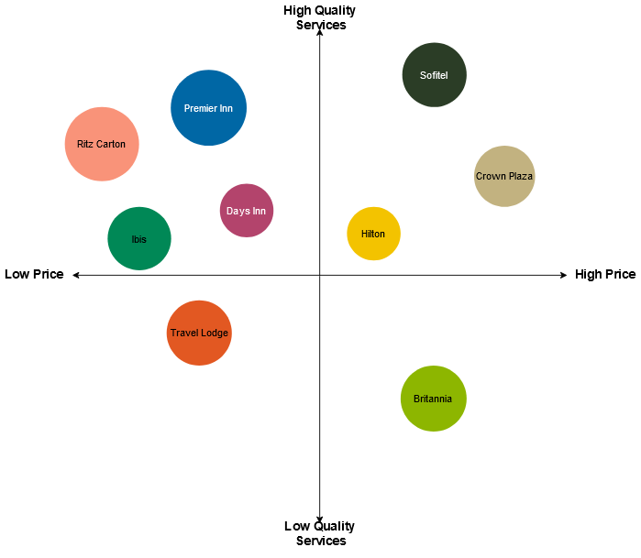
PESTEL analysis
Political Factors
Brexit is among the major political issues affecting the UK hotel industry due to its contribution to staff shortages (Dinev, 2022). Strict government regulations also impact the operations of players in the industry (Dinev, 2022).
Economic Factors
The rising inflation rate in the UK which is causing a cost of living crisis is currently the biggest economic issue impacting the UK hotel industry as demonstrated in Appendix 2 Inflation rate rose to a record high of 11.1% in October 2022 before declining to 10.1% in January 2023. This increases costs for hotels and impacts consumer purchasing power (Dinev, 2022). Rising interest rates are also impacting the industry’s recovery (Pwc, 2023). The decline in disposable income is also negatively affecting consumer purchasing power in the industry (Dinev, 2022).
Social Factors
The shortage of skilled workers is making hotels in the UK including Crown Plaza cut operations (Dinev, 2022). Consumer confidence has also continued to be hit by the cost of living crisis which negatively affects hotel occupancy rates (Dinev, 2022; Pwc, 2023). Changing preferences for hotels that enhance mental and physical well-being are also impacting hotel bookings (Mintel, 2023).
Technological Factors
The growth in online hotel bookings has provided a huge opportunity for hotels as shown in Appendix 2 (Mintel, 2023). Technologies like Virtual Reality and Augmented Reality also offer opportunities to improve customer experience (Celtek, 2020).
Environmental Factors
Increased sustainability awareness is influencing consumer booking behaviours and hotel preferences as demonstrated in Appendix 2 (Verma and Chandra, 2018).
Legal Factors
The operations of hotels in the UK are affected by the rise in National Minimum Wage as well as strict government regulations (Dinev, 2022).
Objectives
The introduction of using VR technology at Crown Plaza Hotel is aimed at increasing the hotel’s net profits by at least 20% and revenues by 15% in the next year. In addition, it is aimed at enabling the hotel to garner a huge market share. Crown Plaza is ranked 3rd place in the Which? Survey. Introducing the use of VR technology can enable the hotel to improve its position in the market. It is also aimed at attracting more clients and improving hotel occupancy rate by at least 50% in the next year. It is also aimed at increasing the number of customers at the hotel by 20% in the next six months.
Strategy
The main value proposition that Crown Plaza will offer through the use of virtual reality technology is enabling existing and potential customers, domestic customers and tourists to tour the hotel conveniently from their homes before booking. Thus, the hotel will differentiate based on the customer experience offered. Hudson and Hudson (2017) argue that customer experience is exponentially more effective than advertising in the hospitality sector. This is because, through positive customer experience, positive word of mouth is generated which is more effective in attracting customers than advertising (Hudson and Hudson, 2017).
This is exactly what Crown Plaza will offer its customers through the use of VR technology. VR will enable the hotel to show customers exactly what to expect before booking (see Appendix 3) (Celtek, 2020). The value proposition will be communicated through social media campaigns and using the hotel’s corporate website. It will strengthen the hotel’s positioning as a modern hotel brand.
Tactics
Product
Crown Plaza offers a wide range of products and services from room service, food and beverage, meeting and conference rooms, parking facilities and banqueting rooms among others. It prides itself on the provision of quality products and services (IHG Hotels and Resorts, 2023). This is what makes Crown Plaza score 74% in customer score based on the Which? Survey. The implementation of using VR technology within the company will add hotel tours to these services to improve customer experience (See Appendix 4).
Place
The place element is one of the most important elements in a company’s marketing mix (Gitman et al., 2018). One of the major competitive edges of Crown Plaza is its easily assessing and convenient locations in the UK. The hotel also uses its corporate website as well as social media platforms such as Facebook, Twitter, Instagram and LinkedIn to reach a wider audience. The hotel also uses traditional brochures to enhance brand awareness (IHG Hotels and Resorts, 2023).
With the implementation of VR technology, traditional brochures will be replaced with VR technology to create new marketing and branding opportunities. Guests will be able to access the VR service on the hotel’s corporate website to learn and experience the hotel’s physical environment before booking. It will include VR presentations, providing 360º videos and more personalised tours to attract more clients.
Price
The price charged for products and services has a huge influence on the success of an organization. It plays a crucial role in attracting customers (Gitman et al., 2018). Crown Plaza currently adopts the premium-pricing strategy. It charges high prices for products and services that are perceived to have excellent quality as well as additional characteristics and features. The hotel charges £129 on average (Bell, 2023). The same pricing strategy will be adopted after the introduction of the VR tours within the company. It will be aimed at enhancing the value offered to customers and improving the quality of customer service and experience, thus, premium pricing is more suitable.
Promotion
The VR technology that will enable Crown Plaza to offer personalised tours will be advertised and promoted through a variety of means. Social media marketing will be the most used promotional technology. The hotel will design and launch several social media campaigns that will be run on social media platforms like Facebook, Twitter and YouTube. Social media marketing is effective in reaching a wide audience (Chaffey and Ellis-Chadwick, 2019). However, word-of-mouth marketing will also be heavily relied on. The hotel will also use its corporate website to promote the new service by making it easy for customers to easily navigate the website and access the service and all the information they need about it.

Action

The most important decisions that will be made include the market to target and how to reach them (See Appendix 5). The aim is to market the new VR service within the hotel. Thus, the main target market will be young, tech-savvy adults. It will be targeted at people who are most interested in convenience when booking hotels online. Thus, they will be mainly reached through marketing channels like social media and the hotel’s corporate website. These two marketing channels are most effective because they will help reach a wider audience.
Control
A wide range of Key Performance Indicators (KPIs) and metrics will be used to measure success. These include KPIs like hotel occupancy rate, revenue per guest, the number of new customers, website traffic, the number of customers using the VR service daily, Net profit margins and turnover rate (See Appendix 5).
Conclusion
This marketing plan is aimed at marketing a new VR service at Crown Plaza. The implementation of this plan will be faced with many challenges including external threats like consumer attitudes towards VR, changes in consumer attitudes and behaviours, rising inflation which will lead to high operational costs and a decline in disposable income which might affect the use of hotel services. However, an opportunity that will be taken advantage of to mitigate the effects of these challenges is the rise in online bookings. In addition, the popularity of social media will also be taken advantage of to raise awareness of the new service.

List of References
Bell, L. 2023. The UK’s best and worst hotel chains. [Online]. Available at <https://www.which.co.uk/reviews/uk-hotel-chains/article/best-and-worst-uk-hotel-chains-aaVVF4u1jZpe> [Accessed 5th March 2023].
Celtek, E. 2020. Handbook of research on smart technology applications in the tourism industry. IGI Global Business Science Reference, Hershey PA.
Chaffey, D., and Ellis-Chadwick, F. 2019. Digital Marketing. (7th Ed.). Pearson, Harlow, England.
Dailly, M. 2019. How virtual reality can transform the hospitality industry. [Online]. Available at <https://www.linkedin.com/pulse/how-virtual-reality-can-transform-hospitality-industry-mickael-dailly> [Accessed 5th March 2023].
Dinev, K. 2022. Hotels in the UK. [Online]. Available at <https://www.ibisworld.com/united-kingdom/market-research-reports/hotels-industry/> [Accessed 5th March 2023].
Gitman, L., McDaniel, C., Shah, A., Reece, M., Koffel, L., Talsma, B., and Hyatt, J. 2018. Introduction to business. OpenStax.
Hudson, S., and Hudson, L. 2017. Customer service in tourism and hospitality. Goodfellow Publishers Limited.
IHG Hotels and Resorts. 2023. Crowne Plaza. [Online]. Available at <https://www.ihgplc.com/en/our-brands/crowne-plaza> [Accessed 5th March 2023].
Mintel. 2023. UK hotels market report 2022. [Online]. Available at <https://store.mintel.com/report/uk-hotels-market-report> [Accessed 5th March 2023].
Pwc. 2023. Hotels forecast 2022-2023. [Online]. Available at <https://www.pwc.co.uk/industries/hospitality-leisure/insights/uk-hotels-forecast.html> [Accessed 5th March 2023].
Verma, V., and Chandra, B. 2018. Sustainability and customers’ hotel choice behaviour: A choice-based conjoint analysis approach. Environment Development and Sustainability, Vol. 20, Issue 4. https://link.springer.com/article/10.1007/s10668-017-9944-6

Appendices
Appendix 1: Situational Analysis
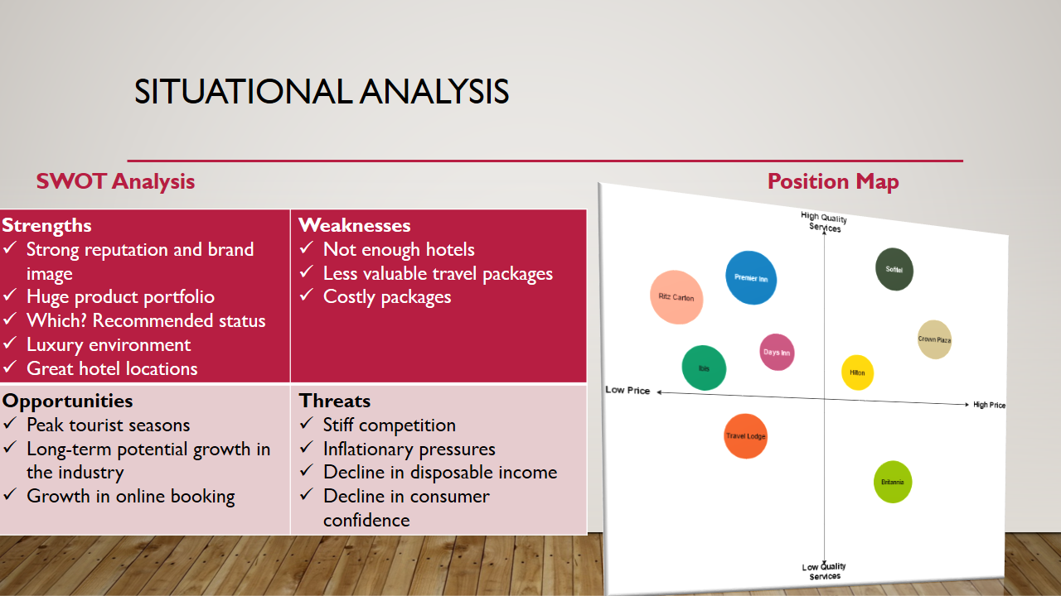
Appendix 2: Situational Analysis Cont...
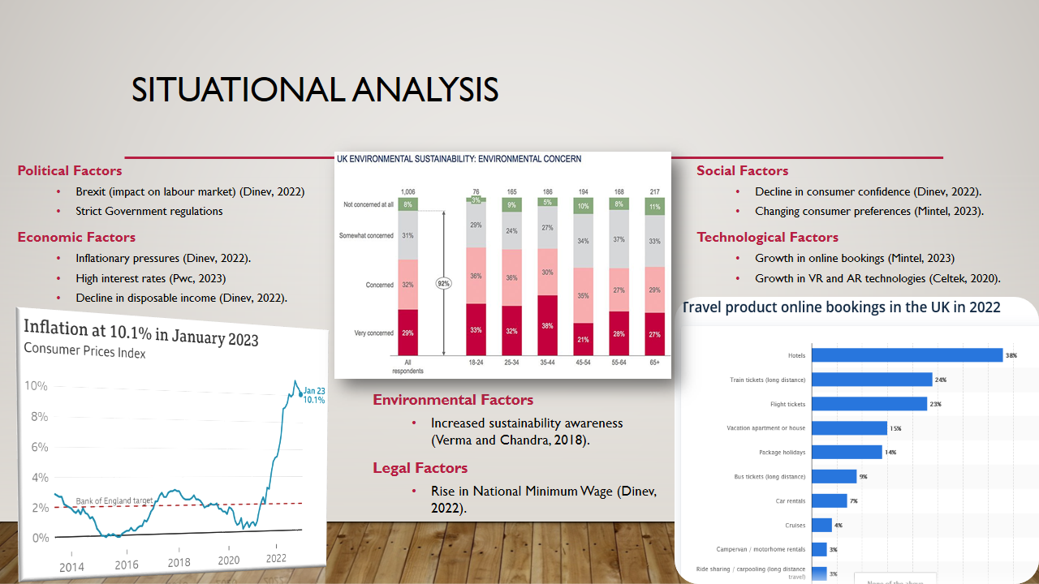
Appendix 3: Objectives and Strategy
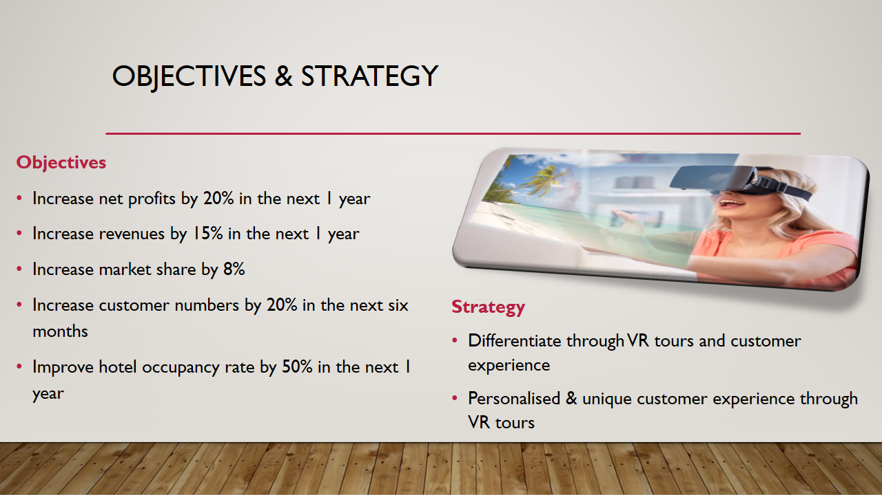
Appendix 4: Tactics
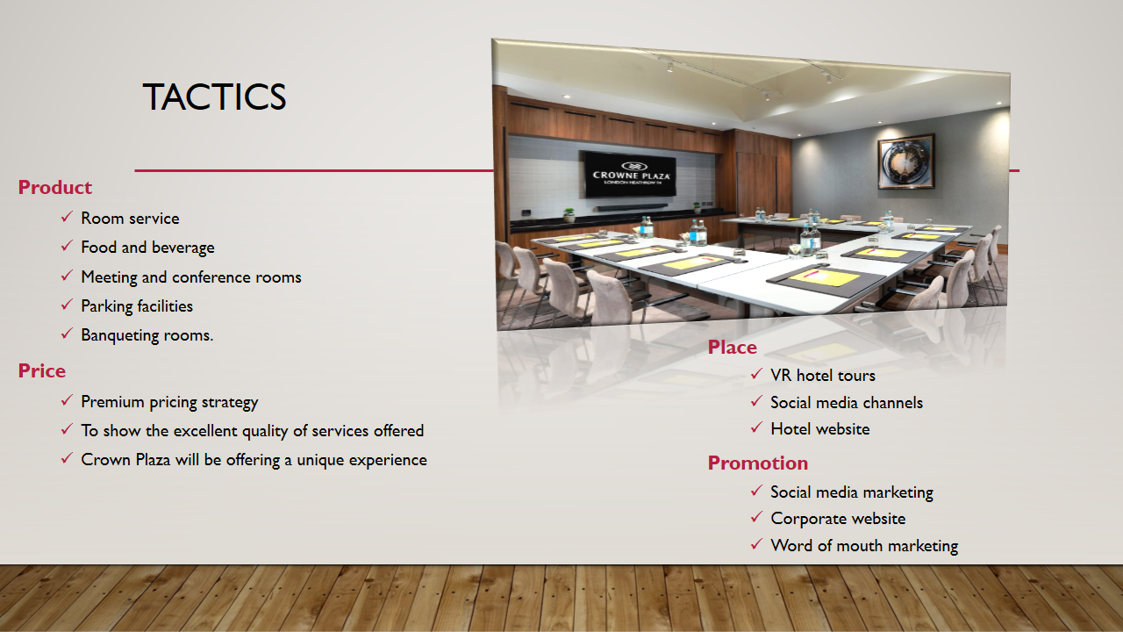

Appendix 5: Action and Control


