UWTSD: Ordnance, Munitions and Explosives
Level 5, DSP & Communications
Name: Andrew. R. Hurley
Student No. 1906810
Date: 25/03/2021
Module: ACDA5008
Lecturer: Stephen Mosey
Assignment Title: Simulation of Digital Modulation techniques

Task: Critically compare the performances of variants of amplitude shift keying and phase shift keying in the presence of additive white Gaussian noise.

Table of Contents
Table of Contents 2
1 Introduction 3
2 Background Information 3
2.1 Digital Signal Processing 3
2.2 Modulation 3
2.3 Amplitude Modulation 4
2.4 Frequency Modulation 4
2.5 Amplitude Shift Key 4
2.6 Binary Phase Shift Key 5
2.7 Quadrature Phase Shift Keying 6
2.8 Additive White Gaussian Noise 6
2.9 Signal to Noise Ratios 6
2.10 Bit Error Rates 6
3 Simulation Models 7
3.1 ASK Modulation and Demodulation Simulation 7
3.2 PSK Modulation and Demodulation Simulation 7
3.3 QPSK Modulation and Demodulation Simulation 7
4 Results 8
4.1 ASK results 8
4.2 PSK Results 9
4.3 QPSK Results 10
4.4 Comparison of Results 11
4.5 Comparison of Trend Lines 11
5 Discussion 12
5.1 Recording results 12
5.2 Discussing results 12
6 Conclusion and recommendations 12
6.1 Conclusions 12
6.2 Recommendations 13
7 Works Cited 13

Introduction

This report details an experiment taken between the relationship of Bit Error Rates and Signal to Noise Ratios, for three modulation techniques; Amplitude Shift Keying, Phase Shift Keying and Quadrature Phase Shift Keying.

All modulation techniques have been researched and documented on their workings to better any understanding before running the experiment and systems are built in MATLAB - Simulink to be able to alter variables and simulate with ease.

The results are displayed, and a discussion used to compare and conclude the findings.

Background Information

Digital Signal Processing

Digital signal processing is at the forefront of technologies to date. It is used in fields such as communications, radar/sonar and medical imaging.

DSP only uses signals as its source of data. In most cases these signals are from real world data like sound waves. The DSP part of DSP are the techniques, algorithms and mathematics that go into manipulating these signals post digitization [1].

Signals are processed like this for the users’ needs such as display, analyzing or converting to another type of signal.

The key components to any DSP are a program memory to store the data processing algorithms. A data memory to store information that needs to be processed, a compute engine to perform the functions stored in the program memory, to use on the data memory. And an input/output to connect the device to other items [2]. 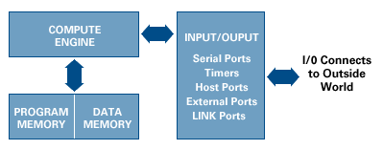

Modulation

Modulation is the process of converting data into a signal by adding information to a carrier wave.

Information can be added to the carrier by changing the variables of its wave, changing its amplitude, phase, or frequency.

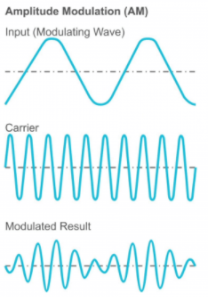
The type of modulation you do depends on the type of receiver you have too, an amplitude modulated carrier will not carry any information to a frequency modulated receiver [3].

The receiver needs to be taking samples at a frequent rate else there is the chance to miss information.

Amplitude Modulation

Amplitude modulation is a form of modulation where the input on the carrier wave sends information by changing the amplitude of the carrier to match its input.

( [4]Figure of Amplitude Modulation – Left)

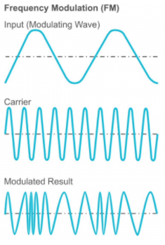
Frequency Modulation

Frequency modulation uses the same concepts as Amplitude modulation (2.3) however instead of the amplitude varying with input, the amplitude stays constant, and the frequency varies with input.

A frequency modulation receiver will ‘decode’ the signal by translating the frequencies of the carrier wave to find the information stored.

Same as prior, the receiver will need to have a rapid sample rate to avoid missing information between each sample taken, else less information on longer wavelength will need to be transmitted to avoid loss.

( [4]Figure of Frequency modulation – Left)

Amplitude Shift Key

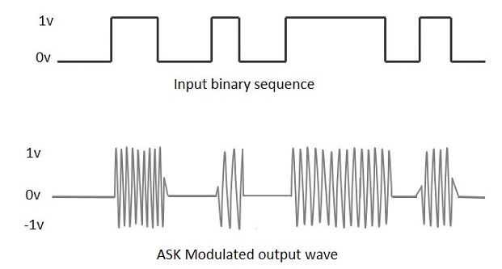
Amplitude shift keying is a type of amplitude modulation where the information translated as Binary.
With ASK, the carrier wave is a high frequency signal which is modulated into binary by having a 0-value given when there is a low input and gives the natural carrier output as the 1-value.
(ASK modulated wave [5])

To demodulate there are 2 techniques, Synchronous ASK demodulation and Asynchronous demodulation.

Synchronous demodulators consist of a square law detector, a low pass filter, a comparator, and a voltage limiter. The ASK modulated input is given to the square law detector, the low pass filter minimizes the higher frequencies and the comparator and voltage limiter help to get a clean digital output [6].

Asynchronous demodulators consist of a half-wave rectifier, a low pass filter and a comparator. The modulated ASK signal is given to the half wave rectifier which delivers a positive half output. The low pass filter minimizes the higher frequencies and gives output to the comparator which delivers the digital output.

Both demodulators take the high frequency carrier wave and translate it into a square signal wave which can be read as binary.

Binary Phase Shift Key

Binary phase shift key modulation (PSK/BPSK) is a modulation technique whereby the carrier wave has a constant amplitude and frequency, but to display a change in binary state, the wave changes phase by 180º.

The receiver would distinguish between the two and because they are large phase shifts, it is easier to distinguish between them.

This form of Modulation means that a 0-value could be phase 90º and a 1-value could be phase 270º, as long as there is 180º between the two-phase shifts.

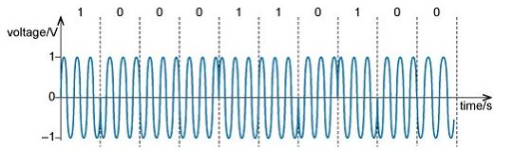
(PSK modulated carrier wave [7])

What is visible in graph above (2.6.4), is that when a value goes from a 1 to a 0 the phase shift is done on the negative amplitude at -180º, when the value changes from a 0 to a 1, the phase shift is done on the positive amplitude at -180º.

This positioning of the phase shift is important as if a sample was taken early or late and some data was missed, if 2 phase shifts where both on the negative amplitude of the carrier wave, then you can be certain that between those two samples there was a change in state from a 0 to a 1 and back to a 0 at some point [8].

As should also be visible from the graph (2.6.4) the phase does not change for every value, it changes when the value changes. This means that every individual value is represented by a set number of wave cycles/periods.

In Graph 2.6.4, its 3 cycles per bit. So, 3 0 states will take up 9 carrier wave cycles. The receiver will be set to receive this and if it is not then either you end up receiving just one 0 value or maybe nine 0 values if it were set to read a value every cycle.

Quadrature Phase Shift Keying

QPSK is a modulation technique that instead of representing one value per x number of cycles, instead represents 2 bits of information.

Rather than modulating individual 0 or 1 states, the QPSK method modulates and transmits the values 00,01,10,11.

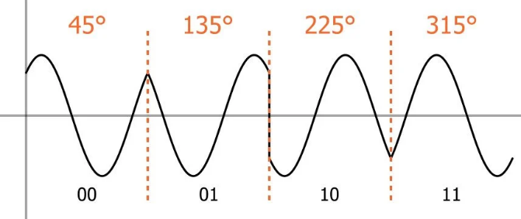
The two bits per sample is due to the carrier wave variations not being limited to the two states of amplitude high or amplitude low. Instead by manipulating the carrier waves’ Phase, the carrier wave can have four different phase shifts for four different outputs, all 45º of the last.

(4 Phase shifts in QPSK [9])

Additive White Gaussian Noise

AWGN is a model to use for noise when trying to mimic random natural noise.

Additive – The noise is added to signal, there is no noise without the signal,
received signal = transmitted signal + noise

White – Used in context of the colour white which is composed of all frequencies in the visible light spectrum. The idea is that the noise has a uniform power across the whole frequency band [10].

Gaussian – The mathematical distribution model [11].

Noise – Any unwanted disturbance in an electrical signal

Signal to Noise Ratios

A signal to noise ratio SNR compares the level of signal power to the level of noise power and has the units of dB.

The higher the SNR the better, as an SNR of 0dB is 1:1 signal to noise, so anything higher will mean there is a greater signal power to noise power.

When noise starts to be greater than the signal (A negative SNR) it becomes increasingly difficult to obtain the signal 100% correctly. Similar to trying to listen to someone talking normally in a full stadium. The noise overpowers and drowns out the signal. [12]

Bit Error Rates

BER is a parameter used to characterize the performance of data channels [13].

When transmitting data such as through ASK modulation, an important variable is the number of errors that will appear in the data when received at the desired location.

When data is transmitted via a wave, there is always a possibility of errors being introduced into the system, such as natural noise or AWGN.

BER is the method to assess the performance of a system by taking the errors found by the total number of bits.

If the Signal to noise ratio is high (greater than 0), then there should be a very small bit error rate – possibly insignificant.

Simulation Models

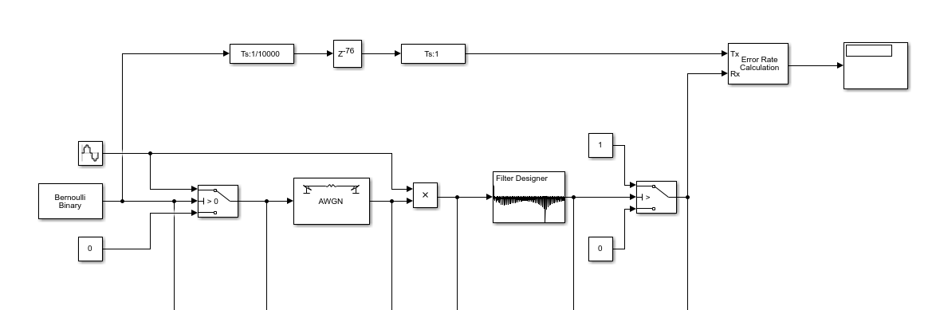
ASK Modulation and Demodulation Simulation

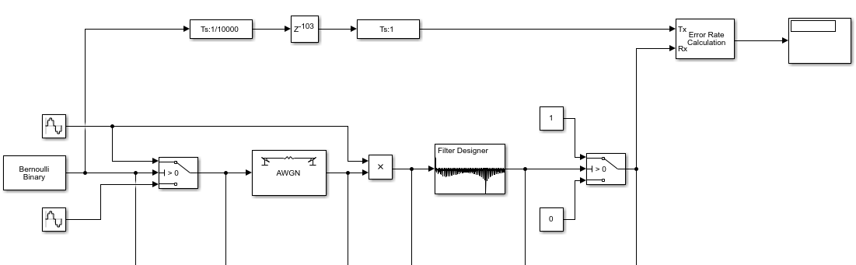
PSK Modulation and Demodulation Simulation

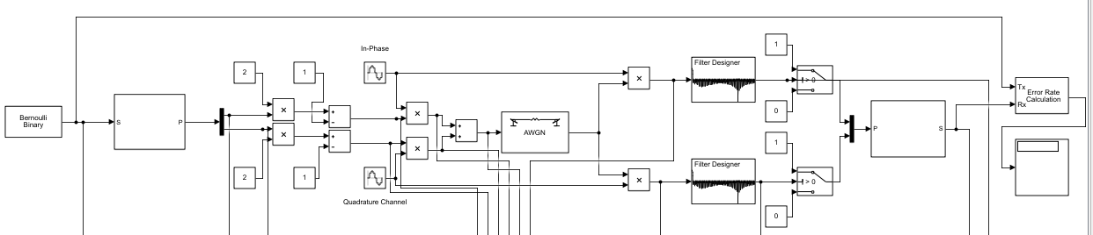
QPSK Modulation and Demodulation Simulation

Results

ASK results
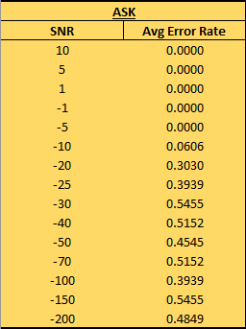
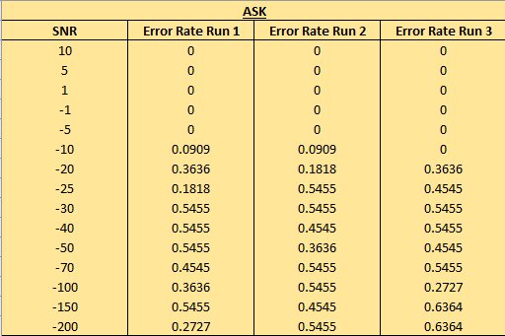

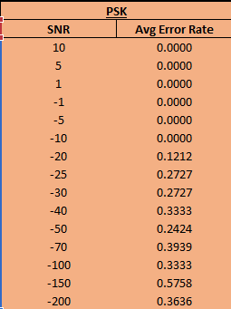
PSK Results
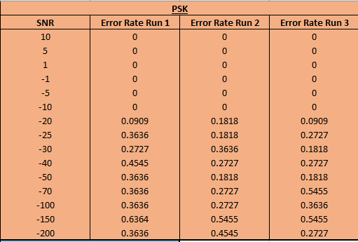

QPSK Results
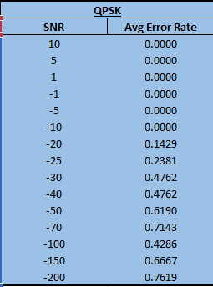
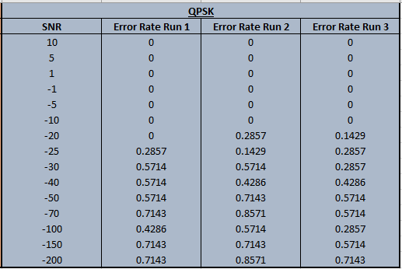

Comparison of Results

Comparison of Trend Lines

Discussion

Recording results

When running the simulations and recording the results, it was run for 10s on every circuit and at each SNR value it was run 3 times so to create an average BER.

Originally the SNR value started at +40 and down to -100, however upon viewing a BER of NIL across all circuits until an SNR of -10, the SNR independent variables were pulled back to have a range of 10 -200.

When running the simulation, it was noticed that the BER value changed on occasion when the SNR value remained the same. Due to this it was decided to run each SNR value through the simulation 3 times to create an average (visible in tables @ 4.1, 4.2 & 4.3).

Graphs for the results were created via Excel functions and from them, polynomial trend lines were added to the individual graphs. The comparison graph then was used to create a moving average trend line (period of 2) graph to grant as much visibility for these results as possible.

Discussing results

The graphs show a fairly consistent pattern of results for all simulations. SNR values of 10 -10 have little to no affect upon the error rate of these transmissions.

SNR values between -10 -30 have a rapid increase in BER across all three simulations, with an estimate of 2.2% increase in BER for every -1 SNR (22/10, these are rough figures taken from the comparison graph 4.4).

Glancing at the trend line graph, the PSK simulation would be the better simulation in terms of BER, as it trends at a lower rate compared to the other two simulations, gradual decrease on the trend graph, (-15% over +100 SNR) capping out at 47% at 200 SNR (Graph 4.5).

The ASK sim has the worst initial slope ending at an average error rate of 55% at -30 SNR, but then trends around the 48% BER from -40 -200 SNR.

Comparing that with the QPSK simulation, the BER result increased from -10 -70 SNR to an error rate of 70%.

When looking at graph 4.4, it is noted that all three simulations have a ‘dip’ in results at the -100 SNR point.

Conclusion and recommendations

Conclusions

The ASK simulation would appear to be the most susceptible to noise, which is to be expected as it is amplitude based and noise can affect hat regardless of frequency.

It starts to have an error rate between -5 and -10 SNR, the lowest SNR level of the three simulations, and has the largest initial peak of bit error rate compared with that of the PSK and QPSK.

However, after the initial peak it appears to be the most stable of the 3 simulations with a trend between 45% and 50% from -50 to -200 SNR.

The QPSK has a slower rise to initial peak, however its maximum peak is 75% which is 20% more errors than that of the next highest peak from the ASK Sim.

QPSK does however give double the data in the same length of time as that from both ASK and PSK, so if the systems SNR is kept to greater than -10, QPSK will be more efficient.

The PSK results show the lowest initial peak and trend line, but does gently creep up as more noise gets into the system, compared to ASK which appears to plateaux after -50 SNR, PSK will continuously creep up in BER as the noise increases.

Recommendations

Running these simulations at smaller SNR intervals would give a more accurate graphical representation, this in turn with running the simulations on each SNR value a few more times, 5-7 and running an average off of those would also produce a more accurate trend line, and also give very accurate error bars.

The dip at -100 SNR would also be less prominent if more SNR values around -100SNR were taken. Running these simulations on other devices would help to rule out system error rather than software.

Running the experiment at different carrier wave frequencies could also be interesting to see if the same trends appear.

Works Cited

[1] | S. W. Smith, "Chapter 1: The Breadth and Depth of DSP," in The Scientist and Engineer's Guide to DSP, 1997, p. Chapter 1 The roots of DSP.
[2] | Analog Devices, "Analog," [Online]. Available: https://www.analog.com/en/design-center/landing-pages/001/beginners-guide-to-dsp.html#. [Accessed 23 02 2021].
[3] | T. A. C.-E. S. John B. Anderson, Digital Phase Modulation, New Jersey: Springer Science & Business Media, 2013.
[4] | Radio Academy, "Radio Academy," [Online]. Available: https://www.taitradioacademy.com/topic/how-does-modulation-work-1-1/. [Accessed 23 02 2021].
[5] | Tutorialspoint, "Tutorialspoint," Tutorialspoint, [Online]. Available: https://www.tutorialspoint.com/digital_communication/digital_communication_amplitude_shift_keying.htm. [Accessed 23 02 2021].
[6] | M. K. A. Foul, "ASK demodulator," Islamic University of Gaza, Gaza, 2010.
[7] | OpenLearn University, "OpenLearn University," [Online]. Available: https://www.open.edu/openlearn/science-maths-technology/exploring-communications-technology/content-section-1.6. [Accessed 24 02 2021].
[8] | A. Bensky, Short Range wireless communication design, Butterworth-Heinemann Ltd, 2000.
[9] | R. Keim, "Understanding Quadrature Phase Shift Keying (QPSK) Modulation," All About Circuits, 17 08 2016. [Online]. Available: https://www.allaboutcircuits.com/technical-articles/quadrature-phase-shift-keying-qpsk-modulation/. [Accessed 24 03 2021].
[10] | Wireless Pi, "Wireless Pi," Wireless Pi, 18 12 2018. [Online]. Available: https://wirelesspi.com/additive-white-gaussian-noise-awgn/. [Accessed 23 02 2021].
[11] | C. Beveridge, AS&Alevel maths for dummies, Chichester: John Wiley & Sons, 2016.
[12] | Cadence PCB Solutions, "What is Signal to Noise Ratio and How to calculate it?," [Online]. Available: https://resources.pcb.cadence.com/blog/2020-what-is-signal-to-noise-ratio-and-how-to-calculate-it. [Accessed 25 03 2021].
[13] | Electronic Notes, "What is Bit Error Rate: BER tutorial," Electronic Notes, [Online]. Available: https://www.electronics-notes.com/articles/radio/bit-error-rate-ber/what-is-ber-definition-tutorial.php. [Accessed 25 03 2021].

