Component 2: Written Assignment (Report)
Changemakers: Creativity and Value Creation
Module Code: BMHP5014
Gazala Haroon
Student ID: 2411422
Lecturer: Parese Ahmed
Contents
Part 1 — Poster 3
Part 2 — Written Pitch 4
Introduction 4
Background / Problem in Health & Social Care 4
Innovation Description (AR in Nursing Training) 4
Creativity & Value Creation 5
Leadership & Change Management 5
Ethical Considerations 6
Reflective Practice 6
Implementation Plan 6
Benefits of Innovation 7
Challenges & Limitations 7
Conclusion 7
References 8

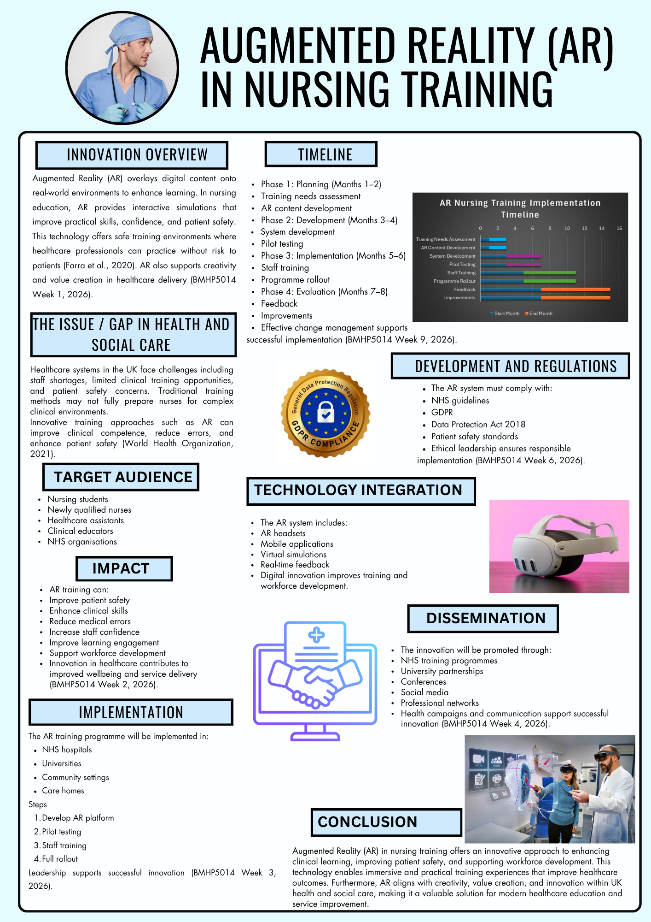
Part 1 — Poster
Figure 1: Augmented Reality (AR) in Nursing Training Poster (Created using Canva).

Part 2 — Written Pitch

Introduction
Augmented Reality (AR) is an emerging digital innovation that enhances learning by overlaying virtual elements onto real-world environments. In nursing education, AR technology can improve clinical skills, confidence, and patient safety through interactive and immersive training experiences. Traditional training methods often limit practical exposure, highlighting the need for innovative solutions in healthcare education. Integrating AR into nursing training supports creativity, innovation, and value creation within health and social care services. This proposal aims to introduce AR-based nursing training to enhance workforce competence, improve patient outcomes, and strengthen healthcare delivery in the UK (Huang, 2024; Shorey and Ng, 2021).

Background / Problem in Health & Social Care
Health and social care systems in the UK are currently facing significant challenges related to workforce shortages, training limitations, and patient safety concerns. Nursing staff shortages continue to place pressure on healthcare services, affecting the quality of care and increasing workload for existing staff (Royal College of Nursing, 2025). Traditional nursing education often relies on classroom-based learning and limited clinical placements, which may not adequately prepare students for complex healthcare environments (Shorey and Ng, 2021). These limitations can contribute to clinical errors and reduced confidence among newly qualified nurses. Patient safety remains a key concern, as inadequate training and high workload pressures increase the risk of mistakes in clinical practice (World Health Organization, 2021). Therefore, innovative training approaches such as Augmented Reality are needed to improve clinical competence and enhance healthcare delivery.

Innovation Description (AR in Nursing Training)
Augmented Reality (AR) is a digital technology that overlays virtual information, such as images, instructions, and simulations, onto real-world environments to enhance learning and performance. In nursing training, AR allows students and healthcare professionals to interact with virtual clinical scenarios while practicing real-life procedures in a safe environment (Shorey and Ng, 2021). For example, AR can simulate patient conditions, guide clinical decision-making, and provide real-time feedback during training sessions. This interactive approach improves engagement, knowledge retention, and skill development compared to traditional teaching methods. AR is considered innovative because it combines technology with experiential learning, allowing repeated practice without risk to patients. Additionally, AR supports flexible learning and improves clinical confidence, making it a valuable tool for modern healthcare education and workforce development (Kyaw et al., 2020).

Creativity & Value Creation
Creativity in healthcare enables professionals to develop innovative solutions that improve service delivery and patient outcomes. Creative thinking supports the development of new approaches, such as Augmented Reality (AR), which enhances clinical training and improves workforce competence. Creativity involves generating new and valuable ideas that address challenges within health and social care settings (BMHP5014 Week 1, 2026). Value creation occurs when innovation produces meaningful benefits for patients, healthcare professionals, and organisations. Resourcefulness also supports innovation by encouraging professionals to use available resources effectively and develop practical solutions to healthcare challenges (BMHP5014 Week 2, 2026). Therefore, AR training enhances patient safety, improves learning outcomes, and promotes sustainable healthcare improvement.

Leadership & Change Management
Effective leadership is essential for implementing innovative technologies such as Augmented Reality (AR) in nursing training. Healthcare leaders play a key role in promoting innovation, supporting staff, and ensuring successful adoption of new training methods. Strong leadership encourages collaboration, improves staff engagement, and facilitates organisational change within health and social care settings (West et al., 2022). Change management is also crucial when introducing new technologies, as staff may require training, support, and guidance during implementation. According to Week 3 materials, innovation in healthcare improves service delivery and enhances patient outcomes through creative problem-solving and technology integration . Additionally, effective health initiatives require structured planning, targeted communication, and measurable outcomes, which are key components of successful change management strategies (Week 4).

Ethical Considerations
Ethical considerations are essential when implementing Augmented Reality (AR) in nursing training to ensure patient safety and professional accountability. Data protection must be maintained when using digital technologies, ensuring compliance with confidentiality and privacy standards. Ethical leadership supports responsible decision-making and promotes safe adoption of innovative training methods. Additionally, reflective and ethical practice helps healthcare professionals evaluate risks and improve service delivery (BMHP5014 Week 6, 2026). Strong ethical leadership also encourages transparency, accountability, and patient-centred care, ensuring AR technology enhances training while maintaining professional standards (West et al., 2022).

Reflective Practice
Reflective practice is essential in healthcare as it supports learning from experiences and improving professional performance. Healthcare professionals use reflection to evaluate training outcomes, identify areas for improvement, and enhance patient care. Continuous reflection also promotes professional development and supports innovation in healthcare environments (BMHP5014 Week 7, 2026). Implementing Augmented Reality (AR) in nursing training encourages reflective learning by allowing staff to review simulations and improve clinical skills. Reflective practice contributes to continuous improvement, enhances decision-making, and supports safe and effective healthcare delivery (Mann, Gordon and MacLeod, 2020).

Implementation Plan
The implementation of Augmented Reality (AR) in nursing training will follow a structured timeline to ensure effective adoption. The first phase involves planning and stakeholder engagement, including NHS organisations, universities, clinical educators, and technology developers. The second phase includes pilot testing and staff training, followed by full implementation across healthcare settings. Effective planning and stakeholder collaboration support successful innovation and service improvement (BMHP5014 Week 9, 2026). Change management strategies also promote staff engagement and reduce resistance to new technologies. Continuous evaluation and feedback will ensure improvements and sustainability of the AR training programme (Kotter, 2020).

Benefits of Innovation
Augmented Reality (AR) in nursing training provides several benefits for staff, patients, and healthcare organisations. For staff, AR improves clinical competence, confidence, and engagement in learning. Patients benefit from improved safety, reduced clinical errors, and better quality of care. Healthcare organisations benefit from enhanced workforce development, improved efficiency, and reduced training costs. Innovation in healthcare training supports improved outcomes and service quality (Shorey and Ng, 2021; West et al., 2022).

Challenges & Limitations
Despite its benefits, implementing Augmented Reality (AR) in nursing training presents challenges. High initial costs for equipment and software may limit adoption. Staff may also require additional training to use the technology effectively. Furthermore, technical issues and limited digital infrastructure may create barriers to implementation in healthcare settings (Shorey and Ng, 2021; Kyaw et al., 2020).

Conclusion
In conclusion, Augmented Reality (AR) in nursing training offers an innovative solution to improve clinical skills, patient safety, and healthcare outcomes. This approach supports creativity, value creation, and workforce development within UK health and social care settings. Implementing AR training can enhance learning experiences, reduce errors, and improve service quality. Therefore, healthcare organisations should consider adopting AR technology as part of modern training strategies to support continuous improvement and sustainable healthcare delivery.

References
Amabile, T.M. and Pratt, M.G. (2016) ‘The dynamic componential model of creativity and innovation in organizations: Making progress, making meaning’, Research in Organizational Behavior, 36, pp. 157–183. Available at: https://www.hbs.edu/faculty/Pages/item.aspx?num=51996 (Accessed: 26 March 2026).
Care Quality Commission (2021) Enabling innovation and adoption in health and social care: Developing a shared view. London: Care Quality Commission. Available at: https://www.cqc.org.uk/publications/themed-work/enabling-innovation-adoption-health-social-care-developing-shared-view (Accessed: 26 March 2026).
Huang, H.-M. (2024) ‘Effectiveness of simulation-based augmented reality in enhancing pediatric nursing and clinical reasoning competency among students’, Clinical Simulation in Nursing, 95, 101601. Available at: https://www.sciencedirect.com/science/article/pii/S1876139924000938 (Accessed: 26 March 2026).
General Medical Council (2021) The reflective practitioner: Guidance for doctors and medical students. Available at: https://www.gmc-uk.org/education/standards-guidance-and-curricula/guidance/reflective-practice/the-reflective-practitioner---guidance-for-doctors-and-medical-students (Accessed: 26 March 2026).
Kotter, J.P. (1995) ‘Leading change: Why transformation efforts fail’, Harvard Business Review, March–April, pp. 59–67.
Kyaw, B.M., Saxena, N., Posadzki, P., Vseteckova, J., Nikolaou, C.K., George, P.P., Divakar, U., Masiello, I., Kononowicz, A.A. and Car, J. (2020) ‘Virtual reality for health professions education: Systematic review and meta-analysis’, Journal of Medical Internet Research, 21(1), e12959. Available at: https://www.jmir.org/2019/1/e12959/ (Accessed: 26 March 2026).
Mann, K., Gordon, J. and MacLeod, A. (2009) ‘Reflection and reflective practice in health professions education: A systematic review’, Advances in Health Sciences Education, 14(4), pp. 595–621.
NHS England (2021) Data Security and Protection Toolkit. London: NHS England. Available at: https://www.dsptoolkit.nhs.uk (Accessed: 26 March 2026).
NHS England (2023) NHS Long Term Workforce Plan. London: NHS England. Available at: https://www.england.nhs.uk/publication/nhs-long-term-workforce-plan/ (Accessed: 26 March 2026).
Royal College of Nursing (2025) UK RCN warns of workforce shortages causing nightmares and panic attacks. Available at: https://www.rcn.org.uk/news-and-events/news/uk-rcn-warns-of-workforce-shortages-causing-nightmares-and-panic-attacks-171125 (Accessed: 26 March 2026).
Shorey, S. and Ng, E.D. (2021) ‘The use of virtual reality and augmented reality in nursing education: A systematic review’, Nurse Education Today, 98, 104662. Available at: https://doi.org/10.1016/j.nedt.2020.104662 (Accessed: 26 March 2026).
UWTSD (2026) BMHP5014 Week 3: Innovation in UK health and social care. Module teaching materials.
UWTSD (2026) BMHP5014 Week 4: Health campaigns: Structure and effectiveness. Module teaching materials.
UWTSD (2026a) BMHP5014 Week 1: Creativity and value creation. Module teaching materials.
UWTSD (2026b) BMHP5014 Week 2: How to be resourceful: Making more with less. Module teaching materials.
UWTSD (2026c) BMHP5014 Week 6: Ethical leadership. Module teaching materials.
UWTSD (2026d) BMHP5014 Week 7: Reflective practice. Module teaching materials.
UWTSD (2026e) BMHP5014 Week 9: Implementation and change management. Module teaching materials.

West, M., Eckert, R., Collins, B. and Chowla, R. (2017) Caring to change: How compassionate leadership can stimulate innovation in health care. London: The King’s Fund. Available at: https://www.kingsfund.org.uk/insight-and-analysis/reports/caring-change (Accessed: 26 March 2026).
World Health Organization (2021) Global patient safety action plan 2021–2030. Geneva: World Health Organization. Available at: https://www.who.int/publications/i/item/9789240032705 (Accessed: 26 March 2026).

