Eleonora Mariana Filip
1807163/London
Problem Solving and Decision Making
Lecturer: Yajesh Kumar

Research report at Coca-Cola Company

Table of Contents
INTRODUCTION 3
MAIN BODY 3
CONCLUSION 15
REFERENCES 16

INTRODUCTION
Change management is one of important discipline that guides and suggests about to prepare, equip and give support to an individual for successfully adopt changes for organisational success and to get positive outcome. Management is one of structured approach to give support to an individual with objective to move from the current state to future state because good management is the backbone of organisation. This report is based on Coca cola or coke which is a carbonated soft drink manufacturing organisation which originally intended as a patent medicine invented in the late 19th century and expand their business gradually. This research report is based on organisational complex problem with its scope and impact on their activities. It also includes each and every factor that includes PESTEL and SWOT analysis to get right kind of information. It also includes the various models and theories that have to apply to achieve organisational goals and objectives.

MAIN BODY
Key information about organisation:
Coca cola originated by John Pemberton who got wounded in the American war and addicted to morphine and find out a substitute of concerning drugs. In year 1885 named as Pemberton's eagle drug and chemical house get registered as an nerve tonic (Foster, 2014.). Primarily engaged in manufacturing and sale of syrup which is an cultural institution In USA which is a symbol of American taste. It has more than 2800 products that are available in more than 200 countries. It is one of largest beverage manufacturer and distributor in whole world. In 1982 that organisation introduced their low calorie sugar free soft drink in market to enlarge business opportunities. That organisation revived their original flavour that marked as coca cola classic. It has 62,600 employees in the whole world.
Complex problem at workplace:
it is very much important for an organisation to bring changes in organisation that are very much necessary to remain always competitive in marketplace. With the help of strategic plans an organisation can improve or bring changes in their internal work environment. But sometimes people get rigid to adopt changes that hinders effectiveness of organisation to get desirable goals and objectives (Frankland and et.al , 2013.). They lead towards the rigidity, bureaucracy and resist to adopt changes in positive manner. So it creates one of most hazardous problems in front of people and organisation to get right kind of results to reap important benefits So it is very much necessary to give proper education to employees about change needs in positive manner. They have to communicate their major benefits or advantages to get right kinds of outputs so that organisational goals and objectives should be attained. Flexibility is one of important factor that ultimately helps to get best results by eliminating the major fear in employees that hinders the self interest of employees in giving their best for organisational as well as individual development (Hayes, 2018). To get flexibility it is very much potential to get know about the major factor behind the resistance of employees and factors that hinders their self interest. On other hand management is one of most important aspect by managing and running the attributes to getting things done to achieve organisational goals and objectives. The major scope of change management that change directly affect the attributes that related with change such as change in organisational goals or policy have a broad impact on who ever involved with it. Change bring variations in amount of work that needs to be done such as in change few people involved primarily in it but it last for a long time. While change comes in an organisation work should be complex gradually and requires expertise to be done in proper manner (Cameron and Green, 2015). So all are major impacts on the organisational overall working and related processes. It proved beneficial for the organisation to remain always competitive in marketplace with career enhancement of employees by attributing a lot of challenging task that enhance their level of confidence in giving their best. So it can said that change management is one of most important aspect for an organisation to remain always competitive in marketplace. The another major problem that is management not able to resolve the cultural issues that arise in their organisation which is very important to get right kind of outputs from the work force by paying attention on major attributes to get desirable outcomes. Different culture have varies kinds of behaviour that mould the working pattern in an organisation to remain always competitive in marketplace. So it is very much important to adopt flexible work environment that can be able to mould their activities as per the requirement. In that regards giving proper education to employees regarding culture with mould their behaviour to get desirable outcomes in positive manner. The major scope of that subject matter is to give best working environment and culture to employees in which they can give their best and put their efforts in right direction. It impacts on the psychology of employees and their working efforts to remain always competitive in marketplace. So it is very much important for an individual as well as organisation to build a great working environment in which every one can give their best.

SWOT:
Strength  Coca cola is one of most leading brand in sector of food and beverages and one of largest non alcoholic company. It sell their products across the 200 countries and have long product portfolio that are one of most important factor in front of them to remain always competitive in marketplace (Doppelt, 2017). They are well known in market that helps to build a strong brand loyalty in front of consumers. Their foremost identity is their unique taste that are very much hard to find elsewhere for consumers that are one of most important strength of coca cola. It bring innovation and change time to time and for that give proper knowledge and information to their employees so that they feel comfortable and confident enough in giving their best for organisational as well as individual development. It has nearly eighty billion dollar company evaluation and their innovative mindset build them one of most leading organisation that are putting names of consumers on their bottles to promote their products, take pictures and next on bottle so all are plays very crucial role to give best products and services to their ultimate consumer base to remain always competitive in market place. With help of it they able to bring changes in their activities in an innovative manner. | Weaknesses  The major weaknesses in front of Coca cola that has lot of competitors in which one of Pepsi that would have a clear market in beverage sector that forces to bring changes in their products and services frequently. The another major weaknesses that they have lower product diversification in comparison to Pepsi that have kinds of snacks such as Lays and Kurkure so in that segment they leg behind so that hinders the self interest of organisation as well as individual in giving their best. With the products of coca cola that are carbonated drinks that are major source of sugar intake that are cause of tow major health issues that are diabetes and obesity. In that case people avoid to consume it that lessen down their profitability (Langley And et.al ., 2013.). So many health practitioners prohibited to consume that kind of drinks.
Opportunities  There are some major opportunities in front of coca cola that helps them to enlarge business opportunities in positive manner that are they can bring new products and can diversify their segment in which they presently working that helps to enhance their revenue (Drucker, 2012). The another major opportunity in front of Coca cola that are they can enhance their presence in developing nations where climate remain always hot so that they prefer the drinks to consume. | Threats  there are some kinds of threats also that creates obstacles in progress of organisation that are they faces some kind of controversies that are water management issues. Many social groups claimed about that it harms a lot of water. The another controversy that are packaging that are not eco friendly in nature that harms self interest of an organisation as well as individual in giving their best. They faces both direct and indirect kind of competition that proved harmful.

PESTLE:
Political factor  Coca cola and other soft drinks such as Pepsico they and their products are come in category of non alcoholic beverages which regulated by government by managing manufacturing procedures and if companies fail to meet their expectations then subjects to fail. Change in accounting standards, taxation directly impacts on their business in UK market. | Economic factor  Economic factor directly affect on the business proceedings of coca cola. At time of 2001 recession to combat from their effects they plan and take aggressive actions for research and development while capitalize new products and services in proper manner. So coca cola plan and coordinate each and every attribute to get desirable outcomes.
Social factor  In social factors people are keenly interested to consume healthy food that strongly influenced to their living style and many consumers switched their products. Consumers in between age of 37 to 55 concerned for nutrition food and large no. of people are baby boomers that hinders their self interest. | Technological factor  New technology and machinery helps to coca cola to bring better products and services. Coca cola have factories in UK with best of machinery that provide fast delivery of goods that helps to give delighted experiences.
Legal factors  Legal factors directly affect the food and beverage producers to control ingredients of products and services so that not face any kind of legal disputes (Doppelt, 2017). They take patents and other intellectual property rights to save their rights. By applying various kinds of laws that are very much necessary to survive in market of UK by saving self interest of employees so that best results should be achieved by harmonious works and activities. | Environmental factor  To save from any kind of controversy organisation planned to bring various kinds of schemes to boost the recycle products in context of materials, packaging that helps to build loyalty of consumers to remain competitive in market place for long time. By using 100 billion single use plastic bottles in a year they save or plan recycle use plastic to remain always competitive in marketplace by bringing best products and services for ultimate consumer base.

Fish bone Diagram:
Fish bone diagram is one of most important concept that also known as Ishikawa diagram that proved useful for giving answers of some important queries or questions to solve various kinds of problems that arise in an organisation. It helps to find out the root cause of problem with the category of process that represents the great source of outputs in variable format. The another name of that diagram is cause and effect diagram that used to identify the root cause that causing a problem. It is one of formal step in screening the cause (Yazdani and Tavakkoli-Moghaddam, 2012. ). After that identify major cause by further testing to confirm about the root cause so that proper solutions should be identified in proper manner. That model or diagram helps in any kind of problem that faced by an organisation and can be change as per the circumstances. In context of coca coal they build various kinds of strategies and tactics to overcome from the problem of inability to change with management problem in which cultural diversity occurs. For an example in context of coca cola their major issue is inability to change that proved harmful in getting desirable goals and objectives in positive manner. In inability to change major cause can be undefined objectives, unrealistic results, misunderstanding regarding the strategy that should be from the planning side of change management and gaps in understanding of people. On other side the problems that arise due to people are lack of teamwork, inexperienced staff that unable to understand the changes and people that come from different backgrounds and poor communication that hinders self interest of organisation as well as individuals (Coccia, 2018.). In that internal and external factors should be evaluated in proper manner such as in case of not proper training and development to employees and external pressure to remain always competitive in marketplace by eliminating causes of hindrances in gaining potential goals and objectives.

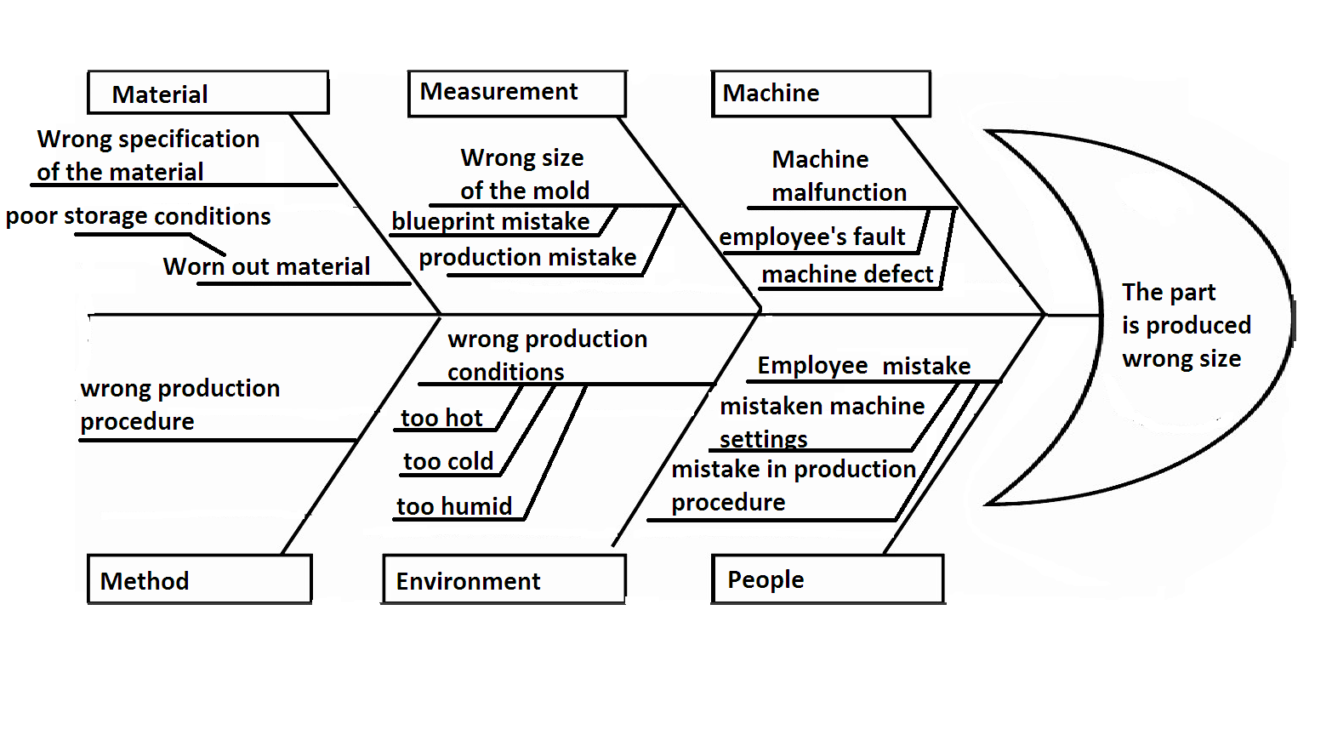Illustration 1: Fish bone method of learning 2019
Source: Fish bone method of learning 2019

Matrix Structures:
The matrix organisational structure that is a combination of two or more kinds of organisational structure. Usually two chains of command by which project team members have the two bosses or managers to deliver right kind of knowledge and information. In context of Coca cola they follow a systematic chain of command in which right kind of knowledge and information should be shared properly (Weaver and Gere, 2012.). They follow the matrix organisational structure in which business responses in majorly large scale projects to get desirable outcomes. To implement that coca cola uses the fast track technology applications and required the ability to process a lot of data and materials in a effective manner. In that regards organisation and its plays a very important role to distribute roles and responsibilities in proper manner so that each and every individual can give their best in organisation as well as individual development. So all these structures helps to understand the problems in depth and then gives their major decisions to solve the problems in proper manner to remain always competitive in marketplace.
Various models and tools:
- Force field analysis:
Kurt lewin's force field analysis is one of most important strategic tool for understand and manipulate requirements to bring changes at both corporate and personal environment. It is one of most Important change management tool that ensure about to respond in positive manner. Change is one of most difficult process for an organisation and its employees and that model applies for those organisations that implement changes (Swanson and Creed, 2014.). In context of Coca cola that are suffer from the problem of resistance to change and cultural diversity in their organisation so in that case need of force field analysis should be must. Force field analysis model developed by the Kurt Lewin that helps to predict in advance about factors that resist to change to bring healthy changes in organisational development and enhancement. Change affected to an organisation in different manner such as in coca cola due to introduction of new technology that helps to them to remain always competent in business environment.
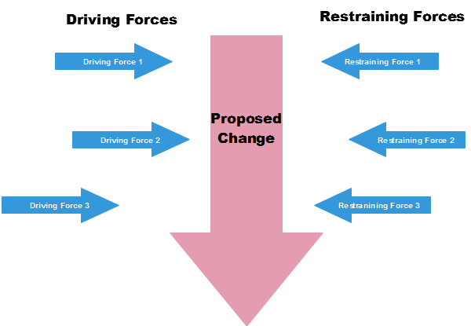Illustration 2: Full understanding – Force field analysis definition 2019
Source: Full understanding – Force field analysis definition 2019
Possible obstacles:
Force field analysis is one of most important strategic tool that helps to evaluate attributes that are require to bring changes in a business and environment. It helps to make clear that respective factors could hinders to bring changes (Stone, 2015.). It helps to Coca cola to get aware about difficulties that they will face while envisaged changes. In respective organisation by sharing the knowledge and information in proper manner they feel responsible about their duties properly.
Driving and restraining forces:
it is very much important distinguish in between driving and restraining forces to bring changes in their organisation. In restraining forces are the obstacles in way of change. In context of coca cola their major forces to resist changes that are employees have fear to lost the job and they are not properly know about working of tools and techniques that used. The most driving forces that management give proper education about benefits of particular change so that competitive advantages should be gain in positive manner.
That tool proved very much important for an organisation to determine the driving and restraining factors to bring changes in organisational development and enhancement by reaching desirable goals and objectives.
- Burke Litwin Model of Organisational change
This model helps in establishing and defining cause and effect relationship of change at organisation. There are 12 dimensions which leads to change in enterprise. It is adopted by Coca-Cola which is described below:
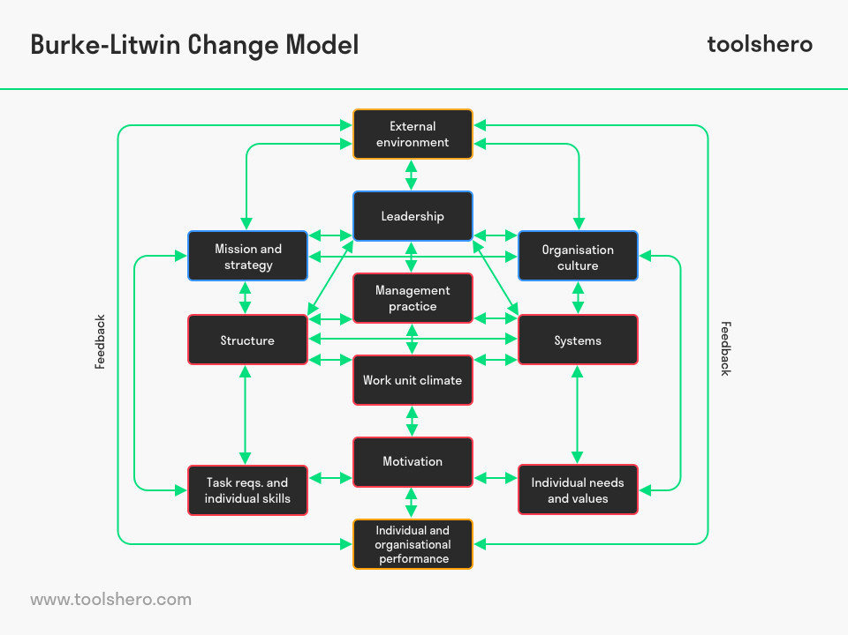Illustration 3: Burke Litwin Model of Organisational Change 2019
Source: Burke Litwin Model of Organisational Change 2019
External Environment- The external environment is significant for organisational change. The changes in competition, economy of nation, legislation, politics, customer behaviour greatly influence Coca-Cola for modifying their business. It helps in knowing direct and indirect impact on business and their operations. As such factors cannot be controlled but their impact can be reduced.
Mission and Strategy- The mission, vision and strategy of organisation are framed by management. It is very important for respective organisation to check their strategy and goal on regularly basis so that objectives can be meet.
Leadership:
Leader is one of important individual that give direction to employees when changes occurs in organisation. In context of Coca cola when changes occurs then managers develop a vision to motivate their workforce. They have key insights about their respective roles and responsibilities that proved beneficial in condition of change.
Organisational Culture:
Organisation follows some kind of values which are less formal from mission and strategy element but that are present through out the whole organisation. Culture of a firm that includes both explicit and implicit rules and regulations, practices and principles (Spangenberg and Theron, 2013. ). In context of Coca cola by maintaining healthy corporate culture they gain harmony in their organisation.
Structure:
In structure includes the hierarchical work format in an organisation, various departments and formal communication system to deliver right kind of message to ultimate user. While changes occurs in an organisation management follows the systematic structure to share the roles and responsibilities for decision making and control.
Systems:
System related with policies and procedures that proved beneficial for organisation to take help and support. By taking help from IT services, various internal departments that cover both employees and organisational activities
Management Practice:
Management practice related with behaviour and activities of a manager and they focus on implementation of strategies that proved beneficial to apply changes.
Working Climate:
Working climate related with the employees experiences while come into working environment. In that aspect mutual relationship with colleagues so that they remain always satisfied in atmosphere of firm.
Tasks and Skills:
Tasks and skills are very much important for an organisation as well as individual to get one of best efforts by aligning job description and expertise of employees. While change occurs in an organisation it is very much necessary to give proper knowledge and capabilities to employees so that they can give their best.
Individual Values and Needs:
In an organisation always a employee expects healthy work environment and evaluate the demand and expectation side such as remuneration, work life balance with roles and responsibilities (Stone, 2015.). In context of Coca cola they focus majorly on expectations of employees that should be fulfilled in proper manner so that they can put best efforts.
Motivational Level:
Motivation refers to setting goals and objectives by inspiring and stimulating employees in positive manner. When employees remain always motivated they become more dedicated in giving their best in organisational as well as self development.
Individual and General Performance:
In that particular dimension includes the performance level at each and every level such as individual level, departmental level and at organisational basis. The performance should be evaluated on basis of turnover, level of productivity and requirement of quality work with consumers satisfaction level and many more. In context of Coca cola they measure performance of individuals on different basis to get right kind of goals and objectives.
- Kurt Lewin's Change Model
Lewin's change model represent state of ready to change. It was first proposed in 1947 in Lewin's paper 'Frontier in Group Dynamics'. The paper of Lewin assessed that how behaviour of different groups affected overall change processes and performance of an organisation. This model is also known as 'Change Management model' describes analysis how an enterprise adapt changes and deal with change. His model proposed three main stages to change its current state to a desired future state, these are as follows:
- Unfreeze: The initial stage of change model is unfreezing. And goal of this phase is to create awareness among employees that how change affect and hindering working conditions of organisation. Old actions, way of thinking and processes create hindrances in smooth working of an enterprise (Cummings, Bridgman and Brown, 2016.). Some individuals accept changes and adjust with them easily as per their behaviour and interest. But few of them may be not ready to adapt changes with transitions in environment and terms & conditions of an organisation. Its a responsibility of leader or management team to aware them of change and get them prepare to adapt modifications. In context to Coca cola, to be in leading position it has to bring changes and make their employees set to adapt those alterations with a proper guidance of change management team of this enterprise.
- Change: This stage of Lewin's model is in relation to transitions or implementation of changes. Change stage is that where people begin to resolve their hesitations and look for new ways to do things effectively (McGarry, Cashin and Fowler, 2012.). In context to Coca cola, from first stage of this model to second one, individuals takes a lot of time to embrace new ways and participate in activities relating to change. This can be achieved by proper time and communication between them. Its a duty of each employee to accept transitions and understand benefits of these changes in long period of an organisation.
- Refreeze: Lewin at this stage describing refreezing as proper reinforcing, stabilizing and hardening new state after modification in environment. This is an important stage in Coca cola also, to ensure that employees are working with new procedures or they doing in old ways. It needs to concrete changes in working of respective organisation's culture and maintain ways of thoughts or processes. Refreezing will give an opportunity to individual and Coca cola to adapt new enterprise and take full advantage of it.

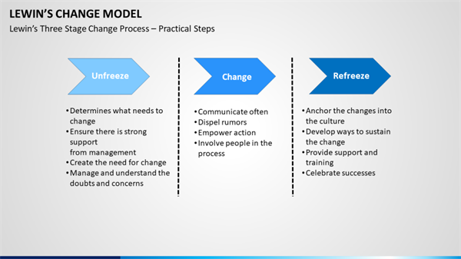Illustration 4: Charting For Change In The Workplace 2019
Source: Charting For Change In The Workplace 2019

CONCLUSION
From the above report it has been concluded that changes are very much important for an organisation to remain always competitive in market place. With the help of change an organisation can deliver one of best value to their consumers that are rare in nature to gain competitive edge. There are various kinds of theories and practices that helps to understand the requirement of change management for getting necessary outputs in positive manner. At that time proper education and information proved beneficial for organisation as well as individual to get important outcomes to reach at large no. of consumer base. So while changes occurs in an organisation proper planning and implementation plays crucial role to get optimum benefits.

REFERENCES
Books and journal:
Cameron, E. and Green, M., 2015. Making sense of change management: A complete guide to the models, tools and techniques of organizational change. Kogan Page Publishers.
Coccia, M., 2018. The Fishbone diagram to identify, systematize and analyze the sources of general purpose Technologies. Journal of Social and Administrative Sciences. 4(4). pp.291-303.
Cummings, S., Bridgman, T. and Brown, K.G., 2016. Unfreezing change as three steps: Rethinking Kurt Lewin’s legacy for change management. Human relations. 69(1). pp.33-60.
Doppelt, B., 2017. Leading change toward sustainability: A change-management guide for business, government and civil society. Routledge.
Drucker, P., 2012. Managing in a time of great change. Routledge.
Foster, R.J., 2014. Corporations as Partners:“Connected Capitalism” and The Coca‐Cola Company. PoLAR: Political and Legal Anthropology Review. 37(2). pp.246-258.
Frankland, R. and et.al , 2013. Integrated change management unit. U.S. Patent 8,484,111.
Hayes, J., 2018. The theory and practice of change management. Palgrave.
Langley, A.N.N. And et.al ., 2013. Process studies of change in organization and management: Unveiling temporality, activity, and flow. Academy of management journal. 56(1). pp.1-13.
McGarry, D., Cashin, A. and Fowler, C., 2012. Child and adolescent psychiatric nursing and the ‘plastic man’: Reflections on the implementation of change drawing insights from Lewin’s theory of planned change. Contemporary nurse. 41(2). pp.263-270.
Spangenberg, H. and Theron, C., 2013. A critical review of the Burke-Litwin model of leadership, change and performance. Management Dynamics: Journal of the Southern African Institute for Management Scientists. 22(2). pp.29-48.
Stone, K.B., 2015. Burke-Litwin Organizational Assessment Survey: Reliability and Validity. Organization Development Journal. 33(2).
Swanson, D.J. and Creed, A.S., 2014. Sharpening the focus of force field analysis. Journal of change management. 14(1). pp.28-47.
Weaver, W. and Gere, J.M., 2012. Matrix analysis framed structures. Springer science & business media.
Yazdani, A.A. and Tavakkoli-Moghaddam, R., 2012. Integration of the fish bone diagram, brainstorming, and AHP method for problem solving and decision making—a case study. The International Journal of Advanced Manufacturing Technology. 63(5-8). pp.651-657
Online:
Burke Litwin Model of Organisational Change 2019 [Online] Available through <https://www.toolshero.com/change-management/burke-litwin-model/>.
Charting For Change In The Workplace 2019 [Online] Available through <https://www.humansynergistics.com/blog/culture university/details/cultureuniversity/2018/01/31/charting-for-change-in-the-workplace>.
Fishbone method of learning 2019 [Online] Available through <https://thriveglobal.com/stories/fishbone-method-of-learning/>.
Full understanding – Force field analysis definition 2019 [Online] Available through <https://www.edrawsoft.com/force-field-analysis-definition.php>.

Full Understanding - Force Field Analysis

Full Understanding - Force Field Analysis Definition

Full Understanding - Force Field Analysis Definition

