Gender and Culture Bias Presentation
By Shannan Condon

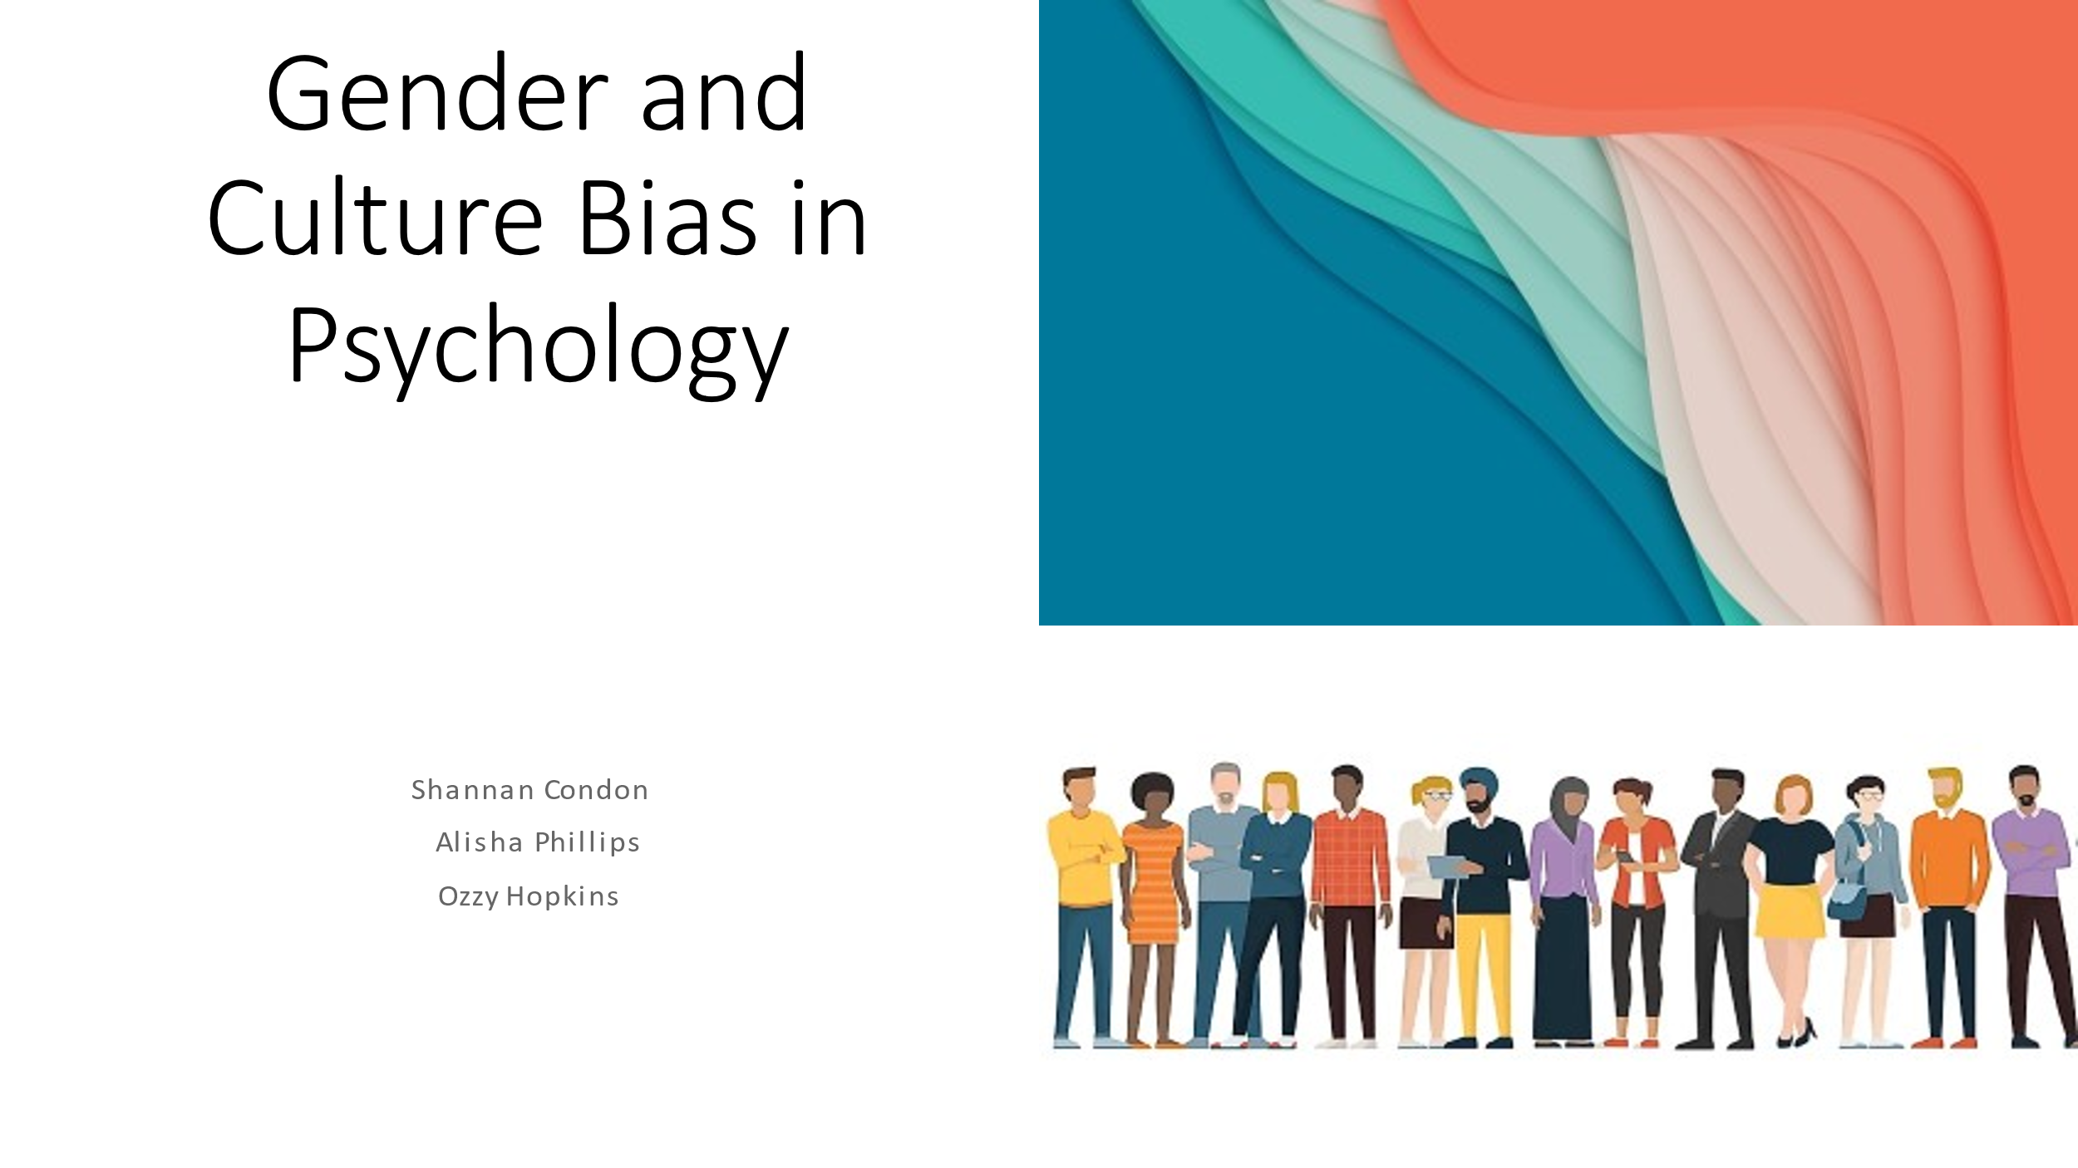

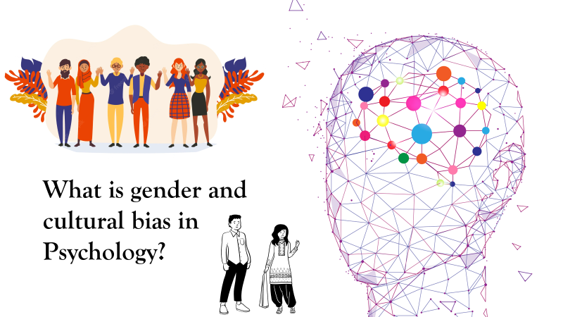

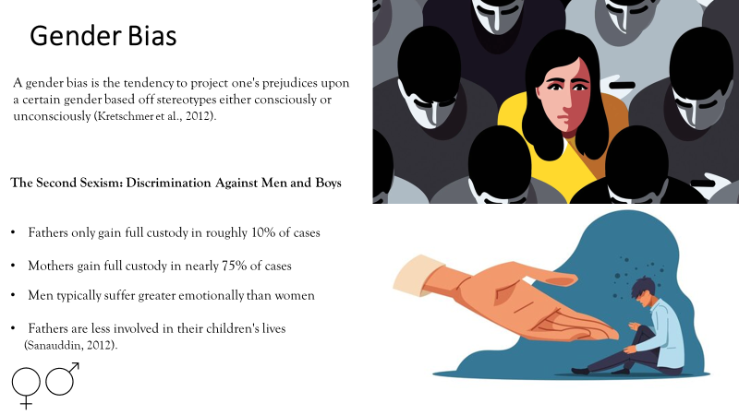

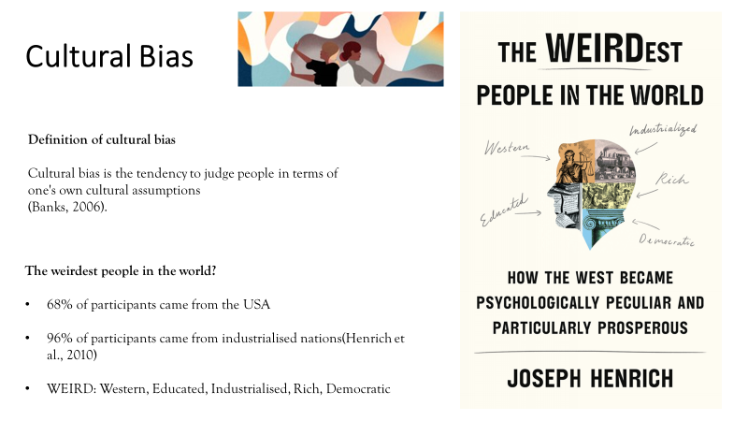

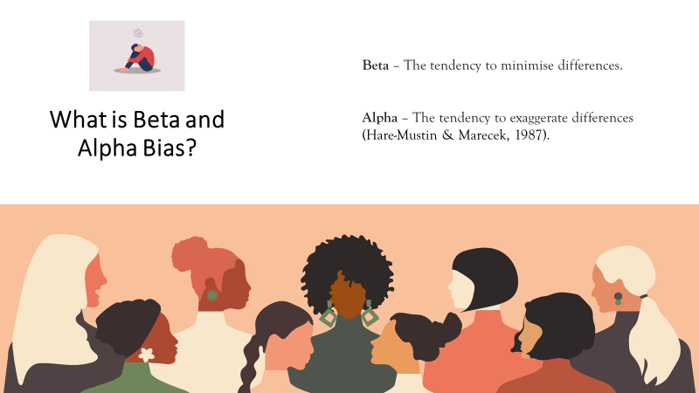

Presentation notes

Slide 1

This presentation will focus on “Gender and cultural bias in psychology” and has been made by Ozzy Hopkins, Alisha Phillips, and myself.

Slide 2

So, what is gender bias?

A gender bias is the tendency to project one's prejudices upon a certain gender which is usually based off inaccurate stereotypes.

A gender bias occurs when one gender is treated less favorably than the other, often referred to as sexism.

This is evident within this study, “The Second Sexism: Discrimination Against Men and Boys”.

Interestingly, this study focuses on gender bias towards males rather than females and makes some interesting discoveries.

Some of these findings include,

Fathers are found to only gain full custody of their children in approximately 10% of all cases. In comparison, mothers gain full custody in an astonishing 75% of all cases.

Men are found to suffer more emotionally when compared to women, again highlighting the contradictions found within stereotypes. It is believed that this is due to father’s being less involved within their children’s lives.

Slide 3

So, what is cultural bias?

Cultural bias is when people are generally judged by their own cultural beliefs and assumptions.

A good example of this can be found within the study “The weirdest people in the world”

This study analysed other studies and found that 68% of people who participated in these studies came from the USA and that 96% of participants came from industrialised nations.

This demonstrates the cultural bias that was prevalent in that time and displays how the results of biased studies may have impacted the general public's cultural opinions.

As shown here Henrich used the ‘Weird’ acronym to highlight the preferred participants used for their studies. Which includes,

- Western
- Educated
- Industrialised
- Rich
- Democratic

This clearly showed a use of cultural bias which would strongly influence the results of these studies by excluding the participation of other’s not represented withing the ‘weird’ group.

Slide 4

Another form of bias seen within studies is what is known as the Alpha Beta bias.

Beta is the tendency to minimise differences and Alpha is the tendancy to exaggerate differences.

Alpha and Beta are forms of bias which can be used within culture and gender studies.

For example, beta bias could lead to ignoring or minimising cultural differences and in turn assuming all people are the same regardless of their culture.

Additionally, an example of alpha bias being used for gender could be the exaggeration of stereotypical characteristics of men and women. Males may seem to be “superior” or “stronger” than females which could include the devaluation of women.

Moving on now to Ozzy, who will discuss in detail the use of these biases within academic studies.

Reference List

​
Banks, K. (2006). A comprehensive framework for evaluating hypotheses about cultural bias in educational testing. Applied Measurement in Education, 19(2), 115-132.​

Burrowes.K. (2021). Gender bias in medicine and medical research is still putting women’s heath and risk. Theconversation.com https://theconversation.com/amp/gender-bias-in-medicine-and-medical-research-is-still-putting-womens-health-at-risk-156495​

Hare-Mustin, R. T., & Marecek, J. (1987). Gender and the Meaning of Difference: Alpha and Beta Bias.​

Henrich, J., Heine, S., & Norenzayan, A. (2010). The weirdest people in the world? Behavioral and Brain Sciences, 33(2-3), 61-83. doi:10.1017/S0140525X0999152X

Kretschmer, H., Kundra, R., deB. Beaver, D., & Kretschmer, T. (2012). Gender bias in journals of gender studies. Scientometrics, 93(1), 135-150.​

Sanauddin, N. (2012). The Second Sexism: Discrimination Against Men and Boys by David Benatar.​

