A Critical examination of trust within the sports supplement market, specifically at eBay.

By Vivian Presgrave
P151998

Supervised by Dr. Caroline Jawad
May 2018

Submitted in part fulfillment of the requirements of the degree of BA (Hons) Business Management

DECLARATION

This work has not previously been accepted in substance for any degree and is not being concurrently submitted in candidature for any degree.

Signed……………………………………………

Date………………………………………………

STATEMENT 1

This dissertation is being submitted in partial fulfilment of the requirements for the degree of BA.

Signed…………………………………………….

Date………………………………………………

STATEMENT 2

This dissertation is the result of my own independent work/investigation, except where otherwise stated.

Other sources are acknowledged by footnotes giving explicit references. A bibliography is appended.

Signed……………………………………………

Date………………………………………………

STATEMENT 3

I hereby give consent for my dissertation, if accepted, to be available for photocopying and for interlibrary loan, and for the title and summary to be made available to outside organisations.

Signed………………………………………………

Date…………………………………………………

STATEMENT 4

I hereby give consent for my dissertation, if accepted, to be available on the university’s IT system to those who have consent to use the system.

Signed………………………………………………

Date…………………………………………………

Acknowledgements
With this bachelor dissertation, I am completing three years of business management studies at the University of Wales Trinity St. David. I am grateful for all the knowledge and experience that I have gained during this educational period. I would like to my family and friends for their help and support during this process and the participants that choose to engage in the survey.
Finally, I would like to express my sincerest gratitude towards my dissertation supervisor, Caroline Jawad, who guided, supported and encouraged me consistently throughout the dissertation process.

Abstract
The lack of trust, is an often-mentioned reason for customers not purchasing from eBay. Physical clues and interaction are almost not prevalent in online transactions, which inevitably makes it more difficult to establish trust with customers. Therefore, it is vital for eBay to learn how to successfully manage consumers trust in e-commerce.
Although, building consumer trust on the Internet is a challenge for eBay. The purpose with this dissertation was to get a better understanding of consumer trust in purchasing sports supplements. The researcher intended to find important factors that help to establish consumer trust in eBay. These factors guided the research, in which the purpose was to investigate how consumers perceive the importance of some selected factors, for them to feel trust to purchase sports supplements. The researcher chose a survey as the research strategy and the primary data was collected through an online questionnaire. The researcher found that there are many factors that help establish trust, which are relevant for the consumer to purchase sports supplements from eBay. Security and privacy were the factors of great importance for the consumers to feel trust, to purchase sports supplements from eBay. Although, eBay is not able to directly control the trust their customers feel. eBay has tried to build environments that encourage people to feel trust, through the seller rating system. However, eBay’s User Agreement states that eBay are not responsible for the quality, safety or legality of the sports supplements advertised and sold on eBay. Which is one of the reasons many consumers struggle to trust the purchasing process at eBay.

Table of Contents
1. Chapter 1-Introduction 11
1.1 Background 11
1.2 Rational 12
1.3 Aims and Objectives 13
1.4 Research 13
2.Chapter Two-Literature Review 15
2.1 Establishing online trust through a community responsibility system 15
2.2 Developing online trust 16
2.2.1. Types of trust 16
2.3 Major online trust barriers 18
2.3.1 Reputation systems 20
2.3.2 Feedback systems 20
2.4 Seller’s reputation in determining the price that buyers are willing to pay for the seller’s product 21
2.5 End of Chapter Conclusion 22
3. Chapter Three - Methodology 23
3.1 Research Onion 23
3.1.1 Research Philosophies and Approach 24
3.2 Research Strategy 25
3.2.1 Deductive Approach 25
3.2.2 Descriptive and Exploratory Study 25
3.2.3 Cross-Sectional 26
3.2.4 Choice 26
3.2.5 Time horizon 26
3..3 Collection and analysis 26
3.3.1 Collection 26
3.3.2 Questionnaire design 27
3.3.3 Survey Question Matrix 28
3.4 Pilot study 31
3.5 Analysis 31
3.6 Sampling 31
3.7 Validity and Reliability 32
3.8 Limitations and ethical consideration 33
3.8.1 Limitations 33
3.8.2 Ethical considerations 33
3.9 Conclusion 33
4. Chapter Four- Data Analysis 35
4.1 Questionnaire Data 35
4.1.1Gender 35
4.1.2. Age 36
4.1.3. Sports supplement use 37
4.1.4. Time frame using sports supplements 37
4.1.5. Where sports supplements are purchased 38
4.1.6. Importance of using sports supplements 39
4.1.7 Reason for purchasing sports supplements- Qualitative data 40
4.1.8 Side effects from, taking sports supplements 42
4.2 Importance of certain factors when purchasing sports supplements 42
4.3 Opinion on seven states, relating to sports supplement purchase 43
4.4 The purpose for taking sports supplements 45
4.5 Celebrities who use or endorse sports supplements – Qualitative data 45
4.6 What eBay should do to ensure the safe selling of sports supplements? – Qualitative data 46
4.7 What the government should do to ensure the safe selling of sports supplements? – Qualitative data 47
4.8 Information regarding sports supplements on eBay 49
4.9 Factors to establish trust when purchasing sports supplements form eBay 49
4.9.1 Perception of factor’s importance 52
4.9.2 Importance of factors according to gender 53
4.9.3 Importance of factors according to age 54
4.9.4 End of chapter conclusion 55
5 Chapter 5- Conclusion 56
5.1 Summary of main findings 56
5.1.1 Requirements for eBay to be trustworthy 56
5.1.2 Most Important Factors: Security and Privacy 57
5.1.3 eBay’s User Agreement 57
5.2 Aims and Objectives 57
5.2.1 Objective 1 58
5.2.2 Objective 2 58
5.2.3 Objective 3 58
5.2.4 Objective 4 58
5.3 Implications of research 59
5.4 Limitations of Research 59
5.5 Recommendations for future studies 59
6. Refrences 61
7. Appendicies 72
7.1 Appendix 1- Copy of the survey explanation for respondents and questions 72
7.2 Appendix 2- List of qualitative responses to question eight 78
7.3 Appendix 3-Ethics forms of approval 82

List of figures

Figure 1- The stages of trust development (Sulin, 2001) 18

Figure 2- The Research Onion (Saunders et al., 2009) 24

Figure 3- Survey Question Matrix 30

Figure 4- Graph depicting the gender of participitants 35

Figure 5- Graph depicting the age of the participitants 35

Figure 6- Graph depicting the type of sports supplements used by participants 36

Figure 7- Graph depicting the time period participants have utilised sports supplements 37

Figure 8- Graph to show where participants purchase sports supplements. 38

Figure 9- Graph depicting the participant’s opinion on the following statement:” Sports supplements are essential in improving sporting performance”? 39

Figure 10- Word cloud representing responses from question seven: Do you know the purpose for each sports supplement you purchase? 40

Figure 11- Table containing the participants results on how important they thought certain factors were factors were when purchasing sports supplement from eBay 42

Figure 12- Table containing the results of how strongly participants agreed with the above eight statements 43

Figure 13- Graph depicting the participants purpose for taking sports supplements 44

Figure 14- Word cloud representing responses from question twelve: Are there any celebrities you know of and the sports supplement they sponsor/advertise? 45

Figure 15- Word cloud representing responses from question twelve: In your opinion what should eBay do to ensure the safe selling and safe use of sports supplements? 46

Figure 16- Word cloud representing responses from question twelve: What should the government do to ensure the safe selling of regulated supplements? 47
Figure 17- Table containing the weighted average of agreement with statements relating to factors for participants to feel trust when purchasing from eBay? 50

Figure 18- Calculated mean values of the answers on each subfactor according to gender 52

Figure 19- Calculated mean values of the answers on each sub factor, according to age 54

Chapter 1-Introduction

The purpose with this dissertation is to get a better understanding of consumer trust, relating to the purchase of sports supplements from eBay. The researcher aims to find important factors that help to establish consumer trust in e-commerce. These factors will guide the research questionnaire, in which the purpose is to investigate how consumers perceive the importance of some selected factors, for them to feel trust to purchase sports supplements from eBay.

1.1 Background

The development of new technological innovations, such as the Internet, has brought on changes for the market. The Internet offers a world-wide network, which connects millions of individuals and businesses and creates a global marketplace with huge business opportunities (E-business and eEurope, 2006). Companies, such as eBay have discovered the advantage of using the Internet as a communication tool to reach consumers at any place and at any time. This also enables consumers to search and gather information about products and services online. The word e-commerce refers to all transactions online (Zhou, 2004). Electronic commerce (e-commerce) is the area in which the researcher intends to do research and throughout this dissertation consumer trust relating to purchasing sports supplements from eBay, will be discussed. The term B2C (business-to- consumer) involves the process when a business or an organization sells its products or services to consumers, for personal use, over the Internet (Khosrow-Pour, 2006). Today B2C includes not only online retailing, but also involves services such as online banking, travel services, online auctions, health information and real estate sites (The ABC of E-commerce, 2006).
The web is more and more integrated into consumers’ normal daily activities. The Web gives the consumers more power to control many aspects of their lives, for example there, time, knowledge, communication, money, decisions and satisfaction. Internet vendors, such as eBay should enable consumers’ control. Consumers need products, services, systems and modes of living that provide convenience and save time (Windham & Orton, 2000). For example, the online store should be easy to reach, the site should be easy to use and products and services should be easy to buy (Loshin & Murphy, 1997).
When using new technologies, including the Internet and e-commerce, to purchase sports supplements trust is considered to be important (Windham & Orton, 2000). New ways of doing things usually create a feeling of uncertainty among people. In most social interactions involving uncertainty and dependency, trust is generally an important factor. An often-mentioned reason for consumers not purchasing from eBay, is the lack of trust (Finne and Sivonen, 2008). Thus, there is a need for promoting trust and confidence on the Internet. For consumers, security and privacy issues are seen as barriers to shopping online (Windham & Orton, 2000). They want their identity and personal information to be confidential, due to fear of being exposed to online fraud (Petrovic et al., 2003). People are more willing to take risks with people or organisations which they trust. The potential risk in e- commerce is greater because of the anonymity, distance and lack of physical interactions (Cazier, Shao & St. Louis, 2006). Many elements of personal interaction that are used in the offline environment, for example, facial expression, gesture and body language, are lost or not applicable in an online environment (Grabner-Kräuter & Kaluscha, 2003). Many consumers appreciate the real shopping experience of touching or seeing the item. So, in order to understand why people, do or do not engage in e- commerce activities, it is important to study online trust (Cazier et al., 2006).
Trust is an essential tool for a transaction to take place, both in an online and offline environment. In e-commerce, eBay can be a trust building source itself. So, it is important for eBay to learn how to manage consumers’ trust in e-commerce. Although, building consumer trust on the Internet is a challenge for eBay. For this reason, the researcher believes it would be interesting to find out which factors are important for establishing consumer trust in the online shopping environment. By reviewing relevant literature on consumer trust in e- commerce, the researcher aims to find important factors that help to establish trust online.

1.2 Rational

This thesis will give an overview of the basic concept of trust and also investigate the elements of online trust, relating to purchasing sports supplements from eBay. According to the Food and Drug Administration (as cited in Pankau, 2016), the sports supplement industry has expanded from $6 billion to over $35 billion in annual sales over the last two decades. However, this has also led to a surge of fake supplements being sold online, from unreputable sellers looking to scam customers out of their money.
Annually, thousands of fake supplements containing fewer ingredients or dangerous ingredients (Dinitrophenol) are sold to uninformed customers (Young, 2018). Which, inevitably leads to trust issues between the customer and Internet Vendor (eBay).
It is difficult to define the concept of trust, partly because trust is always situation-specific. When researchers refer to factors that can help to establish a sense of trustworthiness or which can determine if consumers will trust eBay, different terms are used interchangeably, for example, elements, underlying dimensions or determinants. This use of various terms is because researchers are unable able to agree on a clear and precise definition of the term (Wang & Emurian, 2005).

Aims and Objectives

The aim of this research is to critically examine trust within the sports supplement market, specifically at eBay. The objectives are as follows:

- To critically analyse the debate in the literature review regarding “trust” in the sports supplement market at eBay

- Critically analyse responsibility in the sports supplements market

- Investigate regulation within the sports supplements market

- Make recommendations into how the challenges can be solved for the needs of future consumers

1.4 Research

The researcher will conduct an online questionnaire using the online survey development software Google Docs. This will be distributed to customers that purchase sports supplements. This data collection method is suitable to the research, as it allows the researcher to collect a large amounts of data in a highly economical way (Saunders, et al., 2009). The use of an online questionnaire will enable the researcher to reach a larger number of respondents, that will allow the researcher to discover certain correlations or patterns of behaviour, which impact the purchase of sports supplements at eBay. The proceeding chapter will look at academic literature regarding “trust” in the purchase of sports supplements at eBay

2.Chapter Two-Literature Review

This chapter aims to address the first research objective of this thesis:
- To critically analyse the debate in the literature review regarding “trust” in the sports supplement market at eBay

The research included will be obtained from a wide array of resources, including journal articles, books and websites. Ensuring that all research will be correctly referenced, there will be in-text citations, to indicate the original source of the information.

2.1 Establishing online trust through a community responsibility system

Herrald (2001) states, technology enables market exchanges in ways that were not possible before, such as the online exchange of sports supplements at eBay without ever meeting the trading partner. While the electronic market at eBay brings people together “virtually” from all over the world and opens up new business opportunities, there are also some significant social implications resulting from the existing technology infrastructure. For example, one concern constantly raised is that on eBay, no one knows if people are genuinely who they say they are. This means online trading parties can easily remain anonymous or change their identities. Online transactions therefore turn to impersonal exchanges, which introduces opportunities to misbehave without paying reputational consequences. According to Rampen (2018), eBay is a mecca for scammers. Morgan (2013), supports this, by stating it is easy way to make a dishonest buck in the supplement world, through creating a pill or pills that mirror a name-brand health supplement. Scammers create lookalike packaging and sell worthless pills on eBay for a “discounted” price.
In the conventional marketplace, a set of social, economic, and legal systems provides the basis for protecting business activities and consequently induces trust towards business transactions. Unfortunately, the social, economic, and legal systems have not yet caught up with the growth of electronic commerce. Even when it is, there is no legal system that could support, at low cost, the enforcement required for such exchange. From a social perspective, trust is often built through repeated interactions over time or through established social networks (Prashantham., 2007).
However, most of these forms of exchange are not well established in eBay’s electronic markets since many online transactions occur between buyers and sellers who have no prior relationships (Courtney, 2001). Many buyers and sellers are new entrants to the marketplace without established brand name or recognition. Furthermore, online transactions that occur are characterised by separation between the quid and the quo (what is acquired and what it is acquired for) over time and space (Sulin,2001). In this environment, it may not be unrealistic to establish trust on repeated interactions. However, it could be restrictive and inflexible for transacting parties to explore new opportunities (Schropp, Spchrop and Schropp, 2009). Consequently, the question of how eBay can successfully establish online trust with customers for appropriate and necessary electronic transactions becomes greatly important. There has not been an extensive study of the appropriate social structures required to promote trust in the online world (Sulin, 2001, p324). However, in the e-commerce world, there is a strong move towards community as a social structure, such as in the case of eBay.

2.2 Developing online trust

2.2.1. Types of trust

Trust is viewed from various angles in vast literature, and is interpreted differently by several researchers (Sandy, 2011). Furnell, et al., (2008), define trust as the level of confidence that an entity participating in a network system places on another entity of the same system for performing a given task. It is significant when two situational factors are present in a transaction: uncertainty risk and incomplete product information asymmetry (Ba and Pavlou, 2002). Ford (2001), proposed that trust is essential for understanding interpersonal behaviour and economic exchanges, suggesting that in the beginning of a business relationship trust is often deterrence or calculus based.
According to Smyth (2014), trust is an on-going economic calculation and the value of trust is derived through the comparisons of outcomes resulting from creating and sustaining the relationship to the costs of maintaining or severing it. At this stage, the parties attempt to determine the nature of their interdependence, what can be established and attained from the relationship, whilst also considering what their risks and vulnerabilities are (Harris, 2005).
Feedback of products in the review section of eBay can be crucial is maintaining buyer-seller trust (Mladjenovic,2013). More often, product reviews with a poor rating are often overlooked by potential customers, who are reliant on the experiences of previous customers.
Also, inconsistency in behaviour on the part of either party can easily destroy the relationship and result in one or both parties terminating the relationship. Wen- Harris (2004), believes as the relationship develops, the transacting parties gain more and more information about each other through their experiences. The presence of information communicated by the exchange partners is crucial in the mutual relationship, as it creates a level of predictability between partners and makes it possible to move trust to the next level: information-based trust (Nielsen,2004).
According to Aspers (2018), if partners have knowledge and understanding of one another, they can better estimate the likely actions of the other, thus reducing the sense of uncertainty and risk. O’Daniel and Rosenstein (2008), believe the development of this level of trust grows over consistent contact and communication; the partners monitor one another to learn about the other’s preferences and behaviours. They cultivate their knowledge of one another by interacting with each other in different contexts and building upon those past experiences. The two types of trust stated lay a strong base for an even higher level of trust: transference-based trust (Kim, 2008). As the trustor has developed strong trust towards a third party, they are willing to use this trusted third party’s definition of another as a basis for defining that other as trustworthy (Doney and Cannon, 1997)

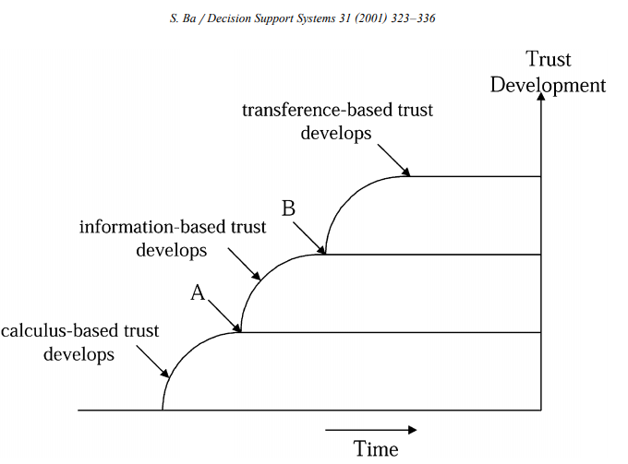
This implies, although the trustor may have no previous direct experience at all with the other party, they form trust by transferring trust of the third party to the latter (Bachmann, 2019). In this level of trust, the trusted third party plays a significant role. For example, research indicates that as eBay is allied with PayPal which is normally considered credible and trustworthy for payment processing, people tend to trust the web site more (Gladis,2018).
Figure 1- The stages of trust development (Sulin, 2001)

At the first stage, some calculus-based trust develops into information-based trust, while other relationships never move past calculus-based trust. At point ‘B’, some information-based trust develops into transference-based trust (Lewicki and Wiethoff, 2000).

2.3 Major online trust barriers

Electronic commerce is a modern form of exchange, in which online transactions occur between entities that have never met before (Takashi,2008). Just like traditional exchanges, trust has been considered crucial in the online transaction process. Even more so, due to impersonal nature of the online environment, uncertainty and the inability to judge and view product quality prior to purchase and information asymmetry. As, the internet is a global carrier of electronic commerce transactions, web sites, such as eBay are often criticised for selling counterfeit products (Marzilli, 2009). Other issues include, identities being forged, and the nature of transactions being altered. Akerlof (as cited in Shaw, 2006) stated once commercial activities started on the Internet, information asymmetry, which means that both parties do not have access to the same information, has been viewed by some to be a crucial barrier to the extensive acceptance of the electronic market.
Simon (2000) states, consumer abuse through fraud and deception is prominent on the internet, due to its informal nature, the lack of personal contact between buyer and seller, and the geographic dispersion of sellers. The existence of asymmetric information does question the authenticity and integrity of business transactions. If not effectively addressed, these market imperfections can undermine the full development of global competition itself. Two major characteristics of information asymmetry that are closely related to online fraud, are being unaware of the identity of online trading parties and the other the product quality uncertainty (Tadelis, 2016). On the Internet, no one knows the authenticity of the seller, and online trading parties can easily remain anonymous or change their identities. For example, in the auction market where numerous individuals participate in transactions, it is very hard to bind one identity to one trader (Shaw, 2006 p.338).
Auction sites, such as eBay identify sellers or bidders by email addresses, this can easily be attained without excessive monetary cost from an array of multiple sources. Akerlof (as cited in, Wankhade and Dabade, 2010) states information asymmetry regarding product quality uncertainty indicates that transacting parties do not have the same information about the product quality. The traditional business setting, allows people the option of getting to know the quality of products through looking, touching, and feeling. However, when bidders view a product listing at an online auction site, they do not have that same degree of freedom. That allows them easy access to information regarding the true quality of the product. Purchasing products such as, as sports supplements from eBay has the underlying problem of verifying user identity and guaranteeing product quality. Song (2007) states, eBay has chosen to excuse itself from the responsibility in its User Agreement, as user authentication on the Internet is difficult and therefore eBay cannot and does not confirm each user’s purported identity. eBay (2019) states, they have no control over the quality, safety or legality of the items (sports supplements) sold, advertised or the truth or accuracy of the listings. These two aspects of information asymmetry uncover e-commerce participants to more risks and fraudulent transactions. Li and Xu (2017), believe many customers, therefore, lack the trust necessary to engage in e-commerce transactions. With an understanding of the different types of trust and how trust develops, it is evident, the more critical question is: what types or forms of mechanisms can assist in generating trust, thus facilitating electronic commerce?

2.3.1 Reputation systems
According to Dierks (2005), repeated interactions and long-term relationships are key to developing trust and a positive reputation. However, this basic assumption is not applicable in the online environment, such as eBay. Cook (2001) states, in many situations, individuals or organisations need to decide whether they can trust a person or an organisation without any prior interactions. An approach, such as a feedback system can be utilised in the trust-building processes identified in Figure 1.

2.3.2 Feedback systems

Zhang and Guizani (2011) states, numerous models have been suggested using game theory approaches. Transactions are analysed as repeated games. Through consistent engagement and repeated transactions in a market, businesses need to be concerned about their reputation. This basically is a calculus-based trust building approach. Compliance with calculus-based trust is usually ensured both by the rewards of being trustworthy and by the “threat” that if trust is violated, the Internet vendors reputation can be damaged severely (Smart, 2006). Therefore, reputation ideally should serve as an effective enforcement measure for honest behaviour. This is the philosophy behind eBay’s Feedback Forum, which allows consumers to utilise the forum to rate their satisfaction towards their trading partners (eBay, 2019). Other users are encouraged to check their trading partners’ ratings before transactions and leave feedback about their trading partners after their transactions (Lee, 2012). The enforcement comes from the idea that dishonest behaviour against one agent causes sanctions or retaliations by other agents in the same market. To some degree, the utilisation of feedback-based reputation systems has, promoted trust in the online environment. Schlagle (2011), believe reputation systems are beneficial as they are a source of information and a potential source of sanctions. The presence of reputation information is an incentive for the participants in a transaction to be trustworthy because of the damaging effects of acquiring a bad reputation.
However, the current reputation systems have numerous limitations. Firstly, the rationale behind the feedback systems suggests the reputation of an online participant is a signal of one’s past trading behaviour. A damaging reputation i.e., low-feed-back rating, could be detrimental to a seller as it is likely to discourage other potential customers from engaging in future transactions with the participant. However, the ratings given to a seller, are just based on online identities which are often not more than an email address. Currently eBay does not provide strong authentication. Consequently, a person with a poor rating can easily acquire a new email address and re-register to remove any trace of the earlier bad reputation. Therefore, the previous history of a scammer remains private information and does not serve as an effective deterrent of future transactions (WhoIsHostingThis.com, 2019). Also, a person who has developed a very bad feedback rating at one site can go to another transaction site as a new user and cheat again (Service, 2010). Both situations result from the lack of strong authentication of online identities.

2.4 Seller’s reputation in determining the price that buyers are willing to pay for the seller’s product

Sexton (2010) demonstrated that markets in which sellers cannot reliably signal product quality may experience market failure. Hopkins (2011) supports this by asserting if a seller is not doing something right, the seller will go out of business and customers will inevitably choose a business that does these things right.
eBay is becoming more popular each day. According to Magana (2018), eBay has reported its revenue increased 9% year-over-year (YoY) to $2.64 billion, from 2017 to 2018. The design of eBay gives an opportunity to study the effects of the seller’s e-commerce reputation on the price of the seller’s good. Typically, eBay assumes no responsibility for the sports supplements listed on its site, and simply acts as auctioneer. Instead, the seller held responsible for the discretion of the product, shipping it, and explaining the details of such things as delivery and payment methods. Importantly, in the majority of instances the shipment occurs only after the payment is received by the seller. The buyer thus assumes a risk when sending a payment (Sachs, and Abegg, 2001). Issues include, the seller shipping a damaged item, the item being incorrectly described in the auction, or the seller may not send the item at all.
However, eBay has set up a mechanism that allows the buyer to leave comments about the seller after the transaction is complete (eBay,2018). This feedback can be positive, neutral, or negative, and comes in the form of statements like “It’s been three months and the item hasn’t arrived yet” or “Excellent seller, thank you!” (Melnik and Alm, 2002). The comments are compiled by eBay and the number of negative feedbacks are subtracted from the positive feedbacks, and the number calculated is the ‘seller’s rating’. Both the rating and feedback comments are then available for future buyers. The seller’s rating is actually displayed on top of each auction of that seller and is easily visible to each visitor of the auction
The existence of information used to construct ratings provides a convenient mechanism for estimating the impact of a seller’s reputation on the price of products sold by the seller.

2.5 End of Chapter Conclusion

This chapter implies seller’s ecommerce reputation is vitally important in determining the price the seller receives in internet auctions. In the absence of other, more direct sources of information about a product, an eBay customer must be reliant upon the accuracy of the seller’s product description and the reliability of the seller’s product delivery in deciding whether and how much to bid for the good. Put differently, the seller’s reputation becomes an important consideration in the buyer’s willingness to bid on the auction item. According to Peitz and Waldfogel (2012), sellers with a better reputation can expect to receive a higher price for the auction good, although this impact tends to be small.
However, new website auction sellers may struggle to compete with existing, established sellers who have built a positive reputation. Furthermore, the lack of mechanisms to transfer successful ratings across sites, for some experienced sellers with a high rating can be costly, as they switch from to one auction website to another. “Reputation” obviously provides some benefits to consumers searching the internet for items upon which to bid. However, such “reputations” may also have negative connotations on consumers purchasing power, especially if the reputation of an online auction sites overpowers and acts as a barrier to entry for new online auction sites. Which inevitably gives monopoly power to already established online auction websites, such as eBay.

3. Chapter Three - Methodology

This chapter aims to address the second and third research objectives of this thesis:

- Critically analyse responsibility in the sports supplements market

- Investigate regulation within the sports supplements market

The method of primary research chosen by the researcher will be carefully detailed using Saunders, et al (2009) Research Onion to identify and justify research strategy, data collection methods and data analysis techniques.
Research can be defined as ‘something that people undertake in order to find out things in a systematic way, thereby increasing their knowledge’ (Saunders, et al., 2009, p. 9). Research is based on logical relationships as opposed to beliefs, and purpose encompasses providing descriptions, explanations, understanding, criticisms and/or analysis (Ghauri & Gronhaug, 2005).
The researcher will be seeking to achieve the objectives through data collection. The researcher intends to achieve the objects, through the data collected via an online questionnaire.

3.1 Research Onion

By comprehending the multitude of research methods available to the researcher is cruical to appropriately choose the most appropriate method for the specified research and therefore, establish effective practice in implementing methods appropriately (Bryman & Bell, 2007). The different pathways presented to the research is depicted in Saunders et al (2009) Research Onion.
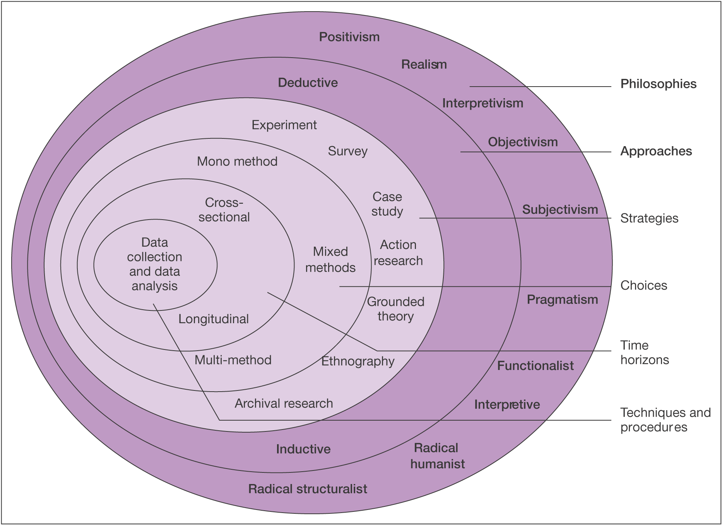
Figure 2- The Research Onion (Saunders et al., 2009)
Following the above figure from the outer layer inwards, the research undertaken for this dissertation will be based upon the philosophical angle known as positivism and use an inductive approach. A survey is the chosen research strategy, and a mono-method will be chosen and applied in the form on an online questionnaire. A cross-sectional approach will be applied, as the research conducted will occur at a specific point in time. The researcher aims to address quantitative data collection and analysis which is at the core of the Research Onion

3.1.1 Research Philosophies and Approach

Research philosophy relates to the way of thinking, based on the development of knowledge. The philosophies utilised in this dissertation are positivism and interpretivism. The positivistic view implies the researcher is an objective viewer of the social reality and the general conclusions of the findings can be made. Finally, the interpretivist researcher has the belief that the social world is too complex to be able to draw general conclusions and the researcher has to understand the difference between humans in our role as social actors (Saunders et al., 2007). This research has adopted the positivistic view. This means the researcher has to remain neutral and not affect or be affected by the subject of the research. The positivistic approach will be for the closed-questions in the questionnaire, due to its highly specific and set answers for the closed-questions.
By utilising an interpretivist philosophy, qualitative research areas such how sports supplements can be regulated can be studied in a great level of depth. Primary data generated via Interpretivism studies might be associated with a high level of validity because data in such studies tends to be trustworthy and honest. Interpretivism will be utilised for the open-ended questions of the questionnaire, as the researcher interprets and categorises the responses from participants.
This dissertation will use a deductive approach. A deductive study is when the researcher identifies theories and ideas using appropriate literature, which can be tested by using data. In short it means testing theory. Quantitative data is used, which is the opposite of the inductive approach which usually uses qualitative data. To be able to reach the aims of this research, the deductive approach seemed the most applicable. The means the researcher started with reviewing appropriate literature related to the objectives, then found relevant factors that were tested empirically, by collecting quantitative data. The intention of this research was not to create a new theory therefore, the inductive approach was irrelevant.

3.2 Research Strategy

3.2.1 Deductive Approach

An online survey was chosen as the research strategy for this dissertation. According to Saunders et al. (2007), this type of strategy is often connected with the deductive approach, which is the approach adopted for this research. Using the survey strategy allows researchers to collect a large amount of data from a sizeable population. The data is obtained by using an online questionnaire that enables the collection of standardised data, which allows for easy comparison. So, the data collected can be expressed in numbers and analysed quantitively. For these reasons, the survey strategy was the most suitable to attain information relating to the set objectives.

3.2.2 Descriptive and Exploratory Study
Research purpose can be classified in three different ways, namely, exploratory, descriptive and explanatory. This dissertation uses both exploratory and descriptive study. The aim of an exploratory study is to find out what is happening, the researcher seeks insights, asks questions and sees phenomena in a new light. It is useful when the researcher wishes to clarify the understanding of a problem. This type of study can be conducted through searching for appropriate literature related to the topic of study. Saunders et al., (2007) believe a descriptive study is when the researcher has a clear picture of the phenomena, which enables them to collect information, prior to the actual collection of the data.

3.2.3 Cross-Sectional
Since this research studies a phenomenon at a particular time (the responsibility within the sports supplement market, specifically at eBay), I can be classified as a cross-sectional study. Cross-sectional studies also, employ the survey strategy, which is the strategy chosen for this research.

3.2.4 Choice

Primary data collected by the researcher will only use one method (mono-method). Although, the mixed-method technique is applicable, the researcher believes the objectives proposed in the research question can be answered effectively through the self-administered online questionnaire. Also, the use of a mono-method reduces complications, often associated with mixed methods, including greater time consumption, effort and financial resources (Azorin & Cameron,2010).
Collins and Hussey (2009), define triangulation as the ‘use of multiple sources of data to investigate the same phenomenon in a study’. Triangulation will be utilised to minimise bias in the data source and method, through performing an extensive review of appropriate literature, and triangulating the information obtained with the results of the questionnaire data.

3.2.5 Time horizon

Saunders et al., (2007), believe time horizons are representative of the time required to conduct research, which could be cross-sectional or longitudinal in nature.
Cross sectional studies are limited to a specific time frame, therefore as this research is also time-constricted it will utilise a cross-sectional time frame.

3..3 Collection and analysis

3.3.1 Collection

According to Collins and Hussey (2009), quantitative data is a numerical form of data and is collected in positivist studies, as specialised and specific nature.
The data gained from this research will be quantitative and qualitative as the researcher is operating under a positivist and interpretative study. Methods to collect survey data in a positivist study, include online questionnaires, telephone and face-to-face interviews (Collins & Hussey, 2009).
For this thesis, the researcher has chosen to design an online self-completion questionnaire that is structured so that each participant is asked the same question in the same order to prevent accidental bias in response to question structure.
The chosen data collection method is appropriate to the research and has the advantage of collecting a large amount of data in a highly economical way (Saunders, et al., 2009). Self-administered online questionnaires are both cost effective and time efficient (Couper, 200). The use of an online questionnaire will enable the researcher to reach a larger number of respondents, who will hopefully demonstrate consumer behaviour and purchasing patterns regarding sports supplements, sold on eBay.

3.3.2 Questionnaire design

The questionnaire will consist of sixteen questions, ranging from demographic questions to questions concerning where and why sports supplements purchased, and what eBay could do to ensure the safe selling and safe use of sports supplements. The majority of questions will be closed-ended multiple choice, as closed questions are most useful for obtaining comparative data, statistical data, and respondents’ preferential data (Cameron & Price, 2009).
Multiple-choice type questions are also helpful for the researcher, as it is an easier task to classify answers and calculate their frequencies when analysing the data (Thomas, 2003).
The Likert scale is an example of a multi-item scale, which provides the researcher with a more complex view of respondents’ underlying attitudes (Balnaves & Caputi, 2001). Within the questionnaire there will be a question regarding the importance of factors, such as security and payment in order to make the customer feel trust when purchasing from eBay. This will be answered by respondents using a Likert scale, and will arguably be the most important question of the survey. Using this scale will enable the researcher to gain knowledge of a greater complexity. The questionnaire will also, contain open-ended questions to incorporate any valuable qualitative data that the respondent may wish to give relating to whether eBay provide customers with enough information on the substances present in the sports supplements being sold. The addition of an open-ended questions will be beneficial to the overall study, as it will allow the researcher to collect a broader set of responses that will better reflect the views of the respondents (Cameron & Price, 2009).
The individual questions will be written in a clear and concise manner, to ensure that respondents will be able to fully understand and the questions and answer accurately.

3.3.3 Survey Question Matrix

Question | Reasoning | Source
Q1. Which age category do you fit into? | To attain a better understanding in supplement use, purchase and importance of trust factors amongst genders. | (Silver, 2013)
Q2. What gender do you identify as? | To gauge if age is a mitigating variable in supplement purchase. | (Silver, 2013).
Q3. What type of sports supplement do you use? | To understand which supplements are the most popular amongst the respondents. | (Volek, 2019)
Q4. How long have you been using sports supplements for? | To analyse if long term supplement use, correlates to the use of more sports supplements. | (Fink, et al., 2009)
Q5. Where do you purchase sports supplements from? | To understand why the respondents, have greater trust in purchasing from certain vendors. | (Planet Express, 2019)
Q6. For the following statement please circle the number that matches your view most closely. "Sports supplements are essential in improving sporting performance?"  (1= not important, 5= very important) | To analyse how important sport supplement use is amongst respondents. | (Saunders et al., 2000)
Q7. Do you know the purpose for each sports supplement you purchase? (If yes, please specify) |  | (Food Supplements Consumer., 2018).
Q8. Did you experience any side effects using sports supplements purchased from eBay? | To analyse how the use of sports supplements has impacted the respondents trust level when purchasing from eBay. | (Fagan, 2019)
Q9. If you have purchased or intend to purchase sports supplements, how important are the following factors:  - Price  - Information  - Familiarity  - Customer Services  - Guarantees  - Ingredients  - Regulation against banned substances  - Reviews from other customers | A Likert question to critically evaluate set responses that have been grounded in existing literature. | (Brechke, 2019)
Q10. Please indicate to what extent you agree or disagree with the following statements:  - ‘The more supplements I take, the better I will perform’.  - ‘Taking supplements gives me the competitive edge I need to win’.  - ‘I feel under pressure to use supplements.  - ‘Exercise increases the need for supplements.  - 'There is a risk of consuming a banned substance when taking a supplement’  - ‘I feel pressured to take nutritional supplements because my competitors/ opponents do’  - 'There should be stricter laws and regulations against banned substances, such as DNP in sports supplements' | A Likert question to critically evaluate set responses that have been grounded in existing literature. | (Graham, 2019)
Q11. What is your purpose for taking sports supplements? | To attain a better understanding as to why the respondents, choose to take sports supplements. | (Floyd et al., 2007)
Q12. Are there any celebrities you know of and the sports supplement they sponsor/advertise? | To gauge if the impact of celebrity or social media advertising, impact the purchase of sports supplements amongst the respondents. | (Tanier, 2019)
Q13. In your opinion what should eBay do to ensure the safe selling and safe use of sports supplements? | An open-ended question, to attain the respondent’s opinion on how eBay can be more responsible for the sale of sports supplements. | (NoFate, 247)
Q14. What should the government do to ensure the safe selling of regulated supplements? | An open-ended question, to attain the respondent’s opinion on how the government can enforce greater regulations on the sale of sports supplements. | (Export.gov, 2019)
Q15. In your opinion does eBay provide customers with enough information on the substances present in the sports supplements being sold? | An open-ended question, to attain the respondent’s opinion about if there is enough credible information on sports supplements, when purchasing from eBay. | (Collins, 2013)
Q16. If you have purchased/ would purchase sports supplements from eBay, how important are the following factors for you to feel trust when purchasing from eBay:  - Secure and reliable payments  - Information about how security solutions work  - Possibility to choose the payment method (for example, invoice, cash on delivery, credit/ debit card).  - Knowledge about the personal information you fill in, when ordering, is handled  - Policy for the handling of personal information, on a visible page on eBay's homepage  - Standard terms in connection to the orderform (terms for returns, refunds etc.)  - Confirmation on the order and purchase  - Possibility to ask questions and get help directly, online or by telephone  - The Brand  - Reputation/Recommendations, for example, in media, from family and friends  - Design- how the website looks  - Functionality- user friendly, easy to navigate in the menus etc.  - Information about the company on the website (for example, who owns the company, number of years in business etc.)  - The price of the product | A Likert question to critically evaluate set responses that have been grounded in existing literature. | (Jakharia, 2019).

Figure 3- Survey Question Matrix
See appendix 1 for a final copy of the distributed questionnaire.

3.4 Pilot study

Before final distribution, the questionnaire itself will be piloted to the experienced dissertation supervisor to ensure its suitability. A pilot study is a test study conducted on a smaller scale prior to the official distribution of data collection methods, and allows the researcher to identify any potential issues and make final alterations (Daniel & Sam, 2011). A pilot study is particularly important for the researcher when considering the chosen method of data collection, as questionnaires do not provide respondents with an opportunity to request clarification of confusing items (Thomas, 2003).

3.5 Analysis

Statistical analysis techniques will be used by the researcher to test for significance after the completion of primary research; this will include examples of weighted average cost tables. This allows the researcher to consolidate data into a summary that can be used to gain insight into the correlation between different variables, and be used as the basis for further statistical comparisons (Veal, 2005).

3.6 Sampling

Due to the restrictions of both time and resources to obtain and analyse all of the data available, the researcher will use convenience and purpose sampling, to obtain primary research data. Convenience sampling means that the researcher chooses only those respondents that are able to participate in the survey, after being asked (Christensen, Andersson, Carlsson & Haglund, 2001). Usually this involves choosing those cases which are easiest to obtain for sample. The selection process continues until the required sample size is reached (Saunders et al., 2007).
Purposive sampling has been defined by Denscombe (2014) as, ‘Reflecting a group of sampling techniques, that rely on the judgement of the researcher; when it comes to selecting the units that are to be studied’. For this research, those respondents that agreed to answer the questionnaire were selected. Participants were specifically chosen, if they have used or currently use sports supplements. To get a variety of respondents, people asked to respond to the questionnaire varied in ages from 18 years and up. Respondents, from several parts of the United Kingdom participated in the survey, from Swansea to London.

3.7 Validity and Reliability
Validity is “concerned with whether the findings are really about what they appear to be about” (Saunders et al., 2007, p.150). It was important for the researcher to get the right information from the questionnaire, in order to answer the set research objectives. The questions in the survey were designed to coincide research aim of examining the responsibility within the sports supplement market, specifically at eBay. Research techniques were discussed with an experienced dissertation supervisor, in order to minimise the risk of observer and participant error. Also, it is suggested that the anonymity and confidentiality is facilitated by an online questionnaire, which allowed for honesty on the part of the participant, therefore the researcher is likely to have greater validity. Warren and Tweeddale (2002), say it is easier to collect sensitive information via (online) questionnaires.
Reliability refers to “the extent to which your data collection techniques or analysis procedures will yield consistent findings” (Saunders et al., 2007, p.149). Reliability is about whether the measures will yield the same results on other occasions, if other researchers will reach similar results and if there is transparency in how sense was made from the raw data (Saunders et al., 2007). One threat to reliability is subject or participant error. The online questionnaire sent out at different times of the week, may yield different results. According to Saunders et al. (2007) a “neutral” time is most appropriate and effective time to send questionnaires, meaning not in the beginning of the working week or just before the weekend. Another threat to reliability is subject or participant bias, which is about whether the respondent’s answer is truthful or not. If the respondent is assured anonymity, the answers are more likely to be truthful. All the respondents of the questionnaire were anonymous and therefore there is no reason to think that their answers were untruthful. So, this can strengthen the reliability. Other threats to reliability can be observer error and observer bias. Since there were some unstandardized, open-ended questions, such as question 7 they could interpret in various ways, which does increase the risk of observer error and obvious bias.

3.8 Limitations and ethical consideration

3.8.1 Limitations

Typical limitations exist for this study in terms of a limited time-frame to conduct primary research and access to resources. The sample used may not be an extensive representation of the wider population but is the most effective sample to implement within the given timeframe. The researcher will attempt to mitigate these limitations by producing a Gantt chart to improve time management, and use existing resources provided by the university to the benefit of the research. The limited timeframe has not allowed for multiple research methods that combine both quantitative and qualitative data, and so the results of this research will only be viewed from a numerical angle.

3.8.2 Ethical considerations

In comparison with experimental or field research designs, survey designs pose few ethical dilemmas because potential respondents can easily decline to participate in the survey if they wish, and an introductory statement prior to the question section can provide adequate information to enable the respondent to make a decision (Crowther & Lauesen, 2017). There will be a statement attached to the researcher’s questionnaire detailing the purpose of the research, assurances of confidentiality and the voluntary nature of the survey, and contact details should any participant want to ask the researcher any relevant questions. See appendix 1 for the full statement.
The leading focus of ethical concern in a survey is most often confidentiality (Cooper & Schindler, 2001). For this research, the respondents will participate anonymously and individual responses will remain confidential. The data collected will be protected in accordance with the Data Protection Act, and the responses will be compiled together and analysed as a group. The data will not be shares or viewed by any persons other than the researcher and the faculty supporting the research (University of Wales Trinity St David).
There is no vulnerable population used in the survey, and all participants involved will be over the age of eighteen. See appendix 3 for a copy of the ethics form approval granted by the university prior to this dissertation.

3.9 Conclusion

Using quantitative and qualitative questions will be beneficial as it will allow researcher to gain additional access to information (Riordan, 2013). It will allow for a greater understanding of the subject matter in addition to generating a greater field of responses.
The following chapter surmises the data analysis of the online questionnaire, in addition to statistical testing. The aim of Chapter 4 is to align the key theory as outlined in Chapter 2 to the primary research results.

4. Chapter Four- Data Analysis

The researcher’s strategy was to conduct a survey, through online questionnaires, to attain primary data. The purpose of the online questionnaire was to obtain information, analyse, correlate, and interpret the researcher in order to fulfil the second, third and fourth aims of the dissertation:

- Critically analyse responsibility in the sports supplements market

- Investigate regulation within the sports supplements market

- Make recommendations into how the challenges can be solved for the needs of future consumers

The questions in the questionnaire, were based on certain factors identified in the literature review. The online questionnaire was sent to participants who use sports supplements and the researcher used convivence and purposive sampling, until the required sample size of 140 responses was attained. The data collected through the questionnaire, enabled the researcher to process and analyse it using the software program SPSS and Microsoft Excel. The questionnaire is presented in the appendix.

4.1 Questionnaire Data
Questions 1-8 served as background questions, which were asked to obtain information regarding the respondent’s gender, age, attitude towards purchasing sports supplements from eBay and the experience of shopping at eBay. Below, the results from the questionnaire will be presented and examined.

4.1.1Gender
Question 1 asked the respondents to specify their gender. The researcher wanted to include gender in the survey, to examine whether there is difference in how males and females perceive the importance of the factors. This will be examined later on the chapter. 65% of the participants identified themselves as males, and only 33% identified themselves as female. The remaining 1% choose the ‘prefer not to say’ category.
Figure 4- Graph depicting the gender of participants

4.1.2. Age
Age was included in the survey, as it allowed the researcher to examine whether there are any differences in how people of different ages perceive the importance of the factors. The smallest represented age group was 50-64 years old at just 6%. At 54% the 21-34-year olds were the most prominent age group that took part in the questionnaire. However, there was a similarity in the responses between the 18-29 years old and 35-49-year olds, which 20% being 18-20 and 19% between 35-49 years old.
Figure 5- Graph depicting the age of the participants

4.1.3. Sports supplement use

Question 3 asked the participants to identify what type of sports supplement they use. Almost 50% of the respondents chose ‘proteins’, and almost a third selected all of supplements listed.
Cotton (2018) suggests market research conducted by Euromonitor International, showed an increase in the UK’s sports supplement market, more than doubling from £350 million in 2012 to £799 million in 2017. Rogers (as cited in Cotton, 2018), believes sports supplements have become more mainstream and normalised for the average individual, rather than just being utilised by elite athletes. The attraction, to increase muscle mass, increase performance and loose bodyfat have led to greater development in the sports supplements industry.

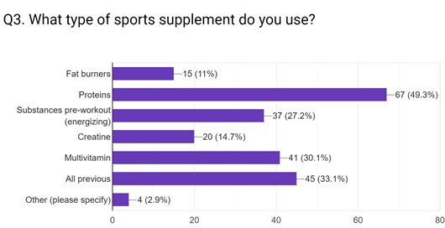
Figure 6- Graph depicting the type of sports supplements used by participants

4.1.4. Time frame using sports supplements

Question 4 asked the participants how long they had been using sports supplements. 41% of participants stated they had utilised sports supplements between three to four years. This was a high proportion of the sample, because the participants in the sample were chosen specifically because they displayed interest in the use of sports supplements.

Figure 7- Graph depicting the time period participants have utilised sports supplements

4.1.5. Where sports supplements are purchased

Question 5 asked the participants where they purchase sports supplements from. At 76%, the largest portion of participants specified that they purchase sports supplements online. However, only 3% of the respondents choose ‘eBay’ as an option, which implies they do not trust the suppliers of sports supplements on eBay. The ‘high street’ was the second most popular response, with 20% of the participants choosing to purchase sports supplements from there. This is possibly because, those individuals feel greater trust and confidence seeing the product in reality and asking questions to the owner or employees of the shop relating to their purchase. The lack of participants choosing ‘eBay’, also suggests that eBay’s lack of responsibility to regulate the sales of banned substances or counterfeit sports supplements has been a deterrent for the majority of the participants.
As previously stated in the literature review, eBay has chosen to excuse itself from the responsibility in its User Agreement, as user authentication on the Internet is difficult and therefore eBay cannot and does not confirm each user purported identity (Song, 2007). eBay (2019), they have no control or regulate he quality, safety or legality of the sports supplements advertised. This is a major cause of concern for many customers and reduces eBay’s trustworthiness.

Figure 8- Graph to show where participants purchase sports supplements.

4.1.6. Importance of using sports supplements

Question 6 asked participants how strongly they agreed with the following statement- “Sports supplements are essential in improving sporting performance?”.
For analysis purposes, the following weights were assigned to each answer choice for every participant: Not Important (1), Somewhat Important (2), Neutral (3), Important (4), Very Important (5). The results are presented in a table below.

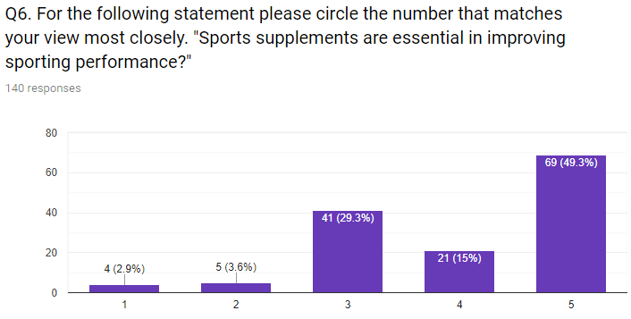
Figure 9- Graph depicting the participant’s opinion on the following statement:” Sports supplements are essential in improving sporting performance”?

Almost, half (49.3%) believed sports supplements were essential in improving sporting performance. Gunn (2018) believes the influence of social media and athletes, is vital in making the vast population believe sports supplements are crucial for sporting performance.

4.1.7 Reason for purchasing sports supplements- Qualitative data

Question 7 asked the participants if they knew the purpose for each sports supplement they purchased, allowing them to respond in their own words without being limited by a certain answer or number of characters. This provided qualitative data summarised below.


Figure 10- Word cloud representing responses from question seven: Do you know the purpose for each sports supplement you purchase?

The word cloud visually represents the most frequent words used in the participants responses. The larger the word, the more often the word appeared in the responses. It is noted that ‘recovery’, ‘repair’, ‘muscle growth’ and ‘gain weight’ are utilised repeatedly, suggesting most respondents utilise supplements for physical improvement. The researcher used the ‘=lookup’ function in Excel in order to determine the most popular responses, before entering the words in a world cloud generator.
Approximately 89% of the respondents knew the purpose for taking sports supplements, with 19% of the respondents stating they buy protein, to ‘help build muscle and BCCA’s to help energise before a work out’. A small minority (9%) of the respondents did not know the purpose for purchasing sports supplements.
See appendix 2 for a complete list of qualitative responses to this question.

4.1.8 Side effects from, taking sports supplements

Question 8 asked the participants, if they had experienced any side effects from sports supplements purchased from eBay. Only 3% of the respondents purchased supplements from eBay, and each of them stated they had never experienced any side effects. This lack of respondents purchasing from eBay, suggests that the respondents do not trust the credibility of the suppliers at eBay and from the results attained, 14% of the respondents believe the sports supplements are unregulated and irresponsibly sold, by the internet vendor.

4.2 Importance of certain factors when purchasing sports supplements

Question 9 addressed the importance of factors, such as price and information when purchasing sports supplements from eBay, and it asked the respondents how important they thought the following factors were:
- Price- The price of sports supplements
- Information- Information about the supplier on the website
- Familiarity- Reputations/Recommendations, e.g. reviews from the website, family or friends etc.
- Customer Services- Possibility to ask questions and get help directly, online or by telephone
- Guarantees- Standard terms in connection to order form (terms for returns, refunds etc)
- Ingredients present in the supplement, for example BCAAS’s, Creatine, Glutamine etc.
- Regulation against banned substances, such as DNP
- Reviews from other customers
For analysis purposes, the following weights were assigned to each answer choice for every participant: very important (1), important (2), moderately Important (3), slightly important (4), not important (5). The weighted average was then used to calculate the average response to each statement, as illustrated in the table below. In order to calculate the weighted average, mean the researcher, utilised the ‘=sumproduct’ function.
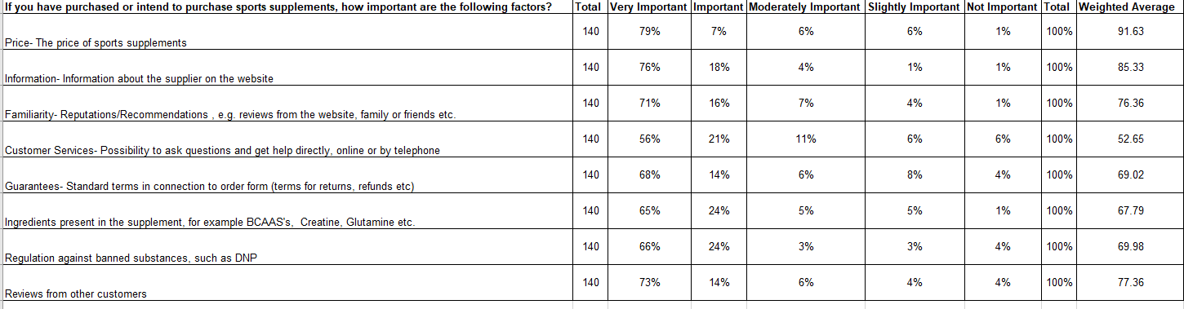
Figure 11- Table containing the participants results on how important they thought certain factors were factors were when purchasing sports supplement from eBay

Statement One (Price) was considered the most important factor, when purchasing sports supplements with a weighted average of 91.63. This was followed by statement 2 (Information) with 85.33, and statement 8 (Customer Reviews) with 77.36. Statement 3 (Familiarity) earned an average weight average of 76.36, whereas statement 5 (Gurantees) received an average weight of 69.02.
The lowest weighted average was 52.65 for statement 4 (Customer Servies). This result implies that, ‘customer service’ is the least important factor in purchasing sports supplements from Ebay. 6% of the respondents believed it was ‘not important’. Perhaps, customers purchasing the sports supplements have great trust in the reviews from previous customers, and therefore feel confident enough not to purchase the product.

4.3 Opinion on seven states, relating to sports supplement purchase

Question 10 asked the respondents how strongly they agreed or disagreed with the following seven statements:

- ‘The more supplements I take, the better I will perform’
- ‘Taking supplements gives me the competitive edge I need to win’
- ‘I feel under pressure to use supplements’
- ‘Exercise increases the need for supplements’
- 'There is a risk of consuming a banned substance when taking a supplement’
- ‘I feel pressured to take nutritional supplements because my competitors/ opponents do’
- 'There should be stricter laws and regulations against banned substances, such as DNP in sports supplements’
For analysis purposes, the following weights were assigned to each answer choice for every participant: strongly disagree (1), disagree (2), neither agree or disagree (4), agree (4), strongly agree (5). The table below, illustrates the results for question.

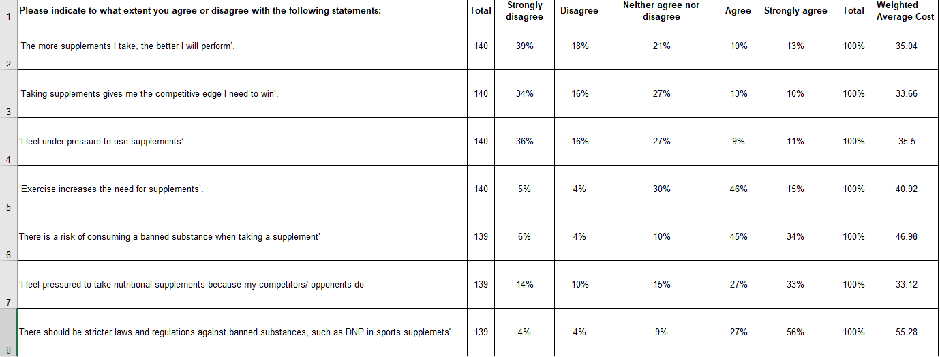
Figure 12- Table containing the results of how strongly participants agreed with the above eight statements

4.4 The purpose for taking sports supplements

Question 11 asked participants what their purpose was for taking sports supplements. The majority of the participants (62%), utilised sports supplements to ‘build muscle’. Followed, by ‘to be healthy’ at 18% and ‘gain weight’ at 13%. A minute percentage of the respondents choose the ‘other’ (2%) and ‘maintain weight’ (1%) options. The fact that 65% of the respondents were young males could’ve influenced the outcome of this question. According to Mulheim (2014), thousands of men across the U.K are on a quest for the ‘perfect’ physique, and this is driving a rise in bigorexia. More formally known as, muscle dysmorphia. The chairman of the Body Dysmorphic Disorder Foundation, Wilson (2015) states, “10% of men in the gym have bigorexia”. The dependency on supplements could fuel young men’s bigorexia.
Figure 13- Graph depicting the participants purpose for taking sports supplements

4.5 Celebrities who use or endorse sports supplements – Qualitative data

Question 12 asked the participants if they knew any celebrities who utilise sports supplements and if they are sponsored or advertise sports supplements. This allowed participants to respond openly, without any restrictions on a character limit. This provided the qualitative data summarised below.
Figure 14- Word cloud representing responses from question twelve: Are there any celebrities you know of and the sports supplement they sponsor/advertise?
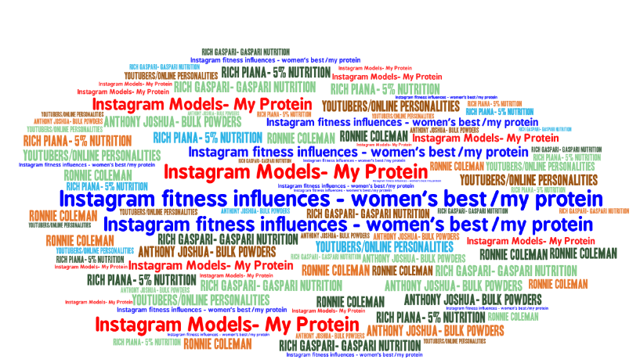
According to Roberts (2016), the word cloud visually represents the most prominently utilised words that have been included in the participants responses; the larger the word the more frequently the word appeared in responses. Words and phrases, such as ‘Instagram fitness influences’ and ‘Instagram models’, were the most reoccurring responses for the question. Sprout Social (as cited in Barker, 2017) states 74% of shoppers make buying decisions, based on social media. This is reflected in the result, with 43% of the responses containing the word ‘Instagram’.

4.6 What eBay should do to ensure the safe selling of sports supplements? – Qualitative data

Question 13 asked the participants what eBay should do to ensure the safe selling and safe use of sports supplements.

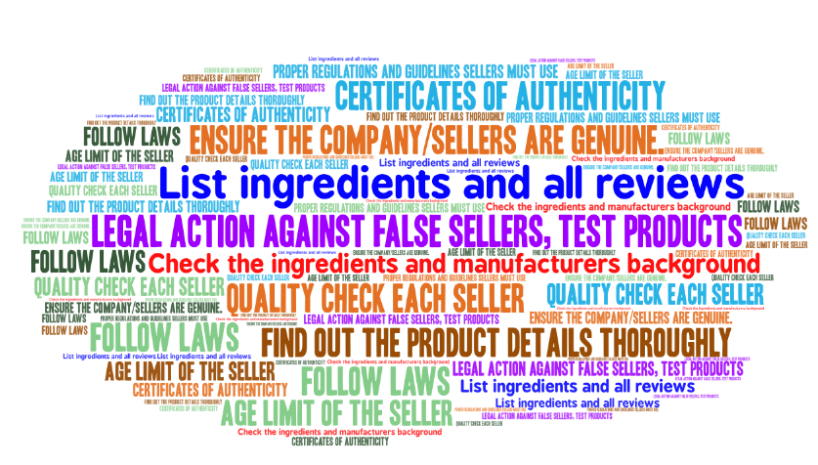
Figure 15- Word cloud representing responses from question twelve: In your opinion what should eBay do to ensure the safe selling and safe use of sports supplements?

Words and phrases, such as ‘Legal action against false sellers, test products to ensure they match up to list of ingredients’ and ‘Quality check each seller’, were the most reoccurring responses for the question, with approximately 33% of the respondents making these suggestions. This implies, that shoppers purchasing online sports supplements from eBay would like to see greater authenticity and product checks from eBay. As previously mentioned in the literature review, eBay does offer customers the opportunity to view a sellers ‘rating’. However, this is not completely accurate as many scammers with a poor rating can easily acquire a new account through utilising a different email and continue to scam many unaware customers.

4.7 What the government should do to ensure the safe selling of sports supplements? – Qualitative data

Question 14 asked the participants what the government do to ensure the safe selling of regulated supplements.

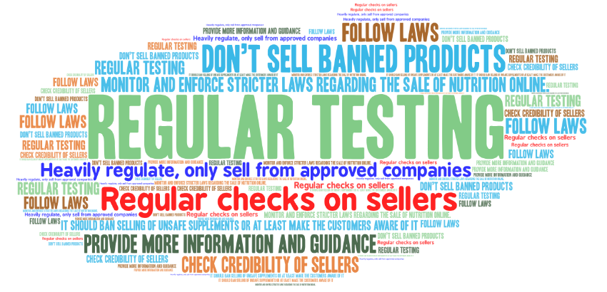
Figure 16- Word cloud representing responses from question twelve: What should the government do to ensure the safe selling of regulated supplements?

This question addressed, the fourth objective of this thesis. Words and phrases, such as ‘Regular Testing’ and ‘Monitor and Enforce stricter laws regarding the sale of nutrition online’, were the most reoccurring responses for the question, with approximately 36% of the respondents making these recommendations. This implies, that shoppers purchasing online sports supplements would like to see the governement carry out tests on sports supplements more regularly, in order to ensure the ingredients present are safe to consume. According to the Food Standard Agency (2019, p.2), Food Business Operator (FBO) selling sports supplements are responsible for ensuring that any products sold are not harmful to the customer. Under the ‘Sale of Goods’ Act the seller is liable to pay damages to customers if the product is harmful. In addition to these responsibilities FBOs also have to comply with specific food supplements legislation.
According to the Food Information (Wales) Regulations 2014 and Food (Sports) Supplements (Wales) Regulations 2003 (as cited gov.uk, 2003 and gov.uk 2014) the sports supplements are meant to be accurately labelled with specified information including a list of ingredients, including common allergens which must be emphasised and the conditions for use, including information on the recommended daily dosage and a warning not to exceed this (Food Standard Agency, 2019, p2). However, eBay’s Users agreement refusal to take responsibility against counterfeit or banned sports supplements, is counterproductive as the sports supplements sold are not monitored or regulated by eBay.

4.8 Information regarding sports supplements on eBay

Question 15 asked respondents if eBay provided customers with enough information on the substances present in the sports supplements being sold. As only 3% of the respondents had purchased sports supplements from eBay, this could have influenced the result for this question. Only 8% of the participitants stated ‘Yes’, whereas 30% of the respondents believed eBay didn’t provide enough information on the substances present in the sports supplements being sold. A small miniorty, (10%), believed of the participitants believed bigger companies such as MyProtein did provide valid information, but the sales from smaller distributors were questionable. According to the Food Standard Agency (2019), in the UK most sports supplements such as, vitamins, minerals or amino acids are regulated as foods and subject to the provisions of general food law such as the Food Safety Act. Suppliers selling sports supplements must be registered as a Food Business Operator (FBO) with local authority.
However, the sale of counterfeit products, particularly on eBay, could be an issue when the product price is considerably cheaper than other suppliers. This is perhaps, the reason only 3% of the respondents purchased sports supplements from eBay.

4.9 Factors to establish trust when purchasing sports supplements form eBay

This was the main question in the questionnaire, which was going to provide the researcher with the answer to objectives two, three and four. Friedberg (2005) stated, participitants have to feel trust before the marketplace be trusted. The main factors, selcted to be included in the questionnaire, were presented at the end of the theoterical framework. The main factors, important for eBay to establish online trust, were:
- Secure and reliable payments
- Information about how security solutions work
- Possibility to choose the payment method (for example, invoice, cash on delivery, credit/ debit card).
- Knowledge about the personal information you fill in, when ordering, is handled
- Policy for the handling of personal information, on a visible page on eBay's homepage
- Standard terms in connection to the order form (terms for returns, refunds etc.)
- Confirmation on the order and purchase
- Possibility to ask questions and get help directly, online or by telephone
- The Brand
- Reputation/Recommendations, for example, in media, from family and friends
- Design- how the website looks
- Functionality- user friendly, easy to navigate in the menus etc.
- Information about the company on the website (for example, who owns the company, number of years in business etc.)
- The price of the product or service

For analysis purposes, the following weights were assigned to each answer choice for every participant: very important (1), important (2), moderately Important (3), slightly important (4), not important (5). The weighted average was then used to calculate the average response to each statement, as illustrated in the table below.

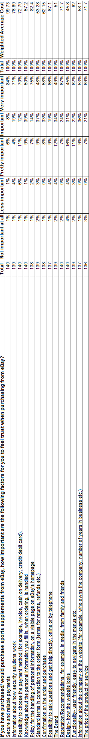

Figure 17- Table containing the weighted average of agreement with statements relating to factors for participants to feel trust when purchasing from eBay?

4.9.1 Perception of factor’s importance

This question enabled the researcher to see if there are any differences in how important the different factors are perceived to be. The researcher was able to distinguish some factors that the respondents perceived as more important. As mentioned in the literature review, security and privacy issues are often seen as barriers for shopping at eBay. The results from the survey showed that the factors ‘secure and reliable payments’ as well as the ‘policy for the handling of personal information, on a visible page on eBay's homepage’, gained a high percentage of responses on the alternative “Very important”. This shows that security and privacy are factors that are of great significance for the customer to feel trust, to purchase from eBay.
The factor secure and reliable payment systems received the highest percentage, of all the factors, on the alternative “Very important. As many as 84% of the respondents perceived this factor to be very important. As previously mentioned in the literature review, it is important for the consumers to feel secure about not being exposed to fraud or that their money is lost, due to technical problems. So, safety is a major concern for many consumers. Other factors that gained high percentages, above 70%, on the alternative “Very important” was the factor ‘Information about how security solutions work’.
Many consumers think it is important that eBay provides information about standard terms. It is also important for them to get a confirmation on their order and purchase. Furthermore, it is important that eBay provides good customer service, by offering the customers help and support online. The price was also perceived as very important. This might show, as previously mentioned before in the literature review, the price of the sports supplements will influence the consumers decision whether to take the step to purchase from eBay. Customers might feel more trust to purchase online if the price of the product or service is low. The factor functionality was also perceived as important. The factors under information and website design were not perceived as important for the consumers to feel trust. After reviewing the literature, the researcher found that information was mentioned as an important factor for establishing trust. However, this factor did not receive so many answers on the alternative ‘very important’ in this study. Hansen (2005) states that the average online buyer does not pay so much attention to the brand. It is more important how the website looks and works.
However, the results from the research conducted differed somewhat from what Hansen claims. In this study the brand was perceived to be more important than how the website looks, which opposes Hansen’s claims. However, functionality, was perceived as more important than the brand. The level of trust needed to take the step and engage in online transactions is different for each individual.

4.9.2 Importance of factors according to gender

As previously mentioned earlier in this chapter, the researcher included gender, age and respondents’ purchase behaviour in the survey to examine whether there are any differences in how the respondents perceive the importance of the factors depending on these variables. From the data collected, the researcher also calculated the mean values for how the respondents had answered on each factor depending on gender. The higher the mean value for a factor, the more important the factor was perceived to be.
The mean value for male and female answers were quite similar, but when it comes to privacy, the researcher noticed that females perceive this factor as somewhat more important than males. This, can indicate that females are a bit more concerned about providing personal information, without knowing how it is handled.

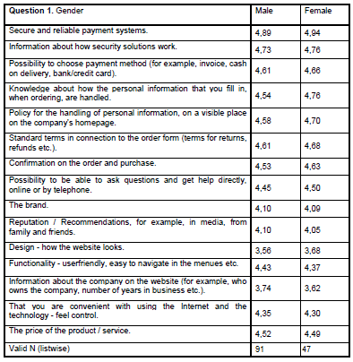
Figure 18- Calculated mean values of the answers on each subfactor according to gender

4.9.3 Importance of factors according to age

Also, the participants age was recorded in the survey and used to examine whether there are any differences in how people of different ages perceive the importance of the factors. When the researcher looked at the mean values for the respondents’ answers on the different subfactors according to the age groups, the researcher found that overall the mean values in the age group 18-20 were the lowest. One reason for the lower mean values can be that younger people are more familiar with using the Internet and also shopping online.
The fact that younger people are more familiar with the online environment make them more easy-going and perhaps therefore, they do not value the importance of the trust factors as high as someone with limited or no experience of the online environment. When examining the mean values further, the researcher found a tendency that the mean value for each factor gradually increased from the age group 35-49 to 50-64 and so on. The respondents in the age group 65 and over received the highest mean values on each factor.
It is possible to assume, that since the respondents in this age group seemed very reluctant and insecure towards using eBay to purchase sports supplements online, they value the importance of each factor higher than the other age groups. This might also indicate that they are unconfident about using new technology. The consumer’s perceptions of shopping convenience mirror ‘s their attitude towards online shopping. eBay’s lack of responsibility (as stated in eBay’s user agreement) to regulate and monitor the sales of banned or counterfeit sports supplements, could also be another deterrent for the older generation. Who potentially perceive the risk factor, greater than the potential reward.
As mentioned under question 2, the fact that 53.6% of the respondents were in the age category 21 to 34 may have influenced the result on this question. As mentioned earlier, the consumer’s trust in eBay may be influenced by the consumer’s past online experiences, since knowledge and experience can lead to an increased view of an Internet vendor’s trustworthiness. Chen and Dhillon (2003) support this by stating, knowledge and/or experience can lead to an increased assessment of an Internet vendor’s trustworthiness.

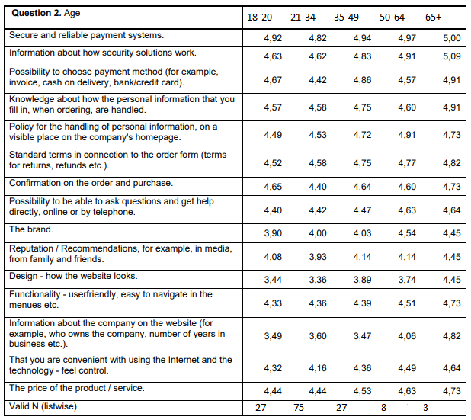
Figure 19- Calculated mean values of the answers on each sub factor, according to age

4.9.4 End of chapter conclusion

To conclude, the purpose with the survey was not to build any new theory or model, but to get a better understanding of how consumers perceive the importance of specific factors, for them to feel trust to purchase online. With this chapter, the researcher has addressed the second, third and fourth research objectives.

5 Chapter 5- Conclusion

In this final chapter the dissertation is summarised. The chapter will also discuss the fulfilment of the aims and objectives of the thesis. The work is criticised and finally, practicle implications and suggestions for future research will be disscused.

5.1 Summary of main findings

An often-mentioned reason for consumers not purchasing from websites, such as eBay is the lack of trust. Thus, there is a need for promoting trust and confidence in eBay. Trust is an essential tool for a transaction to take place, both in an online and offline environment. According to Castaldo (2007), trust is multi-dimensional and difficult to define. The level of trust needed to take the step and engage in online transactions is different for each individual. It is difficult to say what trust is for different people. How people perceive trust can be influenced by different backgrounds, experiences and expectations (Guirdham,1999). In e-commerce, e-Bay can be a trust-building source in itself. So, it is important for eBay to learn how to manage consumers’ trust in e-commerce. Although, building consumer trust on the Internet is a challenge for online vendors, such as eBay. Hernandez and Goodson (2006) state, the potential risk in e-commerce is greater because of the anonymity, distance and lack of physical interactions. The traditional shopping environment often has physical cues, such as the appearance of the store employees and a manager, which allows customers to engage with a sales persons that builds sense of trust. However, this is absent in the online environment. This lack of physical clues and physical interaction in the online environment, make it more difficult to establish trust with the consumers. So, this constitutes a major challenge for eBay that engages in e-commerce. Therefore, it is important to find factors that help to establish consumer trust in purchasing sports supplements from eBay. Businesses are not able to directly control the trust their customers feel. They can just build environments that encourage people to feel trust (Monty,2014).

5.1.1 Requirements for eBay to be trustworthy
A marketplace can be trustworthy, but the participants have to feel the trust before the marketplace can be trusted (Hultmark, 2002). The researcher investigated which factors are important for establishing consumer trust in the online shopping environment. The purpose with this dissertation was to get a better understanding of consumer trust when purchasing sports supplements, from eBay. By reviewing relevant literature on consumer trust in e- commerce, the researcher aimed to find important factors that help to establish trust online.
From these the researcher selected some specific factors that guided the empirical research, where the researcher intended to investigate how consumers perceive the importance of the selected factors, for them to feel trust to purchase sports supplements from eBay. Conducting a survey in form of an online questionnaire seemed like the most appropriate strategy to be able to get a picture of consumers’ opinions on the matter. The purpose with the questionnaire was to gather information about how consumers perceive the importance of different trust factors. The questions in the questionnaire were based on the factors found in the literature review. This study looked at consumer trust towards a specific Internet vendor and its website, eBay. Focusing on consumer trust relating to sports supplements purchase. The researcher found that there are many factors that help establish trust, which are relevant for the customers when purchasing online. The factors that are important for establishing trust depend to some degree on the current situation and consumers’ concerns at that time.

5.1.2 Most Important Factors: Security and Privacy

Security and privacy issues are often seen as barriers to shopping online. From the survey conducted, the results in the survey that the factors under security, as well as under privacy, gained high percentage of responses on the alternative “Very important”. This showed that security and privacy are factors that are of great importance for the consumers to feel trust, to purchase online. The factors, information and website design were not perceived as so important for the consumers to feel trust. The purpose of this dissertation was not to build any new theory or model, but to get a better understanding of consumer trust in e-commerce.

5.1.3 eBay’s User Agreement

From the literature review in chapter two and data collected in chapter 4 it is evident that eBay have chosen to excuse itself from the responsibility of regulating the sales of banned, counterfeit or sports supplements contain dangerous substances. eBay (2019) claims, this is because user authentication on the Internet is difficult and therefore eBay cannot and does not confirm each user’s purported identity. Murray (2018) states, they have no control over the quality, safety or legality of the items advertised, the truth or accuracy of the listings. This is perhaps a major reason, why only 3% of the respondents purchased sports supplements from eBay.

5.2 Aims and Objectives

The aim of this thesis was to examine the responsibility within the sports supplement market, specifically at eBay. This aim was to be achieved by fulfilling the following four objectives:

5.2.1 Objective 1

1. Critically analyse the debate in the literature regarding “trust” with in the sports supplement market at eBay.
Objective 1 was achieved by the researcher in Chapter 2 of this thesis: a thorough summary of appropriate academic literature based on the subject of trust in e-commerce, relating to eBay was discussed, utilising a vast range of academic sources including text books, peer-reviewed journals and websites. Appropriate models and theories, relating to trust provided relevant context for this thesis, and informed the direction of the research.

Objective 2

2. Critically analyse responsibility in the sports supplements market
Objective 2 was fulfilled in Chapter 4 of this thesis, through a summary of how and why FBO’s selling sports supplements are authorised to register with local authorities, as they are responsible for the sale of ‘safe to consume’ supplements. However, the summary also spoke about the lack of responsibility eBay’s User Agreement has towards suppliers that are not reputable. Which often leads to the sale of counterfeit products, and inevitably reduces trust amongst customers.

Objective 3

- Investigate regulation within the sports supplements market
Objective 3 was achieved in Chapter 4, through the discussion of acts, such as the Food Information (Wales) Regulations 2014 and Food (Sports) Supplements (Wales) Regulations 2003 (gov.uk, 2003 and gov.uk 2014). However, this is not the case with sports supplements purchased online from eBay, as it is unregulated. This inevitably reduces trust, amongst customers.

Objective 4

- Make recommendations into how the challenges can be solved for the needs of future consumers
Objective 4 was fulfilled by the distribution of the questionnaire that collected 140 responses from consumers that purchase sports supplements. The methodology relating to this research is described and discussed in Chapter 3 of this thesis, and Chapter 4 analyses the results of the questionnaire in order attain recommendations into the safe selling and use of sports supplements.

Implications of research

Based on this study and the knowledge obtained in the process of writing the dissertation, the findings obtained can provide some practical implications to other online companies, selling sports supplements. In the research a vast array of factors was examined to establish trust in e-commerce, which could be utilised by other companies. The factors constitute tools and techniques, which companies can adopt and utilise in order to improve the requirements consumers need in order to establish trust, between the company and the consumer.

Limitations of Research

At 140 respondents, the sample size was substantial but not large enough to be fully representative. This was an additional limitation of the study, as a larger sample of sports supplement users could have increased the generalisability of the results.
Another criticism of this research, is that it could have been easier to distinguish the importance of the factors by using a ranking method. With this method all the factors would be presented and the respondents would be asked to rank the factors from 1 and up, according to how they perceive the importance of each factor in relation to other factors.

Recommendations for future studies

A possibility for future research is to conduct the same survey, but with a greater sample size in order to generalise the findings. Also, conducting the survey in different parts of the UK or even globally, could yield different results.
As e-commerce at eBay and trust are areas continuously evolving, it would be interesting to see if the research conducted for this dissertation would produce the same results in five or more years. It is very likely the perception of trust amongst consumers would change as e-commerce becomes an integral part of society. Therefore, the factors which are important to establish trust today, may not be as relevant in the future.
This research focuses on consumer trust relating to the sports supplement market at eBay. However, online trust is a relevant aspect for other parties as well, including, employees, suppliers and distributors. By shifting the focus on a particular party, the results for factors to establish online trust may differ.
Finally, until eBay modifies its User Agreement, in order to prevent the reoccuring accounts of scammers, the sales of counterfit, unregulated supplements will always be prominent at eBay. The only solution is to report online scammers to local authories in order to allocate the online scammers. However, eBay (2019) refuse to take any responsibility as they believe the task is too difficult.

Refrences

Alan Marzilli. (2009) The Internet and Crime. 1st Ed. New York: Infobase Publishing, p.99.
Alcantara-Pilar, J. (2015). Analyzing the Cultural Diversity of Consumers in the Global Marketplace Advances in Marketing, Customer Relationship Management, and E-Services:. 1st ed. Hershey, Pennsylvania: IGI Global, p.215.
Aspers, P. (2018). Forms of uncertainty reduction: decision, valuation, and contest. Theory and Society, [online] 47(2), pp.133-149. Available at: https://link.springer.com/article/10.1007%2Fs11186-018-9311-0. [Accessed 5 May 2019].
Azorin, J. M. & Cameron, R., 2010. The Application of Mixed Methods in Organisational Research: A Literature Review. The Electronic Journal of Business Research Methods, 8(2), pp. 95-105.
Ba, S. and Pavlou, P. (2002). Evidence of the Effect of Trust Building Technology in Electronic Markets: Price Premiums and Buyer Behavior. MIS Quarterly, [online] 26(3), p.243. Available at: https://www.jstor.org/stable/4132332?seq=1#page_scan_tab_contents [Accessed 12 Dec. 2012].
Ba, Sulin, Establishing Online Trust Through a Community Responsibility System (January 1, 2001). Decision Support Systems. 31(3): 323-336. July 2001. Available at SSRN: https://ssrn.com/abstract=2853907 [Accessed 5 May 2019].
Babbie, Earl R. The Practice of Social Research. 12th ed. Belmont, CA: Wadsworth Cengage, 2010;
Bachmann, R. (2019). Understanding Institutional-based Trust Building Processes in Inter-organizational Relationships. [online] Surrey: University of Surrey, p.10. Available at: https://core.ac.uk/download/pdf/6200190.pdf [Accessed 5 May 2019].
Blog.smartsurvey.co.uk. (2019). The Pros and Cons of Using Open Ended Questions. [online] Available at: https://blog.smartsurvey.co.uk/the-pros-and-cons-of-using-open-ended-questions [Accessed 5 May 2019].
Bowen, G. (2014). Computer-mediated marketing strategies. 1st ed. Hershey, Pa: Business Science Reference, p.69.
Brechke, N. (2019). The Insider’s Guide to Supplements. [online] Better Nutrition. Available at: https://www.betternutrition.com/supplements/how-to-choose-supplements [Accessed 5 May 2019].
Brians, Craig Leonard et al. Empirical Political Analysis: Quantitative and Qualitative Research Methods. 8th ed. Boston, MA:
Brodwin, E. (2019). The $37 billion supplement industry is barely regulated — and it's allowing dangerous products to slip through the cracks. [online] Business Insider. Available at: https://www.businessinsider.com/supplements-vitamins-bad-or-good-health-2017-8?r=US&IR=T [Accessed 5 May 2019].
Bryman, A. & Bell, E., 2007. Business Research Methods. 2nd ed. Oxford: Oxford University Press.
Cameron, S. & Price, D., 2009. Business Research Methods: A Practical Approach. 1st ed. London: Chartered Institute of Personnel and Development.
Castaldo, S. (2008). Trust in Market Relationships. 1st ed. Cheltenham: Edward Elgar Pub., p.141.
Cazier, J.A., Shao, B.B.M. & St. Louis, R.D. (2006). E-business differentiation through value-based trust. Information & Management, 43:718-727.
Chang, S. and Isoda, M. (2015). Neural basis of social learning, social deciding, and other-regarding preferences. 1st ed. S.L.: Frontiers Media SA, p.55.
Chen, S.C. & Dhillon, G.S. (2003). Interpreting Dimensions of Consumer Trust in E-Commerce. Information Technology and Management, 4:303- 318.
Christensen, L., Andersson, N., Carlsson, C. & Haglund, L. (2001). Marknadsundersökning – En handbok. 2nd ed. Lund: Studentlitteratur.
Collis, J. & Hussey, R., 2009. Business Research: A Practical Guide for Undergraduate & Postgraduate Students. 3rd ed. Basingstoke: Macmillan Publishers Limited.
Cooper, D. C. & Schindler, P. S., 2001. Business Research Methods. 7th ed. New York: McGraw-Hill.
Cotton, B. (2018). What’s driving the booming sports nutrition sector? | Business Leader News. [online] Business Leader. Available at: https://www.businessleader.co.uk/whats-driving-the-booming-sports-nutrition-sector/56861/ [Accessed 5 May 2019].
Crowther, D. & Lauesen, L. M., 2017. Handbook of Research Methods in Corporate Social Responsibility. 1st ed. Cheltenham: Edward Elgar Publishing Limited.
Dan J. Kim (2008) Journal of Management Information Systems: Vol. 24, No. 4, Trust in Online Environments, pp. 13-45
Daniel, P. S. & Sam, A. G., 2011. Research Methodology. 1st ed. New Dehli: Gyan Publishing House.
Denscombe, M. (2014). The Good research guides. 4th ed. Maidenhead, England: McGraw-Hill/Open University Press, p.35.
Dierks, L. (2005). Trust as a Determinant of Consumer Behaviour Under Uncertainty: An Empirical Analysis of Consumers' Reactions to a Random External Shock in Europe. 1st ed. Göttingen: Cuvillier Verlag, p.62.
eBay. (2019). User Agreement. [online] Available at: https://www.ebay.com/help/policies/member-behaviour-policies/user-agreement?id=4259 [Accessed 5 May 2019].
E-Business Research Centre. February 01, 2006. The ABCs of E-Commerce. Retrieved October 13, 2006, from http://www.cio.com/ec/edit/b2cabc.html. [Accessed 5 May 2019].
E-Business, eEurope. (n.d). Retrieved October 13, 2006, from http://www.e- europestandards.org/Docs/E-Business%20to%20press.pdf. [Accessed 5 May 2019].
Export.gov. (2019). EU Regulations on Food Supplements, Health Foods, Herbal Medicines | export.gov. [online] Available at: https://www.export.gov/article?id=EU-Regulations-on-Food-Supplements-Health-Foods-Herbal-Medicines1 [Accessed 5 May 2019].
Fagan, J. (2019). Dangers of Protein Drinks. [video file] Available at: https://www.youtube.com/watch?v=J8CQNrzpgf0 [Accessed 5 May 2019].
Fink, H., Mikesky, A. and Burgoon, L. (2009). Practical applications in sports nutrition. 2nd ed. Burlington, Massachusetts: Jones & Bartlett Learning, p.286.
Finne, S. and Sivonen, H. (2009). The retail value chain. 1st ed. London: Kogan Page, p.47.
Floyd, P., Mimms, S. and Yelding, C. (2007). Personal health. 4th ed. Boston: Cengage Learning, p.311.
Food Supplements Consumer Research. (2018). [online] London: Food Standard Agency, p.48. Available at: https://www.food.gov.uk/sites/default/files/media/document/food-supplements-full-report-final-2505018.pdf [Accessed 5 May 2019].
Food.gov.uk. (2019). Do you sell of supply food supplements? [online] Available at: https://www.food.gov.uk/sites/default/files/media/document/foodsupplementsenglish_0.pdf [Accessed 5 Apr. 2019].
Food.gov.uk. (2019). Do you sell or supply food supplements? [online] Available at: https://www.food.gov.uk/sites/default/files/media/document/foodsupplementsenglish_0.pdf [Accessed 5 May 2019].
Ford, D. (2001). Trust and Knowledge Management: The Seeds of Success. [online] Kingston: Queen’s University at Kingston, p.5. Available at: https://pdfs.semanticscholar.org/f010/204e5277d2504ed797e99ab071ee67ab118c.pdf [Accessed 12 Dec. 2018].
Furnell, S., Katsikas, S. and Lioy, A. (2008). Trust, privacy and security in digital business. 1st ed. Berlin: Springer, p.28.
Gary Collins, M. (2013). Why You Should Never buy Supplements on Amazon or eBay! A Must-Read by Former FDA Special Agent Gary Collins - The Simple Life. [online] The Simple Life. Available at: https://www.thesimplelifenow.com/why-you-should-never-buy-supplements-on-amazon-or-ebay-a-must-read-by-former-fda-special-agent-gary-collins/ [Accessed 5 May 2019].
Gefen, D. & Straub, D. (2003). Managing User Trust in B2C e-Services. e- Service Journal, 7-24.
Ghauri, P. & Gronhaug, K., 2005. Research Methods in Business Studies: A Practical Guide. 3rd ed. Harlow: Financial Times Prentice Hall.
Grabner-Kräuter, S. & Kaluscha, E.A. (2003). Empirical research in on-line trust: a review and critical assessment. Int. J. Human-Computer Studies, 58:783-812.
Graham, T. (2019). Nutritional Supplement Habits and Perceptions of Athletes with a Disability. [online] Lboro.ac.uk. Available at: https://www.lboro.ac.uk/media/wwwlboroacuk/content/peterharrisoncentre/downloads/resources/Nutritional%20Supplement%20questionnaire.pdf [Accessed 5 May 2019].
Groucutt, J., Leadley, P. and Forsyth, P. (2004). Marketing: Essential Principles, New Realities. 1st ed. London: Kogan Page, p.352.
Guirdham, M. (1999). Communicating across cultures. 1st ed. London, UK: Macmillan International Higher Education, p.128.
Hansen, J. (2005). 100 sidor: Om att starta, driva och marknadsföra en butik på nätet. Stockholm: Redaktionen.
Harreld, H. (2001). Exchanges must retool. Info World, [online] (0199-6649), p.8. Available at: https://books.google.co.uk/books?id=uDgEAAAAMBAJ&pg=PA8&dq=technology+enables+market+exchanges+in+ways+that+were+not+possible+before,+such+as+online+exchange+of+goods+and+services&hl=en&sa=X&ved=0ahUKEwj5raTwxofiAhXSWxUIHRwwBtIQ6AEIKzAB#v=onepage&q=technology%20enables%20market%20exchanges%20in%20ways%20that%20were%20not%20possible%20before%2C%20such%20as%20online%20exchange%20of%20goods%20and%20services&f=false [Accessed 12 Dec. 2018].
Harris, M. (2004). Innovations Through Information Technology: 2004 Information Resources Management Association International Conference, New Orleans, Louisiana, USA, May 23-26, 2004, Volume 1. 1st ed. Pennsylvania: Idea Group Inc (IGI), p.273.
Harris, M. (2005). Managing Health Services: Concepts and Practice. 2nd ed. Victoria: Elsevier Australia, p.331.
Hernandez, F. and Goodson, I. (2006). Social Geographies of Educational Change. Berlin‎/‎Heidelberg: Springer Science & Business Media, p.41.
Hu, W. (2009). Selected readings on electronic commerce technologies. 1st ed. Hershey, PA: Information Science Reference, p.111.
Hultmark, C. (2002). Internet marketplaces. 1st ed. Oxford: Oxford University Press, p.181.
Hutt, M.D. & Speh, T.W. (2004). Business Marketing Management – A Strategic View of Industrial and Organizational Markets. 8th ed. Mason, Ohio: Thomson South-Western.
Internet World Stats (2006) – Usage and Population Statistics. September 18, 2006. World Internet Users and Population Stats. Retrieved from http://www.internetworldstats.com/stats.htm [Accessed 5 May 2019].
Jakharia, S. (2019). Why Trust is THE Most Important Factor to Acquiring Customers Online. [online] Spinx: Crafting Digital. Available at: https://www.spinxdigital.com/blog/why-trust-is-the-most-important-factor-to-acquiring-customers-online/ [Accessed 5 May 2019].
Karen Cook. (2001). Trust in Society. 2nd ed New York City: Russell Sage Foundation, p.45.

Khosrow-Pour, M. (2006). Dictionary of Information Science and Technology, Volume 1. 1st ed. Pennsylvania: Idea Group Inc (IGI), p.67.
Kubota, T. (2008). Cyberlaw for global E-business. 1st ed. Hershey PA: Information Science Reference, p.202.

Leaving feedback for sellers. (2019). Feedback. [online] Available at: https://www.ebay.com/help/buying/leaving-feedback-sellers/leaving-feedback-sellers?id=4007 [Accessed 5 May 2019].

Lee, I. (2012). Electronic Commerce Management for Business Activities and Global Enterprises: Competitive Advantages: Competitive Advantages. 1st ed. Pennsylvania: Idea Group Inc (IGI), p137.

Legislation.gov.uk. (2019). The Food Information (Wales) Regulations 2014. [online] Available at: http://www.legislation.gov.uk/wsi/2014/2303/contents/made [Accessed 5 May 2019].
Lewis, P., Goodman, S., Fandt, P. and Michlitsch, J. (2006). Management: Challenges for Tomorrow's Leaders. 5th ed. Boston: Cengage Learning, p.98.
Li, X. and Xu, X. (2017). Proceedings of the Fourth International Forum on Decision Sciences. 1st ed. New York City: Springer, p.262.
Longman, 2011; McNabb, David E. Research Methods in Public Administration and Nonprofit Management: Quantitative and Qualitative Approaches. 2nd ed. Armonk, NY: M.E. Sharpe, 2008;
Loshin, P. & Murphy, P. (1997). Electronic commerce – On-line Ordering and Digital Money. 2nd ed. Rockland, Massachusetts: Charles River Media, Inc.
Magana, G. (2018). eBay's marketplace growth regresses. [online] Business Insider. Available at: https://www.businessinsider.com/ebays-growth-slowing-2018-7?r=US&IR=T [Accessed 5 May 2019].

Michael J. Shaw (2006). E-Business Management: Integration of Web Technologies with Business Models. 2ndEd. New York: Springer Science & Business MediaPublishing, p.338.
Mikhail I. Melnik and James Alm (2002): The Journal of Industrial Economics
Mladjenovic, P. (2013). Micro-entrepreneurship for dummies. 4th ed. Hoboken, N.J: John Wiley & Sons, p.104.
Monty, D. (2014). Trust-based selling. 1st ed. New York City: Apress, p.6.
Morgan, M. (2013). Why You Should Never buy Supplements on Amazon or eBay. [online] Oxford, CT Patch. Available at: https://patch.com/connecticut/oxford-ct/why-you-should-never-buy-supplements-on-amazon-or-ebay_d0e64f41 [Accessed 12 Dec. 2018].

Mulheim (2015). 'Bigorexia': Muscle dysmorphia 'now affects one in 10 gym-going men'. [video] Available at: https://www.bbc.co.uk/news/av/uk-34315196/bigorexia-muscle-dysmorphia-now-affects-one-in-10-gym-going-men [Accessed 5th May. 2019].
Murray, A. (2018). EBay accused of failing to stop scams as another buyer loses £1,500. [online] The Telegraph. Available at: https://www.telegraph.co.uk/money/consumer-affairs/ebay-accused-failing-stop-scams-another-buyer-loses-1500/ [Accessed 5 May 2019].
Neelankavil, J. (2015). International Business Research. 8th ed. Abingdon-on-Thames: Routledge, p.53.
Nefti, S., Meziane, F. & Kasiran, K. (2005). A Fuzzy Trust Model for E- Commerce. Proceedings of the Seventh IEEE International Conference on E-Commerce Technology (CEC’05).
Nielsen, B. (2004). The Role of Trust in Collaborative Relationships: A Multi-Dimensional Approach. Management, vol. 7(3), 239-256. doi:10.3917/mana.073.0239 [Accessed 5 May 2019].
NoFate247, Ebay Supplements Safe or Scam| Sunday Supplement Review. (2019). [video] Available at: https://www.youtube.com/watch?v=U7zpzmS9LME [Accessed 5 May 2019].
O’Daniel M, Rosenstein AH (2008). Professional Communication and Team Collaboration. In: Hughes RG, editor. Patient Safety and Quality: An Evidence-Based Handbook for Nurses. Rockville (MD): Agency for Healthcare Research and Quality (US); Chapter 33. Available from: https://www.ncbi.nlm.nih.gov/books/NBK2637/ [Accessed 5 May 2019].
Pages.ebay.com. (2019). Feedback. [online] Available at: https://pages.ebay.com/services/forum/feedback.html [Accessed 5 May 2019].
Pankau, B. (2016). Tips for Safely Buying Supplements Online. [online] Stack. Available at: https://www.stack.com/a/tips-for-safely-buying-supplements-online [Accessed 5 May 2019].
Patricia M. Doney and Joseph P. Cannon (1997): Journal of Marketing: Vol. 61, No. 2, pp. 35-5
Pennaen, K. (2009). The Initial Stages of Consumer Trust Building in e-Commerce. [online] Jyväskylä: Vaasan ylio, p.18. Available at: https://www.univaasa.fi/materiaali/pdf/isbn_978-952-476-257-1.pdf [Accessed 12 Dec. 2018].
Pennanen, K. (2009). Consumers’ initial e-trust building process: development of an integrative model and research proposition. In S.Samu, R. Vaidyanathana & D. Chakravarti (Eds). Asia-Pacific Advances in Consumer Research, Vol 8.
Petrovic, O., Ksela, M., Fallenböck, M. & Kittl, C. (2003). Trust in the Network Economy. Vol. 2. Wien: Springer-Verlag Wien New York.
Planet Express. (2019). 6 Best Websites for Buying A Supplements From. [online] Available at: https://planetexpress.com/2018/06/27/6-best-websites-for-buying-a-supplements-from/ [Accessed 5 May 2019].
Prashantham, S. (2007). The Internationalization of Small Firms: A Strategic Entrepreneurship Perspective. 1st ed. London: Routledge, p.8.
Pride, W., Hughes, R. and Kapoor, J. (2006). Business Looseleaf Version. 9th ed. Cengage Learning: Boston, MA, p.567.

Ralf Gladis. (2018). This is why eBay is dropping PayPal as their payments provide. [online] IMRG. Available at: https://www.imrg.org/blog/why-ebay-drops-paypal/ [Accessed 5 May 2019].

Rampen, J. (2018). eBay buyer scams: 4 frauds sellers need to watch out for, [online] Mirror. Retrieved from https://www.mirror.co.uk/money/ebay-buyer-seller-scams-fraud-5552823 [Accessed 12 Dec. 2018].
Raska, D. & Shaw, D., 2012. When is going green good for company image?. Management Research Review, 35(4), pp. 326-347.

Riordan, D. (2013). Technical report writing today. 10th ed. Boston: Cengage Learning, p.119.
Robert L. Sexton. (2010). Exploring Microeconomics. 5th Edition. Boston: Cengage Learning, p.221.
Roberts, D. (2016). World of Workcraft: Rediscovering Motivation and Engagement in the Digital Workplace. 2nd ed. London: Taylor and Francis, p.24.
Roy J. Lewicki and Carolyn Wiethoff. "Trust, Trust Development, and Trust Repair." Morton Deutsch and Peter T. Coleman, eds., The Handbook of Conflict Resolution: Theory and Practice San Francisco: Jossey-Bas Publishers, 2000, pp. 86-107
Rule, C. & Friedberg, L. (2005). The appropriate role of dispute resolution in building trust online. Artificial Intelligence and Law, 13:193-205.

Sachs, R. and Abegg, B. (2001). Commercial correspondence: Hauptbd., Volume 1. 1st ed. Munich: Hueber Verlag, p.10.
Sandy Q. Qu, John Dumay, (2011) "The qualitative research interview", Qualitative Research in Accounting & Management, Vol. 8 Issue: 3, pp.238-264, https://doi.org/10.1108/11766091111162070 [Accessed 5 May 2019].
Saunders, M. & Phillip, L., 2012. Doing Research in Business and Management. 1st ed. Harlow: Pearson Educated Limited
Saunders, M., Lewis, P. & Thornhill, A. (2007). Research Methods for Business Students. 4th ed. England: FT Prentice Hall.
Saunders, M., Lewis, P. & Thornhill, A., 2009. Research Methods for Business Students. 5th ed. Essex: Pearson Education Limited.
Saunders, M., Lewis, P. and Thornhill, A. (2000). Business research methods. 2nd ed. Upper Saddle River, New Jersey: Financial Times/Prentice Hall, p.296.
Saunders, M., Lewis, P. and Thornhill, A. (2003). Research Methods for Business Students. 3rd ed. New Jersey: Prentice Hall, p.478.
Schropp, S., Spchrop, S. and Schropp, B. (2009). Trade Policy Flexibility and Enforcement in the WTO: A Law and Economics Analysis. 1st ed. Cambridge: Cambridge University Press, p.51.

Service, M. (2010). eBay buyer sued for defamation after leaving negative feedback on auction site. [online] Daily Mail.con. Available at: https://www.dailymail.co.uk/news/article-1265490/eBay-buyer-sued-defamation-leaving-negative-feedback-auction-site.html [Accessed 5 May 2019].
Shoniregun, C.A., Omoegun, A., Brown-West, D. & Logvynovskiy, O. (2004). Can eCRM and Trust improve eC customer base? Proceedings of the IEEE International Conference on E-Commerce Technology.
Silver, L. (2013). Essentials of marketing research. 3rd ed. Abingdon-on-Thames: Routledge, p.331.
Simon, L. (2000). NetPolicy.Com. 1st ed. Washington, Dc: Baltimore, Md, p.254.
Singh, Kultar. Quantitative Social Research Methods. Los Angeles, CA: Sage, 2007.
Slevin, J. (2000). The Internet and Society. Cambridge: Polity Press.
Smyth, H. (2014). Relationship Management and the Management of Projects. 1st ed. Routledge: Abingdon-on-Thames, p.40.
Social, S. (2019). How Social Media is Influencing purchase decisions. [online] Social Media Week. Available at: https://socialmediaweek.org/blog/2017/05/social-media-influencing-purchase-decisions/ [Accessed 5 Apr. 2019].

Song, R. (2007). Trust in E-Services: Technologies, Practices and Challenges: Technologies, Practices and Challenges. 1st ed. Pennsylvania: Idea Group Inc (IGI), p.105.
SOU - Statens offentliga utredningar, (1999:106). Konsumenterna och IT – en utredning om datorer, handel och marknadsföring. Stockholm: Norstedts Tryckeri.
Tadelis, S. (2016). Reputation and Feedback Systems in Online Platform Markets. [online] California: Haas School of Business, p.20. Available at: http://faculty.haas.berkeley.edu/stadelis/Annual_Review_Tadelis.pdf [Accessed 5 May 2019].
Tan, Y-H. & Thoen, W. (2000). A Logical Model of Trust in Electronic Commerce. Electronic markets, Vol. 10(4):258-263.
Tanier, M. (2019). The supplement industry is built on deception. [online] Sports on Earth. Available at: http://www.sportsonearth.com/article/42089796/ [Accessed 5 May 2019].
Thomas, R. M., 2003. Blending Qualitative and Quantitative Research Methods in Theses and Dissertations. California: Corwin Press.
Veal, A. J., 2005. Business Research Methods: A Managerial Approach. 5th ed. Frenchs Forest: Pearson Education Australia.
Vol. 50, No. 3 pp. 337-349
Volek, J. (2019). 25 top sports supplements. [online] Nutrition Express. Available at: https://www.nutritionexpress.com/showarticle.aspx?id=1724 [Accessed 5 May 2019].
Walsh, K. (2013). Oxford Textbook of Medical Education. 1st ed. Oxford: OUP Oxford, p.616.
Wang, Y.D. & Emurian, H.H. (2005). An overview of online trust: Concepts, elements, and implications. Computers in Human Behaviour, 21:105-125.
Wankhade, L. and Dabade, B. (2010). Quality Uncertainty and Perception: Information Asymmetry and Management of Quality Uncertainty and Quality Perception. 1st ed. New York: Springer Science & Business Media, p.7.
Warren, R. and Tweedale, G. (2002). ‘Business Ethics and Business History: Neglected Dimensions in Management Education.’ British Journal of Management, 13(3):209-219.

WhoIsHostingThis.com. (2019). Online Fraud: How to Avoid Internet Scams. [online] Available at: https://www.whoishostingthis.com/resources/online-fraud/ [Accessed 5 May 2019].
Willson, R. (2015). Muscle dysmorphia: One in 10 men in gyms believed to have 'bigorexia'. [online] Bbc.co.uk. Available at: http://www.bbc.co.uk/newsbeat/article/34307044/muscle-dysmorphia-one-in-10-men-in-gyms-believed-to-have-bigorexia [Accessed 5 May 2019].
Windham, L. & Orton, K. (2000). The Soul of the New Consumer – The Attitudes, Behaviours, and Preferences of e-customers. New York: Allworth Press. Articles

Young, S. (2019). Dietary supplements found to contain potentially 'dangerous' ingredients. [online] The Independent. Available at: https://www.independent.co.uk/life-style/dietary-supplement-dangerous-ingredients-fda-weight-loss-bodybuilding-a8584146.html [Accessed 5 May 2019].
Zhang, Y. and Guizani, M. (2011). Game theory for wireless communications and networking. 1st ed. Boca Raton, Fla.[u.a.]: CRC, p.308.
Zheng, Y. (2010). Trust Modelling and Management in Digital Environments: From Social Concept to System Development: From Social Concept to System Development. 1st ed. IGI Global: Pennsylvania, United States, p.431.

Zhou, Z. (2004). E-commerce & Information Technology in Hospitality & Tourism. 1st ed. Boston: Cengage Learning, p.56.

Appendicies

7.1 Appendix 1- Copy of the survey explanation for respondents and questions

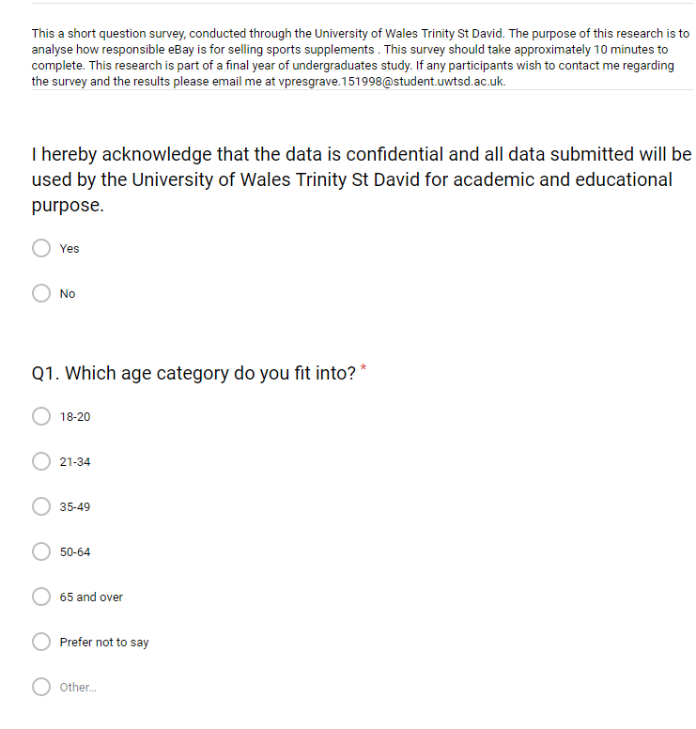

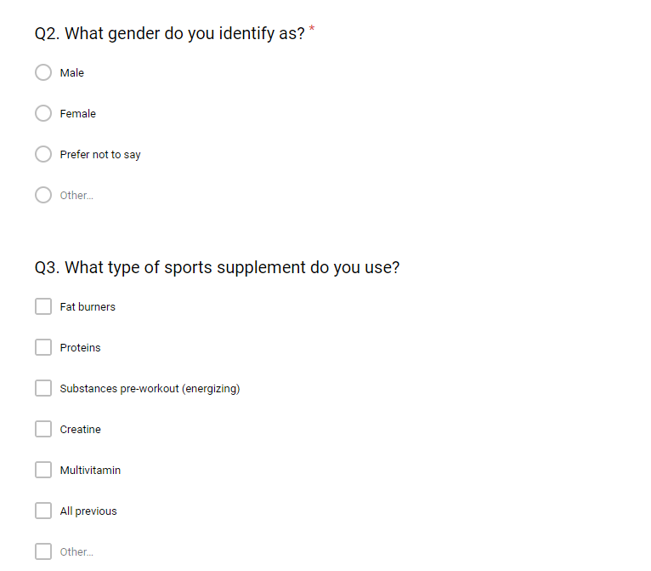

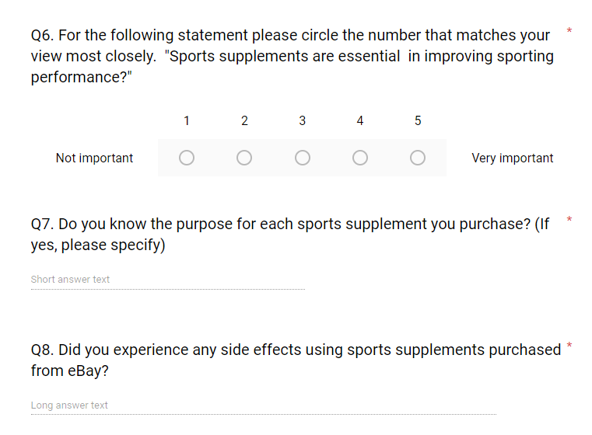
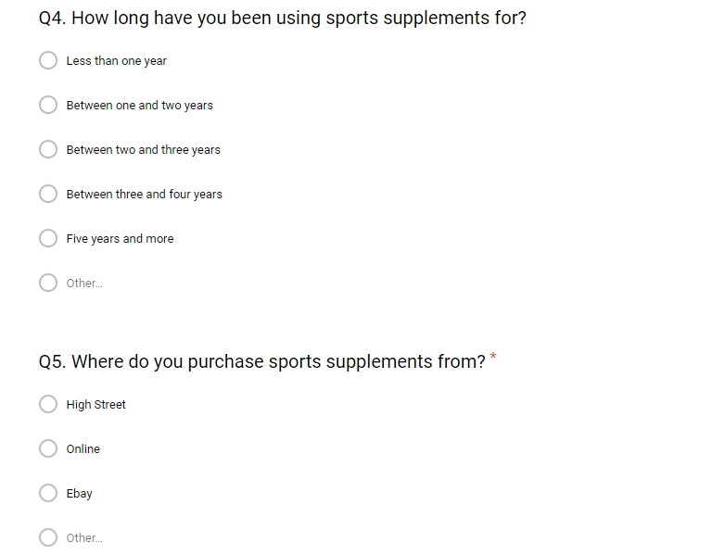
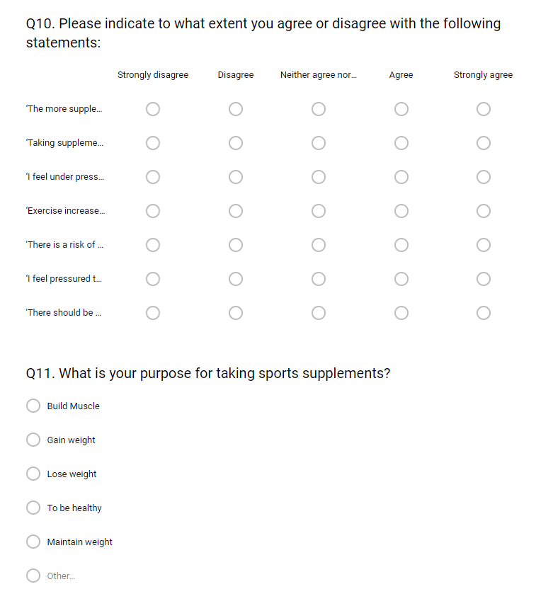
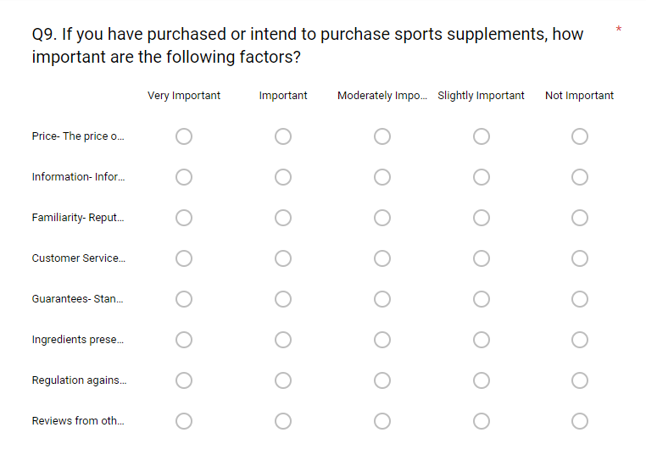
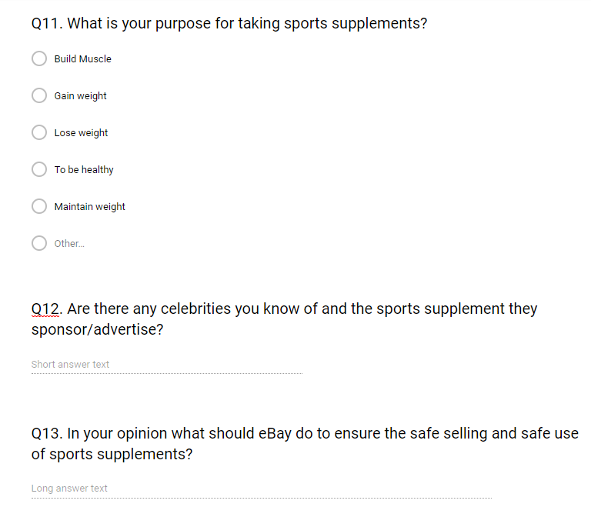
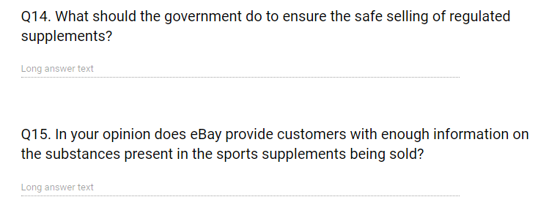

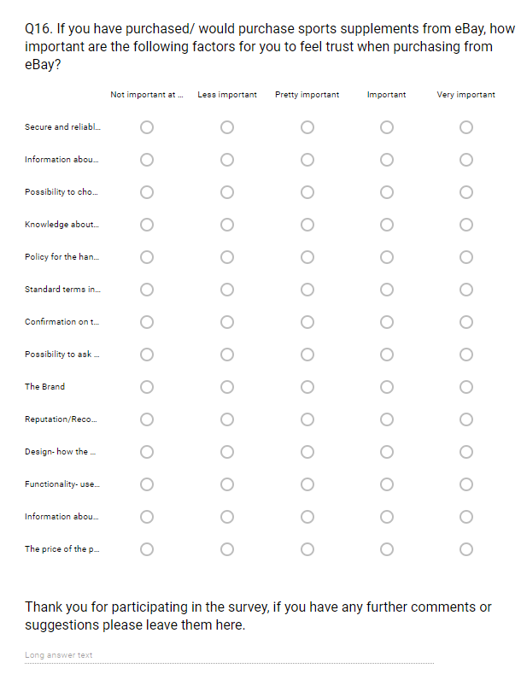

7.2 Appendix 2- List of qualitative responses to question eight

List of qualitative responses to question seven
- Yes, BCCA’s aid in recovery
- Protein to supplement my diet , multi vitamin to stay healthy increase healing time better sleep and help with energy release
- Mostly
- Whey protein for muscle repair, creatine to absorb water more effectively and pre workout to stimulate me
- To gain weight
- Protein for building and maintenance of muscle. Pre workout is for increased energy levels. Multivitamins for covering dietary deficiencies.
- Yes
- Some
- Some
- Proteins to help increase muscle mass multivitamins because I eat unhealthy food
- Yes, as I use protein to help repair replenish and grow my muscles after each session. Creatine to boost my energy for better performance in the short term period I use it.
- Yes, all supplements, nutrients & vitmains
- No
- Yes - i us multivitamins so ensure i'm taking all my required vitamins
- Yes bcaas, to energise and prevent of burning muscle over fat.
- No
- Yes eg protein for muscle building
- BCCA's for recovery
- No
- Yes I buy protein - help build muscle and bcas to help energise before a work out
- Not really
- Yes it assists with training
- Yes, I use protein to help aid recovery after exercise and multivitamins to maintain a healthy diet
- Not really
- Yes, all purpose use
- No
- Yes
- No
- BCAA supplements have been shown to build muscle, decrease muscle fatigue and alleviate muscle soreness
- No
- No
- Yes, protein to build muscle
- Yes e. g. protein for muscle building
- BCCA's for recovery
- Yes I buy protein - help build muscle and bcas to help energise before a work out
- Yes I buy protein - help build muscle and bcas to help energise before a work out
- No
- Yes I buy protein - help build muscle and bcas to help energise before a work out
- BCCA's for recovery
- Creatine to increase strength
- Protein, to help repair and build muscle
- Protien to suppliment my diet , multi vitimin to stay healthy increase healing time better sleep and help with energy release
- Mostly
- Creatine, to build strength
- Protein, to help build build and repair muscle
- Yes, it's good for the bones.
- Yes it assists with training
- Protein, to help build and repair muscle
- Protein, to build and repair muscle
- Yes Calcium- strengthening for bones and teeth.
- Not really
- Recovery
- To help aid muscle gain n recovery
- To help aid muscle gain n recovery
- Yes I buy protein - help build muscle and bcas to help energise before a work out
- Yes I buy protein - help build muscle and bcas to help energise before a work out
- Protein, to help build and repair muscle
- Protein, to build and repair muscle
- Protein, to build muscle
- Protein, to build muscle
- Protein, to build muscle
- Protein, to build muscle
- Protein, to build muscle
- Protein, builds muscle
- Protein, builds muscle
- Protein, builds muscle
- Yes, I use protein to help aid recovery after exercise and multivitamins to maintain a healthy diet
- Protein, to build muscle
- Protein, to build muscle
- Protein, to build muscle
- Protein, to build muslce
- Protein, to build muscle
- Protein, to build muscle
- Yes it assists with training
- Protein, to build muscle
- No
- Yes, I use protein to help aid recovery after exercise and multivitamins to maintain a healthy diet
- Yes, I use protein to help aid recovery after exercise and multivitamins to maintain a healthy diet
- Yes, I use protein to help aid recovery after exercise and multivitamins to maintain a healthy diet
- Yes, I use protein to help aid recovery after exercise and multivitamins to maintain a healthy diet
- Yes, I use protein to help aid recovery after exercise and multivitamins to maintain a healthy diet
- Yes I buy protein - help build muscle and bcas to help energise before a work out
- Yes I buy protein - help build muscle and bcas to help energise before a work out
- Yes I buy protein - help build muscle and bcas to help energise before a work out
- Yes I buy protein - help build muscle and bcas to help energise before a work out
- Yes I buy protein - help build muscle and bcas to help energise before a work out
- Yes I buy protein - help build muscle and bcas to help energise before a work out
- Yes I buy protein - help build muscle and bcas to help energise before a work out
- Yes I buy protein - help build muscle and bcas to help energise before a work out
- Yes I buy protein - help build muscle and bcas to help energise before a work out
- Yes I buy protein - help build muscle and bcas to help energise before a work out
- Yes I buy protein - help build muscle and bcas to help energise before a work out
- Yes I buy protein - help build muscle and bcas to help energise before a work out
- Yes I buy protein - help build muscle and bcas to help energise before a work out
- Yes I buy protein - help build muscle and bcas to help energise before a work out
- Yes I buy protein - help build muscle and bcas to help energise before a work out
- Yes I buy protein - help build muscle and bcas to help energise before a work out
- Yes I buy protein - help build muscle and bcas to help energise before a work out
- Yes I buy protein - help build muscle and bcas to help energise before a work out
- Yes I buy protein - help build muscle and bcas to help energise before a work out
- Yes I buy protein - help build muscle and bcas to help energise before a work out
- Yes I buy protein - help build muscle and bcas to help energise before a work out
- Gain weight
- Gain Weight
- Yes I buy protein - help build muscle and bcas to help energise before a work out
- Yes I buy protein - help build muscle and bcas to help energise before a work out
- Gain weight
- Gain weight
- Gain weight
- Gain weight and build muscle
- Yes, multivitams fill micronutrient gaps.
- yes
- yes, protein for muscle synthesis and repair, creatine for ATP reasons, multivitamin to stop deficiencies
- energy
- not sure
- Some
- Cod Liver oil, to lubricate joints
- Cod liver oil, to lubricate joints
- Cod liver oil, to lubricate joints
- Cod liver oil, to lubricate joints
- Cod liver oil, to lubricate joints
- Protein and BCAA's, to build and repair muscle
- Protein and BCAA's, to build and repair muscle
- Protein and BCAA's, to build and repair muscle
- Protein and BCAA's, to build and repair muscle
- Protein and BCAA's, to build and repair muscle
- Protein and BCAA's, to build and repair muscle
- Protein and BCAA's, to build and repair muscle
- Protein and BCAA's, to build and repair muscle
- Yes
- Yes - I us multivitamins so ensure i'm taking all my required vitamins
- Yes - I us multivitamins so ensure i'm taking all my required vitamins
- Yes - I us multivitamins so ensure i'm taking all my required vitamins
- Yes - I us multivitamins so ensure i'm taking all my required vitamins
- Protein, for muscle growth and repair
- Protein, to build and repair muscle
- Yes - I us multivitamins so ensure i'm taking all my required vitamins
- Yes - I us multivitamins so ensure i'm taking all my required vitamins
- Yes I buy protein - help build muscle and bcas to help energise before a work out
- Yes I buy protein - help build muscle and bcas to help energise before a work out

7.3 Appendix 3-Ethics forms of approval

 |  |  | E3 FORM
APPLICATION FOR ETHICAL APPROVAL – BA level

CAIS AM GYMERADWYAETH MOESEGOL – Lefel BA

Mae'r ffurflen hon i'w chwblhau gan bob BA myfyrwyr. Rhaid i bob ffurflen gael ei ystyried gan diwtor y modiwl.  Dylai un copi o'r ffurflen yn cael ei roi ar y ffeiliau Gyfadran ac un copi cadw ar y ffeil myfyrwyr. |  | This form is to be completed by all BA students conducting research, projects or productions. This form should be completed by the student. All forms must be considered by the Module tutor. A copy of the form must be kept centrally and on the student file.
ADRAN 1 – MANYLION MYFYRIWR |  | SECTION 1 - STUDENT DETAILS
Enw Llawn  Full Name | Vivian Presgrave
Ysgol/Cyfadran/  School/Faculty | UWTSD Swansea Business School |  |  | Rhif Myfyriwr Student Number | P151998
Cydlynydd prosiect / Tiwtor  Module Tutor/ Programme Co-ordinator | Caroline Jawad |  |  | Enw'r Gradd  Name of Degree | BA (Hons) Business Management
Teitl dangosol yr Traethawd Hir: |  |  |  | Indicative Title of Dissertation:
A critical examination of trust within the sports supplement market, specifically at eBay.

ADRAN 2 – MANYLION CYFRANOGWYR / CYNULLEIDFA |  | SECTION 2 - PARTICIPANT / AUDIENCE DETAILS
Pwy yw’r cyfranogwyr arfaethedig? | Who are the intended participants? |  |  | Ydw / Yes | Na / No
Myfyrwyr / staff Y Drindod Dewi Sant | Students / staff of Trinity Saint David |  |  |  | /
Oedolion (dros oed 16 ac yn gymwys i gydsynio) | Adults (over the age of 16 and competent to give consent) |  |  | /
Plant a phobl ifanc dan oed | Children / legal minors |  |  |  | /
Cleifion neu gleientiaid gweithwyr proffesiynol | Patients or clients of professionals |  |  |  | /
Rhywun sy’n cael ei gadw yn y ddalfa neu y mae’r llys wedi cymryd cyfrifoldeb amdano | Anyone in custodial care or for whom the court has assumed responsibility |  |  |  | /
Aelod o unrhyw sefydliad lle mae’n bosibl bod angen i unigolyn arall hefyd gydsynio. | A member of any organisation where another individual may also need to give consent. |  |  |  | /
Eraill: Nodwch: / Others: please identify:
N/A

Nifer, Oed a Ffynhonnell y Cyfranogwyr  Rhowch fanylion yr demograffeg y cyfranogwyr / gynulleidfa. |  |  | Participant / Audience Number and Age  Provide details of the demographics of the participants / audience.
Nifer o Gyfranogwyr / yn y Gynulleidfa | Participant/ Audience number |  | 100+
Grŵp oedran y Cyfranogwyr/y Gynulleidfa | Participant/ Audience age group |  | 18+

ADRAN 3 – GWEITHGAREDD YMCHWIL |  |  | SECTION 3 – RESEARCH ACTIVITY
1. | Ydy’r prosiect yn cynnwys: | Does the project include: |  | Ydy / Yes | Nac ydy/No
Defnyddio holiadur neu offeryn ymchwil tebyg |  | Use of questionnaire or similar research instrument |  | /
Defnyddio prawf ysgrifenedig neu gyfrifiadurol |  | Use of written or computerised test |  |  | /
Cyfweliad (cysylltwch gwestiynau posibl) |  | Interview (attach provisional questions) |  |  | /
Dyddiaduron |  | Diaries |  |  | /
Arsylwi ar gyfranogwyr a hwythau'n ymwybodol o hynny |  | Participant observation with their knowledge |  |  | /
Arsylwi ar gyfranogwyr a hwythau ddim yn ymwybodol o hynny |  | Participant observation without their knowledge |  |  | /
Recordio fideo neu sain |  | Video or audio-taping |  |  | /
Mynediad i wybodaeth bersonol neu gyfrinachol heb gydsyniad penodol y cyfranogwyr |  | Access to personal or confidential information without the participants specific consent |  |  | /
Defnyddio unrhyw gwestiynau, ysgogiadau prawf, cyflwyniad y gallai rhai cyfranogwyr eu profi fel rhywbeth sy'n achosi niwed / tramgwydd corfforol, meddyliol neu emosiynol |  | Administration of any questions, test stimuli, presentation that may be experienced as physically, mentally or emotionally harmful / offensive |  |  | /
Cyflawni unrhyw weithredoedd allai achosi embaras neu effeithio ar hunan-barch |  | Performance of any acts which may cause embarrassment or affect self-esteem |  |  | /
Ymchwilio i gyfranogwyr sy’n ymwneud â gweithgareddau anghyfreithlon |  | Investigation of participants involved in illegal activities |  |  | /
Gweithdrefnau lle defnyddir twyll |  | Procedures that involve deception |  |  | /
Gweini unrhyw sylwedd, cyfrwng neu blasebo |  | Administration of any substance, agent or placebo |  |  | /
Dull arall o gasglu data neu fformat cyflwyno (esboniwch) |  | Other method of data collection or presentation format (please explain) |  |  | /

2. | Restru eich dull o gasglu data | List your method of data collection:
Online questionnaire

3. | Risg Posibl:  (corfforol, seicolegol, cyfreithiol, cymdeithasol neu economaidd) | Potential Risk:  (physical, psychological, legal, social or economic)
A oes unrhyw risg bosibl i: |  | Is there any potential risk to: | Ydw / Yes | Na / No
A | Cyfranogwyr? | Participants? |  | /
B | Ymchwilydd? | Researcher? |  | /
C | BrifYsgol/Cyfadran? | University? |  | /

4. | Rheoli Risg:  Os oes, beth yw'r risg a sut y bydd yn cael ei reoli? | Management of Risk:  If yes, what is the risk and how will it be managed?
N/A

5. | Os ydych yn delio â phlant a / neu oedolion agored i niwed, rhaid i chi gyflwyno eich tystysgrif DBS i'ch tiwtor goruchwylio i'w cymeradwyo cyn i unrhyw gysylltiad â cyfranogwyr hyn. | If you are dealing with children and/ or vulnerable adults you must present your DBS certificate to your supervising tutor for approval before any contact with these participants.
N/A |  |  | Ydw / Yes | Na / No
A | Ydych chi wedi gwneud cais am dystysgrif DBS? | Have you applied for a DBS certificate?
B | A yw eich tiwtor weld a'i gadarnhau eich tystysgrif DBS? | Has your tutor seen and approved your DBS certificate?

6. | A fyddwch yn cael cydsyniad gwybodus ysgrifenedig gan eich cyfranogwyr? |  | Will you obtain written informed consent from your participants?
 |  |  |  |  | Ydw / Yes | Na / No
A | Os na fyddwch, pam hynny? |  |  | If no, why not?  A statement will be read by the participants prior that acknowledges they are giving consent. |  | /
B | Os byddwch, sut byddwch yn sicrhau cydsyniad gwybodus? |  |  | If yes, how will you secure informed consent?
Rhowch eglurhad / Please explain:

Cynhwyswch gopi o’r ffurflen gydsynio os ydych yn defnyddio un. |  |  |  | Please include a copy of the consent form if you are using one.

ADRAN 4 |  | SECTION 4
CEFNOGWYD /APPROVED |  | NIS CEFNOGWYD/  NOT SUPPORTED
Datganiad  Mae'r wybodaeth a gynhwysir yma yn gywir, hyd eithaf fy ngwybodaeth a’m cred. Rwyf wedi ceisio dynodi unrhyw risgiau a phroblemau sy’n gysylltiedig â’r prosiect / ymchwil neu gynhyrchiad ac rwyf yn cydnabod f’ymrwymiadau innau a hawliau’r cyfranogwyr. |  | Declaration  The information contained herein is, to the best of my knowledge and belief, accurate. I have attempted to identify any risks and issues related to the project/research or production and acknowledge my obligations and the rights of the participants.
Llofnodau  Dylai'r ffurflen hon gael ei chwblhau a'i llofnodi gan y myfyriwr a'r Cydlynydd y prosiect /Twitor |  | Signatures  This form should be completed and signed by the student and the Module tutor/Programme Co-ordinator.
Myfyriwr / Student |  |  | Dyddiad: / Date:
Cydlynydd y prosiect /Twitor  Project co-ordinator / Tutor |  |  | Dyddiad: / Date:

Cyfranogwr Rhif Adnabod:
Participant Identification Number:
FFURFLEN GANIATÂD CYFRANOGIAD | SAMPLE PARTICIPANT INFORMATION SHEET
TEITL Y PROSIECT: / PROJECT TITLE: A critical examination of trust within the sports supplement market, specifically at eBay.

This survey will contribute to an undergraduate level dissertation at the University of Wales Trinity Saint David. I would appreciate your taking the time to complete the following survey that should take about three minutes.

This online survey covers the motivational factors behind the purchasing of environmentally-friendly products. For the purpose of the research, environmentally-friendly products are defined as products and services that cause reduced, minimal, or non-existent harm to the environment.

Your responses are voluntary and will be confidential, and data collected will be protected in accordance with the Data Protection Act. Responses will not be identified by individuals and all responses will be compiled together and analysed as a group. The data will not be shared or viewed by any persons other than the researcher and faculty supporting the research.
If you have any questions or concerns, please contact Rhiannon Smith at rsmith.146836@student.uwtsd.ac.uk
Thank you for your participation.

