

Student name: Oya Dogu
Student ID: 2323236
Module name: Changemakers: Building your Personal Brand for Sustainable Employment
Module code: BMHP5015
Lecturer name: Caroline Salami

Table of Contents
1. Introduction 3
2. Unit 1 Reflection: Ambition, Motivation & Personal Direction (Week 1) 3
2.1 Key Learning from Week 1 3
2.2 Personal Reflection 4
2.3 Screenshot 1: Week 1 forum post (career goal). 4
2.4 Screenshot 2: Week 1 goal-setting activity. 5
2.5 Screenshot 3: Pink’s theory of Autonomy, Mastery and Purpose 6
3. Unit 2 Reflection: Boundaryless Careers & Boundaryless Skills (Week 2) 6
3.1 Key Learning from Week 2 6
3.2 Personal Reflection 6
3.3 Screenshot 1: Soft-skills forum post. 7
3.4 Screenshot 2: EI importance brainstorm forum post. 7
4. Unit 3 Reflection: Networking, Evaluation & Diversity (Week 3) 8
4.1 Key Learning from Week 3 8
4.2 Personal Reflection 8
4.3 Screenshot 1: Meaning of networking (forum post). 9
4.4 Screenshot 2: Reflection on video activity. 9
4.5 Screenshot 3: “Who do you communicate with?” task. 10
5. Unit 4 Reflection: Network Society & Making Connections (Week 4) 10
5.1 Key Learning from Week 4 10
5.2 Personal Reflection 11
5.3 Screenshot 1: Week 4 networking definition forum post. 11
5.4 Screenshot 2: Importance of increasing networking (forum). 12
6. Conclusion 12
7. Reference 13

1. Introduction
This is my learning and growth portfolio of Weeks 1 to 4 of the module Changemakers: Building Your Personal Brand to Sustainable Employment. The module enhanced my perception of the role of ambition, self-awareness, emotional intelligence, and networking in the determination of employability and professional identity in Health and Social Care. In this case, personal branding is crucial since at least professionalism and trust directly affect the experiences of patients and the quality of the offered services (Maldynova, Davletova, and Demeuova, 2024; Wong and Ummi Naiemah Saraih, 2024). The weekly activities helped me to explore the ways of clarifying my ambitions (Unit 1), acquiring the skills of the boundaryless career and emotional intelligence (Unit 2), establishing diverse and meaningful networks (Unit 3), and learning how the digital network society affects collaborative practice (Unit 4). In sum, these lessons reinforced my future preparations in HSC roles.

2. Unit 1 Reflection: Ambition, Motivation & Personal Direction (Week 1)

2.1 Key Learning from Week 1
Unit 1 helped me transform my vision of ambition as a general wish into a goal-oriented and systematic way of advancing my career. The definition provided by Roy (2008) motivated me to define my purposes, and the perspective of perseverance offered by Maddux (2016) brought to my mind that I need to work towards achieving my ambitions, especially in the field of Health and Social Care (HSC), where emotional pressures prevail. It was sometimes overwhelming as I set my goals and did not know whether my strengths matched the expectations of HSC.
It was with the help of the Johari Window that I was able to recognize my blind spots, like underestimating my communication skills, and transfer them onto the open list and become more self-aware and employable. The SMART/three-step goal-setting model offered a systematic strategy that divided the long-term goals into attainable phases, which showed planning and responsibility. This can be well elaborated through a practical example, where I volunteered to help a peer in a group activity; autonomy has helped me realise that my ability to take initiative enhances my confidence and performance.
The Autonomy, Mastery, and Purpose (AMP) model by Pink further enhanced my knowledge of motivation. Autonomy made me realise that I work best when left to make my own decisions, which is of great importance in NHS practice. Mastery pointed out the importance of constant skill improvement in clinical and community practice. Purpose also made my goals meaningful instead of being abstract since it allowed me to relate my ambition to the improvement of service-user wellbeing. All of these models have made me a better employable person by increasing my motivation, clarity, and understanding of my career direction.

2.2 Personal Reflection
Figure 1: Week 1 forum task helped me clarify my career intention, even though I had some challenges in defining what I actually desired. I had times when I was not so confident about my ambition, particularly in times of receiving personal values and realities of HSC work. After identifying my strengths, which include compassion, problem-solving, and empathy, the three-step goal model assisted me in refining my goal by aligning it to person-centred care. Another thing that I learned in this unit was the need to be real when establishing a strong personal brand. The theory of personal branding puts emphasis on values-based identity and visibility; with my ambition being based on compassion, integrity, and service-user wellbeing, I stand to be a better presenter of my identity as a future NHS professional. The reflection also helped me to realise that I like a workplace where autonomy, reflective judgement, and meaningful decision-making are promoted. In general, Unit 1 has helped me to clarify my unclear ambition into a value-oriented career path that is based on intrinsic motivation and self-awareness.

2.3 Screenshot 1: Week 1 forum post (career goal).
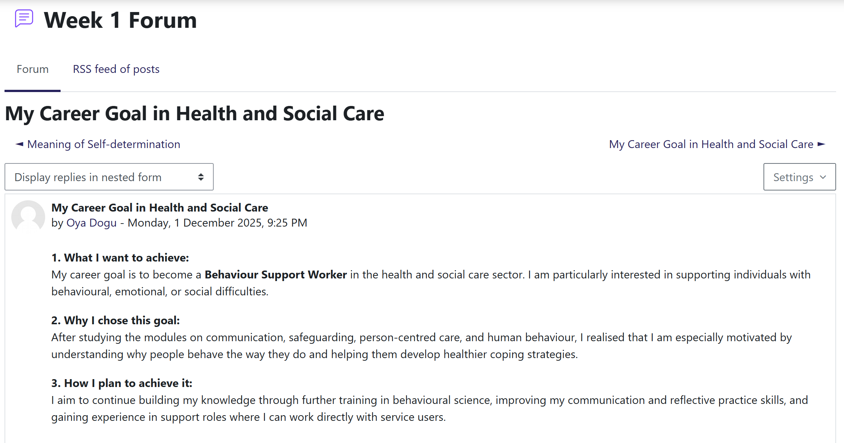

Figure 1: Week 1 forum post (career goal)

2.4 Screenshot 2: Week 1 goal-setting activity.
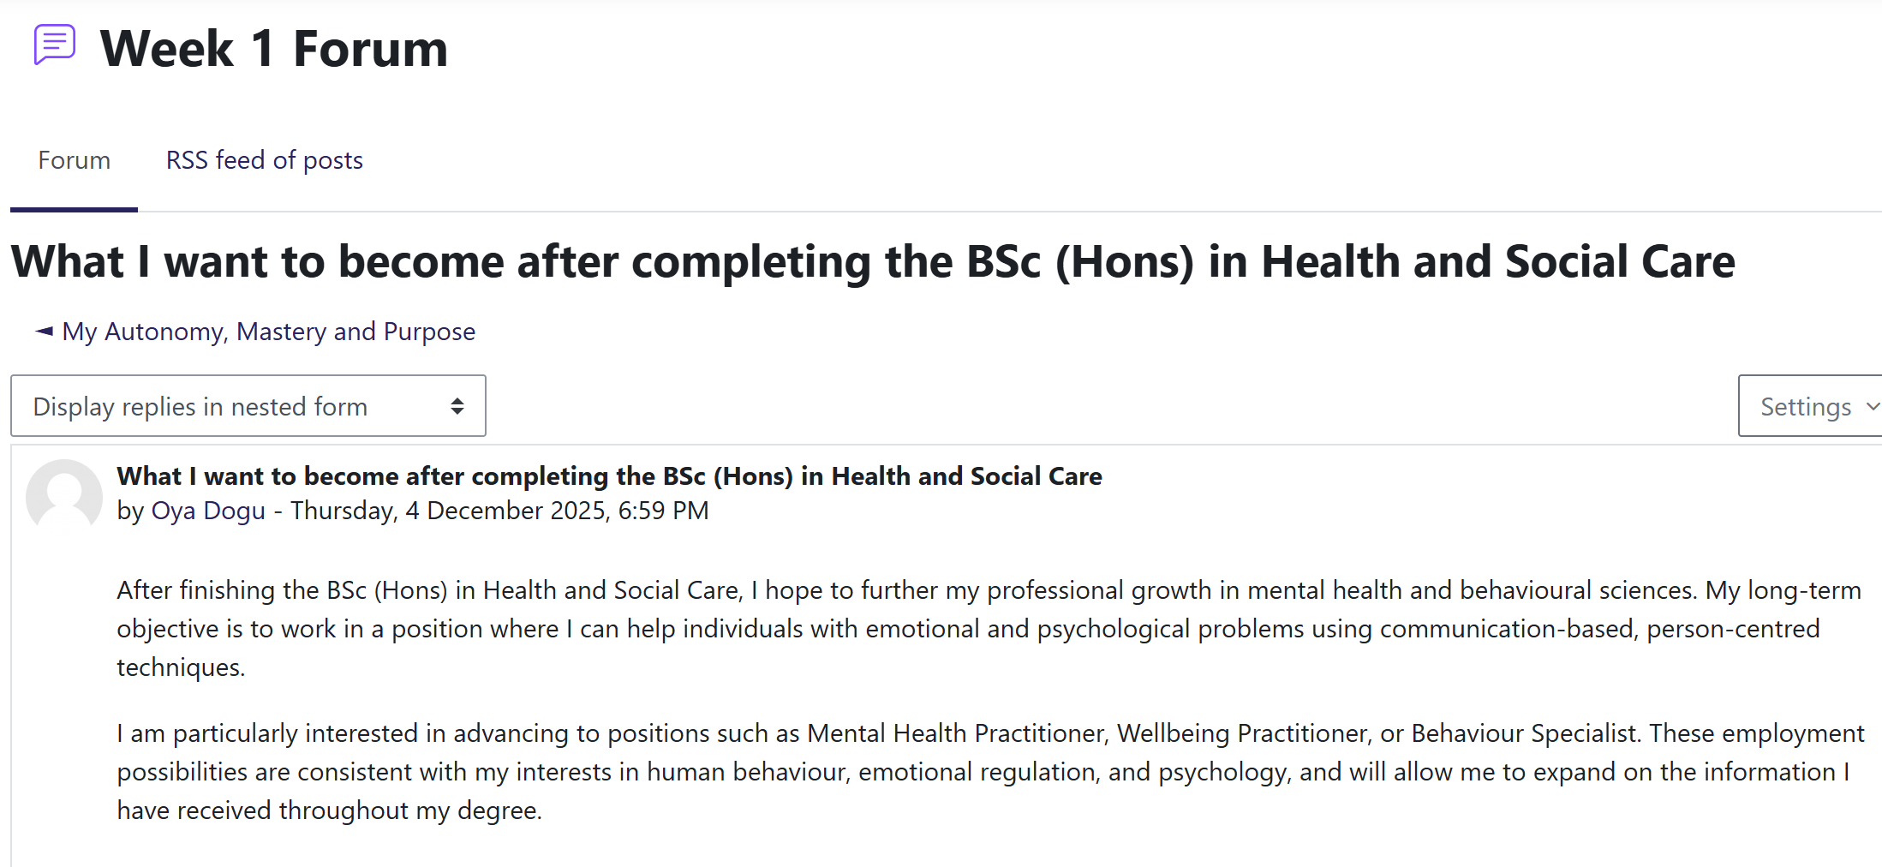
Figure 2: Week 1 goal-setting activity
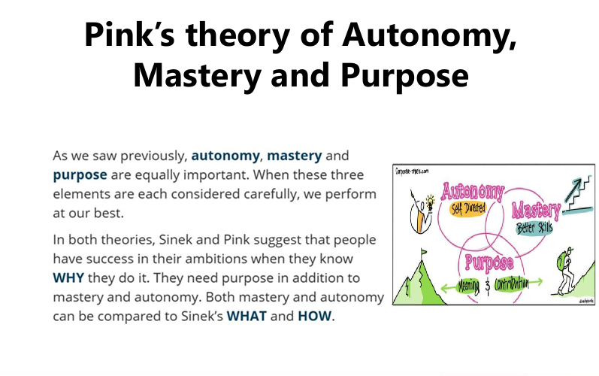
Figure 3: Pink’s theory of Autonomy, Mastery and Purpose
2.5 Screenshot 3: Pink’s theory of Autonomy, Mastery and Purpose

3. Unit 2 Reflection: Boundaryless Careers & Boundaryless Skills (Week 2)

3.1 Key Learning from Week 2
Week 2 expanded my perspective on the career concept in which people cross positions and industries instead of a set course (Arthur et al., 2005). This means flexibility and trust in diverse settings in the Health and Social Care (HSC) (Nadav et al., 2021). Nevertheless, I also came to know that boundaryless careers can be both unstable and may cause burnout, particularly in the case of agency workers who do not have a stable support system.
The balance between insecurity and flexibility was brought up during debates on the gig economy. Cultural Dimensions by Hofstede enabled me to understand how cultural values influence communication; I grew up in a culture that places an emphasis on hierarchy, and I realized why I am sometimes reluctant to confront senior employees, which negatively impacts multidisciplinary teams.
The other central theme was emotional intelligence (EI). Salovey (2004) describes EI as the capacity to identify and control feelings, and Johnson (2015) highlights the necessity to use it to develop trust among service users. Figure 5: Our EI activity demonstrated that activities like the need to calm down distressed patients were supported by empathy, emotional regulation, and communication. The knowledge about the difference between hard and soft skills also supported the reasons why adaptability and curiosity, mentioned in my Week 2 posting (Figure 4), are critical attributes of employability.

3.2 Personal Reflection
The concept of the career without boundaries motivated me to look past one position and seek to gain experience in the community and home context. The EI quiz showed that I am lacking in assertiveness. I also remembered one group activity where I did not want to discuss a misunderstanding, and this resulted in confusion, which is a way to see the impact of low assertiveness on a team. To become more assertive, I will go to assertiveness courses, practise the role-play, and get feedback. Enhancing EI assists in person-centred care by increasing trust and enhancing service-user results (Taylor, 2023). The opportunity to think about my strengths and development areas inspired me to continue self-assessment. Overall, Week 2 has brought about factors such as adaptability, EI, and cultural awareness as some of the essential factors in my development and employability within HSC.

3.3 Screenshot 3: Soft-skills forum post.
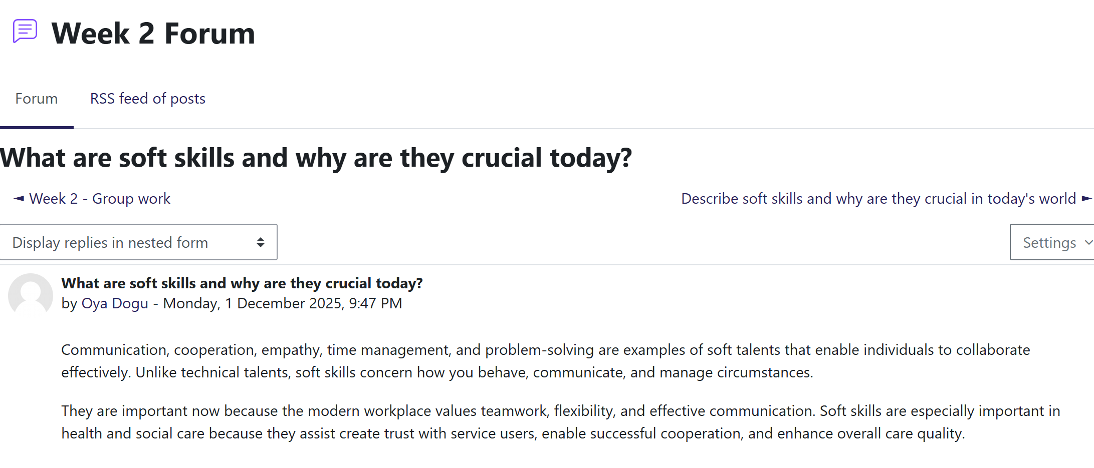
Figure 4: Soft-skills forum post

3.4 Screenshot 2: EI importance brainstorm forum post.
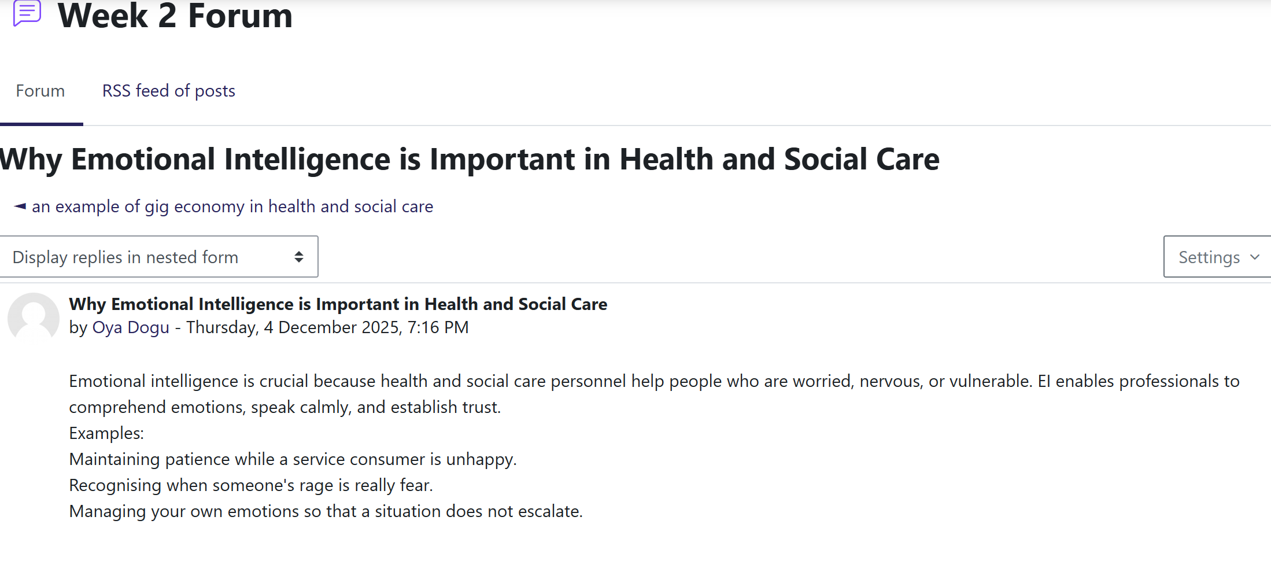
Figure 5: EI importance brainstorm forum post

4. Unit 3 Reflection: Networking, Evaluation & Diversity (Week 3)

4.1 Key Learning from Week 3
Week 3 changed my perception of networking as a non-strategic activity to a strategic behaviour that is critical in Health and Social Care (HSC). In my post in the forum (Figure 6), I referred to networking as the conscious sharing of information to obtain opportunities and support. The session opened up the various types of networking, which are online, offline, academic, and professional, and the necessity to apply all of them in various situations.
The Reflective Cycle by Gibbs contributed to the analysis of the existing habits, and the comparison of it with the Experiential Learning Cycle by Kolb demonstrated that networking involves reflection and experimentation. The goal-based, process-based, and outcome-based evaluation discussion allowed me to realise the role of networking in health system collaboration, including in the case of Integrated Care Boards (Correia et al., 2024).
An important lesson learned was the danger of remaining in a small-world network, whereby learning and innovation are constrained by relying on known people. I also realised that networking may be daunting or lopsided, but it may result in mentoring, shadowing, or placements- gain direct benefits on employability.

4.2 Personal Reflection
I previously viewed networking as non-essential, but the practice demonstrated that networking is necessary for confidence and career growth. Weak ties as sources of unintended opportunities were pointed out in the video reflection (Figure 7).
Figure 8, identified as Who do you communicate with? The task showed me that my network is mostly confined to family, friends, and classmates (Mbodila, Marongwe and Kwahene, 2020). A former classmate who works as a support worker is one of the weak ties that I would like to strengthen, since their experience can assist me in seeing the frontline practice in HSC.
The consideration of digital professionalism also revealed that my profile on LinkedIn requires more clarity of the information and regularity of activities. To overcome these gaps, I will talk to lecturers weekly, participate in one HSC-related online group, and meet two HSC practitioners on LinkedIn monthly. Such steps will assist me in creating a wide range of networks, enhancing multidisciplinary collaboration, and enhancing my employability.

4.3 Screenshot 1: Meaning of networking (forum post).
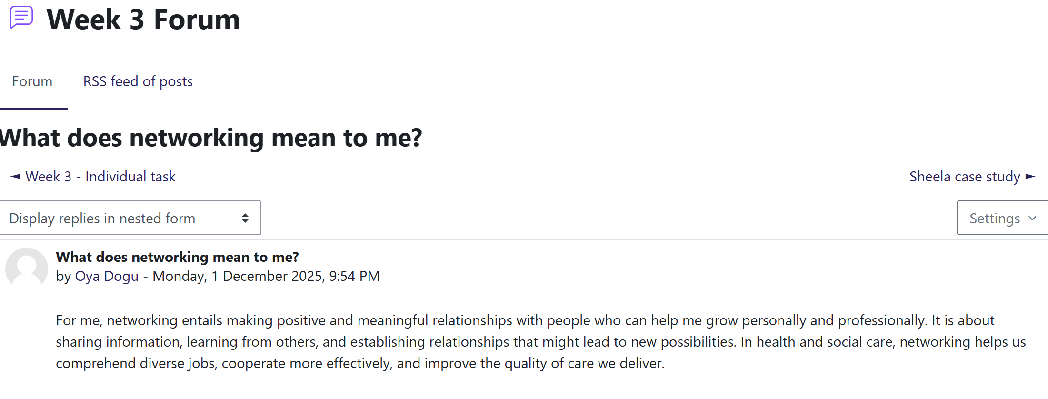
Figure 6: Meaning of networking (forum post)

4.4 Screenshot 2: Reflection on video activity.
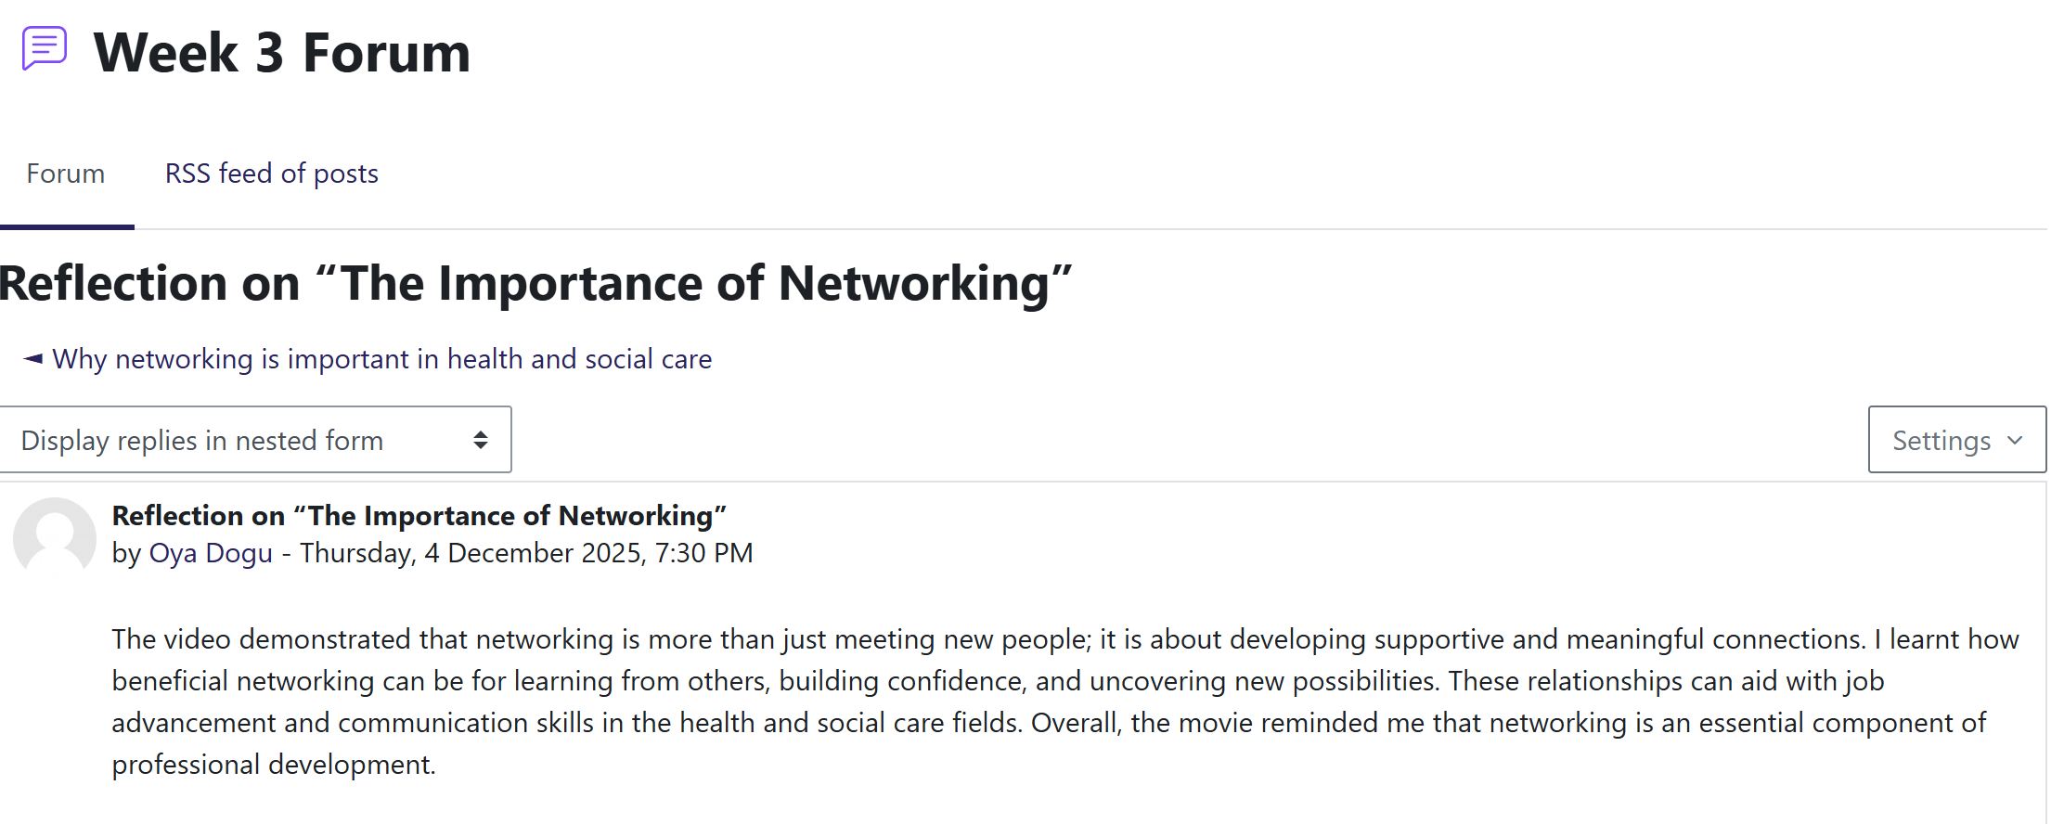
Figure 7: Reflection on video activity

4.5 Screenshot 3: “Who do you communicate with?” task.
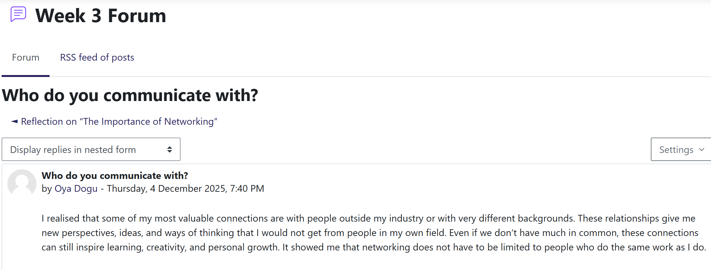
Figure 8: “Who do you communicate with?” task

5. Unit 4 Reflection: Network Society & Making Connections (Week 4)

5.1 Key Learning from Week 4
Unit 4 enabled me to have an insight into networking through a broad understanding of the network society. According to Gibson et al. (2014), networking refers to deliberate communication to establish professional relationships, and this is what has made me realize that what I defined earlier (Figure 9) was rather narrow. The concepts of Castells revealed how digital networks transform communication based on slow and hierarchical frameworks to fast and decentralized frameworks where the visibility and opportunities are constructed online (Dijk, 2020).
The disadvantages of digital networking, including unequal access, misinformation, and blurred boundaries, were also noted during the session, and these issues are especially worrying within the Health and Social Care (HSC) setting, where there is a need to be accurate and professional. The network society clarified to me how to directly connect this learning to NHS collaborative practice, whereby information-sharing, integrated care, and quick decision-making over multidisciplinary teams are supported by digital systems.
The PERMA model reaffirmed that positive relationships enhance well-being and overall resilience, particularly where the setting is emotionally demanding. The comparison between rigid hierarchies and flexible networks taught me that current HSC systems should consist of structure and agility. The persuasion session helped to realize that credibility and trust are important to influence online. Ethical application of persuasion in HSC implies clear and honest communication that helps to promote the well-being of service-users. Social prescribing and the Connecting People model showed how structured networking can increase patient outcomes, transforming networking into an actual intervention.

5.2 Personal Reflection
Week 4 also changed my views on networking, leading me to consider it essential. As my forum post (Figure 10) has shown, my network was very small and focused primarily on classmates. Though I have been using LinkedIn, WhatsApp, and Moodle, I have so far regarded them as academic tools but not as a platform for professional identities. I identified one major barrier on a personal level: I am not confident in my attitude towards practitioners. The methods to overcome it are to invite two HSC professionals on LinkedIn monthly, talk with guest speakers after live sessions, and participate in at least one online HSC discussion group (Ayodele Ajani, 2021). The epidemiology of out of my comfort zone will assist me in developing various networks, enhancing my skills in multidisciplinary teamwork, and raising my knowledge of an actual HSC setting. These associations will eventually improve my confidence, learning, and preparation for professional positions in the future.

5.3 Screenshot 1: Week 4 networking definition forum post.
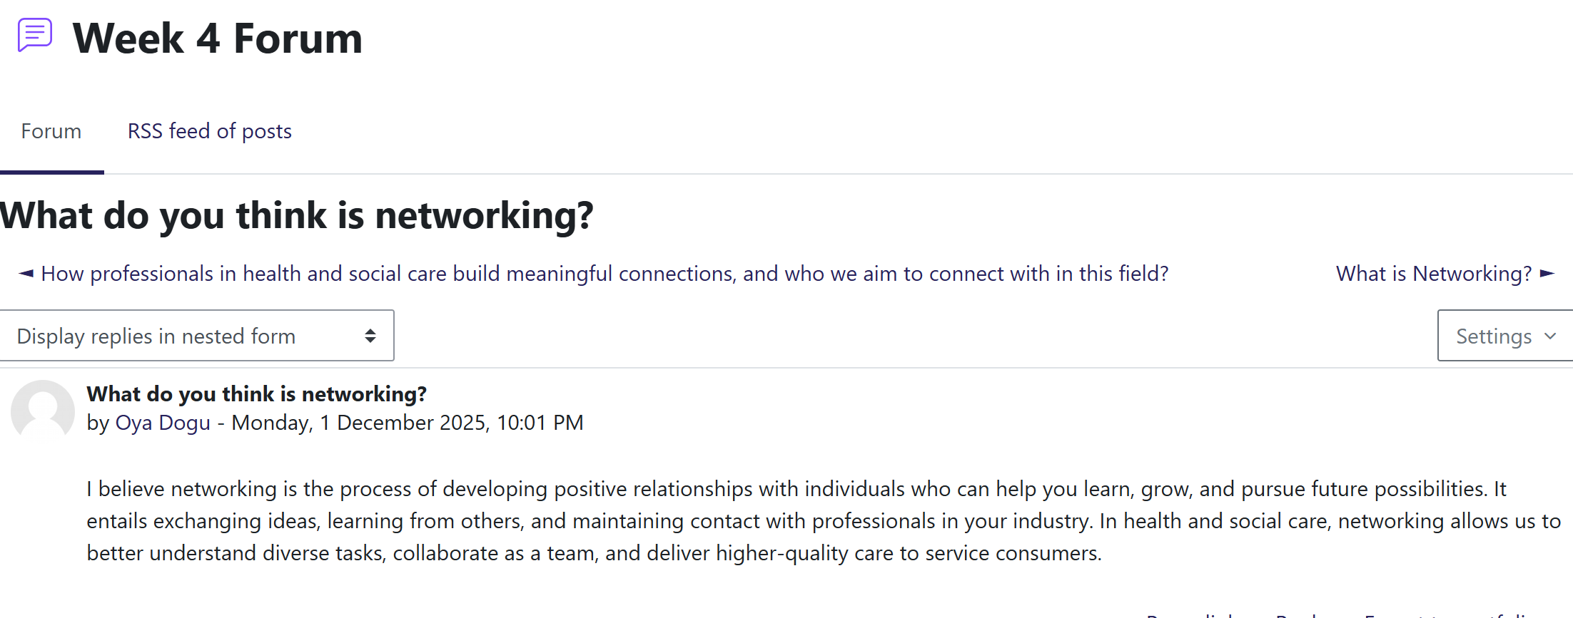
Figure 9: Networking definition forum post

5.4 Screenshot 2: Importance of increasing networking (forum).
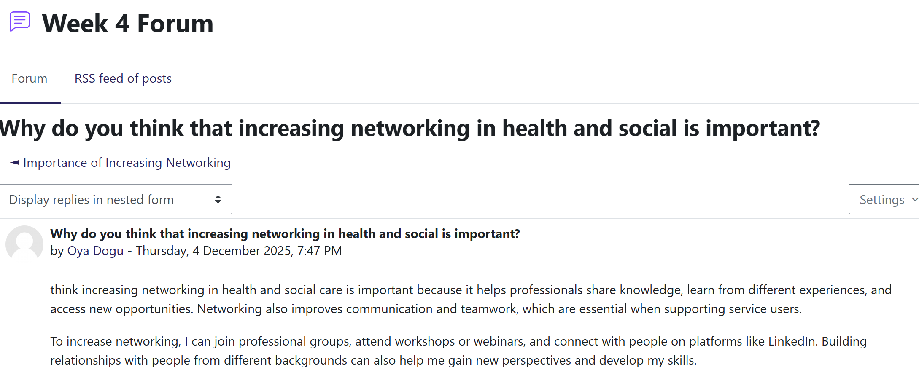
Figure 10: Importance of increasing networking (forum)

6. Conclusion
The reflection on Weeks 1-4 enhanced my beliefs about ambition, emotional intelligence, soft skills, and networking, and how all these aspects reflect on my professional identity in Health and Social Care. These lessons enabled me to match my values and behaviors with my personal brand. In the future, I would continue to engage in professional growth, broaden my professional network, and continue to build resilience and communication to complement my personal brand strategy and person-centred practice, in the long run.

7. Reference

Arthur, M.B., Khapova, S.N., Wilderom, C.P. (2005). Career success in a boundaryless career world. Journal of Organizational Behavior: The International Journal of Industrial, Occupational and Organizational Psychology and Behavior. 26(2), pp.177-202.
Maldynova, A.V., Davletova, M.T. and Demeuova, G.T. (2024). The effectiveness of personal branding in forming a company image. Bulletin of Turan University, (3), pp.207–220. https://doi.org/10.46914/1562-2959-2024-1-3-207-220.
Correia, R., Nascimento, G. do, Fernandes, A.C. and Matos, C. (2024). Implementation and impact of integrated health and social care services: an umbrella review. Journal of Public Health Policy, [online] 45(1), pp.14–29. https://doi.org/10.1057/s41271-023-00465-y.
Dijk, J. van (2020). The Network Society. [online] SAGE. Available at: https://www.torrossa.com/en/resources/an/5018705 [Accessed 24 Nov. 2025].
Gibson, C., H. Hardy III, J. and Ronald Buckley, M. (2014). Understanding the role of networking in organizations. Career Development International, 19(2), pp.146-161.
Houston, (2019) What is Goal Setting and How to Do it Well. URL Available at: https://positivepsychology.com/goal-setting/
Johnson, D.R. (2015) Emotional intelligence as a crucial component to medical education. International journal of medical education. 6, p.179
Legislation.gov.uk. (2025). Legislation.gov.uk. [online] Available at: https://www.legislation.gov.uk/ [Accessed 24 Nov. 2025].
Maddux, J.E., (2016). Self-efficacy. In Interpersonal and intrapersonal expectancies (pp. 41-46). Routledge.
Munienge Mbodila, Newlin Marongwe and Kwahene, F. (2020). THE USE OF SOCIAL MEDIA AS A KNOWLEDGE SHARING PLATFORM DURING COVID-19 AMONG STUDENTS IN A RURAL UNIVERSITY: A COMPARISON OF EMAIL AND WHATSAPP. ICERI proceedings, [online] 1, pp.1001–1010. https://doi.org/10.21125/iceri.2020.0287.
Nadav, J., Kaihlanen, A.-M., Kujala, S., Laukka, E., Hilama, P., Koivisto, J., Keskimäki, I. and Heponiemi, T. (2021). How to Implement Digital Services in a Way That They Integrate Into Routine Work: Qualitative Interview Study Among Health and Social Care Professionals. Journal of Medical Internet Research, [online] 23(12), p.e31668. https://doi.org/10.2196/31668.
Roy, S.K., (2008) Identifying the dimensions of attractiveness of an employer brand in the Indian context. South Asian Journal of Management, 15(4), pp.110-130
Salovey, P., Caruso, D., Mayer, J.D. (2004) Emotional intelligence in practice. Positive psychology in practice. 30, pp.447-63
Taylor, C. (2023). Cultural Perceptions of Psychosis and The Impact on Pathways to Care. Uea.ac.uk. [online] https://ueaeprints.uea.ac.uk/id/eprint/98724/1/2023TaylorCClinPsyD.pdf.
Wong, R. and Ummi Naiemah Saraih (2024). The Influence of Self-Efficacy, Soft Skills, Personality, and Emotional Intelligence on Graduate Employability in Malaysian Technical University Network Institutions. Journal of Communication in Scientific Inquiry (JCSI), [online] 6(2), pp.103–124. https://doi.org/10.58915/jcsi.v6i2.1006.

