Exploring the Hidden Curriculum
The Setting
School H
- Communities First Area.
- 247 Pupils aged between 3 and 11 are registered.
- Prospectus (2018) “We aim to provide a pleasant exciting and stimulating environment in which children will feel secure and which will promote their development. We aim to nurture and develop in all pupils.”
Definition
Abbot et al (2014) as cited by Froehlich and Smith (2017, p.103) states that “The Hidden Curriculum consists of the unspoken or implicit academic, social and cultural messages that are communicated to students while they are in school.”
Home and Community Links
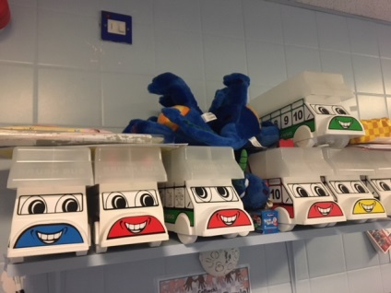
School H has strong ties to the community and positive relationships with parents and families. The school offer various facilities and events:
- Home Link Books
- Community gym.
- Zumba Classes.
- English classes.
- Family Liaison Officer.
- Parenting classes.
- Visits to the Elderly.
- Charity Fundraisers.
- Parent Open Days.
- Parent Suggestion Boxes.

Additional Areas.
TAF - Team around the family, who state
“To train and empower primary school staff in recognising and tackling social challenges facing vulnerable pupils and their families at an early stage. “(School H Prospectus, 2018)
(Design to smile, 2008) state that the Welsh Government have funded a preventative programme to create an early intervention for good oral health habits.
(ESTYN, 2018) reported that School H “develops pupil’s aspirations through shared values, including love, simplicity and tolerance. Pupils, who are from many diverse backgrounds, learn through an innovative curriculum that uses local resources and focuses on creative arts to improve skills.”

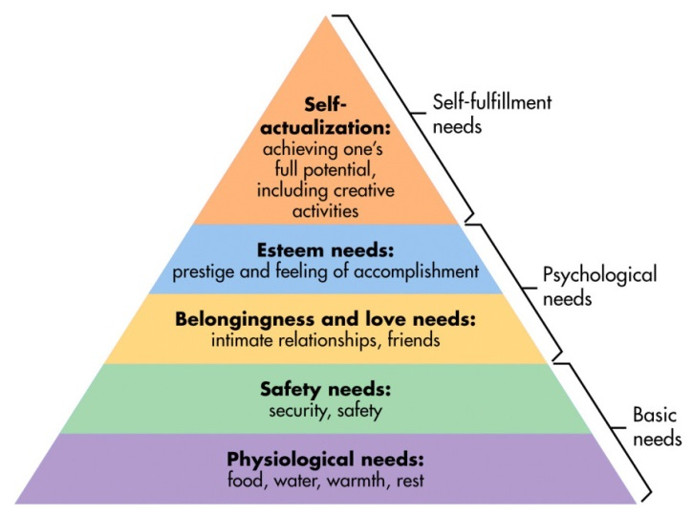

Value Based Ethos
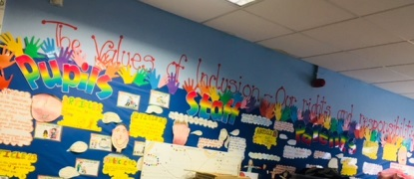
- Rights Respecting School (UNCRC, 1989), cited by (Save the Children, 2018).
- Assemblies
- School council and Eco community
- PTA
- Open Door policy
- Environment
- Multi-cultural School
- Bilingual School
- Community Room

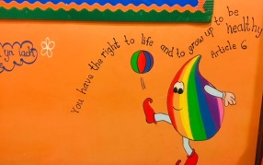
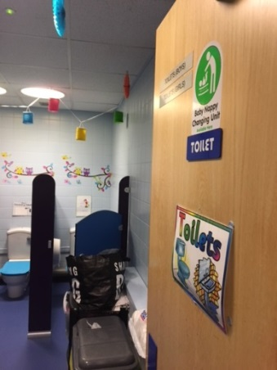
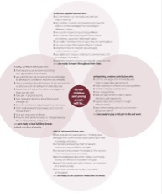

Donaldson (2015) believes “The case for change rests partly on concerns about perceived shortcomings
in the present curriculum and assessment arrangements”. (Leading to the Successful Futures Review, 2015)
which stipulates that the purposes of a curriculum in Wales should be:
- Ethical Informed Citizens of Wales and the World.
- Enterprising, Creative Contributors and ready to take part in life and work.
- Healthy and Confident Individuals
- Ambitious and Capable Learners.
Donaldson (2015) proposes that this review will create a “simpler, more coherent structure for the curriculum.” While adopting the fundamental approach of the Foundation Phase (Department for Children, Education, Life Long Learning and Skills, 2008), yet with further expansion and focus. This will consist of all pupils aged 3-19 years who will have 6 areas of learning and experience:
- Expressive Arts – Health and Well-being – Humanities – Languages, Literacy and Communication – Mathematics and Numeracy - Science and Technology.
Donaldson suggests that through the new devised curriculum the “hidden curriculum” would no longer be “hidden”. As the focus will be more of an holistic approach.

Way Forward.

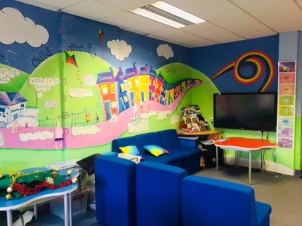

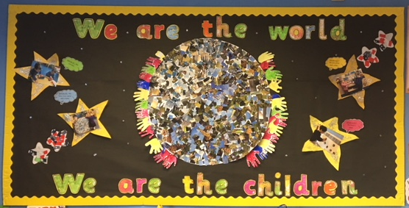

Notes for poster
Practitioners within schools are not only teaching the national curriculum but they are also teaching what is known as the Hidden Curriculum. Today I will be presenting how school H which is left unnamed due to confidentiality reasons; is providing positive messages to their pupils through the hidden curriculum.
Definition.
According to Thompson (2008), the Marxists approach would to expect the hidden curriculum to teach children to conform to society, teach respect for the dominant religion through school assemblies, defining the difference between genders; that girls are feminine and boys are masculine, listening to authority and being punctual. Marxists believe this is an appropriate set of skills for children’s future; Thompson (2008) also found that in contrast the functionalists view on the hidden curriculum would to be slightly different, as they believe schools should help children to; learn to look smart, follow instructions, be punctual and learn the benefits of hard work. Functionalists believe these will positively encourage children to conform to society’s norms and values, more so than a negative system of mandatory rules. 1.

Settings
- School H is a communities first area setting, its situated in one of Wales’ 30% most deprived areas.
- 38% of those are eligible for FSM, 45% are pupils with (EAL) with the school hosting 15 different languages and currently there are 14 children with statements of ALN, cited by (ESTYN, 2018).
- As the school is multi-cultural the school it is provided with the Ethnic Minority Language Acquisition Service [EMLAS] who integrate within the school to give additional support to these pupils, as supported by the Children Act (2004) and the Equality Act (2010).
- Prospectus – The positive aim of School H devises from Bowlby’s (1969) Attachment Theory which is developed by the theorist Maslow (1987) who’s ‘Hierarchy of Needs’ study which found the theory of children requiring the basic needs of love, support and comfort in order to function. Cited by Fitzgerald (2011). As shown here. School H believes strongly about Attachment Theory and the issues that follow, therefore they have ensured all practitioners are trained on it regularly. 2.

Values
- United Nations Convention on the Rights of the Child (UNCRC, 1989) cited by (Save the children, 2018) influences and is implemented throughout the school, via displays that are painted by the head teacher as seen here and here. The pupils also collaborate on individual class charters, as seen here, the nursery pupils have discussed what they believe to be there rights and responsibilities. This is then visualised for continuous reinforcement. (Blake and Pope, 2008) cited that Vygotsky and Piaget describes that social interaction which is collaborative and supportive will promote cognitive development.
- Assemblies are delivered daily by the head teacher; they are often philosophical or inspirational. Value assemblies occur every month: exploring the rights of the child according to the (UNCRC) and Finally golden assemblies occur on Fridays, positive actions or work are rewarded with jewels into a house cup or golden leaf on the golden tree which is an important achievement for a pupil. A positive rewards system which used throughout the school and is promoted in the school’s valued based ethos.
- School H takes the approach of Skinner (1938) who believed that positive reinforcement and rewards through operant conditioning allows children to learn positive behaviour and values, as cited by Jordan (2008) 3.

Values
- School H represents themselves as having an open door policy, cited by School H’s Inclusion Policy (2016), however all doors are pin coded and gates are locked. Education is now acknowledged as secondary to safeguarding which is School H’s priority; (The Welsh Government, 2017) has recently devised the Social Services and Well-being (Wales) Act, which has been introduced to strengthen an effective working partnership towards safeguarding. 4.

Values
- Toilets can also be an area of the hidden curriculum and often cause an impact on pupil’s lives. School H’s toilets are gender neutral in Flying Start and Nursery as you can see here, however not in other years. The overall view from practitioners seem to be that they have not thought of it being a problem for early years but it would be for key stages 1 or 2. Why is this? Would unisex toilets lessen pupil’s curiosity and inappropriate behaviour? Chris McGovern, the Chairman for the Campaign of Real Education suggested that the Scottish Government are “So addicted to the notions of political correctness that they are prepared to place children in danger of abuse or bullying.” Cited by (The Herald, 2018) however if these notions were embedded within the pupil’s early development, it would eventually be the norm, removing the fears or anxiety.
- Supported by the Elton Report (1989) which expressed the importance of multi-cultural education has on children and their future influence on society. School H being multi-cultural allows its pupils to learn, be aware and gain respect for other communities, religions and languages. The pupils celebrate all religions and learn about various cultures.
5.

Additional Areas of School H include:
- TAF – Team Around the Family workers who are a qualified team who train practitioners in School H regarding the Attachment Theory and Disorders; TAF identify and intervene early with families and children in need.
- Design to Smile Programme (2018) A Welsh Government initiative which encourages practitioners to even teach children how to brush their teeth.
- Practitioners within school H not only teach pupils tooth brushing but also how to socialise with peers, treat everyone as equals, be kind to others, good manners, that children have a voice and that there is fun in learning, this is recognised by the School’s Level 2 award for the (United Nations Convention for the Rights of the Child, 2018).
- Magic Room – This is a safe, stimulating and sensory area for children with ALN if they find it comforting. As mentioned early, the approach of (Maslow, 1987) is being adopted here, the children need to feel safe and comfortable in order to want to learn and develop, and this approach is favoured often in this school. However it seems that the magic room is not available to all students, which could lower the perception of cohesion.
- (ESTYN, 2018) furthermore mentioned that School H’s interventions and effects to support pupils well-being is prominent on a daily basis. This could be affected by the schools home and community links.

Home and Community Links:
Due to School H being one of the most deprived areas, the school supports not only the pupils but also their families and wider community.
The school contains a modern gym and community room which is open to the public and classes, such as Zumba, English Classes, Family Learning, Parenting classes and various others activities.
School H’s school council often come together for meetings to discuss with the Head Teacher and Local Authority what they can do to help the community or the school. For example, School H’s older pupils visit regularly the local nursing home to spend time and offer help with the occupants.
Also in practice the pupils have organised fund raisers for the school; Movie Nights with the family in the school hall, Christmas Fete, Jumble Sales, Bake offs and recently they organised the largest group flossing competition.
Throughout these experiences the children are voicing the clear message that it is important to help our friends, neighbours and community.

Home and Community Links:
Due to School H being one of the most deprived areas, the school supports not only the pupils but also their families and wider community.
The school contains a modern gym and community room which is open to the public and provides classes, such as Zumba, English Classes, Family Learning, Parenting classes and various others activities.
Furthermore School H provides pupils with a school council who come together for meetings to discuss with the Head Teacher and Local Authority what they can do to help the community or school.
Throughout these experiences the children are voicing the clear message that it is important to help our friends, neighbours and community. 7.
7.
Additional Areas of School H include:
- TAF – Team around the Family workers train practitioners in School H regarding the Attachment Theory and Disorders; TAF identify and intervene early with families and children in need.
- Design to Smile Programme (2018) A Welsh Government initiative which encourages practitioners to even teach children how to brush their teeth.
- Practitioners within school H not only teach pupils tooth brushing but also how to socialise with peers, treat everyone as equals, that children have a voice and that learning can be fun, this is recognised by the School’s Level 2 award for the (United Nations Convention for the Rights of the Child, UNCRC). As stated in their Inclusion Policy (2018).
- (ESTYN, 2018) furthermore mentioned that School H’s interventions and effects to support pupils well-being is prominent on a daily basis. This could be affected by the schools home and community links. 6.

WAY FORWARD
Donaldson (2015) believes that the curriculum and education within Wales needs to change and improve. This is recognised by the Welsh Government (2016) who implemented the skills of the OECD to produce an “education rapid policy assessment”. The OECD (2017) released their aspirations from this review as creating “An education system in which all learners have an equal opportunity to reach their potential can strengthen individuals’ and societies’ capacity to contribute to economic growth and social cohesion.”
Thank you for listening. 8.

Reference List for Poster

- Blake, B and Pope, T. (2008) ‘Developmental Psychology: Incorporating Piaget’s and Vygotsky’s Theories in Classrooms.’ Journal of Cross-Disciplinary Perspectives in Education, 1, (1, May), pp. 59-67.
- Department for Children, Education, Lifelong Learning and Skills. (2008) Framework for Children’s Learning for 3-7 year olds in Wales. Cardiff: Welsh Assembly Government. [Online] Available at: https://gov.wales/topics/educationandskills/foundation-phase/?lang=en (Accessed 4thDecember 2018).
- Design to Smile (2018) National child oral health improvement programme in Wales. Available at: http://www.designedtosmile.org/welcome-croeso/welcome/ ( Accessed 4th December 2018).
- Donaldson, G. (2015) Successful Futures: Independent Review of Curriculum and Assessment Arrangements in Wales: Welsh Government. [Online] Available at: https://gov.wales/docs/dcells/publications/150225-successful-futures-en.pdf (Accessed 3rd December 2018).
- ESTYN (2018) Placing the rights of the child at the heart of curriculum development. Available at: https://www.estyn.gov.wales/ (Accessed 28th November 2018).
- Fitzgerald, R. (2011) Human Needs and Politics. Oxford: Pergamon.
- Froehlich, H and Smith, D, G. (2017) Sociology for Music Teachers: Practical Applications. London: Routledge.
- Harris, N,S. (2008)’Discipline in Schools: The Elton Report.’ Journal of Social Welfare and Family Law. 2 (13, February) pp.110-127 [Online] Available at: https://www.tandfonline.com/doi/abs/10.1080/09649069108415079?instName=University+of+Sunderland&journalCode=rjsf20 (Accessed 4th December 2018)
- Herald Scotland Online (2018) ‘Parents anger over new ‘gender neutral’ toilets in primary schools.’ The Herald, 22nd August, p.1 [Online]. Available at: https://www.heraldscotland.com/news/16590172.parents-anger-over-new-gender-neutral-toilets-in-primary-schools/ (Accessed 29th November 2018)
- Jordan, K (2008) The Quick Theory Reference Guide: A Resource for Expert and Novice Mental Health Professionals. New York: Nova Science Publishers.
- Mcleod (2018) Maslow’s Hierarchy of Needs. Available at: https://www.simplypsychology.org/maslow.html (Accessed 29th November 2018).
- OECD (2017) The Welsh Education Reform Journey: A Rapid Policy Assessment. [Online] Available at: http://www.oecd.org/education/The-Welsh-Education-Reform-Journey.pdf (Accessed 4th December 2018).
- Save the Children (2018) United Nations Convention on the Rights of the Children (UNCRC). Available at: https://www.savethechildren.org.uk/ (Accessed 25th November 2018).
- School H Inclusion Policy: Open Door Policy (2016)
- School H Prospectus (2018)
- School H: images (2018)
- Welsh Government (2004) Children Act. [Online] Available at: https://www.legislation.gov.uk/ukpga/2004/31 (Accessed 4th December 2018).
- Welsh Government (2010) Equality Act. [Online] Available at: https://www.gov.uk/guidance/equality-act-2010-guidance (Accessed 4th December 2018).
- Welsh Government (2017) Safeguarding. [Online]Available at: https://gov.wales/topics/health/socialcare/safeguarding/?lang=en (Accessed 3rd December 2018).

