Week 6 Homework Activity Instructions

Exercise 1)
Use the ‘Single Use Plastics Survey’ to create an online survey using Forms for Excel.
- Locate the Single Use Plastic Questionnaire in Week 7.
- Download the Single Use Plastic Questionnaire [consisting of 10 questions]
- Create the Single Use Plastic Questionnaire [online survey] using Forms for Excel.
- You should find this intuitive. Choose the question format from the choices provided that best fit the question.
In your Browser, type UWTSD | Quick Links |
MyDay | OneDrive | New | Forms for Excel

Create the first 5 questions, or all 10 questions for practice.
If you make a mistake with any question, just click on it to amend it. If you take a break when you re-open the file in your browser you can continue to edit it. When you open the file in Excel – look along the menu for the light bulb  Tell me what you want to do – type edit form, that will return you to the Form design to continue writing questions.

Name the survey , email to yourself to complete. Complete it a few times as you need to see some data in there.
[Test it work, view the results]

To see the results / responses
Notice at the top of the form – you can see
Questions Responses
If you click on Responses, you are provided with a summary of basic descriptive statistics.
You can also view the results individually by selecting the View Results option. To see the records, each row of data click on Open in Excel - see below what it should look like.
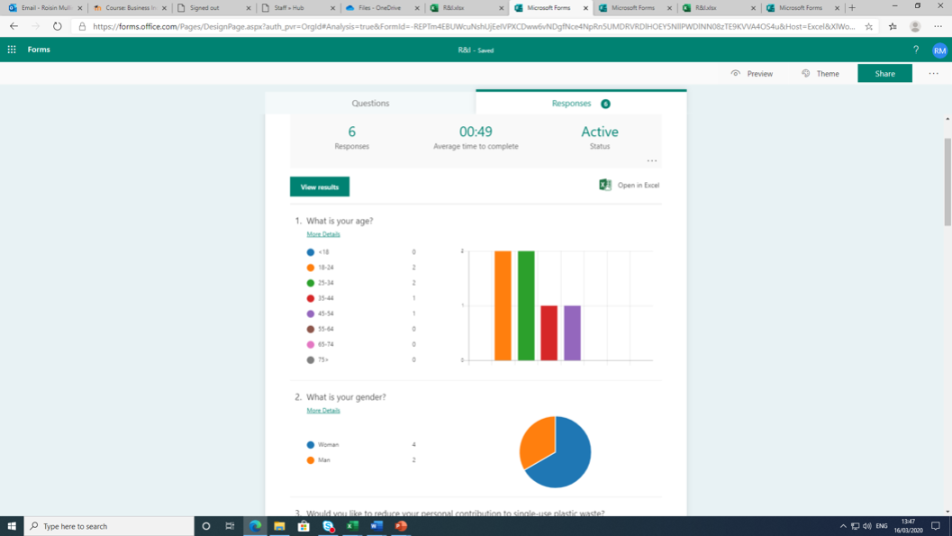

Exercise 2)
Here is one semi completed questionnaire responses that I prepared earlier. This is what it should have looked like.
ID | Start time | Completion time | Name | What is your age? | Would you like to reduce your personal contribution to single-use plastic waste? | Prior to your participation in this survey, were you currently aware of 'bioplastic' technologies? (Plastic substitutes made from biodegradable materials such as plant starch) | How do you feel about (single-use) plastic pollution in Carmarthen and neighbouring counties? | Do you feel businesses in Carmarthen have embraced the 'Plastic Free' initiative | Do you think that the recycling of plastic waste in Carmarthenshire is an adequate and effective solution to plastic pollution?
1 | 3/12/20 10:08:52 | 3/12/20 10:10:01 | Cyclops | 45-54 | 1. Definitely would | 2. I have a moderate understanding. | 1. Highly concerned | No | 3. Somewhat effective.
2 | 3/12/20 14:28:45 | 3/12/20 14:30:27 | Mystique | 35-44 | 4. Definitely would not. | 3. I have heard of bioplastics but possess no further understanding | 2. Moderately concerned | No | 4. Not so effective
3 | 3/12/20 14:28:45 | 3/12/20 14:30:27 | Storm | 25-34 | 3. Probably would not. | 3. I have heard of bioplastics but possess no further understanding | 3. Neither concerned nor unconcerned | Yes | 4. Not so effective
3 | 3/16/20 13:24:44 | 3/16/20 13:25:26 | Charles | 25-34 | 2. Probably would. | 2. I have a moderate understanding. | 1. Highly concerned | Yes | 4. Not so effective
4 | 3/16/20 13:25:29 | 3/16/20 13:26:01 | Gambit | 18-24 | 2. Probably would. | 1. I have a good understanding | 1. Highly concerned | Yes | 3. Somewhat effective.
5 | 3/16/20 13:26:03 | 3/16/20 13:26:28 | Albert | 25-34 | 2. Probably would. | 2. I have a moderate understanding. | 1. Highly concerned | Yes | 3. Somewhat effective.
6 | 3/16/20 13:26:30 | 3/16/20 13:26:58 | Xavier | 18-24 | 3. Probably would not. | 3. I have heard of bioplastics but possess no further understanding | 3. Neither concerned nor unconcerned | No | 4. Not so effective

Notice that the record responses are stored as a number (range) or number and text, but for analysis in Excel or SPSS the records in fields must be converted to a number only. In that case, you need to clean up the data, all the fields you want to analyse.

Exercise 3)
Open Microsoft Excel from the programme list
Convert the text to numbers. Manually change the response to a number - Look at the questionnaire file to see what you need to code the response as . Once you have changed the responses to numbers, you need to make sure they are in a number format. To do this -
Highlight the selected number, right click, select Format Cells, select Number and 0 decimal places. It should now look like this.
ID | Start time | Completion time | What is your age? | Would you like to reduce your personal contribution to single-use plastic waste? | Prior to your participation in this survey, were you currently aware of 'bioplastic' technologies? (Plastic substitutes made from biodegradable materials such as plant starch) | How do you feel about (single-use) plastic pollution in Carmarthen and neighbouring counties? | Do you feel businesses in Carmarthen have embraced the 'Plastic Free' initiative | Do you think that the recycling of plastic waste in Carmarthenshire is an adequate and effective solution to plastic pollution? | Change in the plastic pollution crisis needs to be driven by: | Would you personally be prepared to pay a premium price for products such as bottled water, if businesses switched to using environmentally friendly bioplastics and passed on the additional costs ... | In an ideal world, single-use plastics would be replaced wholly by more environmentally friendly and sustainable products. An example is Corona beer replacing their plastic 6-pack rings with biode... | Have you ever, knowingly (purposefully or accidentally), contributed to plastic pollution? For example: littering and 'fly-tipping'. A reminder that your response is anonymous and honesty would be...
1 | 03/12/2020 10:08 | 03/12/2020 10:10 | 5 | 1 | 2 | 1 | 2 | 3 | 2 | 2 | 4 | 1
2 | 03/12/2020 14:28 | 03/12/2020 14:30 | 4 | 4 | 3 | 2 | 2 | 4 | 1 | 1 | 1 | 1
3 | 03/12/2020 14:28 | 03/12/2020 14:30 | 3 | 3 | 3 | 3 | 1 | 4 | 4 | 2 | 4 | 2
3 | 3/16/20 13:24:44 | 3/16/20 13:25:26 | 3 | 2 | 2 | 1 | 1 | 4 | 2 | 1 | 1 | 1
4 | 3/16/20 13:25:29 | 3/16/20 13:26:01 | 2 | 2 | 1 | 1 | 1 | 3 | 1 | 2 | 1 | 1
5 | 3/16/20 13:26:03 | 3/16/20 13:26:28 | 3 | 2 | 2 | 1 | 1 | 3 | 2 | 2 | 1 | 1
6 | 3/16/20 13:26:30 | 3/16/20 13:26:58 | 2 | 3 | 3 | 3 | 2 | 4 | 4 | 1 | 4 | 2

Now the data is cleaned for analysis in Excel or SPSS. File | Save As | recycling. Save as Excel Workbook.

Exercise 4)

Open IBM SPSS Statistics.
To open your recycling Excel file in SPSS.
File | Import Data | Excel | , select Recycling.xlsx from your folder

Look at the Data View tab, recognise the results. Yes, good it’s the same as it was in Excel. So it has worked.
For each of the questions you now need to tidy up the Variable View tab in SPSS.
Go to the question – What is your Age? In Variable View. Go to the field Values. Click on Value labels.
Open the file - Single Use Plastic Questionnaire . Look at the values and labels for each question.
i.e. Q1. What is your age?
Label
Value

- <18 (1)
- 18-24 (2)
- 25-34 (3)
- 35-44 (4)
- 45-54 (5)
- 55-64 (6)
- 65-74 (7)
- 75> (8)

Value Type 1, Labels, Type <18, then Add. 2, 18-24, Add…… etc
Create all the labels for the question. Do this for each question

Summary
Now you have understood.
- How to create a form in Excel.
- How to capture data.
- How to clean the data for analysis.
- How to export the data to SPSS.
- How to correctly label the question response options for analysis.

Well done!

