Critical Review

Name: Dylan Hopkins
Student number: 1702950
Course: 3D Animation
Module: Critical Review
Work count: 2495
Lecturer: Phillip Organ

Introduction
In this report I will evaluate the entire 3D computer animation course that I have studied on for the past 3 years at the University of Wales Trinity Saint David’s that is located within Swansea. I will first start with writing about where my skill set and knowledge in terms of industrial terminology was before studying the 3D computer animation course.
I will then write about what I have learned throughout my time at the university, what stands out, how online classes have effected work, in terms of learning and accomplishing course work, I will also write about where I was in terms of skill and knowledge before I had started university, and finally I will write about the show reels that I had created for this course, my thought process in compiling the scenes together and why I approached the show reels in a particular way and most importantly whether or not I think the showreels are good enough for use after university. I will then finish the report of with a conclusion of the three years of university that I have attended, if I think I am ready for the industry.

Before University
In this section of the report, I will write about what I knew before starting university, where my skill and knowledge was in terms of practical skill, e.g. drawing skills, modelling, animating and industry terms and software.

Drawing
Before I started university I only knew and had little skills and knowledge that is required for the industry, in terms of drawing, the quality was very poor, as I had recently at the time, switched from drawing from my left hand to my right, as my perspectives where better with the right hand due to being right eyed. In terms of characters, I found difficultly in drawn, I still do today, however painting environments was very much a hard thing for me to do, as I could not do them at all.
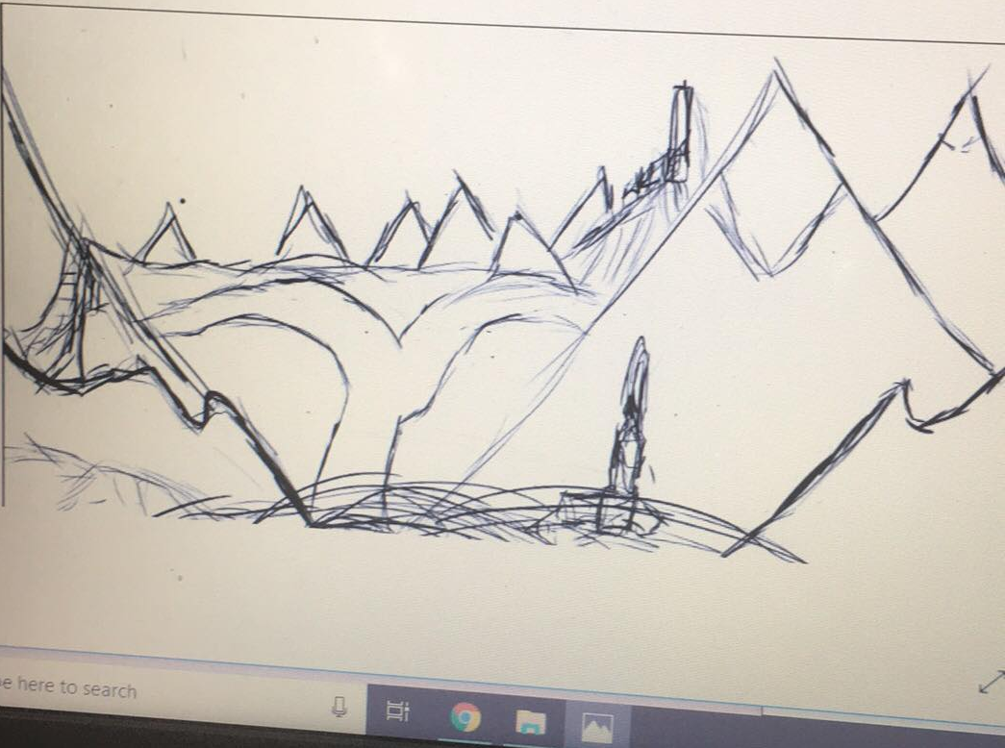

The image above is an example of the quality of work that I would produce before attending the university.

Modelling
In terms of modelling, I had a very basic understanding on how to approach 3D modelling, as I has dabbled around in a software called Blender 3D for a while prior to joining the university, I could only make static meshes (objects that do not move, or if they do its very little)
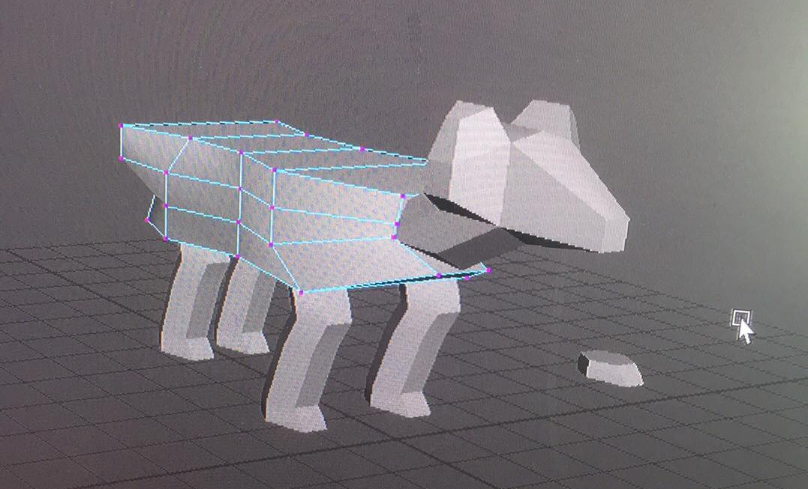

The image above depicts the quality of my models prior to joining the university as you can see the model is made out of multiple objects and the model is too boxy for what the creature is meant to be and the topology is extremely bad, it does not follow the natural bends of the creature, thus animating it would not be a pleasant experience.

Animating
Before joining the university I knew practically nothing about animating in any software and is one of the primary reason for choosing the 3D animation course, the only aspects I knew for sure was how to set keyframes and render the scenes out, I knew nothing about lighting setups, camera sequencer, animation sequencer, rigging, weight painting etc.

Year 1
When the year started, we, first introduced to Autodesk Maya, on the first week we learned to supplicate special, which allows us to duplicate an object, in to which you enter the amount of duplicates you want, as well as how to apart they are set from each other, in terms of location, rotation and scale, so the first object we were tasks to create was a rotating stair case. We also learned about the outliner, which is an index in Maya that contains all entities within the scenes, this includes, meshes, rigs, light sources etc.

Principles of animations
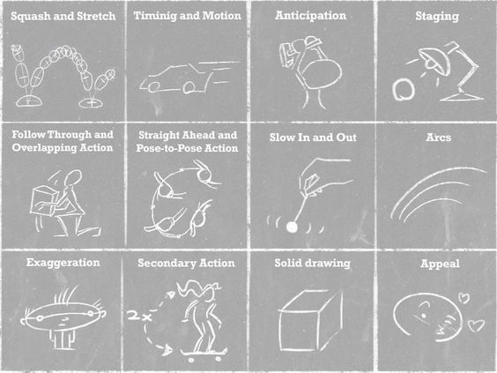
Before attending the animation course I already knew about the 12 principles of animation due to taking an ICT degree at college, in which the 12 principles where a part of the course as we had to develop a 2D animate short within Adobe Flash (now Adobe Animate) however as I had taken a year of for work, I was a bit rusty on them. One of the first practical works that we were tasks to do with this topic covered was to create a bouncy ball, in which we had to apply some of the principles of animation towards the test animation.
The image to the left shows the principles of animation, and whilst it is more suited towards 2D animation, as that was the medium in which the principles were created, using the same principles also works in a 3D setting.

Sketches gesture and character work
Another module in year 1 involved creating a digital piece of a character and environment of our choice, the tutor was Al Kang, and with Al, I learnt a lot about the 2D side of this course, to begin he shows us how to do gesture drawings, by showing us his approach, to getting the proportions, then he played a video of various people posing to which we had to make a gesture drawing of.
Another part of the course was to create an digital environment piece within Photoshop I learnt a lot from that lesson as it transitioned me from drawing out of perspective mountains to grayscale environments.
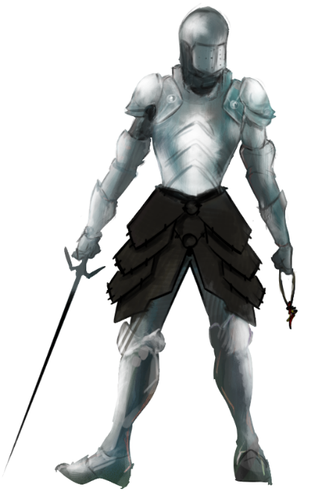
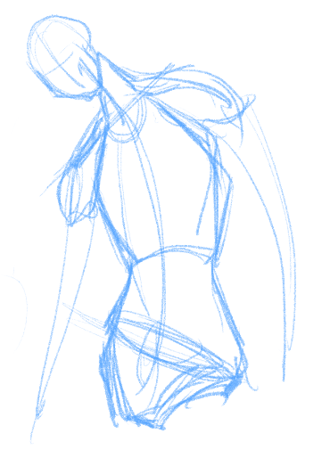

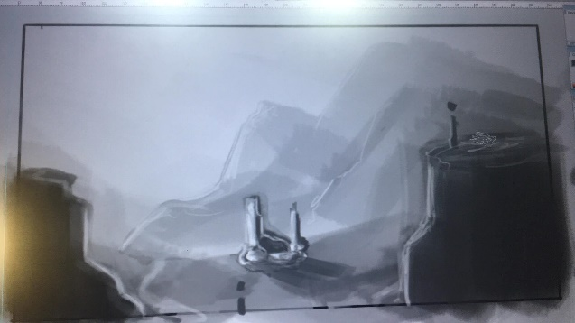

Intro to Zbrush
In year 1 we were also introduced to Zbrush, Zbrush is a piece of software that I was already familiar with in terms of interface having already bought a license for couple of years at this point, however my sculpting abilities where terrible, as I had no idea how to approach characters or creatures. The classes showed me how I should approach these, how to sculpt the shapes and why they are the shape they are, for example, we are aerodynamic beings, because we taper at the front, or the axilla, the joint where the arms connect to the should has a hole there because it is the meeting point of 4 muscle groups, the triceps, the shoulder, front chest and side chest.
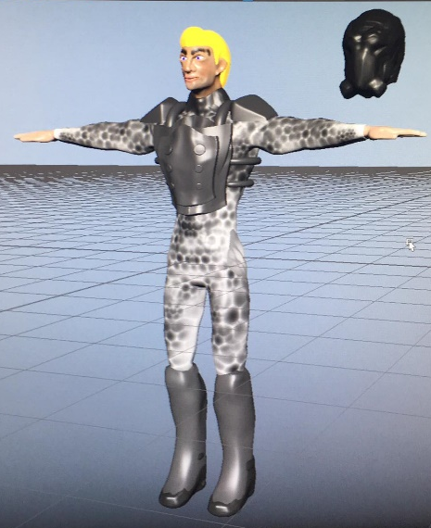
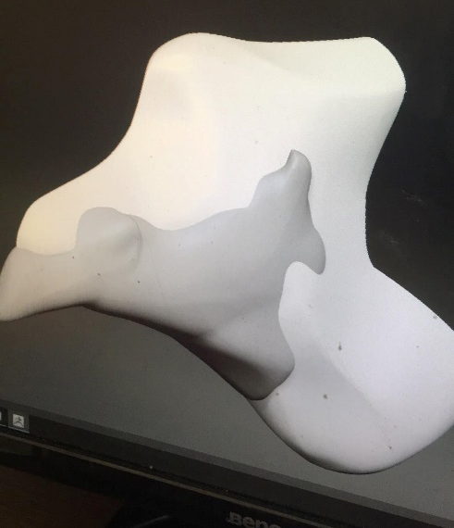
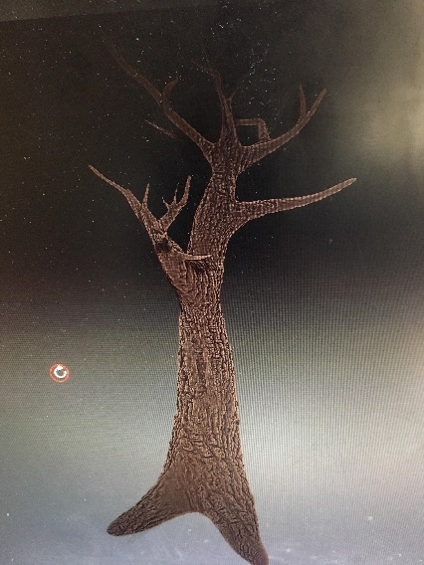
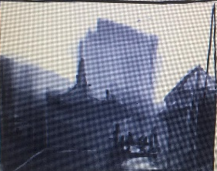
I already knew how to use Photoshop by the time I entered the university, it being the main program I use for drawing, texturing and photo manipulation, thus no new things were learnt during my time here, however more efficient settings where given, such as, canvas size and shortcut hotkeys. However, I did learn a lot about painting characters and environments.
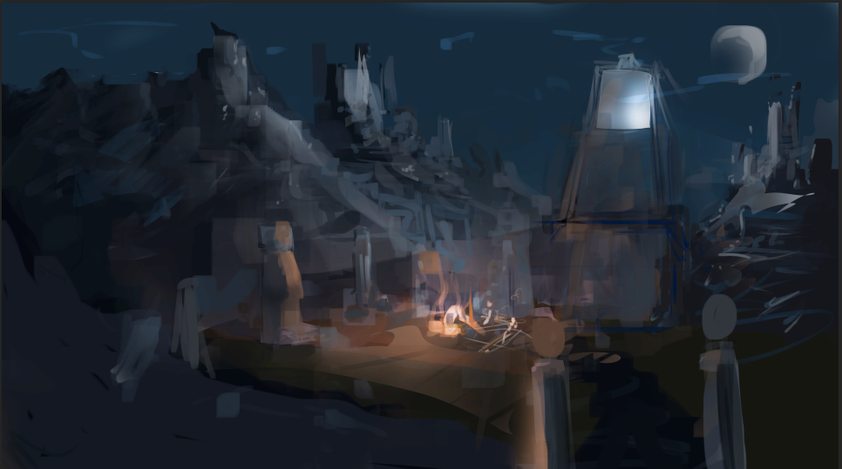
The first image was an environmental piece created at the first week of university, the second image is the quality of work I produce currently as of 12/05/2021

After effects and Premiere
After effects was the program of choice when it came to effect, already having experience in the software due to another module in college, I used after effects to compile the first storyboard that was created in year 1, this was simply a requirement by the tutor at the time, I quickly switched to premiere for the rest of the video work, having much more experience in that program I am more efficient in created video clips in premiere.

Year 2
Year 2 consisted of taking what was learnt in year 1 and improve on them whilst learning new and more industry standard software, such as rigging, at this point, we had only rigged a foot an IK rig (inverted kinematics) this time had to rig an entire character that we had created and bind the rig to the model. The UV editor was briefly covered in this year as it was not the main focus, but it allowed us to texture the models that we created with custom assets created in Photoshop.
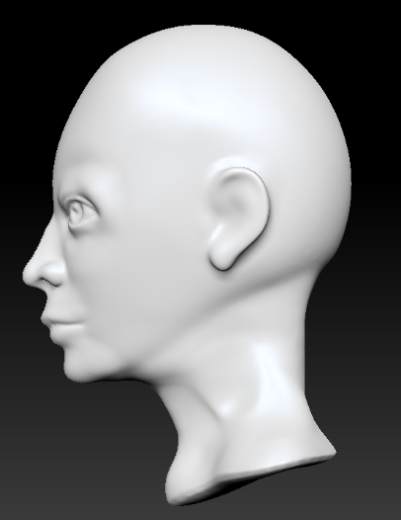
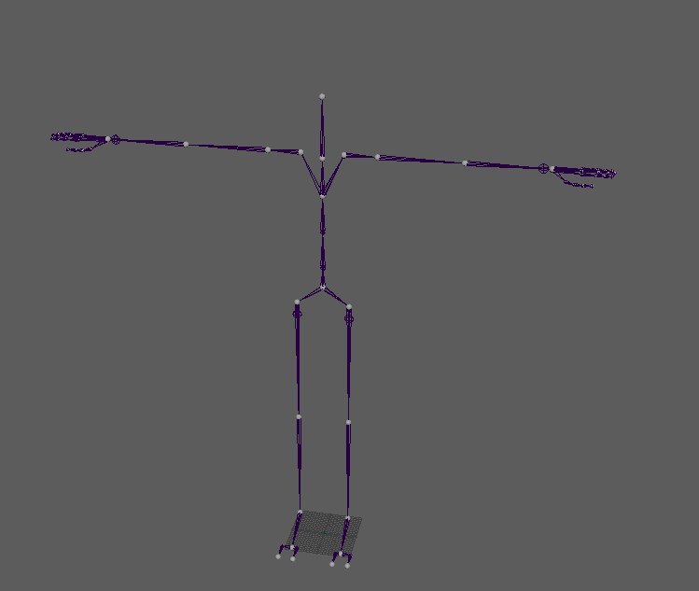

Perforce and FTrack
In this year perforce and FTrack were introduced, perforce being a management system in which users connect to a shared file repository, it is used to transfer files between and individuals workstation, to a centralised one, in which all of out work was stored, this would allow in an industry setting, for one person to do the modelling, when it is uploaded to the perforce server the rigger can simply transfer the file onto his/her workstation and begin the rigging work.

FTrack on the other hand is a project management and production tracking platform, used by most studios to date, it allows us to keep track on what needs doing that day for example. FTrack also allows us to upload images and videos, to which in this case the tutor can look on the work and sent back revisions to be made.

Particle effects and lighting
Particles effects and lighting were learned in this year as well, in terms of lighting, we learned about Mayas lighting engine, where to place the lights and where the dramatic lighting would be places, for the later its anywhere that will enhance the shot even if nothing is there to cast the light.
In terms of particles, we learned to create particles that collide with other objects, as well as collision and physics, we also learned that it was easier to apply the particle effect onto a much lower polygon version of the same model, as the object can be invisible to the render and the particle effect would be able to collide with the model and would be fast to render because, if it were to collide with the high poly model it would have to work a lot harder to collide with the amount of polygons it contains.
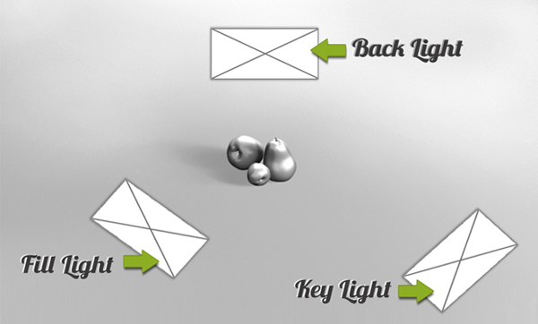

Camera sequencer
The camera sequencer was another things learned, the camera sequencer is a window to which you can add cameras and have them play at different times along the timeline, camera 1 would play from frame 1 to frame 45 then camera 2 would play from frame 45 to frame 60 an Ubercam would then be created, a camera which contains automatic keyframes of the 2 cameras, however now its on 1 camera and played as if I compiles 2 scenes within premiere.

Year 3
In year 3, not many new things were learned, as we now had the knowledge that would take us into the industry, at this point it was just taking what we learned in the previous years and applying them to this year. However, many things had changed in this year. At the beginning we were given the tasks that we would create for the year, but then 2 major events occurred, the first event was the course itself, it had moved from the art and design department to the applied computing department, which meant we the class would be moved into a new room, down at the SA1 waterfront location, but before we could change rooms, COVID-19 happened which impacted is in a major way, it slowed down the workflow tremendously, from physical lessons now being changed to online, really changed how we approached the course work.

Showreels
In this section of the report, I will write about the show reels that I have compiled for this course and for future use to showcase my abilities to potential clients and/or employers. As the final video show reels are meant to later use for finding work within the industry, I ensured that only my best work would be displayed for the 2 videos created.

Modelling and Texture Work
The First showreel is about the modelling and Texturing work that was created over the course of the 3 years, this first show reel is more specific than the other one, as it focuses on modelling and texture work, whilst texturing isn’t the position I would like to obtain, I am able to do such a thing, but modelling is the main focus as I find this baring the animation (for the other showreel) is the most interesting aspect of the process, the show reels includes a turntable of each object created, starting as a textures object, then transitioning into a textured version with a wireframe and a fully white model with the wireframe displayed, in order to show potential clients, how the item looks textured and how clean my topology is.
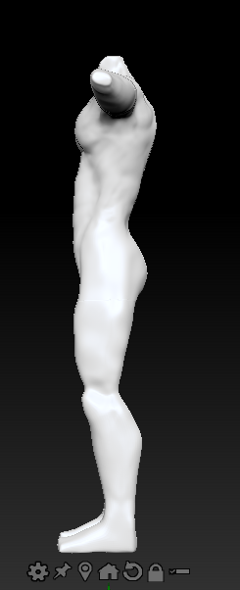
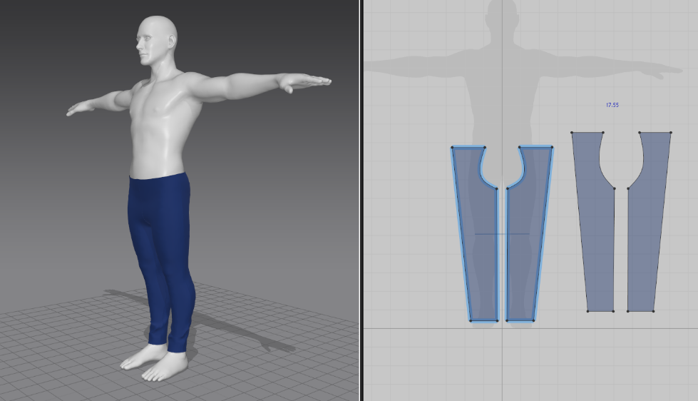

Computer Animation Show Reel
The second show reel is about the best work of the 3 years of attending the university, it starts with some 2D animation that I have created including the breakdown of it, such as, layers, colours, effects etc. then it moves onto art that I have created, concept art, character sheets, landscape concept art, then it moves onto the animations that I have created, which includes a little bit of everything, from weapon animations, creature animation and camera animations, this is so the potential client can see I can do a bit of everything, as these first set of show reel will show a more generalist side of my skills, when the time comes I will compile the show reels into a more specific route, such as, character animations or modelling, however at the moment I lack the content for a specific line of work.
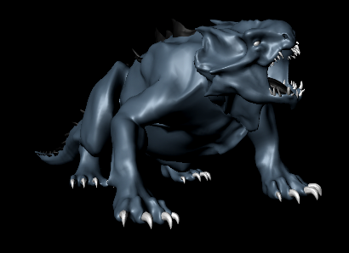
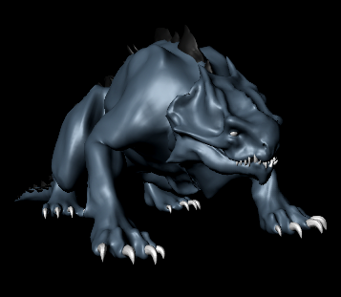
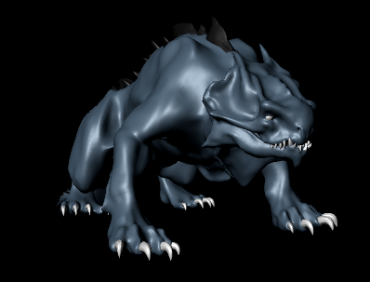

Music
The music that I chose for the show reels were found on YouTubes audio library, which is copyright free, the music is credited at the end, however the volume of the music is purposefully low and generic, as the potential client and/or employee doesn’t need to be distracted by loud, annoying music, and more than likely will mute the video anyway.

Conclusion
In conclusion the 3 years that I have studied at this university, have opened up a door into the industry, whilst I’m not yet 100% confident of my skills I do have the knowledge, it just a matter of practicing what I know and improving and learning new skills, I believe my weakest link are both the topology of the characters that are made, weight painting and the animation sequencer, whilst my strong points are animating to an extent and adapting on the fly, when something goes wrong I will find a way either to correct it or work around it.
As for the show reels, I feel that I created them to a junior level standard, as I don’t have any client work at this time, I can only rely on the work that was created in university and work that was done in my own time, which at this current moment in time is not a lot, add to the fact that I could not add all the work I wanted due to data loss, I feel impacted the final artifact a bit. The show reel was created with a generalist in mind, for the time being, as I do more work in my own time and professional work down the line, I will create a more specific show reel, focusing on one topic, such as animation, or modelling etc.
In the future I would also like to add the amount of time it took me to create the drawing, model, animation etc. to give the clients an estimate of how fast and efficient I am when it comes to animating or modelling etc.

Bibliography
25 tips to create an animation demo reel https://www.youtube.com/watch?v=ynVANlM9ZXQ&ab_channel=SirWadeNeistadt (accessed 10/05/2021)
5 cool tips with freestyle in blender https://www.youtube.com/watch?v=p7mr71nfjFY&ab_channel=SirWadeNeistadtSirWadeNeistadtVerified (accessed 10/05/2021)
Animation demo reel guidelines https://www.youtube.com/watch?v=WC-yGd1Frx8&ab_channel=VeenaV-SocialMediaTipsVeenaV-SocialMediaTips (accessed 11/05/2021)
Part 6, level 1: rendering – blender beginner tutorial https://www.youtube.com/watch?v=ZTxBrjN1ugA&ab_channel=BlenderMadeEasyBlenderMadeEasy (accessed 11/05/2021)
How to fade in out video in adobe premiere pro tutorial https://www.youtube.com/watch?v=uvArpBfJNz0 (accessed 11/05/2021)
A guide to motion design principles https://uxdesign.cc/a-guide-to-motion-design-principles-7f05f10ccd79 (accessed 12/05/2021)
The structure of a report https://www.skillsyouneed.com/write/report-writing.html (Accessed 12/05/2021)
New masters academy https://www.youtube.com/user/NewMastersAcademy (accessed 12/05/2021)
13 tips for creating the best animation showreel https://www.digitalartsonline.co.uk/features/motion-graphics/13-tips-for-creating-best-animation-showreel/ (accessed 12/05/2021)
6 tips from recruiters who look at your animation demo reel https://www.animationmentor.com/blog/6-tips-from-recruiters-who-look-at-your-animation-demo-reel/ (accessed 12/05/2021)
10 tips for making a quality animation demo reel https://www.cartoonbrew.com/educational/10-tips-for-making-a-quality-animation-demo-reel-165953.html (accessed 12/05/2021)

