Table of Contents
Table of Contents 1
Table of Figures/ Tables/ Screenshots etc 2
Abstract 3
Introduction 3
Team Information 3
Part 1 | Practical Work 4
Introduction 4
Setting up a Virtual Machine 5
Setting up Server 1 6
Configuring Network Settings for the Virtual Machine 10
Configuring Server1 and PC1 13
Setting up an Active Directory 14
Part 2 | Observational Tasks 17
1. Justify the reason why Type 2 Hypervisors is used in the above practical task? Give scenarios where Type 1 Hypervisors could be used. Identify benefits and drawbacks of Type 1 and Type 2 Hypervisors. 18
Benefits of Type 1 hypervisors: 19
Drawbacks of Type 1 hypervisors: 19
Benefits of Type 2 hypervisors 19
Drawbacks of Type 2 hypervisors: 19
2. DHCP - explain what it is, how it works (illustrations) and its significance. 20
3. “Active Directory is a distributed database that stores objects in a hierarchical, structured, and secure format”: Justify AD’s technology with illustrations and adequate evidence. 22
4. Give an in-detail description about the different terminologies and its purposes (like (not limited to) Ping, Server Management, Firewall, PAE/NX, OOBE etc) you came across during this worksheet. Compare your list of terminologies in the aspect of their operations/functionality with other Network Operating Systems. (For example: If you select Windows Firewall and describe the operations/functionality of Windows Server 2019 Firewall, you have to compare these features with the operations/functionality of other Network Operating Systems like Linux, Mac) 25
Technologies used: 25
Ping 25
Server Management 25
Firewall 25
PAE/NX 26
OOBE 26
Windows Server 26
ISO File 26
Domain & Domain Users 27
Windows Server Manager 27
Conclusion 27
Reflection on collaborative work 27
Bibliography 28

Table of Figures/ Tables/ Screenshots etc

Figure 1 In this screenshot you can see that the application virtual box is opened and the virtual machine file has been imported into the application, a virtual machine can be set up manually by using an ISO but in this case, it's a pre-configured virtual machine 5
Figure 2 In this screenshot, it shows the menu in which a user would use to import the virtual machine into the virtual box itself 5
Figure 3 In this screenshot, the menu displays different settings that have been changed by someone else and it's asking the user if they would like to make any changes 6
Figure 4 In this screenshot, a user has visited the university Microsoft Azure page which contains all different kinds of software that is accessible to students but in this case, the user is searching for a Windows Server ISO and at the bottom of the screen you 6
Figure 5 In this screenshot, the user has started creating the Server 1 virtual machine which also requires the user to import the Windows Server ISO to be able to correctly configure the virtual machine. 7
Figure 6 In this screenshot the user is now allocating computer resources to the virtual machine, it’s important to allocate the correct amount of computer resources otherwise the virtual machine may not start or may run poorly. 8
Figure 7 In this screenshot, the user has successfully imported the Windows Server ISO into VirtualBox and now it has booted and started setting up the operating system for use. 9
Figure 8 In this screenshot, the user has configured the network services in the virtual machine settings on VirtualBox which allows them to configure which network adapter can access the internet and which adapters can’t access the internet. 10
Figure 9 The same steps were repeated for Server2, as two servers and two clients needed to be created. The user then proceeded to ping the private net from the server to the client by creating network adapters. 11
Figure 10 To achieve this, the user turned on the firewall for all the virtual PCs by accessing the control panel, selecting settings and navigating to the firewall option. The virtual PCs were then restarted to save the changes made. 11
Figure 11 After completing the installation process and configuring the networking settings of the server, the user accessed the control panel and right clicked on the Windows icon to navigate to the Network Connections tab. The two local networks were renamed Pu 12
Figure 12 The same steps were repeated for Server2, as two servers and two clients needed to be created. The user then proceeded to ping the private net from the server to the client by creating network adapters. 12
Figure 13 This screenshot demonstrates that server 1 and PC are connected because a ping between both PC’s have been successful. After starting the server and client, the user used the ping command to test the connection. In the command prompt, the user typed "ping. 13
Figure 14 This screenshot shows the user changing the name of the computer to make it easier to recognise which PC is which. 14
Figure 15 This screenshot shows the user that has completed the installation of adding the roles and features, the user added the Active Domain feature which allows the installation to be completed properly. 14
Figure 16 After installing the roles and configuration then this screen will pop up which demonstrates that the rules and features have been set up correctly. 15
Figure 17 In this screenshot, it shows the admin adding a user to the local domain in which they can control certain aspects of the computer. 15
Figure 18 This screenshot shows all the users that are connected to the local domain including the admins and the guest who is called “John Doe” with his initials JD which is easily identifiable. 16
Figure 19 This screenshot shows the admin configuring a user's timetable in which they can log in at certain times of the day or limit their access at certain times of the day because it can be a security risk if a user had access 24/7. 16
Figure 20 This screenshot is related to the last screenshot which shows the admin configuring the security features for an account in which the admin has turned on the feature “password never expires” and “user cannot change password” which is great for security. 17
Figure 21 The final screenshot shows that all the features have been configured and the guest has now been added to the domain in which the admin has control over the user's computer settings. 17

Abstract
This was a team project where we set up 2 virtual personal computers and connected them to two virtual windows servers using type 2 hypervisor management software. This was a demonstration of setting up a virtual network. We ran Active Directory and Dynamic Host Configuration Protocol (DHCP) in order to show how to build a virtual LAN.

Introduction
This was a team task with a team of 4 working for a month on the project during Friday tutorial sessions. We used an App called VirtualBox and downloaded the software for the Windows profiles and the Windows Server profiles. From there we then created the virtual machines. One of the group members had experience in setting up a virtual machine and was able to help guide the rest of the team. We were able to learn from him and he helped resolve the issues as they arose. The first problem was with the installation of the Windows server ISO into VirtualBox which we subsequently realised was because we were using the wrong version of the Windows Server ISO, which we corrected and after that it worked perfectly.

Team Information

Name of the Team: DCBR
Team Members
Student Name | Student ID
Benjamin Gaylard | 2003557
Charlie Wilkins | 2104032
Rhys Davies | 2104756
Dylan Jones | 2106499

Team Evaluation (Self-Evaluate your Team)
 | 1 | 2 |  | 3 |  | 4 |  | 5
Benjamin Gaylard |  |  |  |  | x
Charlie Wilkins |  |  |  |  | x
Rhys Davies |  |  |  |  |  |  |  | x
Dylan Jones |  |  | x
Rate your Team's Contribution with a scale of 1 to 5 (1 No Contribution and 5 Excellent Contribution)
Benjamin Gaylard: Highly motivated and will get work done.
Dylan Jones: Might get work done but not certain.
Student 5: N/A
Charlie Wilkins: Will get work done but could possibly be late.
Rhys Davies: Will get work done.

Part 1 | Practical Work

Introduction
This documentation will cover any possible issues that will occur when completing the project, the purpose of this report is to document the actions taken when undertaking different tasks so it can then be looked back upon by another team when possible. There will also be screenshots of the virtual machines to display the time and the evidence of completion.

Setting up a Virtual Machine
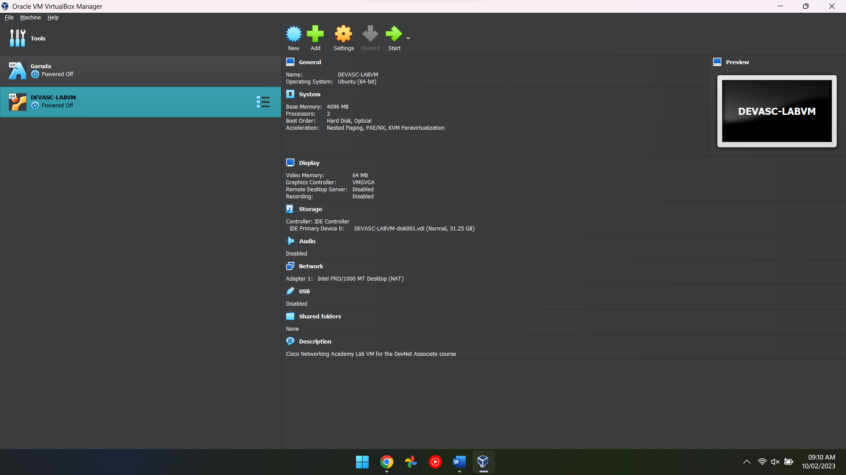
Figure 1 In this screenshot you can see that the application virtual box is opened and the virtual machine file has been imported into the application, a virtual machine can be set up manually by using an ISO but in this case, it's a pre-configured virtual machine

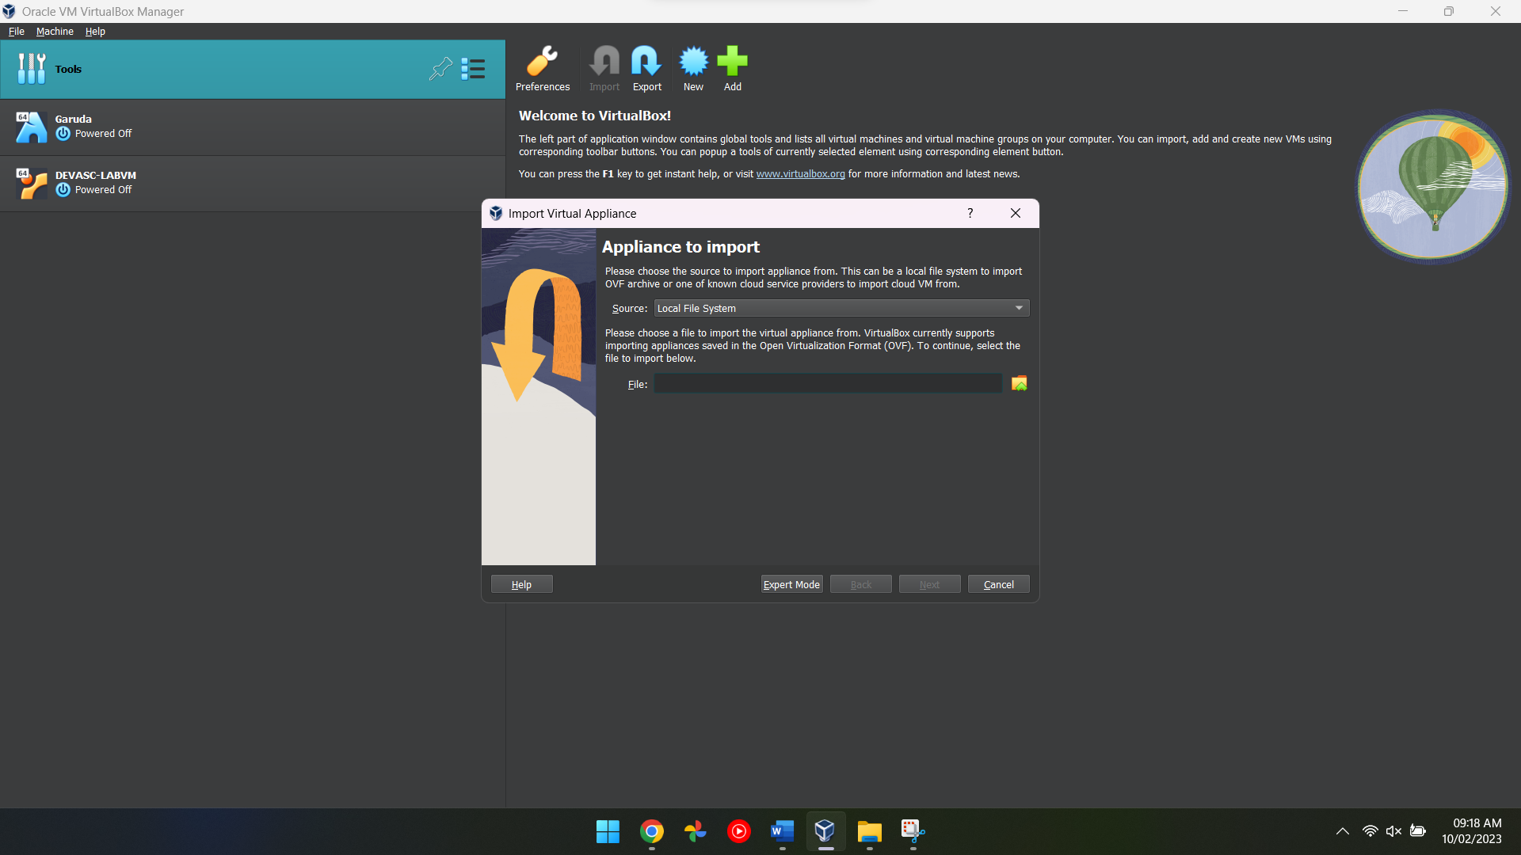
Figure 2 In this screenshot, it shows the menu in which a user would use to import the virtual machine into the virtual box itself

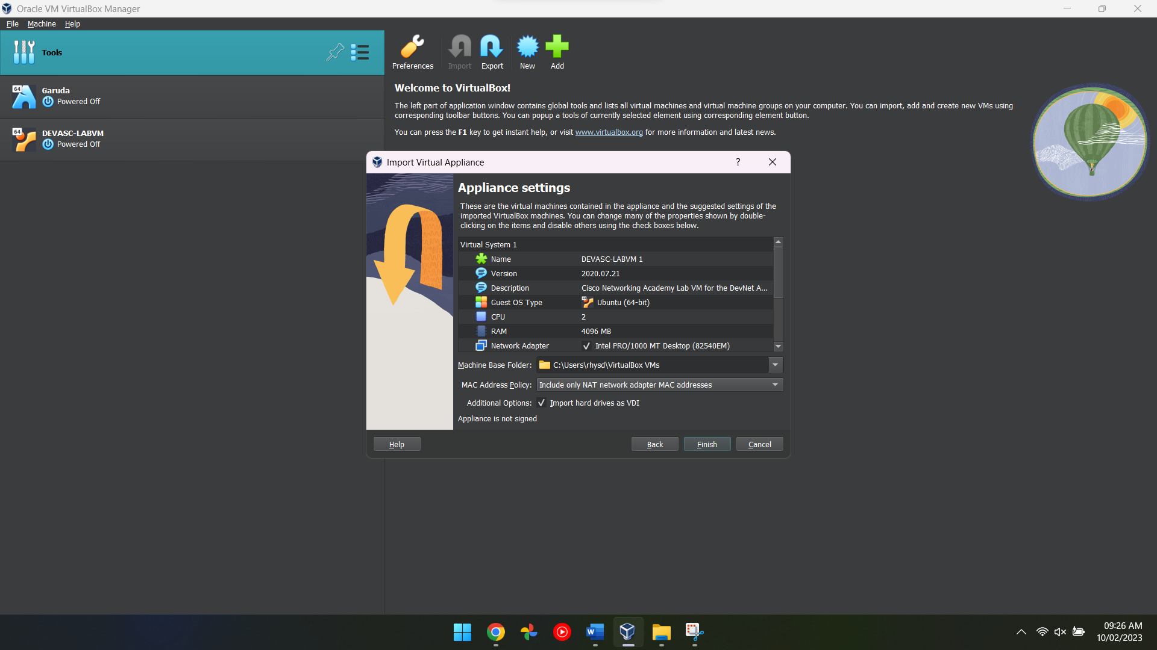
Figure 3 In this screenshot, the menu displays different settings that have been changed by someone else and it's asking the user if they would like to make any changes

Setting up Server 1
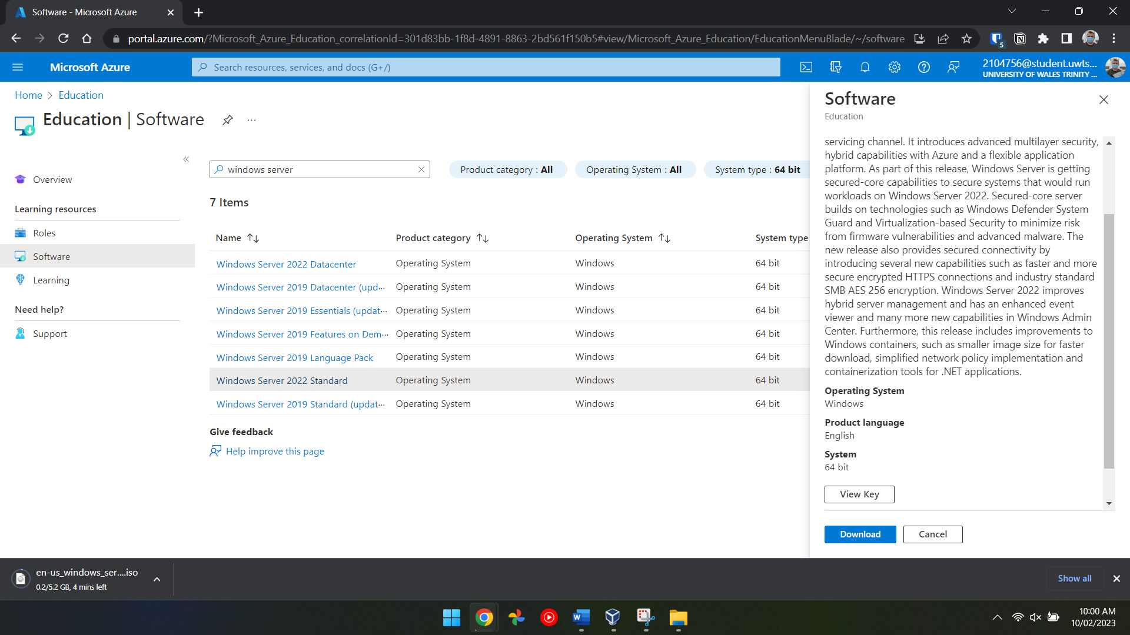
Figure 4 In this screenshot, a user has visited the university Microsoft Azure page which contains all different kinds of software that is accessible to students but in this case, the user is searching for a Windows Server ISO and at the bottom of the screen you
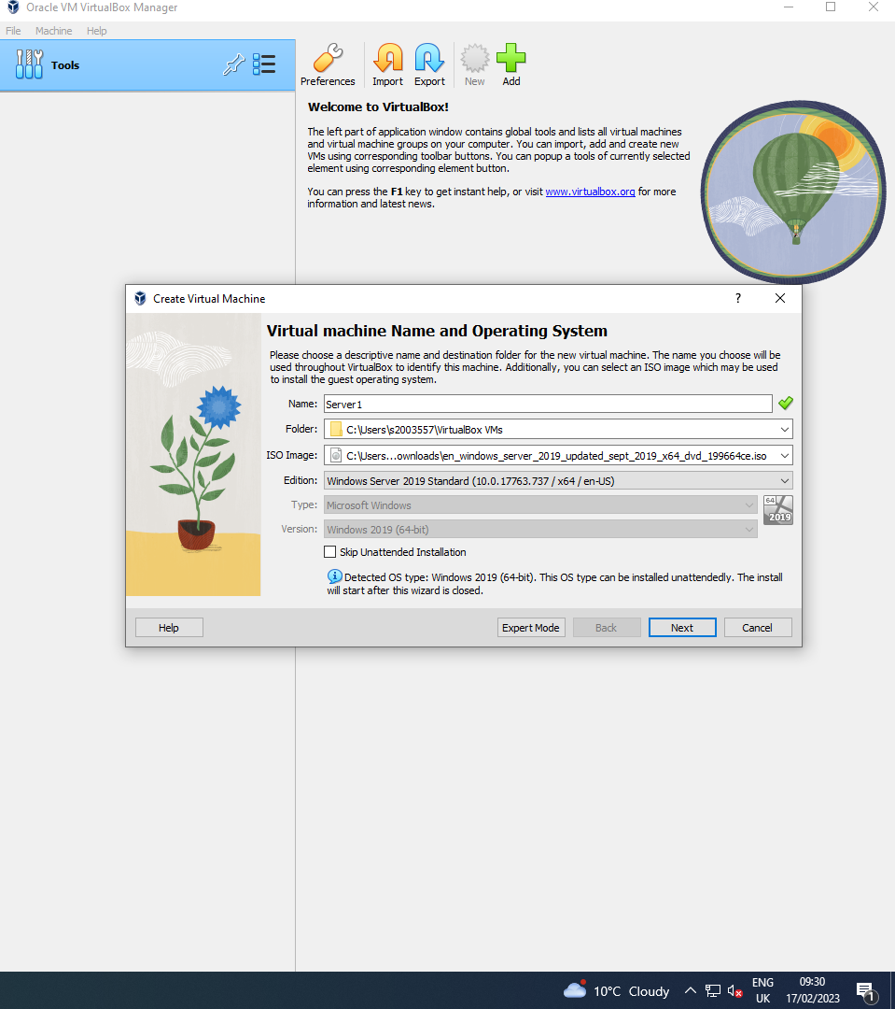
Figure 5 In this screenshot, the user has started creating the Server 1 virtual machine which also requires the user to import the Windows Server ISO to be able to correctly configure the virtual machine.
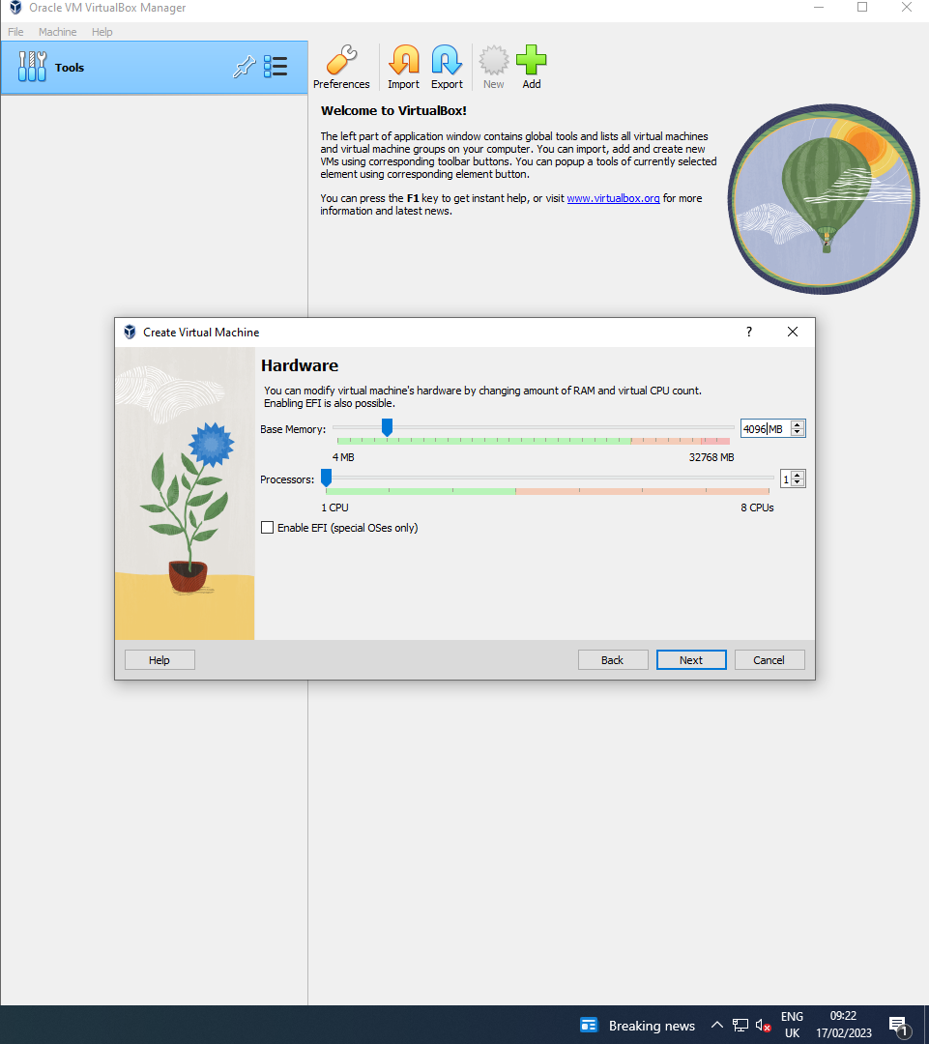
Figure 6 In this screenshot the user is now allocating computer resources to the virtual machine, it’s important to allocate the correct amount of computer resources otherwise the virtual machine may not start or may run poorly.

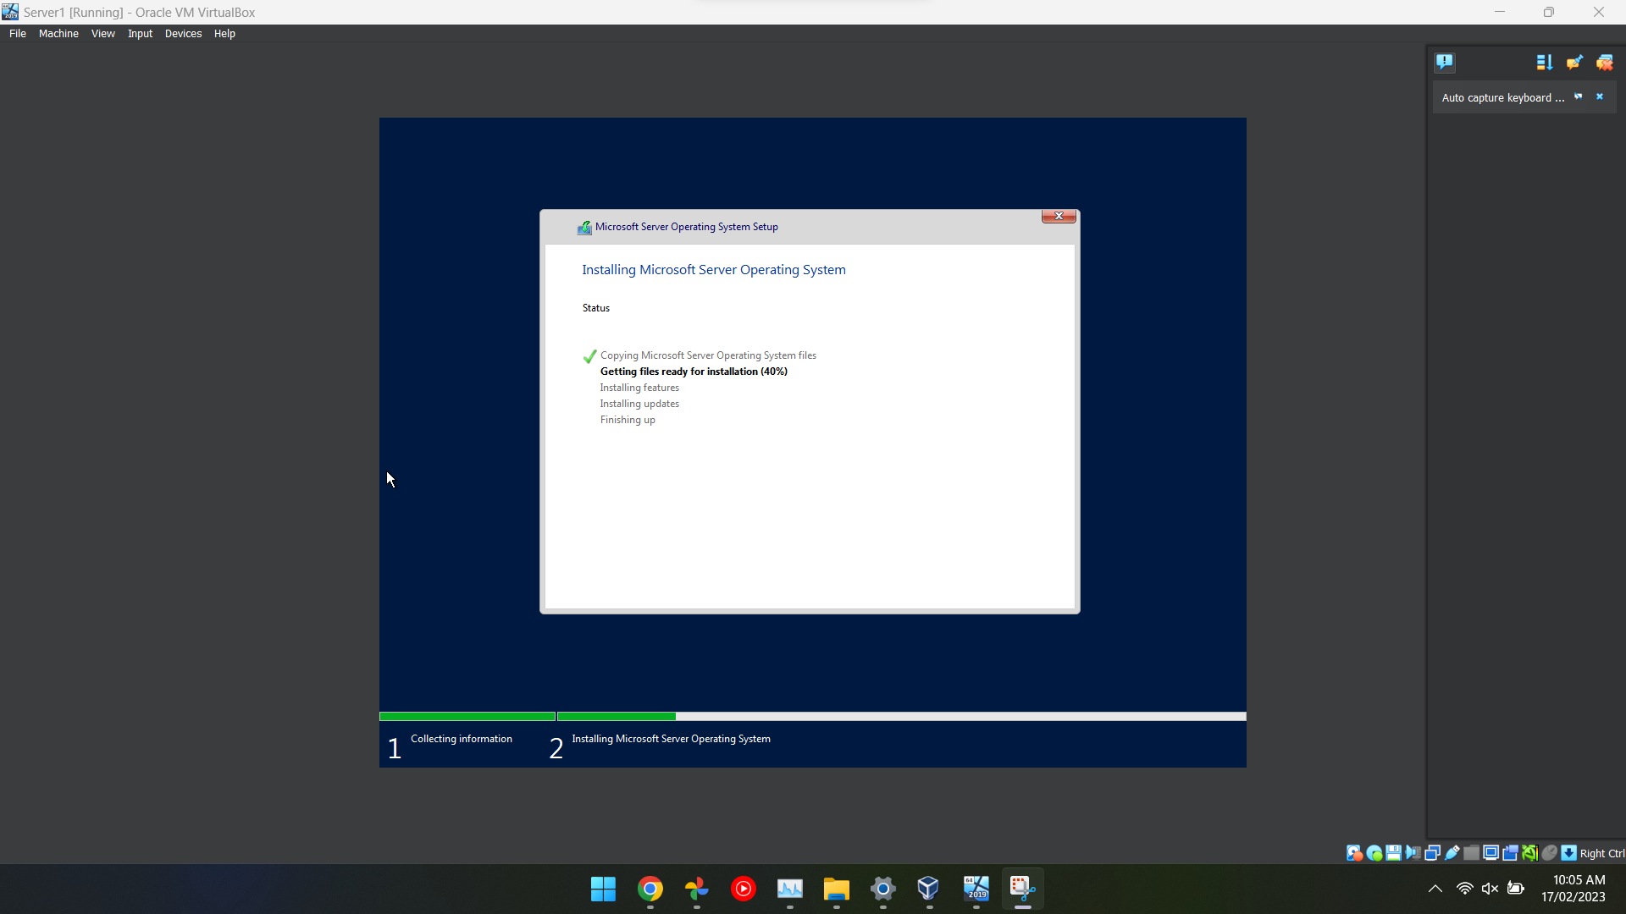
Figure 7 In this screenshot, the user has successfully imported the Windows Server ISO into VirtualBox and now it has booted and started setting up the operating system for use.

Configuring Network Settings for the Virtual Machine
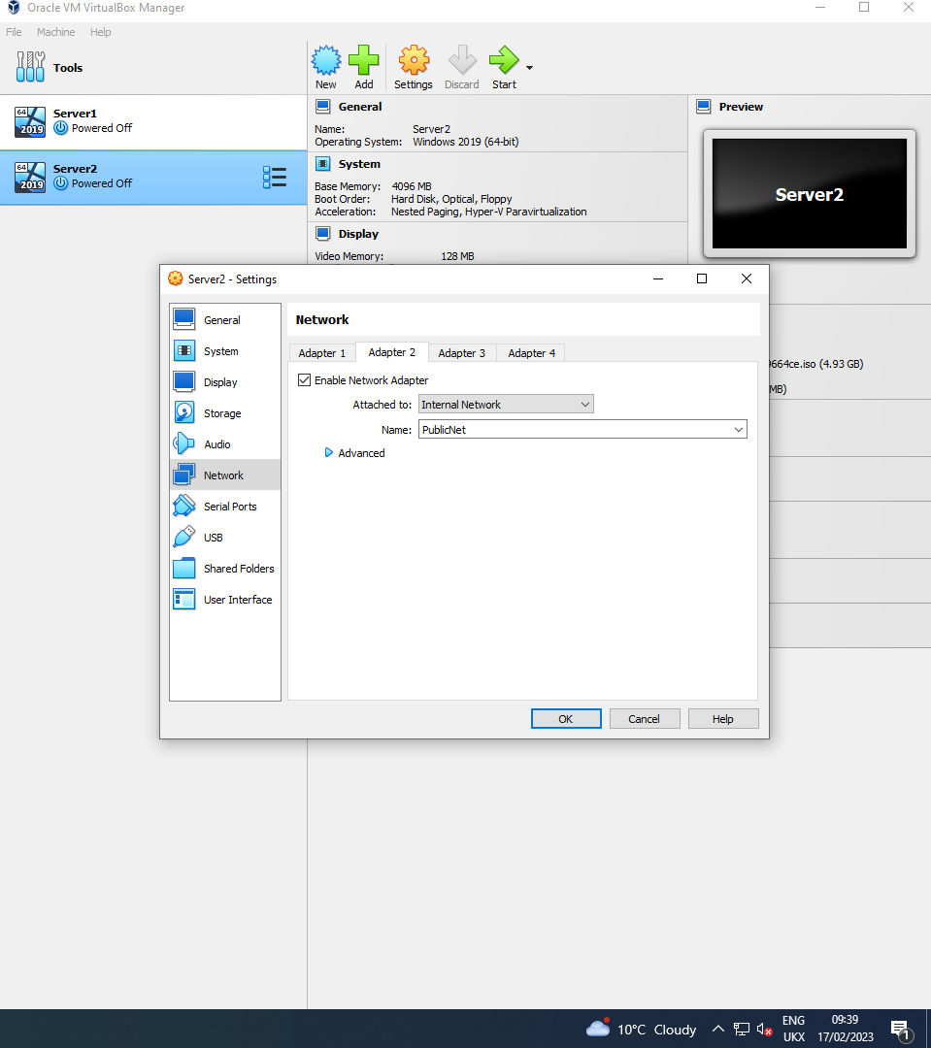
Figure 8 In this screenshot, the user has configured the network services in the virtual machine settings on VirtualBox which allows them to configure which network adapter can access the internet and which adapters can’t access the internet.

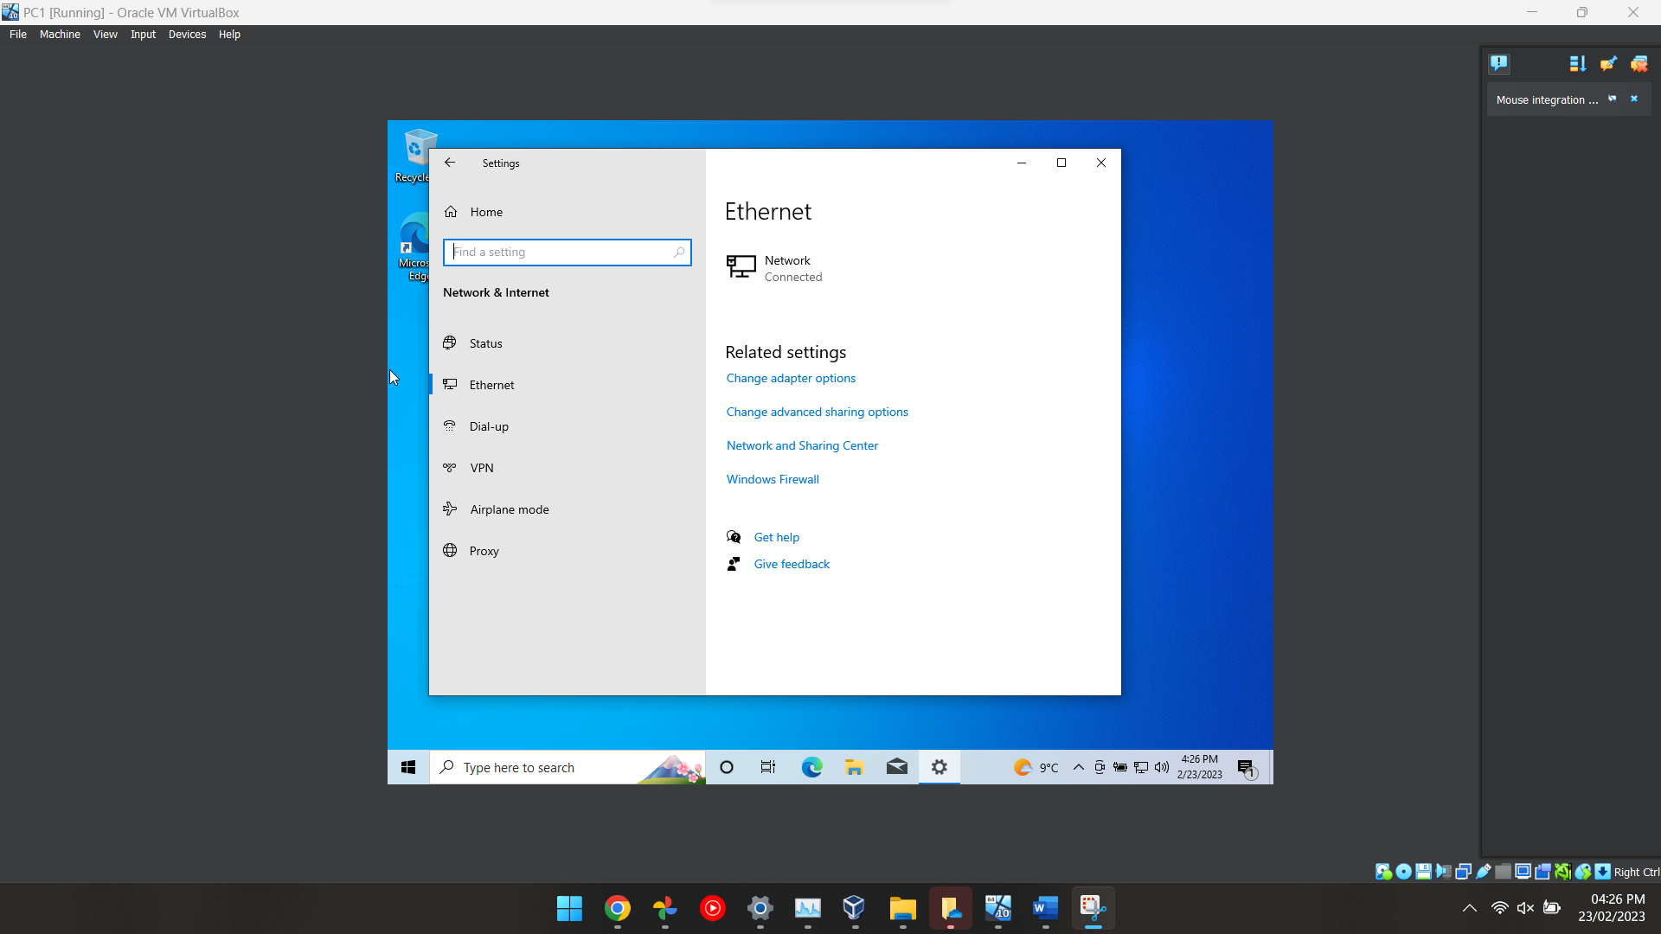
Figure 9 The same steps were repeated for Server2, as two servers and two clients needed to be created. The user then proceeded to ping the private net from the server to the client by creating network adapters.
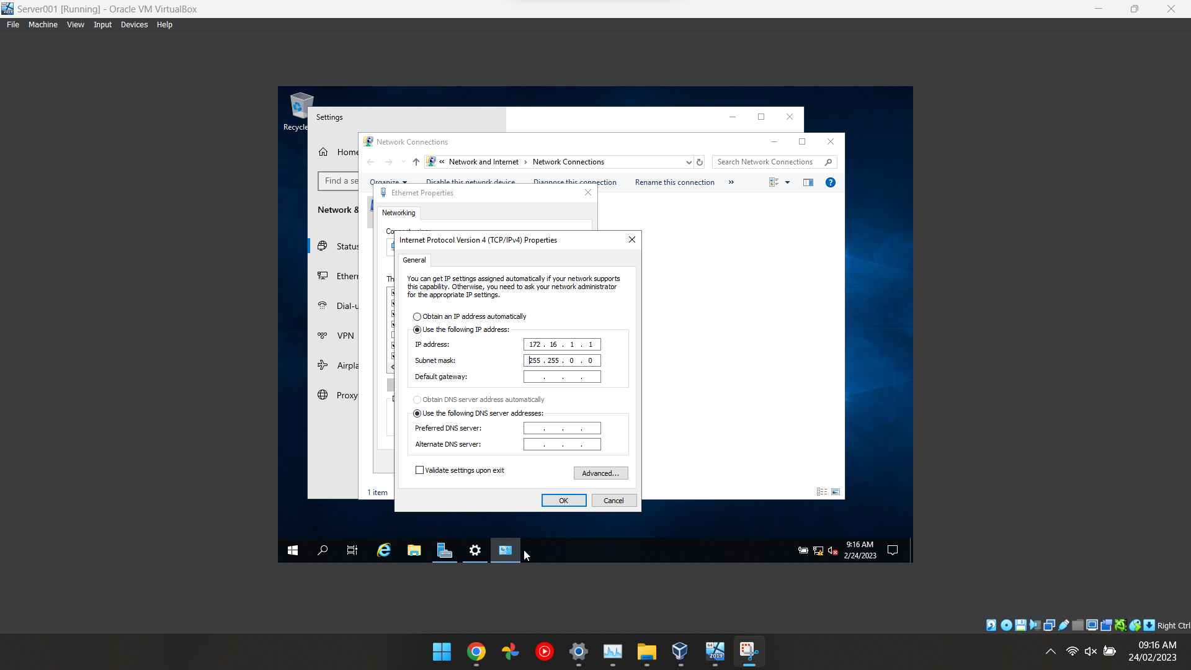
Figure 10 To achieve this, the user turned on the firewall for all the virtual PCs by accessing the control panel, selecting settings and navigating to the firewall option. The virtual PCs were then restarted to save the changes made.
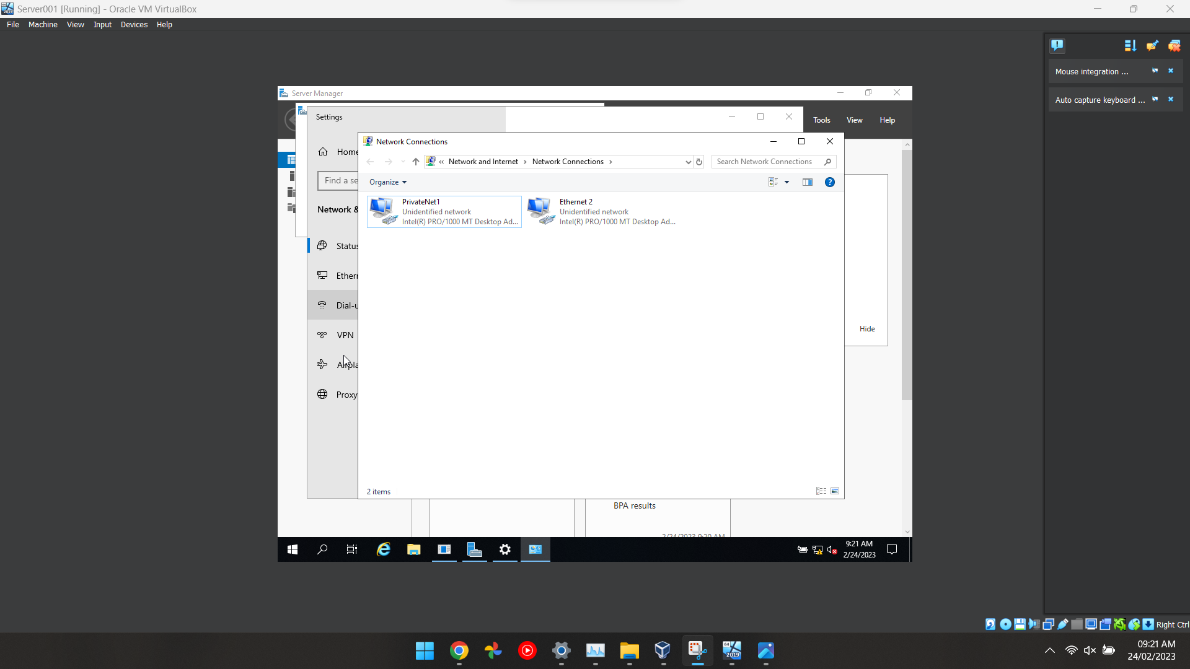
Figure 11 After completing the installation process and configuring the networking settings of the server, the user accessed the control panel and right clicked on the Windows icon to navigate to the Network Connections tab. The two local networks were renamed Pu
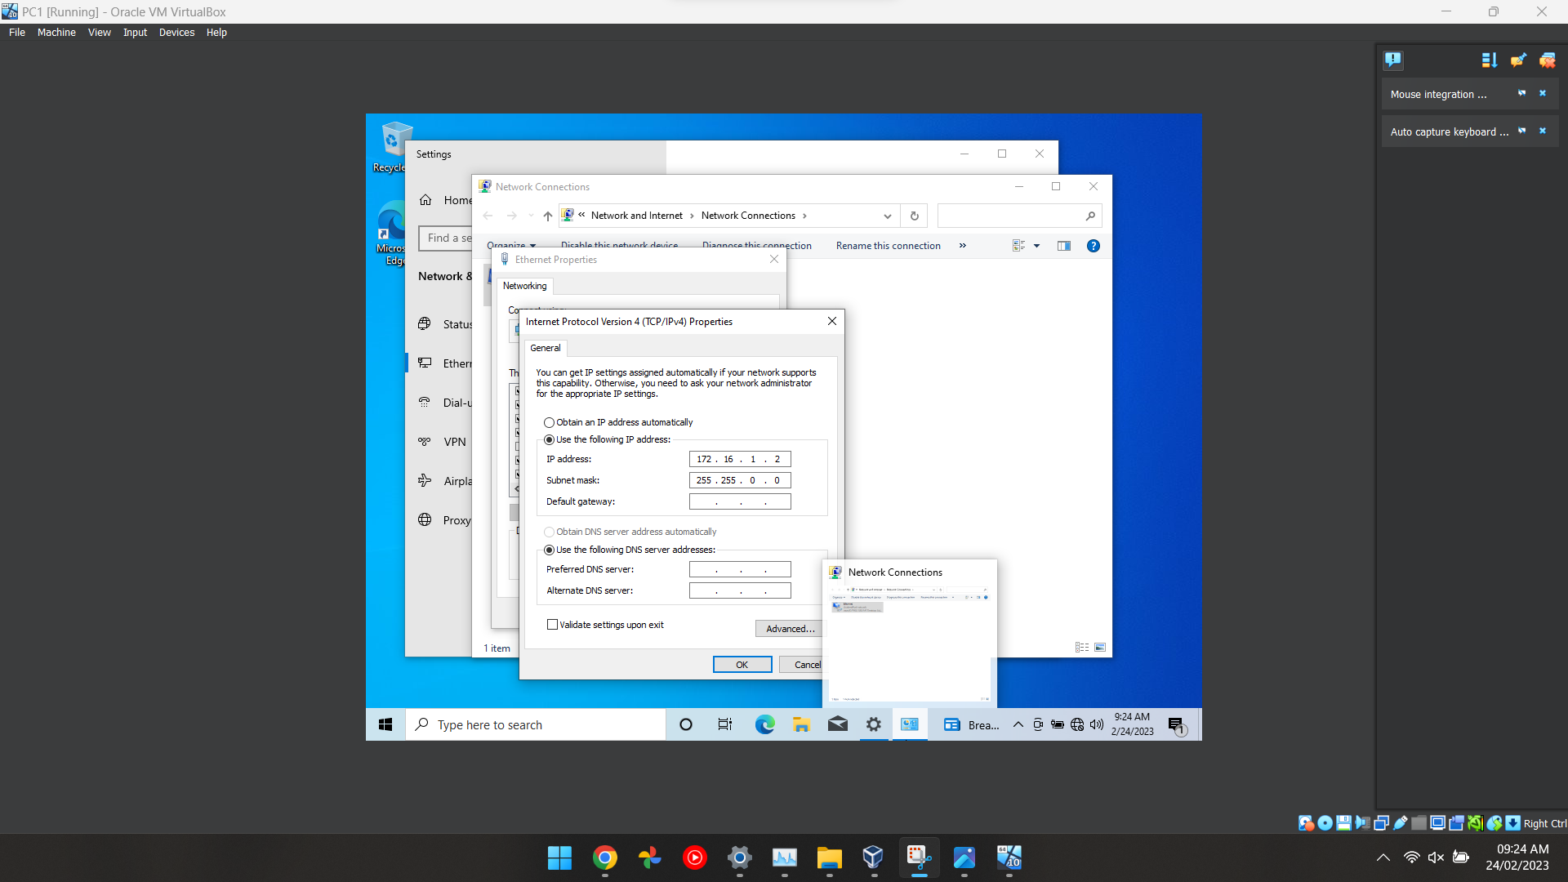
Figure 12 The same steps were repeated for Server2, as two servers and two clients needed to be created. The user then proceeded to ping the private net from the server to the client by creating network adapters.

Configuring Server1 and PC1
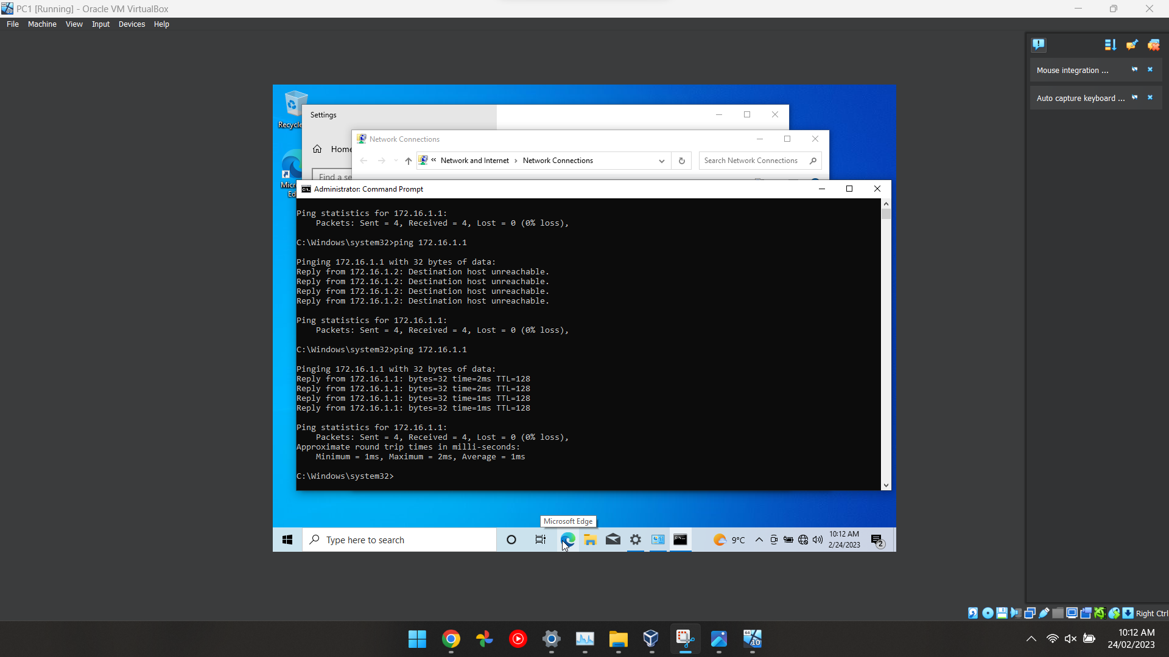
Figure 13 This screenshot demonstrates that server 1 and PC are connected because a ping between both PC’s have been successful. After starting the server and client, the user used the ping command to test the connection. In the command prompt, the user typed "ping.

Setting up an Active Directory
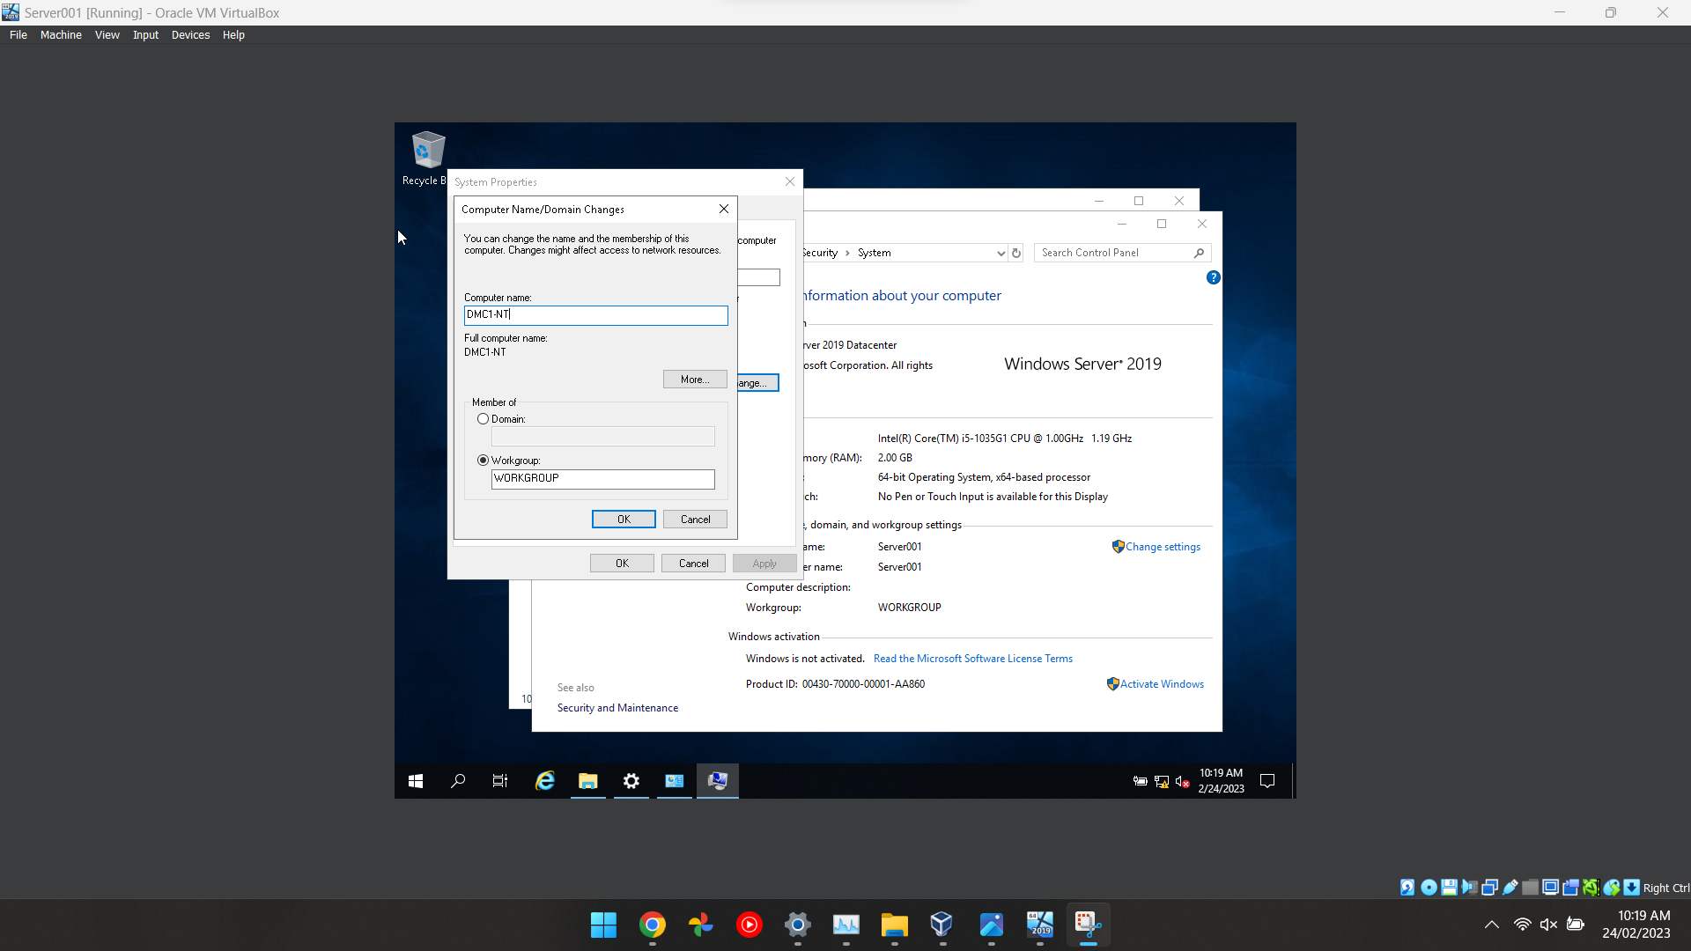
Figure 14 This screenshot shows the user changing the name of the computer to make it easier to recognise which PC is which.
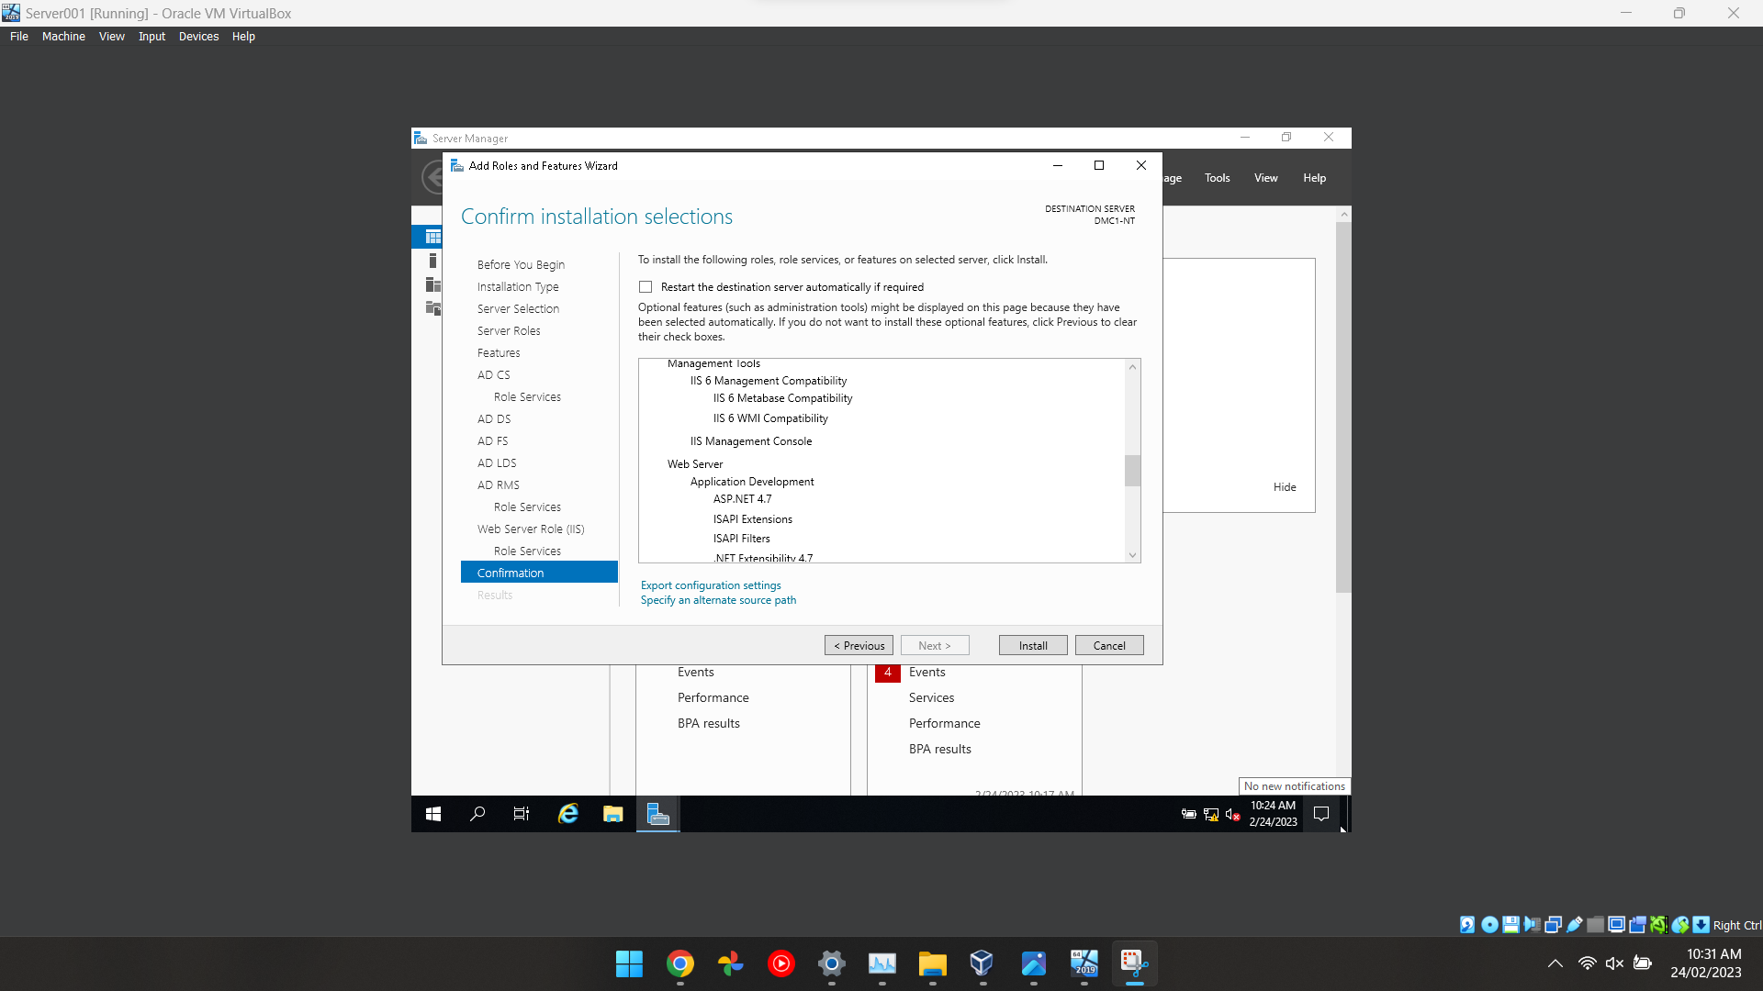
Figure 15 This screenshot shows the user that has completed the installation of adding the roles and features, the user added the Active Domain feature which allows the installation to be completed properly.
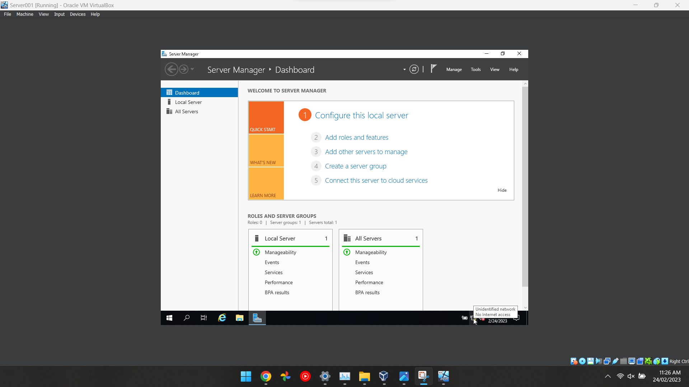
Figure 16 After installing the roles and configuration then this screen will pop up which demonstrates that the rules and features have been set up correctly.
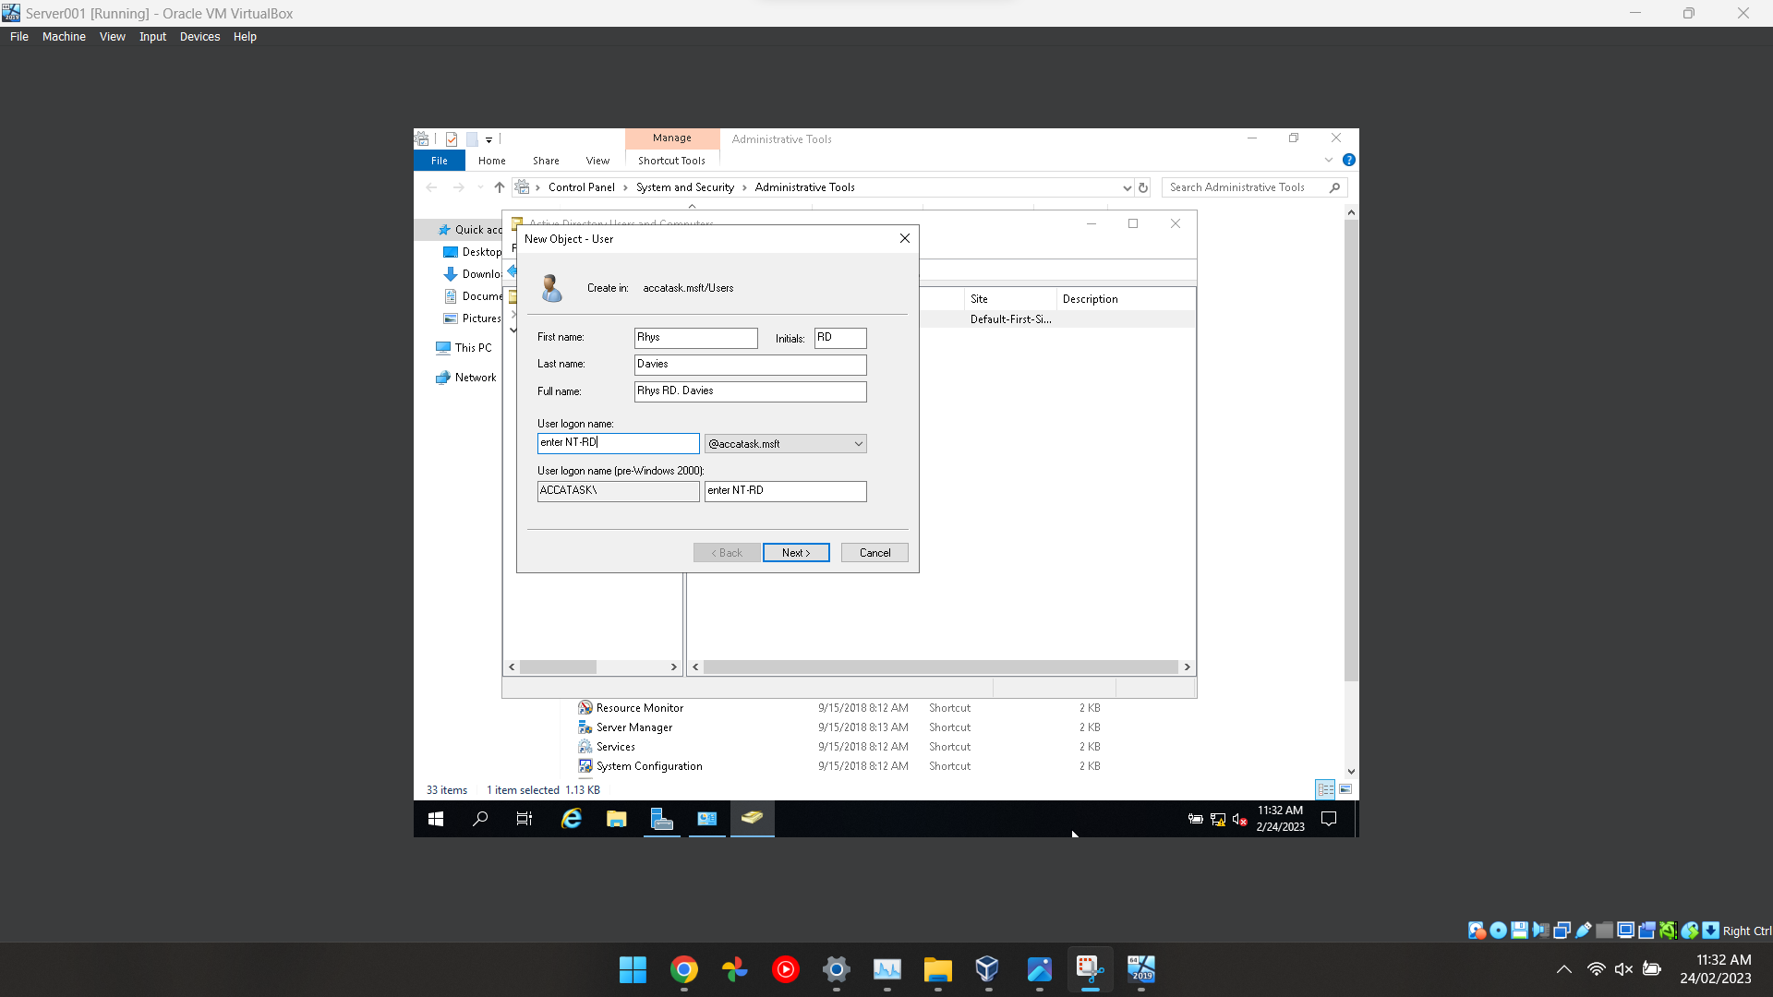
Figure 17 In this screenshot, it shows the admin adding a user to the local domain in which they can control certain aspects of the computer.
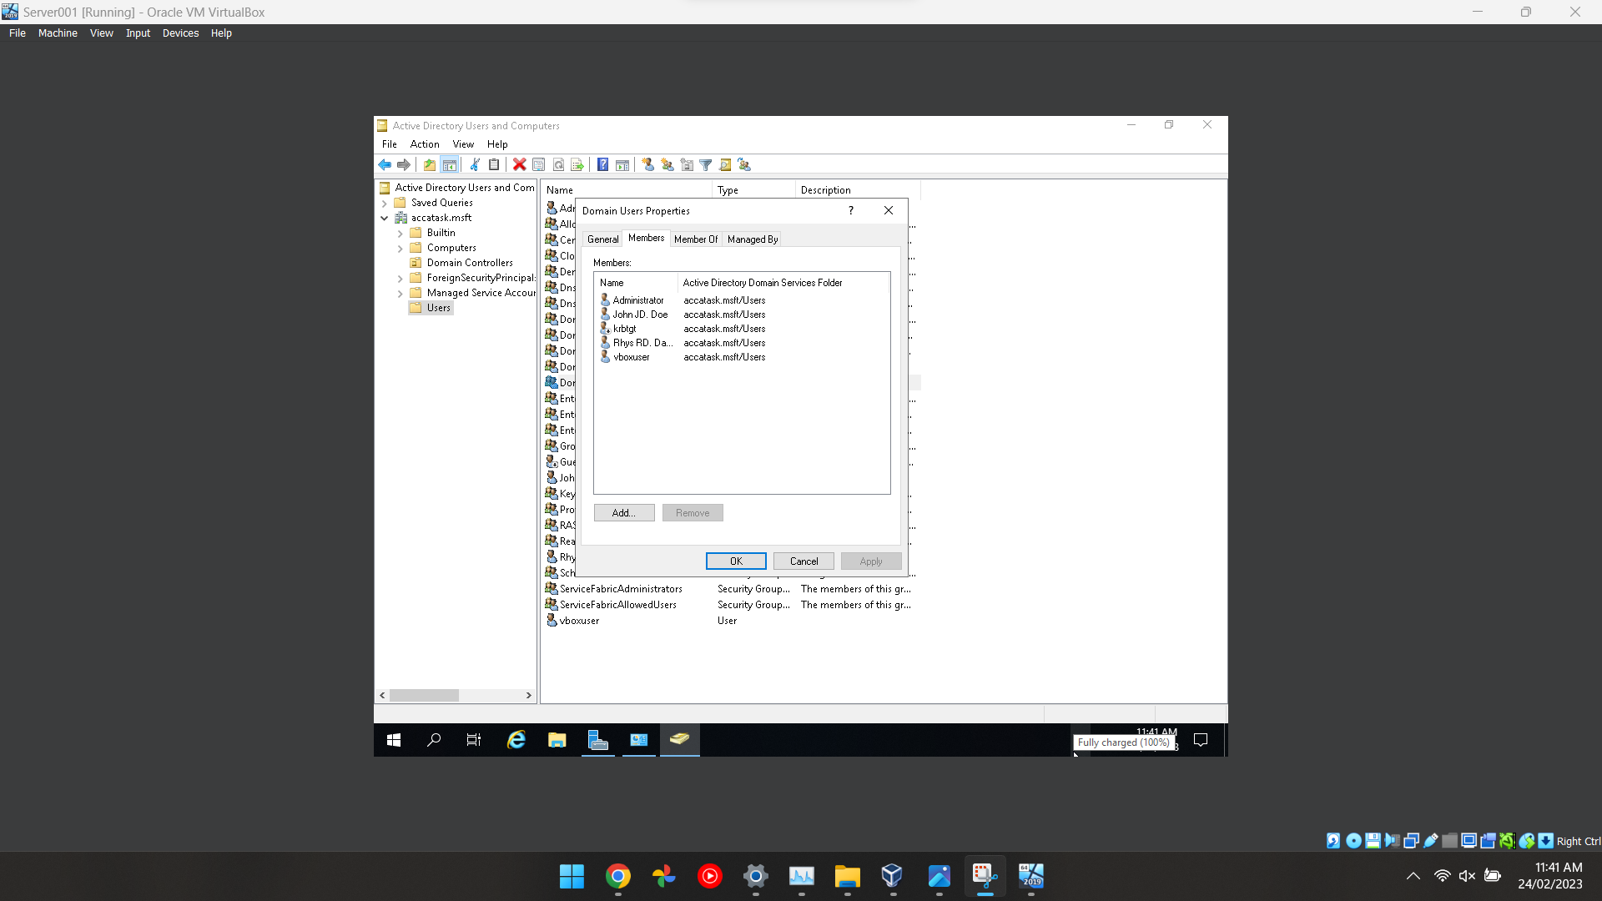
Figure 18 This screenshot shows all the users that are connected to the local domain including the admins and the guest who is called “John Doe” with his initials JD which is easily identifiable.
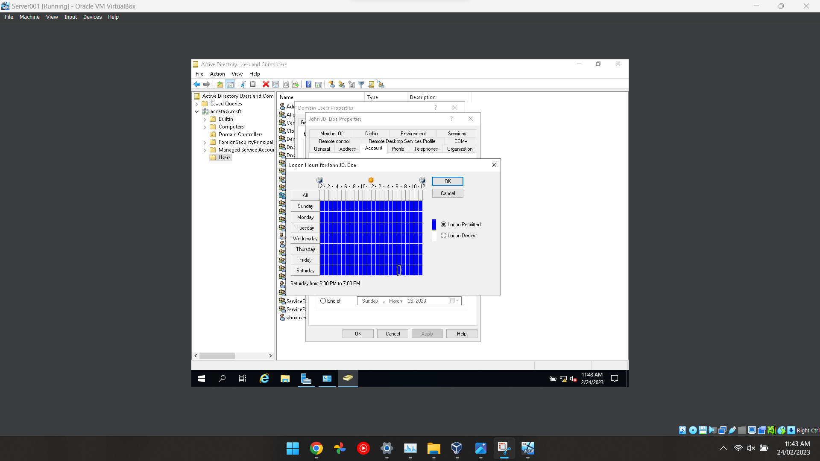
Figure 19 This screenshot shows the admin configuring a user's timetable in which they can log in at certain times of the day or limit their access at certain times of the day because it can be a security risk if a user had access 24/7.
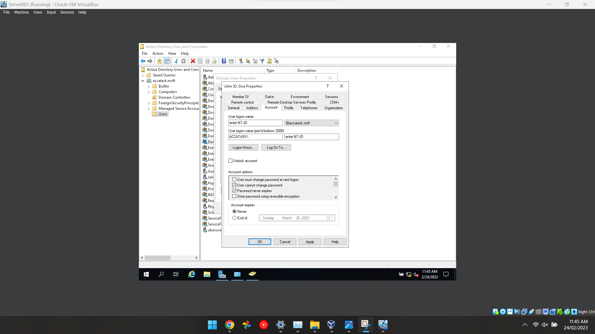
Figure 20 This screenshot is related to the last screenshot which shows the admin configuring the security features for an account in which the admin has turned on the feature “password never expires” and “user cannot change password” which is great for security.
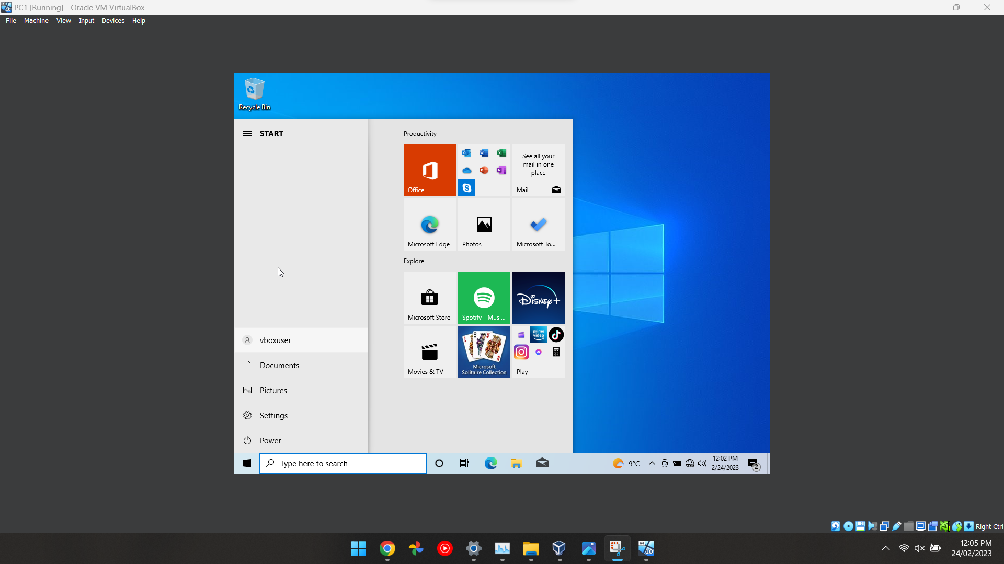
Figure 21 The final screenshot shows that all the features have been configured and the guest has now been added to the domain in which the admin has control over the user's computer settings.

Part 2 | Observational Tasks

Justify the reason why Type 2 Hypervisors is used in the above practical task? Give scenarios where Type 1 Hypervisors could be used. Identify benefits and drawbacks of Type 1 and Type 2 Hypervisors.

A Type 2 hypervisor is a virtual machine which allows you to run application software and run a computer within a computer. The virtual machine software allows the functionality of a physical computer ‘the guest’ from within another Operating System ‘the host’. This allows the testing of software or safety protocols. Virtual machines can be used to run multiple programmes at the same time on the host as a time-saving measure, but this relies on the power of the Operating System.

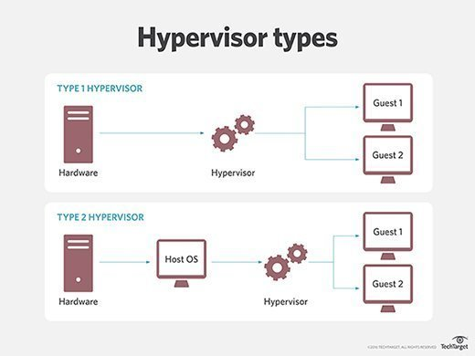
[1]

Benefits of Type 1 hypervisors:
The host machine can coordinate several guest machines running programmes at the same time without having to install separate software packages. These virtual machines are coordinated through a central host which acts as a console.
- High performance; Less physical restrictions, so more resources are available and therefore more efficient than Type 2 hypervisors.
- Increased security; The second system is within the machine so hackers could not compromise Type 1 hypervisor CPUs.

Drawbacks of Type 1 hypervisors:
The guest machines are run indirectly through the host and may lose functionality compared to running a single programme on a physical machine. In particular, the virtual machine will not connect to hardware such as printers, other than through the host which can be done but is more complex. Running several machines at the same time requires computing power divided between the virtual machines which drain the physical resources and slows down the host.
- Complexity; It is more complicated to set up which increases costs and time.
- Cost; The cost of setting up the hardware on several machines compared to setting up several machines on a single computer compared to Type two hypervisors.
Benefits of Type 2 hypervisors:
- Ease of use: Type two hypervisors are extremely easy to use, especially if using Apps such as VirtualBox which have guides and step-by-step instructions for installation and use.
- Cost-effective: Very cost-effective, because with one powerful machine, you can run multiple virtual machines, so it is easy to scale up and down within the company.

Drawbacks of Type 2 hypervisors:
- Reduced performance: Because of how it works, the more resources you allocate to each virtual machine's LSD, the less power the host machine has and therefore the performance would decrease.
- Compatibility issues: The software used to run Type 2 hypervisors including VirtualBox may not be compatible. You can run into problems with different Operating Systems, such as Mac, not liking VirtualBox and the files not being compatible.

DHCP - explain what it is, how it works (illustrations) and its significance.
Dynamic Host Configuration Protocol (DHCP) is a protocol used to control the network configuration of a host through a remote server. DHCP functionality is a default feature in most contemporary Operating Systems and avoids the need to manually configure network settings on a host or a network device. The DHCP automatically provides an Internet Protocol (IP) host with its IP address and other related configuration information such as the subnet mask and default gateway.

DHCP operations fall into four phases: server discovery, IP lease offer, IP lease request, and IP lease acknowledgement. These stages are often abbreviated as DORA for Discovery, Offer, Request, and Acknowledgement.
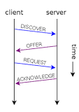

Droms, Ralph (March 1997). "Dynamic Host Configuration Protocol". tools.ietf.org. doi:10.17487/RFC2131. Retrieved 4 July 2017 from https://en.wikipedia.org/wiki/Dynamic_Host_Configuration_Protocol [2]

The first step | A device requests an IP address by broadcasting a DHCP Discover message.
The second step | A DHCP server on the network receives the broadcast and responds with a DHCP Offer message.
The third step | The device accepts the offer by sending a DHCP Request message to the server.
The fourth step | The server sends a DHCP Ack message to confirm that the IP address has been assigned to the device – Acknowledge.

“Active Directory is a distributed database that stores objects in a hierarchical, structured, and secure format”: Justify AD’s technology with illustrations and adequate evidence.
Active Directory is a set of networking tools to create a database with services which connect users to network resources to help get work done. It is useful for managing permissions, and enabling administrators to do their jobs, allocate resources, download files and applications, and categorise and assign attributes to individual profiles and names.

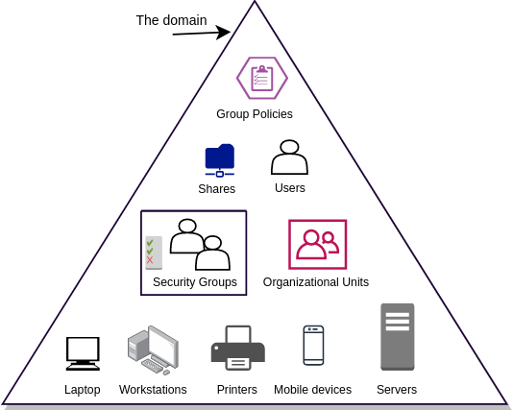

https://rootdse.org/posts/active-directory-basics-1/ [3]
The database contains critical information about the company environment, including the directory of users and computers and their permissions.

https://social.technet.microsoft.com/wiki/contents/articles/52587.active-directory-design-considerations-and-best-practices.aspx [4]
The centralised database stores data within a hierarchy with organisational units (OUs) and child domains, which can be described as forests and individual trees.
Network resources like users, computers, printers, phones and other IOT devices are managed in an organised and safe manner.
The Active Directory makes it easier to find elements by enabling searches on objects such as names, passwords, and groups.
The Active Directory is secure and can be used to store private data about individuals and organisations protecting information on lists, with permissions and encryption. This can be aligned with company policy and security requirements.
The Active Directory has two types of groups: Security groups which assign permissions to shared resources and Distribution groups which are used to create distribution lists.

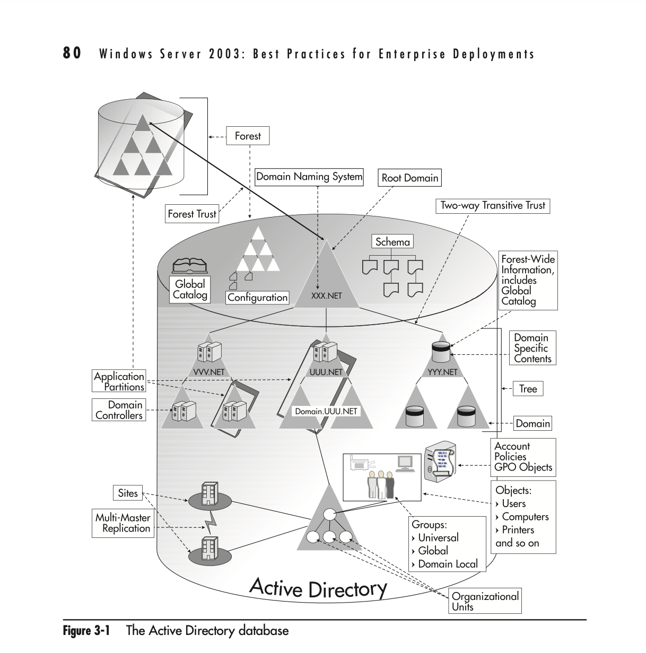

http://archive.visualstudiomagazine.com/books/chapters/007222343X.pdf [5]
In summary, Active Directory is a single management interface that is accessible from anywhere on the network.

Give an in-detail description about the different terminologies and its purposes (like (not limited to) Ping, Server Management, Firewall, PAE/NX, OOBE etc) you came across during this worksheet. Compare your list of terminologies in the aspect of their operations/functionality with other Network Operating Systems. (For example: If you select Windows Firewall and describe the operations/functionality of Windows Server 2019 Firewall, you have to compare these features with the operations/functionality of other Network Operating Systems like Linux, Mac)

Technologies used:

Ping
Ping is a computer network software system used to test whether a host can be reached on an Internet Protocol. Ping is used to test connectivity between two machines and it uses the internet protocol which is available on most operating systems that have net networking capability, including most embedded network administration software.
[6] https://en.wikipedia.org/wiki/Ping_(networking_utility)

Server Management
Server management is the management of hardware, software, security, and backups, including the monitoring and maintenance required for servers to operate reliably and at optimal performance levels.
[7]https://www.ninjaone.com/blog/what-is-server-management-tools-and-best-practices/

Firewall
A firewall is a network security system that monitors and controls the network traffic between Operating Systems and external systems and sets rules and filters to protect the pc or operating system. The firewall only allows access when the communicating systems have permissions and follow certain rules. This establishes security barriers between trusted networks and untrusted networks, such as the Internet.

[8]https://en.wikipedia.org/wiki/Firewall_(computing)

PAE/NX
Physical Address Extension (PAE), which is sometimes referred to as Page Address Extension, is a memory management feature for the x86 architecture. It defines a page table hierarchy of three levels (instead of two), with table entries of 64 bits each instead of 32, allowing these CPUs to directly access a physical address space larger than 4 gigabytes (2³² bytes).
9https://librarysearch.uwtsd.ac.uk/discovery/search?query=any,contains,Physical%20Address%20Extension&tab=Everything&search_scope=Search_ELEC&vid=44WHELF_UWTSD:44WHELF_UWTSD_VU1&lang=en&offset=0&pcAvailability=false
[10]https://en.wikipedia.org/wiki/Physical_Address_Extension

OOBE
OOBE stands for Out Of Box Experience is the initial phase of Windows setup that allows you to customize your Windows 10 experience. The first time to use this it takes you through multiple pages where you have the opportunity to define personalised settings, create user accounts, join a business network, join a wireless network and define privacy settings. In addition to the ‘look and feel’ of the account, it has important requirements such as accepting the license agreement, connecting to the internet, logging in with, or signing up for a Microsoft Account, and sharing information with the OEM.
[11]https://uwindsor.teamdynamix.com/TDClient/1975/Portal/KB/ArticleDet?ID=76042

Windows Server
Windows Server is a group of operating systems designed by Microsoft that supports enterprise-level management, data storage, applications, and communications. Windows Server focuses on stability, security, networking, and various improvements to the file system.
[12]https://librarysearch.uwtsd.ac.uk/discovery/search?query=any,contains,Windows%20Server%202019%20Firewall&tab=Everything&search_scope=Search_ELEC&vid=44WHELF_UWTSD:44WHELF_UWTSD_VU1&lang=en&mode=advanced&offset=0

ISO File
An ISO file is an exact copy of an entire operating system archived into a single file. This file is sometimes referred to as an ISO image and is a smaller representation of large sets of data. This can be used to install the full information to run a virtual machine from a CD, DVD, or Blu-ray. ISO files can be used to back up optical disks or store data in a more functional way.
[13]https://www.freecodecamp.org/news/what-is-an-iso-file-explained-in-plain-english/

Domain & Domain Users
A domain computer is a workstation that is joined to the domain, where domain users are able to log on. Domain users are individuals who log on to a computer with a username and password which is stored on the domain control rather than the computer on which the user is logging on.

When you log in as a domain user, the computer asks the domain controller what privileges are assigned to you and allows this level of access. The domain controller manages and monitors the access and matches this to the resources available, policies and security requirements.

Windows Server Manager
Windows Server manager is the software that allows an administrator to configure rules and roles for each user depending on their requirements. The administrator has oversight of each server and the server roles and is able to manage multiple different servers from a single console. The user interface (UI) is simplified by this software which allows them to easily install, configure and manage different server components.

Conclusion
In conclusion, we recognised that the Type 2 Hypervisor is preferable because of the ability to run multiple machines on one physical device. This work has shown how different hypervisors have different benefits and disadvantages. We learnt how Active Directory manages other protocols and groups and new terminologies, with which we were unfamiliar.

Reflection on collaborative work
Reflecting on the work we did as a team and how the communication could be improved if we did it again. The team members each gained new skills and learnt more about the protocols, we boosted our team working skills and shared responsibility for getting the work done. This was sometimes difficult as three of the team were already friends and the fourth person sometimes worked independently without consulting the group.

We got a good number of screenshots, and the 1,000 words need for the group work by working together. In the team, we had the necessary skills to use VirtualBox, Windows Server 2019, and work on the worksheet.

As a team, we struggled in the beginning because we were trying to find one specific ISO image to install virtual machines 2 PCs and 2 window servers in VirtualBox. With assistance from the lecturer, we got back on track.

Going through the lecture content, I have learnt the vocabulary associated with the protocols for Windows Server and gained some virtual networking skills. I did not previously know about OOBE, and PAE/NX .

With the active directory, we got a bit confused and collected more active directory services than we were meant to say we would be more cautious about over-selecting in future projects. Difficult to find relevant journals and references of quality when trying to complete this.

As a team, we had enough time to complete the group work and it would have been helpful to complete it sooner to allow more time for the independent part.
Team working skills and understanding the protocols on a deeper level will be useful for future jobs.

Bibliography
There are no sources in the c[1]
“What is Server Management? Tools and Best Practices .” [Online]. Available: https://www.ninjaone.com/blog/what-is-server-management-tools-and-best-practices/. [Accessed: 2023]
[2]
“Physical_Address_Extension.” [Online]. Available: https://en.wikipedia.org/wiki/Physical_Address_Extension. [Accessed: 2023]
[3]
“Designing the Active Directory.” [Online]. Available: http://archive.visualstudiomagazine.com/books/chapters/007222343X.pdf. [Accessed: 2023]
[4]
“Windows 10 Out-of-Box Experience (OOBE) setup wizard .” [Online]. Available: https://uwindsor.teamdynamix.com/TDClient/1975/Portal/KB/ArticleDet?ID=76042. [Accessed: 2023]
[5]
“Active Directory Fundamentals (Part 1)- Basic Concepts .” [Online]. Available: https://rootdse.org/posts/active-directory-basics-1/. [Accessed: 2023]
[6]
“ping (networking utility) .” [Online]. Available: https://en.wikipedia.org/wiki/Ping_(networking_utility). [Accessed: 2023]
[7]
“Active Directory : Design Considerations and Best Practices .” [Online]. Available: https://social.technet.microsoft.com/wiki/contents/articles/52587.active-directory-design-considerations-and-best-practices.aspx. [Accessed: 2023]
[8]
“Dynamic Host Configuration Protocol .” [Online]. Available: https://en.wikipedia.org/wiki/Dynamic_Host_Configuration_Protocol. [Accessed: 2023]
[9]
“Type 2 hypervisor (hosted hypervisor).” [Online]. Available: https://www.techtarget.com/searchitoperations/definition/Type-2-hypervisor-hosted-hypervisor. [Accessed: 2023]
[10]
“What Is an ISO File? Explained in Plain English .” [Online]. Available: https://www.freecodecamp.org/news/what-is-an-iso-file-explained-in-plain-english/. [Accessed: 2023]
[11]
“Firewall (computing) .” [Online]. Available: https://en.wikipedia.org/wiki/Firewall_(computing). [Accessed: 2023]

