

MARKETING MANAGEMENT
MODULE CODE: LCMB7001

CASE: Morrisons

Professor Name: Tushara Balendran
Student name: Rohankumar Yogeshbhai Patel
Student ID: 2239383
Table of Contents
Introduction 4
Macro-environment analysis 4
PESTLE analysis 4
Political factors 4
Economic factors 4
Social factors 4
Technological factors 5
Environmental factors 5
Legal factors 5
Porter’s five forces analysis 6
Threat of New Entrants: (Low) 6
Bargaining Power of Suppliers: (Medium) 6
Bargaining Power of Buyers: (Medium) 7
Threat of Substitutes: (Medium) 7
Intensity of Competitive Rivalry: (High) 7
Internal environment analysis 8
SWOT analysis 8
Strengths: 8
Weaknesses: 8
Opportunities: 8
Threats: 9
STP analysis 9
Segmentation: 9
Targeting: 10
Positioning: 10
Marketing mix strategies 11
Product: 11
Price: 11
Place: 11
Promotion: 11
Conclusion 12
Recommendations for future marketing strategies 13
Market Penetration: 13
Product Development: 13
References 15

Introduction
This report conducts a detailed investigation of Morrisons, a well-known UK retail business. It makes use of strategic frameworks to assess Morrisons' particular marketing tactics as well as the larger macroenvironment. The paper looks at how political, economic, social, technical, environmental, and legal variables affect Morrisons' operational environment using a PESTLE analysis. A Porter's Five Forces study is often used to look at the competitive landscape. The research also does a SWOT analysis to evaluate Morrisons' advantages, disadvantages, opportunities, and threats. The company's segmentation, targeting, and positioning (STP) strategies are taken into consideration in this assessment. Additionally, the research explores the Product, Price, Place, and Promotion (PPPP) marketing mix tactics. These tactics offer insightful information about Morrisons' general marketing strategy.

Macro-environment analysis

PESTLE analysis

Political factors
Morrisons, a well-known grocery company with its headquarters in the UK, works in a complex environment impacted by a variety of factors. Governmental directives about food safety standards and rules for product labelling have an effect on the business on a political level.

Economic factors
The buying power of customers may be directly impacted by changes in unemployment rates and inflation levels, which can therefore have a direct impact on the company's financial performance. Morrisons' revelation that its total sales will be over £18.4 billion in 2022 is noteworthy (Retail insight network, 2023).

Social factors
The constant growth of customer preferences is a key factor in determining the sociocultural front's trajectory of Morrisons' strategic efforts. The grocery operator must adjust its product lineup in response to the growing demand for ecologically friendly and healthful food options. A turning point was the COVID-19 epidemic, which led to an increase in internet sales and doorstep delivery. The operational emphasis and resource allocation of Morrisons were significantly impacted by this fundamental shift in consumer behaviour (Shtal et al., 2021).

Technological factors
Morrisons easily adopts technological advancements that transform the retail industry. Innovative technologies that are being included, such as data analytics, self-service checkout systems, and online ordering platforms, help to streamline operations and improve consumer experiences.

Environmental factors
The general emphasis on sustainable practises has given environmental issues increasing importance. Morrisons has made significant environmental commitments with the aim of becoming net-zero operations by 2030 and reducing greenhouse gas emissions by 46% by 2030. These pledges are in line with more general social expectations and legal requirements intended to reduce carbon footprints across a range of businesses (Deepak and Jeyakumar, 2019).
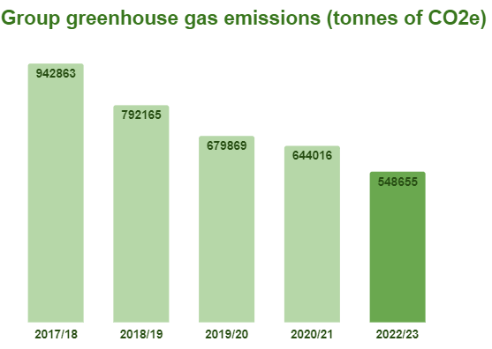
Fig: reduced greenhouse gas emissions (Morrisons, 2023)

Legal factors
In terms of the law, Morrisons is bound by rules that create minimum wage requirements, set health and safety standards for its employees, and regulate employment practises. In addition, the business must abide by data protection laws, particularly those that deal with how consumer data is handled inside its online operations. These legal issues have an effect on personnel management tactics and general business modes, reverberating throughout the company's activities (Shtal et al., 2021).
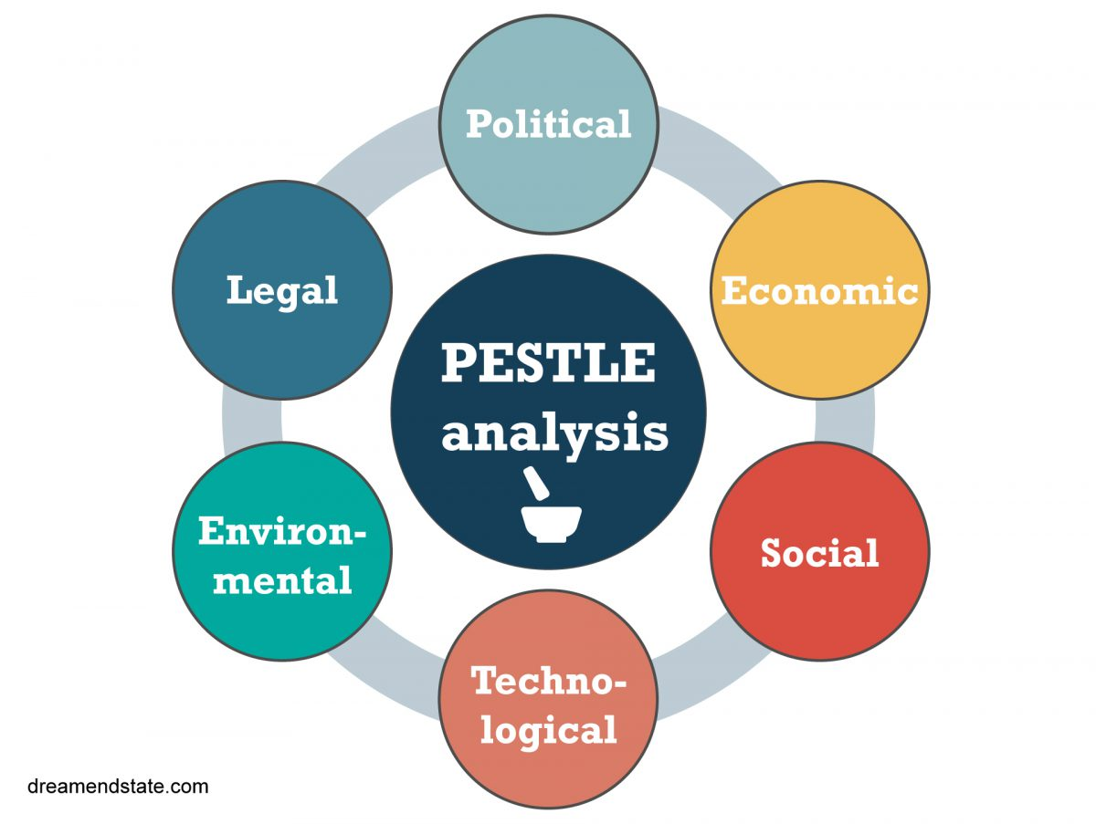
Fig: Pestle analysis

Porter’s five forces analysis

Threat of New Entrants: (Low)
The possibility of new players entering the grocery industry is rather low. This is mainly because establishing necessary infrastructure, creating supply chain networks, and achieving economies of scale require a large financial commitment. Furthermore, long-standing market leaders like Morrisons, Tesco, and Sainsbury's already have a sizable market share and a well-known brand (Bruijl, 2018).

Bargaining Power of Suppliers: (Medium)
Within the grocery sector, the bargaining strength of suppliers falls somewhere in the centre. Major retailers like Morrisons have a lot of buying power because of their large purchase volumes, but the dynamics of supplier power can change depending on things like the accessibility of alternative suppliers and the uniqueness of the items. Suppliers' negotiating strength may increase when they have sole control over a certain commodity or material (Bruijl, 2018).

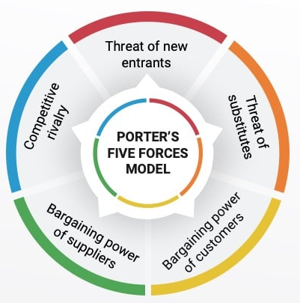
Fig: Porter’s five forces model

Bargaining Power of Buyers: (Medium)
Buyers, or customers, also have a moderate amount of negotiating power. The grocery industry is characterised by intense rivalry between numerous players, giving customers a variety of options. Although shoppers may choose from a variety of supermarkets, Morrisons and its rivals use loyalty programmes and aggressive price tactics to draw and keep customers. This equilibrium strikes a balance between customer influence and the value claims made by businesses (Deepak and Jeyakumar, 2019).

Threat of Substitutes: (Medium)
In the context of supermarkets, the possibility of alternatives presents a modest problem. Alternatives might appear in many different ways, including markets near you, internet shops, and convenience stores. Supermarkets like Morrisons combat this challenge by highlighting their convenience, wide range of products, and high-quality products. While replacements bring new purchasing alternatives, supermarkets' extensive selection and convenience help limit the severity of this threat (Bruijl, 2018).

Intensity of Competitive Rivalry: (High)
Within the grocery sector, there is a noticeable level of fierce competitiveness. Morrisons faces fierce competition from well-known companies like Tesco and Sainsbury's as well as up-and-coming rivals like Aldi and Lidl. The competitive nature of the sector encourages ongoing innovation, customer-centric tactics, and attempts to create distinctive selling advantages. Businesses compete for market share and customer loyalty, which leads to constant improvements in goods, services, and pricing strategies. The increased level of competition reflects the industry's dynamic nature and emphasises the need for businesses to continuously adapt to changing consumer demands (Bruijl, 2018).

Internal environment analysis

SWOT analysis

Strengths:
Morrisons, a significant participant in the grocery sector, has a number of advantages that support its market presence. Its strong brand awareness and extensive track record of producing top-notch products are a key advantage. Furthermore, Morrisons operates a vertically integrated supply chain, sourcing a substantial portion of its products from its own farms and production facilities. The ability to control the supply chain enhances product quality and promotes cost effectiveness. Morrisons reported a revenue of around £18.4 billion in 2023, highlighting its stable market position and displaying impressive financial success (Retail insight network, 2023).

Weaknesses:
Despite its advantages, Morrisons has certain disadvantages that demand attention. Although growing, its internet presence and services may yet lag behind certain rivals. The pandemic-driven increase in online sales creates a challenge for Morrisons in terms of digital platform optimization and delivering seamless customer experiences. Morrisons' physical shop network may also be somewhat small in comparison to some of its rivals, which may limit its ability to reach a wide geographic area (Teoli et al., 2019).

Opportunities:
Morrisons is in a good position to take advantage of several chances to encourage more growth and strengthen its position in the marketplace. The firm has the opportunity to diversify its selection of organic, sustainable, and health-focused products thanks to the rising trend of environmentally concerned and health-sensitive consumers. It is necessary to make ongoing expenditures in improving its online interfaces and delivery services due to the rising demand for convenience and digital shopping options (Teoli et al., 2019).

Threats:
Morrisons is subject to a variety of risks, both internal and external. The grocery industry is characterised by fierce rivalry from long-standing competitors like Tesco and Sainsbury's as well as emerging cheap retailers like Aldi and Lidl, which presents a continuous problem (Teoli et al., 2019). These competitors may use aggressive price tactics or cutting-edge product offerings to entice customers. Additionally, the company's operations and cost structure may be affected by the constantly changing regulatory environment, which includes changes in food safety laws and labour laws.
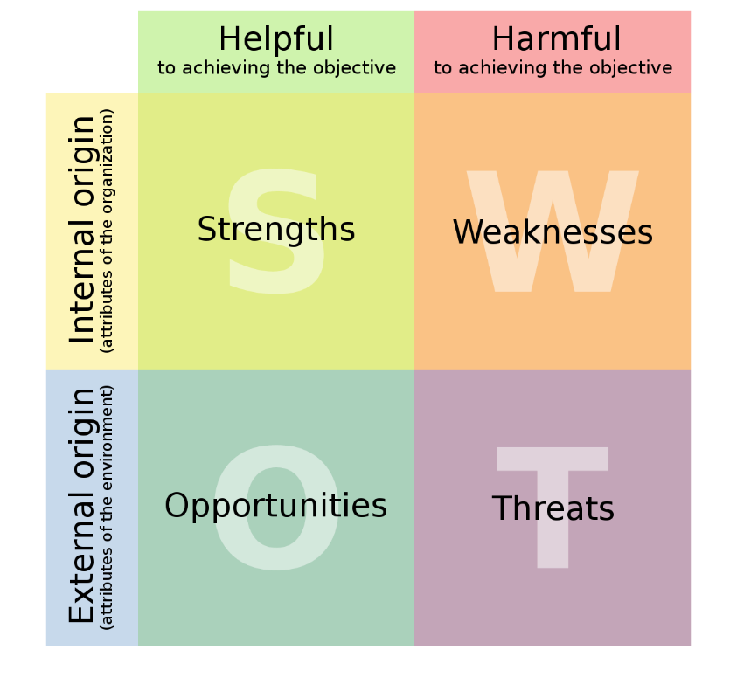
Fig: SWOT Analysis

STP analysis

Segmentation:
Morrisons has a complex segmentation approach to cater to a wide range of customers. To do so, the market must be divided into categories based on demographic, geographic, and psychographic characteristics. Its services are painstakingly crafted to meet the needs of families, individuals, and households across a range of economic levels. Geographically, both urban and suburban areas are covered, with a significant emphasis on the UK market (Kotler et al., 2018).

Targeting:
Morrisons focuses mostly on middle-class customers who are looking for the ideal balance between superior product quality and cost-effectiveness. Families, individuals, and senior citizens who value easy access to fresh, high-quality goods, a wide variety of consumables, and affordable prices are drawn to the supermarket's assortment of items. Notably, Morrisons' focus on locally produced goods appeals to people who value supporting small businesses and supporting environmental practises (Kotler et al., 2018).

Positioning:
Morrisons emphasises its unwavering dedication to sustainability by positioning itself as a provider of high-quality yet affordably priced products. The firm emphasises the freshness and traceability of its products by using its vertical integration and comprehensive farm-to-fork strategy. This approach synchronises perfectly with the growing consumer interest in ethical business practises and responsible purchasing. Morrisons also makes an effort to make convenience available through its physical store network and online delivery services, promoting itself as a one-stop shop for consumers' grocery needs (Kotabe and Helsen, 2022).
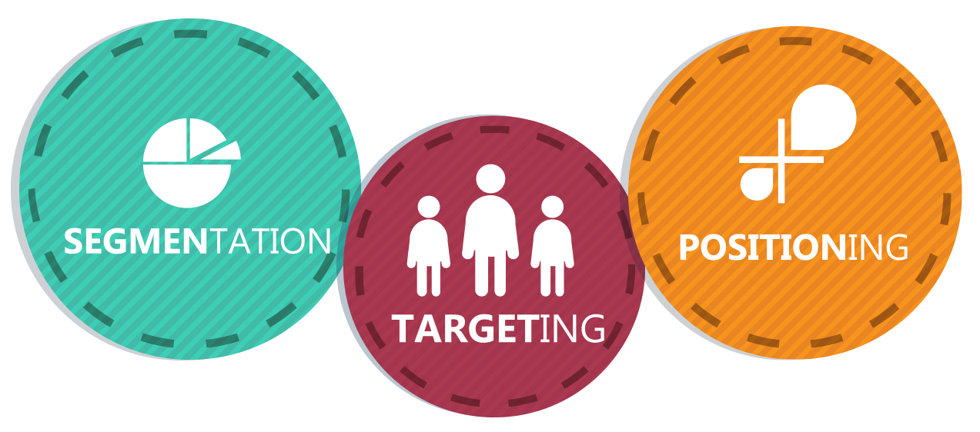
Fig: STP factors

Marketing mix strategies

Product:
Morrisons offers a wide range of items that have been painstakingly crafted to satisfy a wide range of client tastes and needs. Its vertical integration and farm-to-fork mindset usually serve as strong indicators of the quality and freshness of these items. Fresh vegetables, bakery treats, meat, and dairy goods are all included in this extensive selection. The grocery store increases its appeal by offering private-label goods under the "Morrisons" brand, giving customers access to cost-effective substitutes without sacrificing quality (Hutt and Speh, 2021).

Price:
Morrisons has a competitive pricing approach to entice a wide range of clients. The grocery store company aims to provide a good value proposition by maintaining its reputation for excellence. Morrisons often promotes special offers, markdowns, and loyalty programmes to encourage repeat purchases. The firm strives to deliver economically feasible products while preserving the principles of quality by skillfully utilising its economies of scale and an effective supply chain. The pricing methods may also be easily modified to take into account changing customer demand and market developments. Notably, during the pandemic time, this price approach drove spectacular increase in online food sales, which soared by more than 120 percent (Morrisons, 2023).

Place:
Morrisons has a wide-ranging physical network of stores throughout the UK. Urban and suburban areas are covered by these carefully positioned businesses, thus maximising customer convenience. The supermarket operator has also committed resources to improving its online grocery delivery services, enabling customers to conduct business from the comfort of their own homes. The COVID-19 pandemic's turmoil increased the adoption of online shopping, forcing Morrisons to improve its digital portfolio and expand its delivery capabilities (Hutt and Speh, 2021).

Promotion:
Within Morrisons' overall marketing plan, promotion plays a crucial role. The grocery store company organises a variety of marketing campaigns to increase sales and brand recognition. Advertising campaigns that highlight the breadth of the product line are strategically distributed throughout radio, television, and internet media. Morrisons skillfully uses seasonal advertising, targeted incentives, and loyalty programmes to draw in and keep a loyal client base. The company takes a subtle approach to fusing its commitment to sustainability and community participation with their promotional campaigns, which resonates with customers who value ethical business operations. Morrisons continually communicates its value-driven culture through their advertising efforts, as seen by phrases like "More of what matters" and "Price Crunch” (Morrisons, 2019).


Conclusion
Morrisons uses smart tactics to manoeuvre a challenging environment in a retail industry that is always evolving. Its resilience is increased by the PESTLE study, which emphasises its capacity to adapt to political, economic, social, technical, environmental, and legal concerns. Porter's Five Forces analysis confirms its competitive position, which encourages further innovation. The SWOT analysis outlines its advantages, possibilities, threats, and weaknesses as the foundation for making decisions. Morrisons interacts a variety of customers in an effective manner using planned STP initiatives. The business strikes a balance between product quality, pricing, accessibility, and promotional activities by employing a comprehensive marketing mix. Morrisons' strategic know-how places it in a position to meet problems and grab opportunities in the constantly changing retail industry.

Recommendations for future marketing strategies

Market Penetration:
Market penetration refers to the tactic of increasing one's market share within the current market and product lineup. In the case of Morrisons, this strategy would entail focusing on its dominant client groups and product lines in an effort to boost sales and strengthen its position in the market. To improve and expand its loyalty programme would be a practical way to put this approach into effect, "More Morrisons”. The business might enhance the program's features by offering specialised discounts, unique product recommendations, and privileged deals based on customer purchasing preferences. This would encourage repeat business, increase consumer interaction, and develop stronger brand loyalty (Hutt and Speh, 2021).

Product Development:
Morrisons may take into account the launch of new items or modifications to its current product arrays as part of a product development plan. Morrisons can emphasise expanding its variety of organic and locally sourced goods in light of consumers' shifting tastes for ecologically friendly and health-conscious items. The business might offer a wider selection of organic fruits, vegetables, meats, and other shopping staples by working with regional farmers and suppliers. Morrisons may also launch a line of private-label organic products, further demonstrating its commitment to quality and sustainability (Hutt and Speh, 2021).
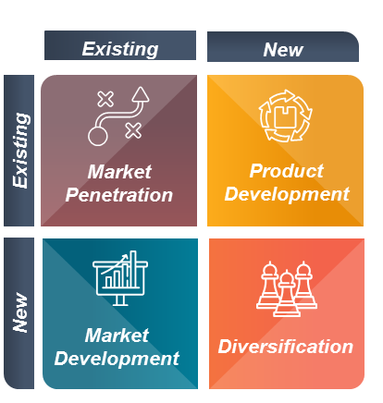
Fig: Ansoff matrix

References
Bruijl, D.G.H.T., 2018. The relevance of Porter's five forces in today's innovative and changing business environment. Available at SSRN 3192207. https://journal-of-marketing-management-and-consumer-behavior.com/index.php/JMMCB/article/download/185/92
Deepak, R.K.A. and Jeyakumar, S., 2019. Marketing management. Educreation Publishing. https://books.google.com/books?hl=en&lr=&id=_DmvDwAAQBAJ&oi=fnd&pg=PA1&dq=Deepak,+R.K.A.+and+Jeyakumar,+S.,+2019.+Marketing+management.+Educreation+Publishing.&ots=u49XmmanZk&sig=ePI3T8ZVMOftTYX5TlwU869kNbU
Hutt, M.D. and Speh, T.W., 2021. Business marketing management: B2B. South-Western, Cengage Learning. http://dspace.vnbrims.org:13000/jspui/bitstream/123456789/4877/1/Business%20Marketing%20Management%20B2B.pdf
Kotabe, M.M. and Helsen, K., 2022. Global marketing management. John Wiley & Sons. http://131.193.209.39:8003/view_syllabi/static/view_syllabi/syllabus/MKTG%20469%20CRN%2016662%20Fregetto%20Spring%2014.pdf
Kotler, P., Keller, K.L., Ang, S.H., Tan, C.T. and Leong, S.M., 2018. Marketing management: An Asian perspective. London: Pearson. https://www.academia.edu/download/58052402/marketingmanagement-an-asian-perspective-5th-edit.pdf
Morrisons, 2019. Listening and responding. https://www.morrisons-corporate.com/globalassets/corporatesite/corporate-responsibility/corporate-responsibility-report/morrisons_cr-2018_20may2019.pdf
Morrisons, 2023. Tackling the climate crisis. https://www.morrisons-corporate.com/morrisons-sustainability/planet/climate/#:~:text=Reducing%20our%20supply%20chain%20emissions&text=In%202023%20we%20also%20joined,emissions%20from%20food%20and%20drink.
Retail insight network, 2023. Morrisons posts 2.2% full-year revenue rise for fiscal 2021/22. Retail Insight Network https://www.retail-insight-network.com/news/morrisons-revenue-2021-22/
Shtal, T.V., Buriak, M.M., Amirbekuly, Y., Ukubassova, G.S., Kaskin, T.T. and Toiboldinova, Z.G., 2021. Methods of analysis of the external environment of business activities. Revista Espacios, 39(12). https://ww.revistaespacios.com/a18v39n12/18391222.html
Teoli, D., Sanvictores, T. and an, J., 2019. SWOT analysis. https://europepmc.org/article/med/30725987

