A written assignment critically evaluating how Assessment for Learning can be utilised in a series of learning opportunities to aid progression across chosen areas of learning and experience.

Introduction
In this assignment, I will be examining the importance that ‘Assessment for Learning (AfL)’ has on pupils learning, and how much it impacts on pupils’ development and progression within their learning. I will investigate a variety of different AfL strategies that can be implemented into a series of different learning episodes across three Areas of Learning (AoLE). Whilst doing this, I will be critically evaluating AfL strategies to consider whether they are effective and will aid pupils’ progression.
To assess the pupil’s learning, I prepared three lessons for my Year 4 class that were completed during the Autumn Term. The activities that were created focussed on Humanities, Languages, Literacy and Communication (LLC) and Expressive Arts. Within these AoLEs, children were working towards progression step 3. Furthermore, throughout the term, pupils were be learning and gaining knowledge on the Tudors. To comply with the class topic, the three activities were be based on the Tudors. These lesson plans were created to allow children to experience different learning opportunities through a variety of different AoLEs. These lessons were taught throughout of the topic. In order for children to complete the three lesson activities, they were utilising their prior knowledge of reading, writing and what they already know about the Tudors previous to the lessons.
This approach recognises that a key purpose of the new curriculum in Wales is to help aid pupil progression, as according to the Welsh Government, an essential aspect to aid pupil progression is assessment. By assessing children, you are providing the best learning opportunity, and ensuring pupils are supported and challenged accordingly to their own ability. (Welsh Government, 2022). Pupil progression also enables children to develop further and to learn/ enhance their skills. The Welsh government encourage teachers to use the four purposes when planning for different learning episodes to assist with pupil progression (Welsh Government, 2021).

Literature Review
Assessment for Learning (AfL) is an approach/ technique used by teachers to help determine the levels of pupil learning and assess where they need to be. This evidence is then used by teachers to examine the teaching strategies and adaptions that need to be put in place. This will allow the individual pupils to progress/ develop in order for them to be where they need to be within their learning. By teachers using (AfL), it gives children the opportunity to reach their full potential and progress within their learning (Cambridge Assesment International Education , No Date ). On the other hand, Claire Gadsby would state that AfL takes place when a pupil engages with another to understand the learning that is occurring (Beere, 2013).
Most of the prior research that has been applied that AfL can be used to monitor and assess pupils’ performance. However, David Didau is an author who would dispute this approach.au. He argues that assessment for learning does not impact a child’s progression and he implies that we cannot guarantee learning performance in any lesson. Due to this, he suggests that we cannot effectively adjust the way we teach to apply with the data based on student achievement (Fletcher-Wood, 2017).
Some researchers would define Assessment for learning as an assessment that is carried out whilst the pupil is actively involved in their own learning progression (Cambridge Assesment International Education , No Date ). Nevertheless, AfL is not just used to collect test results and to gather evidence (Blanchard, 2009). Dylan Wiliams agrees that for Assessment for Learning to impact a child, the evidence needs to be put into action and used to change teaching strategies that are required to meet the learning needs of individuals (LSI: Learning Sciences International, 2018).
In addition, research has provided evidence that Assessment for Learning aids pupils learning by giving them a direct understanding of what is wrong and how they can develop to correct their mistakes (Black & Wiliam, 1998). A series of recent studies has indicated that AfL can be a planning tool, it can give teachers ideas of what strategies and approaches to use whilst teaching and enhancing pupils learning. Furthermore, from the evidence collected Assessment for Learning can be used by teachers when planning different topics and what they need to cover. They can potentially use the evidence to implement the areas where children are struggling to go back and practise whilst using different teaching methods that best suit the individuals needs to develop. (Lambert & Lines, 2000).
The term ‘Assessment for learning’ within classrooms is not just used to carry out tests or exams. It should be used in variety of ways to enhance pupil progression. For it to be beneficial, it should be carried out throughout the whole school year. In addition, there are four elements to Assessment for learning which all impact pupils learning performance. These are
- Sharing criteria with learners,
- Quality of questions/ quality of talk,
- Peer and self-assessment and
- Use and quality of feedback.
Each of these elements play a key role in a child’s learning journey (Welsh Government, 2013).
For effective Assessment for Learning within classrooms, teachers need to carry out observations, discussions in the classroom, assessing pupils written work, providing useful and effective feedback which is going to impact the children’s progression. This has been discussed by a great number of authors in literature (Teaching English with Oxford, 2021).
Alternatively, some studies have suggested that peer and self-assessment can potentially have a negative impact on a child’s learning process (Twinkl, No date ). Research implies that students can be overly harsh on themselves and their peers when marking work, and this can have a negative impact on children’s confidence within the learning. This can potentially lead to them to being reluctant to try hard in their learning progression.
Research has been carried out that has concluded that AfL can be especially effective at raising educational by standards for lower ability children, by closing the spread of the attainment gap and increasing overall performance (Black & Wiliam, 1998). Having studied Dylan Wiliams research he found that assessment for learning allows pupils an additional 8 months of learning a year (Wiliam, No date).
Moreover, Literature suggests that AfL boost pupils’ confidence in their learning by allowing them to become actively involved with their own learning and to be more independent by aiding their own progression (Third Space Learning, 2023). From Estyn’s research and findings, they have recognised the importance of learners having a clear concept of what they are learning. They also need to ensure that learners understand what success should look like within the activities. Estyn also expresses the importance of critical feedback that will benefit and be effective to the Childs learning progression (Welsh Government , 2022). Furthermore, previous studies have emphasised that for AFL to be successful, pupils need to be able to self-assess themselves by recognising what their learning intention are and for pupils to clearly know what the need to do in order to achieve and develop their learning (Cambridge Assesment International Education , No Date ).
John Hattie believes that it is feedback that connects children’s understanding to what is intended to be understood. Furthermore, Royce Sadler supports this statement by claiming he thinks that feedback is knowledge and helps ‘close the gap’ between a student’s current level of ability to where they need to be (Hattie & Clarke , 2019). John Hattie concluded that teachers have the most significant impact on children’s learning and progression. He recommends that teachers should concentrate more on the importance of getting to know how each individual child thinks and learns rather than how they engage and how they do the work (Hattie & Clarke , 2019). He also suggests that the most important aspect in education is knowing where the pupil is at and what you want them to know. He believes that feedback is very effective to aid a child’s learning, particularly if it is personal and relevant to their performance. John Hattie states that ‘where to next’ feedback is very crucial to a child’s progression (Taylor & Francis Books, 2018).

A vital aspect of the new Curriculum for Wales is learner progression. In order to enable each student to advance at a suitable rate and to receive the support and challenges they need, assessment for learning is essential. Having read the new Welsh Government reports and documents on the new curriculum ‘Assessment for learning’ is one of the 12 pedagogical principles. They key role of AfL within the curriculum is to allow every pupil the opportunity to progress (Welsh Government, 2022).

Discussion of lesson planning decisions
The three lessons my year 4 class completed was planned to take place over a series of weeks to allow time for children to confidentially understand the topic. Prior to the topic starting, I allowed the children to discuss and mind map what they would like to learn within the topic. This allowed them to voice and promote the children’s engagement within the lesson episodes and to be actively involved in their learning and take control by deciding what they do. This was important as they were more likely to preserve and allow room for growth and improvements within their own learning (Blanchard, 2009).
In addition, within lesson one (see figure 1), the focus was for children to develop knowledge of understanding of the Tudors. In groups pupils gathered facts and information on the Tudors by using a worksheet that contained key questions which they needed to answer together. Children did this in a form of a carousel , there were multiple stations that iincluded:
- Who are The Tudors?
- Henry 8th and his 6 wives
- The types of clothes they wore
- The Tudor rose
- Tudor houses
- Tudor shield
- Food and drinks
In these stations there were fact files, photos, videos, and real-life objects such as clothes that they can try on. In addition, the Area of Learning (AoLE) for this lesson was Humanities. From this lesson, children learned teamwork skills and how to communicate with others. Theyl also progressed and developed their language skills by gathering and interpreting information which will aid them to put it into their own words. They also expanded and progressed their knowledge of the topic throughout the lesson.
In lesson two (see figure 2) the AoLE pupils directed attention to Languages, Literacy and Communication (LLC). The aim of the lesson was for pupils to work in groups to create a presentation based on the Life in The Tudors. They used the facts and information they collected in the previous Tudor carousel lesson. They then presented their presentations to the class to show what they learnt and their understanding. In addition, the children built on the skills and knowledge used within lesson one. They also showed understanding of how to present to an audience. Similarly, within lesson three (see figure 3), pupils will remain in their groups. However, they will be creating a 3D Tudor house, using raw materials, and thinking of the types of materials they would use in the Tudors. For example, clay, straw, wood. After creating their Tudor house, each group will present their work. Moreover, in lesson plan three, the AoLE children will be focusing on is Expressive Arts. Furthermore, pupils will be focusing on their creative skills and building on their imagination. They will also be progressing to work with others effectively and allowing others input as well as theirs. I chose to group the children together to complete these variety of activities because having read Vygotsky’s research on group work, he alludes that nearly 80% of pupil learning is from their peers (Welsh Assembly Government , 2010). When working with others I strongly believe children feel more confident and work far better. On the other hand, some research would argue that when working in groups some students might only do very little, or no work at all because they know their peers will complete it for them (Indeed , 2022).
Another strategy I decided to use throughout all three learning episodes was the use of feedback. Feedback can be given in a variety of different ways. By pupils being given Feedback allows them to know where they can improve and learn different strategies to help progress further (Black & Wiliam, 1998). By giving pupils’ quality feedback, it allows them to know where to improve. However, for feedback to be successful it needs to be acted on and put into action. Each feedback should end with a particular task based off the feedback for the individual to complete (Beere, 2013). There needs to be time for improvements to be done. This needs to happen straight away to be effective rather than later down the line. By children acting on their targets straight away aids them to potentially understand the area of learning they are struggling with. Welsh Government imply that to ensure pupils have a better understanding of where they need to improve or work on, feedback needs to be specific and clear (Welsh Assembly Government , 2010). Moreover, giving pupils one to one feedback aids pupils to feel valued which then they are more obliged to work on personal improvements (Blanchard, 2009). Feedback should also be positive, by children having positive feedback motivates them to persevere and continue to develop their learning further (Blanchard, 2009). Feeback not only helps with pupil progression, however it aids with children’s perspective of themselves and effects their self-esteem. Children with higher self-esteem are far more likely to be more engaged with their learning (Lambert & Lines, 2000). Sadler emphasizes the importance on feedback, in which it must be meaningful and personal to the individual to make an impact and be worthwhile (Broadfoot, 2007).
Dylan Wiliams implies that the best feedback involves not just saying what the pupil has done wrong, rather teachers should be stating how the pupil can develop and achieve better next time. Giving children strategies or targets to allow them to understand how they can progress within the next activity or exam. He states that by giving this type of feedback is effective and impact a child learning more (LSI: Learning Sciences International, 2018). However, previous research implies that by giving negative feedback can lead to behaviour issues (Visser, 2023). Some children may start to feel like there are failing if they are constantly receiving bad feedback. From this they may feel like there is no point in participating and will get easily bored which will potentially cause distributive behaviour within the classroom. Furthermore, studies would argue that feedback can also cause a negative impact on children’s self-esteem (Brockner, et al., 1987). By children having low self esteem is going to cause them to feel like they can not do the work and easily give up. This will potentially have a big impact on the child’s learning progression because they will not be motivated to keep improving.
Throughout all three learning episodes, the use of live feedback was used consistently. I allowed the children to receive feedback whilst they were completely the activity (Prospero Teaching, 2023). I found this very beneficial because it prevented children from making the same mistakes throughout the lesson and I was able to correct them straight away. Some researchers argue that live marking, is very time consuming and they suggest that it is quite difficult to go around every child in the amount of time in the lesson, especially if you have a large class (TeacherToolKit, 2023). However, others would imply that it is very important and really benefits pupils learning progression. It also allows teachers to know where to change their pedagogies within the lesson to maximize the learning progression (Cambridge Assessment International Education, 2019). Furthermore, whilst I was giving live feedback to individuals, I ensured that feedback was personalised and very clear to allow children to fully understand and to aid their progression. I also provided pupils with examples of how they could improve.
Another Assessment for Learning strategy I used within learning episode two was the use of ‘Quality of questions/ quality of talk’. I used this strategy to allow children to start thinking of how it would feel and what it would be like to live in the Tudor period. Giving children this question, ensured that answers that were given were detailed and enable learners to use gather and learn different describing words from their peers, which they will be able to use later within the lesson.
To get children to answer this question, I used the questioning strategy of ‘think, pair, share’. This strategy consists of children individually processing the question with sufficient time to think of their answer, then they talk to their partner and discuss the question, and finally they then share their answers and ideas to the whole class. By sharing it with the class it opened debates and further discussions. Pupils’ partners were chosen for them when they were discussing the question with another pupil.
Having read further research, it suggests that to improve a pupils’ quality of talking, teachers should randomly pair pupils with another. This has been shown to be very beneficial as it allows individuals to build on their vocabulary and develop their oracy skills through talking to people they may not normally talk to. However, it was reported in literature that some children may found this very difficult (Cypher Learning , 2021). For many children having to discuss their opinions to children they do not normally talk to can trigger anxiety and their confidence can quickly become very low. This can cause a negative impact on the individuals learning and possibly lead them to not want to join in. The use of ‘talk partners’ allows for peer assessment, pupils to seek help and advice and to share ideas between one another (Clarke, 2012).
Another way, to build on quality of talk is to not ask for “hands up”. This allows pupils who do not normally answer questions time to reflect and show their understanding. Moreover, if teachers turn away from using ‘closed questions’, it will increase pupils’ confidence in answering questions because they will get to express their opinions and further expand on their answers. It also gets all children to think more because they do not know who the teacher will pick to answer. Teachers should apply more open and valuable questions as it also allows answers to be up for discussion and debates (Clarke, 2012). Meanwhile, having read recent research, it has been stated said that teachers do not give pupils enough time to process a question and adapt it to their own words and then be able to think and recall the answer. By not allowing children to have enough time (Kerry, 1982), it does not give them the opportunity to think of their own answer.
From this, I ensured that children were given a length of time to answer that was suitable to the question to allow them to process, discuss and answer the question with depth. Research suggests that teachers should allow 3-5 seconds wait time before allowing children to answer a question (Kent State University, 2024). From trailing this out on my placement, I disagree with this research. I do not think this is enough time for pupils to process what is being address to them and then be able to think of an answer. According to a study, they argue that by increasing the wait time allows pupils response to be more detailed (Improving Teaching, 2013). By allowing pupils to have thinking time increases the quality of response because it gains pupil confidence to get the correct answer (Blanchard, 2009). In a study it was concluded that if a wait time was ‘less than one second’ less children were taking part and answering (Black , et al., 2006). Due to this happening, in most classrooms it is the same children answering the questions. Some pupils do bother thinking because they know that other children will answer quicker. This means that the rest of the pupils are lacking the opportunity to develop their thinking and questioning. To prevent this from happening, teachers should use strategies such as pose, pounce and bounce to allow pupils time to process and think. For learning to be at high quality, pupils need to have high order thinking skills and transferable skills (Clarke, 2012).
In lesson three, I used the questioning strategy of hot seating. This technique is where a child sits in a seat (hot seat) at the front of the classroom. In my lesson the child that was sat in the hot seat was acting as Henry the 8th. Pupils then had to ask the individual on the hot seat questions to answerer (Farmer, No date ). For example, they may want to ask him why he had so many wives, what it is like to live in that period, what clothes he wears. These questions will be linked to what they had learnt in the pervious lessons. I used this strategy as a type of quiz/ recap of what children learnt previously. By doing this, children were able to recall what they can remember. Throughout this questioning activity, the childr enused all six of the “thinking hats” on from Edward de Bono thinking hats theory. Edward De Bono is a theorist who belives we should use parellel thinking. This is where you can examine and study topics from different perspectives and directions. Each of the six thinking hats symbolises a different way of thinking. By using the different hats opens up discussions and allows room for arguements/ debats (IndigoTrainingUK, 2008). The type of thinking for each of the six hats are:
- White Hat – Information
- Red Hat – Feelings
- Black Hat – Cautious
- Yellow Hat – Benefits
- Green Hat – Creativity
- Blue Hat – Process/ Decision making. (Litmos Heroes, 2014)
Some studies argue that using hot seating allows students to strongly understand how different characters are feeling and why they might feel that certain type of way (Dawson, 2012). Allowing children to have these experiences is helps their creativity to picture what is happening in different scenes or periods of time and some children may feel like they are connecting with the different characters. Furthermore, it aids their vocabulary skills and speaking skills because they are physically able to voice what they are thinking. Nevertheless, other researchers would argue that hot seating can lead to some children feeling left out (Rothman, 2022). If children aren’t as confident as their peers, they might not feel as comfortable to voice their arguments, opinions, or questions in front of the whole class.
Conclusion
To plan 3 learning episodes, I used the Yr Athrofa lesson plan template. Using this template ensured that I linked each activity to the new Welsh curriculum. It helped me to underpin where I would use different assessment for learning strategies in which section of the lesson.
The theme of the learning episodes came from the school topics which they will be completing over the course of the year. Furthermore, to help me decided what activities to plan, I used pupil voice which was previously mentioned within this assignment. Pupils were able to mind map what they would like to learn throughout the topic. From this, I further created three lesson plans based of their input and ideas. Having read an Estyn report, they encourage teachers to use pupil voice within their lessons to allow them to be actively involved in their learning (Estyn, 2018). Pupils are far more likely to be engaged in their learning, if they have decided what they want to learn.
Throughout the lesson plans, I used a variety of AfL strategies from the four elements. From examining and studying research, I concluded that feedback is a very important aspect to aid pupils’ progression. By providing pupils with feedback to ensure that they clearly understand where they need to improve and how best they can achieve that improvement. In addition, feedback needs to be acted on straight away in order for it to be effective, because children will forget what they done wrong and will continue to make the same mistakes.
Moreover, I can conclude that the use of hot seating really benefitted my students. They were able to better understand and appreciate what it might have been like to live in the Tudor period and what it would have been like to be Henry the 8th. It allowed pupils to understand how he might feel by putting themselves in his shoes. It also opened discussions and further questions within the classroom. Additionally, the use of ‘think, pair, share also worked considerably well in my classroom. It aided pupils’ discussion skills and vocabulary. For some children, it helped build their confidence by talking to peers they might not normally do so. Likewise, children were able to also start to think of the possible lifestyle Tudors had and what it was like to live in that era.

Appendix
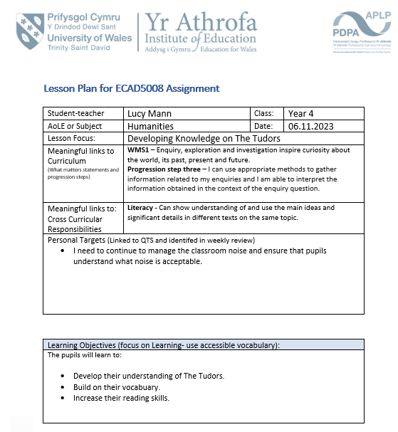
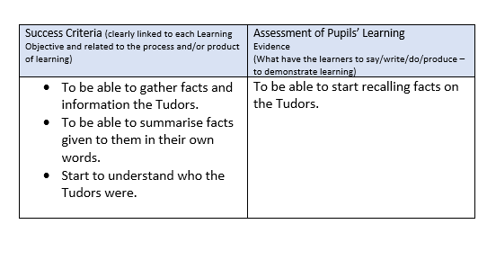
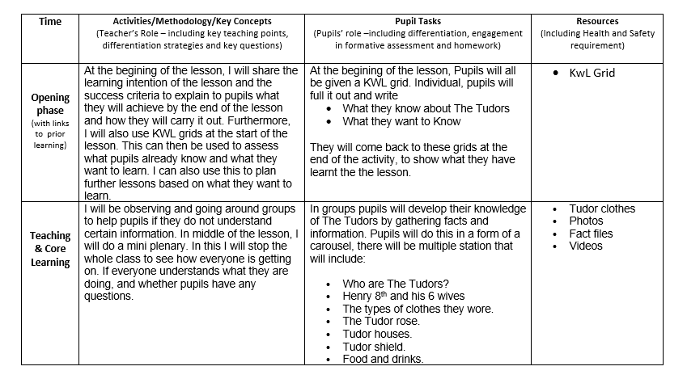
Figure 1: Lesson Plan 1
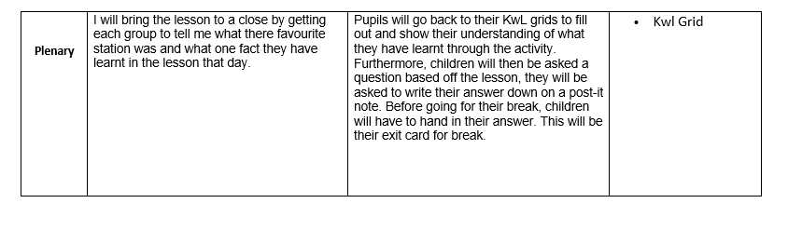
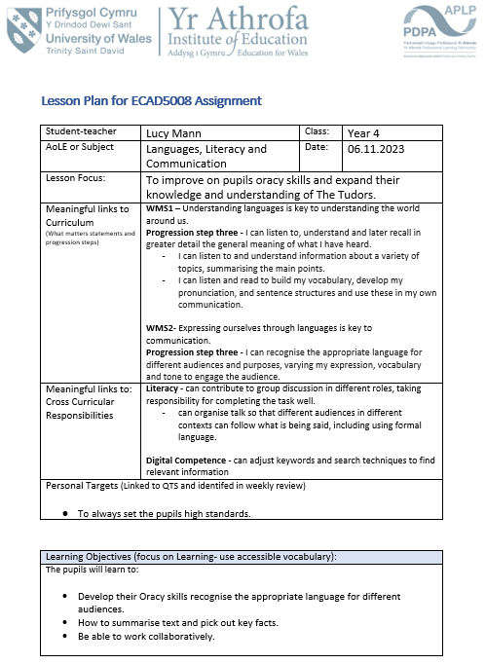
Figure 2: Lesson Plan 2

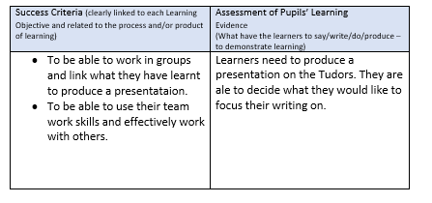

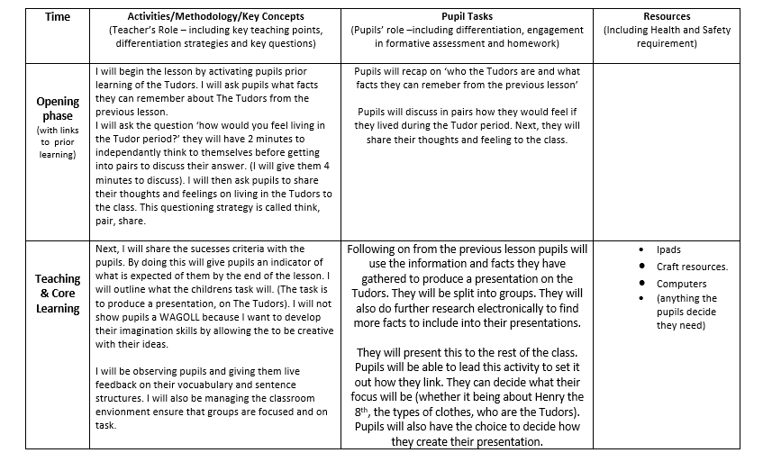
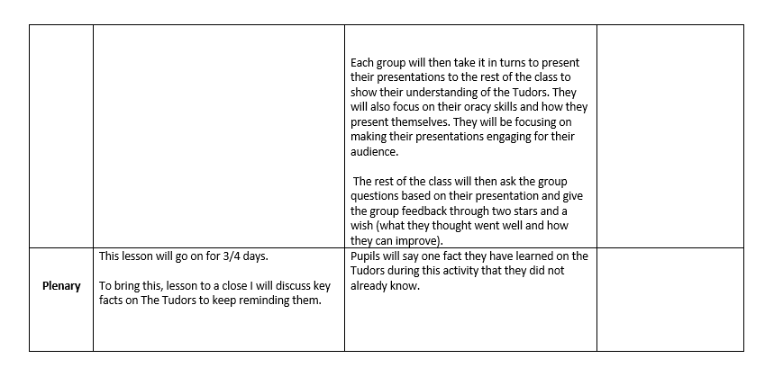

Figure 3: Lesson Plan 3
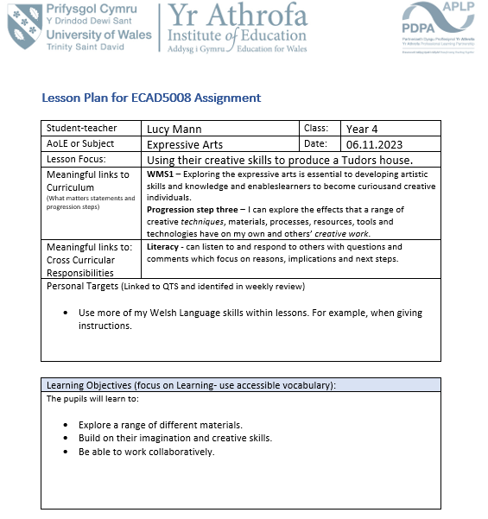
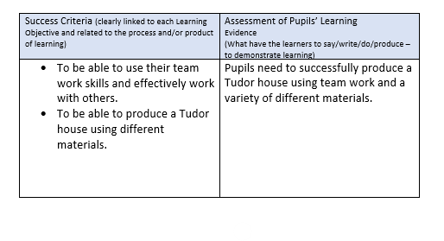

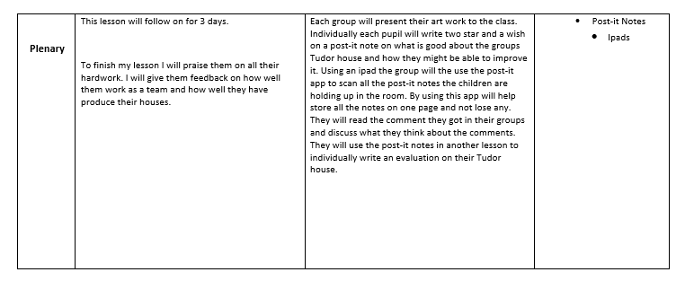
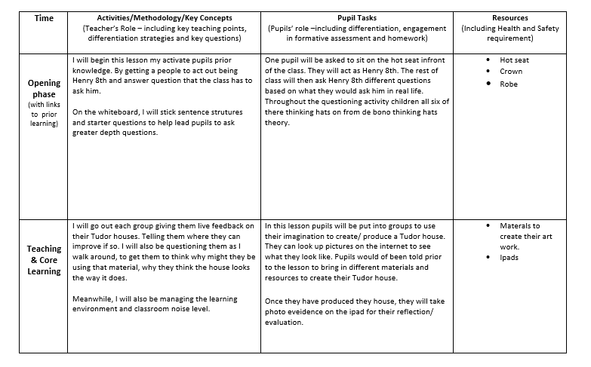

References
Beere, J. (2013) Perfect Assesment. Carmarthen: Independent Thinking Press.
Black , P. et al. (2006) Assessment for Learning Putting it into practice. Berkshire: Open University Press.
Black , P. and Wiliam, D. (1998) Inside the Black Box: Raising standardsthrough classroom assessment, London : GL Assessment.
Blanchard, J. (2009) Teaching, Learning and Assessment. Berkshire: Mixed Sources.
Broadfoot, P. 2(007) An Introduction to Assessement. New York: Continuum International Publishing Group.
Brockner, J., Derr, W. R. & Laing, W. N., 1987. Self-esteem and reactions to negative feedback: Toward greater generalizability. Journal of Research in Personality, 21(3), pp. 318-333. Available at: Self-esteem and reactions to negative feedback: Toward greater generalizability - ScienceDirect (Accessed: 5th January 2024)
Cambridge Assesment International Education. (No Date) Getting started with Assessment for Learning.
Available at: https://cambridge-community.org.uk/professional-development/gswafl/index.html
(Accessed: 17th December 2023)
Cambridge Assessment International Education (2019) The power of effective feedback.
Available at: https://www.cambridgeinternational.org/Images/557886-09.-the-power-of-effective-feedback.pdf
(Accessed: 17th December 2023)
Clarke, S. (2012) Active Learning Through Formative Assessment. London : Hodder Education.
Cypher Learning. (2021) The gains and pains of the think-pair-share strategy.
Available at: https://www.cypherlearning.com/blog/k-20/the-gains-and-pains-of-the-think-pair-share-strategy#:~:text=Anxiety%20triggering,will%20negatively%20impact%20their%20learning
(Accessed: 17th December 2023).
Dawson, K. (2012) Hot Seating: Katie Dawson [Video].
Available at: https://www.youtube.com/watch?v=rGRhWHc5tf0
(Accessed: 5th December 2024).
Estyn. (2018) Pupil voice shapes the curriculum. Newport: Estyn.
Farmer, D. (No date) Hot Seating.
Available at: https://dramaresource.com/hot-seating/#:~:text=What%20is%20Hot%20Seating%3F,of%20fleshing%20out%20a%20character
(Accessed: 5th January 2024).
Fletcher-Wood, H. (2017) 'Is formative assessment fatally flawed? Confusing learning & performance'. Harry Fletcher-Wood [Blog].
Available at: https://improvingteaching.co.uk/2017/03/26/formative-assessment-flawed-confusing-learning-performance/#:~:text=David%20Didau%20has%20argued%20that,to%20evidence%20of%20student%20achievement
(Accessed: 17th December 2023).
Hattie, J. & Clarke , S. (2019) Visible Learning: Feedback. 1st ed. Oxford: Routledge, an imprint of Taylor and Francis.
Improving Teaching (2013) Increasing wait time.
Available at: https://improvingteaching.co.uk/2013/08/17/increasing-wait-time/#:~:text=%E2%80%93%20Increasing%20teacher%20wait%20time%20leads,student%20confusion%20and%20higher%20achievement
(Accessed: 5th January 2024).
Indeed. (2022) 19 Disadvantages of Working as a Team (And How To Overcome Them.
Available at: https://www.indeed.com/career-advice/career-development/disadvantages-of-working-as-team
(Accessed: 17th December 2023).
IndigoTrainingUK. (2008) Edward de Bono - discusses the Six Thinking Hats: IndigoTrainingUK [Video].
Available at: https://www.youtube.com/watch?v=o3ew6h5nHcc
(Accessed: 5th January 2024).
Kent State University. (2024) Wait time: Making space for authentic learning.
Available at: https://www.kent.edu/ctl/wait-time-making-space-authentic-learning#:~:text=Wait%20at%20least%203%20%E2%80%93%205%20seconds%20for%20another%20student%20to,the%20instructor%20always%20doing%20so
(Accessed: 5th January 2024).
Kerry, T. (1982) Effective questioning. London: Macmillan.
Lambert , D. & Lines, D. (2000) Understanding Assessment. London: RouledgeFalmer.
Litmos Heroes. (2014) What Is Six Thinking Hats?: Litmos Heroes [Video].
Available at: https://www.youtube.com/watch?v=UZ8vF8HRWE4
(Accessed: 5th December 2024).
LSI: Learning Sciences International. (2018) Dylan William: What do we Mean by Assessment for Learning? [Video].
Available at: https://www.youtube.com/watch?v=q-myBw36_DA&t=325s
(Accessed: 17th December 2023).
Prospero Teaching. ( 2023) Live Marking: A Time-Saving Solution for Teachers?: Prospero Teaching [Blog].
Available at: https://www.prosperoteaching.com/blog/2023/01/live-marking-a-time-saving-solution-for-teachers
(Accessed: 17th December 2023).
Rothman, N. (2022) Hot seats: it’s time to put out the fire.
Available at: https://theblackandwhite.net/71532/opinion/hot-seats-its-time-to-put-out-the-fire/#:~:text=However%2C%20hot%20seats%20don't,class%20are%20often%20left%20out
(Accessed: 5th January 2024).
Taylor & Francis Books. (2018) John Hattie on Visible Learning and Feedback in the Classroom: Taylor & Francis Books. [Video]
Available at: https://m.youtube.com/watch?v=Vpq09eY4pZo&pp=ygU-am9obiBoYXR0aWUgb24gdmlzaWJsZSBsZWFybmluZyBhbmQgZmVlZGJhY2sgaW4gdGhlIGNsYXNzcm9vbSA%3D
(Accessed: 17th December 2023).
TeacherToolKit (2023) The Pros and Cons Of Live Marking.
Available at: https://www.teachertoolkit.co.uk/2018/03/04/live-marking-2/
(Accessed: 17th December 2023).
Teaching English with Oxford (2021) What is Assessment for Learning?: Teaching English with Oxford. [Video]
Available at: What is Assessment for Learning? (youtube.com)
(Accessed: 17th December 2023).
Third Space Learning. (2023) What Is Assessment For Learning And Why Is It Still Important For Your Teaching?: Third Space Learning. [Blog]
Available at: https://thirdspacelearning.com/blog/what-is-assessment-for-learning/
(Accessed: 17th December 2023).
Twinkl. (No date) What is Self-Assessment?.
Available at: https://www.twinkl.co.uk/teaching-wiki/self-assessment#:~:text=Perhaps%20a%20more%20prominent%20disadvantage,child's%20confidence%20and%20self%2Dbelief
(Accessed: 17th December 2023).
Visser, C. (2023) Effects of negative feedback on self-image, emotions, cognitions, and behavior of bachelor students.
Available at: https://www.progressfocused.com/2023/08/effects-of-negative-feedback-on-self.html#:~:text=Impact%20of%20negative%20feedback&text=Kim%20and%20Lee%20(2019)%20showed,they're%20not%20good%20enough
(Accessed: 17th December 2023).
Welsh Assembly Government. (2010) How to develop thinking and assessment for learning in the classroom.
Available at: https://hwb.gov.wales/api/storage/663d00fd-9c3b-4003-9a1f-0012bad39fad/how-to-develop-thinking-and-assessment-for-learning-in-the-classroom.pdf
(Accessed: 17th December 2023).
Welsh Government. (2022) Effective approaches to assessment that improve teaching and learning.
Available at: https://www.gov.wales/effective-approaches-assessment-improve-teaching-and-learning-html
(Accessed: 17th December 2023).
Welsh Government. (2013) Assessment for learning and the National Literacy and Numeracy Framework.
Available at: . https://hwb.gov.wales/api/storage/b447d1fe-5463-4382-9726-e68623a05dd2/assessment-for-learning-and-the-national-literacy-and-numeracy-framework.pdf
(Accessed: 17th December 2023).
Welsh Government. (2021) The Curriculum for Wales – Progression Code.
Available at: https://www.gov.wales/sites/default/files/publications/2021-11/curriculum-for-wales-progression-code.pdf
(Accessed: 17th December 2023).
Welsh Government (2022) Supporting learner progression: assessment guidance.
Available at: https://hwb.gov.wales/curriculum-for-wales/assessment-arrangements/supporting-learner-progression-assessment-guidance
(Accessed: 17th December 2023).
Wiliam, D. (No date). 'Assessment for Learning: why, what and how?' [PowerPoint presentation]. Available at: Inaugural 2 final.ppt (live.com) (Accessed: 5th January 2024)

