By Elena Nedelcheva Lecturer: Anupam Mazumdar

University of Wales Trinity Saint David
Data analysis & Visualisation
Data Handling and Business Intelligence

Table of Contents
Part A 1
Significance of data in business 1
Determining Sales and Profit for four years: 2
Order Quantity 3
Analysis through Pivot Table for Profit: 4
Analysis through Pivot Table for Order Quantity: 5
Part B 6
How many students like vanilla flavour? 6
How many students are male or female? 7
Mean and median of participants, preferring chocolate or strawberry flavored ice-cream 7
Cluster Observation 8
Data Mining and Text Mining 10
Comparison between softwares 12
Conclusion 13
References 15

Part A
First, the research examines a supermarket's sales and profit statistics to establish a downward trend over time. In this section, the analysis has been performed in Microsoft Excel, which has been used for both preliminary data processing and data visualisation.

Significance of data in business
It is impossible to successfully communicate information without first establishing a framework, and data is what makes this possible. Handling the data carefully is the only way to assuage concerns about the security, maintenance, and privacy of the company's data. This is one of the reasons why this topic is so important to the preservation of data integrity. The precise design of data management can result in several benefits, including efficient and low-cost data storage, recovery, and deletion, to name just a few of these potential outcomes (Jalil & Hwang, 2019). Since data analytics may assist a company in forecasting client behaviour, enhancing decision-making, recognising market trends, and estimating the return on investment (ROI) of its marketing efforts, data is of crucial relevance in the business world. Because the outcomes and performance of a company are entirely dependent on the analysis of data, it is essential that the data be relevant when it is being evaluated for business objectives to get knowledge about the firm's clients, its market, and its competitors.
The data were analysed using Microsoft Excel, and the necessary summary statistics, including the mean, median, mode, range, and standard deviation calculations, were utilised in the process (Hrehova & Vagaska, 2017).
In addition to this, graphs and charts were utilised so that the results could be visually illustrated while also providing further context for the analysis. The visualisation of data makes it easy to locate problematic areas even within massive databases. In today's world, everything from the simplest spreadsheets to the most advanced enterprise resource planning programmes are dependent on digital data to produce accurate financial records (for example, SAP). With the use of this programme, accountants can have a better understanding of the repercussions that the outcomes have as a result.

Determining Sales and Profit for four years:
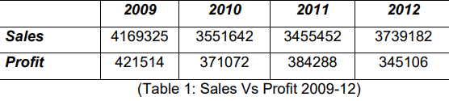
There has been a consistent upward trend in sales and profits for the Superstore since 2009. The sales margin fell by 14.81 percent between 2009 and 2010, then it fell by another 2.7 percent in 2011. Despite this, sales figures show a rise in 2012, from 3455452 reported at the end of 2011, to a total of 3739181. Table 2 displays the decline in sales volume experienced by businesses and consumers throughout the specified years. When a company's sales fall short of their historical norms, it's a sign that they're failing to capitalize on opportunities or are struggling to meet customer demand. As a result, the company stands a good chance of experiencing tragedy as time passes and profits continue to dwindle. Without sales, no business could survive, hence transactions are essential to survival. That's why it's always crucial to learn why customers aren't buying your products or using your services.
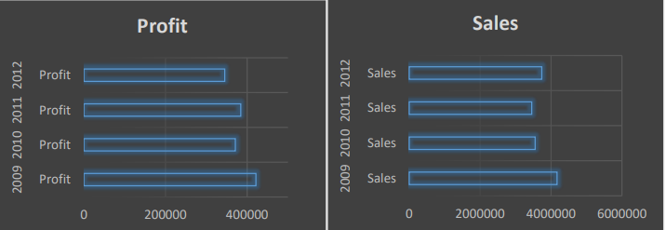
Fig 1: Profit Vs Sales Superstore
The evolution of the Superstore’s sales and earnings is depicted over time in Figure 1, and it is plain to see that both have significantly decreased. It is fair to say that the leadership of the company has been unable to find a happy medium between sales and profits since 2009. Since sales and profits go hand in hand, especially for the Superstore, it is fair to say that the leadership of the company has been unable to find a happy medium between the two. This has had a negative impact on the Superstore’s overall revenues and has provided their competitors with an advantage in the market. Figure 1 also demonstrates quite clearly that profits decreased between 2009 and 2010, but then increased once more in 2011. The profit margin increased in 2011, even though overall sales were lower than they were in 2010.
The discount rate, which ranges from 1% to 9% now but is forecast to reach 10% in the year 2010, is the root cause of this phenomenon. When the rate of discount is larger, the profit margin as a proportion of total sales will be lower. The current circumstances place the Superstore in a vulnerable and uncertain position. Despite this, the primary focus of the inquiry was on determining how changes in sales influenced earnings. The investigation found that the challenge of falling profit rates in economies emerges to the forefront and becomes effective because of the recent halt in the development of the financial situation, as well as the stagnation and crisis tendencies that have emerged. Most of the research on these orientations has been conducted within Keynesian and post-Keynesian frameworks. Decreasing benefit rates are just one of many factors that contribute to the unstable and crisis-prone character of private enterprise. Some of these other factors include Marxist theories, various explanations (such as the underutilization problem), the anarchic and unprepared character of capitalism, and excessive financialization.

Order Quantity
The orders and their historical reception are described below. With that in mind, this section will attempt to quantify how many orders the Superstore administration has received over the course of study.
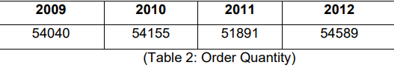
The table below shows that the total number of delivery orders booked in 2009 was 54040, that this number rose to 54155 in 2010, and then fell to 51891 by the end of 2011. In 2012, however, it rose again, with a total of 54589 being the highest reported number when compared to the preceding three years. In other words, the years with the largest order booking were also the years in which Superstore's management was able to achieve a satisfactory level of sales and revenues, indicating that when sales and profits were down, the main reason was a drop in order booking. However, sales and revenues have been significantly affected by the drop in order booking.

Analysis through Pivot Table for Profit:
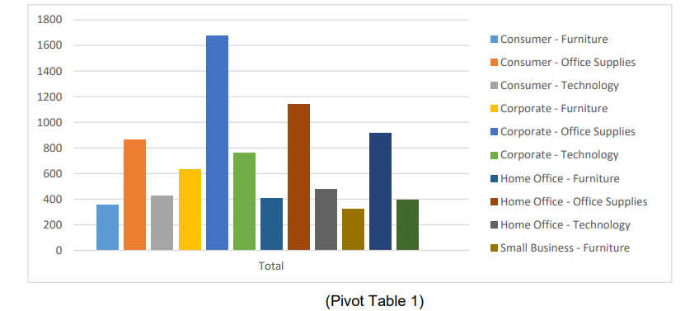
That Crucial Point in Time in Table 1, a study of the Superstore's sales and earnings is shown, broken down by the demographics of its customers and the categories of products they buy. Utilization of different products in various states and provinces can be compared with ease thanks to the Pivot table (Stratvert, 2020). Large organisations, small businesses, home offices, and individual consumers are all examples of the different types of customers that shop at the Superstore. When compared to those of consumer furniture and business technology, the profit margins for business office supplies, consumer office supplies, and consumer technology all fall below those of consumer furniture and business technology. In addition, the earnings of various sorts of consumers are shown in contrast with one another in the pivot table that may be found below. As an illustration, let's say that the technology used at the corporate office displays a profit of around 760, but the technology used in the home office displays only 400.
Based on the findings, the Superstore has been successful in appealing to three distinct customer demographics over the course of the past four years (2009, 2010, 2011, and 2012): customers who like to purchase products and services for their homes; company industries who can get the goods for one's office use; and private offices for the employees who are employed from home. According to the findings in Pivot Table 1, it appears that throughout the period in question, the item that consumers purchased the most frequently was furniture. Following that, the next two slots are taken by home offices and supplies for the office. Therefore, for the Superstore to be able to compete with its competitors, the leadership of the firm must ensure that these goods are continually updated in response to changing or differing demands and preferences of customers. Only then will the Superstore be able to succeed. Customers will feel valued and loyal because of this, and they will also have the opportunity to express constructive criticism regarding how the quality of the items may be improved. The company experienced some difficulties with the sales of home and office furnishings, which are both essential to the profitability of the business.

Analysis through Pivot Table for Order Quantity:
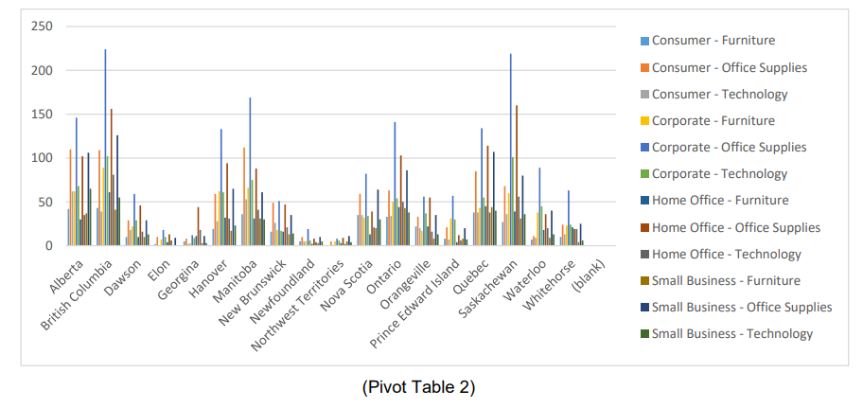
The quantity that customers in each of the major market categories, as well as those in the various states and provinces, have placed an order for is outlined in Pivot Table 2. As an illustration, the consumers in the West region and Ontario had scores higher than 400. On the other hand, the order quantity for corporate office supplies in the Yukon region is 120 if we use the same scenario as we did for the other regions. It is possible to analyse the order number of various products using pivot table 2, but in general, it demonstrates that the demand for corporate office supplies is higher. Consumer office supplies, on the other hand, come in at a close second in terms of demand. The demand for consumer office supplies is currently at a level of 140 for the Atlantic area.
On the other hand, although the demand for consumer office supplies in the Yukon region ranges from 40 to 60, this category was ranked second in terms of demand in the same region. In addition, if we understand the province segment correctly, the market for consumer and corporate office supplies was the same. When we look at the relationship between the quantity ordered and the profit, we find that the relationship is linear; that is, the bigger the order quantity, the greater the profit. For instance, there is a significant demand in Pivot Table 2 for corporate office supplies. As a result, the margin for this product and market sector represents the maximum possible profit level in all the countries and states.

Part B

How many students like vanilla flavour?
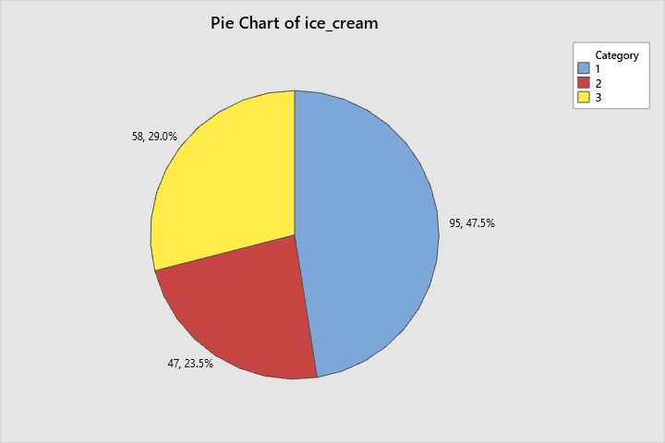
Figure 1: Pie chart for the ice creams

The data above shows that, out of a possible 200 pupils, 95% selected vanilla

How many students are male or female?

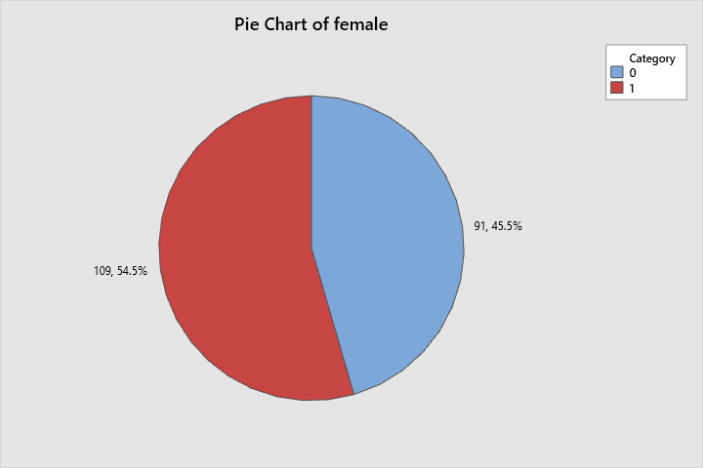
Figure 2: Pie chart indicating the division in male and female
The data plainly shows that there were 91 male students and 109 female students out of a total of 200.

Mean and median of participants, preferring chocolate or strawberry flavored ice-cream

Chocolate Flavour
Mean 99.02618
Media
98

Strawberry Flavour
Mean 100.899
Median 100.5

Cluster Observation
Final Partition
 | Number of  observations | Within  cluster  sum of  squares | Average  distance  from  centroid | Maximum  distance  from  centroid
Cluster1 | 200 | 597 | 1.63821 | 3.37967

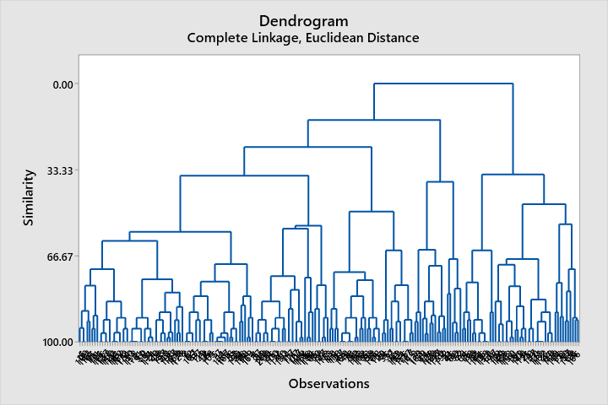

Interpret the results
Distances between clusters and similarities between clusters are also included in the table, along with the clusters that were linked at each stage.
Similarity will be progressively reduced by threes or less through step 15. When clusters are connected, the distance between them grows, first by a factor of roughly 0.6 or less. This is most evident between stages 16 and 17, when the number of clusters is lowered from 4 to 3. Stages 16 and 17 see a reduction from four to three clusters, increasing distance by more than a factor of 1. (From 1.81904 to 2.82229)
The results of the distance and similarity analysis suggest that four clusters are sufficient for the ultimate division (Jalil & Hwang, 2019). Choosing this kind of grouping is usually a good option if it seems intuitive to the designer. In order to better understand the relationships between the nodes in the tree, the data in the table is displayed as a dendrogram (Maheshwari, 2015) .
The designer must rerun the study and settle on the final number of clusters to partition. When you construct a final partition in Minitab, new tables appear showing the attributes of each cluster that made the cut. After a final partition is chosen, these tables will be displayed.

Data Mining and Text Mining

Data mining methods
- Clustering
Clustering is a technique used in graphical representation of data, such as in charts showing customer demographics or purchase histories for a given product (Maheshwari, 2015). Clustering refers to the process of grouping similar data items into similar groups based on shared characteristics. Doing so allows data miners to cleanly divide the data into subsets, which in turn allows for more accurate generalisations to be made about target audiences (such as consumers or users) and their related behaviours. The goal of the partitioning method is to enable independent evaluation of each cluster in the dataset using criteria specific to that cluster. In this method, each data point belongs to exactly one cluster. Using a hierarchical structure, data points are first grouped together into a single cluster. In the following stage, these newly formed clusters can be studied separately from one another.
- Association
Clustering algorithms are a useful tool for discovering patterns and connections in large datasets. Data miners use the association method to search for interesting relationships between dataset variables. In order to better analyses and plan their respective markets, many firms rely on the insights and expertise of associations. For a one-dimensional connection, you need to look for a single instance of a data item or feature that appears several times (Gaskin, 2016).
- Data Cleaning
Clustering algorithms are a useful tool for discovering patterns and connections in large datasets. Data miners use the association method to search for interesting relationships between dataset variables. To better analyse and plan for their respective markets, many firms rely on the insights and expertise of associations. For a one-dimensional connection, you need to look for a single instance of a data item or feature that appears several times.
Text Mining
Around 80% of all data in the world is text, making Text Mining one of the most essential and helpful ways for analysing and processing vast volumes of data (Jalil & Hwang, 2019). Almost every organisation nowadays uses database software or the cloud to collect and store massive amounts of information. As new data continuously pours in from many sources, the volume of this information continues to grow exponentially.
- Information Extraction
It's the gold standard in text mining techniques. Information exchange refers to the process of extracting relevant details from large amounts of text. Extracting entities, attributes, and relationships from semi-structured and unstructured texts is the focus of this text mining technique. Following data extraction, the collected records are stored in a database for further use. The results are evaluated and analysed for their usefulness and relevance using the accuracy and recall methodologies.
- Information Retrieval
IR, or Information Retrieval, is the method used to find meaningful and associated patterns from a set of keywords or a small set of phrases. By employing several algorithms, IR systems can track and analyse user behaviour and retrieve content that is tailored to that behaviour, a process known as text mining. Google and Yahoorespective !'s search engines are currently the most popular IR platforms.
- Categorization
A "supervised" form of learning, this is one of the text mining strategies. Standard language texts are categorised into a predetermined set of topics in this method of education. Accordingly, categorization, or more precisely Natural Language Processing (NLP), is a process that requires gathering text documents, then processing and analysing those messages to determine the suitable subjects or indexes for each document. The co-referencing strategy is a technique commonly used in natural language processing (NLP) to extract relevant synonyms and abbreviations from textual input. Natural language processing has developed into an automated process with numerous uses today. This includes the dissemination of targeted advertisements, the screening of spam, and the categorization of websites according to predetermined hierarchies.

Comparison between softwares

Software | Advantages | Disadvantages
SPSS | Full-featured data management software. It takes the most time and effort to enter data for any data analysis. You won't get a reliable result from your analysis if you enter the data incorrectly (WN write need, 2020). There is a great deal of flexibility when it comes to options for data entry, however IBM SPSS is typically the best option. IBM SPSS has a user-friendly spreadsheet format for entering data. This structure is simple and easy to pick up quickly. Importantly, IBM SPSS provides a great deal of data documentation, especially value labels, which can help you keep your data entry consistent. | You can't just buy it and have it in your possession without paying the exorbitant price tag and getting a licence to do so. It's worth noting that R is completely free to use, and that SAS and STATA do not require annual licence renewals (at least, that wasn't the case the last time I used SAS (Grande, 2015).
EXCEL | Financial and everyday accounting tasks are both made easier with Excel's widespread use in the office. All of your work-related files will remain safe and sound. The structured information may be presented to your manager at any moment. A yearly balance sheet and income statement can be generated if desired (Singal, 2017). | You know that Excel can have macros. Anybody can insert a virus into an Excel file if they know it can run macros. Should this occur, the infection will spread to your machine.  Compared to more common programmes like Microsoft Word, this one is much more complicated to learn. The application relies on formulas, and learning to use these formulas can be more of a challenge for a new user than learning the rest of the programme (H.Hayslett & P.Murphy, 2017).

Conclusion
In the first part of the report to establish a decreasing trend over time, the study first analyses the supermarket's sales and profit information. Microsoft Excel has been utilised throughout this part for analysis because of its versatility in both preliminary data processing and data visualisation. Data provides a framework without which effective communication of information is impossible. The only approach to calm nerves about the safety, upkeep, and privacy of the company's data is to handle it with care. Therefore, this subject is crucial to the protection of the data's integrity. The second part of the report mainly looked at the SPSS software using some of the program's characteristic features and analysis and concluded with a comparison of the pros and cons of Excel and SPSS.

References
Gaskin, J., 2016. K-means cluster analysis SPSS. [Online]
Available at: https://www.youtube.com/watch?v=e27G-UCju0E&t=2s
[Accessed 28 12 22].
Grande, D. T., 2015. Sensitivity, Specificity, False Positives, and False Negatives in SPSS. [Online]
Available at: https://www.youtube.com/watch?v=XdPAjO718Fg
[Accessed 05 1 2023].
H.Hayslett & P.Murphy, 2017. Statistics MS. 2nd ed. London: Elsevier Science.
Hrehova, S. & Vagaska, A., 2017. Introduction to MS Excel advanced techniques via e-learning. New Trends and Issues Proceedings on Humanities and Social Sciences, 4(1), pp. 255-260.
Jalil, N. A. & Hwang, *. J., 2019. Technological-Centric Business Intelligence: Critical Success Factors. International Journal of Innovation, Creativity and Change, 5(2), pp. 1499-1516.
Maheshwari, A., 2015. Business Intelligence and Data Mining. 1st digital ed. New York: BEP.
Singal, A., 2017. MS Excel: Let's advance to the next level. 1st ed. New York: BEP.
Stratvert, K., 2020. Pivot Table Excel Tutorial. [Online]
Available at: https://www.youtube.com/watch?v=m0wI61ahfLc
[Accessed 17 11 2022].
WN write need, 2020. What are the benefits of SPSS. [Online]
Available at: https://www.youtube.com/watch?v=gqYZoCEfMos
[Accessed 05 12 2022].

