

Programme: MBA – Master of Business Administration
Student name: Alina Jubea
Student number: 2023149
Module name: Banking and Financial Economics
Module Code: LCMB7032
Lecturer name: Isaiah Oino

Report: Banking Financial Management and Financial Markets

Table of Contents
Introduction 3
Airbnb's business model and long-term plan 3
Reasons to go public 4
Problems and risks that Airbnb's S-1 filing lists 5
Value and how the market is doing 5
CAGR for Airbnb from 2020-2024 and for Booking.com for the year 2024 6
Sharpe and Treynor Ratio for AIRNBN, 2022 and 2023. 9
At-the-Money Call Option Payoff 11
At-the-Money Put Option Payoff 13
Straddle Strategy 14
Performance of the 10Y note 15
Conclusion 17
List of references: 19
Appendix: 21

Introduction
This report will discuss how Airbnb, the world's biggest platform for short-term rentals, has grown, as well as its business plan and strategic problems. The report's primary goal is to look at Airbnb's growth from its start in 2008 to its successful IPO in 2020, worth more than $100 billion (Airbnb, 2024). It will look at the company's business plan, specifically how Airbnb makes money from its platform and the steps it has taken to protect users and ensure they can trust it. The report will also discuss the strategic choices that led Airbnb to add luxury options and the company's problems, such as regulatory risks and the ongoing effects of the COVID-19 pandemic. The report's goal with this analysis is to give a complete picture of Airbnb's place in the global travel business and its plans for the future.

Airbnb is a website that pairs hosts with travellers who need short-term lodging. The company was started by Brian Chesky, Joe Gebbia, and Nathan Blecharczyk in 2008. It has since grown into a global travel giant with over 7 million ads in more than 220 countries (Airbnb, 2024). Airbnb started out as a way to rent air mattresses for conferences, but it quickly grew to include a wide range of places to stay and one-of-a-kind events. Airbnb had a great initial public offering (IPO) in December 2020, and the company was valued at more than $100 billion. This achievement showed how strong the company was, especially during the COVID-19 pandemic, which made people look for safer ways to travel and led to a change towards private and extended stays (Sarath, 2021).

Airbnb's business model and long-term plan
Airbnb's business model is based on its platform, where hosts can add different places to stay, like private stays, apartments, and houses. Guests see this when they go to Airbnb's website or mobile app to look around, book, and pay for their stays. Both owners and guests pay service fees to the company, which makes money. Guests pay a fee ranging from 10% to 20%, based on the length of stay and where the listing is located. Hosts usually pay a service fee of about 3% of the booking amount. This fee system ensures that Airbnb makes money and makes things easy for its users (Hostaway.com, 2020).

The site's success depends on ensuring that transactions can be done safely and reliably. Airbnb has put vital safety steps in place to ensure hosts and guests are happy and safe. This includes ensuring users are who they say they are, secure ways to pay, and a complete review system where users can rate their experiences. There is another reason for Airbnb's success: its host model works. Hosts are motivated to maintain high standards to become "Superhosts," which has been linked to better performance and happier guests (Gunter, 2018).
The company also puts a lot of money into customer service to settle conflicts and fix problems quickly, which gives users a reliable experience. Because of these efforts, Airbnb now has over 7 million listings in more than 220 countries, making it one of the biggest names in the travel business worldwide. Airbnb has also expanded its services to include high-end listings and luxury experiences to serve a wider group of customers (SEC, 2020).

Reasons to go public
Several strategic factors led Airbnb to decide to go public in December 2020. In the first place, the IPO gave Airbnb access to a lot of money, which it could use to grow in essential areas like technology, marketing, and entering new markets. The IPO raised a lot of money that helped the company build a solid financial base for future growth, especially as it tried to get back on its feet after the COVID-19 pandemic hit the economy. The pandemic greatly affected Airbnb's business, and bookings and income dropped sharply. However, the company quickly changed its focus to local and long-stay stays, which helped lessen some of the pandemic's harmful effects (SEC, 2020).

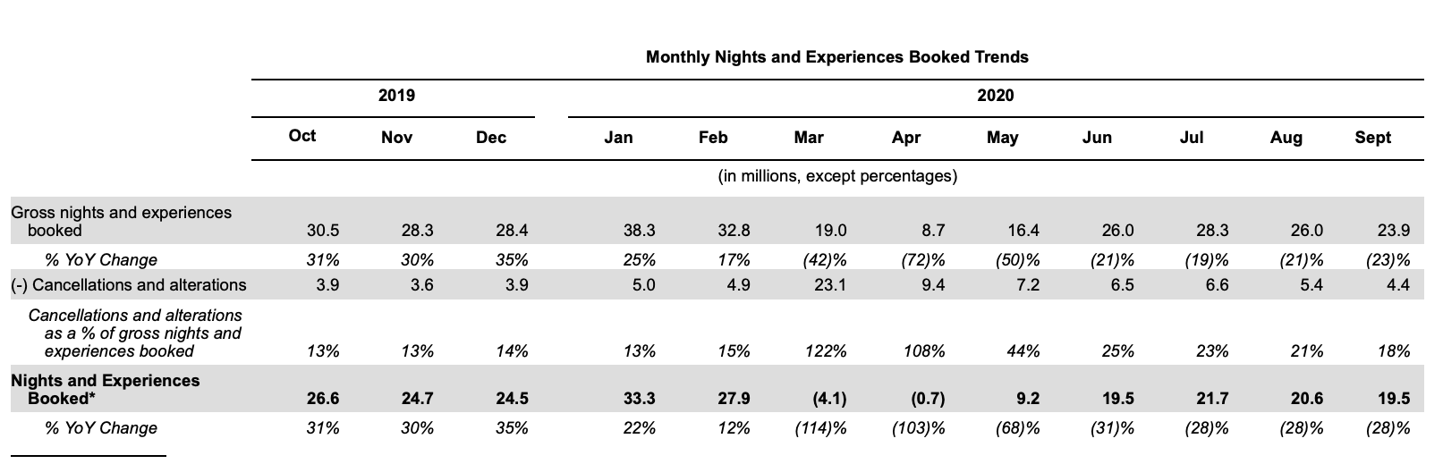
Source: (SEC, 2020).

In addition to getting money, Airbnb was able to give its early investors and workers cash through the IPO. Many of these people had stock options or private shares in the company that could be turned into cash when the business went public. This move paid employees who had been with the company from the start and helped Airbnb keep and hire top talent by tying employees' pay to the company's success (SEC, 2020).

Problems and risks that Airbnb's S-1 filing lists
Even though its IPO went well, Airbnb faces several significant risks, as described in its S-1 filing. One of the most important things to worry about is how the COVID-19 outbreak still affects people. Because of the pandemic, bookings and income dropped significantly. Airbnb has changed its strategy to focus on domestic and extended stays. However, the pandemic's unpredictability still threatens the company's recovery and future growth. Travel limits, the distribution of vaccines, and changes in how people behave could all affect Airbnb's ability to recover from the pandemic (SEC, 2020).

Another big problem for Airbnb is that it faces regulatory risks. The business works in many countries, each with its own rules about short-term renting. In its S-1 filing, Airbnb talked about how stricter enforcement or passing new laws could make it harder for the company to do business in key countries. These unknowns about regulations could make it more expensive to run Airbnb and slow its growth, especially in places where local governments are cracking down on short-term rentals. It can be expensive to follow these rules because of fines, the need for compliance workers, and the time it takes for employees to learn and follow the new rules. According to Cassini (2023), these things could significantly affect Airbnb's ability to make money and grow.

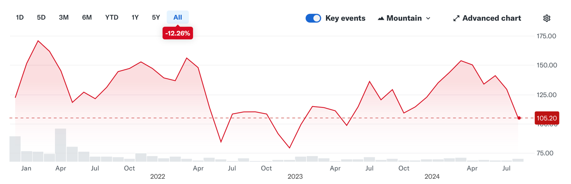

Source: (Yahoo Finance, n.d.)

Value and how the market is doing
Airbnb's shares were sold for $68 when the company went public. The stock price rose to $144.71 by the end of the first business day. This shows that investors were very interested in the company and were optimistic about its future (Sigalos, Smith & Berger, 2020; Yahoo Finance, n.d.). However, since its IPO, Airbnb's price has been everywhere. For example, by July 2022, the stock price had dropped to $89.08, showing that the market didn't believe Airbnb would be able to keep growing at the same rate before the pandemic. This instability brings to light the problems that Airbnb is facing, such as the ongoing effects of the COVID-19 pandemic and the legal risks that come with doing business in more than one market (Yahoo Finance, n.d.).

When the company went public, it was valued very highly. Part of this was because people thought Airbnb would quickly recover from the pandemic and continue to grow. However, the business faces significant risks, such as future pandemics, regulation changes, and reliance on a vast network of hosts and guests. When investors consider adding Airbnb to their portfolio, they must weigh these risks against the possible benefits. How long the company can keep growing and making money will rest on how well it handles these problems in the coming years (SEC, 2020).

Airbnb has grown from a small business renting out air mattresses to a global travel giant worth more than $100 billion (Yahoo Finance, n.d.). This is due to its creative business plan and long-term vision. However, the company faces significant risks, such as the ongoing effects of the COVID-19 pandemic and problems with regulations in several countries. Airbnb got the money it needed to grow through the IPO, but the company needs to be careful to avoid these risks if it wants to be successful in the long run. When investors look at Airbnb's chances for future growth and profit, they should think about these things.

CAGR for Airbnb from 2020-2024 and for Booking.com for the year 2024

The compound annual growth rate (CAGR) shows the average yearly growth rate of an investment over a period longer than one year. It gives a smoothed rate of return that removes volatility. The CAGR is especially helpful for comparing the growth rates of various stocks or businesses, as it gives a clear picture of how well they did over time.

Year | Start Price | End Price | CAGR (%)
2020 | $144.71 | $146.70 | 1.37%
2021 | $146.70 | $175.18 | 19.44%
2022 | $175.18 | $85.46 | -51.22%
2023 | $85.46 | $137.21 | 60.52%
2024 (Jan to Jul) | $137.21 | $142.39 | 3.78%

Source: Authors Calculations based on Yahoo Finance (Yahoo Finance, n.d.)

2020 (CAGR: 1.37%)
Airbnb went public for the first time on December 10, 2020, at a price of $144.71. By the end of 2020, the stock price had gone up slightly to $146.70 (Yahoo Finance, n.d.).
The stock price initially went up, as shown by the CAGR of 1.37 per cent from the IPO date to the end of the year. This small increase shows how excited people were about the IPO initially, but it also indicates that the stock price stayed pretty steady soon after the company went public.

2021 by 2021 (CAGR: 19.44%)
Airbnb's stock price went from $146.70 at the start of the year to $175.18 by the end of the year, showing how much the company grew (Yahoo Finance, n.d.).
The 19.44% CAGR shows the market's strong success in 2021. This rise is because the market felt good as the economy started to recover from the pandemic, which made more people want to travel. The big rise in Airbnb's stock price shows that investors were likely confident in the company's ability to benefit from the comeback in global travel.

In 2022, the CAGR was -51.22%.
Airbnb's stock price fell from $175.18 at the start of the year to $85.46 by the end of the year (Yahoo Finance, n.d.). It was a tough year for the company.
The big drop in 2022, which led to a negative CAGR of -51.22%, shows how hard things were for Airbnb during a general market slowdown. This big drop was probably caused by several things, such as rising prices, higher interest rates, and a general correction in the market that hurt high-growth tech stocks the most. Investors may have needed to be more confident because they are still worried about how COVID-19 variants will affect travel and shopper spending.

2023 (CAGR: 60.52%)
The price of Airbnb stock rose sharply in 2023, from $85.46 to $137.21 by the end of the year (Yahoo Finance, n.d.).
The impressive CAGR of 60.52% in 2023 shows a strong rebound. The continued recovery in the travel and hospitality sector led to this bounce back. This happened because global travel restrictions were eased, and customer confidence returned. Airbnb's flexibility, such as its focus on more extended stays and good choices for people who work from home, also helped it do well this year.

2024 (January to July) (CAGR: 3.78%)
Airbnb's stock price increased from $137.21 to $142.39 in the first seven months of 2024 (Yahoo Finance, n.d.).
The modest CAGR of 3.78% in 2024 shows a time of more stable growth after years of being more volatile. This growth suggests that Airbnb is still doing well, but the rate at which the rising stock price has slowed. This could mean the market is stabilising or investors are becoming more wary. Outside factors, such as the economy, competition, and what the market thinks will happen, can also affect the stock price.

Since its initial public offering (IPO), Airbnb's stock has experienced many ups and downs. There have been years of strong growth followed by sharp drops and then rebounds. This fluctuation shows both the company's chance to make a lot of money and the risks associated with the economy as a whole and the market.
Even though Airbnb had problems in 2022, its strong comeback in 2023 and steady growth in early 2024 show that it is resilient and can take advantage of good market conditions. People thinking about investing in Airbnb should know the pros and cons, especially since the price has been very volatile in the past.

Company | Start Price (2023) | End Price (2023) | CAGR (2023)
Booking.com | $1,889.61 | $3,178.19 | 68.27%
Airbnb | $85.46 | $137.21 | 60.52%

Source: Authors Calculations based on Yahoo Finance (Yahoo Finance, n.d.)

From January 3, 2023, to December 29, 2023, Booking.com's stock price grew at 68.27% per year, called its Compound Annual Growth Rate (CAGR). A rise in travel demand probably caused this growth as more people started to travel again after the pandemic. With its wide range of services, Booking.com was in an excellent situation to take advantage of this trend. The company's focus on improving the user experience, giving more, and going after new markets helped it do well. As a result, investor confidence and, ultimately, the stock price went up. Economic conditions, such as stable inflation and rising customer confidence, helped this (Yahoo Finance, n.d.).

With a CAGR of 60.52%, Airbnb also did well during this time. This growth shows that the business can adjust to new market conditions, like the ongoing need for short-term rentals and one-of-a-kind trip experiences. Airbnb's focus on long-term stays and places to stay for people who work from home made its situation even more vital. However, Airbnb's rise was a little slower than that of Booking.com. This could be because of more competition and problems with regulations. Despite both companies growing a lot, Booking.com has been better able to take advantage of the travel market's overall rebound (Yahoo Finance, n.d.) because it had a slightly better year overall.

Sharpe and Treynor Ratio for AIRNBN, 2022 and 2023.

Year | Annual Return | Risk-Free Rate | Volatility | Beta | Sharpe Ratio | Treynor Ratio
2022 | -51.22% | 2.91% | 60.52% | 1.19 | -0.89 | -0.45
2023 | 60.52% | 3.45% | 42.50% | 1.19 | 1.34 | 0.48

Source: Authors calculations based on the data from Yahoo finance and U.S. Department of the Treasury (Yahoo Finance, n.d. ; U.S. Department of the Treasury, n.d.).

A look at the Sharpe and Treynor ratios for Airbnb in 2022 and 2023:

Sharpe Ratio: -0.89
When volatility is considered, a negative Sharpe ratio means that Airbnb's profits were less than the risk-free rate. This negative ratio from 2022 shows that Airbnb failed to give investors positive returns, and the company did not provide enough money to cover the risk they took. This is a clear sign of poor performance, as buyers would have done better with a risk-free asset like a Treasury bond instead of Airbnb stock. The high level of volatility and the significant negative gain about -51.22% (Yahoo Finance, n.d.) caused this poor Sharpe ratio.

The Treynor Ratio is -0.45.
The negative Treynor ratio also shows a lousy result for 2022. When systematic risk (measured by beta) is considered, this ratio shows that Airbnb's profits were insufficient. If the Treynor ratio is negative, buyers were not paid enough for the risk they took compared to the market as a whole. The company's market risk and the negative return made for a bad risk-adjusted return. This suggests that 2022 was a challenging year for Airbnb compared to the rest of the market (Yahoo Finance, n.d.).

2023: Sharpe Ratio: 1.34
When considering risk, a Sharpe ratio above 1 usually means good results. The Sharpe ratio for Airbnb in 2023 was 1.34 (Yahoo Finance, n.d.), which means that the company gave investors good returns compared to the amount of risk they had to take. This upbeat number shows that Airbnb not only made up for its bad performance in 2022 but also gave returns much higher than the risk-free rate, even when the stock's volatility was considered. This improvement shows that Airbnb's performance has changed significantly and says that buying the stock in 2023 was a good idea.

Ratio of Treynor: 0.48
The fact that the Treynor ratio for 2023 was positive shows that Airbnb gave a good return compared to its market risk. If the Treynor ratio is 0.48, buyers get a good return above the risk-free rate for every unit of market risk (beta). This shows that the company's systematic risk was well managed, and it says that Airbnb could make good returns compared to how the market worked. The positive Treynor ratio proves that 2023 was a good year for Airbnb, with the company making enough money to cover the risks of being open to the market (Yahoo Finance, n.d.).

2022: It's clear that 2022 was a challenging year for Airbnb because both the Sharpe and Treynor ratios were negative. The business needed to do better to justify the risks buyers took by giving them good enough returns. This poor performance was caused by several macroeconomic factors, including market volatility, economic insecurity, and problems within the company that hurt its stock price.
2023: On the other hand, there was a significant rebound in 2023, as shown by the positive Sharpe and Treynor ratios. Airbnb was able to produce strong returns when risk was taken into account. This suggests that the company dealt with the previous year's problems and took advantage of market possibilities. The positive ratios show that the balance between return and risk has been well handled, making Airbnb a good investment at this time.

The Sharpe and Treynor rates tell us a lot about Airbnb's performance over the past two years. There were many problems and poor performance in 2022, but things got better in 2023, with Airbnb showing strong results compared to its volatility and market risk. Investors probably saw 2023 as Airbnb's "redemption year," rewarding those who kept or added to their shares of the company after the rough year in 2022.

At-the-Money Call Option Payoff

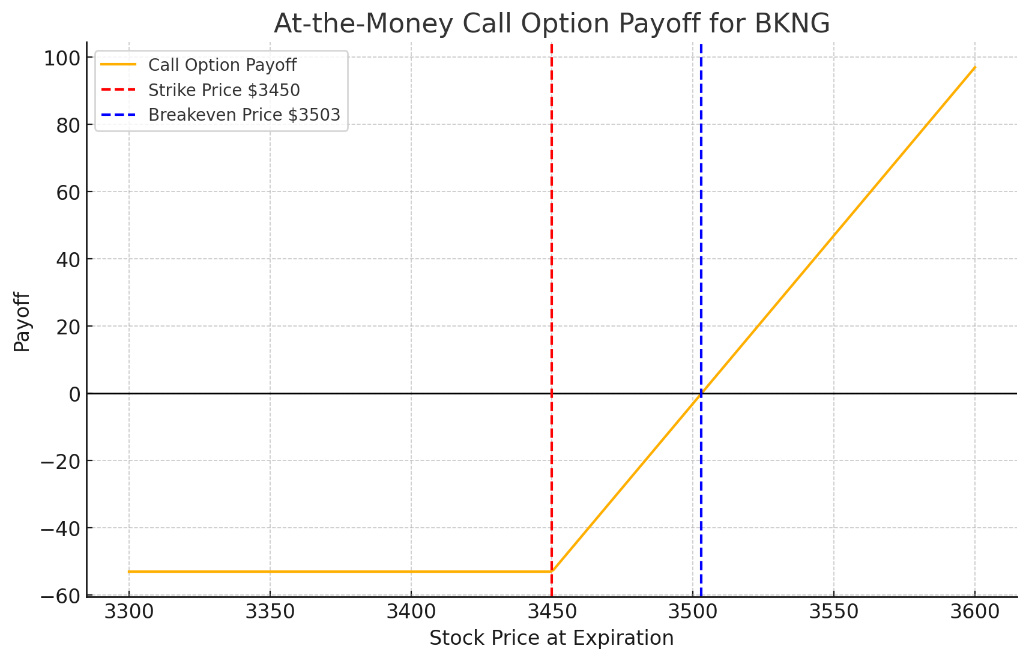

Source: Author’s calculations based on NASDAQ.COM.

The return structure for an at-the-money call option on Booking Holdings Inc. (BKNG) shows how the value of the option changes based on the price of the stock when the option expires. The NASDAQ data shows that the call option will end worthless if the stock price at expiration is less than the strike price of $3,450. In this case, they would lose the bonus they paid, which is $53 per share. The payoff diagram shows that if the stock price is at or below the strike price (NASDQ.COM, 2024), the option holder neither wins nor loses money. This is shown by the horizontal line at $0.

The strike price is $3,450, shown on the graph by the red straight dotted line. This is the point at which the option starts to gain value. The option has no worth if the stock price stays at or below this level until it expires. The holder loses the premium they paid. If the stock price exceeds this strike price, the option will start making money.

The blue vertical dashed line shows the point where you break even, which is $3,503. The $53 bonus is added to the strike price of $3,450 to get this number. To make money, the cost of the stock has to go above this amount by expiration. After this point, the option's value increases as the stock price increases.

On the other hand, the at-the-money call option for Airbnb, Inc. (ABNB) works the same way but with different numbers. The bonus is $5.45, and the strike price is $120. This means that the point at which the trade breaks even is $125.45. The ABNB option is more accessible because its strike price and premium are lower. However, it also needs a smaller price rise to make a profit. However, the possible returns are lower than with BKNG's option, which has a more significant risk and a higher potential reward because the price needs to move higher to break even (NASDAQ.COM, 2024).

The overall risk-to-reward ratio for the BKNG at-the-money call option is higher than that of the ABNB option. For investors in BKNG to make money, the price needs to go up a lot more than $3,503; on the other hand, ABNB has a more minor breakeven point, which makes it a safer bet with lower potential returns.

At-the-Money Put Option Payoff
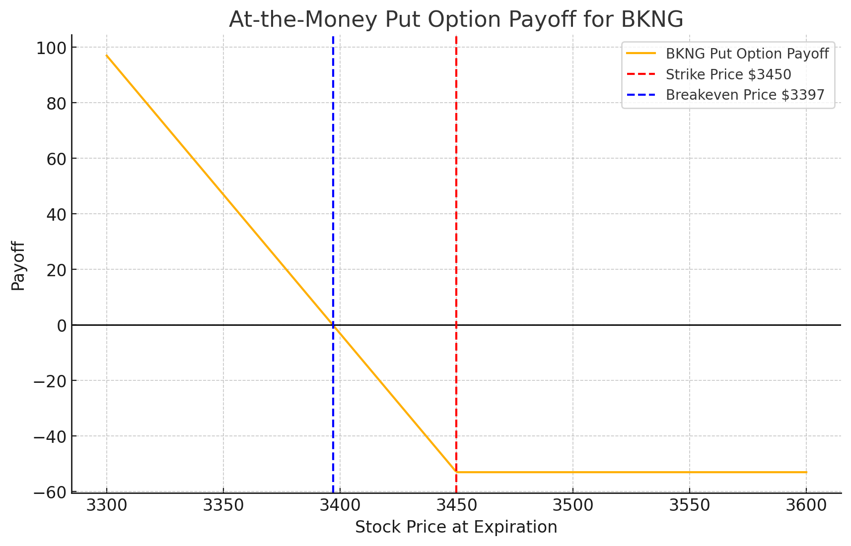

Source: Author’s calculations based on NASDAQ.COM.

The graph above illustrates the payoff structure for an at-the-money put option on Booking Holdings Inc. (BKNG), highlighting how the option's value changes as the underlying stock price varies. This analysis compares the BKNG put option with a similar option for Airbnb, Inc. (ABNB).

For the BKNG put option, the payoff structure shows that if the stock price at expiration is above the strike price of $3,450, the option expires worthless, resulting in a maximum loss of the premium paid, $53(NASDAQ.COM, 2024). The option becomes profitable as the stock price decreases below the strike price. The breakeven point is $3,397, calculated as the strike price minus the premium ($3,450 - $53) (NASDAQ.COM, 2024). Below this breakeven point, the option holder starts to realise a profit, with the potential profit increasing as the stock price drops further.

The ABNB put option operates similarly but with different parameters due to the lower stock price. If the stock price at expiration is above the strike price of $120, the option expires worthless, and the maximum loss is limited to the $5.45 premium paid (NASDAQ.COM, 2024). The option becomes profitable as the stock price falls below the strike price, with the breakeven point at $114.55 ($120 - $5.45) (NASDAQ.COM, 2024). Below this breakeven price, the option holder begins to profit, with potential gains increasing as the stock price declines.

The breakeven point for BKNG is higher ($3,397) than ABNB's ($114.55), reflecting the higher strike price and premium associated with BKNG's options (NASDAQ.COM, 2024).
The premium for BKNG's put option is $53, much higher than ABNB's $5.45, indicating a more significant initial investment requirement for BKNG (NASDAQ.COM, 2024).

Both options offer similar payoff structures, where profit increases as the stock price falls below the breakeven points. However, BKNG's option requires a more substantial decline in the stock price to become profitable. In contrast, ABNB's option is less costly and more accessible to profit from due to its lower breakeven point.

The BKNG put option is more expensive and requires a more extensive stock price decline to achieve profitability than the ABNB put option. The ABNB option, being less costly and with a lower breakeven threshold, maybe more accessible to investors expecting a moderate decline in the stock price. Both options, however, offer significant profit potential in scenarios where the respective stocks experience a substantial price decrease.

Straddle Strategy
The Straddle Strategy and How Booking Holdings Inc. (BKNG) Can Use It
A straddle is a good way to deal with uncertainty in quickly moving markets when taking derivatives. This method works well when there is a chance that a stock's price will change a lot, but no one knows which way it will go. The MDPI article about the history of derivatives says that these tactics help investors protect themselves against changes in the market that they cannot predict. This improves risk management (Orkhan Rustamov et al., 2024).

When you trade Booking Holdings Inc. (BKNG), you must buy both a call option and a put option with the same strike price and end date. Someone who wants to put money into BKNG stock would buy both a call option and a put option with a strike price of $3,450. The fee for both options adds up to the plan's cost. Adding or removing the total premium paid from the strike price will find the breakeven points. This method will make money if the stock price exceeds or below those points.

The MDPI study stresses how important derivatives are for giving investors options and freedom. People who use straddles may make money from market instability, even if the price goes down or up, without having to guess which way the price will move. This makes the straddle a flexible strategy that can be used when the economy is unclear or before significant market events (Orkhan Rustamov et al., 2024).

Performance of the 10Y note
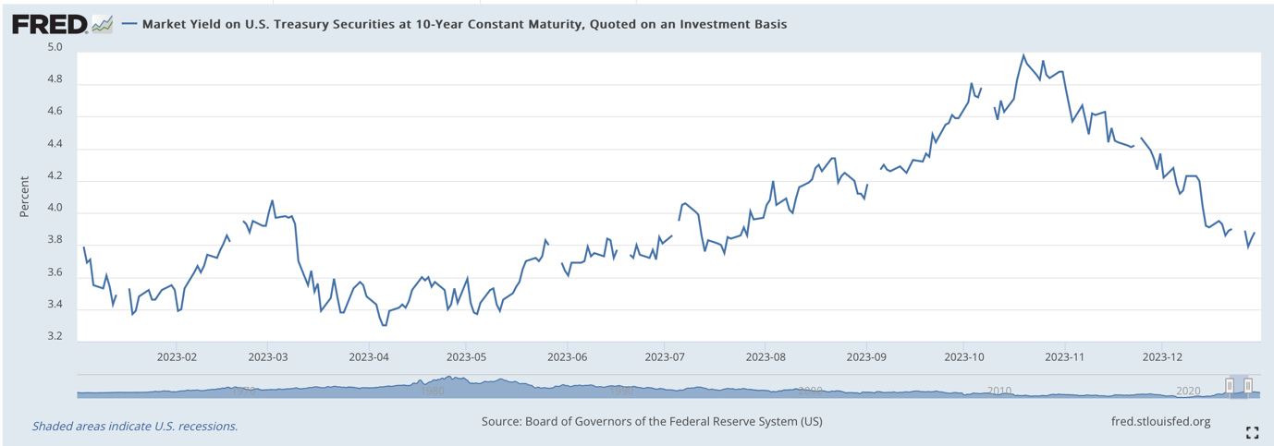
Source: (FRED, 2024).

As shown in the graph, the 10-Year Treasury Note's performance throughout 2023 changes a lot in reaction to changes in the economy and policy decisions. The yield started at about 3.55% at the beginning of January 2023. Since the beginning of the year, the yield went down; by late January, it was at a low of about 3.30%. The market was worried about an economic slowdown and thought the Federal Reserve might loosen its policies on tightening money (FRED, 2024), which led to this drop.

On the other hand, the yield started to rise as the year went on. This was because the Federal Reserve kept raising interest rates to fight inflation. Between June and July of the middle of the year, the yield slowly went up until it reached around 4.00%. This was because investors expected more rate hikes and higher borrowing costs. According to Powell (2024), this rise is because the market has adjusted to the Fed's plan to keep interest rates high for a long time to control inflation.

There was a lot of inflation and a strong job market in October 2023, which caused the yield to reach its highest point of about 4.80%. This kept the Federal Reserve on a road of aggressively tightening the money supply. After this high point, the return decreased slightly, ending the year at about 3.85% in December. Investors may have started to think that the Federal Reserve might be nearing the end of its rate-hike cycle if inflation started to ease (FRED, 2024) because of the slowdown at the end of the year.

Overall, the yield on the 10-Year Treasury Note in 2023 showed how inflationary pressures, Federal Reserve policy, and larger economic expectations were all interacting in a complicated way. The movement of the yield is a critical indicator of investor sentiment and has substantial implications for borrowing costs throughout the economy, including mortgages, corporate debt, and other long-term loans (FRED, 2024).
The yield on the 10-year Treasury Note is a critical measure that significantly impacts interest rates on consumer debt, especially mortgage, car loan, and credit card debt. If this return changes, it can dramatically affect how much the business has to pay to borrow money.

How much do mortgages cost?
One straightforward way the return on 10-year Treasury Notes changes things is by affecting mortgage rates. This return is what fixed-rate mortgages are based on. In other words, mortgage rates rise along with the return. People will have to pay more to borrow money, meaning their monthly mortgage payments and living costs will go up. Forbes, for instance, said that the rise in Treasury yields in 2023 caused mortgage rates to rise, which made it harder for people to buy homes (FRED, 2024).

On the other hand, mortgage rates usually go down when the yield on the 10-year Treasury note goes down. Because of this, people may be able to get loans to buy homes more cheaply. This rise in affordability usually increases demand in the housing market, which can bring in more sellers and possibly speed up the economy.

Credit cards and car loans
The 10-year Treasury yield still significantly affects interest rates in general, even though short-term rates have a more significant effect on interest rates for things like credit cards and auto loans. Lenders often raise interest rates on credit cards and auto loans when Treasury yields increase to keep making money. According to CNBC, the rise in yields in 2023 made it more expensive to fund cars and carry credit card balances, which put even more pressure on family budgets.

People spending money and paying off debt.
It costs more to pay off present debt when the yield on the 10-year Treasury Note is higher. This is especially true for people whose loans have variable rates, like credit cards and mortgages. When interest rates increase, people may have to pay more monthly for their debts. This can cut into their extra cash flow and make more people stop paying their debts. People may be less likely to spend money, essential for economic growth. Based on information from the Federal Reserve Bank of St. Louis, the costs of taking out different types of consumer loans went up as rates increased in 2023. (FRED,2024) This could make people spend less and hurt the business.

In short, changes in the rate of the 10-year Treasury Note significantly affect people's debt. Higher returns usually mean higher costs to borrow money, which makes people spend less and slows down economic growth. On the other hand, lower returns mean lower borrowing costs, which can make the economy grow faster.

Conclusion

After thoroughly analysing Airbnb's innovative business model, rapid growth, and strategic challenges, this study presents a comprehensive view of its position in the global travel industry. The first Airbnb, a humble air mattress rental service that debuted in 2008, has evolved into the world's largest short-term rental platform, boasting over 7 million listings across 220 countries. The company's valuation soared to over $100 billion upon its 2020 IPO, a testament to its ability to navigate challenges like the COVID-19 pandemic and seize market opportunities (Sarath, 2021).

When you look at Airbnb next to Booking.com, its unique business plan stands out even more. Booking.com has grown significantly, with a Compound Annual Growth Rate (CAGR) of 68.27% in 2023 compared to Airbnb's 60.52% (Yahoo Finance, n.d.). However, the two companies do things in different ways. Booking.com mainly collects entries for hotels and other places to stay, but Airbnb's platform is based on individual hosts' unique and personal stays. Airbnb has carved out a spot in the travel market by focusing on unique and customised stays instead of standard hotel rooms (SEC, 2020).

However, Airbnb has a harder time with rules than Booking.com, especially in places where short-term rentals are strictly forbidden. Also, the COVID-19 pandemic still affects Airbnb's business plan, which depends heavily on travel and tourism. This shows how important it is to be flexible with your strategy. On the other hand, Booking.com's more traditional business plan may be more stable in these areas (SEC, 2020).

Airbnb has grown from a small business to a public company worth over $100 billion. This shows how creative and adaptable its business plan is. But, as this study shows, its future success will depend on how well it deals with regulation risks, changes in the market, and staying ahead in a very competitive field. Even though Airbnb came up with a new way to rent out rooms, Booking.com shows that the company needs to keep coming up with new ideas and working out how to handle problems to stay at the top of the market.

List of references:

Airbnb (2024) Airbnb [online]. Available from: https://news.airbnb.com/about-us/ [Accessed 24 July 2024].

Cassini, A. (2023). The Real Cost of Compliance: Regulatory Expenses. [online] GreenGrowth CPAs. Available at: https://greengrowthcpas.com/compliance-costs-of-regulatory-expenses/.

FRED, 2024. Market Yield on U.S. Treasury Securities at 10-Year Constant Maturity, Quoted on an Investment Basis. [online] Available at: <https://fred.stlouisfed.org/series/DGS10/> [Accessed 24 August 2024].

Griffith, E. (2020). Airbnb prices I.P.O. at $68 a share, for a $47 billion valuation. The New York Times. [online] 10 Dec. Available at: https://www.nytimes.com/2020/12/09/business/airbnb-ipo-price.html [Accessed 10 Aug. 2024].
Gunter, U. (2018). What makes an Airbnb host a superhost? Empirical evidence from San Francisco and the Bay Area. Tourism Management, 66, pp.26–37. doi: https://doi.org/10.1016/j.tourman.2017.11.003.
Hostaway.com. (2020). Airbnb Host-Only Fee | What to Know about the 15% Host Fee. [online] Available at: https://www.hostaway.com/blog/airbnb-host-only-fee-what-to-know-about-the-15-percent-host-fee/ [Accessed 25 Aug. 2024].
NASDAQ.COM, 2024. Airbnb, Inc. Class A Common Stock (ABNB) Option Chain | Nasdaq. [online] Nasdaq. Available at: <https://www.nasdaq.com/market-activity/stocks/abnb/option-chain> [Accessed 16 August 2024].
NASDAQ.COM, 2024. Booking Holdings Inc. Common Stock (BKNG) Option Chain | Nasdaq. [online] Nasdaq. Available at: <https://www.nasdaq.com/market-activity/stocks/bkng/option-chain> [Accessed 16 August 2024].
Orkhan Rustamov, Fuzuli Aliyev, Ajayi, R. and Suleymanov, E. (2024). A New Approach to Build a Successful Straddle Strategy: The Analytical Option Navigator. Risks, 12(7), pp.113–113. doi:https://doi.org/10.3390/risks12070113.
Page, B. (2023). Risks Associated with Airbnb Arbitrage [Complete Guide]. [online] BNB Formula. Available at: https://bnbformula.com/exploring-the-risks-associated-with-airbnb-arbitrage-a-comprehensive-guide/ [Accessed 15 Aug. 2024].
Powell, J.H., 2024. Monetary Policy Report. [online] Available at: <https://www.federalreserve.gov/monetarypolicy/files/20240705_mprfullreport.pdf>.

Sarath (2021) Airbnb IPO: All you need to know | Eqvista [online]. Available from: https://eqvista.com/airbnb-ipo-all-you-need-to-know/.

SEC (2020). S-1. [online] www.sec.gov. Available at: https://www.sec.gov/Archives/edgar/data/1559720/000119312520294801/d81668ds1.htm [Accessed 13 Aug. 2024].

Sigalos, M., Smith, J. and Berger, A. (2020) Airbnb’s jaw-dropping IPO surge, explained: CNBC After Hours, CNBC. Available at: https://www.cnbc.com/2020/12/10/airbnbs-jaw-dropping-ipo-surge-explained.html.

Yahoo.com. (2024). Airbnb, Inc. (ABNB) Stock Historical Prices & Data - Yahoo Finance. [online] Available at: https://finance.yahoo.com/quote/ABNB/history/?period1=1566753258&period2=1724606054 [Accessed 20 Aug. 2024].

Yahoo Finance.com. (n.d.). Airbnb, Inc. (ABNB) Valuation Measures & Financial Statistics. [online] Available at: https://finance.yahoo.com/quote/ABNB/key-statistics/ [Accessed 16 Aug. 2024].

Yahoo Finance (n.d.). Booking Holdings Inc (PCE1.HM) stock historical prices and data – Yahoo Finance. [online] Available at: https://uk.finance.yahoo.com/quote/PCE1.HM/history/ [Accessed 18 Aug. 2024].

Appendix:

Calculations CAGR for AIRBNB

2020 (From IPO on December 10, 2020, to December 31, 2020)

Beginning Value: The stock price on the IPO date, December 10, 2020, was $144.71.
Ending Value: The stock price on December 31, 2020, was $146.70.

CAGR= (146.70 / 144.71)-1= 0.0137 or 1.37%

2021

Beginning Value: The stock price on January 4, 2021 (the first trading day of 2021), was $146.70.
Ending Value: The stock price on December 31, 2021, was $175.18.

CAGR= (175.18 / 146.1)-1= 0.1944 or 19.44%

2022

Beginning Value: The stock price on January 3, 2022 (the first trading day of 2022), was $175.18.
Ending Value: The stock price on December 30, 2022 (last trading day of the year), was $85.46.

CAGR= (85.46 / 175.18)-1= −0.5122 or −51.22%

2023

Beginning Value: The stock price on January 3, 2023 (the first trading day of 2023), was $85.46.
Ending Value: The stock price on December 29, 2023 (last trading day of the year), was $137.21.

CAGR= (137.21​ / 85.46)-1= 0.6052 or 60.52%

2024

Beginning Value: The stock price on January 2, 2024 (the first trading day of 2024), was $137.21.
Ending Value: The stock price on July 31, 2024, was $142.39.

CAGR= (142.39 / 137.21)-1= 0.0378 or 3.78%

Calculations for Booking.com January 2023 – December 2023

Starting Price (January 3, 2023): $1,889.61
Ending Price (December 29, 2023): $3,178.19

CAGR= (3,178.19 / 1,889.613)-1=0.6827 or 68.27%

Calculations for Sharpe and Treynor 2022 and 2023:

Year | Annual Return | Risk-Free Rate | Volatility | Beta | Sharpe Ratio Calculation | Sharpe Ratio | Treynor Ratio Calculation | Treynor Ratio
2022 | -51.22% | 2.91% | 60.52% | 1.19 | (-0.5122 - 0.0291) / 0.6052 | -0.89 | (-0.5122 - 0.0291) / 1.19 | -0.45
2023 | 60.52% | 3.45% | 42.50% | 1.19 | (0.6052 - 0.0345) / 0.4250 | 1.34 | (0.6052 - 0.0345) / 1.19 | 0.48

