Emma-Sian Davies (1502478)

Budgeting
Management Accounting: Manjit Biant

Table of Contents
Executive summary 2
Introduction 3
Part 1: A critical analysis of how budgeting has developed over the past 50 years 4
Budgeting Processes: 4
Traditional Budgeting 4
Better budgeting / Beyond budgeting 4
Rolling forecast 5
Zero-based budgeting 5
Balanced scorecard (BSC) 5
4 perspectives 5
Managing strategy 5
Activity based budgeting 5
Part 2: Analysis of the success of Beyond Budgeting since its introduction 6
Conclusion 7
References 8
Appendix 1 9
Appendix 2 10
Appendix 3 11
Appendix 4 12
Appendix 5 13
Appendix 6 14
Appendix 7: 15

Executive summary
This report will focus on the detailed analysis of how the budgeting process has evolved over the past 50 years, critically evaluating the benefits and limitations of the different methods of accounting and the success of beyond budgeting within the modern accounting industry.

Introduction
It has been identified that organisation senior management feel the traditional budgeting process is time consuming, costly and supports bad practice (Biant, 2017). By analysing the different budgeting methods introduced over the past 50 years, we will endeavour to discover if the alternative methods devised have improved processes. With a continuing change in environment, can we concede the traditional method is redundant?
By critically analysing the different budgeting methods and comparing them with the success of beyond budgeting we can hopefully give an insight into what modern process are preferred.

Part 1: A critical analysis of how budgeting has developed over the past 50 years

Budgeting Processes:
In the 1920’s, budgeting was introduced to assist managers in controlling costs and cash flows of an organisation and over time evolved to play an essential role in evaluating managerial performance (Goode & Malik, 2011); though Rickards (Rickards, 2006) considers the purpose of budgets is to implement an organisational strategy. The effects of PESTLE have led to a change in budgeting, as a result, more modern processes such as activity based budgeting and zero-based budgeting have been developed.
Knowledge of the budgetary process is required for an organisation to create an effective budget. An organisation must first have in place a strategic plan outlining the future objectives to which all sections should aim (Drury, 2012). The strategic plan is an integral process from which an organisation could predict peak profit and any negative impacts during the year. A hierarchy of objectives was recognised in 2010 by Johnson, Scholes and Whittington which outlines the steps for reaching a strategic planning process, see Appendix 1.

Traditional Budgeting
This form of budgeting is used to plan the revenue and expenses of an organisation for the upcoming year based on the previous years’ budget. By reviewing previous records, an organisation can amend the coming years budget to reflect the previous years; allowing amendments to be made for to variable costs; seasonal trade, labour, direct materials, productions, sales and any other hurdles the organisation may come up against. As defined by the Chartered Institute of Management Accountants (CIMA):
'A quantitative expression of a plan for a defined period of time. It may include planned sales volumes and revenues, resource quantities, costs and expenses, assets, liabilities and cash flows.' (Ross, 2008)
Though this is the original method of budgeting it does have its limitations. It has been described as an unrealistic and undependable process and an inaccurate representation of the goal set (HStreasures, 2018). According to Nolan (Nolan, 2005), the traditional budgeting method consists of two different processed; Top-down and Bottom-up, examples of these can be seen in Appendices 2 and 3. Neither of which seems to promote a good working process. The top-down method provides a complex and excruciating approach of delivery due to the requirements set whereas the bottom-up method has little to no consideration of goals set by senior management and can be manipulated to show alternative results.
With such an unrealistic and unreliable budgeting process filled with conjecture and the capacity for manipulation, it was only a matter of time before more effective processes were developed.

Better budgeting / Beyond budgeting
To better suit the modern business world, researchers have developed alternative budgeting processes. Beyond Budgeting is one process, a further analysis of beyond budgeting will be discussed in part two of this report but in brief; beyond budgeting is a process by which an organisation can become more agile and adaptive and perform better. With this process in place the organisation can, in turn create autonomy, trust and transparency whilst focusing on the leadership and management principles (Beyond Bugeting Institute, 2016). It is an activity based process which decentralises the budget allowing each department to be responsible for their own section. Two methods within the process are rolling forecast and zero-based budgeting.

Rolling forecast
In contrast to the traditional budgeting method, a rolling forecast requires the organisation to review and adjust the budget several times a year and can help forecast the organisations long-term financial trajectory for 5 to 10 years, see ‘Appendix 4’. The rolling forecast has been a popular process for many years as it allows the organisation to change its goals as the macro-environment develops. Though it is popular, (Mayers, 2001) states that the increase in number of adjustments is again time consuming and costly.

Zero-based budgeting
Zero-based budgeting was introduced in the mid 1970’s and quickly fell out of favour in the US after it failed when the government attempted to apply it to federal budgets (FP&A Trends, 2017). In recent years’ zero-based budgeting has gained more popularity and is used by major organisations within the Consumer Packaged Goods sector (CPG), such as Kraft Heinz. It requires the user to itemise and justify each entry, and by process can aid in a quick financial return. However; it is costlier and time consuming that the traditional budgeting methods and is less flexible.

Balanced scorecard (BSC)
The Balance Scorecard is an entirely different process of budgeting in comparison to the traditional budgeting processes. It uses a combination of financial and non-financial control measures.

4 perspectives
It is suggested by Kaplan and Norton (Shaw, et al., 1995) there are four principles derived from the balance scorecard, each focusing on a qualitative approach based on tracking performance and goals, evidence of which is sown in ‘Appendix 5’:
- Financial Perspective
- Customer Perspective
- Internal Perspective
- Learning and growth Perspective

Managing strategy
This strategy follows the 4 perspectives but also introduces Porters 5 Forces. By doing this, managers within an organisation can create objectives aimed at consumers and shareholders, ‘Appendix 6’ (Tfliu90, 2017).

Activity based budgeting
ABB uses activity framework and uses cost driver data and modified feedback processes. Its focus is on three stages;
1. Identify activities and their cost drivers
2. Forecast the number of units of cost driver for the required activity level
3. Calculate the cost driver rate (cost per unit of activity). (CGMA, 2013)
It can be difficult to identify individual responsibilities for activities and again, takes a considerable amount of time to prepare.

Part 2: Analysis of the success of Beyond Budgeting since its introduction

Since its introduction, researchers have strived to adapt a process of budgeting which is more diverse and user-friendly; allowing more flexibility for managers to outline strategies to improve individual goals, sales and consumer satisfaction. A rolling budget can adapt to the daily changes faced by an organisation and with monthly or quarterly budgets produced can eliminate mid-term complications caused by annual reports. ‘Appendix 7’ demonstrates the main differences between the flexibility of beyond budgeting and the fixed targets and incentives in place with traditional approach (Kaplan Financial, 2012).
Hope and Fraser (Hope & Fraser, 2003) state that the use of beyond budgeting radically decentralises the processes, unlike traditional budgeting where senior managers control an organisation from a central point. To enable an organisation to delegate authority there are six common principles to adhere to:
- Build a governance framework based on clear principles and boundaries:
Enabling on-site managers to monitor employees and support them, provide accurate training, consequently providing excellent customer service.

- Create a high-performance climate based on the visibility of relative success at every level:
This enables managers to set realistic goals for employees and increase morale and productivity through incentive.

- Provide front-line teams with the freedom to make decisions that are consistent with governance principles and strategic goals:
Creating high standards with higher expectations by favouring a strategy process to a ‘safety first’ approach.

- Place the responsibility for value-creating decisions on teams:
Allowing individuals and teams a greater responsibility, empowering them to take control, and be responsible for managing their resources.

- Focus teams on customer outcomes:
From the previous note this allows better consumer attention and creates satisfied consumers.

- Support open and ethical information systems:
In turn, creating a more transparent and ethical reporting system.

Although the beyond budgeting process allows flexibility it has been noted that it is inherently far more time consuming than the traditional method.

Conclusion
Though many organisations make use of the differing budgeting methods, none of which are 100% accurate and are out of date as soon as they are drawn up. Traditional budgeting is well known and appears to be the simplest and less time-consuming method, though Beyond Budgeting does allow more flexibility. Each process is time consuming in their different ways and the predominantly focus on short-term goals. Through the process of research, budgeting discourages organisations to take risks and to stay within the set goals, this could prevent expansion by some. It all comes down to the preferred method each organisation chooses to use and until a more accurate and more adaptable (to an organisation) process is developed, organisations and professionals will continue to dispute the efficiency of all processes.

References
Beyond Bugeting Institute, 2016. The Beyond Budgeting principles. [Online]
Available at: https://bbrt.org/the-beyond-budgeting-principles/
[Accessed 25th April 2018].
Biant, M., 2017. MODULE HANDBOOK: Management Accounting SBUS5118. Carmarthen: UWTSD.
CGMA, 2013. ACTIVITY-BASED BUDGETING (ABB). [Online]
Available at: https://www.cgma.org/resources/tools/essential-tools/activity-based-budgeting.html
[Accessed 24th April 2018].
Drury, C., 2012. Management and Cost Accounting. 5th ed. Hampshire: Cengaeg Learning.
FP&A Trends, 2017. Traditional Budgeting: what are the alternatives?. [Online]
Available at: http://www.fpa-trends.com/article/traditional-budgeting-what-are-alternatives
[Accessed April 24th 2018].
Goode, M. & Malik, A., 2011. Beyond Budgeting: The Way Forward?. Pakistan Journal of Social Sciences (PJSS), 31(2), pp. 207-214.
Hope, J. & Fraser, R., 2003. BEYOND BUDGETING. Concordville: Soundview Executive Book Summaries.
HStreasures, 2018. The Traditional Budgeting and its Criticisms Accounting Essay. [Online]
Available at: https://hstreasures.com/the-traditional-budgeting-and-its-criticisms-accounting-essay-4026/
[Accessed 25th April 2018].
Kaplan Financial, 2012. Budgeting: Beyone Budgeting. [Online]
Available at: http://kfknowledgebank.kaplan.co.uk/KFKB/Wiki%20Pages/Beyond%20Budgeting.aspx
[Accessed 25th April 2018].
Mayers, R., 2001. Budgets on a Roll. Journal of Accountancy, 129(6), pp. 41-46.
Nolan, G., 2005. The End of Traditional Budgeting. s.l.:Journal of Performance Management.
Rickards, R. C., 2006. Beyond budgeting: boon or boondoggle?. Investment Management and Financial Innovations, 3(2), pp. 62-76.
Ross, L., 2008. Budgeting Topic Gateway Series No. 27, s.l.: CIMA.
Shaw, D. G., Schneier, C. E., Beatty, R. W. & Baird, L. S., 1995. The Performance, Measurement, Management and appraisal sourcebook. First ed. Anherst(Massachusetts): Human Resources Development Plc.
Tfliu90, 2017. A "Porter's Five Forces" Analysis of Nokia. [Online]
Available at: https://toughnickel.com/industries/A-Porters-5-forces-analysis-on-Nokia
[Accessed 20th April 2018].

Appendix 1

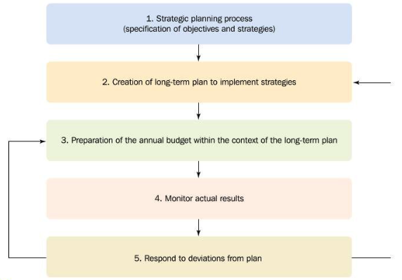

Appendix 2

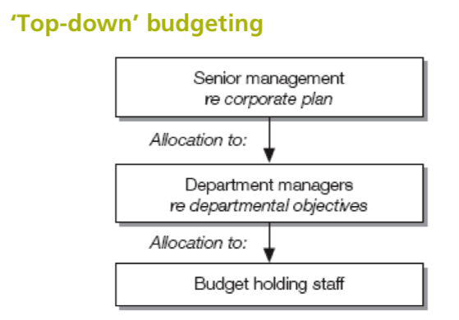

Appendix 3

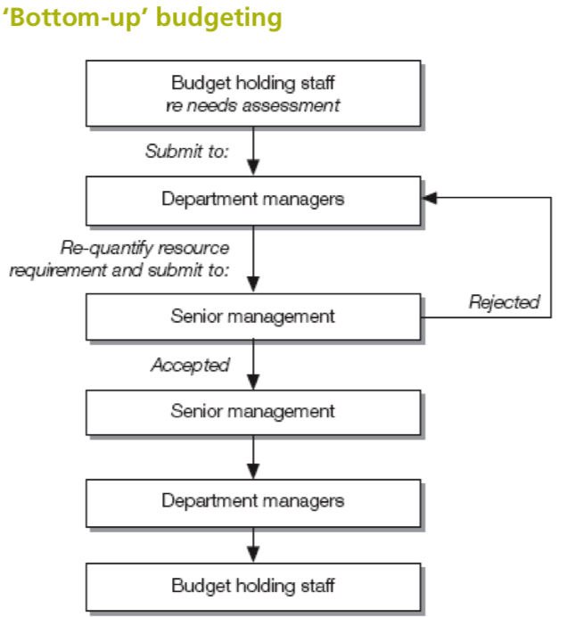

Appendix 4

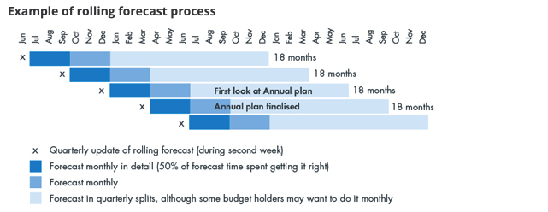

Appendix 5

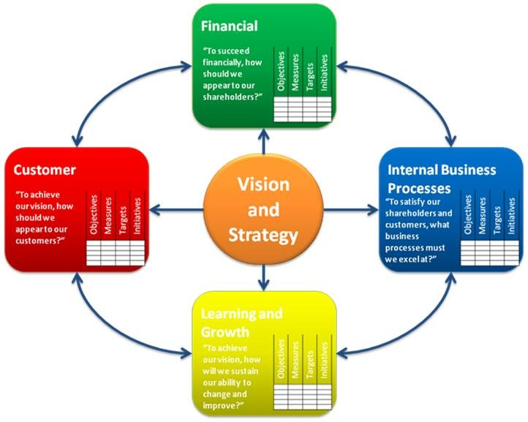

Appendix 6

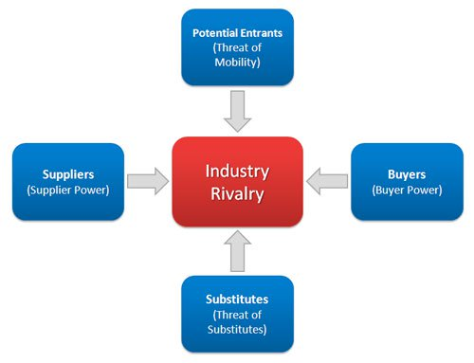

Appendix 7:



