Name Naome Wrightson
Student Number 1907790

Human Evolution and the Origins of Modern Human Behaviour

Practical exercise 2021

Please indicate your response clearly

Looking at faces 1
Look at the following images and then compare them to the list below. Indicate clearly (circle or highlight) the name of the early hominin skull you believe this to be.
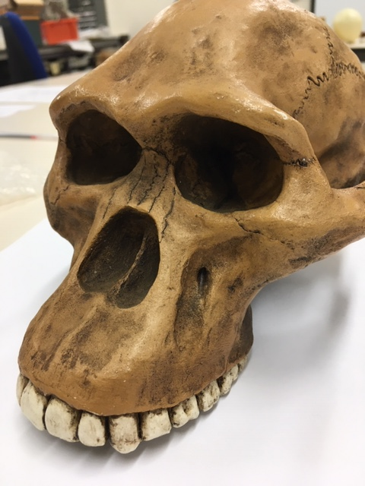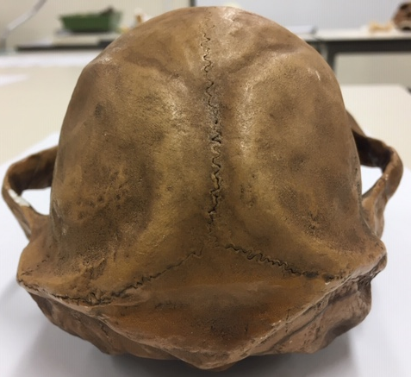

Chimpanzee

Australopithecus afarensis

Australopithecusafricanus

Australopithecus robustus

Homo habilis
Looking at faces 2
Look at the following images and then compare them to the list below. Indicate clearly (circle or highlight) the name of the early hominin skull you believe this to be.
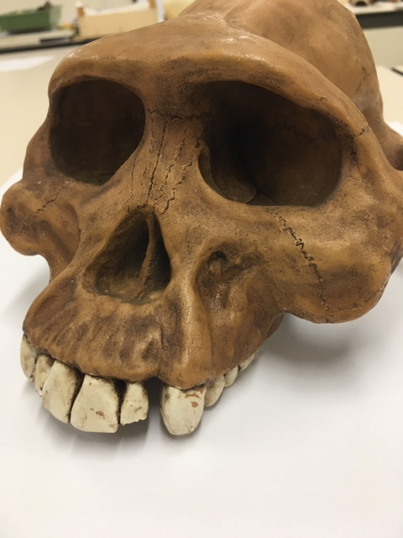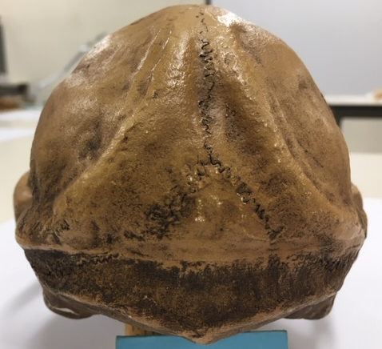

Chimpanzee

Australopithecus afarensis

Australopithecusafricanus

Australopithecus robustus

Homo habilis

Looking at faces 3
Look at the following images and then compare them to the list below. Indicate clearly (circle or highlight) the name of the early hominin skull you believe this to be.
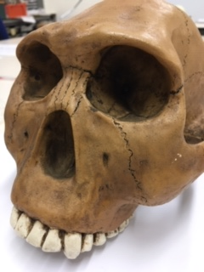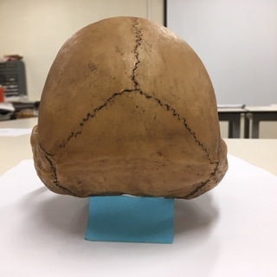

Chimpanzee

Australopithecus afarensis

Australopithecusafricanus

Australopithecus robustus

Homo habilis
Maxilla (upper jaw): Identify the species these belong to
A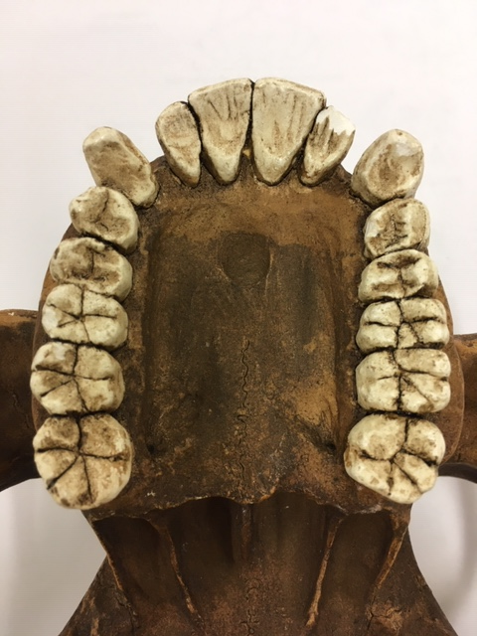B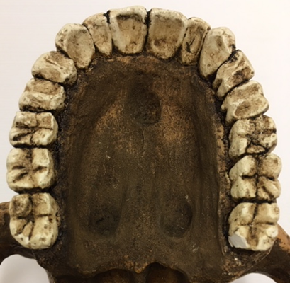
A Australopithecus afarensis B Australopithecus africanus
Top row left Chimpanzee, Middle Australopithecus afarensis, Right modern human
Lower row Left Australopithecus africanus, Right Australopithecus robustus
Indentify the skull to genus and species level
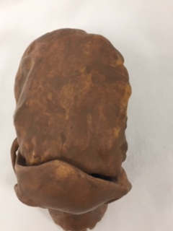
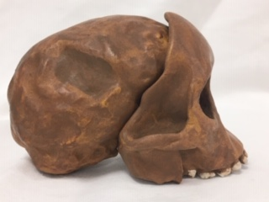
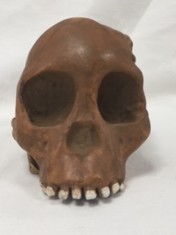
Answer Australopithecus africanus
Indentify the skull to genus and species level
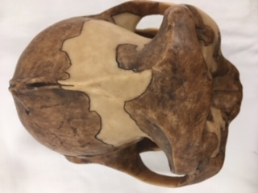
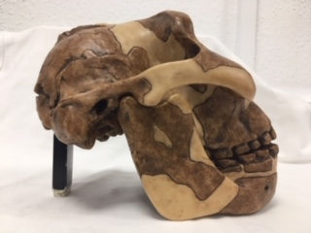
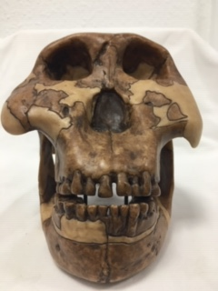
Answer Zinjanthropus boisei (Robust Australopithecus )
Identify the hominin skull to genus and species level
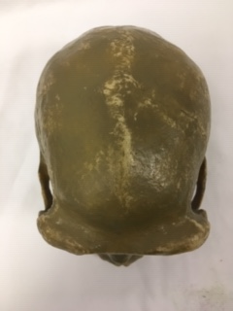

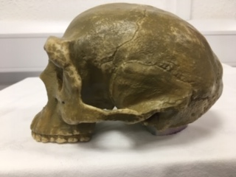

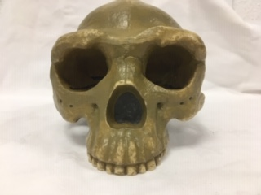
Answer Homo erectus
Indentify the skull to genus and species level
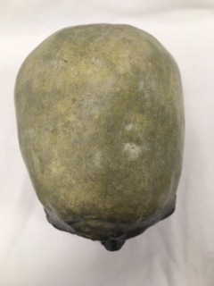
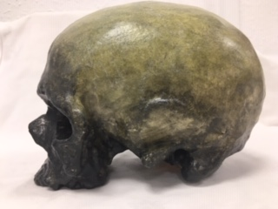
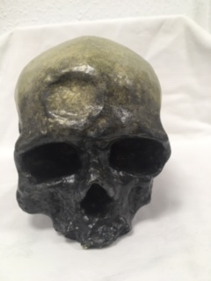
Answer Homo sapiens
Identify, compare and contrast these two mandibles. Use the illustration below to help if you need to.
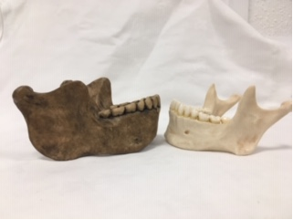
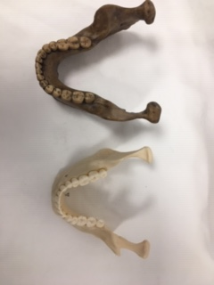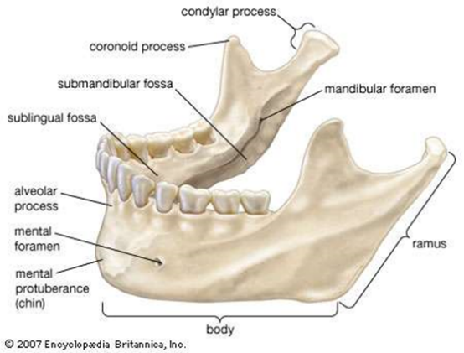

Answer The mandible on the left is Homo heidelbergensis, and the right is Homo sapiens sapiens. The heidelbergensis mandible features a larger parabolic curve compared to the mordern humanon the right. The Homo sapiens sapiens mandible has a smaller body and ramus than that of the heidelbergensis. There is also a distinctive curve beneath the alveolar process excentuating the mental protuberance.

Stone tools and tool technology: How to tell a stone is worked.
What suggests this has been worked?
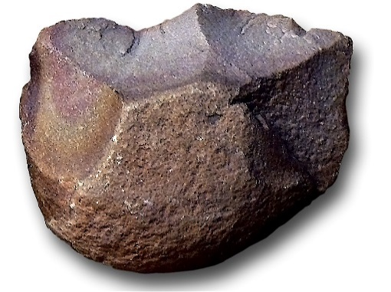
Answer: There are visible sections of the cortex and reworking to create a sharp edge, this creates the scraper shape. The multiple edges of core visible suggest that multiple flakes have been taken of the cortex.

Features of stone tool flaking: identify features 1-5
1. Striking platform
2. Bulb of percussion
3. fissures
4. fracture scars
5. ripple mark
Stone tools and tool technology: Stone tools not to scale
Below left: Oldowan Below Right: Acheulean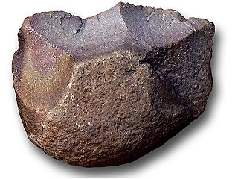 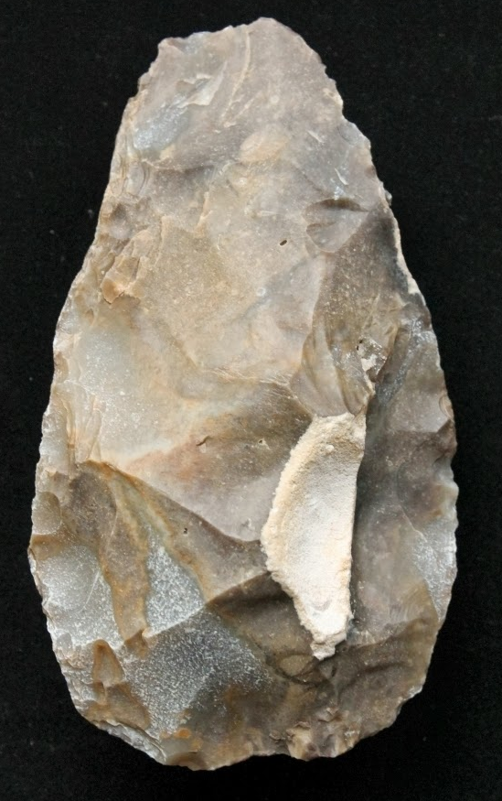
Images taken from https://images.search.yahoo.com

Task: Compare and contrast these two stone tools
The Oldowan tool only has one workable edge while the other surface remains mainly cortex. The Acheulean tool however has little to no visible cortex and shows evidence of working to create multiple sharp edges forming the tear drop shape. The Acheulean axe shows that a lot of time and effort has been placed upon this tool, in the symmetry of the tear drop shape and clear evidence of multiple flakes being taken from the original to create the shape. This contrasts the Oldowan which considerably less time to form, with fewer flakes being taken to create an edge sharper enough for the intended function and would only be useful until blunt whereas the Acheulean would remain sharp longer. There would also be a far greater calue placed upon the Acheulean because of the time and effort that went into the production than the Oldowan.

