Web Applications Development

February 16, 2018
By Steffan Lewis

Table of Contents
ERD 4
Data Dictionary 5
Users 5
Messages 6
Equipment 6
Event 7
Loginlog 7
UniqueEquipment 8
BMI 8
SQL Scripts 9
Storyboard 12
Home Page 12
Login Page 12
Dashboard Page 13
View Unique Equipment Page 13
Add Unique Equipment Page 14
Message Page 14
View Equipment 14
Event Page 14
Add Equipment 15
Members Page 15
Settings Page 15
Add User Page 16
Source Code 17
Analytics index page 17
Dashboard 23
Add Equipment page 33
Equipment index page 39
Add equipment type page 43
Equipment Type index page 48
Add Event page 52
Delete Event page 59
Event index page 60
Member Navigation 75
Navigation link 77
Staff Navigation 78
Top Navigation bar 80
Loading Screen 81
Footer Links 82
Header Links 84
Login index page 87
Login user script 90
Log out script 92
Blank Page 93
Configuration script 96
Add user page 97
Check user script 106
Delete all user script 107
Delete user script 109
Settings index page 110
View User page 121
Add update page 134
Updates index page 139
Redirect link to index page 144
List of procedures/functions 145
List of Variables 146
Analytics 146
Index.php 146
Dashboard 147
Index.php 147
Equipment 148
Index.php 148
Addequipment.php 148
Equipment type 148
Addequipmenttype.php 148
Index.php 149
Event 149
Addevent.php 149
Deleteevent.php 150
Index.php 150
Viewevent.php 151
Login 151
Index.php 151
Login-user.php 151
Logout.php 152
Other 152
Blank-page.php 152
Settings 152
Adduser.php 152
Deletealldata.php 152
Deleteuser.php 153
Index.php 153
Viewuser.php 154
Checkuser.php 154
Updates 155
Adduser.php 155
Index.php 155

Screenshots of Gym Application

Analytics index page
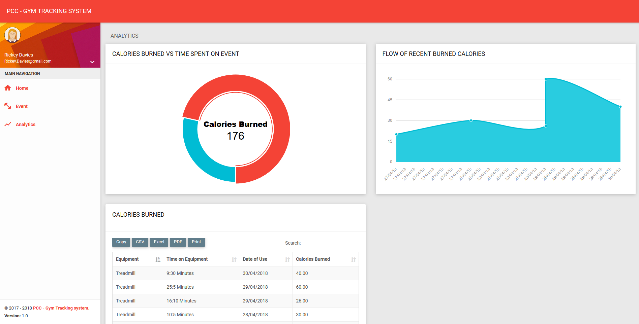

Dashboard page

Staff
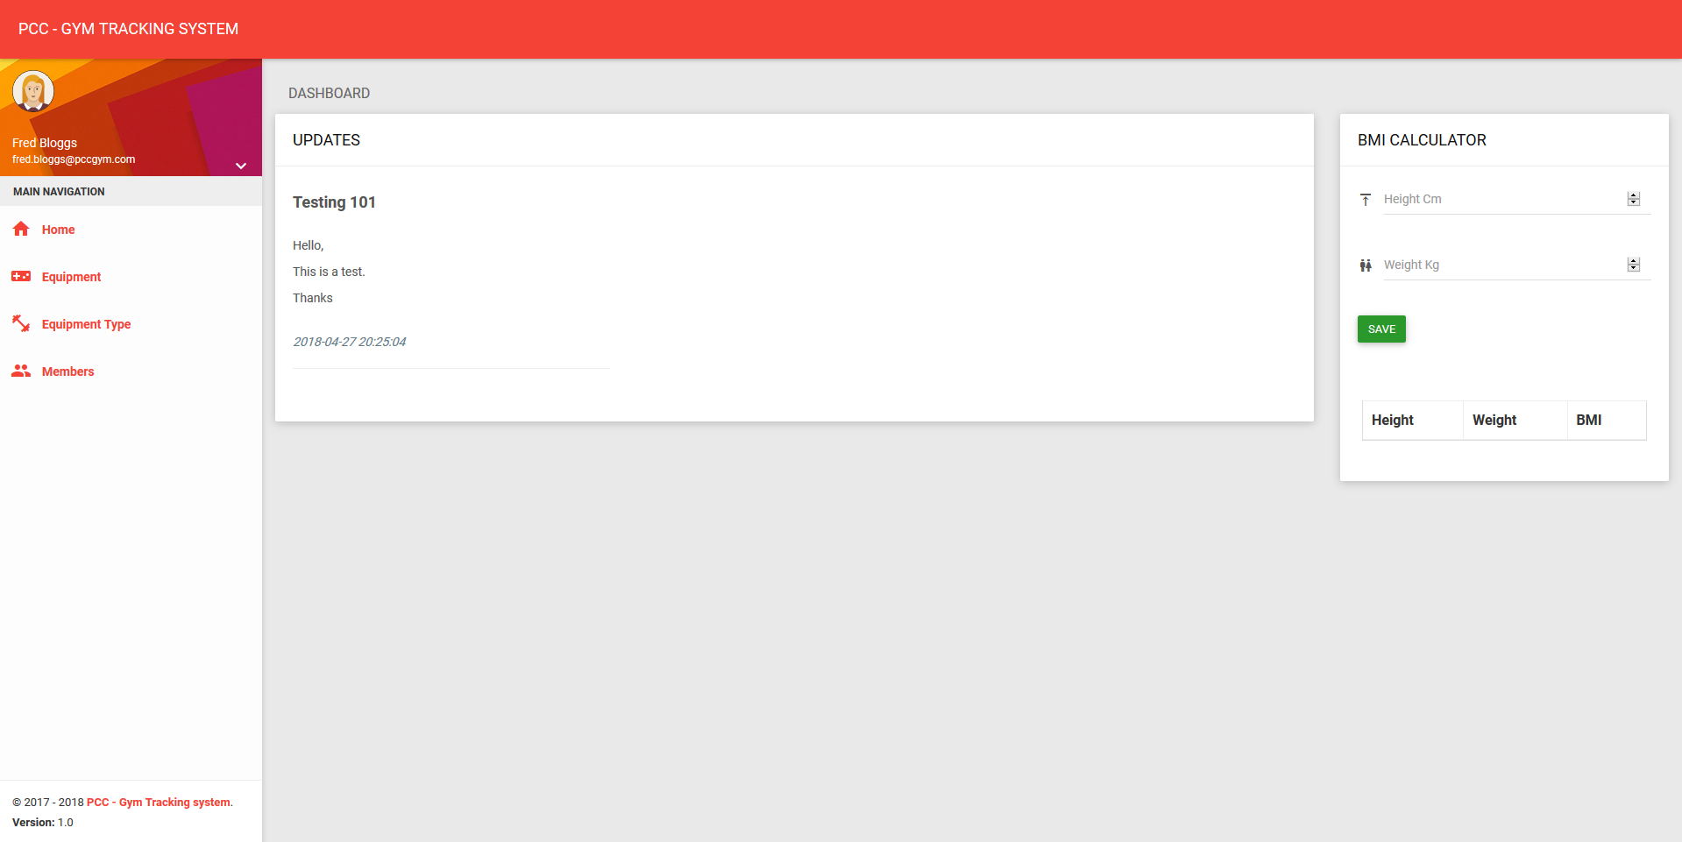

Member
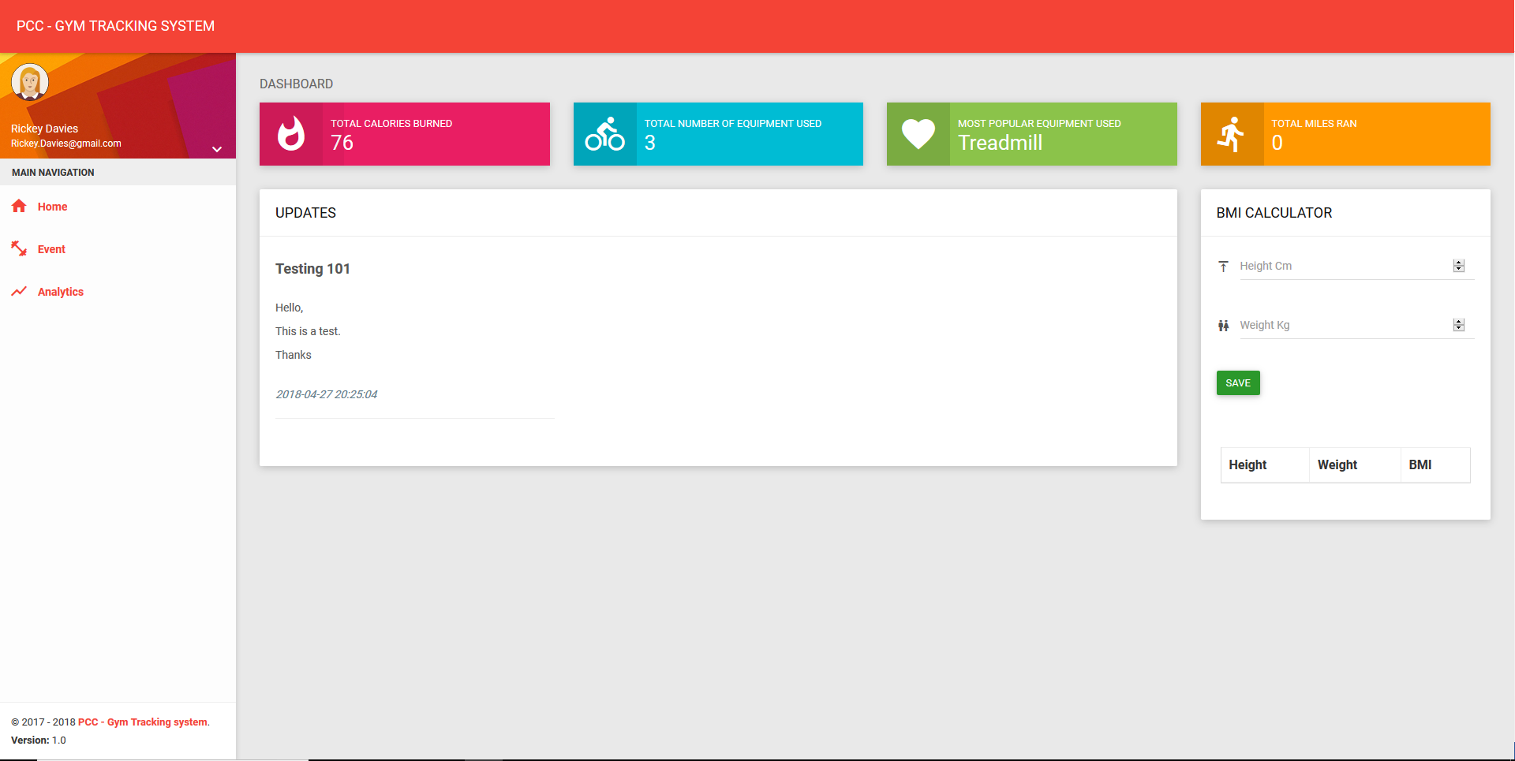

Admin
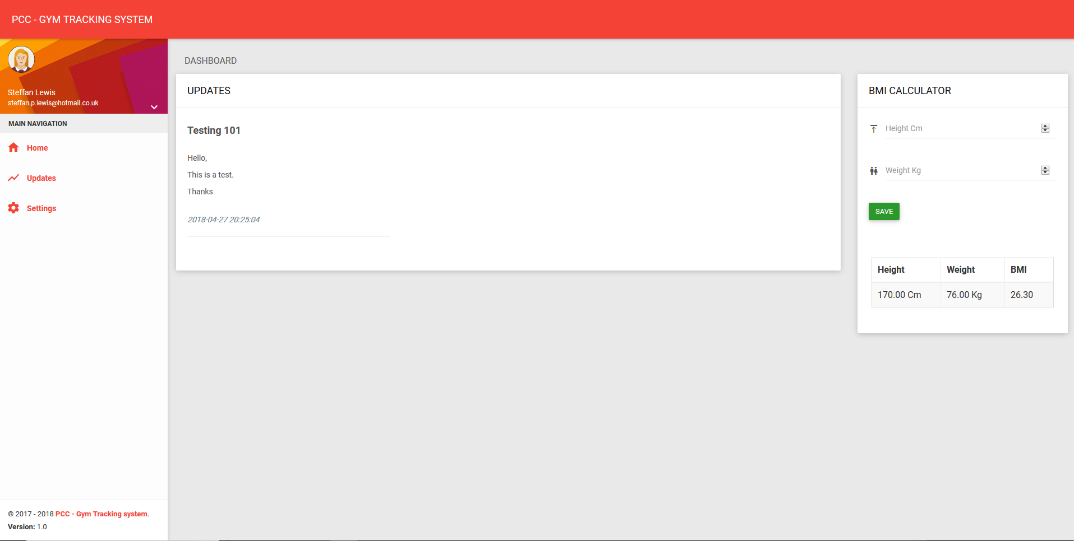

Add equipment page
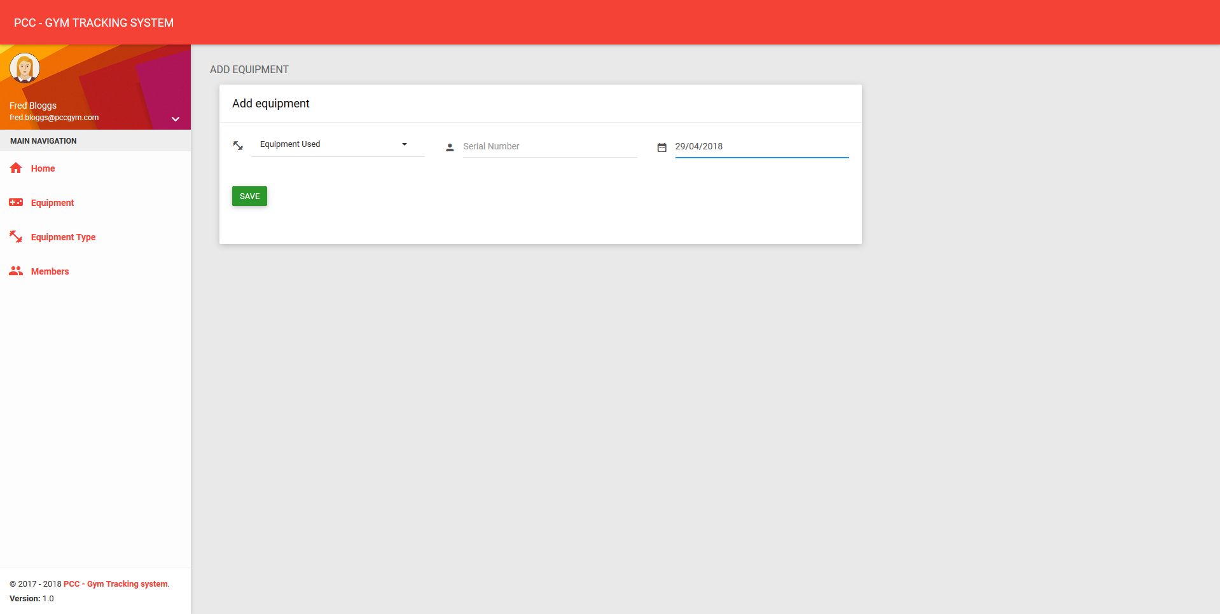

Equipment index page
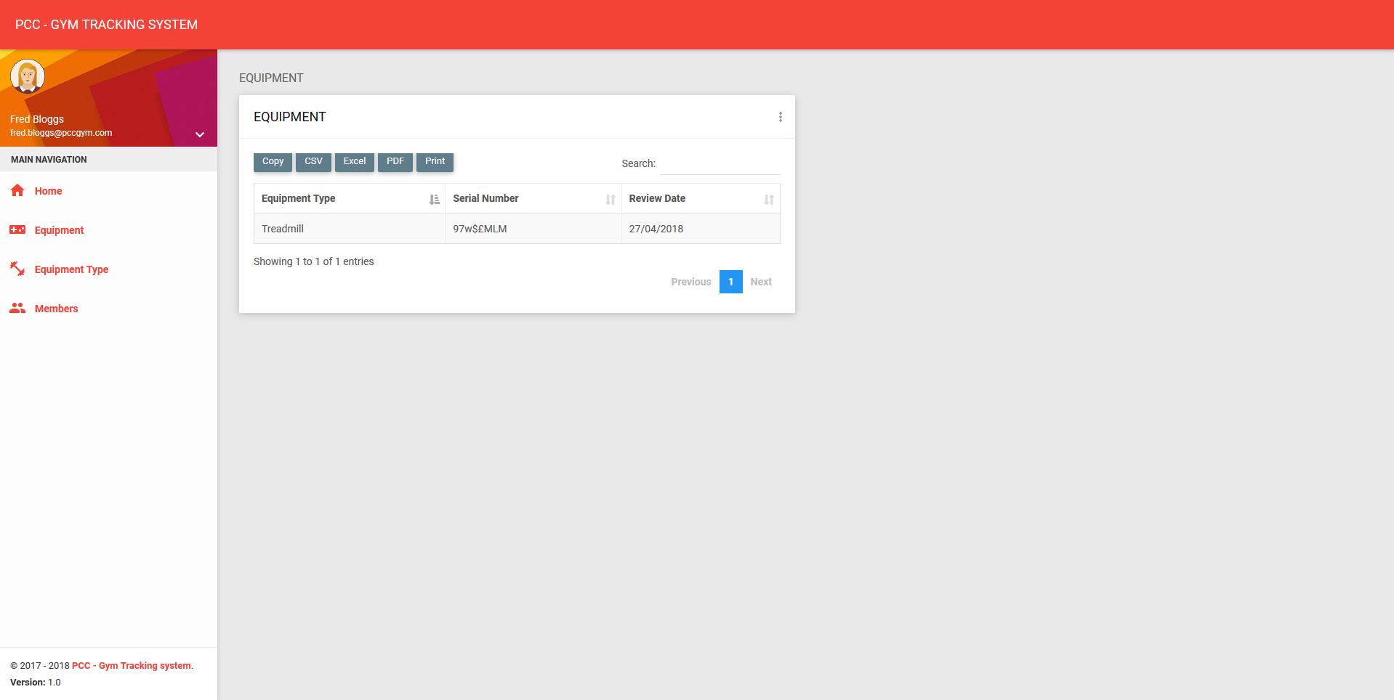

Add equipment type page
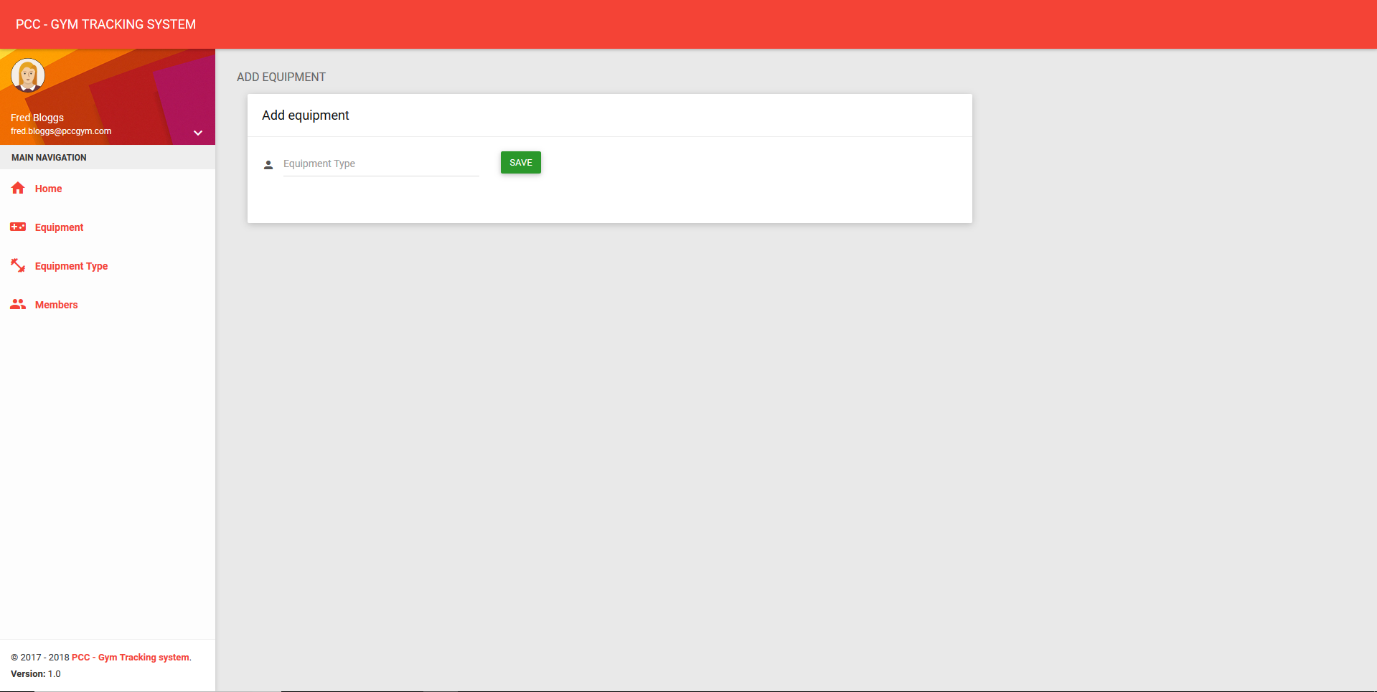

Equipment Type index page
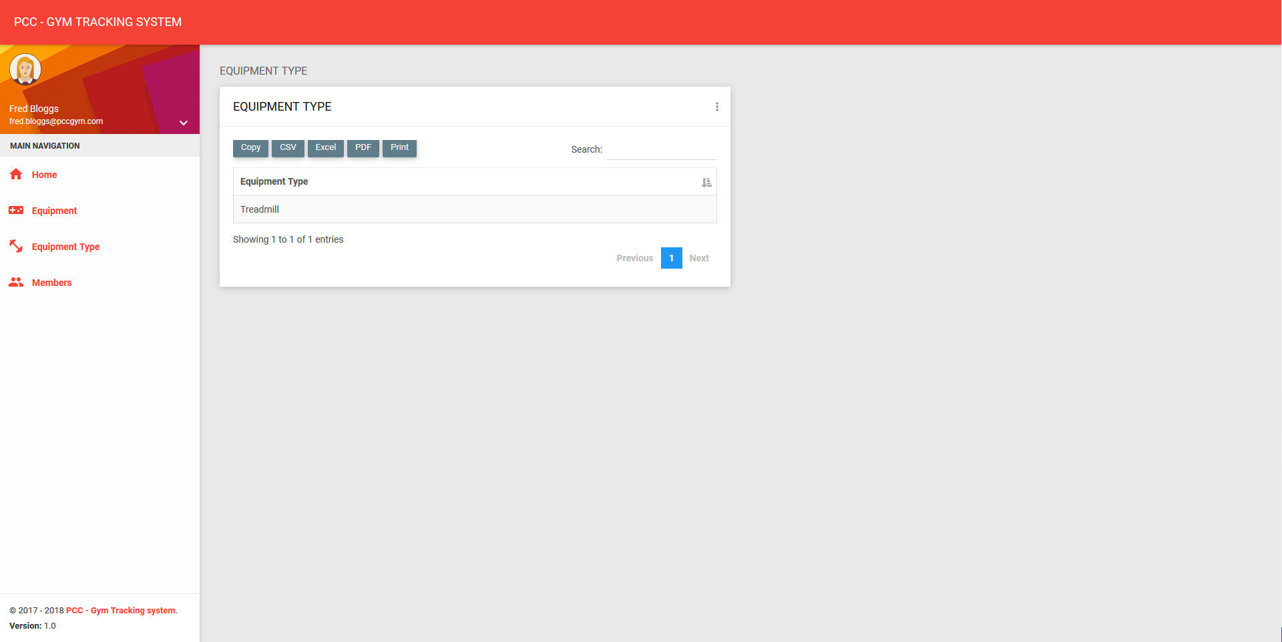

Add Event page
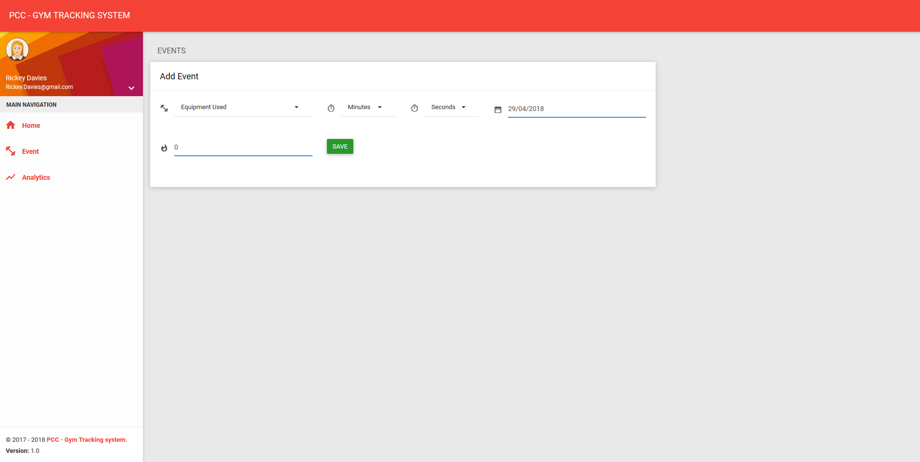

Event index page
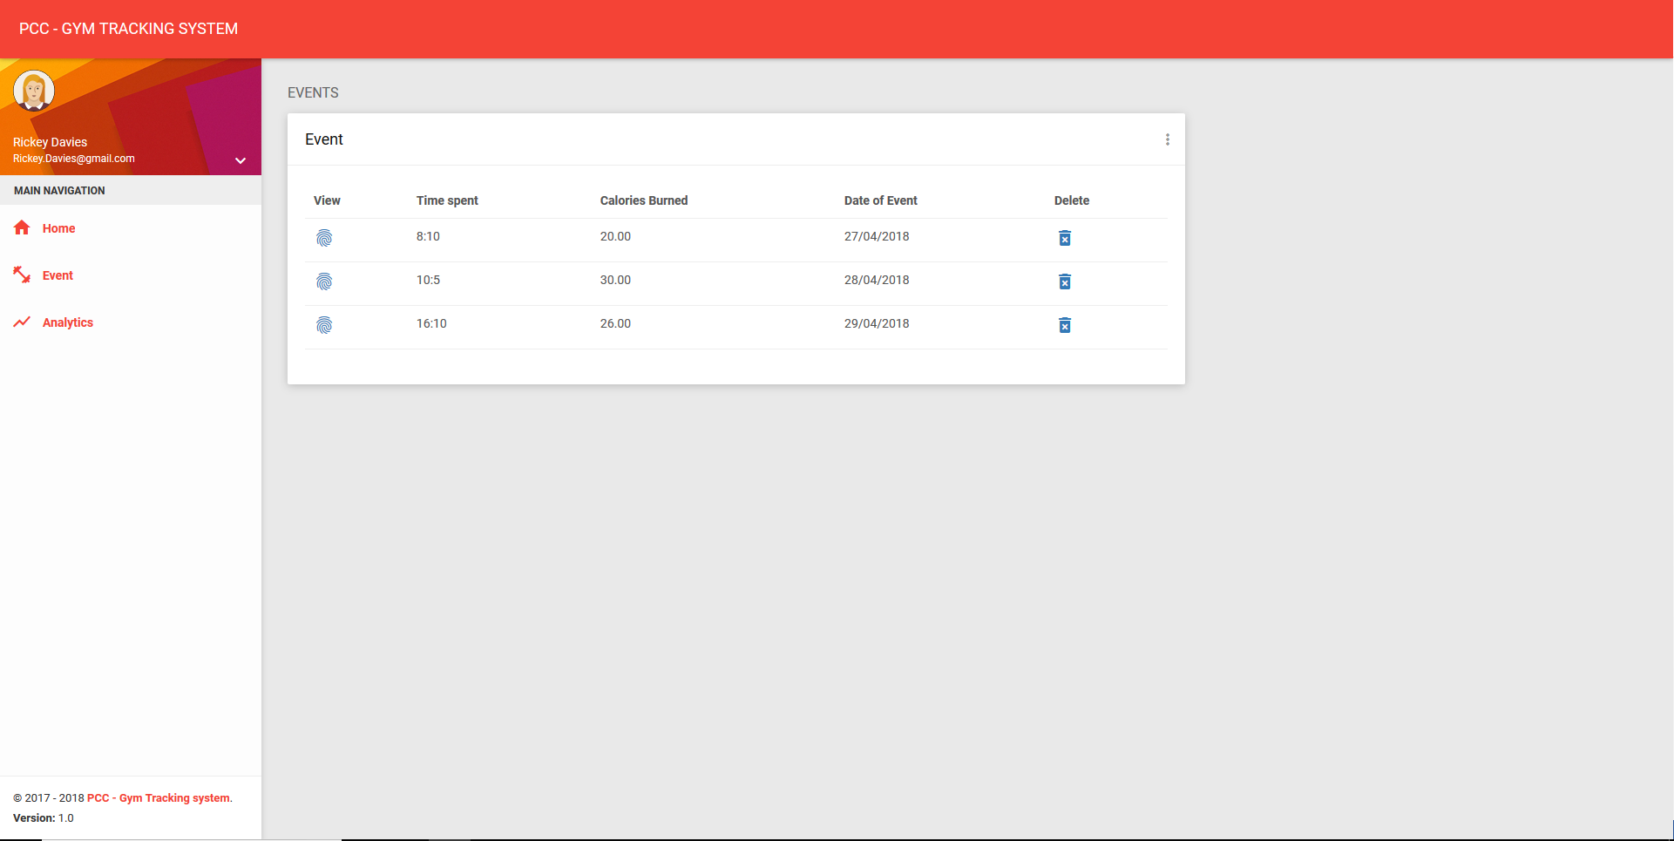

View Event page
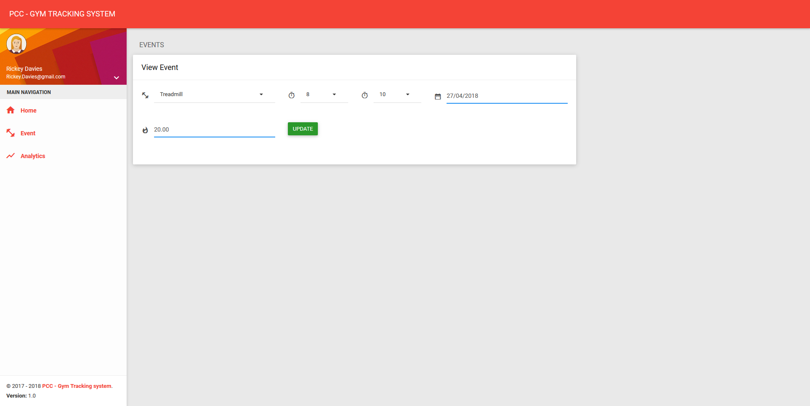

Login index page
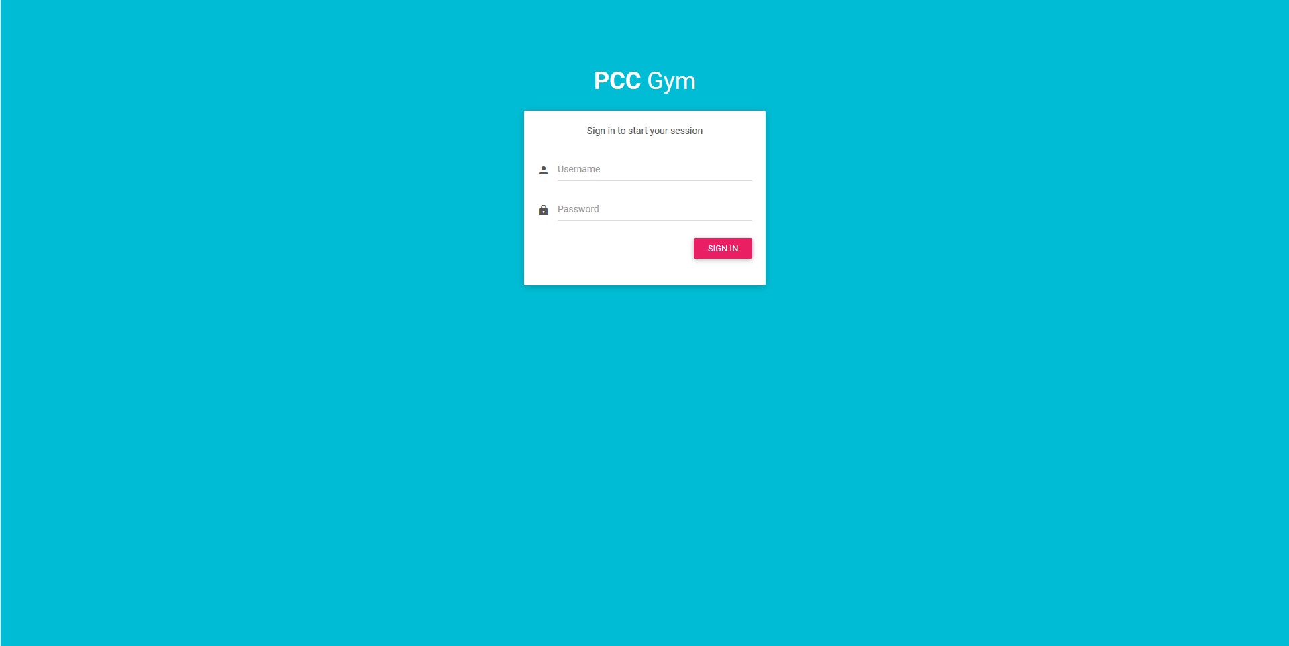

Blank page

Settings index page

Staff
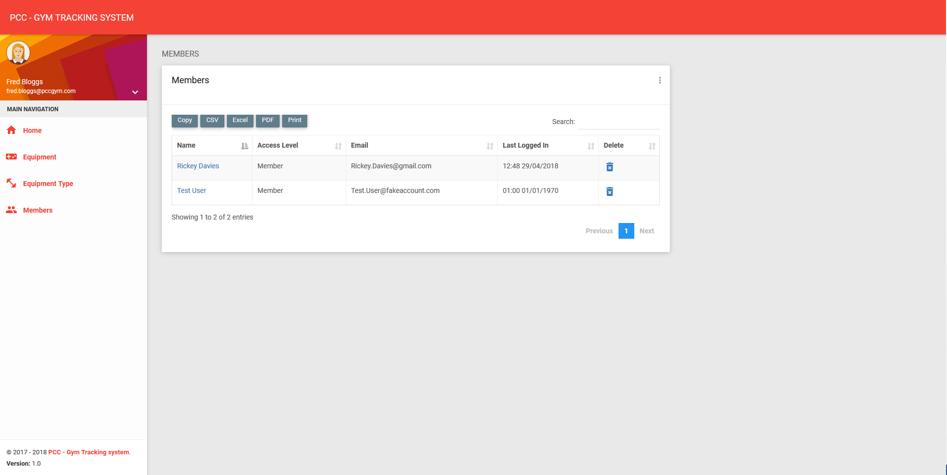

Admin
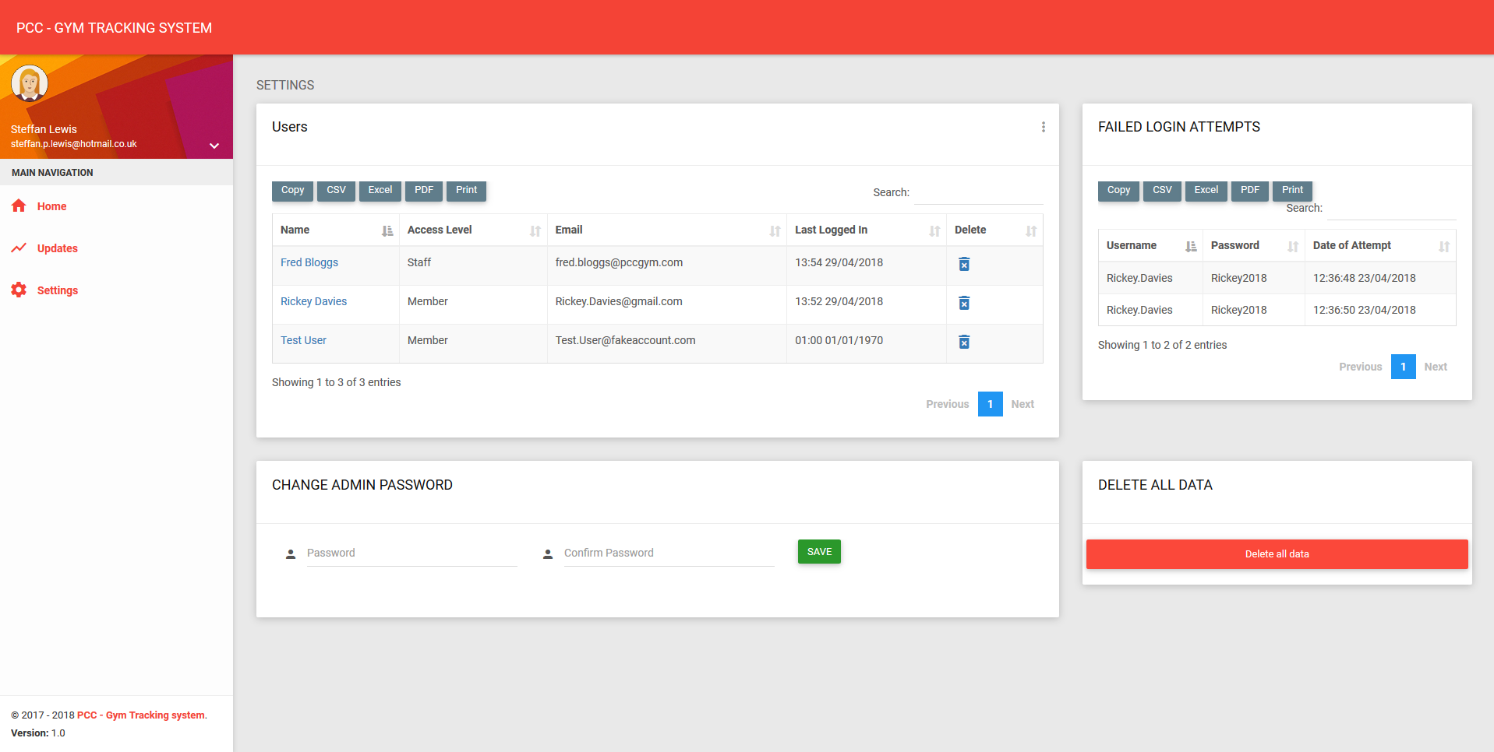

Add User page
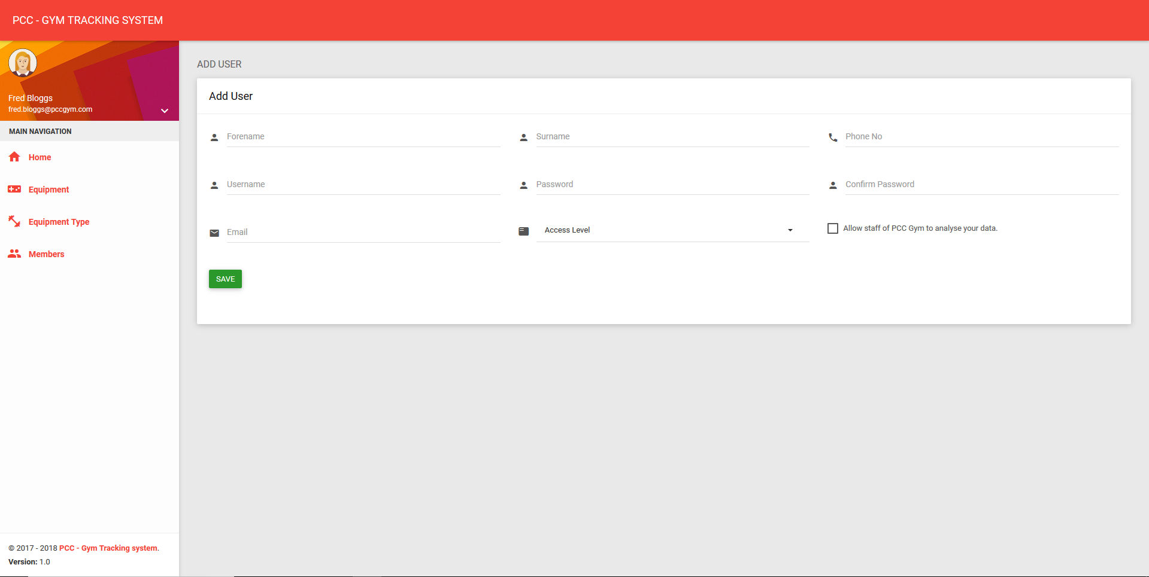

View User page

Staff
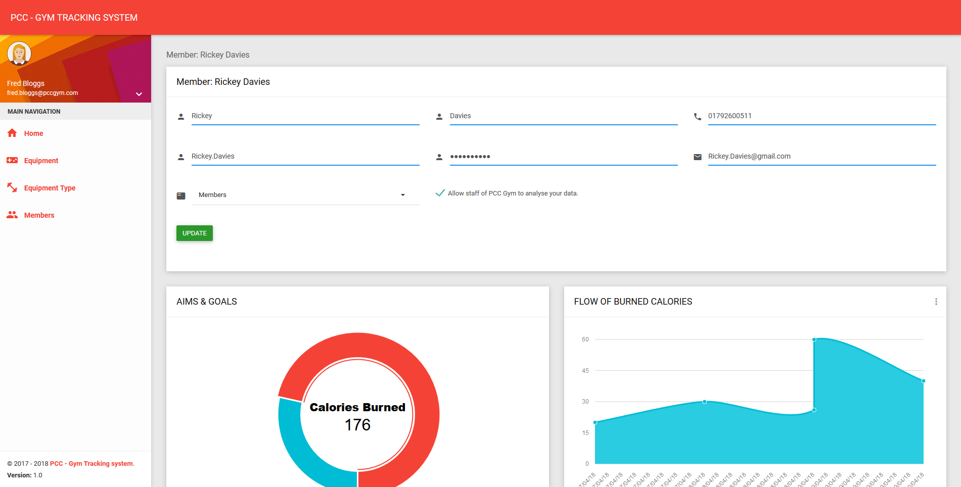

Admin
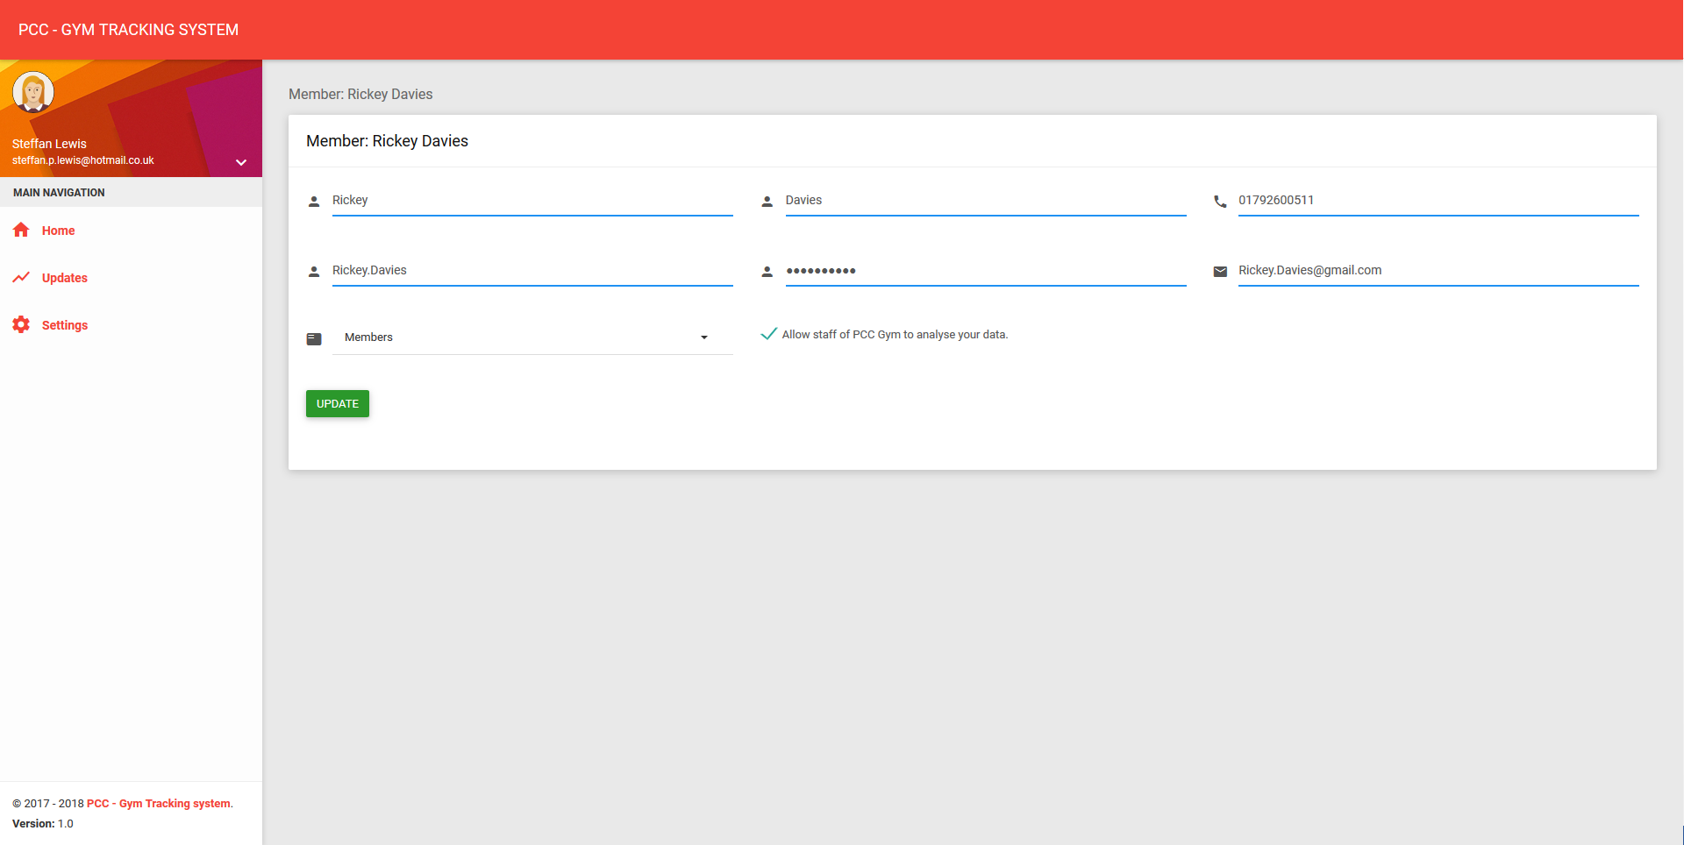

Add Update page
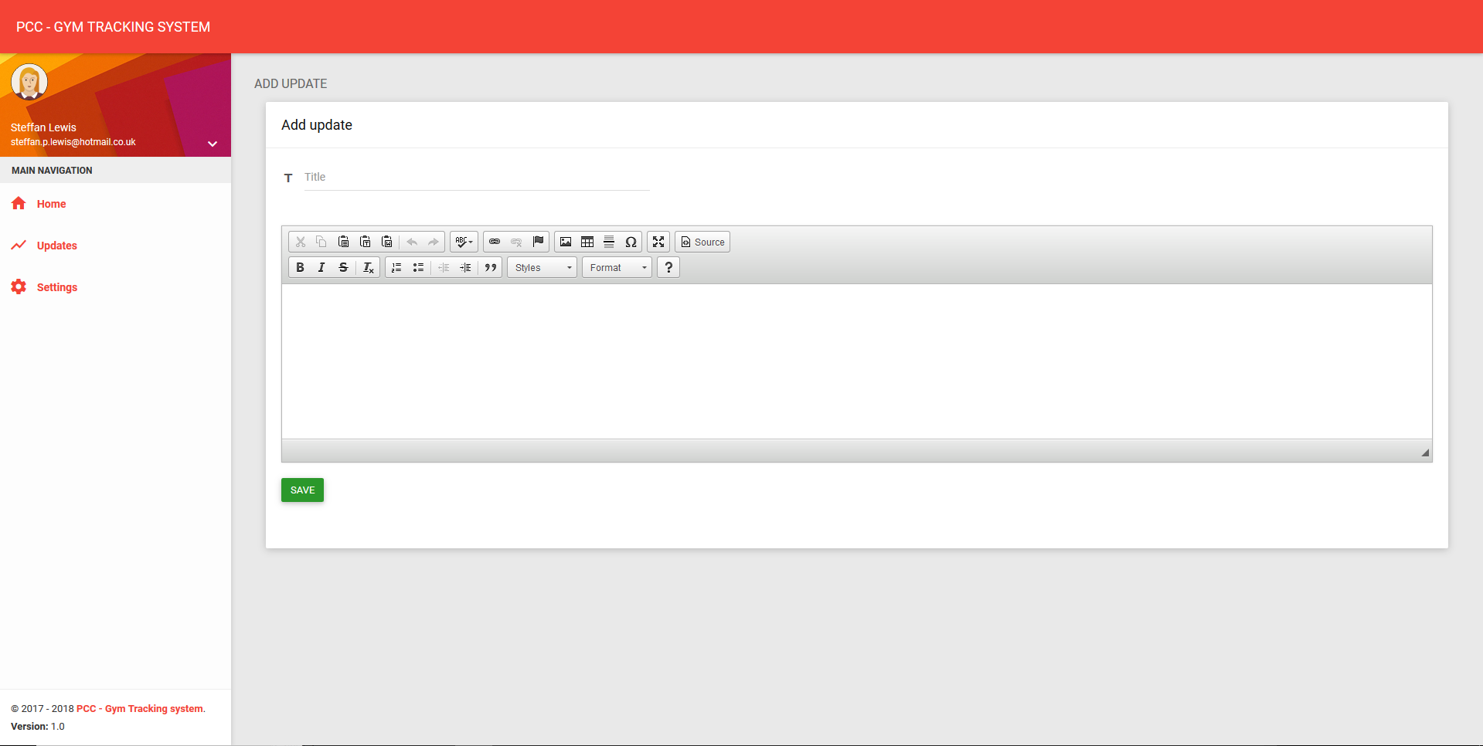

Update index page


