ASD Pathfinding Assignment

Student Name : Teifion Gibson
Student Number : 2304294
CONTENTS

Comparison of Dijkstra's and A* path-finding algorithms 3
Development of a Path-finding solution 5
Appendix 8
Solution code 8
References 11

Comparison of Dijkstra's and A* path-finding algorithms
The first part of the assignment asks for a brief discussion of Dijkstra's algorithm and the A* path-finding algorithm, and compare the two in terms of efficiency and usage scenarios.

Dijkstra's algorithm is a path-finding algorithm designed to find the shortest path in a set of data. Dijkstra's algorithm is often used in GPS software to find the shortest path from a point to a destination [1], effectively Dijkstra's algorithm begins at a starting node on a graph, and then analyses the graph to find the shortest amount of nodes to travel from that node to others in a graph[1].

The algorithm keeps track of the shortest known distance from each node to the source node, and updates the values if a shorter path is found[1], these nodes are marked as visited. This algorithm repeats itself until all the nodes in the graph are added to the path, this is then used to identify and show the shortest path from the source node, to the rest of the nodes in the graph[1], Dijkstra's algorithm has a Big O notation of O(N2) when implemented into an array [4], this is a good speed algorithm when implemented.
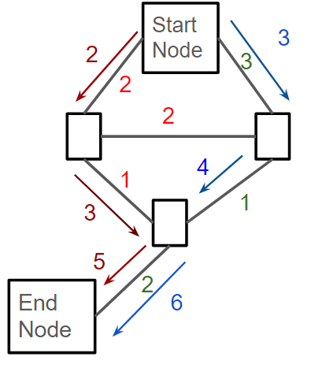
Fig 1: Visualization of Dijkstra's Algorithm traversing a binary tree

Dijkstra's algorithm calculates the shortest path by adding the cumulative cost of the path of nodes to reach the end node[5]. Then the path with the lowest cost is the most efficient path found, therefore the algorithm checks all nodes, this process is shown in the image above. The cost to traverse the nodes are in green, the red arrows are where the algorithm traverses first then after finding the end node it starts again to attempt to find a shorter path, this is shown by the blue arrows, this is repeated until all potential paths have been found, the lowest cost path is saved and returned, showing the resulting path, the shortest path is determined by the path with the lowest total cost to traverse the tree.

The A*algorithm, is a path-finding algorithm, designed to approximate the shortest path, to an exit [2]. It has common usage for maps, and can be applied to approximate the shortest path to a point[2]. The A*algorithm is using a combination of two different algorithms, the Dijkstra's algorithm, which is used to find the shortest path between the nodes, and the greedy best first search algorithm which explores the node closest to the End node, based on a heuristic function[3]

The A*algorithm in the worst case scenario has a big 0 notation of O(N) as it may have to traverse every node to find the best path available. This is the same notation for djinstra in the worst case scenario as both algorithms will have to traverse the entire tree to find the shortest path available. A* will check each path available until a path is found with a priority for paths that approach the exit first.

While Dijkstra's starts by searching from the starting node[1], while the A*algorithm prioritizes from the start node the paths that are closer to the position of the exit to the maze[3].
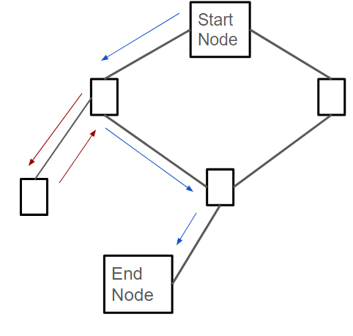
Fig 2: traversal visualization of A* algorithm on a binary tree

In the visualization above the algorithm traverses the tree from the closest path to the exit before backtracking to a split, and taking the next available path, this is repeated till the exit is found. Once the exit is found the path with minimum moves found is shown in blue above while the red arrows are the total traversed path.

Development of a Path-finding solution
The implemented solution uses a do while loop until the exit is reached by the path-finding algorithm. The solution begins by moving the player up in the maze, until a wall is reached. The coded solution also updates the y values which are used to track location in the grid. This function is looped while the UpCheck bool is set to true, if a wall is reached this is set to false advancing the loop to the next condition, all loops within this solution are do while loops.
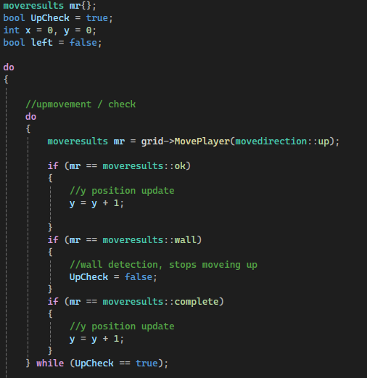
Fig 3: UpCheck function in solution

The left movement check in the code moves the player one tile to the left, before it sets UpCheck to true, and the code loops back to the UpCheck function. The code only runs if the left bool is true, by default it is false as the player starts in the bottom left corner, so it's inefficient to check the left when the code starts. If the wall is detected the left bool is set to false, meaning the right movement function will trigger next, before the code loops back to the up movement function.
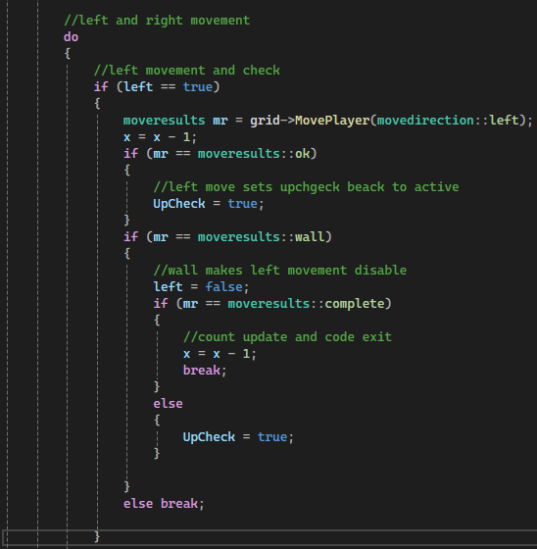
Fig 4: Left movement function
The right movement function is functionally similar to the left movement function; the major difference in this function is that the movement check is to the right of the player. Additionally when the loop ends for the right movement function then the UpCheck function is set to true. Both the left and right movement functions loop, while the UpCheck bool is false.

There is another loop for the x and y, which ends the larger path-finding algorithm
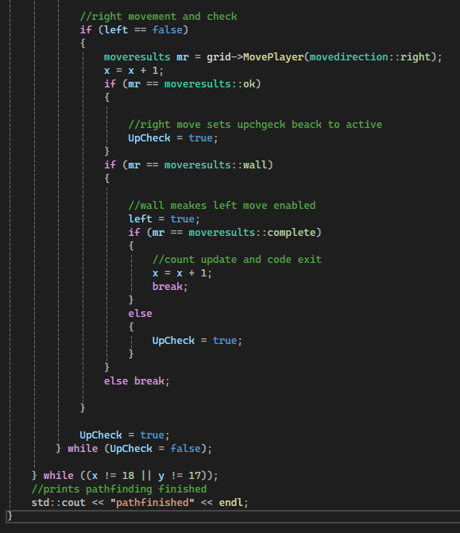
Fig 5: right movement function
The path-finding solution finds the path to the exit of the maze every time, it has some benefits as it checks path movement towards the exit first, however when moving up, the search will move away from the exit if the movement is moving to the left, additionally the solution works by colliding with a wall and then returning if its a wall, this increases the amount of moves needed to find the exit.
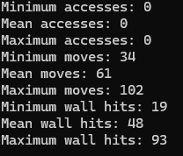
Fig 6: path-finding efficiency results

In conclusion this is an efficient and effective solution for reaching the exit, however it has some flaws that may be able to be improved within the solution. The code may loop too often, and if the exit is not found such as an incorrect xy value, or the maze is larger/smaller, the code will not finish.

Appendix

Solution code
void GridNavigatorAutomatic::Navigate()
{

moveresults mr{};
bool UpCheck = true;
int x = 0, y = 0;
bool left = false;
do
{
do
{

//upmovement / check
do
{
moveresults mr = grid->MovePlayer(movedirection::up);

if (mr == moveresults::ok)
{
//y position update
y = y + 1;

}
if (mr == moveresults::wall)
{
//wall detection, stops moveing up
UpCheck = false;
}
if (mr == moveresults::complete)
{
//y position update
y = y + 1;
}
} while (UpCheck == true);

//left and right movement
do
{
//left movement and check
if (left == true)
{
moveresults mr = grid->MovePlayer(movedirection::left);
x = x - 1;
if (mr == moveresults::ok)
{
//left move sets upchgeck beack to active
UpCheck = true;
}
if (mr == moveresults::wall)
{
//wall makes left movement disable
left = false;
if (mr == moveresults::complete)
{
//count update and code exit
x = x - 1;
break;
}
else
{
UpCheck = true;
}

}
else break;

}

//right movement and check
if (left == false)
{
moveresults mr = grid->MovePlayer(movedirection::right);
x = x + 1;
if (mr == moveresults::ok)
{

//right move sets upchgeck beack to active
UpCheck = true;
}
if (mr == moveresults::wall)
{

//wall meakes left move enabled
left = true;
if (mr == moveresults::complete)
{
//count update and code exit
x = x + 1;
break;
}
else
{
UpCheck = true;
}
}
else break;

}

UpCheck = true;
} while (UpCheck = false);

} while ((x != 18 || y != 17));
//prints pathfinding finished
std::cout << "pathfinished" << endl;

} while ((x != 18 || y != 17));
//prints pathfinding finished
std::cout << "pathfinished" << endl;
}

References
[1]
E. C. Navone, “Dijkstra’s Shortest Path Algorithm - A Detailed and Visual Introduction,” freeCodeCamp.org, Sep. 28, 2020. https://www.freecodecamp.org/news/dijkstras-shortest-path-algorithm-visual-introduction/ (accessed Jan. 16, 2025).
[2]
R. Belwariar, “A* Search Algorithm - GeeksforGeeks,” GeeksforGeeks, Sep. 07, 2018. https://www.geeksforgeeks.org/a-search-algorithm (accessed Jan. 16, 2025).
[3]
R. Kumar, “The A* Algorithm: A Complete Guide,” Datacamp.com, Nov. 07, 2024. https://www.datacamp.com/tutorial/a-star-algorithm (accessed Jan. 16, 2025).
[4]
geeksforgeeks, “Time and Space Complexity of Dijkstra’s Algorithm,” GeeksforGeeks, Feb. 09, 2024. https://www.geeksforgeeks.org/time-and-space-complexity-of-dijkstras-algorithm/ (accessed Jan. 16, 2025).
[5]
S. SHANKAR, “Dijkstra’s Algorithm: Unlocking the Path to Efficient Graph Navigation!,” www.linkedin.com, May 29, 2023. https://www.linkedin.com/pulse/dijkstras-algorithm-unlocking-path-efficient-graph-shubham-shankar/ (accessed Jan. 16, 2025).

