Bridget Edoghogho Albert

5200452

MBA Sustainability Leadership

BMSP7001

Dr Laura James

Magazine Article

14th November 2025

Sustainability Challenge for Businesses
Millions of People are Trapped in Forced Labour: How Ethical Leadership Can Help Organisations Tackle Forced Labour

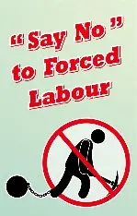
FORCED LABOUR:
Forced labour as defined by the International Labour Organisation (ILO) Forced Labour Convention (No 29) 1930 “all work or service which is exacted from any person under the threat of penalty and for which the person has not offered himself / herself voluntarily” (Lerche, 2007). The definition emphasises the absence of genuine consent and coercion. Making forced labour directly violating the fundamental human rights of the individuals.
Forced Labour is a Sustainability Challenge for Businesses:
This is because forced labour is a severe human rights violation. It stands for an extreme social risk, not only a moral and legal failure but also a risk for organisations to achieve ethical and a sustainable operation, which leads to a significant legal penalties, reputational damage, and shareholder divestment. Therefore, addressing forced labour requires a proactive commitment with ethical leadership and effective human rights due diligence across the levels of corporate governance.
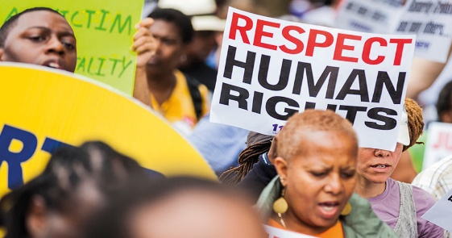
Human Rights: These are fundamental entitlements that belongs to every individual and affect all aspects of their life. They ensure these rights are treated fairly with respect and dignity. It also includes the freedom to voice ideas openly. Human rights protect individuals from arbitrary or excessive actions that could result in the loss of life or liberty, degrading treatment, or intrusion into personal privacy (Amengual et al., 2022).
In business context, human rights specifically include, safe working environment, freedom from discrimination, fair remuneration and equal pay for equal work, privacy, and the right to be protected from forced labour and trafficking (United Nations, 2011). Forced labour undermine sustainability in the business context by directly violating human rights through organisations by perpetuating inequality, exploiting vulnerable workers, and compromising supply chains.
Acknowledging that human rights are embedded within sustainability frameworks, organisations are increasingly expected to address issues such as forced labour as part of their commitment to both ethic responsibility and business performance, moral obligation, and strategic advantage. Integrating these principles help the organisations support their brand reputation, customer trust, and enhance long term resilience according to Equality and Human Rights Commission, EHRC (2019).
Relentless Pursuit of Profit:
Firstly, globalisation has created both opportunities and complexity.
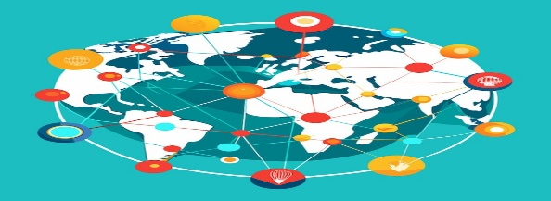
Globalisation is an important issue regarding sustainability, and this issue of globalisation is how is define and measure according to Protrafke, (2015), as a multifaceted concept that includes economic, social, and political dimensions extending beyond indicators such as open trade and capital movement. It shows the growing interconnection of markets, societies, and governance systems across the world. Compassing the complexity and comprehensive indices have been developed integrate economic, social, and political factors to measure the depth and impact of global integration.
Secondly, as businesses increasingly operate globally and complex supply chains, this has a significant influence on the individual by shaping the consumers experiences, workers, and the communities. As a result of these, organisations are supposed to recognise any human rights abuse and remedy according to regulatory bodies. When organisations are not recognising and preventing the human rights abuses, this may lead to serious consequences for businesses such as forced labour, unsafe working environment, and harmful environmental practices. These abuses not only directly to harm the individuals but also impact on business negatively, leading to a loss of contracts, reputation damage and most seriously closure.
Finally, the Case Study: This was starkly evident in cocoa production across West Africa, particularly in Ghana. Reports shown that low costs production and expansive global supply chains contribute to widespread forced and child labour. The world largest chocolate manufacturer has been criticised for failing to adequately monitor the supplier practices, to avoid forced labour. However, this revealed a persistent gap between corporate commitments to ethical sourcing and realities on the ground. (Berlan, 2013). This example highlights how commercial pressures to minimise costs can undermine corporate social responsibility and expose the limitations of voluntary compliance framework.
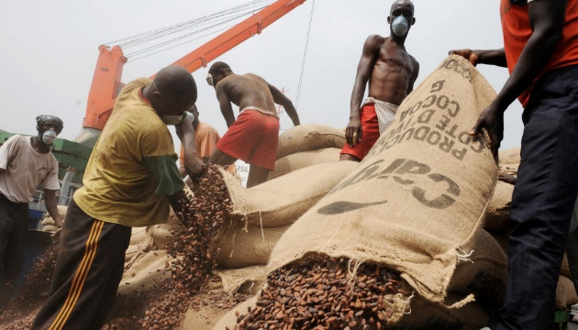
Understanding the Complexity of Forced Labour
The complexity of the global chains supply has allowed unethical labour practice such as forced labour a modern form of slavery. Over the last two decade it has be evidenced by statutory, voluntary agencies, investigative journalists and academics confirming that Modern Slavery, specifically forced labour is present across the UK in different industries and locations (Scott et al., 2012). In addition, Modern slavery is one of the most severe challenges and risks facing industrial global supply chains today. According to the International Labour Organisation (ILO in 2017), in 2016 an estimated 40.3 million people worldwide were victims of modern slavery, including approximately 24.9 million in forced labour. These figures prove that exploitative labour practices are not confined to developing regions but continue to exist across industries in both developed and emerging economies (Gold et al., 2015).
According to Lotfi & Pisa (2024), for decades the global supply chains has enabled companies and consumers in wealthier nations to ignore the conditions under which the goods are produced in the industrial supply chains. The disconnection underscores the urgent need for stronger international regulation, ethical procurement practices and enhanced supply chain that is transparent to combat modern slavery such as forced labour effectively. The figure above is deeply highlighting the embedded forced labour is within the economic systems. Urging the need for regulatory enforcement, ethical leadership, and accountability to address the issue urgently and effectively.
This also signify that forced labour have become a key dimension of sustainability that falls under the social pillar of sustainability of the Environmental, Social, and Governance (ESG). According to Buhmann (2017), organisations are expected to consider the social impacts, environmental, and financial performance of operations to reflect the principles of the triple bottom line sustainability that measure business’ success in three key areas. These are profit, people, and the planet. This framework identifies that long term profitability does not depend only on ethical governance, but it also includes respect for people and the planet. In addition, the due diligence describes range of processes and procedures for organisations to put in place for their business to identify, avoid and monitor forced labour. This emphasises that it is important for business enterprises to ensure that human rights are respected to avoid forced labour. This means, in practice, adopting comprehensive human rights through due diligence systems that identify, prevent, and mitigate risks throughout supply chains which is very important for organisations. This will support regulatory compliance, enhance trust, and contribute to the creation of a fairer and more sustainable global economy, thereby eliminating challenges for sustainability.
Accountability/ Ethical Leadership: turning policy into practices.
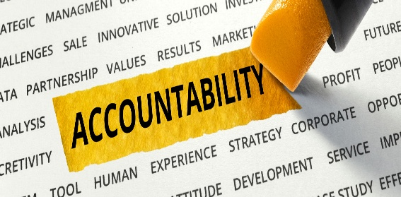
Accountability: Accountability of today’s major corporations is under increasing scrutiny by communities and stakeholders worldwide, as interest grows in developing genuine sustainable industries. Sustainability is generally understood as an approach to development that meet the needs of the present generation without compromising the ability of the future generations.
In business context, corporate sustainability is defined as an organisation’s capacity to maintain economic long term in the context of environmental responsibility and social stewardship. This connection is crucial, as human rights are not separated from economic and environmental concerns in modern sustainability frameworks. Consequently, sustainability reporting has emerged to systematically measure, disclose, and be accountable to both internal and external stakeholders for performance towards the goal of sustainable development to avoid challenges (Baskaran et al., 2012). This highlights that it is very important to mandate and motivate organisations to implement the due diligence, to ensure transparency, and establish a clear legal framework for non-compliance as these mechanisms will shift the focus from voluntary compliance to enforced responsibility, thus making it difficult for forced labour to be undetected or unpunished. In addition, acknowledging that human rights are integrated into sustainability to provide effective and holistic framework avoids forced labour through different key benefits.
However, moving beyond superficial compliance is rooted in the practical impossibility of due diligence within the complex global supply chains. According to Venkatesan (2017), despite the growing importance and number of corporate social responsibility efforts across the industries, many sectors continue to face systematic issues. The global garment industry, known for high mobility and perennial search for low production costs, provides a stark example. This focus on low costs often pushes manufacturing well-known products in regions, where working conditions are not properly regulated or monitored which may now lead directly to unsafe working environments that encourage forced labour, as supported by the case study in Ghana above.
Therefore, the essential structures for managing human rights violations such as forced labour to avoid sustainability challenges, are the regulatory frameworks and through due diligence, they provide effectiveness which ultimately depends on the values and behaviours of those leading the organisation. Leaders who prioritise integrity and accountability can transform compliance from a procedural requirement into a genuine commitment to human dignity to avoid forced labour and develop sustainability (Ciravegna & Nieri, 2021). In this sense, ethical leadership becomes the force that aligns business objectives with social and environmental responsibilities.
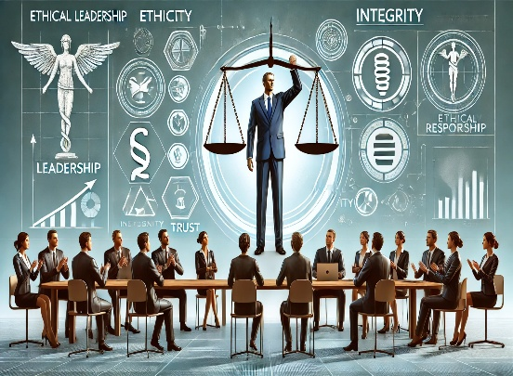
Ethical Leadership: Ethical leadership plays a crucial role shaping policy into practice by organisational culture, promoting transparency, and ensuring that moral considerations influence decision making. Ethical leadership is the act of consistently demonstrating principled, value driven behaviour grounded in universally accepted moral norms. It shows up in a leader’s personal integrity, fairness, and relational conduct in their interactions with others (Prokopenko et al., 2025). Empirical research indicates that ethical leaders act as moral role models, influencing the ethical climate of their organisations by shaping team behaviour and fostering a culture of trust, accountability, and shared responsibility (Santiago-Torner et al., 2025).
Forced Labour has undermined sustainability in the society today by damaging the three pillars leaving a big gap that hinder long term development. Therefore, an ethical relational leadership is needed to reform and development a long-term sustainability. This is because, this form of ethical leadership practice is increasingly recognised as essential for addressing the complex social, economic, and environmental challenges that define modern sustainability. As organisations navigate interconnected global systems, leadership grounded in
empathy, collaboration, and ethical awareness become crucial, and this is what is needed today.
Although, both relational leadership and leadership for sustainability are receiving increased attention, the ethical dimensions of these approaches remain underdeveloped. This limitation remains problematic because both sustainability and relational leadership essentially involve moral responsibilities, which requires leaders to balance competing interests, uphold integrity, and foster trust across diverse stakeholder groups. Ethical leadership, therefore, serves as the foundation for ensuring that sustainability initiatives are not only effective but also just and inclusive (Nicholson & Kurucz, 2017).
Ethics in relation to sustainability have become increasingly significant in the context of high-risk and rapidly changing environments, where leadership decisions can profoundly influence organisational, social, and environmental outcomes. Ethical leadership is no longer a theoretical ideal but a practical necessity to navigate uncertainty, global volatility, and heightened stakeholder expectations. In today’s dynamic context, organisations face the dual challenge of ensuring operational performance while maintaining moral integrity. Therefore, values based, decision making, transparency, and accountability are central to responsible corporate behaviour and long-term sustainability to address these challenges (Forced Labour) across industries and regions.
Risks of Inaction: Avoiding responsibilities that violate human rights has a serious impact on organisations, this is because they overlook forced labour and the risks facing such organisations are reputation damage, financial instability, and legal penalties. However, political risk has been identified as the major barrier to sustainable accountability (Turi & Sarfraz, 2022). Due to political risk many investors face political instability which has a significant effect on project investment processes and expected investment values under uncertainty economic situation. Directly hindering its ability to achieve its Environmental, Social, and Governance (ESG) goal.
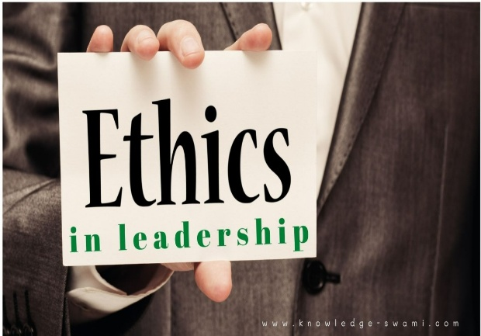
Through Responsibility, there comes opportunities for change Sustainability.
The solution lies in awareness and transforming this into a meaningful action. Raising awareness about forced labour is crucial to sustainability change. Within the organisations and society, it requires genuine progress translating understanding into concrete measures. This connection is crucial, as human rights are not separated from economic and environmental concerns in modern sustainability frameworks. Consequently, sustainability reporting has emerged to systematically measure, disclose, and being accountable to both internal and external stakeholders for performance towards the goal of sustainable development. This practice enables organisations to demonstrate transparency (Baskaran et al., 2012)
In conclusion, forced labour remain one of the most serious challenges facing sustainability in business today. Though awareness of forced labour has grown, transforming that awareness into ethical action is needed. Therefore, Ethical leaderships merge as the critical tools in cooperated with frameworks such as UN Guiding principle and the EHRC’s five step guide provide guidance to delineate the responsibilities of different organisations to address Human Rights violations, by meeting the responsibilities required to leads a comprehensive and proactive human rights due diligence approach (Natour, 2016). Tackling forced labour requires genuine respect to human rights through collaboration by spotting gaps on governance and accountability as these will help to integrate strategy which embeds ethical accountability through binding legislation that improves sustainability accountability for business (Booth 2023).

Lists of Bibliography
Amengual, M., Mota, R. and Rustler, A. (2022) ‘The “Court of Public Opinion:” public perceptions of business involvement in human rights violations’, Journal of Business Ethics, 185(1), pp. 49–74. doi:10.1007/s10551-022-05147-5.
Baskaran, V., Nachiappan, S. and Rahman, S. (2012) ‘Indian textile suppliers’ sustainability evaluation using the Grey Approach’, International Journal of Production Economics, 135(2), pp. 647–658. doi: 10.1016/j.ijpe.2011.06.012.
Berlan, A. (2013) ‘Social Sustainability in agriculture: An anthropological perspective on child labour in Cocoa production in Ghana’, Journal of Development Studies, 49(8), pp. 1088–1100. doi:10.1080/00220388.2013.780041.
Booth, K. (2023) ‘Mind the governance gaps: Harmful corporate strategies leading to avoidance of responsibility and civil society counterstrategies’, Business and Human Rights Journal, 8(2), pp. 284–291. doi:10.1017/bhj.2023.23.
Business and human rights: A five-step guide for company boards / equality and human rights commission (2019) Equality Human Rights Commission. Available at: https://www.equalityhumanrights.com/en/publication-download/business-and-human-rights-five-step-guide-company-boards (Accessed: 28 October 2025).

Buhmann, K. (2017) ‘Connecting corporate human rights responsibilities and state obligations under the UN guiding principles: Communication and human rights due diligence’, Ethical Economy, pp. 281–295. doi:10.1007/978-3-319-46973-7_17.
Ciravegna, L. and Nieri, F. (2021) ‘Business and human rights: A configurational view of the antecedents of human rights infringements by emerging market firms’, Journal of Business Ethics, 179(2), pp. 431–450. doi:10.1007/s10551-021-04861-w.
Gold, S., Trautrims, A. and Trodd, Z. (2015) ‘Modern slavery challenges to supply chain management’, Supply Chain Management: An International Journal, 20(5), pp. 485–494. doi:10.1108/scm-02-2015-0046.
LeBaron, G. and Gore, E. (2019) ‘Gender and forced labour: Understanding the links in global cocoa supply chains’, The Journal of Development Studies, 56(6), pp. 1095–1117. doi:10.1080/00220388.2019.1657570.
Lerche, J. (2007) ‘A global alliance against forced labour? unfree labour, Neo‐Liberal Globalization and the International Labour Organization’, Journal of Agrarian Change, 7(4), pp. 425–452. doi:10.1111/j.1471-0366.2007.00152. x.
Lotfi, M. and Pisa, N. (2024) ‘Child slavery in supply chains: Actors of the dirty scene’, Journal of Transport and Supply Chain Management, 18. doi:10.4102/jtscm. v18i0.942.
Natour, F. (2016) ‘Respecting human rights in the on-demand economy: Closing the new Governance Gap’, Business and Human Rights Journal, 1(2), pp. 315–320. doi:10.1017/bhj.2016.7.
Nicholson, J., and Kurucz, E. (2017) ‘Relational leadership for sustainability: Building an ethical framework from the moral theory of “ethics of care”’, Journal of Business Ethics, 156(1), pp. 25–43. doi:10.1007/s10551-017-3593-4.
Prokopenko, O. et al. (2025) ‘Bridging Risk Ethics and Sustainability: A data-driven study of ethical leadership practices in Risky Business Environments’, Business Ethics and Leadership, 9(2), pp. 211–224. doi:10.61093/bel.9(2).211-224.2025.
Protrafke, N. (2015) The evidence on Globalisation - Potrafke - 2015 - the world economy ..., https://onlinelibrary-wiley-com.ezproxy.uwtsd.ac.uk/doi/10.1111/twec.12174. Available at: http://onlinelibrary.wiley.com/doi/10.1111/twec.12174/pdf (Accessed: 05 November 2025).
Santiago-Torner, C., Jiménez-Pérez, Y. and Tarrats-Pons, E. (2025) ‘Interaction between ethical leadership, affective commitment and social sustainability in transition economies: A model mediated by ethical climate and moderated by psychological empowerment in the Colombian electricity sector’, Sustainability, 17(13), p. 6068. doi:10.3390/su17136068.
Scott, S., Craig, G., and Geddes, A. (2012) Report May 2012 www.jrf.org.uk experiences of forced labour in the UK food, Available at: https://aa.ecn.cz/img_upload/224c0704b7b7746e8a07df9a8b20c098/forced-labour-food-industry-full.pdf (Accessed: 05 November 2025).
Turi, J.A. and Sarfraz, M. (2022) ‘The impact of perceived organizational politics and political risk on project success through ethical leadership and the psychological contract’, Kybernetes, 52(11), pp. 4829–4845. doi:10.1108/k-11-2021-1192.
United Nations (2011) Sustainable development through Human Rights | Ohchr, The UN Guiding Principles on Business and Human Rights: Un Guiding Principles Reporting Framework. Available at: https://www.ungpreporting.org/resources/the-ungps/ (Accessed: 28 October 2025).
Venkatesan, R. (2017) ‘The UN Framework on business and human rights: A workers’ rights critique’, Journal of Business Ethics, 157(3), pp. 635–652. doi:10.1007/s10551-017-3664-6.

