Rapport

Effective teamworking for team success

MODULE CODE: BMSW4002

Effective team working and communication

Student Name: Adrian Pop Lecturer: Richmond Lamptey

Student Number: 2109183

TABLE OF CONTENT
- INTRODUCTION……………………………………………………PAGE1
- OWERVIEW OF TEAMWORK
WHAT DEFINE A TEAM
WHAT CONTRIBUTE TO AN EFFECTIVE TEAM WORKING? PAGE2
3.0 MODEL OF TEAM DEVELOPMENT……………………………. PAGE3,4,5
4.0 TEAM ROLES ………………………………………………………PAGE6,7
5.0 DISCCUSION ………………………………………………………PAGE7,8
6.0 CONCLUSION AND RECOMANDATION ………………………PAGE 9.

1.0 Introduction
We have a man named Abdul in this report. He is given responsibility for a new project for Vodafone, with an 18-person team. Abdul must organise a community event in collaboration with local stakeholders, companies, and non-profit organisations. Abdul's team had been working for two mounts but had failed to meet the team's criteria. He had received several calls from people complaining about the lack of communication between them, and one of his project staff had failed to attend or apologise at an important meeting with the local MP and community groups the day before.
In the following section of the study, I show how Abdul may construct an effective team using a theoretical model. What impact does effective teamwork have on team success, what responsibilities are required to form an effective team, and what hurdles to effective teamwork have I discovered.

1.

2.0 Overview of team working

2.1 What defines a team?
A collection of people working together for a same goal is referred to as a team. In theory, members of a team should have comparable goals, objectives, and ways of thinking. Individuals that are incompatible with one another will never be able to work together to form a team. Interests, mental processes, attitude, perception, and likings should be similar, if not identical. In Abdul's case, we can say that we have a team that is working toward the same goal, but the rest of the criteria are missing. Objectives are not the same, and they do not think in the same way. Abdul's interest in creating mitting's online because of the Covid-19 pandemic, it is impossible to meet in person. Giving the team the opportunity to come with their opinions, discuss the project, and share their ideas was critical.
A team must meet for the first time to get to know one another, to demonstrate respect, to work for the same goal, and to establish regular meetings. The team leader must allow the team to discuss their ideas, respect their decisions, and work together to determine the best conclusion and solution.
2.2 What contributes to effective teamwork.
Participants understand their purpose and share their goals – the combination achieves mission (Francis & Young, 1979). Successful teams are motivated, engaged, and strive for the maximum degree of performance. Successful teams are highly motivated, engaged, and strive for excellence. Team members should be opened to receiving and giving constructive criticism as well as providing genuine feedback.

2.
EFFECTIVE TEAMWORK:

Respect | Motivation | Constructive | Engaged
Determined | Flexible | Innovative | Effective
Interdependence | Honesty | Supportive | Energised

3.0 Model of team development
3.1 Tuckman’s Model:
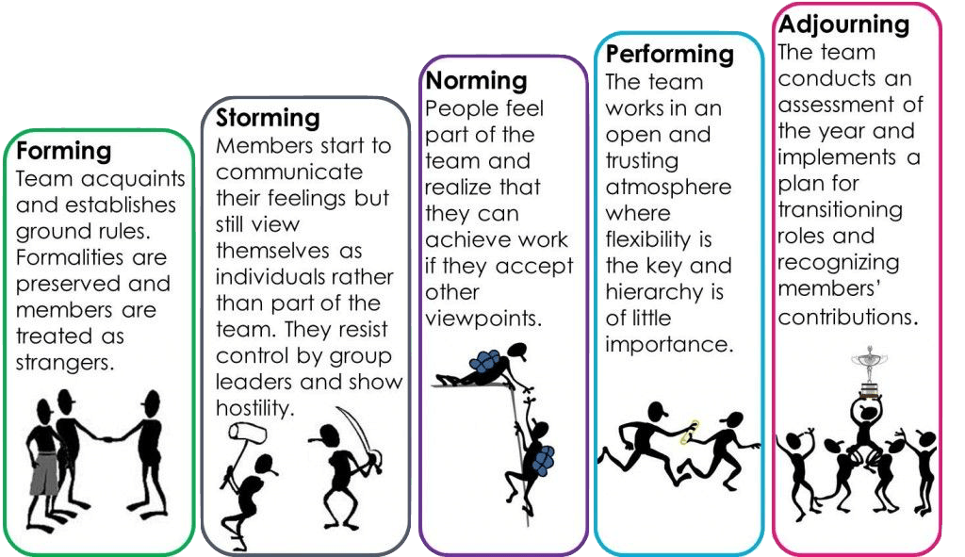
Abdul may use Tuckman's strategy to meet the targets he and his team set for themselves when delivering a community event for Vodafone.
According to the case study, Abdul is a team leader who contacts each member of the team and informs them of the team's rules and obligations. Additionally, each member of the team is treated as a stranger because a meeting was not held due to the covid-19 pandemic.
We know from the case study that the group's community, has already called them several times to alert them of the problems and to inform them
3.
that there is a major problem with communication between the team and the leader. Even after these setbacks, such as a member failing to show up for a meeting and several members attempting to abandon the project, there are still opportunities for the project to be completed.
With this scenario, Abdul must adjust his attitude because some of the team members failed to complete the assignment by the deadline, for the odder people he needs to begin holding online meetings with the rest of the team to respond to emails and offer them opportunity to express themselves in order to convince them that they can produce the community event if they continue to work together in regular meetings and accept different points of view.
If Abdul puts all of this in place, his team can begin to work in a friendly environment where they can trust each other, and he can also create a flexible team where online meetings and all communication platforms give them the opportunity to share their ideas and criticise without offence, and he can also create a flexible team that is based on trust and respect, and a team that can achieve its goals.
According to Tuckman's model, if Abdul decides to utilise it, he will discover that he will form a team that will lead to success, with each member understanding his function in the team, delivering the project to success, and each member of the team acknowledging his or her contribution to success.
3.2 Gersick 1988 1989 model:
It is obvious that Abdul will fail if he chooses to utilise the Gersik 1988 1989 methodology of team building from the start. According to Gersick's approach, the first phase is a stable phase in which the team members meet. Because the initial meeting of Abdul and the entire team did not take place due to the Pandemic, it is apparent that this will not be a success.
The transition period occurs between the first and second phases. In Abdul's case, the transition period is very difficult because we do not have the opportunity to meet with group members,
4.

plus, the fact that the interest in the team leaves something to be desired because communication between members is completely lacking, the interest in the team does not appear anywhere, and in some cases team members are absent without prejudice from the team.
Given the circumstances, Gersick’s model 1988 1989 will not be repeated in the second phase due to a lack of enthusiasm, a lack of communication, and the fact that the 18 members do not constitute a team. Some team members missed critical meetings with the MP and community groups, as well as failing to finish the assignment by the deadline. It is clear that they do not have the same objectives and will not work together to achieve them.

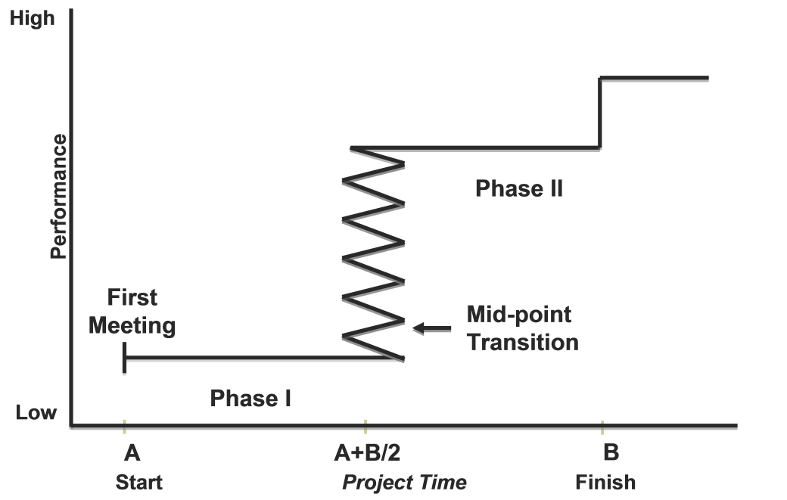

5.
4.0 Team Roles
4.1 Belbin’s Team roles
"The types of behaviour in which people engage are infinite. But the range of useful behaviours, which make an effective contribution to team performance, is finite. These behaviours are grouped into a set number of related clusters, to which the term 'Team Role' is applied."(Meredith Belbin | Team Roles at Work)
If we look at Belbin's rule, the 9 most crucial jobs for a team to be cohesive and efficient may be identified. All these 9 rules came whit strengths and weaknesses:
- PLANT: Has a proclivity for being very creative and adept at addressing difficulties in unexpected ways. Strengths like open mind and ready to confront difficult problem. Weaknesses Could miss out on little details and be too distracted to communicate properly.
- MONITOR EVALUATOR: Provides a rational eye, makes unbiased decisions when necessary, and assesses the team's choices objectively. Strengths smart and discriminating Considers all choices and makes accurate decisions. Weaknesses Lacks motivation and the capacity to motivate others at times and may be unduly critical.
- SPECIALIST: Brings extensive understanding of a critical area to the team. Strengths Focused, self-motivated, and committed. They offer specialised expertise and knowledge. Weaknesses He tends to contribute on a limited front and might get caught up in the details.
- SHAPER: Offers essential motivation to keep the team going forward and not lose concentration or enthusiasm. Strengths It thrives on pressure and is challenging. Has the determination and fortitude to face challenges. Weaknesses Could be pretty frustrating and may occasionally hurt feelings and thoughts.
- IMPLEMENTER: It was necessary to devise an embedded vision and execute it out as best as possible. Strengths Simple, dependable, and affordable. Converts thoughts into activities and arranges tasks that must be completed. Weaknesses Has a tendency to be rigid and reluctant to adjust to new opportunities.
- COMPLETER FINISHER: Most successfully performed at the end of activities to polish and investigate the work for faults, submitting it to the strictest product testing requirements. Strengths Anxious, diligent, and meticulous. Looks for mistakes. buffs and refines Weaknesses Can be prone to excessive concern and reluctance to relinquish. 6.
- RESOURCE INVESTIGATOR: curious attitude to brainstorm for the team. Strengths Excited and extroverted. Looks for new prospects and makes new relationships. Weaknesses Hopeful and prone to losing confidence once early zeal has worn.
- TEAMWORKER Assists the team in gelling by identifying and doing work on the team's behalf. Strengths Cooperation, sensitivity, and diplomacy. Listens carefully and avoids causing a squabble. Weaknesses When faced with a difficult decision, she might well be hesitant and prefers usually avoid conflicts.
- CO-ORDINATOR: Focused on group goals, drew out teammates, and allocated work effectively. Strengths Experienced, self-assured, and capable of seeing talent. Goals are clarified. Weaknesses Can indeed be perceived as deceptive and may unload their own portion of the task.
When it comes to team initiatives, clearly outlining responsibilities and objectives may have a good influence on the firm. Everyone is aware of the situation. When you define clear roles and duties, organizational factors ones, everybody in the community understands what is required of them.

5.0 DISCUSSION
Teams and teamwork help to promote deep learning that occurs through interaction, problem solving, dialogue, cooperation, and collaboration (Johnson & Johnson, 1995)
5.1 Advantages of an effective teamwork:
There are four major benefits of good teamwork, which are regarded to be - establishing output, assistance for all practitioners, the proportion of knowledge and suppleness ensuring the desired performance are reached for all – especially if there is a strong feeling of working as a team throughout the entire setting.
PRODUCTIVITY: This is founded on the principle that having multiple hands is preferable to having only one. Although if the team performs together well, they can do much more. To achieve this, the entire team must collaborate successfully, including all professionals considering encouraged and respected. This may be aided by ensuring that everyone has read their position description and understands their responsibilities and position inside this department.
7.
SUPPORT: When a group works well together, it shows that each member is cared for. This builds a solid workforce, maintains great confidence, and reduces practitioner fluctuation to a minimum. Everyone in the team will feel that they can obtain the information, guidance, and reinforcement they need from another, resulting in increased comfort and the promotion of guiding principles.
EXPERIENCE: When a group of people operates collaboratively, they may have varying degrees of expertise and knowledge. It might be beneficial to have a staff with varying degrees of expertise and understanding.
FLEXIBILITY: Because practitioners will need to collaborate, flexibility is a key consideration. Practitioners must be adaptable and motivated to complete well together irrespective of the scenario that brings them together to exchange expertise.
5.2 IMPACT OF INEFFECTIVE TEAM OR POOR TEAMWORK:
Engagement has a significant influence on productivity and efficiency, which have a direct impact on the bottom line. It's difficult to envisage a team functioning efficiently together if they aren't communicating, don't have a common vision, and don't have a feeling of shared responsibility.
With an imminent skills scarcity, employee engagement is critical for firms to remain competitive, and the environment produced by a failing team will only drive people away. Turnover will cost time, money, and inventive concepts as a consequence.
Whenever a TEAM lags behind in development, it becomes increasingly hard to get anything done, perhaps resulting in the corporation's demise. Partnership will be difficult if civility, common vision, obligation, and commitment are lost. This prohibits any form of synergistic contact among teams, stifling innovation even further. This means that without interaction, creativity will be unachievable and impossible to implement.
Real life example: Having a team of 11-12 members under my supervision as a line leader, we hold a short morning brief where I communicate to the team members the target for that day, the strings of each member, and we share our ideas to form a team that can easily touch the target, and each perspective is treated with respect and taken into account.

8.
6.0 CONCLUSION AND RECOMANDATION
In my opinion, for a team to be more effective, it is critical from the start to ensure that you are prepared for a challenge like this to work on a team or to be the leader of the team to see if you can deal with all problems, what are there in team work and always follow the rules, understand your duty for the team and the role, be polite and respect any decision, and communication is the key to success.
Efficient teamwork It is crucial because while working as a team, more ideas are exchanged, more information is provided, and more knowledge is gained. With all of these combined thoughts, ideas, and emotions, it is easier to reach the goals.

9.
7.0 REFERENCES

- Bonebright, D.A. (2010) ‘40 years of storming: a historical review of Tuckman’s model of small group development’, Human resource development international., 13(1), pp. 111–120. doi:10.1080/13678861003589099.
- Belbin Associates (2022) Available at Belbin Team Roles | Belbin ,Accessed on 05.03.2022 at 21:35
- The Ebola effect: HCWs working in teams could protect co-workers, patients from other infections. 2015. Hospital employee health, 34(9),
- Wheelan, S.A. (2009) ‘Group Size, Group Development, and Group Productivity’, Small group research., 40(2), pp. 247–262. doi:10.1177/1046496408328703.
- Tarricone, P. & Luca, J. (2002) Successful teamwork: A case study, in Quality Conversations, Proceedings of the 25th HERDSA Annual Conference, Perth, Western Australia, 7-10 July 2002: pp 640-646.
- Early yeas career (2022) Available on http://www.earlyyearscareers.com ,Accessed on 01.03.2022 at 15.22
- Argote, L. (2000) ‘Knowledge Transfer in Organizations: Learning from the Experience of Others’, Organizational behaviour, and human decision processes., 82(1), pp. 1–8. doi:10.1006/obhd.2000.2883.
- Griffith, BA, & Dunham, EB 2014, Working in Teams: Moving from High Potential to High Performance, SAGE Publications, Thousand Oaks.

