The retrofit of stone-built grade II listed buildings using Passivhaus techniques – is this possible?

Ayesha Williams
University of Wales Trinity Saint David
2107932

Contents
Needs to be completed

Title……………………………………………………………………………………………..2
Purpose/Rationale For Study……………………………………….….2
Research Context; ……………………………………………………………....2
- Aim
- Objective
- Key Questions
Initial Literature Review…………………………………………………...4-5
Outline Methodology…………………………………………………………… 5
Proposed Structure……………………………………………………………. 5-6
Referencing and Additional Reading…………………………….6

- Methodology
The research will explore the importance of net zero homes and the use of Passivhaus’s to help reduce the carbon emissions used in domestic homes and whether we can use Passivhaus techniques to reform grade 11 listed buildings. We will undertake this research by using a number of research methods which include exploratory research that seeks to gain a greater understanding of the topic area and use for future projects. The secondary research that will be used by the researcher will include library-based research using certified articles, sustainability journals and official reports and handout’s documented by the Passivhaus trust. The research will also be undertaking conference participation as other form of secondary research. In relation to ethical concerns with research, efforts must be made to ensure the protection of conflict of interest which means throughout any of the research, the research must always remain unbiased. The researcher will obtain informed consent from any participants taking part and keep all information obtained confidential and anonymous. The relation to data collection using online sources will be correctly referenced and all information clearly displaying the official authors credentials using Harvard referencing structure.
- Introduction
Climate change is accelerating at rapid paces from the many contributors. Carbon Dioxide (CO2) being one of the “most dominant greenhouse gas” (Rosado, 2020). “2.7 tonnes of carbon dioxide” is emitted from UK Homes each year (Citu, 2022), Therefore, as we move forward in reducing the amount of greenhouse gases we produce within our homes when we use energy, we must not forget about the historic past and by moving forward with new domestic buildings it is important that we incorporate our knowledge and technology in to listed buildings which are defined as grade 2, incorporating the history and keeping the external appearance as much possible. Buildings currently consume around 85% of energy by using only it’s heating, lighting, and heating of its domestic water supply. (M.Mihai et al , 2017) and with the European Union deciding that buildings energy consumption must be reduced by 20%, changes need to be made. This report will hope to endeavour whether it I possible to retrofit, grade 2 listed buildings into passive homes making them future proof for climate change and government goals of becoming net zero. The report will be based around whether it would be possible for stone built listed buildings to have necessary passive home alterations and what this would entail and whether it would be possible to do so with all current restrictions. Weather and climate has been taken into consideration during this report, to identify whether climates and weather patterns can affect the results of passive homes.
- Global warming
Climate change has been driven by humans and their everyday activities, especially their constant burning of fossil fuels such as coal, oil and gas (United Nations, 2021). The growing cause for concern of global warming has never been more of an education point as it is now due to greenhouse gases being their highest rates in 2 billion years states the United Nations (United Nations, 2021) and the world is now 1.1 degrees Celsius warmer (United Nations, 2021). These evident figures shown indicates that now more than ever we need to act on global warming.
- What is Net Zero
Net zero is referring to “the state in which the greenhouse gases going into the atmosphere are balanced by removal out of the atmosphere” (University Of Oxford, 2022) Net zero comes hand in hand with “To go net zero” which creates this ultimate target and goal for all to achieve and strive to in which all greenhouse gases released are combated and balanced by the removal of these gases. (University Of Oxford, 2022).
- What is a passive house?
Passive homes are designed to provide maximum amounts of comfort all year round and can be heated or cooled with the use of very minimal energy usage. The building envelope of a passive house is the main focus of the design, it’s extremely airtight- envelope and using a ‘Heat Recovery Ventilation system known also as a MVHR or a an alternative high-tech ventilation system, these are there to continuously supplies the home with high quality fresh air without the need for opening and closing windows, the ventilation system evenly heats or cools the home on the interior using the air supply within the home, keeping the heat at a constant temperature internally despite external hot or cold periods and seasonal months (M.Mihai et al , 2017). Passive homes incorporate passive solar gains into their designs which uses the absorption of solar radiation converting these rays into energy for the home’s usage.
5.1. Passive Houses- Apparent advantages and disadvantages
The apparent advantages of a passive house are easily identified as a Socio-economic and environmental cost benefit, with its low-cost energy efficient way to heating and powering homes, along with a vast contribution to becoming net zero by reducing the carbon dioxide release into the atmosphere. On the other hand, with the extensive design and use of high tech system to ensure full capability of the passive home and the use of high quality energy efficient materials such as its insulation and ensuring its air tight envelope, it can be deemed a large costly short term expense and costly procedures in relation to the design and build process as a whole, although the long term expenses will show the home repaying its short terms costs by low energy consumption and money saving on energy usage. In a recent online article by (Alter, 2021) they argued that passive homes may never payback their initial costings due to the cost of energy being so low for a prolonged period of time although with the recent hike in energy costs, this has change Alters perspective who claims that a thirty year payback time is likely for a passive home in the year of 2021. During an interview with (Alter, 2021) and Sheena Sharp, sharp stated her perspective that passive homes immediately payback on their costs “Because when you are in a comfortable, well designed and balanced space it can improve your family’s quality of life right–away”. Additional disadvantages circling around passive houses as detailed by (McLeod, Robert S et al , 2019) who cautioned that there may be an increased risk of overheating within a passive house especially within the near future as increase temperatures are rising from global warming. They have stated there may be serious consequences with adverse health effects caused by overheating.
- Building Characteristics in a stone built listed building
Stone built historic buildings were the greatest achievement in respect of designs and appearance, weight and durability during the medieval period, and a point of overall structural strength. Stone is an extremely durable construction material, with tough against wind, fire, water, decay, and insects. The typical constructions of a stone built historic building does vary with alterative ages from the 1900s way of stone construction would be erected as two outer leaves and bonded together with large amounts of lime mortar or alternatively for wealthier builds, rubble would be tightly bonded together to form a very strong wall traditionally single skinned. The use of cavity walls and insulation did not get introduced until the mid to late 19th century therefore it would be very unlikely to find one of these types of thermal efficient wall in a listed building.
6.1 Stone thermal abilities
Typically, the construction of a stone wall is not adequately equipped with great thermal abilities and inefficient as these typical stone walls allow both heat and cold through to the interior. Using a past article from (Mary Felix Et Al, 2017), they complete an investigation testing thermal efficiencies within different climate zones, although the majority of the articles compares the warmer climates, there is a climate zone focus on stone heating and cooling space within thermal efficiencies, after analysing their data, you can clearly see that stone built walls of 20cm thickness, in terms of total energy consumption, stone built buildings are satisfying the necessary consumption needed, overall meaning that stone buildings are great at retaining and insulating heat, however, stone walls may take that little bit longer to heat up initially.
- Grade 2 listed buildings – including their restrictions of repairs and adaptions.
Listed buildings are classified as a building which has a specific past, historic background or is of an architectural importance. This means that listed buildings are subject to tight restrictions which ultimately protect the buildings historic background and exceptional character. Listed buildings can be banned in such matter if located in an area of special heritage or interest. (Johnson, 2020). There is an act governed by law known as the “Planning (Listed Buildings and Conservation Areas) Act 1990”. This act governs listed buildings and buildings of historical interest as well as providing restrictions of work which preserve the building itself and maintains its features.
Grade 2 listed building are those which the majority of buildings fall into which are classed as ‘listed’. These banded buildings allow for subtle work helping to preserve the building without changing its original features.
7.1. Repair and adaptations restrictions
Grade 2 listed buildings allow for little repairs and upkeep and are exempt from the requirement for listed building permission. There is need permission before doing anything that is considered to be a "material modification,”. Simple solutions like painting external doors and windows a different colour could fall under this category. (Alan Boswell Group, 2022).
There is a need for consent for the following modifications:
- Replacing windows or doors.
- Painting a building’s exterior
- Roof repairs / replacement.
- Adding a satellite dish.
- Erecting a new building or structure within the listed building’s curtilage.
- Building an extension, porch, or conservatory
- Creating a fence, gate, or wall.
- Exposing timbers or brickwork.
- Adding solar panels or wind turbines.
There is major concern for grade 2 listed building in relation to modifications if they intend to change the external features of the building. These following modifications are those which are unlikely to be allowed as suggested by (Alan Boswell Group, 2022)
- Removing architectural features
- Stone cleaning
- Adding pipes, flues, or alarm boxes
- Removing boundary walls or gates.
- Repointing using the incorrect materials.
- Removing chimney stacks or pots.
- Painting or rendering stonework.
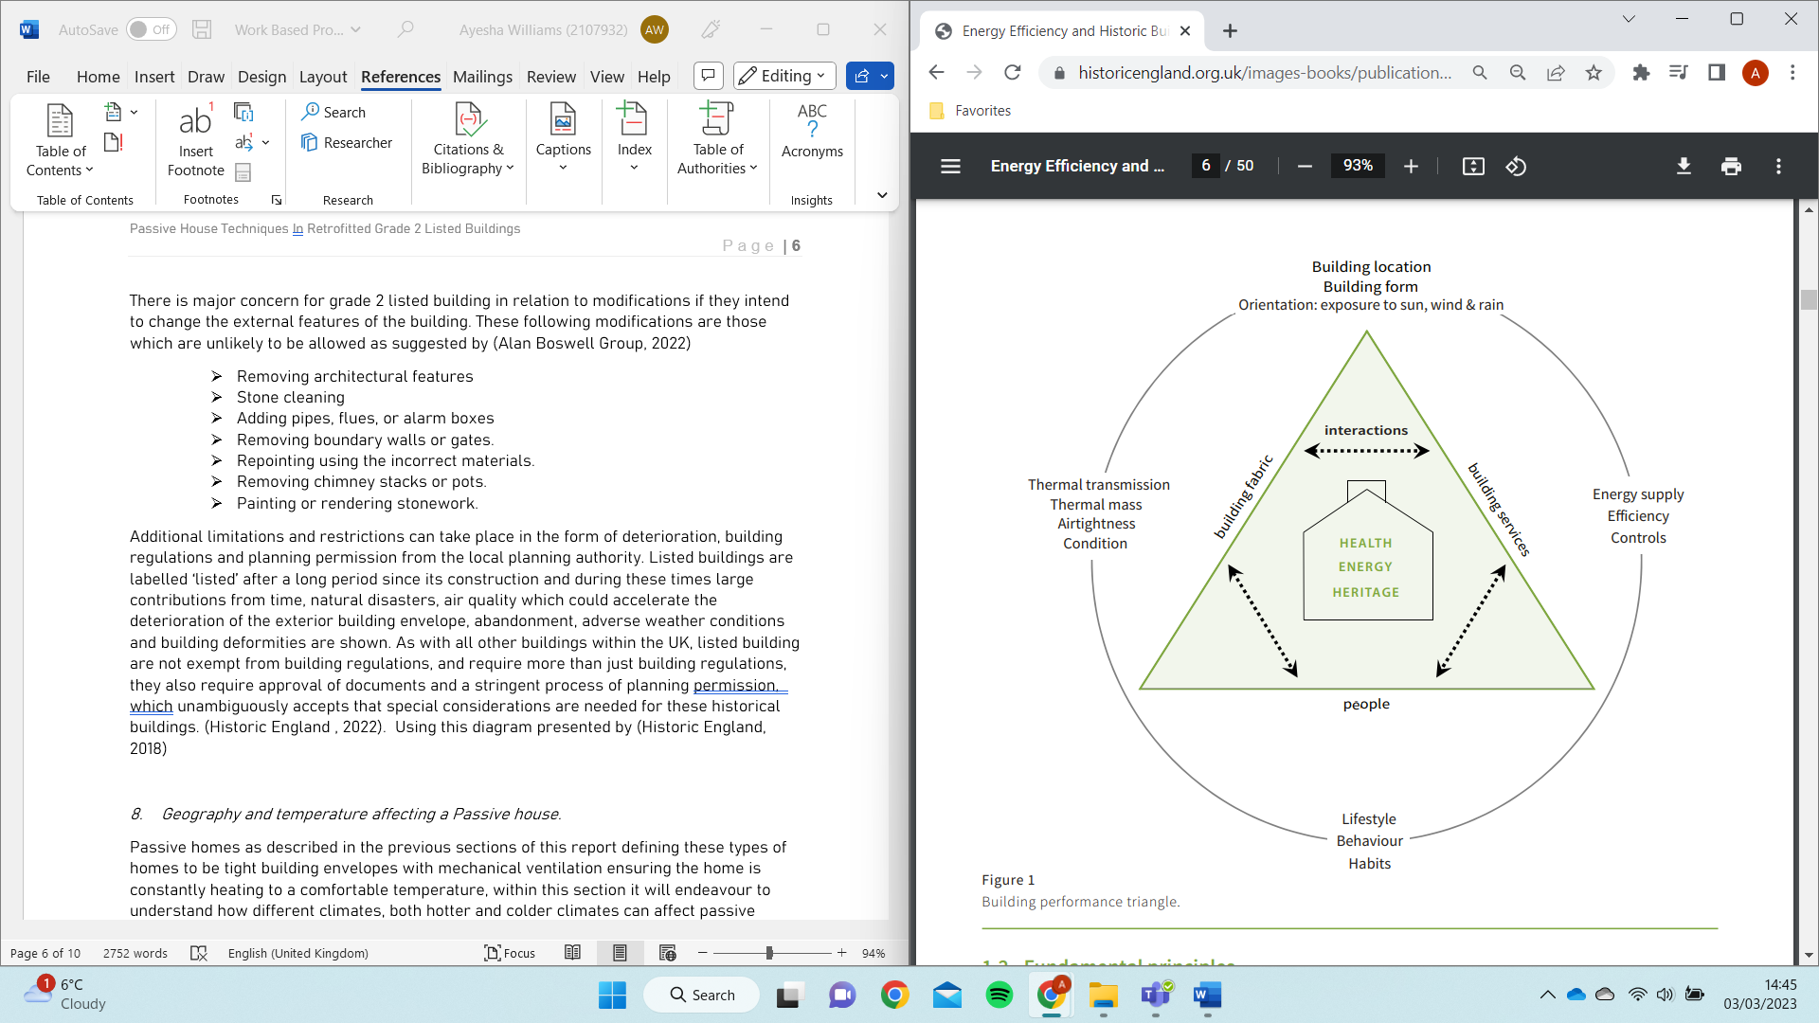
Additional limitations and restrictions can take place in the form of deterioration, building regulations and planning permission from the local planning authority. Listed buildings are labelled ‘listed’ after a long period since its construction and during these times large contributions from time, natural disasters, air quality which could accelerate the deterioration of the exterior building envelope, abandonment, adverse weather conditions and building deformities are shown. As with all other buildings within the UK, listed building are not exempt from building regulations, and require more than just building regulations, they also require approval of documents and a stringent process of planning permission, which unambiguously accepts that special considerations are needed for these historical buildings. (Historic England , 2022). Using this diagram presented by (Historic England, 2018) it shows that “no one size fits all” however there are principles which can be enforced, these are fundamental principles such as:
- Identify its significance
- Research local environment and climate
- Initial design and construction of the building
- Current fabric performance
- Intended building use and occupancy
            - Available resources; financial and materials
            - Identify the constraints
It is noted that attempting small repairs can vastly increase the buildings envelope efficiency without damaging its retaining building envelope. Attempting to make listed buildings more energy efficient, a need for care and a gentle approach in relation to ensuring the value of the building is sustained for the future generations.
- Geography and temperature affecting a Passive house.
Passive homes as described in the previous sections of this report defining these types of homes to be tight building envelopes with mechanical ventilation ensuring the home is constantly heating to a comfortable temperature, within this section it will endeavour to understand how different climates, both hotter and colder climates can affect passive homes and whether different forms of mechanical ventilation have to be used to withstand those differing climates.
8.2. Mediterranean climates
As with all Mediterranean climates, summer and winter climates prevail, bringing with them different temperatures, conditions, moisture levels, humidity, and adverse weather conditions as a result of the above. All these conditions may result in beneficial impacts or negative impacts on passive home techniques. Mediterranean climates during the winter are usually cooler with periods of rainfall followed by small amounts of sunny weather. Summer months pose large amount of sunny, hot weather with high humidity levels.
8.3. How are buildings designed within a Mediterranean climate
Homes built within a Mediterranean climate are usually designed with its local style with the emphasis on the home as a refuge and sanctuary is present in all forms, even though they differ, and they all provide simple access to the outside through large doors and windows, terraces, atriums, and patios. (TAYLOR, 2022). There are key features that (TAYLOR, 2022) states is included within Mediterranean homes as part of their design criteria, these include:
- A connection and seamless change from interior to outside
- A feeling of space produced by high ceilings and arches.
- Red-tile roofs
- Rough-hewn wood or carved doors
- Brick
- Stone
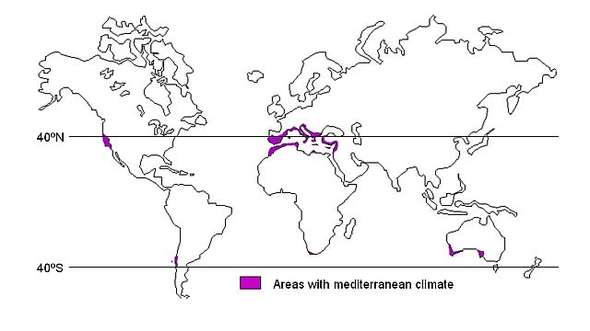

Figure 1- Showing the areas with Mediterranean climate 31 - 40 degrees north and south of the https://www.mediterraneangardensociety.org/climate.html
Humidity within the summer months with a Mediterranean climate can reach medium to high humidity through its summer months and around no humidity to low humidity within its winter and cooler months.
8.3. Colder climates
Northern Europe has been assigned for investigation for this report, a study into how cooler climates affect passive homes with either a positive or negative impact. Cooler climates can be easily resembled to the UK climate in relation to some of the months. In a recent research article by (Patrik Rohdin Et al , 2014) they stress the increase in windy weather and storms which increase the overall draught level throughout a home in this climate. Therefore, the concern shifts from overheating in the hotter climates to extreme precautions in relation to air tightness around the building envelope.

8.4. How are buildings designed within a colder climate such northern Europe
There is not too much difference in weather climates from the UK to Northern Europe due to the similar locations within the equator. The design focus is very similar, Buildings are well equipped and focus more on stability and protection from the external weather conditions. Strong structures along with fully insulated cavity walls and full equipped rooms for each climate.

9.. Successful passive home case studies within the UK- Results and analysis
9.1. Lark Rise Case Study
The UK is now home to many passive homes, using the Passivehaus Trust online facilities, it is encouraging to see how many projects of passive homes have become successful within the UK. This help keep focus and encouragement that there may still be opportunity to create the next projects of passive homes within the listed building sector. Each project shown on the Passivehaus documents, show great success in residents satisfaction, providing a self-servicing and maintaining homes, recycling all parts of its used energy as well as using the most of its natural surrounds to produce its own energy power. Using the ‘Lark Rise’ case study from Passivhaus trust, this is a large cold farmhouse containing 2 bedrooms in a guest house, this property is a detached project of approximately “175cm2” floor area, situated on a northwest facing slopes of hills in Buckinghamshire. (Bere, 2018), The architect expressed the main challenge of incorporating the openness of the site, using the current landscape to the homes advantage by “cutting the house into the slope” as well as partially burying the home to ensure it keeps a low profile so that it can enhance the landscape it currently holds. Mr Justin Bere also stressed within his interview with Passivhaus trust (Passivhaus Trust , 2018) that the values of the home being self-efficient and independent have been achieved or at least on track to becoming successful years after monitoring. The performance outcome has shown that the thermal energy demand was predicted at 14.54kWh/m² a year however actual data shows its energy demand was only at 7.11 kWh/m² a year with a demand of 37 kWh/m² in renewable energy demand and generating way over the demand by generating 79 kWh/m² per year.

9.2.New Farmhouse
This project within the Passivhaus trust combines yet another rural property with limited energy resources which resulted in being quite costly. As seen clearly in the (Passivhaus Trust , 2013) The New farmhouse was created to solve the costly energy costs but having the property use its natural resources to run itself. The farmhouse is equipped with a” domestic hot water systems using a heat to air pump” and the use of the continuous wind will be utilized and used to create energy for the house to use. This project won a ‘Passivhaus Trust Award 2014’. The sustainability of the home presents energy demand of 101 kWh/m2 and heat demand of 13kWh/m2 as well as incorporating heat strategies from electric and wood fuelled appliances and a “shading strategy of deep set windows”.

Conclusions
Overall conclusion – NOT COMPLETED
Humidity – most comfortable according to Environmental Protection Agency (EPA should be below 60 percent ideally between 30 – 50 percent https://www.weatherstationadvisor.com/ideal-summer-indoor-humidity-level/

Within the Mediterranean summer and winter climates, temperatures differ largely
Do hot and cold countries apart from the UK have listed buildings?

Is it good to know the results of Mediterranean climates and colder climates so that we can implement design considerations due to global warming?

Hotter climates designs are to blend in with local and surrounding architecture, however this means that the design needs to include the spacious living with easy access and adaptations to the interior and exterior however with passive homes, this designed mean that the ease of interior to exterior will not work due to the restraints of a tight building envelope needed. The high ceilings and arch ways may also pose difficulty due to larger amounts of heating within the cooler months to ensure constant temperature all year round.

Problems with age and detorizsation of the building - and there is questions as to whether this could pose design questions for suitability for structural strength to hold the weight of the passive house equipment.

Many different types of stone, all with possibly different thermal performance and air tightness therefore choose a specific type of stone to focus on or all if have enough time

There may be more accuracy in data collection if the researcher was to carry out an investigation to measure the thermal efficiency of stone.

Some people would not like to see a listed building become anything other than what it was built for, therefore trying to please all may be the reasons that a listed building may not make it to a passive house. Disagreements would be stated that it would be changing its character.

Case studies – shows that passive homes can be don with incorporation of their surroundings providing reassurance that the natural and historic surroundings can be incorporated,

References
Alan Boswell Group, 2022. Guide to Grade II listed building restrictions. [Online]
Available at: https://www.alanboswell.com/news/grade-2-listed-building-restrictions/#:~:text=There%20are%20many%20things%20you,unless%20there%20are%20exceptional%20circumstances).
[Accessed 24 February 2023].
Alter, L., 2021. Is It Payback Time for Passive House?. [Online]
Available at: https://www.treehugger.com/is-it-payback-time-for-passive-house-5204761
[Accessed 2023 February 2023].
Citu, 2022. What is the carbon footprint of a house?. [Online]
Available at: https://citu.co.uk/citu-live/what-is-the-carbon-footprint-of-a-house
[Accessed 25 November 2022].
Concrete Renovations , 2019. What are the Differences Between Grade I and II Listed Buildings?. [Online]
Available at: https://www.concreterenovations.co.uk/news/what-are-the-differences-between-grade-i-and-ii-listed-buildings/#:~:text=What%20is%20a%20Grade%20I,is%20placed%20on%20such%20sites.
[Accessed 2022 November 25].
Green Building Store, 2020. What is Passivhaus. [Online]
Available at: https://www.greenbuildingstore.co.uk/information-hub/what-is-passivhaus/
[Accessed 25 November 2022].
Hiscox, 2016. Grade II Listed Building Regulations. [Online]
Available at: https://www.hiscox.co.uk/home-insurance/cover-stories/grade-ii-listed-building-regulations/#:~:text=Grade%20II%20listed%20buildings%20are,consent%20from%20the%20relevant%20authorities.
[Accessed 2022 November 25].
Historic England , 2022. Building Regulations, Approved Documents and Historic Buildings. [Online]
Available at: https://historicengland.org.uk/advice/technical-advice/building-regulations/#:~:text=Listed%20buildings%20or%20buildings%20in%20conservation%20areas%20are%20not%20exempt,regulations'%20approved%20documents%20covered%20below.
[Accessed 28 February 2023].
Historic England, 2018. Energy Efficiency and Historic Buildings. [Online]
Available at: https://historicengland.org.uk/images-books/publications/eehb-how-to-improve-energy-efficiency/heag094-how-to-improve-energy-efficiency/
[Accessed 03 March 2023].
Johnson, B., 2020. What can you do to a Grade II listed building?. [Online]
Available at: https://www.yopa.co.uk/homeowners-hub/what-can-you-do-to-a-grade-ii-listed-building/#:~:text=What%20is%20a%20Grade%20II,which%20protect%20its%20unique%20character.
[Accessed 14 January 2023].
Krämer, K., 2016. The first Passive House: Interview with Dr. Wolfgang Feist. Kranichstein: Internation Passive House Association.
M.Mihai et al , 2017. Energy and Buildings. [Online]
Available at: https://pdf.sciencedirectassets.com/271089/1-s2.0-S0378778817X00078/1-s2.0-S0378778817308290/main.pdf?X-Amz-Security-Token=IQoJb3JpZ2luX2VjEB4aCXVzLWVhc3QtMSJGMEQCIGXe5X552aMkkSiGTPr5rJ7qe7nRjJgHYpc6uOxWH3buAiBvoLX0ggOTlMBYytDxca4XqHOTXTfJ0ncZKLtk4w8lgSrV
[Accessed 10 February 2023].
Mary Felix Et Al, 2017. The Efficiency of Using Different Outer Wall Construction. [Online]
Available at: https://reader.elsevier.com/reader/sd/pii/S1876610217322282?token=29015EF0DAAB2B678232BCDC0CF63418B73031AFAC3B103147716DB62D12C52D3802ABCE37CF90A1F6BA34132D8783E4&originRegion=eu-west-1&originCreation=20230303132151
[Accessed 03 March 2023].
McLeod, Robert S et al , 2019. An investigation into future performance and overheating risks in Passivhaus. [Online]
Available at: file:///C:/Users/aye-s/Desktop/Uni%20Work/Work%20Based%20Project/Assignment/Reading%20Lists/McLeod%20Hopfe%20Kwan%20-%20overheating.pdf
[Accessed 2023 February 10].
Patrik Rohdin Et al , 2014. Experiences from nine passive houses in Sweden, Sweden : Elsevier.
Rosado, H. R. a. M. R. a. P., 2020. Greenhouse Gas Emissions. [Online]
Available at: https://ourworldindata.org/greenhouse-gas-emissions#:~:text=Greenhouse%20gases%20are%20measured%20in,CO2e%20each%20year
[Accessed 2022 November 25].
TAYLOR, L. H., 2022. 17 Breathtaking Mediterranean Homes. [Online]
Available at: https://www.thespruce.com/breathtaking-mediterranean-homes-4688755#:~:text=Key%20features%20of%20Mediterranean%20home%20design%20include%3A%201,wood%20or%20carved%20doors%208%20Brick%20More%20items
[Accessed 20 February 2023].
United Nations, 2021. What Is Climate Change?. [Online]
Available at: https://www.un.org/en/climatechange/what-is-climate-change
[Accessed 25 November 2022].
University Of Oxford, 2022. WHAT IS NET ZERO?. [Online]
Available at: https://netzeroclimate.org/what-is-net-zero/
[Accessed 2022 November 25].

