Data Analysis and Visualisation
ACCB4002
T-test

Lecturer Name: Dr. Anupam Mazumder
Submitted by: Kaloyan Georgiev Kolev
Student Name: Kaloyan Georgiev Kolev
Student ID: 203078
Submission Date: 03.09.21
Table of Contents
1. Introduction: 3
2. Hypothesis: 3
3. Hypothesis developed: 4
4. Check outliers: 6
5. Exploratory data analysis: 8
5.1 Descriptive Statistics 8
5.2 Test of normality 10
5.3 Histogram 11
5.4 Q-Q plot 12
6. Effect of another factor (Comorbidities): 14
7. Conclusion: 15
8. References: 15

Introduction:
T-test is a sort of statistical test being used compare the two-group means. This is one of the statistical hypotheses most commonly employed. There are several ways to test for normality in statistics, but the most frequent is to use the "t" test. As a result, the test statistics (under certain conditions) follow Student's t distribution when the scaling component is unknown. For example, the t-test may be used to assess if two sets of data have significant differences in their means. The statistical inferences exist in two types: parametric and non-parametric. Parametric techniques relate to a statistical approach in which the probability distribution of probability variables is defined and the distribution parameters are inferred. Non-parametric techniques are used in instances when the probability distribution cannot be determined. Testing is a parametric technique type; it may be employed when the samples meet normality, equal variance and independence criteria.
Most typically, in medical research, t-tests and Chi-square tests are the most popular statistical tests. Student's t-test distribution is used in any statistical hypothesis testing circumstance where a test statistic follows the null hypothesis. Testing of correlation coefficient and regression coefficient against a postulated value which is generally zero are the most often utilized t-tests. During a one-sample location test, it is determined whether or not the population's mean value matches the null hypothesis. There are two types for t tests. The independent t-test may be used if the two comparative groups are independent from each other, while the paired t-test can be used when both groups rely on each other. In case of divisions of the experimental participants into two separate groups, T-tests are generally utilized [3].
For assessing the significance of a small sample mean, t -test is the most precise parametric test [1].

Hypothesis:
An explanation for suggested phenomena is a hypothesis. The scientific approach implies that you can test it to make a hypothesis a scientific hypothesis. Scientists usually build scientific hypotheses on past findings that are not explained sufficiently by the scientific theories available.
The initial stage in the scientific method is not to observe but to create a hypothesis, to which observations and experiments may be critically evaluated. The objective of the scientist's work is not to check but to falsify the starting assumption. The truth of a general rule cannot be verified logically by repeated observations, but, at least in principle, a single observation can invalidate that law [2].

Null hypothesis ($H_{0}$): A population parameter (for example, the average, standard deviation etc.) is equal to a postulated value under the null-hypothesis. Null hypothesis is frequently an original assertion based on earlier analyzes or expertise.
Alternative hypothesis ($H_{1}$): The alternative hypothesis says that the demographic parameter of the null hypothesis is lower, larger or different than the assumed value. You could believe that the alternative hypothesis is right or expect to prove correct.

Hypothesis developed:
Now we have a collection of 50 white people and BAME samples of COVID-19 infections. We must build a hypothesis in order to monitor the infection rate between those two groups. This is why the null hypothesis is that there is the same infection rate between white and BAME persons. The alternative hypothesis, on the other hand, is that the infection rate between White and BAME persons is not same.
$H_{0}$: white people and BAME people have same infection rate
$H_{1}$: white people and BAME people don’t have same infection rate
For P= 0.10, P = 0.01 and P = 0.02, we test the hypothesis.

P = 0.10

One-Sample Test
 | Test Value = 0
 | t | Df | Sig. (2-tailed) | Mean Difference | 90% Confidence Interval of the Difference
 |  |  |  |  | Lower | Upper
White Patient | 21.591 | 49 | .000 | 36.580 | 33.74 | 39.42
BAME | 18.149 | 49 | .000 | 60.040 | 54.49 | 65.59

Interpretation: As the significance value is less than, P < 0.10, the null hypothesis is rejected and we don’t have enough evidence to conclude that white people and BAME people have same infection rate.

P = 0.01

One-Sample Test
 | Test Value = 0
 | t | Df | Sig. (2-tailed) | Mean Difference | 99% Confidence Interval of the Difference
 |  |  |  |  | Lower | Upper
White Patient | 21.591 | 49 | .000 | 36.580 | 32.04 | 41.12
BAME | 18.149 | 49 | .000 | 60.040 | 51.17 | 68.91

Interpretation: As the significance value is less than, P < 0.01, the null hypothesis is rejected and we don’t have enough evidence to conclude that white people and BAME people have same infection rate.

P = 0.02

One-Sample Test
 | Test Value = 0
 | t | Df | Sig. (2-tailed) | Mean Difference | 98% Confidence Interval of the Difference
 |  |  |  |  | Lower | Upper
White Patient | 21.591 | 49 | .000 | 36.580 | 32.51 | 40.65
BAME | 18.149 | 49 | .000 | 60.040 | 52.08 | 68.00

Interpretation: As the significance value is less than, P < 0.01, the null hypothesis is rejected and we don’t have enough evidence to conclude that white people and BAME people have same infection rate.

Check outliers:
An outlier is an observation in a random sampling from a population that stands at an exceptional distance from other values. In a sense, the analyst (or a consensus process) has to choose what is considered abnormal.
There are various methods to check whether there exist outliers in data. We will use box plot for this purpose.
A box-plot is a standardized technique to represent data distribution on a 5-number summary (median, minimum, maximum, 1st quartile (Q1), third quartile (Q3)) basis. It will tell you what its values are. It can tell you whether your data is symmetric, how tightly and how skewed your data is clustered. And from boxplot we can find the outlier value.
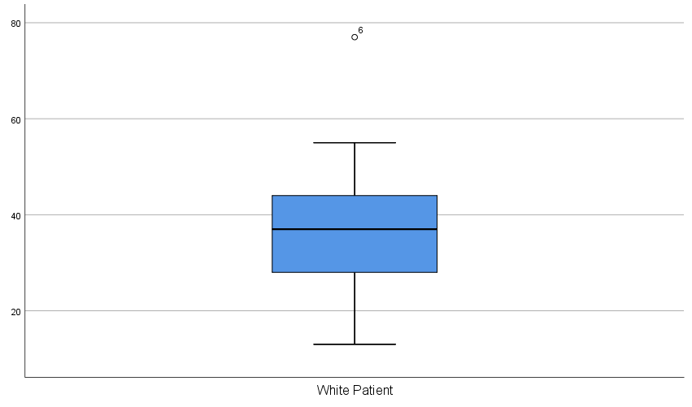
Interpretation: From the boxplot of white patient, we see there exists value outside minmax fence. So, we can say there are outliers in the data.

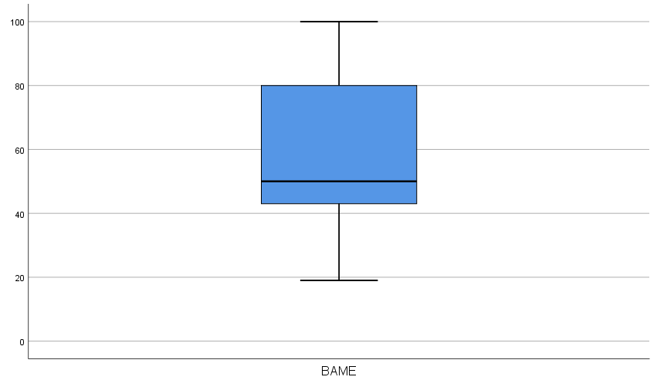
Interpretation: From the boxplot of BAME we see there exists no value outside minmax fence. So, we can say there are no outliers in the data.

Exploratory data analysis:
Other elements such as descriptive statistics, test of normality, histograms, Q-Q plots etc. have developed during our approach to test hypotheses and verify outliers.

Descriptive Statistics
Descriptive statistics are used to describe fundamental features of data in a research. A simple summary of the sample and measurements is made. In combination with simple graphical analysis, they form the basis for virtually all quantitative data analysis. In general, descriptive statistics and inferential statistics are distinguished from each other. With descriptive statistics, you only explain what is or what the data suggests. Description of statistics are used to provide quantitative information in a comprehensible way. In a research study, we can do a lot of action. Or, a large number of individuals can be measured in any parameter that is available to researchers. Describing statistics enables us to simplify huge amounts of data with minimal effort. Any descriptive statistic reduces a lot of data to a simple summary.
Descriptives
 |  |  | Statistic | Std. Error
White Patient | Mean |  | 36.58 | 1.694
White Patient | 95% Confidence Interval for Mean | Lower Bound | 33.18
White Patient | 95% Confidence Interval for Mean | Upper Bound | 39.98
White Patient | 5% Trimmed Mean |  | 36.33
White Patient | Median |  | 37.00
White Patient | Variance |  | 143.514
White Patient | Std. Deviation |  | 11.980
White Patient | Minimum |  | 13
White Patient | Maximum |  | 77
White Patient | Range |  | 64
White Patient | Interquartile Range |  | 16
White Patient | Skewness |  | .448 | .337
White Patient | Kurtosis |  | 1.348 | .662

Descriptives
 |  |  | Statistic | Std. Error
BAME | Mean |  | 60.04 | 3.308
BAME | 95% Confidence Interval for Mean | Lower Bound | 53.39
BAME | 95% Confidence Interval for Mean | Upper Bound | 66.69
BAME | 5% Trimmed Mean |  | 59.82
BAME | Median |  | 50.00
BAME | Variance |  | 547.182
BAME | Std. Deviation |  | 23.392
BAME | Minimum |  | 19
BAME | Maximum |  | 100
BAME | Range |  | 81
BAME | Interquartile Range |  | 38
BAME | Skewness |  | .270 | .337
BAME | Kurtosis |  | -1.174 | .662
Using descriptive tables, we may calculate the central tendency, standard deviation, minimum, maximum, range, and other values.

Test of normality
Standard statistical tests are more accurate as real probabilities are determined. Normality testing calculates the likelihood of a normal population taking the samples.
The assumptions utilized are as follows:
Ho: The data from the sample does not differ substantially from the usual population.
Ha: The sample data differs considerably from a normal population.
• Probabilities >0,05 suggest that the data is normal when testing for normality.
• Data are NOT normal for probabilities <0.05.

Tests of Normality
 | Kolmogorov-Smirnovª |  |  | Shapiro-Wilk
 | Statistic | Df | Sig. | Statistic | Df | Sig.
BAME | .186 | 50 | .000 | .935 | 50 | .008
a. Lilliefors Significance Correction

we see the BAME data doesn’t follow normal distribution as the P value for both Kolmogorov-Smirnov and Shapiro-Wilk test is less than 0.05
Tests of Normality
 | Kolmogorov-Smirnovª |  |  | Shapiro-Wilk
 | Statistic | Df | Sig. | Statistic | Df | Sig.
White Patient | .091 | 50 | .200* | .962 | 50 | .107
*. This is a lower bound of the true significance.
a. Lilliefors Significance Correction

we see the white patient data follows normal distribution as the P value for both Kolmogorov-Smirnov and Shapiro-Wilk test is greater than 0.05

Histogram
It is the graph of frequency distribution that is the most commonly used in composition. It looks like a bar chart, but there are important contrasts between it and a bar chart. This handy information gathering and analysis tool is one of the seven essential quality tools.

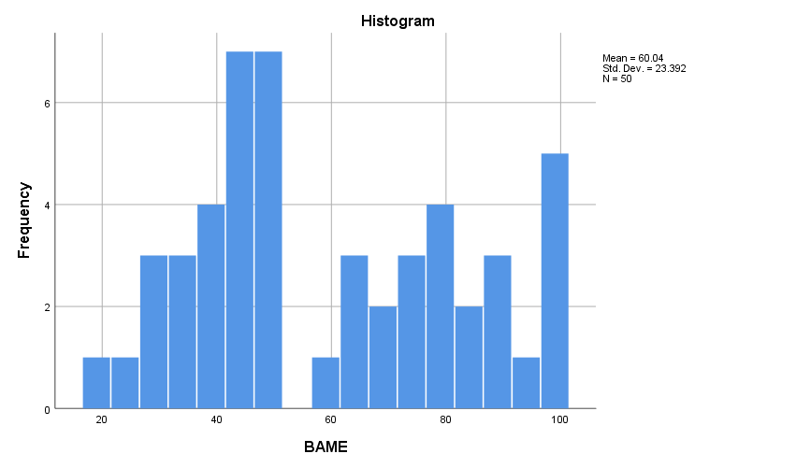
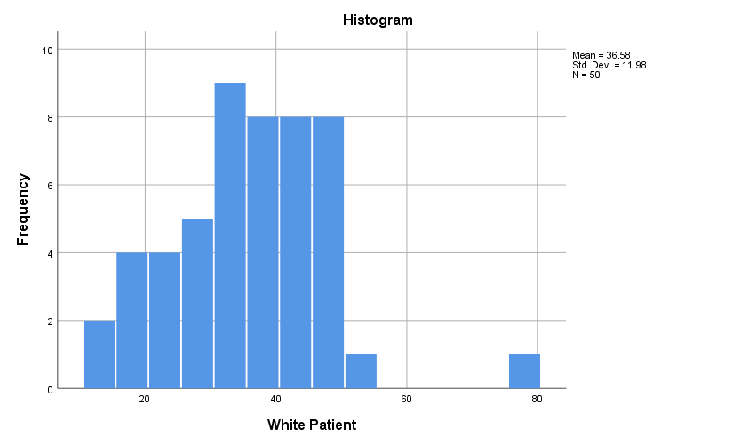

Q-Q plot
Q-Q (quartile-quartile) plots are plots of two sizes opposite each other. A quantile is a proportion that is below that quantile for specified values. The median is, for example, a quantity in which 50% of the information falls below and 50% lie above it all. Q-Q plots are used to determine if two sets of data originate from the same distribution. An angle of 45 degrees is shown in the Q-Q plot; the points will fall on that line if both data sets originate from a similar distribution.

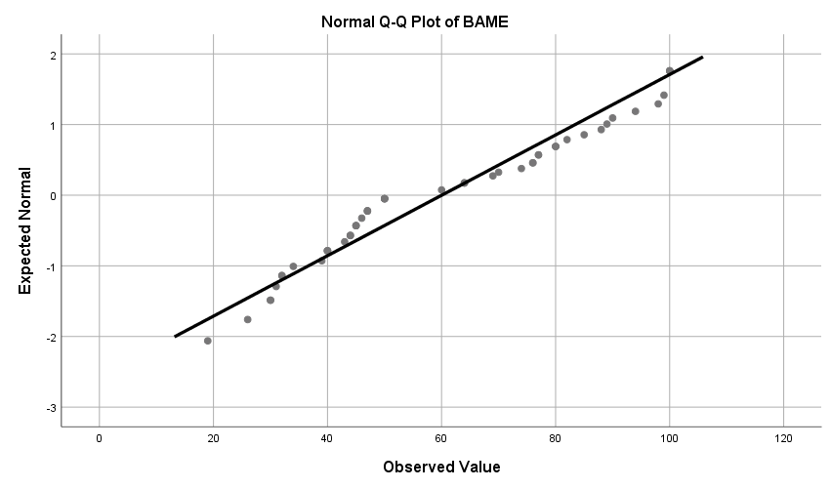
As the data falls on the line and just around it, we can say that BAME data follows normal distribution.
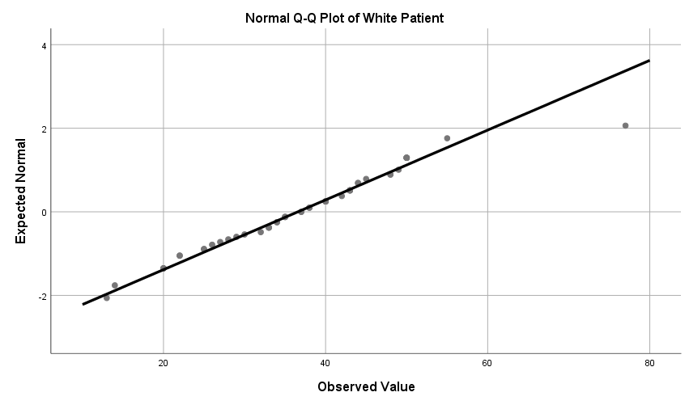
White patient data also falls on the line except one. It is called outlier.

Effect of another factor (Comorbidities):
Medically stated comorbidity is the presence of one or more extra diseases that commonly co-occur with a main illness. An individual patient's "comorbidity" refers to any additional conditions he or she may have outside the primary disease of interest. Comorbidity can be a medical or psychological condition. This is typically the case when illnesses co-exist, such as depression and anxiety disorder, in the setting of mental health. "Comorbidity" can refer to a condition that exists simultaneously with another ailment, but independently, or a condition that is connected to a related medical condition. Comorbidities enhance the chances of persons who have a virus that has worse health consequences and more seriously. People with cardio metabolism, such as heart disease, diabetes, and the risk of hypotension is greater. Chronic renal disorders can lead to asthma or chronic bronchitis and pulmonary illnesses more severe coronavirus symptoms also occur. Obesity is another factor in risk in the coronavirus, due to the metabolic disorder, as shown by British Journal of Metabolic Diseases Director Stephen O'Rahilly at Cambridge University. In persons with certain BAME origins, these risk factors were disproportionately greater. In Black African and Caribbean populations, hypertension prevalence is much greater than in white, and hypertension linked risk of cardiovascular disease in South Asia might be exacerbated. The diabetes of Asian and Black ethnic groups is younger than the diabetes of the Whites. Some BAME persons have a lower weight in comparison with the White populations of obesity-related illnesses such as diabetes type 2.
BAME persons have a danger of coronavirus becoming more severe and sometimes unfavorable in their health. Primary prevention should be given priority in the fight against comorbidities. The decision to dissolve Public Health England might lead to a vacuum in preventative efforts already underway. For at least two years, the NHS Health Check, presently being conducted for the ages of 40 to 70, should be extended to persons from BAME who are 25 years old. Culturally relevant is the Government's obesity policy. When Public Health England disbands, the Government must guarantee that any work carried out in this area is not lost.

Conclusion:
From BAME and white patient we can say that there is significant difference between the infection rates is not same. BAME people are more likely to be infected by COVID than white people because of their diversity and lifestyle. They are more exposed to virus than native people. And the house of common is trying to get this fact into light.

References:

- Kim, T., 2015. T test as a parametric statistic. Korean Journal of Anesthesiology, 68(6), p.540.
- Popper, K, 1976. Unended Quest. An Intellectual Autobiography. Fontana Collins, p. 42
- Ruxton, G., 2006. The unequal variance t-test is an underused alternative to Student's t-test and the Mann–Whitney U test. Behavioral Ecology, 17(4), pp.688-690.

