ACCA7052 Web Service

ACCA7051 Web Development

Parjal Rai

2420643

Table of Contents
1. Application Documentation 3
2. GraphQL implementation and benefits 6

Application Documentation

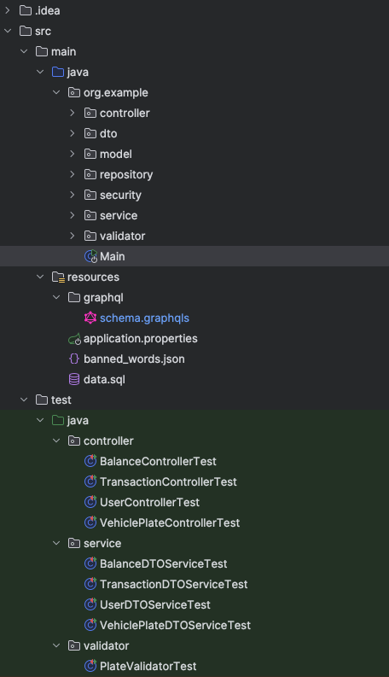

Figure 1: Project Structure of the server-side application.

The application follows the Model-View-Controller (MVC) architecture, with the Model and Controller implemented on the backend.
- The Model directory contains entity definitions and handles Object-Relational Mapping (ORM) to the database.
- The Repository directory is part of the persistence layer, abstracting database access. It also includes custom queries.
- The Service layer contains the business logic.
- The Controller layer exposes the API for client communication.
- The DTO (Data Transfer Object) directories are used for encapsulating data and enhancing security by preventing direct exposure of internal entities.
- The Validator directory checks for banned words, ensuring they are not used as vehicle plate entries.
- The Security layer centralizes authentication and other security-related features.
- Unit tests are located in the test directory.
Additionally, within the resources directory:
- SQL files are provided for importing data into a local PostgreSQL database.
- A JSON file contains the list of banned words.
- A GraphQL schema is included for API structure definition.
- Application properties file for application configuration.

Running the code (on the server side)

- To run the application with keycloak and database already set up, go to the terminal and run the command:
docker compose up
Or
docker compose up -d (to run the app on the background)

Running the code (on the client side)
  - To run the application, open the project, navigate to the terminal in the project's root directory, and run the following command:
docker compose up

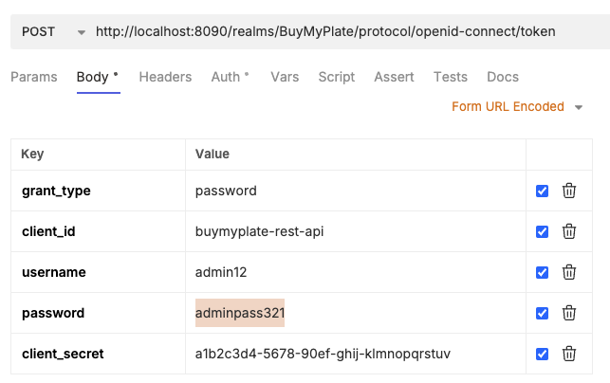
Figure 2: Keycloak body configuration on Bruno.
- To run the test, run the command: mvn test

GraphQL implementation and benefits

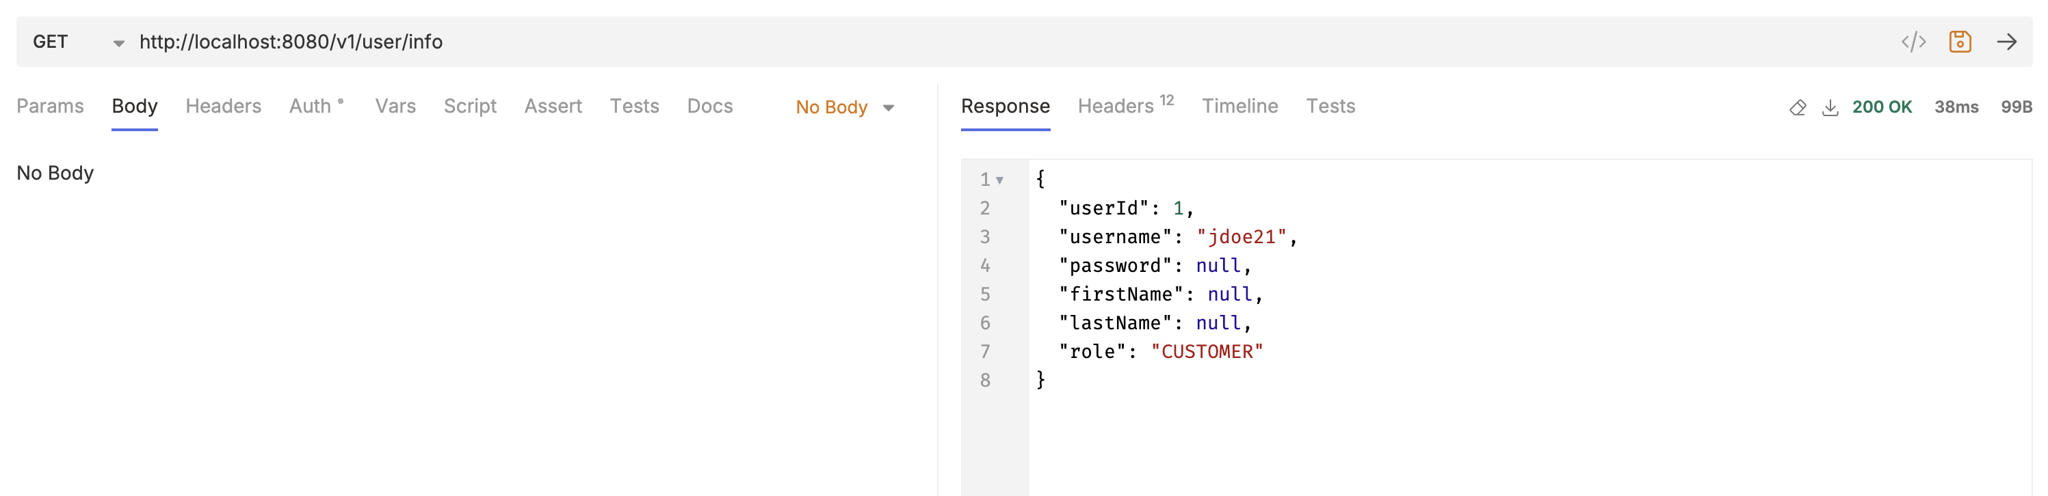
Figure 3: REST endpoint to fetch user profile details.

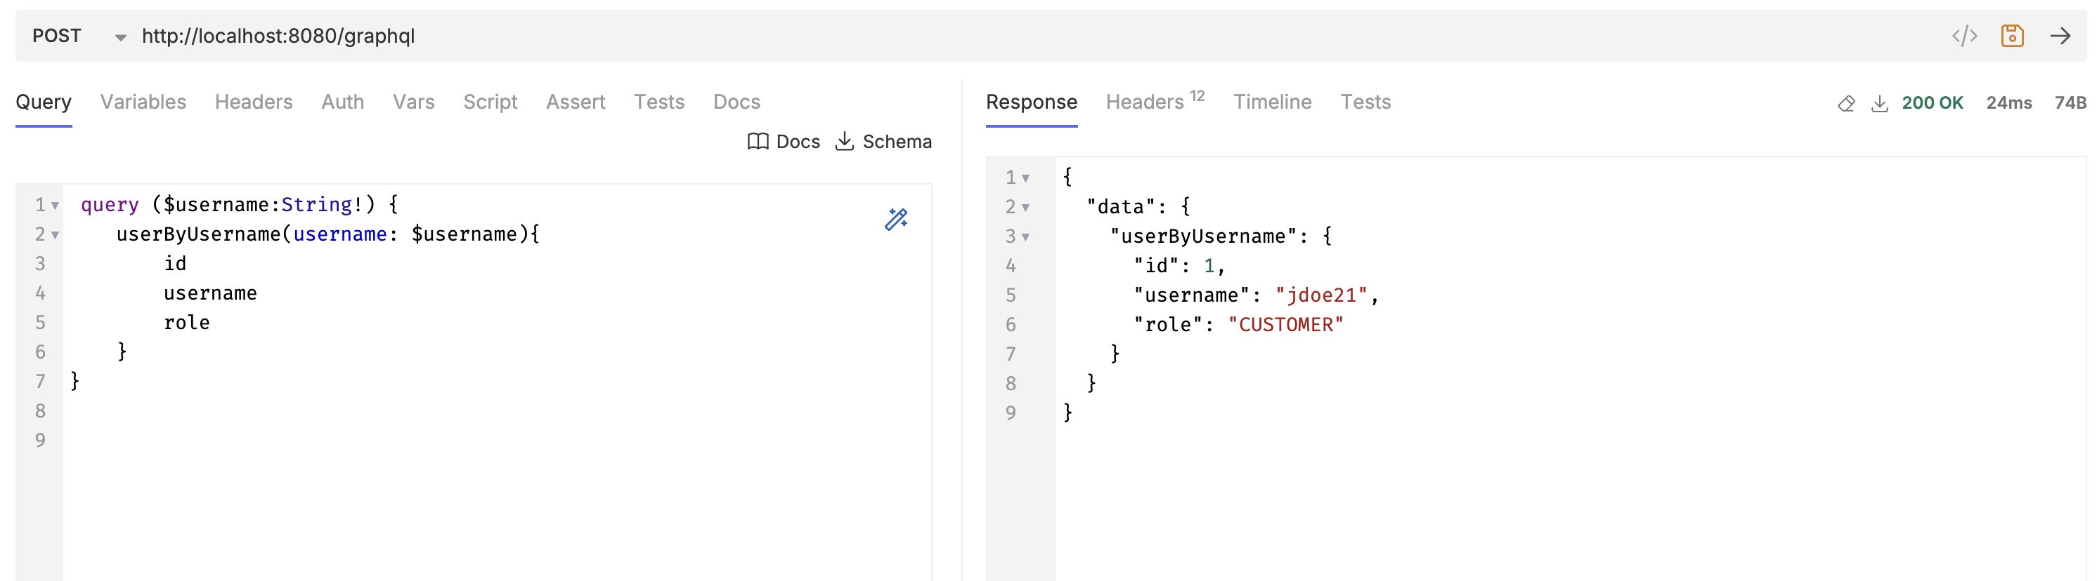
Figure 4: GraphQL endpoint to fetch user details.

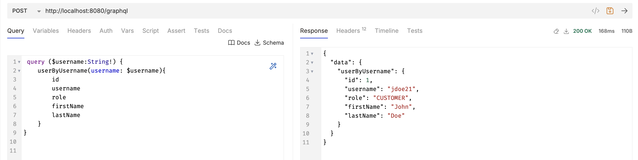
Figure 5: GraphQL endpoint to fetch user details with additional fields.

The Representational State Transfer (REST) endpoint (Figure 3) and the GraphQL endpoint (Figure 4) both aim to fetch user details. However, REST is a less optimal choice in this context due to its tendency to over-fetch or under-fetch data. In REST, the structure of the response is fixed by the server, meaning clients often receive more data than necessary or must make additional requests to retrieve related information [1,2].
While REST can be adjusted using different Data Transfer Objects (DTOs), this introduces additional problems. Supporting multiple use cases often requires creating and maintaining multiple DTOs and endpoints on the backend, increasing overhead and tightly coupling the client and server. This also results in multiple round trips to the server to assemble the required data [2].
By contrast, GraphQL shifts control to the client (Figure 6). Clients can specify exactly what data they need through a single, flexible query. On the backend, a universal schema (Figure 7) defines the types and relationships within the data model, allowing for nested queries. This enables the retrieval of complex, related data in a single request, reducing network latency and simplifying frontend logic [2].
Unlike REST, GraphQL responses are shaped by the client’s query, not by the server’s endpoint structure. As shown in Figures 4 and 5, clients can avoid both over-fetching and under-fetching by requesting only the fields they need. This eliminates the need for custom endpoints and supports a more maintainable and scalable architecture [1]. Since the client defines the response shape, it can evolve independently of the server — as long as the queried fields exist in the schema — without requiring backend changes [2].
In conclusion, GraphQL offers a modern, efficient alternative to REST for web service applications. By empowering clients to request precisely the data they need and reducing the number of backend endpoints, GraphQL improves performance, scalability, and developer experience. Its ability to minimise over-fetching, eliminate unnecessary round trips, and support flexible, schema-driven interactions makes it particularly well-suited for dynamic and data-rich applications. As such, GraphQL represents a valuable architectural choice for building responsive and maintainable modern web services.

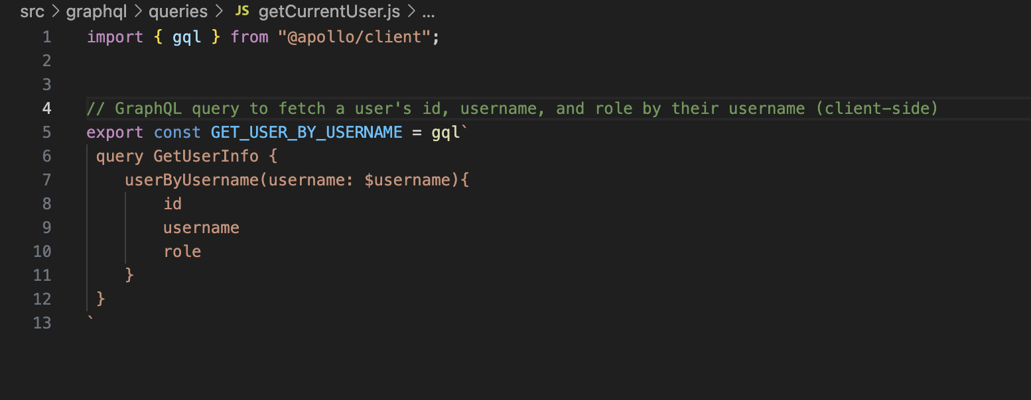
Figure 6: GraphQL query on the client-side requesting specific user attributes.

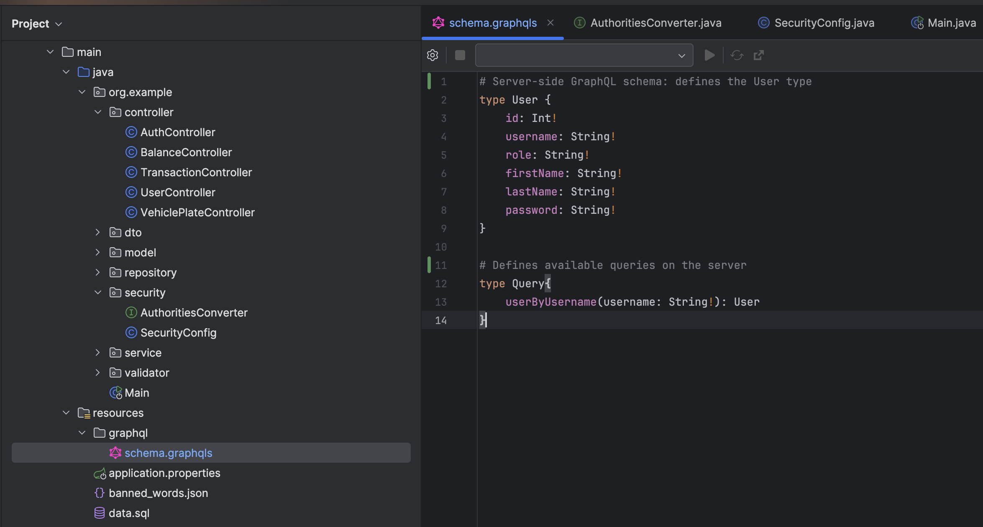
Figure 7: GraphQL User Schema and queries on the server-side.

References

[1]
G. Brito and M. T. Valente, “REST vs GraphQL: A Controlled Experiment,” IEEE Xplore, Mar. 01, 2020. https://ieeexplore.ieee.org/abstract/document/9101226

[2]
S. L. Vadlamani, B. Emdon, J. Arts, and O. Baysal, “Can GraphQL Replace REST? A Study of Their Efficiency and Viability,” 2021 IEEE/ACM 8th International Workshop on Software Engineering Research and Industrial Practice (SER&IP), Jun. 2021, doi: https://doi.org/10.1109/ser-ip52554.2021.00009.
‌

