
Skills for the Workplace
Module Assignment Submission
Student Name: | Emma Leanne Nightingale
Student Number: | 2008693
Module No: | BMSK4006
Module Title: | Part 1 Business Plan

Statement of Confirmation of Authenticity

By the act of making this submission, the student declares that this is the work of the student named above. The work has not, in whole or in part, been knowingly presented elsewhere for assessment, or where assessment has been built on a previous assessment, this has been identified. Where materials have been used from other sources it has been properly acknowledged. If this statement is untrue, the student acknowledges that an assessment offence has been committed.
Attention is drawn to the plagiarism and unfair practice policies of both the University and of ILM.

Table of Contents
Title Page 3
Executive Summary 4
Business/Industry Overview 4
Market Analysis and Competition 4
Sales and Marketing Plan 6
Product or Service Offerings 6
Pricing Strategy 7
Sales and Distribution 8
Advertising and Promotion 8
Ownership and Management Plan 8
Operating Plan 9
Financial Plan 9
Appendix 1 10
Appendix 2 10
Appendix 3 11
Appendix 4 14
Appendix 5 15
Reference 18

Title Page

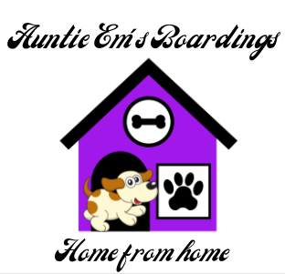

Business Plan for Auntie Em’s Boarding’s

Dated ~ 11th June 2021

Registered Owner ~ Mrs Emma Nightingale
Registered address ~ 149 Middle Road,
Cwmbwrla,
Swansea,
SA5 8HE
Telephone ~ 07999890949
Email ~ Auntieemsboardings@gmail.com
Limited Company

Executive Summary
The Company mission is to provide luxury boarding with home from home comforts to dogs. A place dogs don't want to leave and look forward to returning year after year! It aims to take the guilt away from dog owners when going on holidays and leaving their much loved family members behind. It will create an environment which will feel like a home and unlimited amounts of time to give them a fun filled holiday of their own which they will look forward to returning to.
The business will consist of 6 outside kennels and internal boarding also. The kennels will have individual secured areas attached to each individual kennel and be made with high quality timber to give a high quality craftsman’s finish and lodge like feeling to the kennels. At full capacity the company and single occupancy the business could board up to 16 dogs including 4 dogs boarding within the family home. The kennels will be situated on the grounds of the family home. It is located extremely close to the M4 and is very accessible. Road parking will be available for up to 2 cars. A collection and delivery service will also be available.

Business/Industry Overview
According to Griffin, K (2021) there are over 5 million dogs within the UK with Wales having the higher number of dogs. It is an industry in high demand and is not showing any signs of slowing down. 90% of dog owners seek boarding to go on holidays. Owners view their pets as a member of their family and always seeking the best for their much loved pooch.
The business will provide luxury boarding for dogs that will feel like home for them. Every kennel will have home from home comforts in them such as an armchair, smart TV & pictures on the wall. Webcams will be installed in every kennel and this will allow owners to log in and see their dogs at any time. The business will aim to create a place dog owners know their family pet will be safe, comfortable and extremely well looked after.
Located 2 miles from the beach, 1 mile from the river and 500 yards from a local park, daily walks will be varied and exciting.
The business will aim to meet the needs of all dogs whether it is medical and/or mobility. A detailed and comprehensive plan will be drawn up and agreed before any residence takes place.

Market Analysis and Competition

The businesses target market will be all dog owners that book holidays, work commitments or require boarding for unexpected reasons such as hospital stays and home renovations. The business main market will be families, professional individuals and retired owners also.

TAM analysis carried shows the following results:-

Total available market ~ 247,000 (Swansea)
Served available market ~ age 25 – 75+ 170,300
Target market ~ Dog owners 49,387 (29% of households)

A Pestle and the potential risks to the business was conducted as detailed below:-

Political | - Brexit  - Pet Passports  - Travel restrictions
Economic | - Negative impact from Covid19.  - Furloughed workers
Social | - Concerns leaving their pets  - Dog sitting services
Technological | - Not all customers confident to use technology  - Technology breaking down
Legal | - Licences  - Neighbours disputing service.
Environmental | - Negative carbon footprint.

Due to new regulations post Brexit it has become more difficult to travel to an EU Country with your pet. According to Gov.uk (2021) Pet Passports previously granted by Great Britain are no longer valid. It is believed this will have a positive impact on the pet boarding industry and with this in mind the Companies services will be in demand with the new legislation granted.

Whilst the current Covid restrictions have had a negative impact on travel it has seen a large increase in the demand for dogs. With the introduction of the CoronaVirus vaccine and it being widely available and administered in the UK restrictions have continued to ease and the trend will continue. In turn the market for holiday accommodation has increased within the UK. According to Christian (2021) the holiday letting market has seen an increase of 460% since 2019. This shows the high demand at present for holiday lettings and in turn would have a positive impact on the dog boarding industry.

CCTV service will be available for owners to see their pets during their boarding. An intruder alarm will be installed at the boarding’s and also wider CCTV for monitoring the surrounding area.

The company will use local companies and businesses to try and eliminate the carbon footprint. Waste disposal companies will be used to dispose of dog waste in an economical friendly style.

The way in which dog owners view and think of their dogs are changing. They are considered as much loved family members. Owners want the best for their pets and in turn the service this business is offering is a highly dedicated service and will treat their pets as if they were part of their own family. The owner endeavours to provide a high level service to keep all dogs in their care happy and safe. The main aim is to ensure all dogs receive an enjoyable and fun packed holiday whilst at Auntie Em’s Boarding’s.

According to primary research (Nightingale, 2021) completed by 108 local dog owners over 77% had difficulties with availability and 57.5% had difficulties with distance/location (Appendix 1). This indicates that although there are 2 other boarding’s within a 5 miles radius of the business then there is still a high demand due to lack of availability and location. Whilst other local businesses are established one of them doesn't have a website or any reviews on yell.com. With Google ranked second highest and websites fourth highest within the primary research on the most used way to research boarding’s this business will develop this area (Appendix 2). Word of mouth was the highest ranked tool when researching boarding business and this is an area the owner feels confident the business will excel in.

Sales and Marketing Plan

The business service it has to offer will be highly advertised in many different methods to reach as many of my target market as possible this will include:-
- Website
- Facebook
- Yell.com
- Leaflet drop
- Adverts in local Vets, Community Centre, shops, Cafes etc.
- Business cards.
These are relatively cheap if not free marketing tools and will help promote the business greatly.
Product or Service Offerings
Auntie Em’s Boarding’s will be offering luxury boarding for dogs. They will receive as much time, attention and love they need to feel relaxed and at home whilst at the boarding. A safe and clean environment will be provided. Minimum of 1 hour a day of external exercise will be provided. This can be and will be increased if the dog requires it to enable us to meet their energy levels. Walks will be varied daily to include river walks, Local Park and beach walks. The business will aim to walk a maximum of 3 dogs at a time but it could be reduced to single walks if the dog’s temperaments do not allow mixing with other dogs. A comprehensive plan of the dog's needs will be carefully drawn up so dog owners can see exactly what activities their pets will receive whilst at Auntie Em’s Boarding’s. It is also important to have a clear picture of any needs the dog may have in order for the company to meet these needs fully. All dog owners will be offered the free option of having their dogs washed and dried prior to collection if they book for 4 or more consecutive days.
The business 6 luxury heated outdoor kennels can offer double occupancy to allow 2 large dogs or 3 even small dogs of the same household to share. The boarding situated in the owner’s family home will be best suited for elderly dogs or dogs that suffer with separation anxiety. This option can offer this service for up to 4 dogs at any one time. They would need to fit the suitability criteria and be of good temperament and used to socialising with other dogs and children to book this service. They will also receive regular walks (as detailed above) and the owners and extended families time and dedication to make them feel welcome.
All owners will be provided with a secure and password protected log in for the 24/7 CCTV service to check in on their dog. Regular updates during the dogs stay and photographs of them during their walks and enjoying their holidays will be provided. All dog owners will be offered the service of ringing at any time if they wish to receive an update and reassurance on their dogs. The business will aim to make the whole process of leaving their dogs as carefree and reassuring as possible as it understands that leaving their much loved family dog can be an extremely anxious and difficult time for some owners.
The boarding and full services will operate 24 hours a day 365 days of the year.
Pricing Strategy
The price structure is
Peak season ~ Jan, Feb, Mar, Oct & Nov

Outside boarding
- 1 dog £20 per night = £140 a week
- 2 dogs (sharing) £25 = £175 a week
- 3 small dogs (sharing) £27.50 = £192.50

In house boarding
- 1 dog £22.50 per night = £157.50
(no discount for double occupancy with in house boarding)

Off Peak season ~ April, May, Jun, Jul, Aug, Sept & Dec

Outside boarding
- 1 dog £17.50 per night = £122.50 a week
- 2 dogs (sharing) £22.50 = £157.50 a week
- 3 small dogs (sharing) £25 = £175 a week

In house boarding
- 1 dog £20 per night = £140
(no discount for double occupancy with in house boarding)

Sales and Distribution
The company expects the sales/bookings to steadily grow year after year. The service will have higher demand peak seasons however the target market also includes retired and business people alike and it would be expected to have regular bookings out of peak times and the prices have been reduced to reflect this. Although the wooden lodges will be fully heated the Company will also be offering indoor boarding within the owners own family home. The dog owners might feel this is more a suitable option to fit their dog’s needs to use the service during winter months.
Advertising and Promotion
Primary research recently conducted (Appendix 2) reports word of mouth is the best advertising tool with google, Facebook and website being the next most popular advertising tools. The company will focus on creating an eye-catching but easy to navigate website and Facebook page which will catch customers' attention. Customer feedback will be welcomed and encouraged to all customers. When customers make contact with enquiries or booking the owner or employees will conduct ongoing market research into how they found out about the services. This will give the owner the information to keep reviewing how efficient the company's advertising tools are and adapt if needs be.
There will be promotion offers with discounts for loyal and returning customers. For customers using our service more than twice a year the 3rd booking will receive 5% off. This will run on a January to December timescale. It is important that returning customers feel valued and appreciated.
The Company also offers discounts for multi dogs sharing the luxury lodgings on offer. The aim will be to be more cost efficient to dog owners with multiple dogs.
Ownership and Management Plan
Auntie Em’s Boarding will be run and managed on a full time basis by Emma Nightingale. Emma has a Level 5 Business and Management Degree. She also has experience of successfully running a school budget and fully understands the importance of bookkeeping and audits (see CV attached appendix 3). All maintenance and building work will be undertaken by Andrew Nightingale who is a qualified builder and electrician free of charge.
Emma will be the sole Director of Auntie Em’s Boarding’s. The Company will operate as a Limited Company and be fully registered. The Company predicts that by Year 3 the company will be well established and employees will be recruited. Tailor made job descriptions will be drawn up and skill matrix will be used during the interview process to ensure that only the best quality and committed employees join the company. It will be essential they share the business attributes and values. Regular performance management reviews will be undertaken by the owner. High level of training and support will be provided for all employees to grow to their full potential.
Operating Plan
- Provide a top quality service.
- Effective methods to keep owners up to date and take the guilt and worries away whilst holidaying without their dog.
- Safe and fun filled experience for all dogs in our care whilst on their holidays.
- Top quality level of communication between owners and the company from first query and through the whole process.
- Tailor made plans to meet the needs of each dog in our care, e.g. medical, social anxiety, likes/dislikes etc.
- To grow the company into a well-respected and high demand service.
- By Year 3 start to employ.
- By Year 5 expand the business and take on more staff.
Financial Plan
The business will use a start-up loan from Welsh Government Banc. In order to meet the criteria of the Welsh Government loan it is required that investment from the owner is also required into the business. Please see breakdown below (Appendix 5):-

Loan Start-up - Banc (Welsh Government) £30,000 interest 6.4% over 5 years monthly fee £532.
Loan from owners parents - £10,000 interest free over 5 years monthly £166.67

The cost to build the kennels including labour is £11,554 (quote attached from local builder Appendix 4). In order to be as cost effective as possible £8,500 will be deducted for solar panels to produce enough energy for the kennels. The owner has received a quote of £4,000 to install underfloor heating to the outside kennels. No labour charge will be added as the owner's husband will install them free of charge as a qualified builder and electrician.

The Company will hire a highly trained and local Accountant to support the business in line with the limited company status and required returns and will be able to provide advice and support accordingly. The fee will be charged monthly at £150 a month for the first year and with the cash flow spreadsheet (Appendix 5) it has allowed a small increase yearly thereafter to allow for inflation.

Land charges have been considered and will amount to £159.60 and Licence fee of £182 with the Kennel Club for initial set up.

During Year1 & Year2 the Owner Emma Nightingale will be the only employee in the Company. In year 3 it is hoped the Company would employ an individual for peak season to work assisted alongside and supervised by Emma Nightingale. In year 4 & 5 the company will employ one full time member of staff to support the business. As the business grows the need to employ more staff will be considered but the business do not plan within the next 5 years to require this.

The company is not expected to exceed the current VAT registered threshold of £85,000 in the next 5 years. Therefore to keep the business prices down for customers the business does not volunteer to register the business in such a way for VAT purposes.
Appendix 1

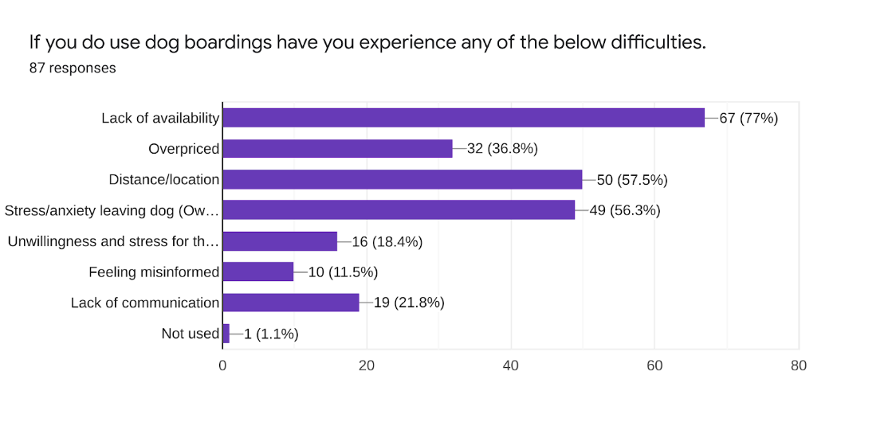
Appendix 2
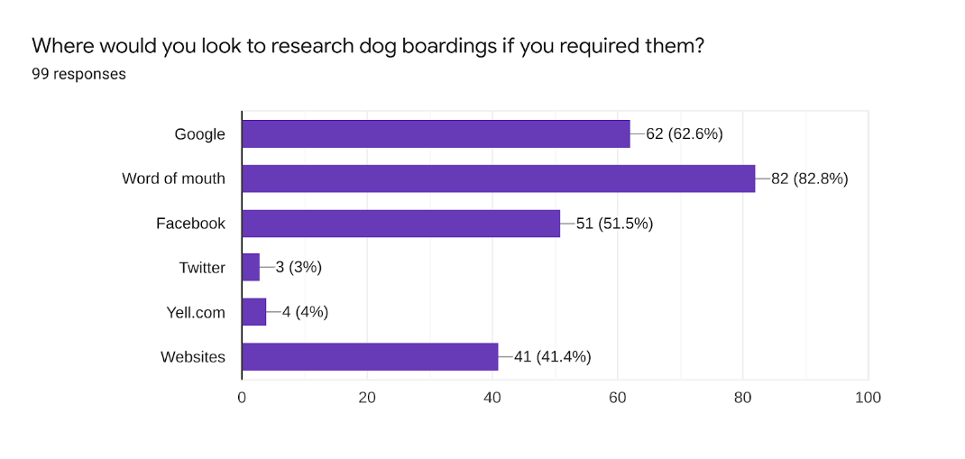

Appendix 3

Emma Nightingale

149 Middle Road, Cwmbwrla, Swansea, SA5 8HE | emmanighingale11@gmail.com | 07999890949
Summary
I have recently successfully completed a BA Leadership and Management Degree. I feel this has been extremely helpful and beneficial. It has definitely helped me to grow and I have been able to apply my new knowledge and skills to my current post. I have a confident leadership and management style. I am a very approachable person and I believe in an open door policy.

During my whole working life I have always been required to communicate with either clients, customers, parents etc. I have always been able to build good and relevantly quick relationships with clients and parents. I believe communication is key to a successful business and I am highly trained in providing top quality customer service. I am a very caring and dedicated person.

My love for dogs started at a very young age and has continued into my adulthood. I understand the important role a dog plays within the family unit. I have a Level 3 in Pet First Aid and CPR which is an extremely important skill to have incase of emergency.

Experience
SCHOOL CLERK & CLERK TO THE GOVERNORS
Hafod Primary School ~ 2018 to current
- Ensuring the correct running of our school budget, Financial System (FMS) including placing all purchase Orders, record keeping, processing Bank statements and issuing all invoices.
- Processing invoices and completing cheque runs in a timely manner.
- Monitoring school funds.
- Completing all statutory returns e.g. PLASC, SWAC etc as required.
- Monitoring all policies and amending and updating when required.
- Taking minutes in any meetings required by the Senior Management team.
- Completing introductions for new staff members including ensuring all required paperwork is correct. Drafting contracts and performing inductions and ensuring new staff are up to date with all school policies.
- Ensuring all staff paperwork including DBS are up to date and stored correctly in line with GDPR guidelines.
- Keeping all pupils records and SIMS up to date including attendance.
- Enrolling new pupils and providing families with the correct information regarding our school and supporting them and completing the necessary paperwork for all leavers.
- Communicating with all parents/carers and visitors and helping with all queries and providing them with support if necessary.
- Signing in all visitors and contractors into the school safely.
- Clerking and attending all Governing Body meetings and providing support to the Chair of Governors as required.

LEGAL SECRETARY
DJM Law Ltd ~ 2001 to 2018
- Typing all letters, Court documents and attendance note using audio.
- Filing and keeping all files up to date.
- Answering all telephone calls and emails for the department.
- Booking appointments and meetings.
- Covering reception and switchboard when required.
- Complying with Money Laundering and GDPR regulations.
- Photocopied all correspondence, documents and other printed materials.
- Being the first form of contact and liaising between clients, solicitors and barristers.
- Processed and distributed invoices for clients in a timely manner.

OFFICE JUNIOR
DJM Law Ltd ~ 1999 to 2001
- Photocopying Court bundles.
- Covering reception and switchboard.
- Completing deliveries.
Skills
- Excellent Financial management Skills
- Good Multitasking and ability to prioritise workload
- Approachable & adaptable
- Good leadership skills
- Excellent team player & able to work on an individual basis
- Enthusiastic, passionate & committed
- Excellent IT skills.
- Drive to learn and develop skills further

Education
University of Wales Trinity Saint David ~ 2020
BA Leadership & Management

University of Wales Trinity Saint David~ 2018
Certificate of Higher of Education in the work place Level 4

Level 3 CPD Award ~ 2017
Pet First Aid & CPR

Swansea College ~ 2002
NVQ Level 3 Word Processing

Swansea College ~ 2001
NVQ Level 2 Word Processing

Pentrehafod Comprehensive School ~ 1999
GCSE Maths, English, Science, IT, Art, Childcare

Appendix 4
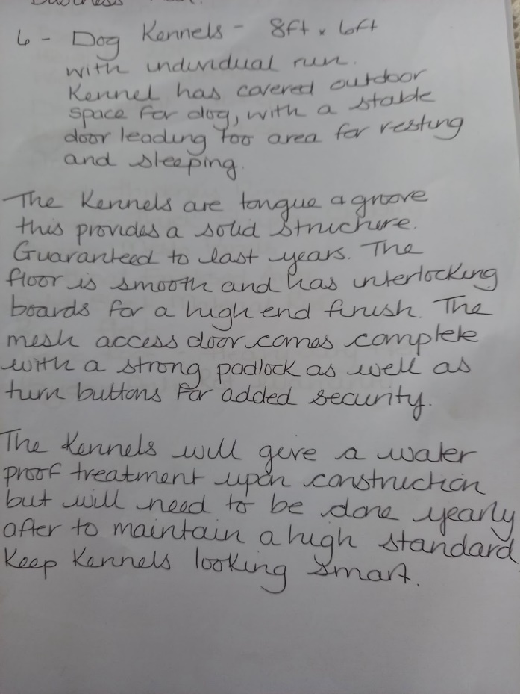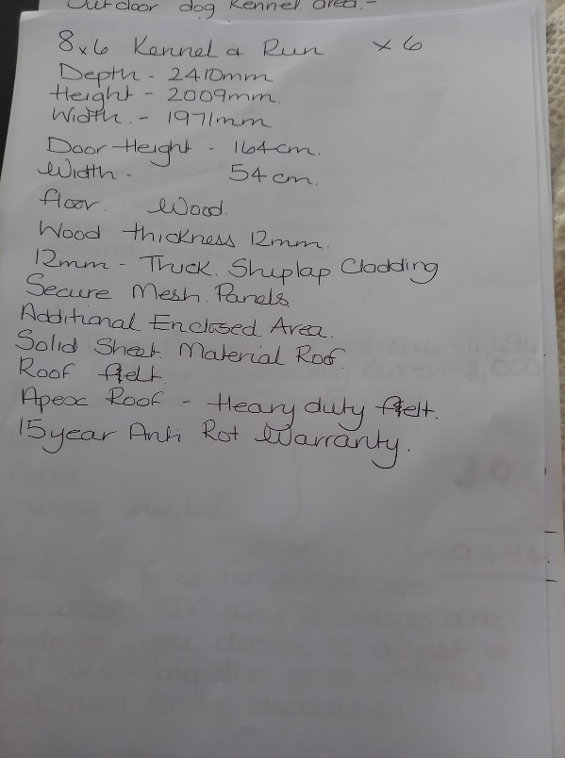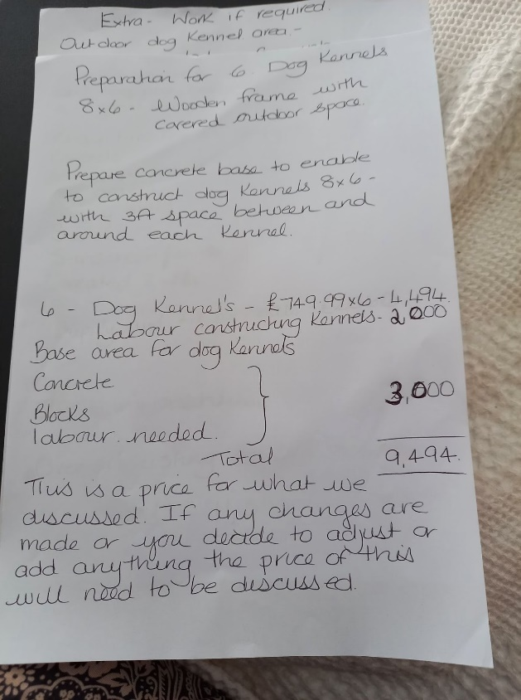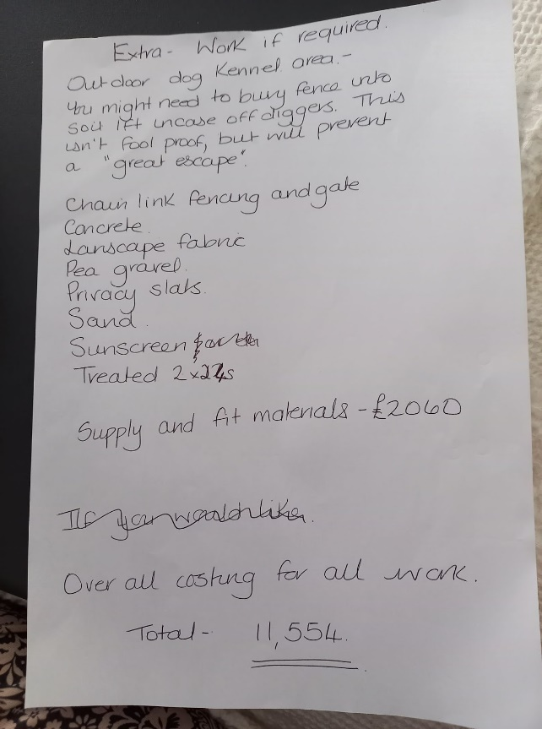

Appendix 5
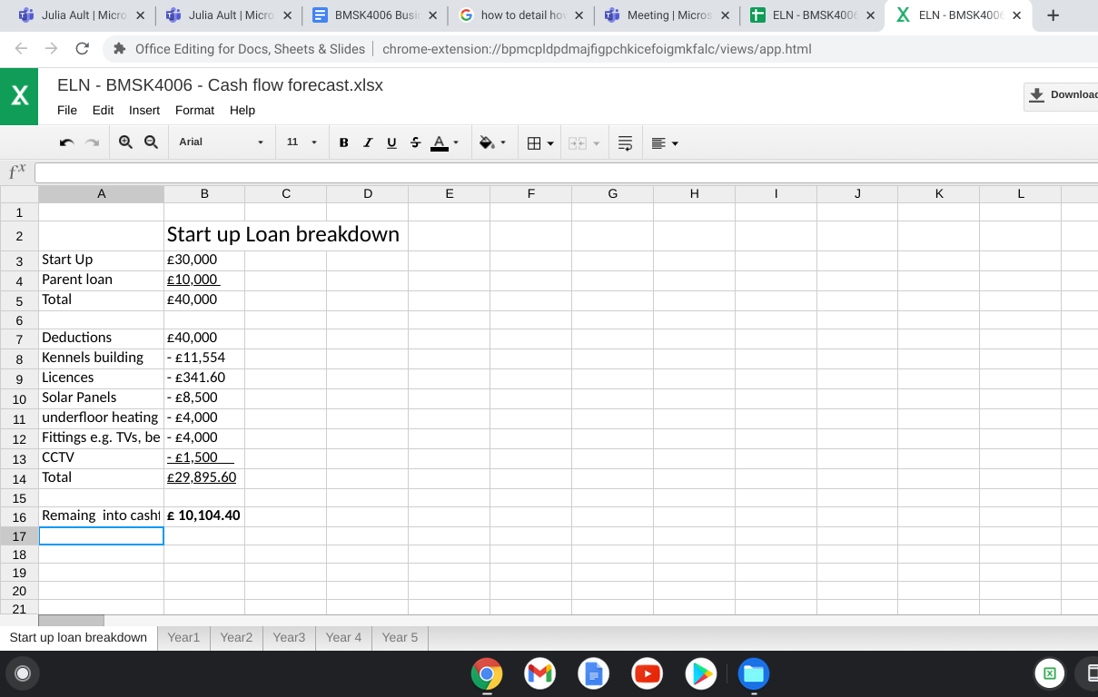
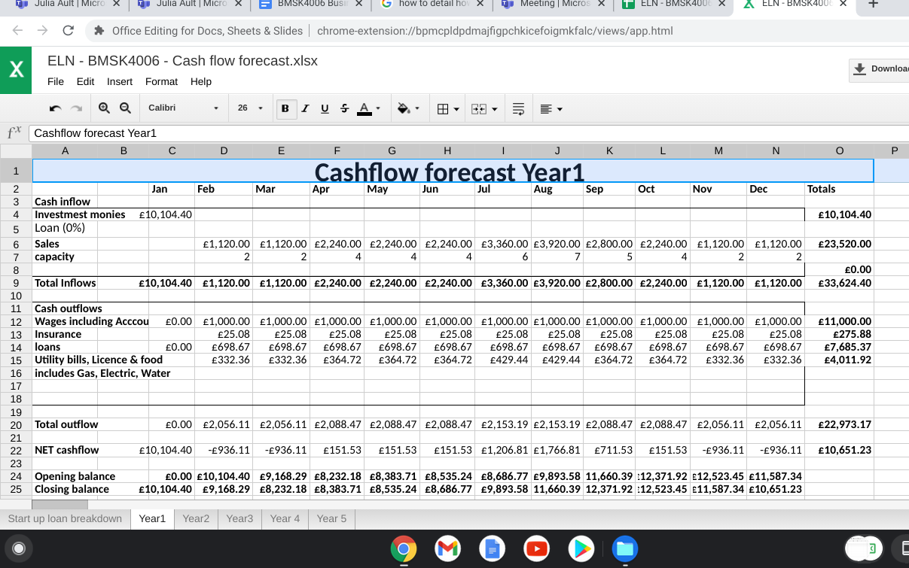
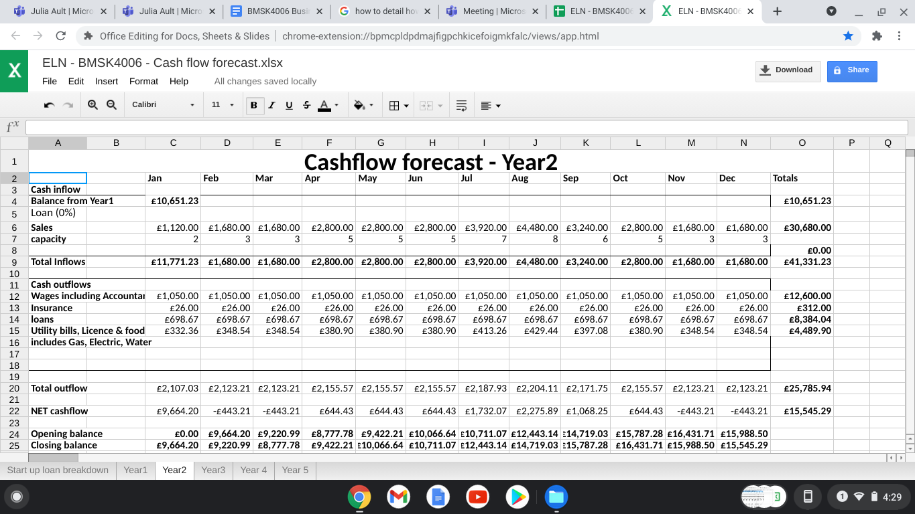
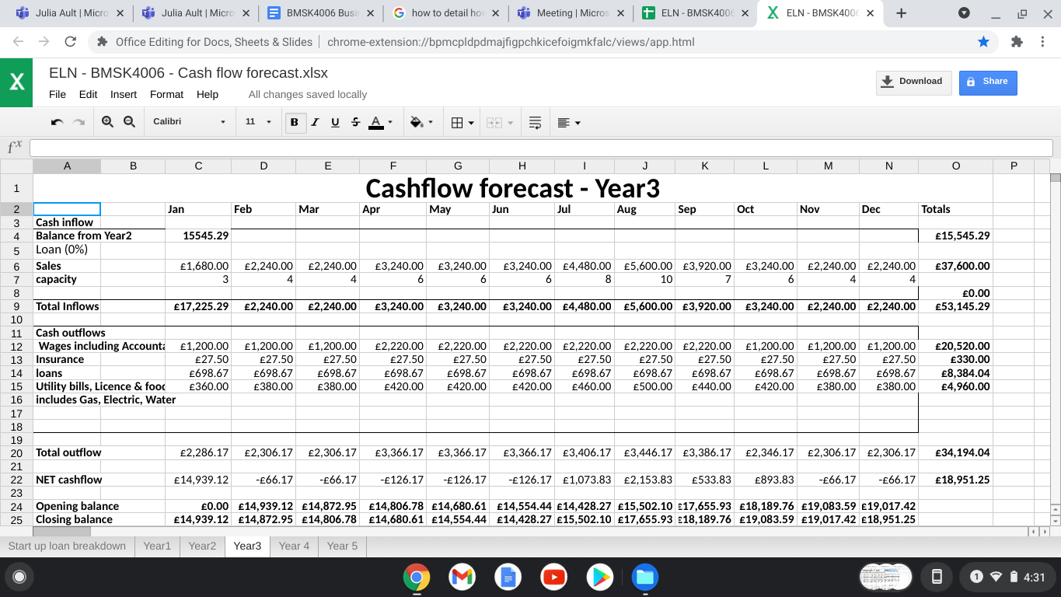
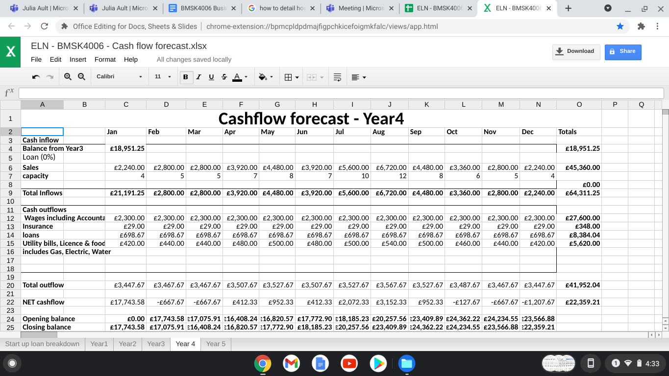
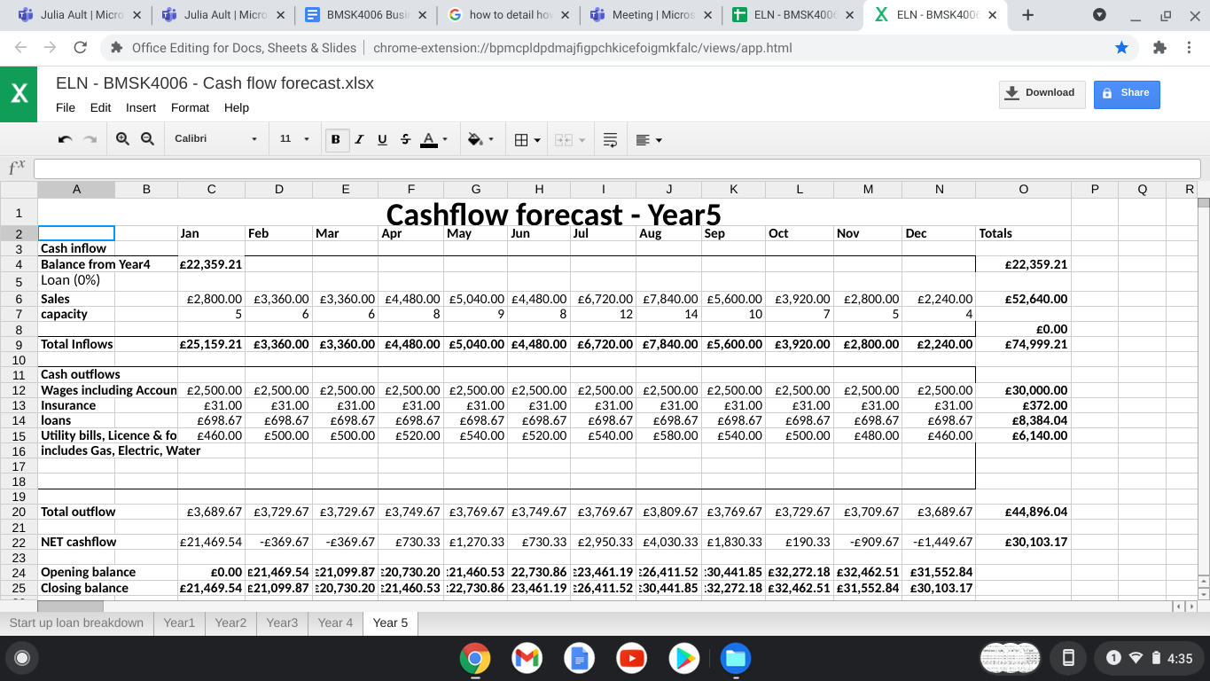

Reference

Banc (2021) Interest Rates [online] Available at: https://developmentbank.wales/get-business-finance/interest-rates (Accessed 09.06.21)

Christian, A. (2021) Staycation Statistics for 2020-2021 [updated 2021] [online] Available at: https://www.snaptrip.com/c/information/staycation-statistics/ (Accessed 13.07.21)

GOV.uk (2021) Taking your pet dog, cat or ferret aboard [online] Available at: https://www.gov.uk/taking-your-pet-abroad/travelling-to-an-eu-country-or-northern-ireland (Accessed 10.06.21)
Griffin, K. (2021) Sector Spotlight: Boarding Kennels [online] Available at: https://uk.businessesforsale.com/uk/search/boarding-kennels-for-sale/articles/sector-spotlight-boarding-kennels-1 (Accessed 17.06.21)
Nightingale, E.L (2021) Luxury Boarding for your Pooches [online] https://docs.google.com/forms/d/1kTGu5xZy1J95wVHsJUg1dl70NQo3KwC5p3wOFgJAg2U/edit (Accessed 19.06.21)

