Coaching & Mentoring

09/04/2021
Student Name: Caracostea Georgica
Student Number: 1806984

Lecturer: Rachel Cook
Module Unit: Coaching & Mentoring

University of Wales Trinity Saint David

Executive summary
The present report explains the concept of coaching and mentoring, in the organizational context of Tesco, a UK based retailer. The similarities, dissimilarities between these two schools have been discussed with example. The work tries to establish the importance of both in an organizational situation and how managers can improve it. The work also discusses the change management concept, along with useful models for making the description. Finally, a reflective part has been provided showing the learning experience of a coach along with his PDP plan.

Table of Contents
Introduction 3
Task 1 3
Task 2 6
Task 3 10
Personal Reflection 13
Conclusions 15
References 16

Introduction
Within any organization there are various requirements to be fulfilled to meet the organizational goal. Therefore, the need of learning new things and new processes becomes important. There are several aspects which an employee needs to understand such as business processes, use of skills, maintaining time and behave accordingly to an organization’s culture which their mentors and coaches can make them learn in an efficient way (Garvey et al., 2017). The purpose of this report is to highlight the purpose and roles along with the difference and implementation of coaching and mentoring in the context of Tesco, an UK based retail organization. The necessary skills and behaviors of manager will be discussed so that it can help the readers for identifying the same and improve themselves. The report will also discuss how coaching, and mentoring can induce change management within the system.

Task 1
Coaching is considered as a learning process which is aimed to improve the performance of people and is done to motivate and reorient the focus of them to present condition or situational demand. For professional development this is a necessary requirement for which a coach guides the others. Coach is a person who can provide the necessary details that are required to improve professionally, discover the strengths, identify the weakness in one and make a plan in order to achieve professional goals (MacLennan, 2017). Coaches help to solve any situational problem with their knowledge and expertise mainly. When a teammate or a fresh employee in Tesco faces any problem with their working style or demand and feel confused, it is advised to them to meet the manager who performs the role of a coach too, and with his expertise instinct, he can advise the person on what to do. In order to help him with that, there are several coaching models such as GROW and OSCAR models which can help the manager in dealing with the employee.
On the other hand, mentoring is a defined process, through which employee training system is performed. Here, a senior person acts as the mentor and is assigned with advising, guiding, counselling to any trainee under him (Woo, 2017.). A mentor is expected to give support and feedback to the person so that the employee can make quick changes to be successful. This process is done in big organizations so that mentors can encourage the employees to achieve their career goals through maximizing their potential, developing their skills etc. Tesco has their own mentoring programs, where mentors discuss with the employee from time to time and is very much successful to increase the production, to solve the problems of the employees regarding work, to reduce high turnover rates, tackle diversity problems and improve employee engagement etc. They also suggest the employees to take PDP plans from time to time so that the employees can measure their own success by setting their professional objectives to be achieved within time.
There are various similarities and differences between coaching and mentoring that has been observed within an organizational context. Both processes are designed to support person’s development and could follow 1-1 relationships. Both the processes require good understanding between the two parties and trust so that they can work in a synchronization. Both can take several months to mitigate the situational requirement and several seating could be called for. Both processes can be integrated into L&D programs and require personal agreement of the parties. In both formats, the employee should have desire to develop, and the mentor or coach should have the mentality of knowledge sharing. Easy communication is needed in so that discussion of target could be done which will create the pave of progress plan. The coach or mentor should be innovative and encourage new ways of thinking and the sole focus should be kept on career progression (Cornelius et al., 2020).
The difference between coaching and mentoring are few. Mentoring is a softer approach and is focused on relationship making, whereas coaching is a structured training approach. Mentoring is also a longer- term approach as this needs resolve of longer -term topics. This requires involvement of at least six months. Whereas coaching is a shorter- term approach and could be solved within a two- month time frame also (Marcdante and Simpson, 2018). Coaching address immediate topics related to skills and performance, while mentoring aims to improve a person in a complete way. Professionally mentors form within the busines, but coaches are mainly sourced externally.
According to Clutterbuck (2014), for effective mentoring, the mentor needs to consider developmental mentoring as well as sponsorship mentoring model. In any of these two directions, the learner´s need at the time could be observed and necessary steps could be taken. The learner could use challenging behaviors of stretch coaching or empathetic listening of counselling both of which are used in mentoring and coaching sessions. In developmental mentoring, emphasis is given on the empowerment and personal accountability, whereas in sponsorship mentoring, the role of power and influence is given the focus. The helping to learn model suggest these two dimensions, where the first dimension offers a spectrum of the mentoring relationship from directive to non-directive way. The other dimension offers a spectrum of the individual need from being stretching to nurturing. According to this model there are four styles namely Coaching, counselling, networking and guiding (cdn.ymaws, 2021).
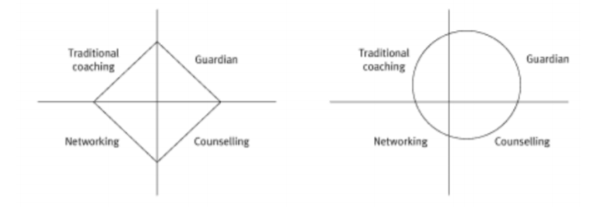
•

Figure 1: Developmental mentoring and sponsorship mentoring model
(Source: cdn.ymaws, 2021)
For Tesco, coaching and mentoring bring tangible and intangible benefits to employer and employee in various forms. Firstly, such coaching and mentoring helps the employees to understand their organizational goals and set their own professional progress according to that. This realistic approach helps to build their skill set and improve their professional behavior. Level of engagement with the organization is increased through these processes and hence the productivity for the organization increases. Employees feel more motivated towards their role and this helps to make improvements through personal goal setting. If any employee feels any disturbing issue regarding organization or any professional aspect, that can hinder his progress, he can share those with the coach or mentor, who can give him proper guidance about it and again continue his journey (Malešev, 2018). Such programs help to build persona awareness and create deeper level of learning. It has also seen that such coaching or training program at the initial stage of employment, they understand the professional demand sin a better way. Use of such facilities have proven worthy against staff turnover for businesses. Continuous growth and development of employees result in better production also increasing the profit margin.

Task 2
A line manager is the first layer of management, who directly works with the employees and has to play a multi-facing role of a manager, coach and mentor. A line manager has to perform various duties as well as coach or mentor his employees at various times. He has limited times for doing so and generally they emphasize on the coaching process, as this takes less time than mentoring. The following are the roles, a line manager needs to play within Tesco:
- The line manager becomes a part of the mentor pool, so that the team members feel comfortable with the manager and discuss every problem in open mind with him.
- He needs to clarify with the team members about their expectations from him as a coach or mentor so that he can progress accordingly.
- The manager has to prepare discussing career with the direct reports at any time and make clarifications on the subject (Małota, 2017).
- The manager needs to make sure that all employees have their own personal development plans, including short-term, medium-term and long-term objectives.
- He needs to have regular conversations with the employees and have updated information about their tasks and provide useful guidance.
- He needs to provide emphasis on building strength rather than overcoming weaknesses. Also focus on opportunities must be given rather than concentration on threats.
- Regular performance review should be conducted by him to understand the effect of his own coaching and mentorship process.

There are both benefits and drawbacks of line managers being a coach or mentor, such as:
Benefits | Drawbacks
- Coaching or mentoring increases the communication skills of a line manager  - Coaching helps a manager to sharpen their social awareness and social management skills, increasing their emotional intelligence (Bradford et al., 2017).  - Coaching increases the observing nature of a manager  - The processes of coaching and mentoring increases the questioning power of a manager which can trigger reflections and insights in an employee  - This increases self- awareness  - Increases knowledge about team strengths and weaknesses for planning further improvement | - Engagement as coach or mentor creates extra work pressure on the manager  - While planning something new, he can face resistance from senior management  - The manager can experience lack of time and resources  - If mentee is not progressing quickly or unwilling to follow the direction of the manager, this can cause frustration.  - Personal relationship with the mentee can deteriorate.
Table 1: Benefits and drawbacks of line managers
To be successful as a coach/mentor, a person can need to have particular skills and behaviors. There are GROW and OSCAR models of coaching and mentoring which can help a person in this case.
GROW Model of Coaching and Mentoring
It is one of the most popular coaching models for goal setting, problem solving, and performance improvement, developed by Sir John Whitmore. The term GROW stands for G-oals, R-eality, O-ptions and W-ill (Smith, 2017). It is not confined in setting SMART objectives but inspires a person to develop his own target through questioning himself about the factors.
Goal: In order to keep motivation high, the person need to understand his objective to achieve and want is waiting for him in the bigger frame.
Reality: The person needs to analyse the current situation and what qualities can help him to achieve the better position. He also needs to identify the internal and external obstacles so that he can eliminate them through improvisation.
Options: the person needs to identify the current options and what else could he do if those were not available.
Will: it is the last factor where the person makes a plan considering what needs to be done, its correct timing, process of knowing the success or failure and how will he rate himself for performing so.
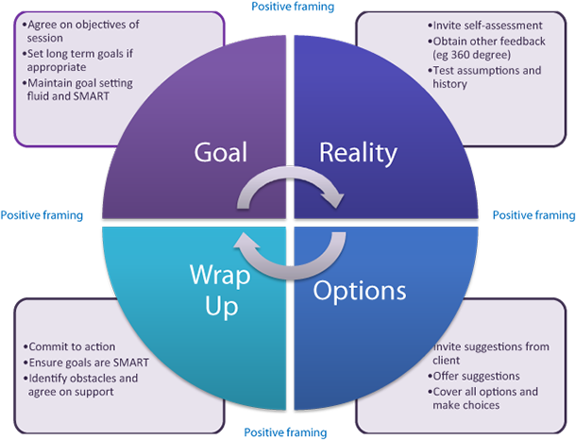

Figure 2: GROW model
(Source: Smith, 2017)
OSCAR model
This model was developed by Karen Whittleworth and Andrew Gilbert based on GROW model, so that managers can adopt a developmental coaching style for the company and team (Chica, 2019). The acronym stands for:
O- utcome: In this phase, the coach and the employee discuss the issue at hand and work to identify the desired outcome, long-term goals for all.
S- ituation: Identification of the skill/ability/knowledge is done in this phase. Based on that improvement planning or encouraging discussions are done to raise the mentee’s understanding and awareness about their situation.
C- hoices: Based on the previous stage, now brainstorming of the available choices are discussed, so that the most viable route of success could be followed.
A- ctions: The nooks of improvements are identified and now adaptation of SMART objectives is done to achieve the immediate and attainable targets
R- reviews: In this last stage, coach and coaches sit in regular meetings, review checkpoints based upon the deadlines for tasks, that were targeted in the action section of the process.
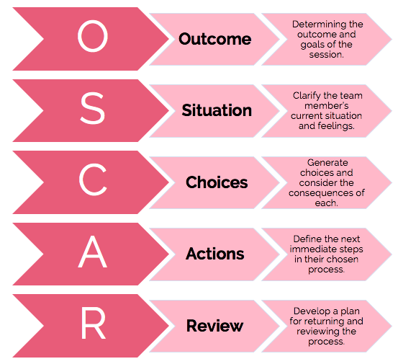

Figure 3: OSCAR model
(Source: Chica, 2019)

Task 3
Change management refers the developments done by any managerial authority within a business environment. The purpose of such action is to control on all other changes, so that beneficial changes could be made only for the sake of the organization.
Trends for ‘managing change’ in the workplace
- High-performing companies, such as Tesco, multi-generational workforce has been in use and it provides advantages of mixing experience with energy. Therefore, making space for all generation so that they feel comfortable working together is a factor of change in workplace.
- In order to work in a healthy way, organizations are trying to build mindful workplace where employees can reduce psychological stress and work with digital connectivity. This requires huge change in the organizational system (Church and Burke, 2017).
- Using Internet and sensor technologies have become inseparable in this digital world, and to create a working environment that can foster creativity, innovation, collaboration and productivity timely changes are needed.
Drivers for ‘managing change’ in the workplace
- The rapid change in human source, their qualities, skills and expectations are major drivers of change.
- The demand of customers is everchanging. To support them, timely changes become necessary in business.
- Technological development is necessary to follow which is one of the important drives of change.
- Tough competition initiates innovation, adaptation leading to abrupt change.
- With the business growth, it is necessary to make changes in business processes, policies and approaches (Kang et al., 2020).
- Multinational organizations such as Tesco, need to manage international laws, politics, and agreements leading to overall changes.
There are also a few suggestive models of change such as KUBLER ROSS and DREC which discuss change and the stages associated with it. According to Kubler-Ross Change Curve, there are 5 stages of grief experienced by a person approaching to death, which was surprisingly found similar with change (Williams and Braddock, 2019).
Denial: In this stage, the employee can face shock that he/she has to undergo change and adapt to something new.
Anger: When situation settles in, the employees may feel fear or anger due to the uncertainty lying ahead.
Bargaining: After understanding the change and its adaptation process, employees try to find the easiest method to fit in with it
Depression: If the change is not comfortable for the employee their excitement drops leading to depression.
Acceptance: People start to embrace the change by realizing the importance of it
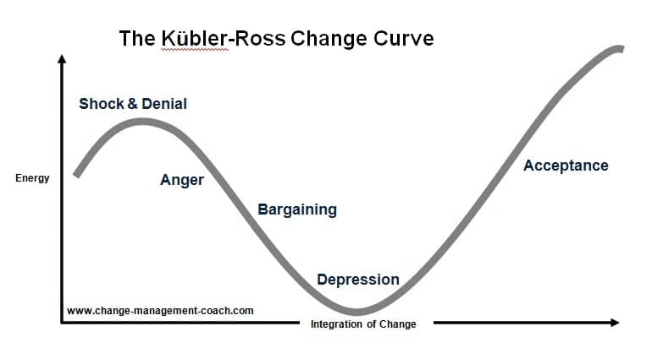
Figure 4: Kubler-Ross Change Curve
(Source: Williams and Braddock, 2019)

According to DREC model, there are only four stages of changes as follows:
Denial - Here the employee does not consider the change as a problem and denies the fact.
Resistance – In this stage, even they realize that they could face a problem, they console themselves that they can do nothing about it.
Exploration – In this phase, the employee identifies the problem, and searches for the available options for dealing with it (Insua et al., 2020)
Commitment – After finding the solution, now the employee is ready to deal with it.

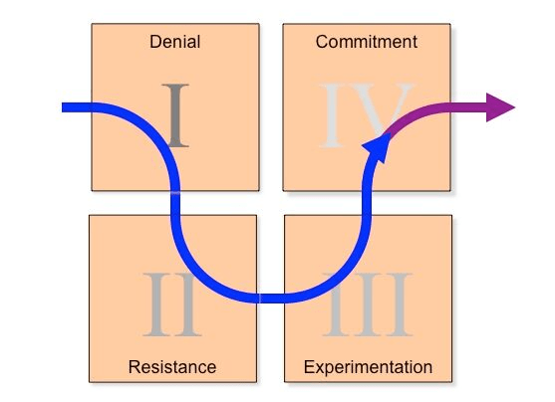
Figure 5: DREC model
(Source: Insua et al., 2020)

Personal Reflection
As a role of a mentor or coach, I have identified my own skills and drawbacks that needs review. Also, I can reflect my experience with the help of Kolb reflective cycle as follows:
1. Concrete Experience – This was a new experience for me to coach my colleague and help her to reveal her weaknesses. I was happy and excited about this exercise.
2. Reflective Observation- I pointed out any inconsistencies between experience and understanding, so that I can improve my performance (Subekti, 2020).
3. Abstract Conceptualization- Understanding my role and its importance, encouraged my colleague to overcome her weaknesses.
4. Active Experimentation - I have asked closed and open questions to identify the problems that my colleague is facing and help her to understand what she needs to improve.
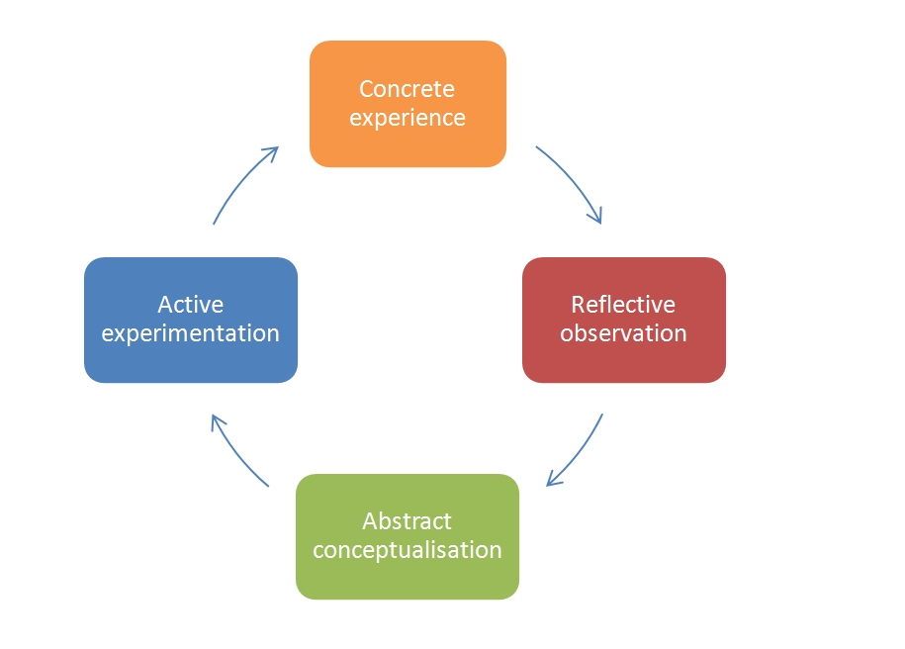

Figure 6: Kolb reflective cycle
(Source: Subekti, 2020)

I have also developed a PDP plan for my further improvement
Objective | Process | Resources | Target date
Planning improvement | Reading more books on the subject and discussing with seniors | Books and journals | Within six months
Improvement of communication skills | More group conversations and group activities | Group meetings arranged frequently | Within two months
Improvement of empathy | Work on body language, use of positive gestures | More interaction with people and spending time with them | Within two months
Improve my mentoring skills | Taking part to webinars. Training programs | Personal and professional growth | Within three months
Table 2: PDP plan

The Instant Pay Off Model was effective for me in cases where I was out of time but wanted to help a person to overcome his problems. Therefore, I use to ask him about the background of the issue and describe it with specific examples. Then I asked about the desired outcome of the person out of the issues so that any emerging idea can solve it. Next all obstacles were identified and grouping of them were done based on their nature and finally, brainstorming was done so that final approach, actions and timing could be agreed upon (Chai, 2021).
During the exercise, as a coach and coachee, I was feeling confident, the only minus I can say that it was the time management, because the presentation should last at least 15 min, but we finished early.

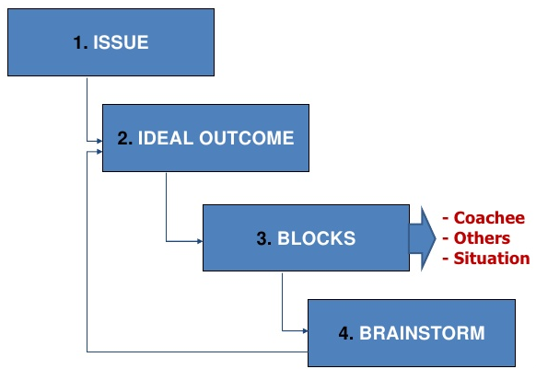

Figure 8: Instant Pay Off Model
(Source: Chai, 2021)

Conclusions
Overall, the present report discusses about the coaching and mentorship, their similarities and differences. Various models of change, models of Coaching and Mentoring was also discussed. The role of manager, benefits and drawbacks were also analyzed and finally a PDP plan was developed in this report so that a complete picture of the importance of the subject could be established.

References
- Bradford, S.K., Rutherford, B.N. and Friend, S.B., 2017. The impact of training, mentoring and coaching on personal learning in the sales environment. International Journal of Evidence Based Coaching and Mentoring, 15(1), pp.133-151.
- Cdn.Ymaws.Com. 2021. [Online]. https://cdn.ymaws.com/www.healtheconomics.org/resource/resmgr/files/mentorship_program/booklet_mentoring_ihea_nh.pdf. [Accessed: 27th March, 2021]
- Chai, J., 2021. A model of ambition, aspiration and happiness. European Journal of Operational Research, 288(2), pp.692-702.
- Chica, Ó.D., 2019. Towards a Comprehensive Model of Educational Coaching? Inference towards executive competences and leadership. Revista Iberoamericana de Psicología, 12(3).
- Church, A.H. and Burke, W.W., 2017. Four trends shaping the future of organizations and organization development. OD Practitioner, 49(3), pp.14-22.
- Clutterbuck, D., 2014. Everyone needs a mentor. Kogan Page Publishers.
- Cornelius, K.E., Rosenberg, M.S. and Sandmel, K.N., 2020. Examining the impact of professional development and coaching on mentoring of novice special educators. Action in Teacher Education, 42(3), pp.253-270.
- Garvey, R., Garvey, B., Stokes, P. and Megginson, D., 2017. Coaching and mentoring: Theory and practice.
- Insua, D.R., Baylon, C. and Vila, J. eds., 2020. Security Risk Models for Cyber Insurance. CRC Press.
- Kang, L., Jiang, Q., Peng, C.H., Sia, C.L. and Liang, T.P., 2020. Managing Change with the Support of Smart Technology: A Field Investigation of Ride-Hailing Services. Journal of the Association for Information Systems, 21(6), p.4.
- MacLennan, N., 2017. Coaching and mentoring. Taylor & Francis.
- Malešev, M., 2018. Coaching and mentorship: Mutual relations and implications for learning within an organisation. Andragoške studije, (2), pp.87-117.
- Małota, W., 2017. Motivational Factors to be a Mentor in Formal Mentoring in Organisations. The Role of Intrinsic and Extrinsic Motivation in the Propensity to Mentor. Central European Management Journal, 25(4), pp.119-143.
- Marcdante, K. and Simpson, D., 2018. Choosing when to advise, coach, or mentor. Journal of graduate medical education, 10(2), pp.227-228.
- Smith, S., 2017. Using a blended style of coaching. International Journal of Evidence Based Coaching and Mentoring, 15(1), pp.65-77.
- Subekti, A.S., 2020. Undergraduate Novice Researchers’ Experiences in Conducting Mini-Research in Education: Kolb Learning Cycle. | IRJE| Indonesian Research Journal in Education|, pp.448-465.
- Williams, M. and Braddock, M., 2019. AI case studies: potential for human health, space exploration and colonisation and a proposed superimposition of the Kubler-Ross change curve on the hype cycle. Studia Humana, 8(1), pp.3-18.
- Woo, H.R., 2017. Exploratory study examining the joint impacts of mentoring and managerial coaching on organizational commitment. Sustainability, 9(2), p.181.

