 | Student No: | 2502522
 | Module Title: | Business skills for the International hotel industry
 | Module Code: | BM1H4007 / BM1H4007D
 | Lecturer: | Daniel Payne

Component One: Reflective Journal 1000 words
Reflective journal – Business Module.
Introduction:
This reflective journal critically applies the era model of reflection, which includes:(experience, reflection, and action), to evaluate my learnings throughout the business skills module ( week 2-8) at the University of Wales Trinity Saint David ( UWTSD). This reflection is based on the understanding that reflective and experiential learning are essential employability skills in higher education, as they support both academic success and workplace readiness.
The main purpose of this reflective journal is:
- Explore how I have developed key academic and professional skills including:
- Effective time management.
- Academic presentation writing skills.
- Active participation in teamwork and communication activities.
2. Examines, how these constructive experiences have contributed to overall academic and professional growth. By adopting this structured reflective approach, I analyse my learnings, recognise strengths, and weaknesses, and plan actions for future improvement.

Experience 1: student trips and time management
During my academic journey at (UWTSD), I participated in several informative and memorable student trips that supported my academic learning and professional awareness. One of the most significant experiences was attending a conference held at the “Novotel Hotel” in London. This event provided valuable insights into the hospitality industry, particularly in relation to organisational structures and contemporary marketing issues. The conference also included career fairs that introduced a wide range of employment opportunities for students in sectors such as: hotels, restaurants, the Army and the Royal navy.
Participating in this experience encouraged me to reflect on my academic responsibilities and future career aspirations. I realised that achieving success at university requires consistent effort and effective study habits. Throughout the module journey, one of the main challenges, I faced, was managing my time efficiently, especially during the early stages of the course. I often underestimated to complete academic tasks, which resulted in unnecessary stress. Balancing lecture attendance, assignment deadlines, and academic presentation alongside my personal responsibilities as a mother and wife required accurate planning and organisation.
Gradually, I have learned the importance of prioritising tasks and using a structured approach to my daily routine. By planning my duties, step by step, I began to allocate sufficient time for reading, reach, and completing my assignments. Overall, this experience highlighted the importance of effective time- management and the ability to manage multiple tasks within a limited timeframe, which is an essential skill for both academic success and future employability.
Experience 2:Academik presentation writing skills
As English is my second language, writing academic presentations was initially challenging for me. I had to carefully select appropriate vocabulary, structure my sentences accurately, and pay attention to grammar and proper referencing. As Stephen Bailey states, “effective academic writing requires not only correct grammar and vocabulary but also, the ability to structure ideas rationally and support arguments with credible evidence.”(Bailey,s.(2025,Academic writing,p.12).
Fortunately, during weeks (2-8), I had several opportunities to improve these skills, I learnt to borrow books and academic resources online conduct research strategies effectively, and apply infoskills techniques to organise and present information clearly. These experiences strengthened my confidence in academic communication.
Experience 3: Communication skills
Although, I usually communicate well with others, and I am comfortable sharing my ideas in small groups, I found it extremely difficult to express my thoughts, feelings and ideas clearly in front of peers. I realised that I often became very nervous , started speaking too fast, struggled to maintain eye contact ,and appropriate body language. This sometimes led to my message being misunderstood.
Through these experiences, I understood the importance of practice, preparation, and self-awareness in developing effective- communication skills.
Reflection on time management
By reflecting on my poor ability in time management during the business skills Module (weeks 2-8), I became more aware of how creating an effective time management plan is essential and plays a vital role in reducing stress, improving the quality of my academic tasks, and ultimately achieving my academic goals.
Moreover, by attending university classes regularly and participating in tutorials, I gained a better understanding of the subject and learned practical strategies for researching and organising my workload. First of all, I started dividing my tasks into smaller parts, manageable steps and aligning them with realistic deadlines. For instance: scheduling one day for finding references, another for research and slide design, and a third for rehearsal, allowed me to focus on tasks confidently, complete them on time, and highlighted the important of prioritisation and planning in academic performances.
Reflection on academic presentation writing skills
Reflecting on my academic presentation writing experience, I recognised that practicing continuously in a supportive learning environment allowed me to develop comfort and confidence in writing. In this case, after reviewing infoskills and attending informative tutorial lessons, I realised that designing a clear roadmap could guide the readers and audience effectively towards the main purpose rather than presenting ideas in a disorganized or confusing manner. Additionally, reflecting on this experience helped me to understand that linguistic challenges supported the development of my knowledge of a new language.
I also, found that reducing constant difficulty in finding appropriate words required expanding my subject academic vocabulary.
Overall, this experience demonstrated that strong presentation skills are essential for academic success and future professional development.

Reflection on communication skills
At the beginning of the module, I sometimes struggled and feared to express my ideas clearly in group discussions due to limited confidence and language barriers.
Gradually, I realised the importance of collaborating with classmates who had diverse strengths, ideas and communication styles. Indeed, engaging in teamwork activities and receiving feedback from tutors and peers removed my fears and concerns. In the following, this instruction helped me to improve active listening, clear pronunciation, eye contact, and audience engagement.
All in all, I learnt that successful communication combines clear ideas, confident, body language delivery, and active audience interaction.

Component Two: Action Plan

Action plan:
As a starting point, This action plan provides a clear and organized framework that supports the successful achievement of set goals. Furthermore, It outlines specific actions, timelines, and expected outcomes to enhance academic and professional development. During the business module weeks (2-8), I realised that even “nonprofit organisations in their initial stages, create action plans for example: in marketing, to guide their fundraising and outreach efforts. “(Philip Kotler & Armstrong, 2019, p.638).Indeed, this action plan has been developed based on the reflections presented in my reflective journal and focuses on identifying areas where I need to improve. The main purpose of this action plan is to outline smart -based actions that are clear , realistic, and achievable, in order to support my academic learning process and enhance my professional development throughout my higher education journey.
Through continuous study of academic references, I realised that there is a strong link between the current position and the desired goals; therefore, strategic action planning requires a competent management to ensure that objectives are effectively achieved (Walker, 2020, pp.607, 608, 609). Hence, by applying structured strategies, this plan aims to promote continuous improvement, confidence, and reflective practice will enable me to maximise opportunities for academic growth and long-term success. One of the main areas identified for improvement is time management.
This subject is really important, because the process of organizing and planning how to divide your time between specific requires some techniques and elements. At the beginning of the module, ineffective planning often caused stress and difficulty meeting deadlines.
To address this, I plan to create a structured weekly timetable that allocates specific time slots for lectures , independent study assignments, and revision. Large tasks will be divided into smaller, manageable steps with realistic deadlines. I will also, follow this formula that prioritise tasks based on urgency and importance to avoid last- minute pressure. These actions are expected to improve and facilitate all functions of management and organisation, decision making, motivation, support consistent academic performance, and reduce stress, which is essential in fast-paced hospitality and hotel management environment where time is crucial. Another key area for development is academically presentation writing.
In the first stage, structuring presentations clearly and using academic language was challenging. To enhance this skills, I will design a road map before beginning any presentation, I will follow research strategies, using academic sources via online research skills.
To improve this skill, I plan to allocate dedicated time each week for academic research. In the next stages, apply correct referencing and expand my subject specific vocabulary through reading and note-talking. Regular practice and reviewing feedback from tutors will further support improvement.
Next, communication and teamwork skills represent both an area of growth and an emerging strength. While language barriers affected my confidence in group discussions, participating in collaborative tasks helped me recognise the importance of active listening, respectful interaction, and clear verbal communication. To further enhance these skills, I plan to actively contribute to group discussion, practise presentations with peers and apply tutor feedback regarding pronunciation, eye contact and body language.
Totally, these strategies will improve my confidence and effectiveness in my academic performances.
In conclusion, this reflection highlights my development in time management, communication and writing presentation skills. Actually, the business module has increased my confidence and self-awareness effectively. I am confident in my ability to enhance my academic performances and this reflective process has reinforced the importance of continuous learning and professional growth.
Reference list
Bailey, S. (2025). Academic Writing. p.12. doi:https://doi.org/10.4324/9781003509264.
Kotler, P. and Armstrong, G. (2021). Principles Of Marketing, Global Edtion. 18th ed. S.L.: Pearson Education Limited, p.368.
Project Management Videos (2017). How to Make an Action Plan - Project Management Training. YouTube. Available at: https://www.youtube.com/watch?v=lwoVRVgKg-o [Accessed 27 Feb. 2020].
Schon, D.A. (1983). The Reflective Practitioner.
Walker, J.R. (2020). Introduction to hospitality management. Boston: Pearson, pp.607, 608, 609.
Component Three: Professional development: build a personal brand and promote a professional identity. (700 words)
Canva Document
Linkedin Screenshot
https://www.linkedin.com/in/mehrnoosh-amani-tehrani-52736a397?utm_source=share&utm_campaign=share_via&utm_content=profile&utm_medium=android_app
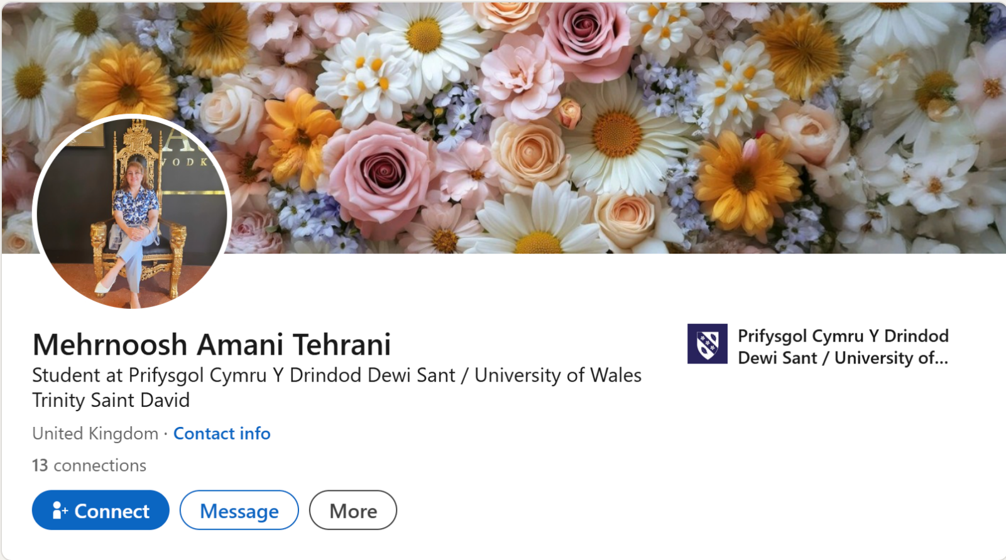
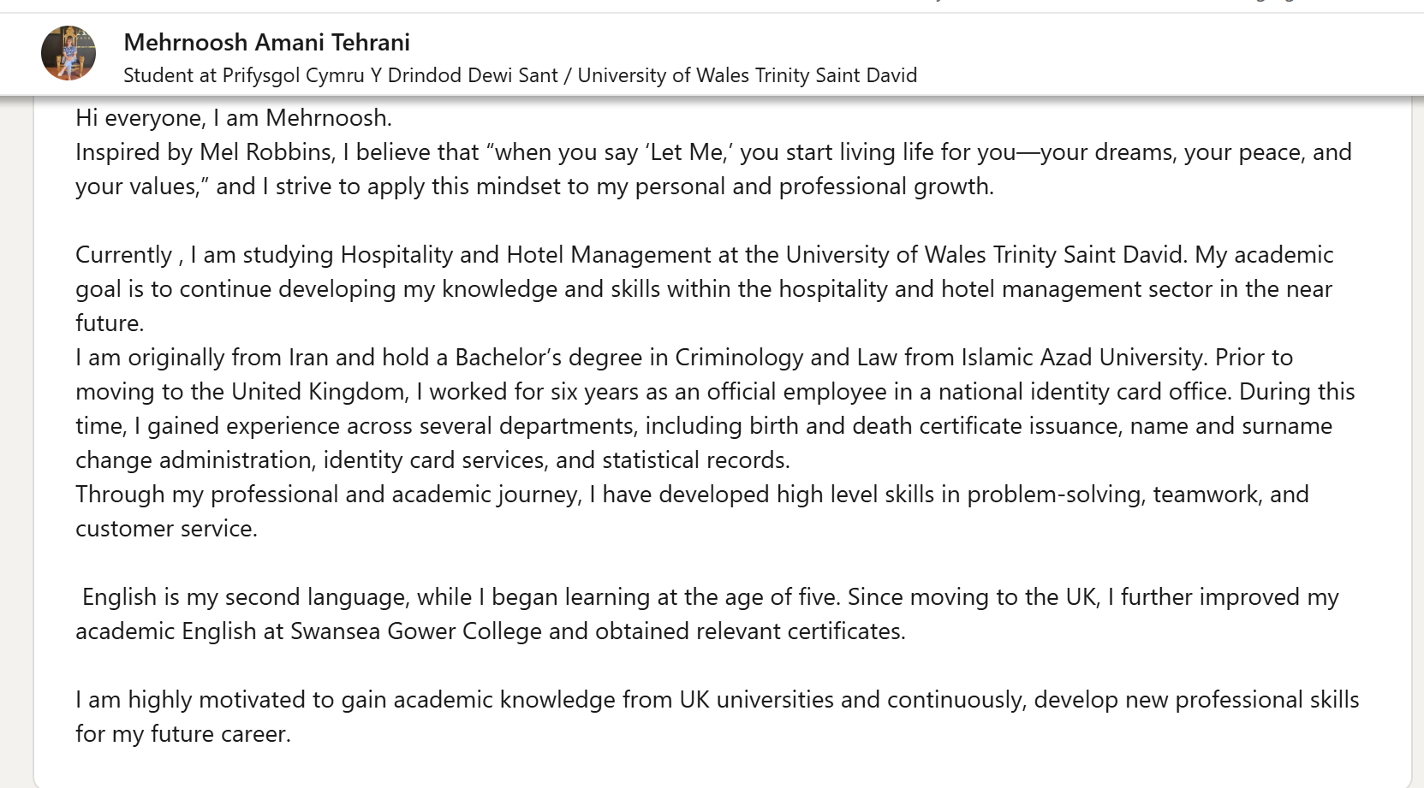

Component Four: Using the information prepared for your CV, present a 5 minute presentation on the key attributes that a person working within the hospitality industry should possess.

This Presentation will be completed in person on site.

Place your presentation time below.

Timeslot: 12:30 pm

