Sophie Evans (2108843)

Business Inquiry & Research (BMSP5007)
Part 1 & Part 2

Table Contents Part 1

Introduction 3
Procedure 4-5
Data presentation and Findings 5-8
Conclusion/Reflection 8-9
References 10-11

Introduction
This qualitative report presents the research of waste management practices, and addresses the phenomenon of “What are your experiences within your workplace to how they deal with their waste? What do you think about the waste management practices at your workplace?.” To collect data for this study I used face to face unstructured interviews with three participants. The participants were people that are known to me. I have addressed this phenomenon as many organisations including the organisation I work for are not recycling and are not using sustainable methods for their waste. With my positionality as an undergraduate, the topic sustainability has been brought up several times and it has become an important topic to myself because of the economic impact waste is presenting. The ontological perspective is concerned with sustainability specifically waste management in my organisation. Sustainability is the way forward and I wanted to seek other individual’s views and experiences on waste management practices within their workplace. According to The World Bank (2022) the global production of solid waste was projected to reach 2.24 billion tonnes in 2020. The yearly waste output is anticipated to rise by 73% from 2020 levels to 3.88 billion tonnes in 2050 due to increasing population expansion and urbanisation. The epistemology research base is wide but recent authors such as Melville (2021) mentions that 55% of the worlds single use plastic waste are generated by 20 organisations. In 2019, more than 130 million metric tonnes of single-use plastics were disposed, the most of which were burnt, dumped in landfills, or released into the environment. Whilst Ekshtein (2022) mentions the rising rate of plastic utilisation and production of waste is mostly the result of large corporations who could also be able to offer an environmentally friendly solution.
Instead of a quantitative method, the paradigm chosen was a qualitative approach for the study because it was crucial to learn the participants' views on their workplace waste management practises and this technique allowed the participants to voice their opinions on the subject. According to Bhandair (2023) to better comprehend ideas, views, or experiences, qualitative research collects and analyses non-numerical data. It may be applied to get comprehensive understanding of a situation or to come up with fresh research concepts.

Procedure
Once the phenomenon was chosen, the steps to carry out this qualitative approach included:
- An ethics form to be completed as ethics forms are important as according to World Health Organization (n.d.) they are in place to respect the dignity, rights, and wellbeing of research participants and ensuring that the correct ethical standards are being maintained, an ethics committee should examine every study involving people.
- The use of purposive sampling was used for the phenomenon using 3 participants known to me. Purposive sampling is according to Robinson (2014) an intentional selection of respondents based on their capacity to clarify a certain subject, concept, or phenomena. An unstructured interview process which included prompts in case of any long pauses would be used to discuss the phenomenon. Sanchez (2014) mentions that unstructured interviews entail a dynamic exchange of information between interviewers and interviewees in an effort to learn more about their thought processes, social environments, and personal experiences. Before any interviews could be carried out all participants had to sign a participant agreement form.
- The unstructured interviews were conducted and recorded separately in a quiet room, free from distraction. The interviewees were all sked the same questions along with the same prompts when long pauses were presented and allowed a maximum of 20 minutes each for the interview.
- The interview responses were then transcribed onto a word document and stored on the universities one drive for analysis. The transcriptions adhered to the ethical code and privacy regulations, which included anonymizing or coding all interview names.

Using a thematic analysis defined by Braun and Clarkes, their 6 step process which according to Bachelor Print (2022) uses a comprehensive, six-step paradigm to analyse qualitative prose assertions where frequent patterns are then recognised, categorised, and analysed for more in-depth understandings. The six steps include:
- Familiarise yourself with the data.
- Generating initial codes
- Searching for themes
- Reviewing themes
- Defining and naming themes
- Producing the report (The JVR Africa Group, 2016)
This thematic process aided in the data presentation and findings below.

Data presentation and findings
Within the data presentations and findings, tables have been created to display the qualitative analysis of coded participants interviews and interpretation by the researcher of the interviews and lastly themes identified.
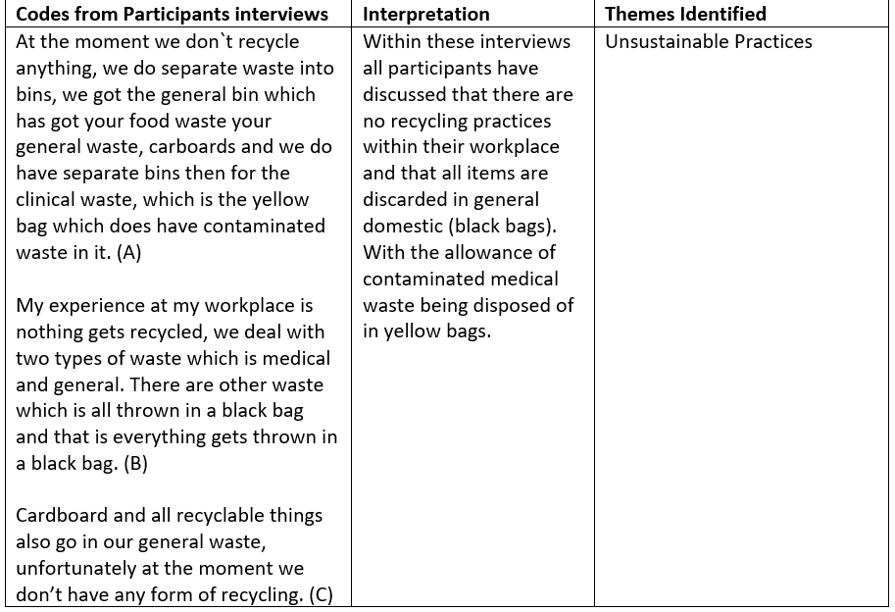

This first theme sets out to explain that there are unsustainable practices within the 3 participants organisation. There are no waste management practices in place, with all waste being disposed rather than recycled and that there are also other forms of waste being disposed of such as medical waste.
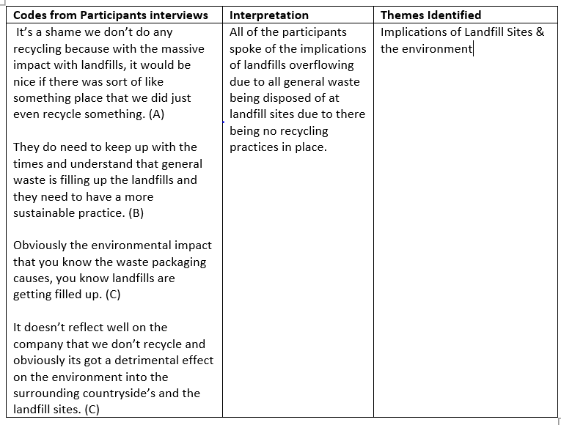
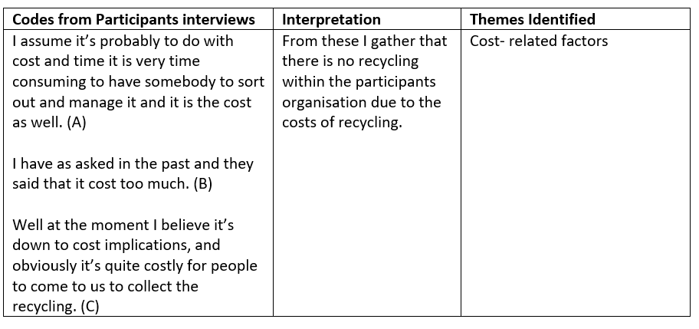
Within this second theme all 3 participants discuss that cost implications are the reason for not being able to recycle within their organisation and that it can be expensive to have other companies to come in to collect recyclable waste.
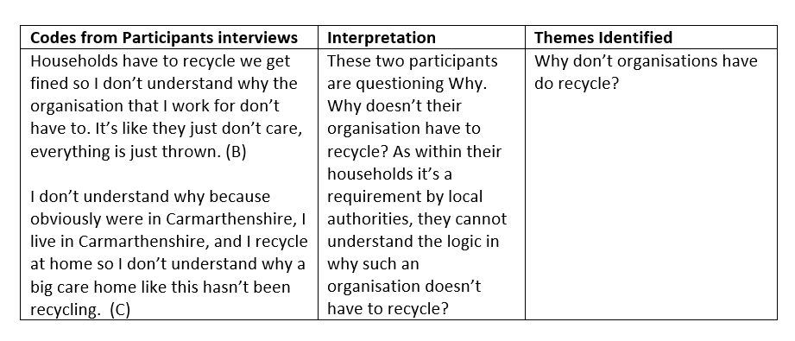
This third theme discusses the implications of landfill sites and the environment with how much general waste is generated and being sent to landfill which then in turn causes landfills to overflow. Within this theme I gathered that the participants would like to see sustainable practices put in place within their organisation as they understand the implications it already has on landfill sites and the damage it causes to the environment.

The fourth theme sets out to ask the question “why don’t organisations have to recycle?” Two participants discussed the fact that there are systems in place that require all households to recycle, but there are no procedures currently in place that require the organisation for which they work to recycle. From this I could gather that the individuals were quite irritated by what they had stated especially when penalties are involved for households and there not being anything in place for their organisation having to recycle.

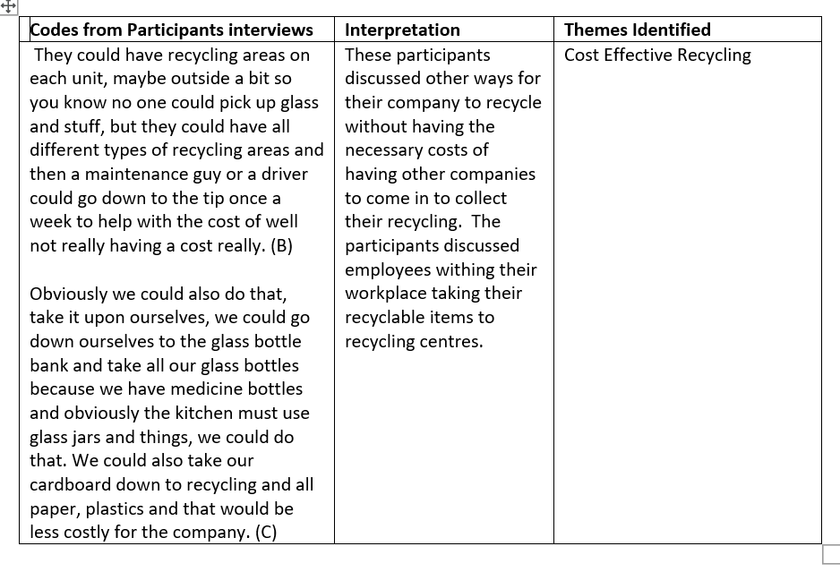
The fifth theme looks at ways to address cost effective recycling, where the organisation could take recycling into their own hands by utilising local recycling facilities. Two participants have ideas where their organisation could look at cost reductive ways to enable recycling within their workplace, by collecting all recyclable items and disposing them correctly at recycling centres by utilising the workforce.

Conclusion/Reflection
The study's data collection focused on the perspectives of three participants who worked for the same organisation. The researcher made sure there was no bias in the interview by using the same questions and prompts for each participant. Each participant spent the same amount of time in a quiet distraction-free environment. I did find the recording process made the participants feel uncomfortable and that they concentrated on the recording device. The positioning of the recorder may have been preferable; possibly concealing the device would have allowed the interviewers to be more relaxed during the interview as opposed to having it visible in front of them. Recording is a useful technique to employ in a process such interviews to verify the validity and reliability of the research as well as the validity and reliability of the themes produced by tables from the unstructured interview.
I would say the studies strengths came from how themes could be constructed by using an unstructured interview process which I found to the best method to use as the use of prompts within the interview helped get the answers required for the research and aided in any long pauses. It is a method I would continue to use again. I found that using a qualitative technique rather than a quantitative allowed for better answers and it let the participant to express their view and allowed them to express it in their own words. To provide more data on the phenomenon, interviewing additional participants from various organisations alongside the three already gathered may have provided further information on waste management practises within organisations and how employees perceive their workplace waste management practices to be. With additional data collected the study could have looked at how organisations differentiate in their waste management practices.
I drew from the study that having waste management practices within organisations is a high priority and that a lot of items within the interviewee’s organisations could be recycled but instead all items are discarded and sent to landfill. Their views point to what this organisation is doing is detrimental to the environment and to future generations. The main theme that got my attention was the question Why, why don’t organisations have to recycle and households do as they can be fined by local governments. I found this question quite compelling and truthful in what was discussed. The data has given me insight on organisations on their waste management practices and whether governments should look into these practices to protect our environment and our future generations.

Table Contents Part 2

Introduction 13
Procedure 13-14
Data presentation and Findings 14-20
Conclusion/Reflection 20-21
References 22

Introduction

This report presents the study on individuals job satisfactory within the health care sector which has been carried out in a quantitative process using surveys. Closed questions should be used in surveys rather than open ones that seem to be trying to elicit a specific response. Making surveys anonymous encourages honest replies. This study was chosen because of my positionality as an individual working in the health care sector, the last years have been tough within the health care sector especially with the covid 19 pandemic, the rise in staff shortages and the low wages which led to low morale among individuals working within the health care sector. “Social care staff are exhausted and depleted.” (BBC News, 2021). According to BBC News (2021) the CQC confirms concerns that social care providers are dealing with a staffing problem, losing employees to higher paying positions in retail and hospitality, and struggling to find replacements in its most recent State of Health and Social Care in England report. According to Balasurbamanian (2022) the lack of qualified nursing personnel has been one of the most notable problems facing healthcare organisations recently, according to numerous medical specialists, and has resulted in risky patient care procedures .
My survey was created using Forms along with a link to the survey sent to social media platforms to gain anonymous responses for a generic response. The data was entered into SPSS once all 40 replies had been acquired. With the use of SPSS, I was able to apply the cross-tabulation tool, frequencies and Chi -Square tests to retrieve the necessary data. The quantitative study will examine whether individuals are satisfied and feel valued within their profession within the health care sector. It will examine individual’s attitudes on whether their salary reflects their position, feeling valued along with their current annual salaries and what motivates individuals in their current position. The study will also include annual income depending on gender.

Procedure
The paradigm chosen is quantitative research method was used for this procedure, which allows an objective and positive view of the research process. According to Bhandani (2022) the process of gathering and analysing numerical data is known as quantitative research. It may be used to identify trends and averages, formulate hypotheses, examine causality, and extrapolate findings to larger groups. The process consisted of constructing a survey composed of 10 questions with a single correct response, which I did by utilising Forms ( Forms, n.d.). The survey stated the phenomenon which was individuals job satisfactory within the health care sector, it also entailed it was an anonymous, not targeted to any particular organisation and by individuals participating in the research study are giving consent. An ethics form was also carried out before the survey reached any participants. Once the survey was completed, the survey link was then posted on social media platforms for participants to engage with the study. The link for the survey on social media allowed for a small number of individuals known to me to pass the link on to other individuals this was then known as “Snowball Sampling.” Tenzek (n.d.) mentions that a technique called snowball sampling is used to find volunteers for a study. In this recruiting approach, each participant recruits’ others they know to participate in the study, and the new participants in turn recruit more people they know to participate. However, random sampling was applied as the wide capturing of responses were not known to the researcher. According to Taylor (2023) one of the most common and straightforward ways for gathering data is random sampling. It enables the collecting of impartial data, which enables research to draw findings that are unbiased. This method used was a positive outcome which enabled for a generic survey of 40 anonymised individuals.
With all 40 responses collected, the data was then gathered from and inputted into SPSS. In order to examine the variables and evaluate the data, I utilised the cross-tabulation tool in SPSS. According to Tech Target Contributor (n.d.) Software called SPSS is used to analyse statistical data. Data analysis for descriptive and bivariate statistics, predictions for numerical outcomes, and predictions for group identification are all accessible through SPSS. I utilised the crosstabulation tool to search for variables between several survey questions, specifically individual occupations against pay reflection, annual income, job satisfaction, and feeling valued within one's professional life. Annual income will be investigated in relation to gender. A chi-square test was used to analyse feeling valued within a profession and pay reflection. The frequency tool was used to examine what motivates individuals in their profession. According to Alchemer (2019) cross tabulations assist researchers to comprehend the link between several factors by grouping variables together. A chi – square test is according to Stewart (2023) is a hypothesis-testing technique in which experimental results are evaluated with observed and anticipated frequency distributions.

Data Presentation/Findings
The data I first analysed was a cross tabulation of the level of professions individuals worked at and if their salary reflected their position.
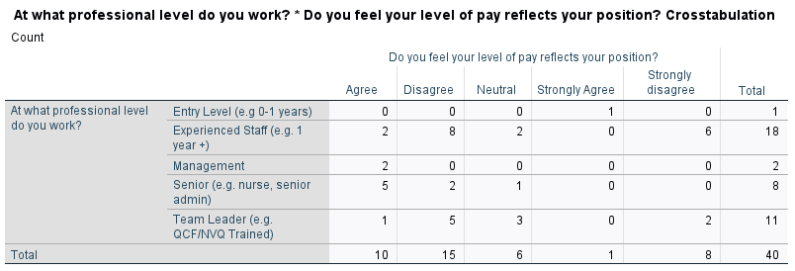
Within the first data presented above 8 experienced staff and 5 Team leader positions disagree that their pay does not reflect their position whilst 5 of the Senior position agree that their pay does reflects their position

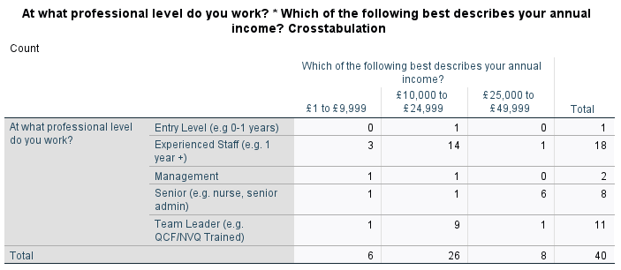
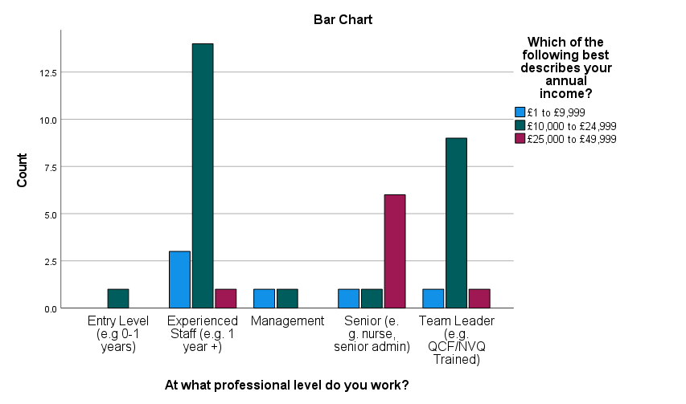
Looking at the data from SPSS, there is a variety of individuals pay for the positions they work at. 26 out of the 40 responses earn an annual income of £10,000 - £24,999 which mainly consists of 14 experienced staff and 9 Team leader positions. The higher annual income of £25,000-£49,999 consists of 8 responses which mainly includes senior positions which is 6 responses out of the 40. Based on the bar chart there is a variety of positional income which could also be related to how many days/hours an individual works which then relates to the annual income they receive.

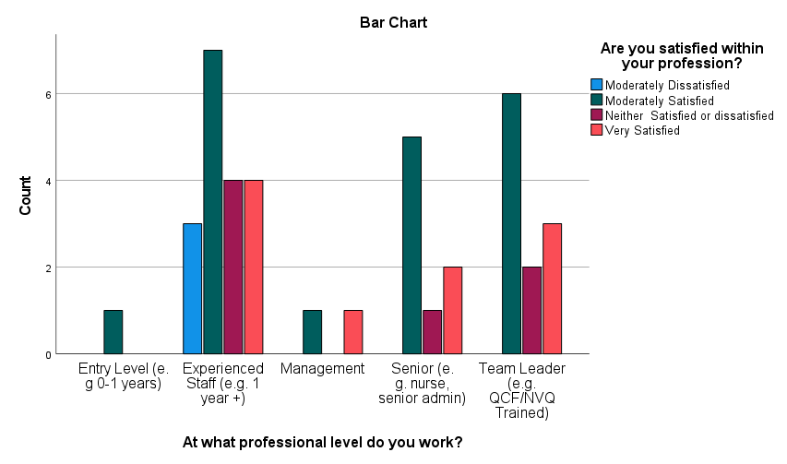
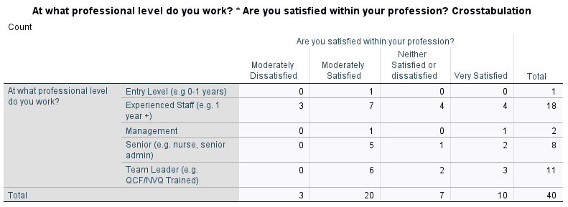

This crosstabulation along with a bar chart looks at peoples positions they work at and whether they are satisfied within their profession. Each profession (20 of respondents) has included the response of moderately satisfied within their role. With 3 respondents of experienced staff indicating a moderately dissatisfied response.

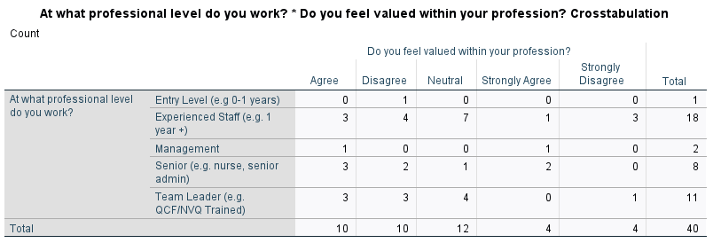
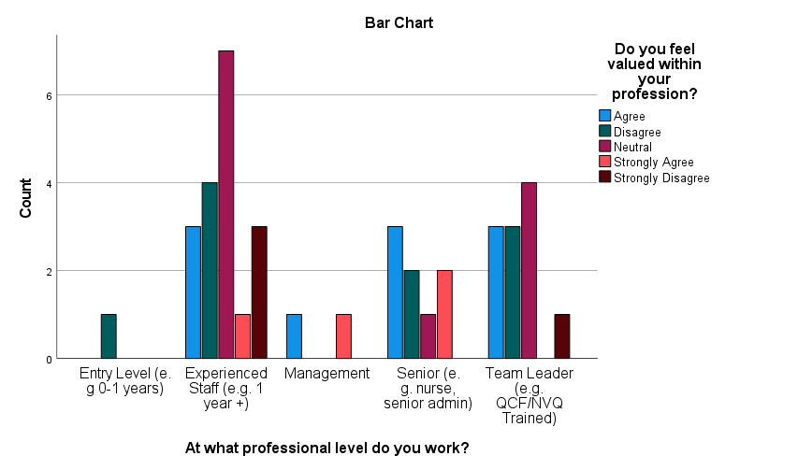
This crosstabulation and chart analyse how people feel about their professional value. Looking at the bar chart, all occupations show they disagree with feeling appreciated, with the exception of management. In the crosstabulation, 10 out of 40 respondents disagree and another 10 agree with the statement that they feel appreciated in their profession, whereas 4 respondents strongly disagree and 12 respondents fall into the neutral category.

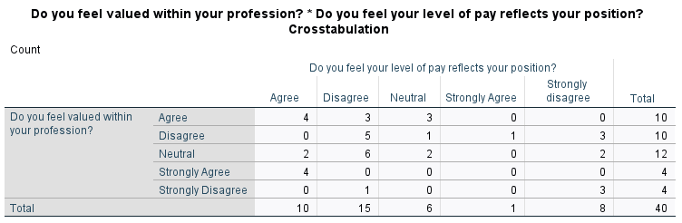

This crosstabulation analyses feeling valued in their profession to whether their pay reflects their position, 15 respondents disagree, 10 agree and 8 strongly disagree

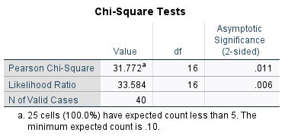

Using the chi square distribution table the 95% confidence level is 26.3 at 16 degrees of freedom. The calculated Pearson chi square value for the 2 variables is 31.77. In this case the calculated value is higher than the table statists showing disproportionality between the two variables meaning that we can reject the null hypothesis because P is .011 which is less than .05. Therefore accept the alternative hypothesis that Do you feel valued within your profession is associated with Do you feel your level of pay reflects your position.

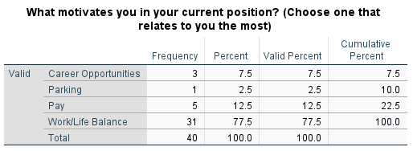

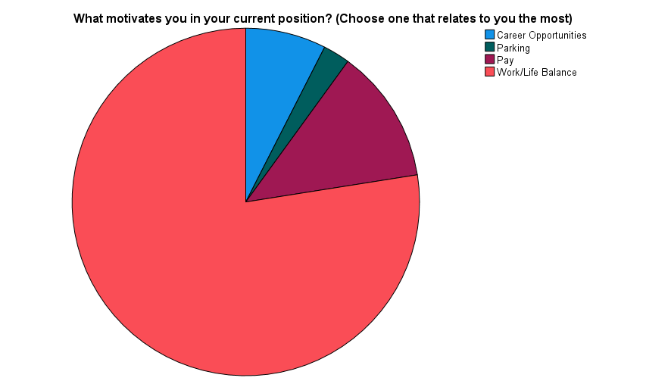

When considering what motivates people in their roles, the research shows that "work/life balance" comes up in every position, accounting for 77.5% of replies which the pie chart clearly indicates. Whereas 12.5% of individuals are motivated by pay and 7.5% are motivated by career opportunities.

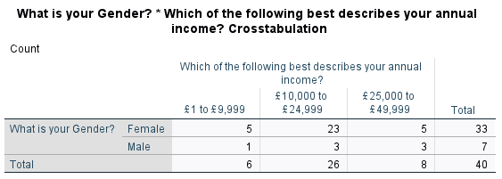
Lastly the data above will analyse if annual income between male and females differentiate. Looking at the data the respondents are mainly females, 23 of female’s annual income are between £10,000 - £24,999 where 3 males earn the same income. The higher income of £25,000 - £49,999 are earned by 5 females and 3 males. The lower income indicates that 5 of female respondents and 1 male respondents earn £1 - £9,999 annually. With the statistics provided it sees male and females earning a similar annual income.

Conclusion/Reflection
One of the finest elements for me was generating and using the survey, and the structure of using Forms was straightforward. The advantage of employing the snowball sampling approach was that it gave a rapid pace of replies with generic responses which concluded at 40, and it is a strategy I would use again. If I were to construct a survey all over again, I would include more questions with multiple choice answers and with roughly 100 replies, ensuring that all my questions are thoroughly thought out and to have an even ratio of gender included within my survey.
I discovered that I should have included more alternatives for individuals' annual income in my survey as I would have had a better outcome matching individuals' professions and gender against their salaries and comparing them to other professions. I did at first decide to ask what their annual income is, but I found that too personal to ask and a multiple choice of income a better option for people to respond to my survey. I did find within my survey that out of the 40 respondents only 7 were male, more male respondents would have been beneficial for my data analysis. SPPS being a new software to learn was hard to grasp at times, but with the assistance of tutorials and instruction aided in the research enabled me to analyse the data using the crosstabulation tool, frequencies and a chi – square test. The data has concluded that there are mixed reviews to individuals satisfactory within the health sector but with the overall of individuals being moderately satisfied and a work life/balance motivates the majority of the respondents within their profession. There is no indication of a gender pay gap within the responses, but many respondents disagree that their level of pay reflects their position.

