
University of Wales Trinity Saint David (London Campus)”
BA (Hons) Business Management Department

Dissertation – Proposal
LCBB6000
Title: The Impact of organisational leadership in Stonegate Group within the food and beverage industry

Tutor: Alfred Mensah, lecturer (HPL)
Student name: Stefania Prohnitchi
Student ID: 1917713
Session: January 2023
Abstract
This research project is based on the discussion of the impact of organisational leadership within the Stonegate Group. In which the main aims and objectives along with the expectations which have been set form the research project has also been provided. The main purpose of this study is to simply identify and discuss the importance of the organisational leadership within the food and beverage industry of the Stonegate company in detail. In which the different aims and objectives of the research have been explained as well. Then a detailed Literature review will be presented which will help in presenting a detailed information and analysis of the research topic in detail. The best possible methodology approaches were identified including the justification for the utilisation of interpretivism philosophy, inductive approach, secondary data, and qualitative research method. The data required for the study was conducted using online data sources that were analysed through a thematic analysis. With eight different sources, four key themes were evaluated through which different leadership styles were found to impact businesses differently. It was also understood that businesses like Stonegate Group within the food and beverage industry are facing changes and challenges in their leadership practices. In terms of the identification of these challenges, Stonegate was recommended with appropriate strategies to follow for its better performance in the future.

Table of Contents
Chapter 1: Introduction 5
1.1 Background 5
1.2 Research Problem 5
1.3 Rationale 6
1.4 Aim 6
1.5 Objectives 7
1.6 Research questions 7
1.7 Company information 7
Chapter 2: Literature Review 8
2.1 “Organisational leadership styles applied within the food and beverage industry” 8
2.2 “Identify some of the leadership theories and models used within the food and beverage industry” 9
2.3 “Impact of leadership styles within the food and beverage industry” 10
2.4 “Advantages and disadvantages of leadership style in the food and beverage industry” 11
Chapter 3: Methodology 13
3.2 Research Design 13
3.3 Data Collection 14
3.4 Data Analysis 15
3.4.1 Search Strategy 15
3.5 Data analysis 15
3.6 Ethical Considerations 16
3.7 Potential outcomes and limitations 16
Chapter 4: Findings and Discussion 18
4.1 Findings: Thematic Table 18
4.2 Discussion 19
Chapter 5: Conclusion and Recommendations 25
5.1 Conclusion 25
5.2 Recommendation 26
References 27
Appendix 30

Chapter 1: Introduction

1.1 Background
The research will be discussing the different organisational leadership style which is used specifically within the food and beverage industry in detail. During the discussion of the different types of organisational leadership styles the importance and the definition of organisational leadership will also be included. The discussion and the identification of the different types of organisational leadership will also be included along with the roles and responsibilities of those organisational leadership styles within the industry. The research will also be identifying as well as discussing some of the famous leadership theories and models which are commonly used within the food and beverage industry. The explanation will be done critically along with the importance of theories and models in detail. The analysis of the impact of the different leadership styles upon the food and beverage industry will also be covered or explained in detail. At the end the advantages and disadvantages of the different leadership style used within the food and beverage industry will be evaluated in detail. In short it can be seen that the research will be focusing on the leadership, styles, theories and models used within the food and beverage industry in detail.

1.2 Research Problem
Organisational Leadership helps a leader in analysing and better assessment of each and every situation which has been created within the organisation and develops some strategies which will help in achieving new as well as better results for the organisation. The major problems which will be discussed in this research project is the impact of organisational leadership within the organisation of Stonegate Group. Organisational Leadership if applied strategically can help the organisation attract more growth opportunities but if the application and the use of the leadership management is not done properly then it will adversely impact the organisation as well as its development (Tortorella et al., 2021). The research will help in identifying the different negative as well as positive impacts of organisational leadership upon. The research will also identify the major issues which are going through the chosen organisation and find the needed solution which should be made within the organisational leadership of the organisation (Hendrawan and Pogo, 2021). The research will help the Stonegate group in identifying the major problems which are being faced by the organisation in regard to its organisational leadership and then help the organisation finding the possible solution which will help in making it organisational leadership more effective and impactful growth strategies.

1.3 Rationale
Leadership can be understood as that action by an individual who helps the individual in leading a group of people or even an organisation. Leadership is very important for any organisation as it helps an individual in being a good leader who will help the employees of the organisation identifying the different abilities that help employees and help them in achieving the different set aims and objectives of the organisation. Good leadership is considered to be very important for an organisation. It helps in motivating the employees of the organisation and helps the organisation in gaining growth and development (Wu et al., 2021). The research project will help in discussing the different types of organisational leadership style which are very much impactful and useful for the proper development of the organisation. It is very much important for any organisation to have effective leadership within the organisation to ensure the development of the organisation. Identifying the leadership style for a particular organisation helps the organisation running successfully along with its different features within it. It is so because every organisation has its own type of organisational features which are mostly different from any other organisation (Asbari et al., 2021). The identification of the appropriate leadership style helps an organisation in developing different organisational development strategies which will help the organisation in developing more growth opportunities as well strategis. It is very much important to identify the key weakness as well as the strengths of the organisation so that the organisation can develop strategies to mitigate the different issues being faced. The identification of the major advantages and disadvantages of the leadership style used within the organisation will help the organisation in having more growth and development opportunities and help in mitigating different issues being faced within the organisation effectively.

1.4 Aim
The main aim of this research project is to determine the effect of organisational leadership within the organisation of Stonegate Group.

1.5 Objectives
- To identify the different organisational leadership styles applied within Stonegate Group
- To discuss the advantages of organisational leadership upon the operations of Stonegate Group
- To evaluate the major disadvantages of the organisational leadership applied within Stonegate Group.

1.6 Research questions
- What organisational leadership styles are followed in Stonegate Group?
- What are the major advantages of the organisational leadership adopted by Stonegate Group?
- What are the disadvantages of organisational leadership which are impacting the development of Stonegate group?

1.7 Company information
Stonegate Group was formed in the year 2010 which has 333 different pubs and is the largest pub company in the whole of the UK. The company generated a revenue of 707 Million GBP in the year 2020 (Stonegate Group, 2022). The company having so many different pubs which are spread all over the different parts of the UK makes organisational control difficult for the company. It has been seen that since the pandemic the organisational leadership of the organisation has been changed (Statista, 2022). The research will help in identifying and discussing the importance of the impact of the organisational leadership within the organisation of Stonegate Group. The research will help in discussing the different advantages and disadvantages which have been impacted by the organisational leadership within the organisation. The research will help in understanding the key strengths and weaknesses of the organisational leadership within the organisation. Organisational Leadership helps in motivating the people to believe as well as comprehend the vision of the company to work collaboratively for achieving the different aims and objectives of the organisation (Stonegate Group, 2022). Organisational Leadership is considered to be very much important for any organisation for better development and enhancement of the working performance of the employees for better development of the organisation.

Chapter 2: Literature Review

2.1 “Organisational leadership styles applied within the food and beverage industry”
As per the thoughts of Wahyudi and Subanidja (2022), Organisational leadership is related to the coordination and the directing of the different individuals within an organisation in order to achieve the different missions or goals of the organisation effectively. Organisational leadership helps the leaders in seeing the bigger picture and has the abilities which are required in order to look forward and ahead and in being focused as well as goal oriented. Organisational leadership is important to any organisation as it helps the organisation developing different competitive strategies to be ahead of the competitors of the organisations. Unlike any industry, organisational leadership is considered to be very much important within the food and beverage industry as well as help in improving the benefits of the business and helps in keeping all the guests and the customers of the different organisations safe and valued. In order to have effective organisational leadership the businesses have to use or apply the different leadership styles within the organisation for ensuring the betterment of the organisation. Under which the most commonly used and effective leadership styles used within the food and beverage industries are the Autocratic leadership style, consultative leadership style, democratic leadership style, Laissez-faire leadership styles and many more. These different kinds of leadership styles are applied because there are many different issues which are faced within the food and beverage industry in which most common issues are the clash between the leadership and management within the organisation. It is also applied to ensure that the employees of the organisation get proper guidance from the leaders so that their performance can be enhanced more. Leadership styles are also applied within the organisation in order to ensure that the professional developments of the employees are being fostered appropriately and effectively.
As mentioned by Jaiswal (2022), the most commonly used leadership style which is applied within the food and beverage industry is the Democratic leadership style as it helps the leaders in better engagement and involvement with the different subordinates within the organisation which helps them in being more intelligent, communicative, team worker, accountable and full of positivity which helps them in managing everything effectively. For example, there are many multinational companies in the food and beverage industry which use different leadership styles. In which it has been seen that Mcdonald's uses the autocratic leadership style, on the other hand Burger King uses the Free rein leadership style. In which it had been seen that within the UK most of the companies under the food and beverage industry use autocratic, authoritative democratic, coaching, leadership styles more often.

2.2 “Identify some of the leadership theories and models used within the food and beverage industry”
As stated by Jobs (2020), there are various leadership theories and models which are often applied within the food and beverage industry. These different leadership styles different from the nature of the environment of the organisation as well as the structure of the organisation. The leadership style differs from the situations, the decision-making process, the personality traits of the leader of the organisation. In which leadership theories which are used mostly within the food and beverage industry are Trait leadership theory, Behavioural theory, transactional or management theory, situational theory and transformational or relationship theory. It has been seen that trait leadership theory focuses on the development of those different skills and requirements which are needed in order to be a strong leader with effective leadership skills. In short this theory explains that an effective leader should have different leadership skills in order to be a good leader. On the other hand, behavioural theory is mainly focused on its surrounding the environment of the leaders and the ways by which the individual leader reacts and reflects on the environment. In short, the theory explains that anyone can be a good leader by behaving like what other leaders do within a given situation. Whereas, Transactional or management theory is based on the concept of reward and incentives. In which the leaders focus on motivating the employee to enhance their performance on the basis of rewards and penalties given to them.
As discussed by Akanmu et al (2021), situational theory focuses on the flexibility level of the leaders and focuses on how the leaders will cope with the different situations which are created within the organisation. It focuses on how leaders adapt themselves within the situation and come up with the best solution to the different problems which are created within the situation. Lastly, the transformational or relationship theory is based on the creation of positive and effective relationships with the team members and the employees within the organisation which works collaboratively and achieves the different aims and objectives of the organisation. This theory focuses on the collaborative nature and the environment of the organisation in which communication skills and diligence is mostly considered and focused. These different leadership styles are those leadership styles which are used or applied within the food and beverage industry. These different leadership styles are based on the different situations and environments within the organisation. Most of the theories are based or focused on building good relations within the customers for the team to ensure that the performance of each employee is being met or not. On the other hand, some of the leadership styles focus on the development of the different effective leadership skills which are needed within the organisation for ensuring effective guidance and support to the employees. Some of the skills which are focused are interpersonal skills, communication skills, intelligence and many more.

2.3 “Impact of leadership styles within the food and beverage industry”
According to Sürücü and Sağbaş (2021), leadership is very important for any organisation as it works as a foundation about the environment of the organisation. In order to control the different situations which are created within the organisation effective leadership styles are very much essential. As the implementation of effective leadership styles it has been observed that the benefits of the business are very much improved and helps in valuing the customers more which helps in enhancing the customer loyalty. Not just that, it has been seen that the leaders who use effective leadership styles help in effective development of different competitive advantages within the organisation as it helps them in developing the different effective strategies which helps in enhancing competitive advantages within the organisation. It also helps leaders in effectively enhancing the productivity of the employees of the team members within the organisation. It helps in enhancing the collaborativeness amongst the organisation which helps in developing the performance level of the employees and helps in achieving the different objectives and targets of the organisation. This will be helping the organisation gaining the set target of development and growth. It also helps in providing effective training and development process of the employees which helps in developing their personal as well as professional skills and development which leads them in doing the work of the organisation effectively which brings profit to themselves as well as the organisation.
As per the sayings of Saputra and Mahaputra (2022), leadership styles also help in developing the different interpersonal skills and professional skills which are required for an individual leader in developing effective performance within the organisation. Relating the leadership and the food and beverage industry then its leadership styles then it is very much important to have good communication within the employees as well as the customers. In order to ensure that the communication is properly maintained it is very much important for the leader to choose that leadership style which enhances communication effectively. With the help of effective leadership style within the food and beverage industry the leaders are able to enhance the productivity of the employees and help them by guiding them the correct ways to serve the customers. The leadership styles also motivated the employee in effectively doing its activities to ensure that they will serve the customers in their best manner. Leadership styles also ensure that the organisational development and growth is also supported by the performance of the employees and the team team working done by the employees and the management together.

2.4 “Advantages and disadvantages of leadership style in the food and beverage industry”
As per the sayings of Premratan (2020), the implementation of leadership styles has both positive and negative impacts within the organisation. Within the food and beverage industry as well there are many different leadership styles which are applied or implemented in which it has been seen that the different leadership styles negatively as well as positively impact the organisation as well as the industry. The major advantage of leadership styles applied within the food and beverage industry is that it helps in effective sharing of ideas and concepts, making the team members and helps increasing productivity of the employees as well as the enhancement of the performance of the employees. It also helps in reducing the amount of communication gap and helps in the effective decision-making process for the leader and can be able to handle any situation created within the organisation effectively. Even within the help of effective leadership the different roles and responsibilities of each team member is also effectively divided or separated equally amongst everyone and helps in enhancing and promoting collaborative working. Leadership style also helps the leaders in encouraging and motivating the employees to achieve the different set aims and objectives of the organisation and enhances more interaction and communication within the organisation. In short, effective leadership style helps make the employees more productive, effective decision-making strategies, helps in developing different effective growth and development of personal and professional skills of leaders as well as the employees which helps in gaining more growth and development opportunities for the organisation.
According to Grujović et al. (2022), despite having so many advantages there are some major disadvantages of implementing different leadership styles used or implemented within the food and beverage industry in which one of the difficult tasks is to maintain the coordination between the different employees and group members. It often leads to conflicts between the employees and the people working within the organisation. Decision making processes are also very not collaborative at times which makes the employees accept and follow the different decisions which are made within the organisation and find difficulty in relation to adopt new changes and in the organisation. The forecasting of the future situation and problems which often leads to inaccurate results which impacts the working of the organisation in which the flexibility also does not work often.

Chapter 3: Methodology

Every piece of research requires a set of procedures and methods that systematically determines what and how the researcher wants to commence the research process referred to as the research methodology (Gupta and Gupta, 2022). A research methodology includes the explanations and determinations of a research’s overall design and structure in terms of collecting and analysing required datasets.

3.2 Research Design
Research design includes a set of procedures and foundational assumptions adopted to structure a research methodology (Zhang, 2022). Research design helps in developing an overall strategy which helps in integrating of. The research design for this research has been developed using different approaches and procedures of research methodology as depicted below. It will determine the philosophy, approach, method, data collection strategy, and data analysis strategy that were used for conducting this study and how it helped the researcher conduct this study successfully.
3.2.1 Research Philosophy
Philosophies like interpretivism, pragmatism, positivism, and realism are some key philosophies supporting a research procedure (Goldstein, 2022). The researcher adopted the Interpretivism Philosophy for this study based on the levels of reliability and trustworthiness of the data collection process presented by the interpretivism philosophy. The reason why interpretivism philosophy is because this philosophy is based on the different principles which helps the researcher in identifying and observing the different roles which are played by the specific individuals within the social world (Nickerson, 2022). With the help of this philosophy the researcher will be able to present meaningful as well as understandable information about the experiences, the environment and the overall review of the situation and the topic chosen. Hence, using this philosophy helped the researcher to thoroughly identify the discussions and arguments portrayed throughout the secondary datasets that were collected for conducting this study.
3.2.2 Research Approach
Research approaches are defined by Sharp and Munly (2022), as a collection of the best suitable procedures and techniques for conducting research through which researchers are enabled to plan the entire research process. Abductive, deductive, and inductive approaches are three different ways adopted by researchers in the planning of their research process. The researcher has utilised an inductive research approach for this piece of study. The researcher was enabled to use this approach to involve themselves throughout the researcher process for understanding and analysing the topic of organisational leadership and its involvement in the food and beverage businesses.
Two key research methods shape the approaches and techniques that a researcher takes to collect and analyse data which are quantitative and qualitative methods (Nickerson, 2022). In this context, the researcher chose the Qualitative Method for this dissertation paper so that in-depth information on the topic of organisational leadership and its impact on the food and beverage businesses can be acquired (Hughes et al., 2022). Collecting and analysing secondary qualitative data was essential in this research as it allowed the researcher to delve deeper into understanding the concept of organisational leadership and its negative and positive aspects. The researcher could effectively utilise qualitative data for this research as it would be aligned with all other chosen methods like the chosen research philosophy, approach, and data collection and analysis methods.
3.2. Research Strategy
Research Strategy can be defined as a thorough step-by-step structure or plan that the researcher follows to determine the flow of the thoughts and actions involved in the research process (Goldstein, 2022). Strategies like explanatory, exploratory, survey, action, experimental, and many more can be used to form an appropriate plan for a research. Among these, the researcher applied exploratory strategy to the study so that in-depth information on organisational leadership and its impact on the food and beverage industry of the UK, particularly Stonegate Group can be gathered, analysed, and interpreted.

3.3 Data Collection
Primary data involves human participants or similar objects providing first-hand data (Taherdoost, 2022). In contrast, the secondary process involves collection of information from existing research or databases providing peer-reviewed, credible, and authorised studies in the subject areas under discussion. The Secondary Method of data collection has been adopted by the researcher so that wider sets of information could be collected and utilised for the study. The researcher will be taking the help of different journals, books, newspapers, magazines and many other different forms of data that will help the researcher in assimilation of data with the help of different sources. The use of the different credible source will be ensured by the researcher by taking help of the teacher or the guide to help in choosing and identifying the credible source which can be used in this research. This researching method will help the research in providing and providing a more in-depth, analysed, cleaned as well as structured data within eth research (Ruggiano and Perry, 2019). Also, this method is highly cost-effective and less time-consuming which is the key reason for the researcher to use this method as it allows the researcher to complete the study within a given timeframe.

3.4 Data Analysis
As the researcher chose the secondary method for collecting qualitative data, the researcher found Thematic Analysis to be the most suitable method for analysing the data collected through this process. Thematic Analysis is a technique of reviewing qualitative information descriptively (Sale, 2022). The processes of identification, analysis, and reporting of repeated patterns throughout different datasets are included in this approach. This method allowed the researcher to thoroughly identify the secondary data collected through online sources and communicate them in a descriptive manner.

3.4.1 Search Strategy
Online search strategy was applied in this research to find the most relevant pieces of existing work related to the discussed research topic (Nickerson, 2022). In doing so, keywords like organisational leadership, leadership styles, leadership in the food and beverage industry, and similarly related words were used. Databases like Google Scholar, ScienceDirect, Wiley Online Library, Sage Open, ProQuest, and so on were used as the key sources for searching and collecting relevant data (Chong and Plonsky, 2021).

3.5 Data analysis
Data analysis can be understood as that systematic princess through the application of the different statistical as well as logical techniques which are simply used to describe as well as illustrate the collected data. The Researcher will be using the excel sheet of Microsoft because this is one of the most effective tools used for manipulating the different spreadsheets and helps in building effective analysis as well (Pandey and Pandey, 2021). Not just that with the help of this tool the research will be able to support any standards of analytical workflow easily.

3.6 Ethical Considerations
Ethical considerations can be understood as the set of different principles and guidelines which helps a researcher in designing and practising the different practices effectively while conducting research. Ethical considerations are considered to be very much importance it helps a researcher in being accountable, and helps in ensuring that the researcher has used the provided funds appropriately and will avoid academic misconduct or research misconduct. While completing this research project as well the researcher has followed some of the required ethical considerations to ensure that the researcher has done the research project in the correct manner (Gregg et al., 2022). In which the researcher has taken the secondary method of data collections in order to justify the works of the different authors, the researcher has maintained accountability by inserting the references of the authors and their works which have been used for the research. The researcher has also presented full justice to the works of the different writers and the authors from where the information has been taken out. Even the research has followed and considered the four different ethical considerations in which beneficence, justice and autonomy has been maintained by the researcher.

3.7 Potential outcomes and limitations
The Potential outcomes of this research project are that it will be presenting an in-depth evaluation about the topic which will be helping the industry as well as the organisation in identifying its key problems and needs. The research will also be providing brief information about the different leadership styles which will help the other industry as well as organisation to understand the use and the application of the different leadership styles and their importance. The research will help in providing brief information about the requirements of the food and beverage industry in relation to leadership which can be helpful for the future researchers as well. On the other hand, the different limitations which are seen within this research project is that the use of a secondary method of conducting research has made the research project a little ineffective as there is very less data and interpretation given. The lack of data and information has made this research project a bit limited to its boundaries.

Chapter 4: Findings and Discussion

4.1 Findings: Thematic Table
Four key themes were identified after researching and analysing the eight different sources:

“Themes” | “Author(s)” | “Publication Year” | “Book/Journal/Article”
Styles of leadership in the food and beverage industry | - “Tourky, M., Alwi, S.F.S., Kitchen, P., Melewar, T.C. and Shaalan, A.  - Kim, S. and Toya, K”. | - 2020  - 2018 | “New conceptualization and measurement of corporate identity: Evidence from UK food and beverage industry. Journal of Business Research, 109, pp.595-606.”  “Leadership style required for the transition to servitization in Japan. Journal of Manufacturing Technology Management.”
Benefits of organisational leadership for the food and beverage industry | - “Elias, E.M., Mahidin, N. and Bahaudin, A.Y”.  - “Rabiul, M.K. and Yean, T.F”. | - 2019  - 2021 | “The influence of religiosity leaderships practices towards the SMEs business performance in food and beverages industry. Int. J Sup. Chain. Mgt Vol, 8(4), p.1082.”  “Leadership styles, motivating language, and work engagement: An empirical investigation of the hotel industry. International Journal of Hospitality Management, 92, p.102712.”
Limitations of organisational leadership | - “Salih, A.M.  - Nangoli, S., Muhumuza, B., Tweyongyere, M., Nkurunziza, G., Namono, R., Ngoma, M. and Nalweyiso, G”. | - 2020  - 2020 | “Cross-cultural leadership: Being effective in an era of globalization, digital transformation and disruptive innovation. Routledge.”  “Perceived leadership integrity and organisational commitment. Journal of Management Development, 39(6), pp.823-834.”
Strategies for enhancing organisational leadership practice in the food and beverage industry | - “Riggio, R.E. ed.  - Brown, J”. | - 2018  - 2019 | “What’s Wrong With Leadership?: Improving Leadership Research and Practice. Routledge.”  “How to be an inclusive leader: Your role in creating cultures of belonging where everyone can thrive. Berrett-Koehler Publishers.”
Table 2: Thematic table for the findings
Source: (self-created)

4.2 Discussion
Theme 1: Styles of leadership in the food and beverage industry
As per Tourky et al. (2020), four styles of leadership are widely famous across organisations within the food and beverage industry. These include autocratic, laissez-faire, transformational, and democratic leadership styles that have been evidenced to help organisations achieve successful outcomes. Further, evidence from some of the leading businesses has been discussed by them which determines that these leadership styles were highly useful for businesses in this industry. It assisted them in increasing their operational effectiveness while ensuring that they have achieved their objectives. In the findings of this study, the importance of theory of transformational leadership and theory of democratic leadership were found to have been mostly used within pubs and restaurants. Similarly, in hotels and food service businesses, the autocratic leadership theory was found to have more influence over the working processes and training and development of employees. This study depicts that these leadership styles play a great role in shaping the corporate identity of organisations that has been explicitly evidenced from the UK food and beverage industry.
Kim and Toya (2018) referred to the effectiveness of the theory of situational leadership and theory of transaction which were found to have been implemented by a range of food and beverage sector business. Its findings indicate that the industry could help businesses implement servitization across the sector through the traits and approaches of leadership styles that favoured hierarchical and flat business structures. It also included a comparison of the effectiveness of different leadership styles in relation to successful servitization within organisations. Charismatic leadership was found to be incredibly helpful for the initiation and elevation of the process while the autonomous and autocratic leadership styles were found to contribute to the impedance of this process.
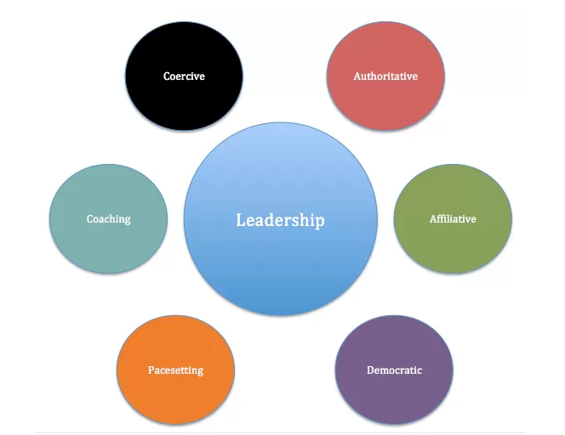
Figure.1 Types of leadership styles
(Source: Kim and Toya, 2018)

Theme 2: Benefits of organisational leadership for the food and beverage industry
Based on the findings and conclusions drawn by Elias et al. (2019), it can be understood that organisational leadership plays a key role in ensuring that the employees of an organisation are constantly motivated and committed. In this context, leadership has numerous implications within an organisation among which continuous leadership of the productivity and work quality of employees within an organisation is valued the most. Further, organisational leadership is found to be associated with the development of cultural and multicultural understanding of organisational teams working within the food and beverage industry. This is further related to the managers and owners of businesses within the food and beverage sector who are focused on implementing multicultural practices within their workplaces. It indicates and emphasises that incorporation of behaviours like respect and inclusion of different cultures and people with diverse values and attitudes within one
the workplace is only possible through effective organisational leadership. The collaboration of leadership and management practices are the ones leading businesses within the food and beverage industry to not only work effectively with diverse cultures but also understand the importance of acknowledging cultural differences between different customers.

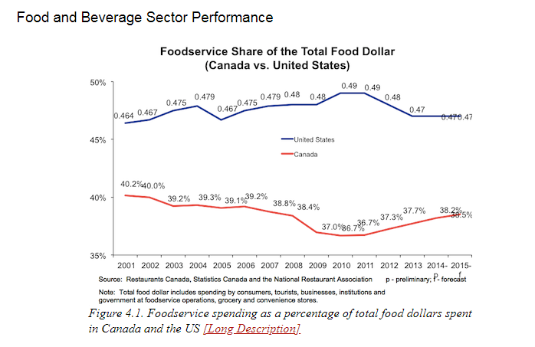
Figure.2 Performance of food and beverage sector
(Source: Rabiul and Yean, 2021)
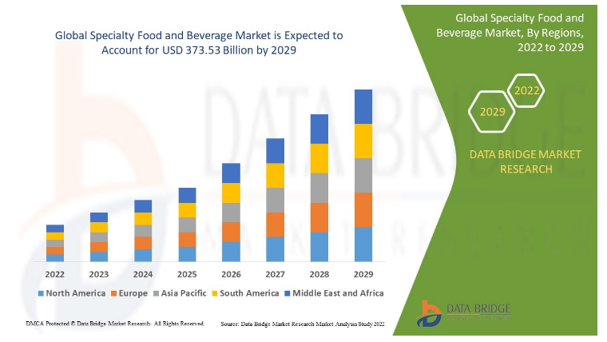

Figure.3 Specialty food and beverage market expectations
(Source: Rabiul and Yean, 2021)

According to Rabiul and Yean (2021), organisational leadership presents businesses with a range of benefits, the most basic being the benefit of increased employee motivation and productivity. Leadership is not only found to have impacted the values and beliefs of people across the workplace but also increased the engagement of people working within the food and beverage sector while reducing the rate of turnover. As business structures and practices are becoming complex with continuous developments and changes in the practices and working environments, leadership has helped effectively lead and implement numerous changes. The improvement of risk management among teams and individuals working for an organisation as well as enhancement of coordination of business tasks are also found to increase organisational capacities and capabilities.

Theme 3: Limitations of organisational leadership
According to Salih (2020), the limitations of organisational leadership like practices of micromanaging employees within organisations have led businesses to face higher rates of turnover. In addition, leadership alone is evidenced to not be capable of increasing current businesses towards success. Their findings relay that the businesses in this industry have been highly focused on increasing their potential after digitisation and that has affected the capabilities of leadership alone to meet the requirements of a business. Further, organisational leadership is said to be facing difficulties in understanding and meeting the training and development needs of the Gen Z employees. It is one of the most significant issues that has been limiting the effectiveness of business leaders to achieve greater effectiveness and achievements within organisations. Such weaknesses and limitations of organisational leaders are said to create efficiency in the business processes as the food and beverage industry has been developing rapidly to keep up with the pace of market changes.
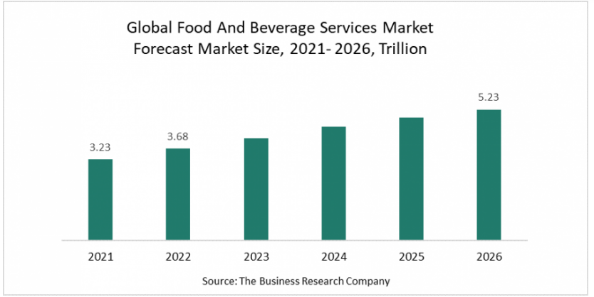
Figure.4 Global Food and Beverages services market forecast
(Source: Nangoli et al., 2020)
)
According to the findings of Nangoli et al. (2020), a;lthough leaders within different sectors have been operating effectively, the businesses within the food and beverage sectors are dealing with certain issues. Considering the main issues, the impacts of technological developments in this industry has brought significant changes to the structures and practices of the businesses. Similarly, as the “Woke” generation has come into the picture, the need for more effective leaders has increased sufficiently. Despite increasing efficiency of leadership training procedures in the industry, the limitations of the leaders’ capabilities to inspire and deal with the issues of imposter syndrome has increased. The need for leaders to be more versatile might also be determined as the limitation that current generation’s leaders are associated with.

Theme 4: Strategies for enhancing organisational leadership practice in the food and beverage industry
Brown (2019) emphasises that although leadership practices have been continuously providing businesses with effective results, they will be required to face and deal with numerous challenges in the future. In such situations, the effectiveness of the four points matrix of silent, questioning, answering, and conversational leaders can be highly effective to deliver best possible results for the businesses. As per Riggio (2018), the necessity of building effective teams is considered as one of the most important needs of the current business world which is further focused on the development of next-gen leaders. The key focuses of businesses have remained on through development of the skills and competencies possessed by their existing leaders. It further increases the need for companies within the food and beverage industry to focus on developing better performance assessment and individual development activities for their leaders so that they can work collaboratively with experts. Doing so is found to not only increase the capabilities of leaders to have a greater outlook of the business world but also envision high-performing teams in a highly competitive environment.

Chapter 5: Conclusion and Recommendations

5.1 Conclusion
This dissertation was conducted to identify how organisational leadership impacted the food and beverage industry of the UK with special reference to Stonegate Group which is a leading company in this industry. The key issues that have been arising within leadership practices and its effectiveness for businesses have been considered as one of the most important concerns of this study. It not only analysed different pieces of literature for the topic but also tried to emphasise how and why organisational leadership is considered essential in business sectors. The research studies conducted to understand different leadership styles and their impact on business performance have been considered for the study. They have also been reviewed to understand how different theories help businesses and their people in performing more effectively compared to organisations without effective leadership. After a thorough review of the advantages and disadvantages of leadership, the research study followed through an appropriate methodology that helped explain the methods and procedures that contributed to the completion of this study. In this context, it helped determine that the researcher has utilised interpretivism philosophy with an inductive approach for this research followed by an appropriate exploratory design. It also depicted why the researcher chose to use a qualitative secondary method for this study and how it would benefit the successful completion of this study.
The data for this research was acquired through online sources and analysed using thematic analysis that helped reach the conclusion that the food and beverage industry of the UK must possess effective leadership teams to achieve success. Especially the importance of different leadership theories were highlighted throughout the study. It not only benefited the researcher to understand the type of leadership that was most suitable for organisations like Stonegate, but also to achieve better performing teams. In comparison to the disadvantages of leadership, the benefits were found to be more essential for the company as the limitations could be maintained using effective processes.

5.2 Recommendation
After the completion of this study, the researcher can hereby recommend Stonegate Group with several methods and processes that can be beneficial for it to achieve success in the upcoming years.
- Keeping the changing business environment into proper consideration, Situational and Democratic leadership styles are recommended to the company so that it can achieve greater results. This suggestion is based on the performance of the company in terms of its current leadership as the company is growing continuously with its current leadership practices. The utilisation of the suggested leadership styles will not only help the company retain the Gen Z employees it possess but also help it attract more skilled workers (Bui et al., 2022).
- Stonegate Group can further be recommended to implement virtual leadership and knowledge sharing practices within its workplaces (Vandenbrink et al., 2020). It is initiated so that the multicultural teams and their effectiveness can be increased to meet the requirements of the current business environment and working culture.

References
Akanmu, M.D., Hassan, M.G., Mohamad, B. and Nordin, N., 2021. Sustainability through TQM practices in the food and beverages industry. International Journal of Quality & Reliability Management.
Asbari, M., Hidayat, D.D. and Purwanto, A., 2021. Managing employee performance: From leadership to readiness for change. International Journal of Social and Management Studies, 2(1), pp.74-85.
Brown, J., 2019. How to be an inclusive leader: Your role in creating cultures of belonging where everyone can thrive. Berrett-Koehler Publishers.
Bui, T.D., Aminah, H., Wang, C.H., Tseng, M.L., Iranmanesh, M. and Lim, M.K., 2022. Developing a Food and Beverage Corporate Sustainability Performance Structure in Indonesia: Enhancing the Leadership Role and Tenet Value from an Ethical Perspective. Sustainability, 14(6), p.3658.
Chong, S.W. and Plonsky, L., 2021. A primer on qualitative research synthesis in TESOL. TESOL Quarterly, 55(3), pp.1024-1034.
Elias, E.M., Mahidin, N. and Bahaudin, A.Y., 2019. The influence of religiosity leadership practices towards the SMEs business performance in the food and beverages industry. Int. J Sup. Chain. Mgt Vol, 8(4), p.1082.
Goldstein, S.B., 2022. A systematic review of short-term study abroad research methodology and intercultural competence outcomes. International Journal of Intercultural Relations, 87, pp.26-36.
Gregg, E.A., Kidd, L.R., Bekessy, S.A., Martin, J.K., Robinson, J.A. and Garrard, G.E., 2022. Ethical considerations for conservation messaging research and practice. People and Nature, 4(5), pp.1098-1112.
Grujović, M.Ž., Mladenović, K.G., Semedo‐Lemsaddek, T., Laranjo, M., Stefanović, O.D. and Kocić‐Tanackov, S.D., 2022. Advantages and disadvantages of non‐starter lactic acid bacteria from traditional fermented foods: Potential use as starters or probiotics. Comprehensive reviews in food science and food safety, 21(2), pp.1537-1567.
Gupta, A. and Gupta, N., 2022. Research methodology. SBPD Publications.
Hendrawan, M.S. and Pogo, T., 2021. The effect of organisational culture, leadership style, and career development on employee engagement. International Journal of Innovative Science and Research Technology, 6(7), pp.333-341.
Hughes, K., Hughes, J. and Tarrant, A., 2022. Working at a remove: continuous, collective, and configurative approaches to qualitative secondary analysis. Quality & Quantity, 56(2), pp.375-394.
Jaiswal, S. (2022) What is Leadership? Definition, Meaning & Importance | Emeritus India, Emeritus - Online Certificate Courses | Diploma Programs. Available at: https://emeritus.org/in/learn/what-is-leadership/ (Accessed: 26 November 2022).
Jamshidi, L., Heyvaert, M., Declercq, L., Fernández-Castilla, B., Ferron, J.M., Moeyaert, M., Beretvas, S.N., Onghena, P. and Van den Noortgate, W., 2022. A systematic review of single-case experimental design meta-analyses: Characteristics of study designs, data, and analyses. Evidence-based communication assessment and intervention, pp.1-25.
Jobs , S (2020), 4 Leadership Styles to Use for Restaurant Business . Available at: https://www.foodfindsasia.com/4-leadership-styles-to-use-for-restaurant-business/ (Accessed: 26 November 2022)Jobs , S (2020).
Kim, S. and Toya, K., 2018. Leadership style required for the transition to servitization in Japan. Journal of Manufacturing Technology Management.
Nangoli, S., Muhumuza, B., Tweyongyere, M., Nkurunziza, G., Namono, R., Ngoma, M. and Nalweyiso, G., 2020. Perceived leadership integrity and organisational commitment. Journal of Management Development, 39(6), pp.823-834.
Nickerson, C., 2022. Interpretivism paradigm and research philosophy.
Pandey, P. and Pandey, M.M., 2021. Research methodology tools and techniques. Bridge Center.
Premratan (2020) Different types of leadership and their advantages and disadvantages - PloPdo (2020). Available at: https://plopdo.com/2018/12/19/different-types-of-leadership-and-their-advantages-and-disadvantages/ (Accessed: 26 November 2022).
Rabiul, M.K. and Yean, T.F., 2021. Leadership styles, motivating language, and work engagement: An empirical investigation of the hotel industry. International Journal of Hospitality Management, 92, p.102712.
Riggio, R.E. ed., 2018. What’s Wrong With Leadership?: Improving Leadership Research and Practice. Routledge.
Ruggiano, N. and Perry, T.E., 2019. Conducting secondary analysis of qualitative data: Should we, can we, and how?. Qualitative Social Work, 18(1), pp.81-97.
Sale, J.E., 2022. The role of analytic direction in qualitative research. BMC Medical Research Methodology, 22(1), pp.1-12.
Salih, A.M., 2020. Cross-cultural leadership: Being effective in an era of globalization, digital transformation and disruptive innovation. Routledge.
Saputra, F. and Mahaputra, M.R., 2022. Effect of job satisfaction, employee loyalty and employee commitment on leadership style (human resource literature study). Dinasti International Journal of Management Science, 3(4), pp.762-772.
Sharp, E.A. and Munly, K., 2022. Reopening a can of words: Qualitative secondary data analysis. Journal of Family Theory & Review, 14(1), pp.44-58.
Statista (2022). Largest UK pub companies by units 2020 | Available at: https://www.statista.com/statistics/310844/ten-leading-independent-pub-companies-in-the-united-kingdom-uk-by-number-of-pubs-owned/ (Accessed: 26 November 2022).
Stonegate Group (2022) Home | . Available at: https://www.stonegategroup.co.uk/ (Accessed: 26 November 2022).
Sürücü, L. and Sağbaş, M., 2021. The impact of leadership styles on job satisfaction: A study of the hospitality industry. Yönetim Bilimleri Dergisi, 19(40), pp.323-346.
Taherdoost, H., 2022. Measurement and scaling techniques in research methodology; survey/questionnaire development. International Journal of Academic Research in Management, 6(1), pp.1-5.
Tortorella, G.L., Fettermann, D., Fogliatto, F.S., Kumar, M. and Jurburg, D., 2021. Analysing the influence of organisational culture and leadership styles on the implementation of lean manufacturing. Production planning & control, 32(15), pp.1282-1294.
Tourky, M., Alwi, S.F.S., Kitchen, P., Melewar, T.C. and Shaalan, A., 2020. New conceptualization and measurement of corporate identity: Evidence from UK food and beverage industry. Journal of Business Research, 109, pp.595-606.
Vandenbrink, D., Pauzé, E. and Potvin Kent, M., 2020. Strategies used by the Canadian food and beverage industry to influence food and nutrition policies. International Journal of Behavioral Nutrition and Physical Activity, 17(1), pp.1-13.
Wahyudi, E. and Subanidja, S., 2022. The Effect of Leadership Style Strategy and Innovation Strategy on Competitive Advantages and Implementation of Industry 4.0. Jurnal Riset Perbankan, Manajemen, dan Akuntansi, 5(1), pp.12-28.
Wu, Y.L., Shao, B., Newman, A. and Schwarz, G., 2021. Crisis leadership: A review and future research agenda. The Leadership Quarterly, 32(6), p.101518.
Zhang, Y., 2022. Research methodology. In Assessing Literacy in a Digital World (pp. 51-71). Springer, Singapore.

Appendix
Figure.1 Types of leadership styles
(Source: Kim and Toya, 2018)
Figure.2 Performance of food and beverage sector
(Source: Rabiul and Yean, 2021)

Figure.3 Specialty food and beverage market expectations
(Source: Rabiul and Yean, 2021)

Figure.4 Global Food and Beverages services market forecast
(Source: Nangoli et al., 2020)

