Implement as Group and Demonstrate Task 1

Team Formation

To promote productive teamwork, roles were discussed and decided upon at the beginning of the project based on individual strengths and confidence levels.
Heaven Beni Elonga – Testing, validation, documentation, demo preparation.
Mohammad Yaqoob – Responsible for designing and coding the Python weather application, integrating REST APIs, implementing test cases, and ensuring CI/CD workflows are in place.
Microsoft Teams, email, and GitHub were the main means of communication this enabled frequent updates, task collaboration, and responsibility definition. This organised strategy made it possible for each individual to contribute to the project in an efficient manner.

Planning

As a team, we decided on Option 2, a Python application based on the REST API, because it clearly illustrates network programmability through the integration of external APIs.
Task | Responsible | Timeframe
Planning & API research | Both | 17 Jan
Application development | Mohammad | 17-18 Jan
Testing & CI/CD | Both | 18 Jan
Documentation & demo prep | Heaven | 18-19 Jan
The goal of this project was to create and show a network-based Python application for collecting real-time data from an external REST API. The application was expected to illustrate fundamental network programmability principles such as API interface, automated testing, and continuous integration. The application was also built to check user input by processing both legitimate and invalid city names correctly.
A REST API-based weather application was chosen since it is directly relevant to the module content and demonstrates real-time network connection. Python was chosen as the programming language because of its simplicity, excellent support for network automation, and abundance of relevant libraries.
Python was chosen as the programming language because of its ease of use, readability, and robust support for network automation. Requests libraries, for example, provide for quick API contact, whereas pytest supports structured and automated testing. These tools are frequently used in industry and are consistent with this task.
The project was designed within a tight time frame, with responsibilities divided to maintain consistent progress to avoid problems as shown in figure 1.
Figure 1: Project planning timeline showing tasks, responsibilities, and completion dates.

The project was built with PyCharm as the whole development platform. PyCharm was chosen for its built-in terminal, virtual environment support, and GitHub connectivity, which made it easy to run the application, execute pytest tests, and manage project files quickly.
This planning method enabled the project to be finished successfully while preserving clarity about the responsibilities.

Resources
The following tools and resources were used throughout the project:
- Python 3 – Programming language
- Open Weather REST API – Source of real-time weather data
- requests – Python library for HTTP requests
- pytest – Automated testing framework
- GitHub – Version control and collaboration platform
- GitHub Actions – CI/CD automation
- PyCharm – Integrated Development Environment (IDE)
The GitHub repository remained private, with access granted to both team members. Version control was utilised to manage changes, track progress, and keep the project organised.
Repository link: https://github.com/MohammadYaqoob2419891/weather-app.git

Implementation

The implemented application allows users to retrieve real-time weather information by inputting a city's name. The software sends an HTTP GET request to the Open Weather API, parses the JSON result, and displays suitable weather information to the user.

The main process of the app is as outlined below:
1. The user is prompted to provide the city name.
2. The software initiates an HTTP request to the Open Weather API.
3. The API returns weather data in JSON format.
4. The application retrieves temperature and weather descriptions.
5. Results are shown to the user.
6. If the city name is invalid or the request fails, an error message will be displayed.

Error Handling:
Basic error handling was developed to guarantee that the program behaves properly when invalid input is entered. If a user provides an invalid city name or the API fails to return proper data, the program displays an appropriate error message rather than quitting abruptly. This increases both reliability and user experience.

Participation Rating Table

Team Member | Contribution Summary | Rating (1-5)
Mohammad Yaqoob | Application development, REST API integration, automated testing, CI/CD setup | 5
Heaven Beni Elonga | Testing execution, validation, documentation, evidence collection, demo preparation | 3
Figure 2: Team participation and contribution rating table for group members.

Testing and Validation

Testing and validation were performed to guarantee that the application delivered accurate and dependable data.
Manual testing was carried out by launching the application in the terminal on a MacBook and entering several city names. When an actual city name, such as London, was supplied, the application correctly returned the current temperature and weather description. When an invalid city name was entered, the application successfully displayed an error message, demonstrating that basic error handling was working correctly.
In addition to manual testing, the pytest framework was used to automate it. The test suite was run locally with the command: python3 -m pytest
All automated tests completed successfully, confirming that the app's main functionality worked as planned. Although warnings were displayed due to the MacOS SSL configuration, they had no effect on the test results or the way the app worked.
Figure 3,4 ,5 of the terminal output and pytest results are provided to show that both human and automated testing were completed successfully.

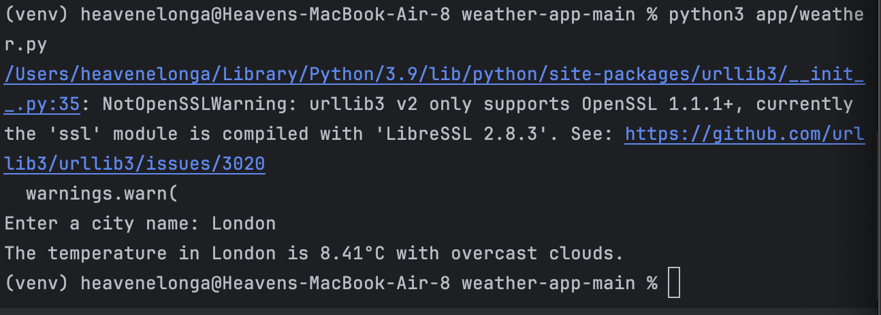
Figure 3: Manual testing showing successful retrieval of weather data for a valid city input (London).

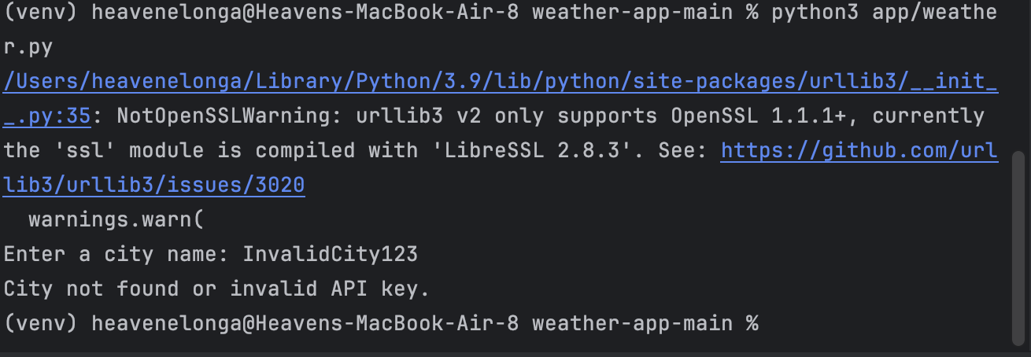
Figure 4 — Manual Testing (Invalid Input)

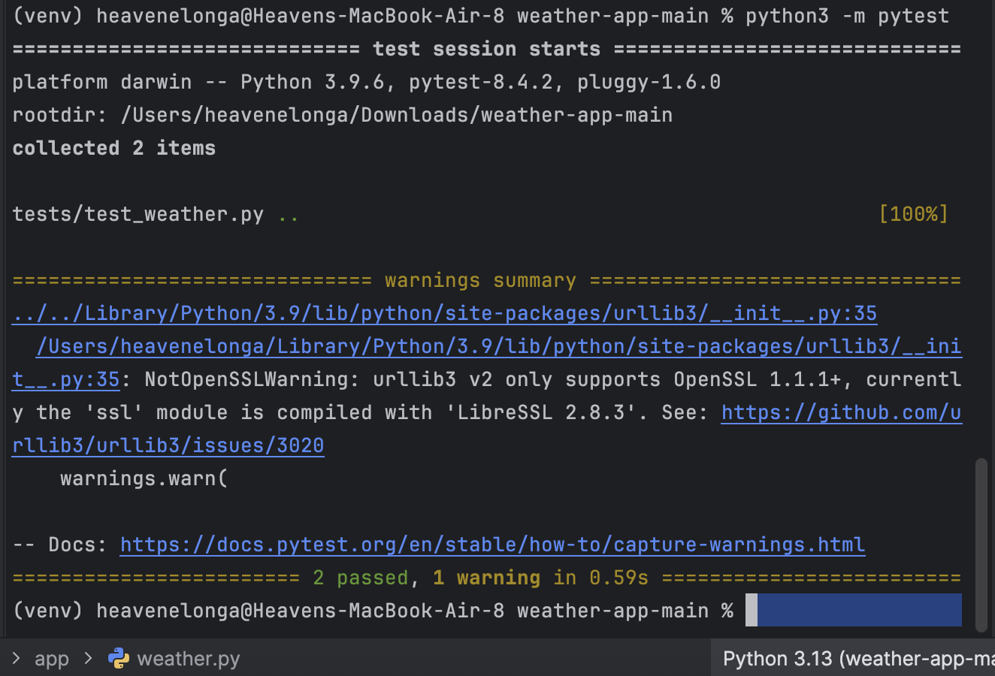
Figure 5: Automated testing using pytest showing successful execution of all test cases (2 passed) on macOS, with a non-critical SSL warning.

CI/CD

To assist automated testing in the project, a CI/CD pipeline was created using GitHub Actions. The workflow is set up to automatically run the pytest test suite whenever changes are posted to the repository or a pull request is submitted.
Although I did not develop the CI/CD configuration, I did analyse the workflow in the GitHub repository to understand how it works and to ensure that automated testing was properly implemented. The workflow executes the existing test cases without requiring manual input, allowing issues to be identified early and ensuring that modifications won't affect existing functionality.
The usage of CI/CD promotes consistent code quality by automatically validating the application as updates are done. This decreases the likelihood of errors occurring during development and shows the usage of modern software development practices.
figure 6 successful GitHub Actions workflow run is presented in the presentation to demonstrate that the CI/CD pipeline was working as expected.
Figure 6 — GitHub Repository and CI/CD Workflow Overview

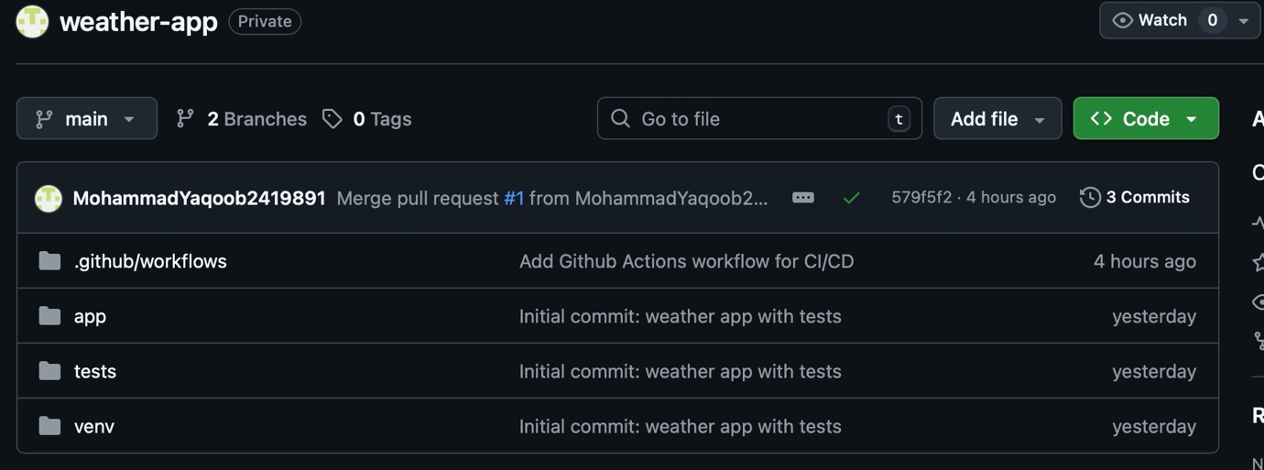

Figure 7 — GitHub Actions CI/CD Workflow Configuration File

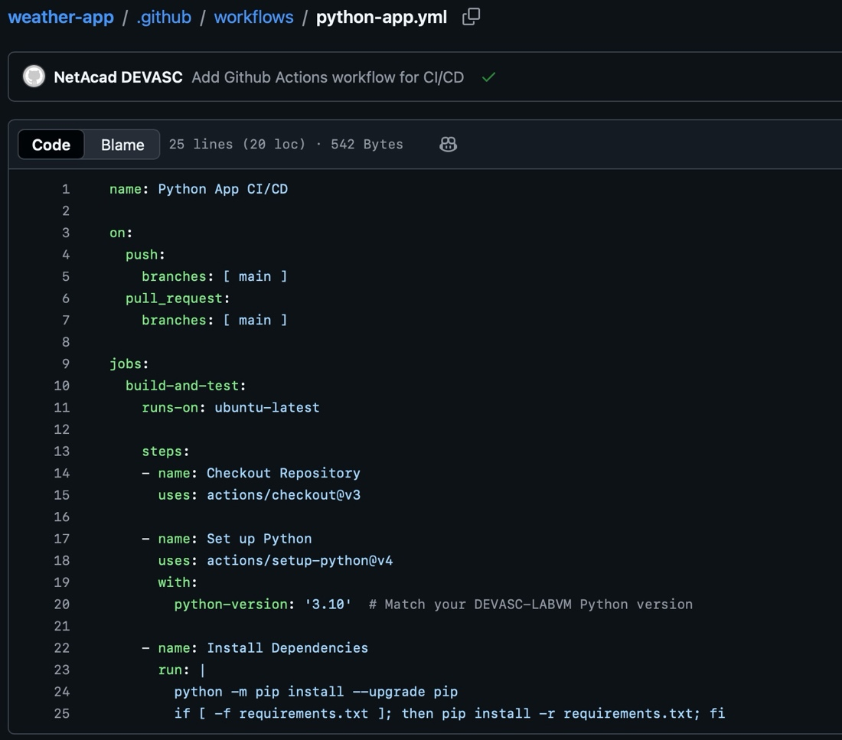

This workflow option indicates that automated tests run whenever changes are posted to the main branch or a pull request is created. The workflow creates a Python environment, installs the necessary dependencies, and prepares the repository for automated testing with Pytest. While my teammate implemented this configuration, reviewing it helped me understand how CI/CD pipelines automate testing and ensure code dependability throughout the development process.

Future Improvements
If more time was available, various improvements may have been implemented to increase the application's usefulness and usability. One potential update would be to allow multiple weather APIs, such as AccuWeather, in addition to the existing API. This would increase reliability and allow for comparisons of weather data from various sources. The software might possibly be expanded to show multi-day weather forecasts instead of just present circumstances, giving users more detailed and useful information.
Another enhancement would be the inclusion of a graphical user interface (GUI), either through a Python library like Tkinter or a basic web-based interface. This eliminates the need to interact with the application via the terminal, making it more accessible to users. Finally, the application might be deployed as a web application with cloud integration, allowing for remote access while reflecting real-world deployment and scalability principles.

Appendix
This appendix contains screenshots and visual evidence to support the implementation, testing, validation, and collaboration aspects of the project, as required by the module specification.
Figure 1 — Project Planning Timeline

Figure 1 shows the project planning timeline used by the group. The table outlines the key project tasks, assigned responsibilities, and completion dates, demonstrating structured planning and task allocation.

Figure 2 — Team Participation and Contribution Rating

Figure 2 presents the team participation rating table, summarising the level of contribution made by each team member as required by the assessment specification.

Figure 3 — Manual Testing with Valid City Input

Figure 3 shows the application being executed in the terminal on macOS with a valid city name (London). The output confirms that the application successfully retrieved and displayed real-time weather data from the external REST API.

Figure 4 — Manual Testing with Invalid City Input

Figure 4 demonstrates manual testing using an invalid city name. The application correctly handled the invalid input by displaying an appropriate error message, confirming effective input validation and error handling.

Figure 5 — Automated Testing Using Pytest

Figure 5 shows the execution of automated tests using the pytest framework. The results confirm that all test cases passed successfully, indicating that the application functions correctly under automated testing conditions.

Figure 6 — GitHub Repository Structure and CI/CD Overview

Figure 6 displays the private GitHub repository structure used for the project, including the application files, test directory, and CI/CD workflow configuration directory. This demonstrates the use of version control and repository organisation.

Figure 7 — GitHub Actions CI/CD Workflow Configuration

Figure 7 shows the GitHub Actions workflow configuration file (python-app.yml) used to implement continuous integration. The workflow defines triggers for automated testing and outlines the steps required to set up the Python environment and install dependencies.

Appendix: Presentation Slides



