Module: Academic and employability skills
Lecturer: Rita Ukachi
Student name: Edson B. Rondon Neto
Student ID number: 1908212

Contents

Introduction

What is a Reflective writing?

Reflective Cycle

Reflection-in-action

Experiential learning

Self-reflection

Conclusion

References

Appendices

Introduction

The aim of this report is to give a better insight on what reflective writing is, as well, show my understanding on the matter. Different reflection models will be used to demonstrate my learnings, self-reflections, the outcomes from my own experiences and how reflecting about personal life, work and projects helps to overcome situations and finding solutions to daily problems. As well, demonstrate from a personal experience how the self-reflection could of changed past situations and helped to avoid unnecessary experiences.

What is Reflective writing?

The word reflection may sound a little scary when it comes to reflecting about yourself which is also called self-reflection, and that is exactly what reflecting writing is about, but with more depth. Reflective writing is a mental process, it is a point between thinking and learning, learning from your thoughts, surrounds and thinking about the coming situations and how the things you learnt on your self-reflection can help you with these situations. It is a way to look deeper in your soul and be honest with yourself, your response to experiences, opinions, feelings, and thoughts also a way of improving your writing and achieve clarity.
‘’In essence, reflective writing is an opportunity to demonstrate how you have gained experience and skills, or improved your practice, to your tutors (or others) by analysing specific events and actions you have been part of and using these to demonstrate that you are aware of your own personal development. This not only allows you to reflect on what you have done, but also to make informed decisions about how you will continue to develop. It also really helps to have this skill of reflection when it comes to CV writing and interviews.’’ (Burns, T., & Sinfield, S. 2009)
There are three models of reflective writing that can be used to help you on your self-reflection: reflective cycle, reflection-in-action, and experiential learning. Each one of them is different but have the same purpose of helping you to self-reflect. Usually reflective writing is a powerful tool that lead us to find our anxieties, weaknesses, also our strengths and key points to succeed.

Reflective Cycle

‘’Gibbs Reflective Cycle encourages people to think systematically about the experiences they had during a specific situation, event or activity. Using a circle, reflection on those experiences can be structured in phases. This often makes people think about an experience, activity or event in more detail, making them aware of their own actions and better able to adjust and change their behaviour. By looking at both negative and positive impacts of the event, people can learn from it.’’ (Patty Mulder,2013).

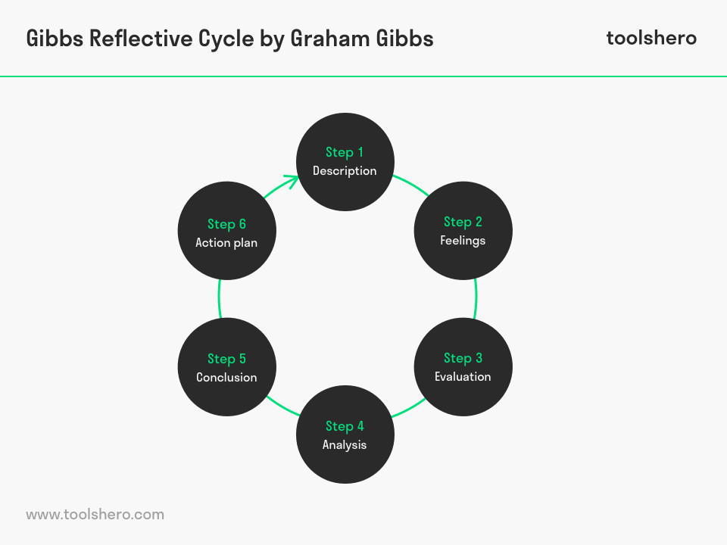

Reflection-in-action

‘‘Reflection-in-action or reflecting on your actions as you are doing them, and considering issues like best practice throughout the process. For Schön, professional growth really begins when a person starts to view things with a critical lens, by doubting his or her actions. Reflection in action/Reflection on action provides an additional element by making a distinction between reflection during the event and reflection after the event. It may be helpful to take account of the distinction between the two during your own reflective practice.’’ (Schön, Donald A. , 1983)

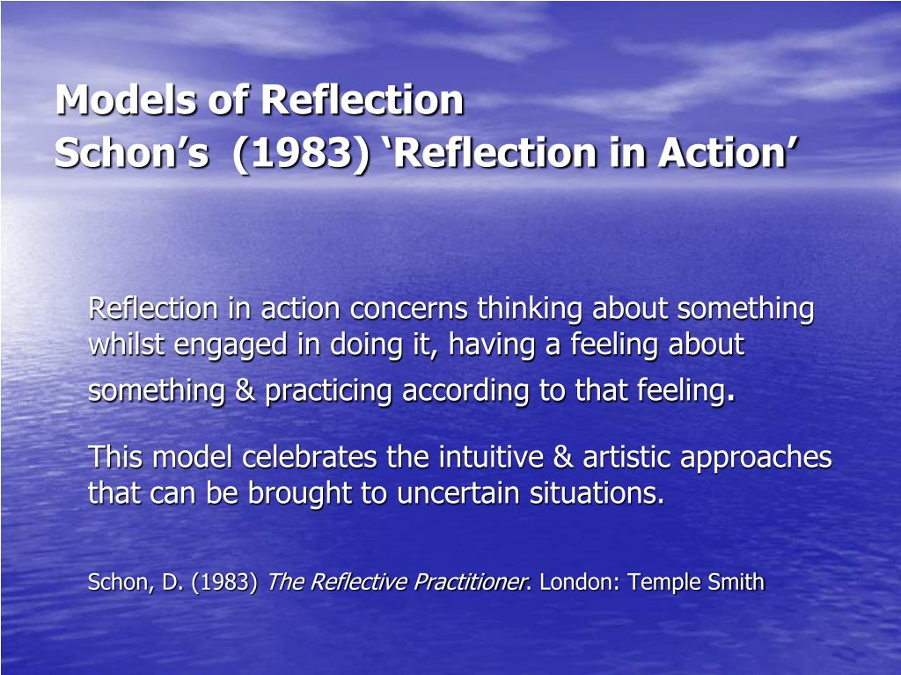

Experiential Learning

‘’Experiential learning also known as (EXL) is the process of learning through experience and is more specifically defined as "learning through reflection on doing". Hands-on learning can be a form of experiential learning but does not necessarily involve students reflecting on their product. The learning cycle basically involves four stages, namely: concrete learning, reflective observation, abstract conceptualization and active experimentation. Effective learning can be seen when the learner progresses through the cycle. The learner can also enter the cycle at any stage of the cycle with logical sequence’’

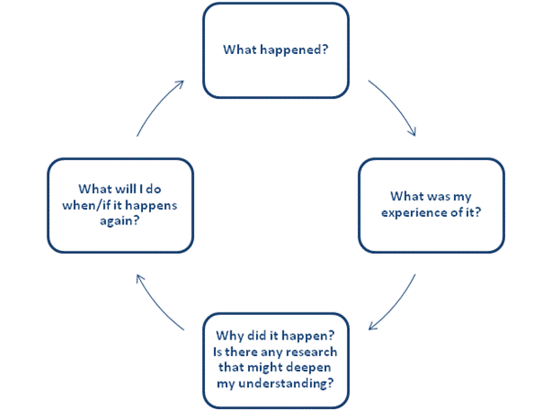

Self-Reflection

Being someone in today’s society is hard. All the pressure surrounding work, home and the unknown future is stressful to say the least. People change, things change, the world change and we change with them, developing new ways to adapt to our surroundings.
Around seven years ago I moved from a small town in Brazil to London in UK, and that is an experience that has changed my life in so many ways, specially the difference in the cultures and how things work. The need to adapt and to mix in the crowd has led me to situations that I did not necessarily had to go through. In addition, the lack of communication and a very limited English only made things harder, for example finding a job, trying to make friends with people, having a normal human relation. I would look around and see everyone as robots, it was not their fault but mine as I was not able to communicate so I would label all the people over here as robots, lacking feelings and with no sense of humour. When I moved to London at first, I did not have any interest on learning English or communicating with people, as I thought it would be hard to learn something that I never heard of. Going through terrible work experiences, where people would pay me less, make me work more and I would see all of that happening around me and not be able to say anything. It was a horrible feeling of being impotent and weak to the point to just go with the flow and let people take certain advantage at work.
One day I decided to start studying English everyday after work. Every single new word that I learnt I would try to put in use the next day at work and I would try my best to communicate with people, even if that meant I had to use sign language. I started to see the difference on how people would treat me just because I could communicate a little. I was still very limited but the difference was huge. Day by day I would learn more and more till the point that I got myself writing my own vocabulary, in a way that I could look it up easily and know what people were on about. I was addicted to learn. I would get earlier to work and leave late just to have more time to use everything that I learnt the day before. I started to make friends with people, and making real connections in a long time, I do not think I was ever excited like that. Being able to communicate in other language was an amazing feeling and it also meant that I could finally chase my dreams and find a better job. I quit my old job where I made many friends, it was time to turn the page and write a new chapter, a new beginning in London. I found a job as a tattoo artist and as part-time music producer.

I think this whole learning process had I bigger meaning to it than only being able to communicate. Reflecting more about it I can see my strengths and my weaknesses. As a musician I am constantly trying to connect with people through my music, and deliver a message that people can relate too, so when I was not able to communicate it felt like part of me was dead which explains why I would see people as robots. In fact, I was the robot. On the other hand, the process of learning something new out of my comfort zone showed me that I am able to learn things and do things if I want to and all it takes is me to push myself to do better and not waste time on unnecessary things that will not have any use or relevance in my daily life. One of the weaknesses was the fact that I let people take advantage of me at work just because I was not able to communicate. Now days with the mind set I have I would not allowed that to happen even if I could not express myself, I would find a way around it to show to people that I am well aware of the situation and taking advantage of someone is unacceptable.
Although I believe all the experience is what made me who I am, it is with a clear mind now I can see what was the best option I had at the time an how I could have avoided all these situations. We have to be ready for any challenge we might face in the future, before leaving my country I should learn at least the basic of English and be more opened to the culture of the country I was moving to. With that in mind, I make most of the time I spend here to learn more and more about the culture and improve the language. Hopefully, all of this will be worthy when it comes to the point where I start to give steps and work towards to get where I want to get, but never forgetting the lessons. With no doubt self-reflection is a mental exercise I will be implementing in my life to help me better understand my challenges and myself, always being honest with myself and trying to be able to face the truths we do not want to see.

Conclusion

I believe that some of the most difficult things is to be able to honest with ourselves and find some clarity. Usually I have a lot of good ideas but I have issues on getting them out of my mind to organize and make them look professional in a way that makes easier to seek for some information.
This course in general has improved my skills and confidence to get where I want to get, giving me a structured base on how to behave in certain situations and how to make myself clear in my workplace as well developing and improving my writing skills. The teacher has also giving me topics I have never worked which allowed me to use things that I have some information about but I did not know how to put them into words. I have not had a self-reflection in that depth before and looking back I can see that I had some limitations when it came to express the thoughts I have.

References

Burns, T., & Sinfield, S. (2009). Essential Study Skills: The Complete Guide to Success and University (2nd ed.). London: Sage.

My assignments services, how to write an effective paragraph? ,2020. Available from:
https://www.myassignmentservices.com/blog/how-to-write-a-reflection-paragraph-in-an-assignment/
[03 April 2020]

Pen and the pad, how to write a reflective essay, 2018. Available from:
https://penandthepad.com/write-selfreflective-essay-2138.html
[03 April 2020]

Toolshero, reflective cycle, 2015. Available from:
https://www.toolshero.com/management/gibbs-reflective-cycle-graham-gibbs/
[03 April 2020]

University of Bradford, Reflective models, 2016. Available from:
https://www.bradford.ac.uk/wimba-files/skill-space/Reflective_Writing_HTML/page_04.htm
[03 April 2020]

Appendices



