  FALLINGWATER FRANK LLOYD WRIGHT  AN EXEMPLAR OF MODERN ARCHITECTURE | HISTORY AND THEORY [M4X01975]  The early phase of modern architecture in Europe and the USA was characterised by the development of new spatial and structural strategies realised through new building technology. In addition, many architects and designers drew inspiration from the possibility of creating social utopias.  Clare Joe Padilla  190143

Frank Lloyd Wright began constructing ‘The Fallingwater’ in 1935, located on the mountains of Pennsylvania. It was designed as a private residence and a weekend home for the family of Edgar J. Kaufmann.
Kaufmann’s family lived a city life, and on their vacation breaks they would often visit the area known as Bears run, where their family time was often spent by a hidden waterfall surrounded by the forest. Fallingwater is one of Wright’s famous designs, where he expressed his philosophy of organic architecture as a house to be emerging from the landscape.
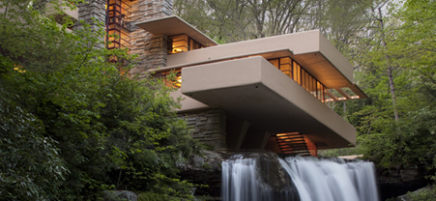
(Western Pennsylvania Conservancy, 2020)
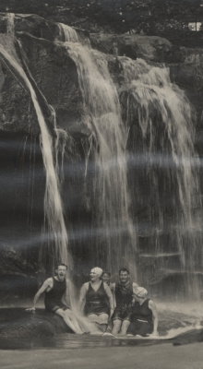
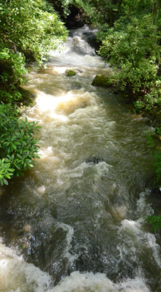

(Fig 1.1, 1.2, 1.3 – Western Pennsylvania conservancy, 2020)

[HISTORICAL BACKGROUND]

When Wright explained his plans to Kaufmann, many thought that the design of the house over the waterfall was crazy, and that the structure was likely to be unstable due to the movement of the falls. Kaufmann agreed with his engineering friends that the building is not engineered in a sensible manner.

(Fig 1.4 – Frank Lloyd Wright, 1935-1936)
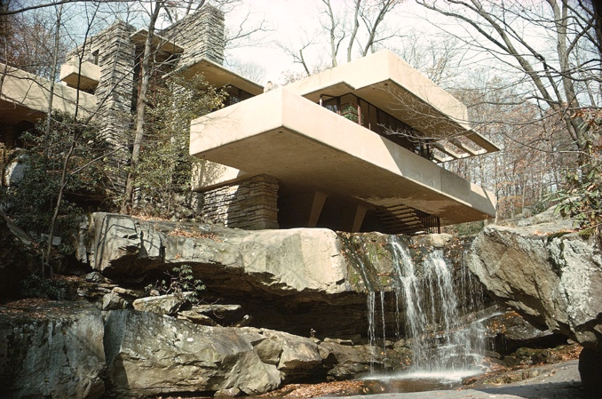
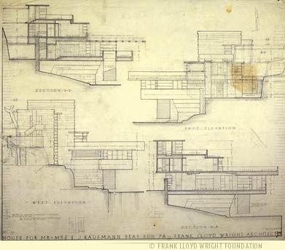

Despite all these negativities, Wright had a strong belief that “human life was an intrinsic part of life, and the true essence of human existence lay in its understanding of its relationship to its surroundings.”
(Kaufmann Jr, 1995)

When looking at the boulders on the site, Wright picked a particular boulder to plan the centre of the house, which would be the living room. This boulder extended all the way to the ground. Wright thought that the boulder was too bumpy, so he suggested to make it flat in order to be levelled with the rest of the floor. However, Kaufmann suggested to let it bump up, and it turned out nicely done. From this analysis, each floor was integrated with nature and was placed on different levels of the boulders.

(Fig 1.5 – Jan Moline, 2017)

[STRUCTURE]

Throughout the building, there are three main horizontal concrete levels, each involve a cream concrete terraces that are cantilevered over the waterfall. Wright saw this by putting ledges on top of another, creating a link between the lower levels and the upper levels of the falls, creating an effect in building a house that would float.

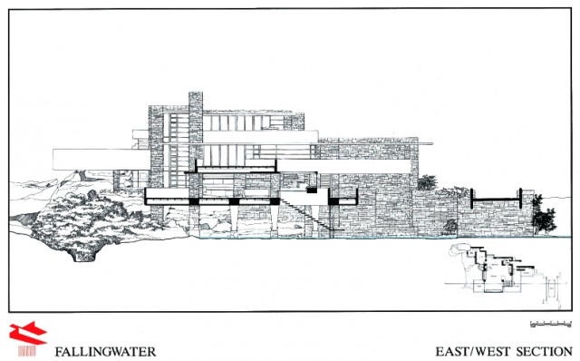
(Fig 2.1 – Braley. J, Hendricks. J, Tedesco. M, 2011)
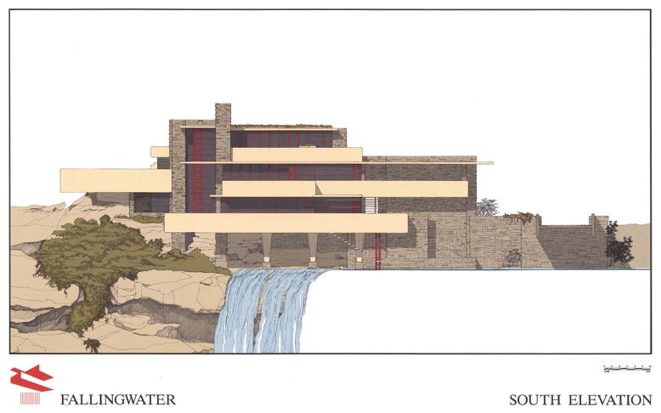
The materials used was connected with the surroundings; wood, concrete, and steel. The materials were picked by Wright and was approved by Kaufmann. However, based on the site analysis, the choice for materials was restrictive, but Wright was able to embrace the principles of organic architecture, by using nature’s resources into a structure of his own.

The concrete was mainly used for horizontal elements such as the ledges, and steel was used for the vertical elements, to keep the layers of concrete separated, while protecting them against any torsion and twisting. The horizontal elements which were the cantilevers, was inspired by the pools of the water, and the vertical elements that supports the house, mimics the vertical waterfall.
(Shannon Hall, 2015)

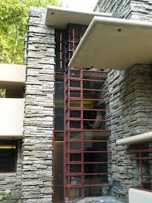
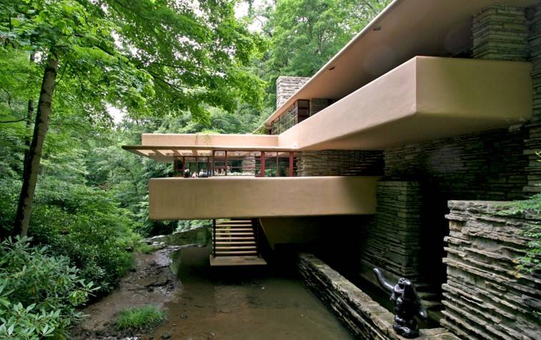

(Fig 2.2 – Rana. M, 2017)
(Fig 2.3 – N/A, 2000)

[FALLINGWATER]

The house was not designed to take advantage of the view, but to have been a part of the view and landscape. Wright saw the huge boulders and rock edges as an opportunity to make use of the visual feature of what remained.
The building consists of three floors and two parts; the main house (1936-1938) and the guest room (1939).

(Fig 3.1, 3.2 – Padilla. C, 2020)
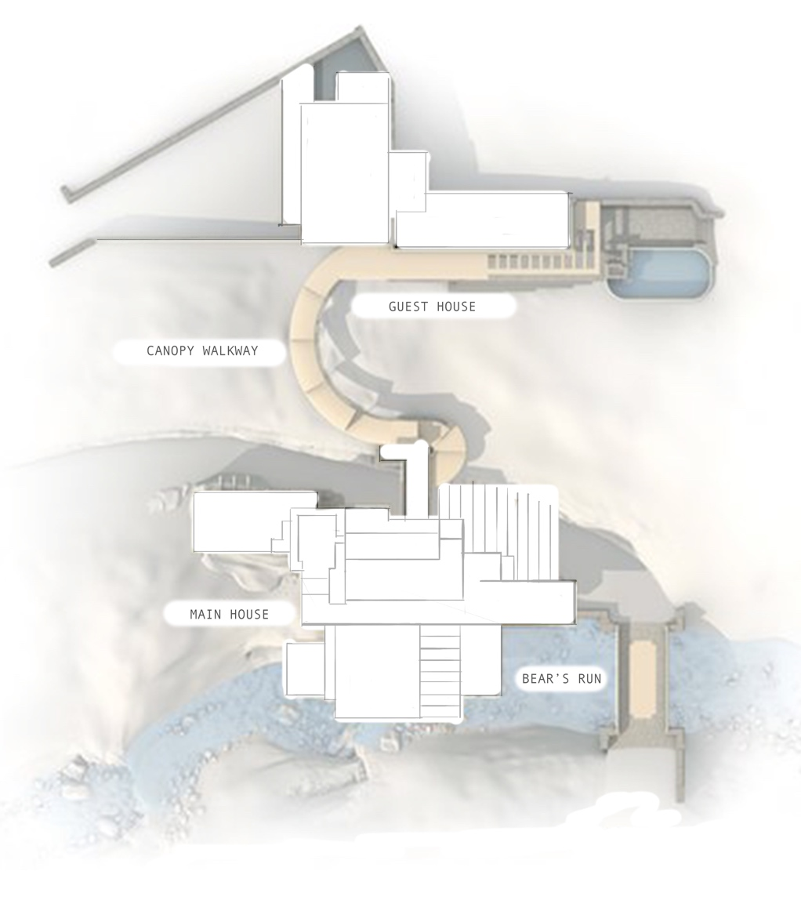

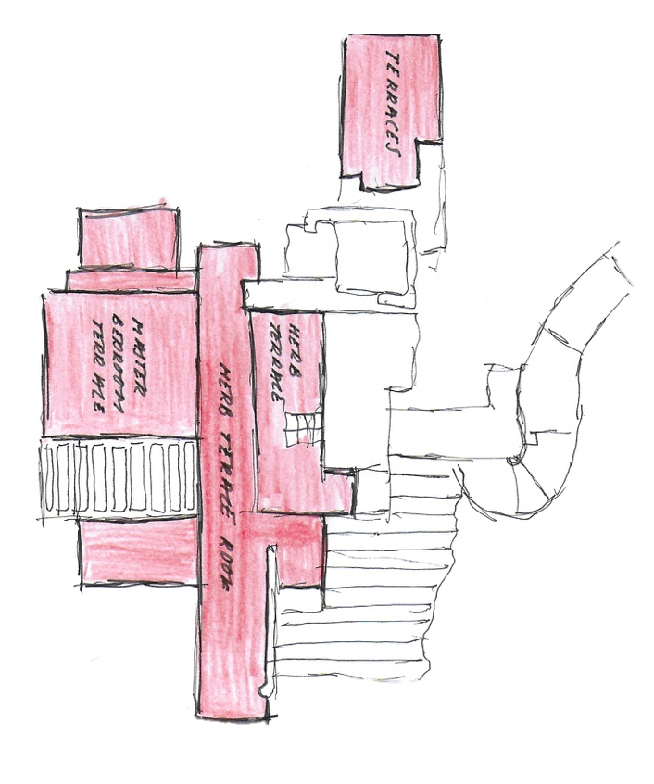

[MAIN HOUSE]

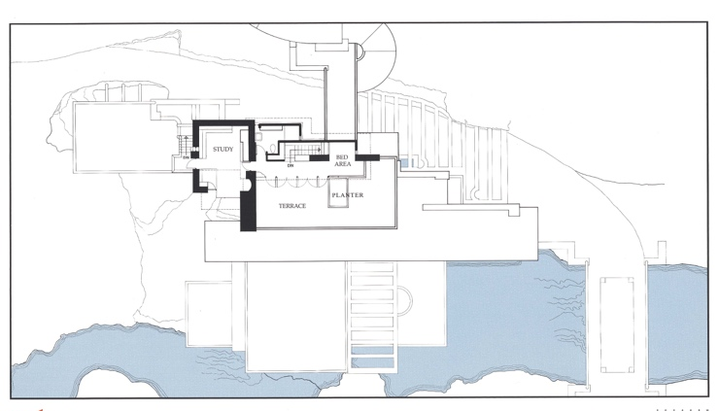
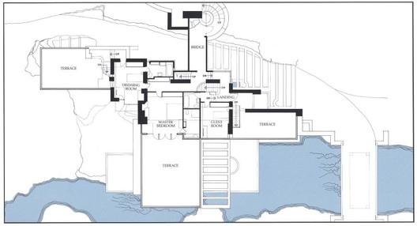
(Fig 3.2 – Perez. A, 2010)
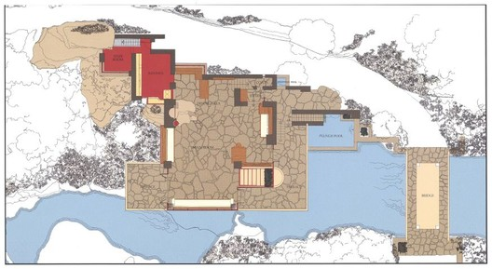

Many of Wright’s house designs, like Fallingwater, has a strong centre shown in the main room, located on the first floor. Within the empty square, there are alcoves to help create a constant sense as one moves through the entrance; dining room and the two sitting alcoves near the fireplace. The fireplace was the main part of the whole building, which has the
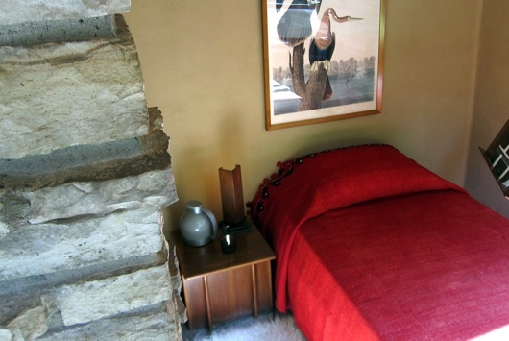
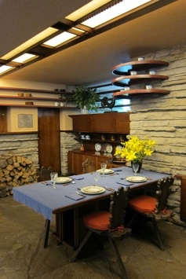
biggest masonry placed. The second level opened as the main bedroom floor.
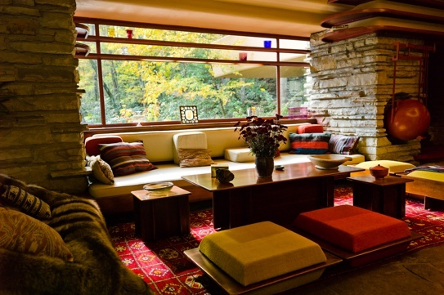
(Fig 3.3 – Portier. R, 2015)
(Fig 3.4 – Gobetz. W, alcove 2011)

The top floor was designed for Kaufmann Jr, who liked to wake up to the sun, so then they moved his room from the west to the east of the plan. Fallingwater was inspired by its surroundings of open space. The whole physical shape of this building creates spatial relationships of its structure.

[GUEST HOME]

(Fig 4.1 –N/A, 2013)
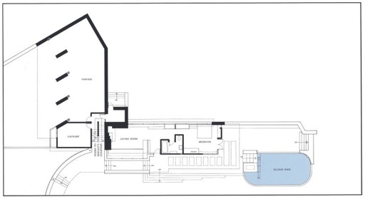
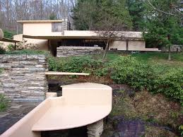
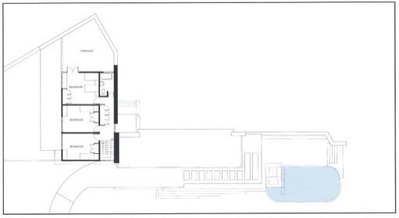
(Fig 4.2 – Perez. A, 2010)

After creating the main house, Wright later knew that he needed to construct a guest house, which was planned to be located up the hill from the waterfalls. Designed to offer additional space and privacy. A canopy walkway would give access to both parts. Originally it would have accessed the top level of the main house, but to make it easier, they changed it to the second floor. The semi-circular canopy cover was made out of thick concrete and cantilevered infolded planes, while being supported with slender steel posts.

Wright had the idea of Cherokee red, as he believed that you should colour the structure in its tonality suggested by the chemical nature of the materials such as iron steel, relating to the actual material itself. Originally, Wright suggested to colour the concrete, gold leaf but it was too expensive. It would have appeared that Wright was inspired by the famous Japanese screens that had gold leaf background, which was seen as a way of pulling the light all the way to the back of the room.

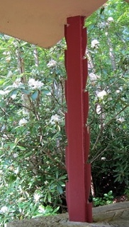
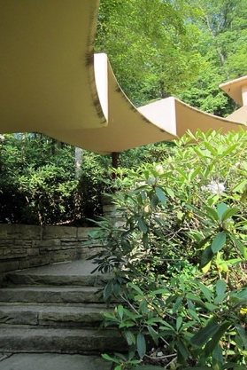
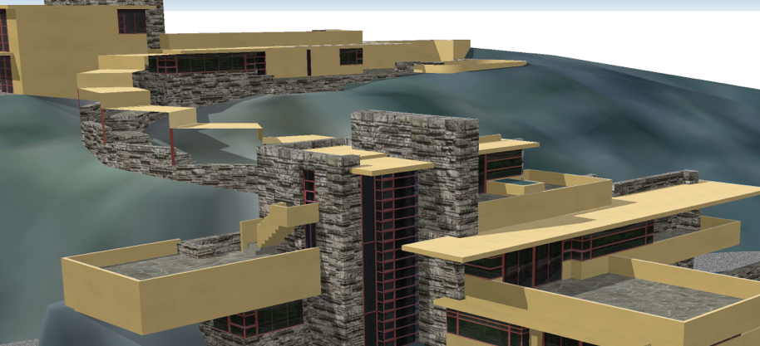

(Fig 4.3 – Braley. J, Hendricks. J, Tedesco. M, 2011)
(Fig 4.4, 4.5– Gobetz. W, 2011)
[EXTERIOR & INTERIOR]

The exterior and interior walls throughout the building are made from extracted stone. The floor is brown stone, which allows the interior to blend with its surroundings. Each space is sparsely open, allowing visitors to move freely though each space, Wright demonstrated it through the use of alcoves. Wright personally furnished the whole building, most of his furniture were flexible to its own space. For example, tabletops were extended widely beyond their support, mimicking the concrete ledges.

(See Fig 5.1 – Western Pennsylvania conservancy, 2020)
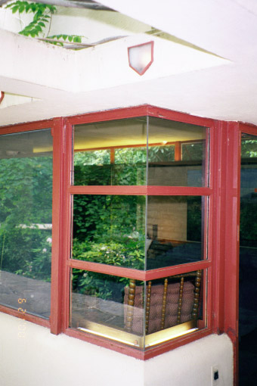
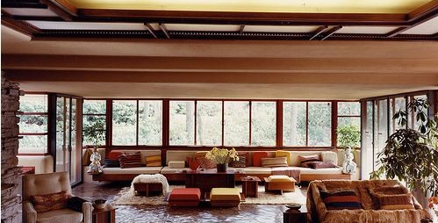

The flow of the house is directed through dark and narrow passageways, with low ceilings in order for the eyes to inevitably be directed towards the edge of the room, or beyond the windows. At the corner of each walls, Wright created windows corners out of glass, meaning that there was no visible element obstructing the view. For Wright, it was important to make it more of an open area within a space, while considering the amount of support needed. Wright was always conscious when it came to the frame of the windows, but all agreed to design the windows in sequences of horizontal divisions opposed to vertical elements.

(see Fig 5.2 - N/A, 2015)

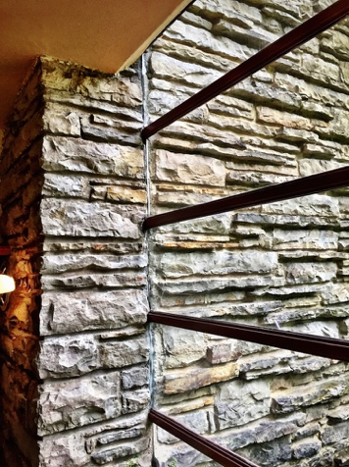
The large living room has a glass wall which allowing those inside to enjoy the view, while listening to the sound of the waterfalls. The use of large windows throughout the building, eliminates the separation between the rooms and the terraces, as well as serving the purpose of reflecting and projecting the natural light. Another window feature, is the glass and metal frames inserted into a premade slot in the stone, creating an effect where the glass meets the stone walls.

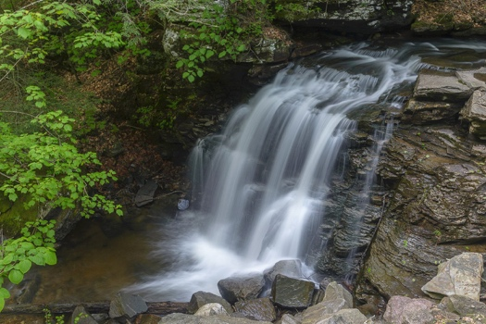
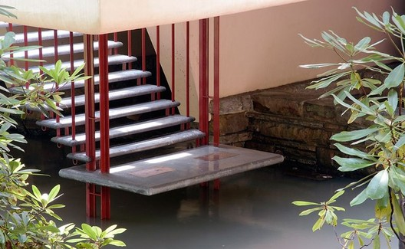
(See Fig 5.3 – N/A, 2015)

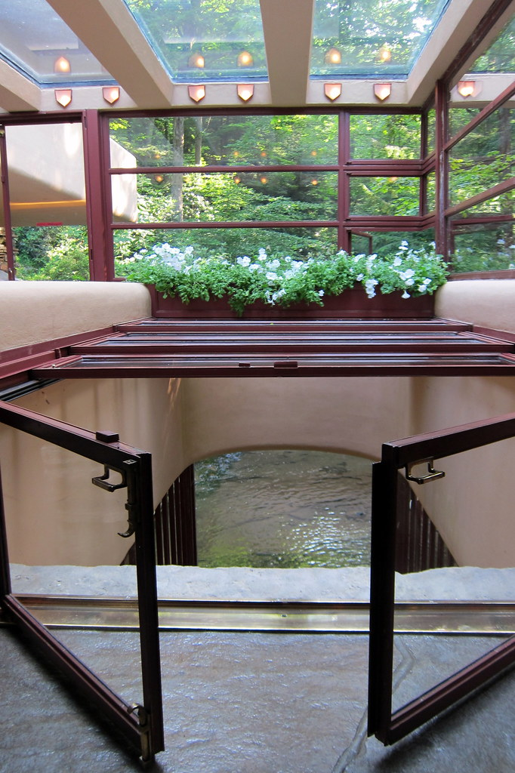

From the living room, there are steps leading towards the stream known as the ‘Staircase of water’. It was known that a lot of the guest’s time and family time were spent by the waterfalls. Wright wanted the visitors to have an immediate contact from the space within and the space outside. The steps are suspended from traction cables, which are attached towards the first slab. Above the steps is a trellis, which open up to the sky, balancing the vertical shaft of space and the materials.

(Fig 5.4 – Perez. A, 2010)
(See Fig 5.5 – World Waterfall database, 2018)
(Fig 5.6 – Gobetz. W, 2011)

[IDEAS & INFLUENCES]

Fallingwater demonstrates how he envisions form and function as a single, interconnected element through the principles of organic architecture. These organic principles are still being used for contemporary architecture that relates to the same principles used for Falling water. An example of this is the ‘Koehler residence’ in New Brunswick Canada. The construction materials used is stone, glass, wood, and stainless steel. Mostly created with horizontal elements, designed to slow activities of everyday life by admiring the ocean horizon.
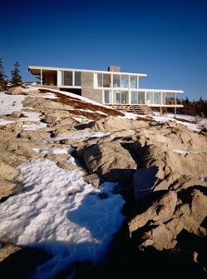
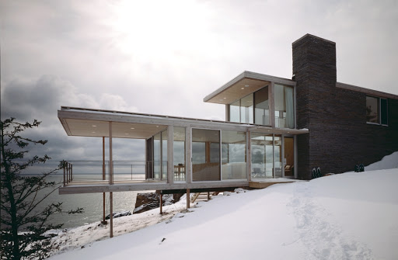

(Fig 6.1 – SNOW KREILCH ARCHITECTS, 2000)

[CONCLUSION]

Overall, the distinctiveness of the whole design is amazing, especially for a house that receive a lot of negativity at the beginning. But now, it is an elegant building that complements the nature that surrounds it with its beauty in harmony.
Through its progress with the use of vertical and horizontal elements, there were many structural complications, which made the overall structure unsuccessful. Features such as the roof systems and terraces have been replaced many times. Fallingwater was designed as a series of cantilevers and supporting shelves, but this meant that it required more attention when it came for the need of requiring waterproofing. A continuing renovation was needed to keep the structure intact and safe due to these complications.
Although it is clear to see that Wright often prioritised design above all else, Wright was able to embrace his theory with organic architecture, by using nature’s resources into a structure of his own. Wright wanted a house design to have a continuing link between the indoors and the outdoors, just like the gold leaf Japanese screens. Throughout the process, Kaufmann and his family were not as formal as Wright thought they would be, but they preferred a simpler living, of which the Fallingwater was designed for.

[REFERENCE LIST]

[INTRODUCTION]
Western Pennsylvania Conservancy (2020) What is Fallingwater?
Available at: https://fallingwater.org/what-is-fallingwater/
(Accessed date: 14 April 2020)

[Fig 1.1] – Western Pennsylvania Conservancy (2020) Frank Lloyd Wright’s Fallingwater
Available at: https://fallingwater.org/what-is-fallingwater/
(Accessed date: 14 April 2020)

[Fig 1.2] - Western Pennsylvania Conservancy (2020) The house over the waterfall
Available at: https://fallingwater.org/history/about-fallingwater/designing-fallingwater/
(Accessed date: 14 April 2020)

[Fig 1.3] - Western Pennsylvania Conservancy (2020) The landscape
Available at: https://fallingwater.org/history/about-fallingwater/designing-fallingwater/
(Accessed date: 14 April 2020)

[HISTORICAL BACKGROUND]
[Fig 1.4] Frank Lloyd Wright (1935-1936) Elevation plans of Fallingwater [Drawings]
Available at: https://fallingwater.org/history/about-fallingwater/designing-fallingwater/
(Accessed date: 15 April 2020)

‘Fallingwater and Frank Lloyd Wright’ (1995) A conversation with Edgar Kaufmann Jr. [Youtube]
Available at: https://www.youtube.com/watch?v=UDmlzRtyVNM
(Accessed date: 18 April 2020)

[Fig 1.5] Jan Moline (February 7th, 2017) Fallingwater Home in Bear Run [Photograph] Available at: https://fineartamerica.com/featured/fallingwater-home-in-bear-run-pa-jan-moline.html
(Accessed date: 19 April 2020)

[STRUCTURE]
[Fig 2.1] John Braley, Javier Hendricks, Matthew Tedesco (October 5, 2011) Elevations [Drawing]
Available at: https://698a820d-a-62cb3a1a-s-sites.googlegroups.com/site/a2amajorbuilding/plans-elevations-sections/selevation.jpg?attachauth=ANoY7copZpc5qX_vxVEi_Dab6pDGcmNdzv6miCFo8GiX2QY4bykFSAZdbcVT5YotpsVe7DgDDHCJWsLK6X3oBfdIXtj_mwtPlciRtYMF7hif7AoXF31cEbBWShAys4LXMjOREx__EGvJTLIE3HxDTqp-qH_ZpCcCgVUjxIoIT2ryy1noUDGzG2lYR0pl3_dCIB1BRHWv5VI-sx7bW7rz-Z0xrZrf0MJ_RjAYHyHhoEsjgbfeugJYxIWb8gdGlN_6ARRNxqFPNh1c&attredirects=0
(Accessed date: 19 April 2020)

Shannon Hall (2015) Fallingwater: A building with nature and dance. Nautilus [Blog] June 10. Available at:
http://nautil.us/blog/fallingwater-a-building-that-bonds-with-nature-and-dances-with-time
(Accessed date: 18 April 2020)

[Fig 2.2] Masud Rana (January 10, 2017) Fallingwater (Kaufmann Residence) Pennsylvania by Frank Lloyd Wright
Available at: http://architectboy.com/fallingwater-frank-lloyd-wright/
(Accessed date: 19 April 2020)

[Fig 2.3] N/A (2000) Floor to ceiling windows, West tower [Photograph] Available at:
http://www.wright-house.com/frank-lloyd-wright/fallingwater-pictures/c7-windows-west-tower-fallingwater.html
(Accessed date: 19 April 2020)

[FALLINGWATER]
[Fig 3.1] Clare Joe Padilla (2020) Site plan and building positioning [Photoshop]

[Fig 3.2] Clare Joe Padilla (2020) Master plan of Fallingwater [Drawing]

[MAIN HOUSE]
[Fig 3.2] Adelyn Perez (2010) Floorplans of the main house [Photograph] Available at: https://www.archdaily.com/60022/ad-classics-fallingwater-frank-lloyd-wright
(Accessed date: 15 April 2020)

[Fig 3.3] Robin Portier (2015) Furniture in Fallingwater [Photograph] Available at:
https://issuu.com/robinportier/docs/integrated_furniture_robinportier_1
(Accessed date: 19 April 2020, 03:41pm)

[Fig 3.4] Wally Gobetz (July 11, 2011) Fallingwater - Dining alcove and Sleeping alcove [Photograph] Available at:
https://www.flickr.com/photos/wallyg/with/6011496790/
(Accessed date: 19 April 2020)

[MAIN HOUSE]
[Fig 4.1] N/A (2013) Guest house, from main house [Photograph] Available at:
http://www.wright-house.com/frank-lloyd-wright/fallingwater-pictures/7x-guest-house-S.html
(Accessed date: 19 April 2020)

[Fig 4.2] Adelyn Perez (2010) Floorplans of the guest house [Photograph]
Available at: https://www.archdaily.com/60022/ad-classics-fallingwater-frank-lloyd-wright
(Accessed date: 15 April 2020, 03:12pm)

[Fig 4.3] John Braley, Javier Hendricks, Matthew Tedesco (2011) 3D Perspective view [Photograph]
Available at:
https://sites.google.com/site/a2amajorbuilding/plans-elevations-sections
(Accessed date: 15 April 2020, 03:12pm)

[Fig 4.4] Wally Gobetz (July 11, 2011) Fallingwater – Canopy cover [Photograph]
Available at:
https://www.flickr.com/photos/wallyg/with/6011496790/
(Accessed date: 19 April 2020)

[Fig 4.5] Wally Gobetz (July 11, 2011) Fallingwater – Steel posts [Photograph]
https://www.flickr.com/photos/wallyg/with/6011496790/
(Accessed date: 19 April 2020)

EXTERIOR & INTERIOR]
[Fig 5.1] – Western Pennsylvania Conservancy (2020) Living room [Photograph]
Available at: https://fallingwater.org/what-is-fallingwater/
(Accessed date: 14 April 2020)

[Fig 5.2] - N/A (2015) Corner window at guest house [Photograph] Available at:
http://www.wright-house.com/frank-lloyd-wright/fallingwater-pictures/34SE-guest-house-window.html
(Accessed date: 14 April 2020)

[Fig 5.3] – N/A (2015) Window set directly in stone [Photograph] Available at:
http://www.wright-house.com/frank-lloyd-wright/fallingwater-pictures/c8-window-in-stone-no-frame.html
(Accessed date: 14 April 2020)

[Fig 5.4] - Adelyn Perez (2010) Staircase of water [Photograph] Available at:
https://www.archdaily.com/60022/ad-classics-fallingwater-frank-lloyd-wright
(Accessed date: 15 April 2020)

[Fig 5.5] – World Waterfall database (2018) Bear Run Falls [Photograph] Available at:
https://www.worldwaterfalldatabase.com/waterfall/Bear-Run-Falls-18504
(Accessed date: 19 April 2020)

[Fig 5.6] - Wally Gobetz (July 11, 2011) Fallingwater – hatch [Photograph] Available at:
https://www.flickr.com/photos/wallyg/with/6011496790/
(Accessed date: 19 April 2020)

[IDEAS & INFLUENECES]
[Fig 6.1] – SNOW KREILCH ARCHITECTS (2000) Koehler residence [Photograph] Available at:
http://snowkreilich.com/work_type/residential/
(Accessed date: 15 April 2020)

