Hospitality and Guest Services
MODULE CODE: M4X01915
STUDENT NAME: RADU GRECU
STUDENT CODE:
Lecturer: Mr. Olu Adegbite



Content Page:
Introduction ………………... p.03
Discussion and critical analysis…………p.04- p.05
SWOT Analysis………….… p.05-p.06
Marketing Micro/Macro Environment……p.07- p.08
Conclusion…………………p.08
References…………………p.09

Introduction The task of this assignment is to discuss and describe how guest services are delivered in an hotel which must be chosen. The hotel which is going to be discussed in this essay is the Intercontinental Hotel which is locate in Bucharest, Romania. Next to the guest services aspects of the hotel, aspects such as the quality of management and such as the adaptability of the hotel to the Guests aspirations. Guest services are very important in any hospitality and tourism industry and this because of the increased level of competition between hotels and therefore “most of the hotel’s coordinators started to invest more and more in the service-delivery with the aim of having the guest satisfaction at a high level” (Kotler, Bowen and Makens 2003). Considering the mentioned statement, we real that the guests are mainly in “charge” of how the hotels are run in now-a-days and this because of the fact that if there are guests that are not showing satisfaction/ pleasure when coming into the specific hospitality environment then the people in charge of the hotel must be thinking about what needs to be done for the hotel to increase its quality of service and they must plan how they are going to manage all the situations which in the end will make them successful. Hotel Intercontinental is a 5-star hotel in Bucharest, located on the University Square, sector 1. Hotel Intercontinental is the first 5-star hotel built in Romania and one of the tallest buildings in Bucharest. The Intercontinental Hotel is the only one in Bucharest with a conference room and a swimming pool at 80 metres high, thing that is highly attracting the guests comparing to other competitors such as “Epoque Hotel” or “Grand Hotel”, which are as well 5 stars hotels. Spacious and elegant, the 283 rooms and apartments offer guests a sense of relaxation and comfort. The Imperial apartment is the only one in Bucharest equipped with a sauna and piano. Because of its great sections and areas of the hotel, guests usually opt to chose this hotel as they consider th t the leisure areas will make them relax in the way they really want to.
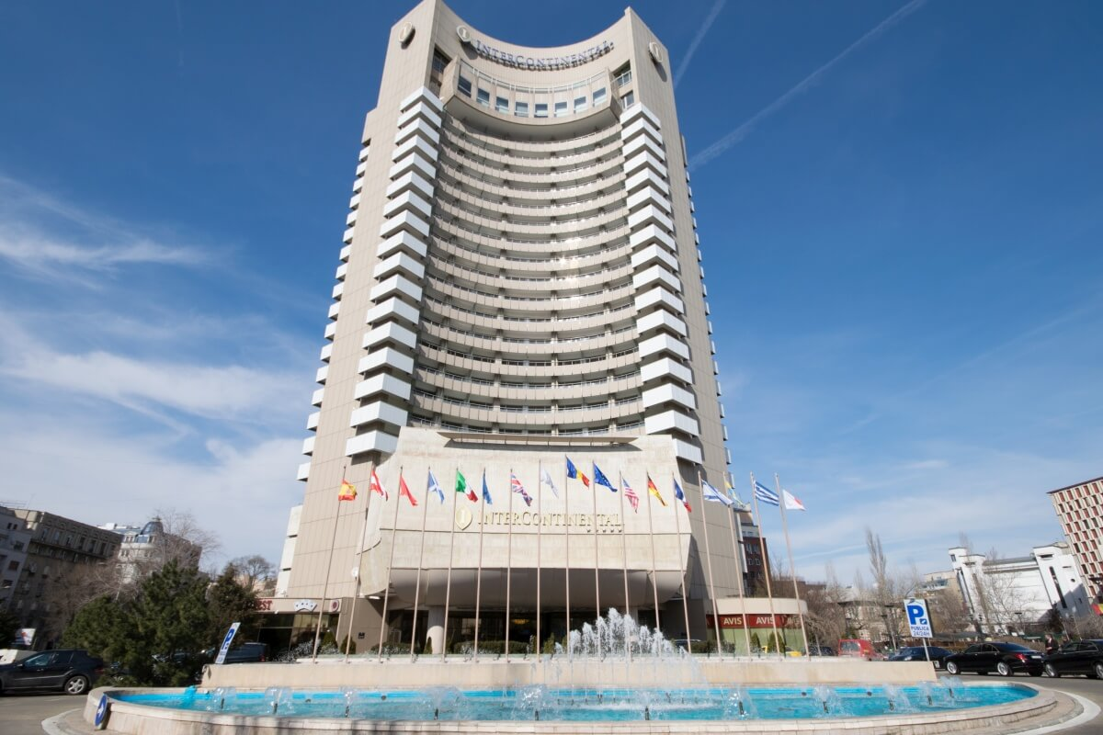https://www.seebucharest.ro/intercontinental-bucharest [accessed on: 29/01/2020]
DISCUSSION AND CRITICAL ANALYSIS
Focusing the attention on the quality of management in the Intercontinental Hotel in order to deliver the expected guest services, the main important thing to mention is that they are using lots of strategies that are helping them to attract customers easily comparing to other hotels, which are as well 5 stars hotel, being their competitors. One of the strategies that they are using is linked with the FIVE SERVICE QUALITY DIMENSIONS (Zeithaml and Bitner, 2000):
- Reliability: As they always do the thing, they promise to guests they will do. For example, if they are saying that in about one year a specific new service will be introduced then they are trying to make sure that the thing they promised will be introduced on time in order to show to guests trust and reliability
- Responsiveness: Thing that is showing how they are not answering to the guests questions/ requests with responses such as “let me finish what I am doing I will be with you immediately”, they rather help the guest first and then carry on what they were initially doing.
- Assurance: All the members of staff are treating the guests coming in the hotel with perseverance, showing confidence in everything they are saying, thing that matters so much for the guest’s first impression which most of the times build trust.
- Empathy: The way they are using the body language and the tone of voice when speaking to the guest has a massive impact over the guest’s behaviour within the members of staff.
- Tangibles: The way the people in charge of the academic look of the hotel has an impact over the way the guest reacts to the way the equipment is arranged in the hotel, especially when it comes to the physical facilities (gym, pool, spa) 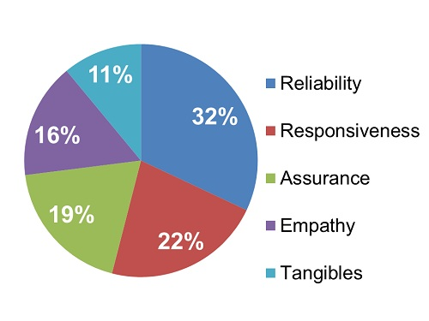 http://www.serviceperformance.com/the-5-service-dimensions-all-customers-care-about/ [accessed on: 28/01/2020]
The Intercontinental Hotel has 283 rooms, including 174 superior rooms, 40 luxury rooms, 20 junior suites, 48 clubs rooms and one imperial apartment, therefore, using this information, it is clearly that the rooms were designed in a way, which is accessible for any type of guests, for example business mans, families, couples, middle classes, working classes… Even for the international guests the rooms are well-designed and this because it makes them face the decision making within which they have to chose which room they want to go for, which is again fascinating for a guests as there are some hotels in which you have limited rooms/ services to chose from. When it comes to the services provided by the intercontinental hotel, there are plenty of services where the guests can choose from. Services such as: Indoor pool, high-speed WIFI access, Fitness Suite, Cocktail Room, Dry Cleaning/ Laundry, Sauna, 24h ROOM SERVICE, All inclusive offers, office airline ticket agency, are just some of the service provided to the guests in the hotel. However, next to that there are some specific service for business guests coming in the hotel such as: print/copy services, FAX services, executive floors, email access/ internet, PC Services, Business Centre… All the mentioned service, overall are showing how developed the hotel itself is, thing outling the implication of the good quality of the managerial team which is in charge of all changes that are taking place in the hotel with the aim of making each guest happy and motivating it to leave the hotel with a good impression which will make them recommend the hotel to some other people as well.
Another important thing that all members of staff must be aware of is the DISNEY S.E.R.V.I.C.E. MODEL which will highly support them to use the key things in order to build a good relation with the guest during their stay of the hotel, the SERVICE from the Disney SERVICE Model is the abbreviation of Smile, Eye Contact, Respect, Value the Magic, Initiate Guest Contact and End with a THANK YOU. All these things are playing an important role in the members of staff behaviour within all the guests. The way the members of staff tend to use the aspects from the Disney SERVICE model is very important at it helps at managing to maintain a good relation within all the guests which are in charge of their financial state, or their services/ products delivered…
When it comes to the adaptability of the hotel service/ products considering the guests aspirations, the members of staff from the intercontinental hotel, tend to do questionnaires frequently with the aim of testing what the guests are expecting to see changed in the hotel and what products they would want to see provided at the hotel in order for them to be more satisfied with what they are getting at the hotel. Therefore, the managerial teams of the hotel, are working hard when comparing the guest’s responses as they want to take the best decisions which is bringing advantages to everyone. However, when the people in charge of the hotel are taking decisions about changing such products, they must check how the competitors are delivering that specific product and then they are trying to adapt the product to another style which will attract the customers. Guests even more. For example, if there is a wrapped product and one of the competitors will keep it wrapped as it is in a simple foil, the members of staff from the intercontinental hotel will try to adapt that product to another package which will make the guest wish to have the product.
SWOT Analysis
Hospitality (Hotel) Industry SWOT Analysis One of the main reasons in preforming a SWOT analysis on or in any industry is to help form a well-built and secure business approach. SWOT’s main aim is to assess the business strengths, weaknesses, opportunities and threats in order to see what needs adjustments (Phal and Richter 2007)
A well-built approach depends on knowing the strength and weaknesses of the industry and find a way to turn those weaknesses into strengths.
The capital needs in the industry are going to be on the high end. With the everyday wear and tear of certain items there is always a constant need of incoming capital. The industry also faces a “unique tax structure in most communities. Many rooms have a specific tax that is charged per night when they are booked. They may also face higher levels of sales tax and other fees that other industries don’t face for their goods and services” (Gaille, 2014, para. 6).
THE INTERCONTINENTAL HOTEL BUCHAREST (SWOT)
Strengths:
* Standard services and brand notoriety
* Best Central Booking system
* Occasion wide brand portfolio
* Customer experience & relationship focus
* Very good location in the centre of the city

Weaknesses:
* Not an intimate hotel
* Far away from the Airport
* Old furniture
* slipped to 3rd position as a worldwide brand

Opportunities:
*Situated in City Centre
*Join The EU
*Organizing conferences, symposia at national and international level

Threats:
*The Bushy legal framework
*Decreasing the purchasing power of the population
*Strong competition
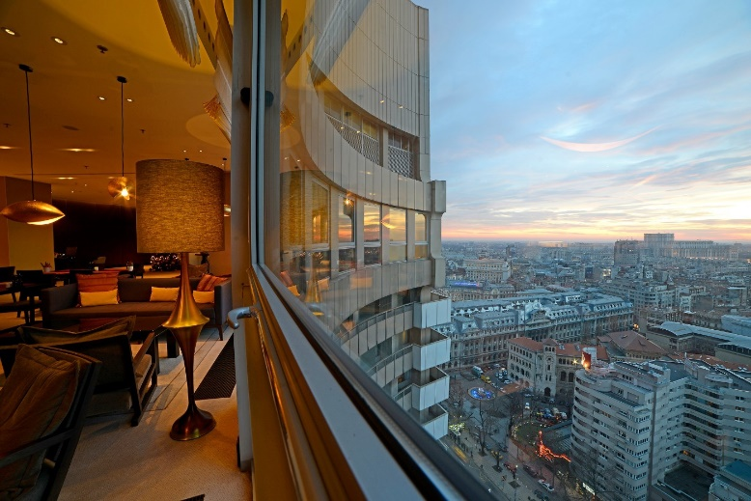 https://www.linkedin.com/company/intercontinental-bucharest

#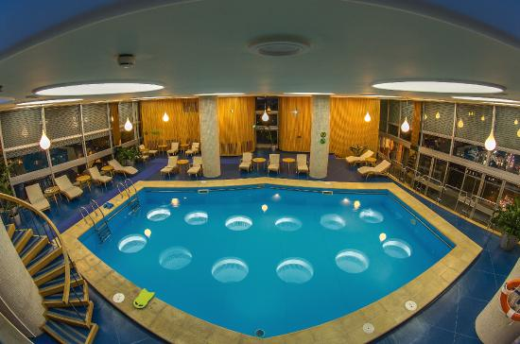 https://www.tripadvisor.co.hu/Hotel_Review-g294458-d304878-Reviews-InterContinental_Bucharest-Bucharest.html

Intercontinental' s marketing Microenvironment
The microenvironment comprises those forces and factors, with which the unit enters direct relations, which depends on the success of its activity. They are:
Providers
The company's suppliers are of two types:
1. Commodity suppliers – are individual companies or individuals, which provide resources (raw materials, materials, machinery, machinery, installations, etc.) necessary for the production of goods and services.
2. Labour providers – are institutions and agents (educational establishments, labour offices, etc.), which prepare and make available the workforce, as well as non-framed persons who are in search of work.
Buyers
It constitutes the main element of the enterprise's micro-environment. There are five types of market buyers that an enterprise can operate on:
1. Consumer market, which relates to the purchase of goods and services for personal or household consumption;
2. Industrial market. Consisting of economic agents buying goods and services to produce new goods and services;
3. Distribution market, consisting of economic agents buying goods and services for sale, obtaining profit;
4. The governmental market, consisting of institutions or agencies, which buys goods and services in order to provide public service or to transfer them to other needy sectors;
5. The international market refers to external buyers, including consumers, producers, intermediaries and external public institutions.
- Competitors: in that area and in all Capital City of Bucharest there’s some 4- and 5-stars hotels that they provide for guests almost the same service like The Intercontinental Hotel.
-Public bodies and institutions
According to Kotler, public bodies and institutions present the following categories:
• The financial public (banks, investment firms, etc.), which offers the possibility to obtain funds;
• Media (mass media), which include newspapers and magazines, radio broadcasting and television;
• Interest groups (Movement for consumer protection, environmentalists, movement, etc.);
• The company's own staff, etc. That is why each undertaking seeks to provide goods and services and thus carry out promotional activities that provide a favourable image among buyers.
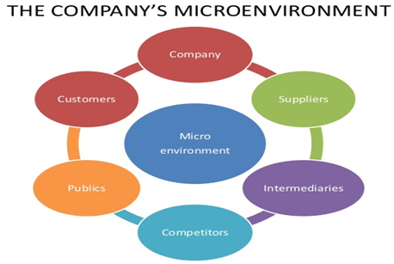 https://www.locusassignments.com/solution/marketing-principles-assignment-help
Intercontinental' s marketing Macroenvironment
The enterprise, alongside all the factors of its macroenvironment, acts in a large macroenvironment of forces that create favorable conditions or brake the activity of the unit. We distinguish the following components of the macroenvironment:
• Demographical Environment
The first force to be pursued is the population, because humans are the ones that form the markets.
• The economic environment in a purchasing power economy depends on current incomes, prices, savings size, debts and lending possibilities in the age of departure.
• Technological environment
• Public environment
• Cultural environment
• Institutional environment
• Natural environment.

Conclusion:
The hotel’s quality of management works hand in hand with the quality of the services that they deliver. However, the hotel, shows and proves every day that it deserves the position it has and the reputation it has as well and this because of the great services/ facilities/ products they offer to everyone coming in the hotel.

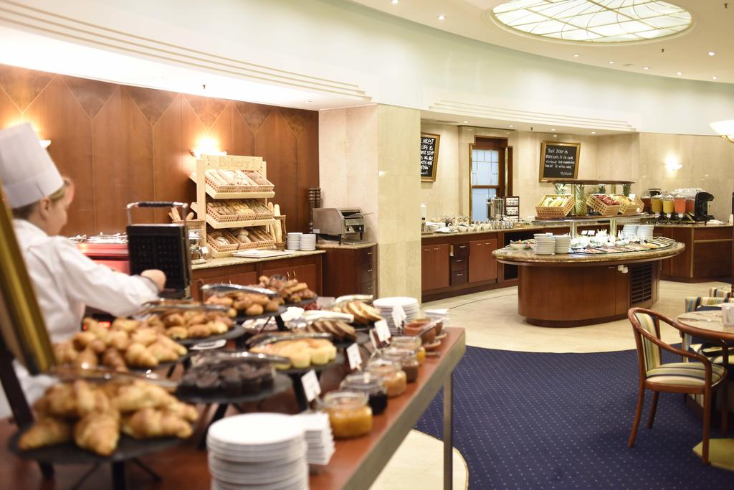

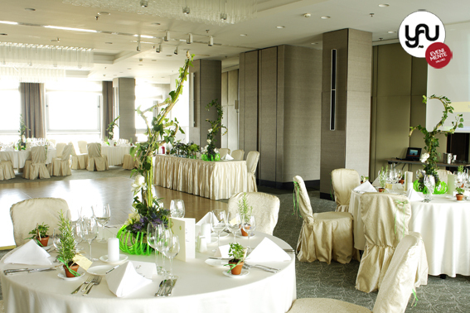

References:

- History of The Intercontinental Hotel in Bucharest (2018) Found on: https://ro.wikipedia.org/wiki/Hotelul_Intercontinental_din_Bucure%C8%99ti [accessed on 26/01/2020]

- Hotel Intercontinental Bucharest (2000) Found on: https://www.emporis.com/buildings/111628/hotel-intercontinental-bucharest-bucharest-romania [accessed on 26/01/2020]

- InterContinental Hotels Group PLC. (2019) Found on: https://www.ihgplc.com/en/about-us/our-global-presence [accessed on: 27/01/2020]

- Kotler, P., Bowen, J. and Makens, J. (2003), Marketing for hospitality and tourism, (3rd ed), Prentice-Hall, Upper Saddle River, NJ Found on: https://www.researchgate.net/publication/43800550_Managing_Service_Quality_in_Hospitality_Industry_through_Managing_the_'Moment_of_Truth'_A_Theoretical_Approach/link/544217ba0cf2a6a049a5cd0e/download [accessed on: 29/01/2020]

Osborne, Charlie (2017) “InterContinental data breach” Found on: https://www.zdnet.com/article/intercontinental-data-breach-expands-to-thousands-of-hotels/ [accessed on: 30/01/2020]
- Phal, N. and Richter, A. (2007). “SWOT analysis”. 1st ed. [München]: GRIN Verlag, p.9 Found on: https://www.scirp.org/(S(351jmbntvnsjt1aadkposzje))/reference/ReferencesPapers.aspx?ReferenceID=1592997 [accessed on: 28/01/2020]

- The Imperial Apartment (2010) Found on: https://www.ihg.com/intercontinental/hotels/us/en/bucharest/buhha/hoteldetail?cm_mmc=GoogleMaps-_-IC-_-RO-_-BUHHA [accessed on: 27/01/2020]

- Zeithaml, V. and Bitner, J. (2000), “Services marketing: Integrating customer focus across the firm”, (2nd ed), McGraw-Hill, Boston. Found on: https://www.researchgate.net/publication/43800550_Managing_Service_Quality_in_Hospitality_Industry_through_Managing_the_'Moment_of_Truth'_A_Theoretical_Approach/link/544217ba0cf2a6a049a5cd0e/download [accessed on: 29/01/2020]

