University of Wales Trinity Saint David

Student: Morea Kastrati
Student ID number: 2000288
Module: Identity and Approaches to Applied Business Research
Module code: BMDM7001
Assignment title: Portfolio

Date: 24.04.2020
Content

- Introduction
- Positionality and individuality
- Reading and evaluating literature and information sources
- The contribution of research to knowledge and organisational development
- Defining the research question
- Philosophical frameworks for research
- Research ethics and integrity

Appendix

- List of useful academic sources of information
- List of useful websites, including links to codes of practice, advice.
- Any useful quotations, frameworks, tables.
- Any personal self-development activities that have been undertaken.

Introduction

This portfolio will show a critical narrative review of the key issues relating to the seven topics mentioned below. This portfolio will demonstrate the knowledge enhanced throughout the course and how can this knowledge be used in practise and reliable examples will be given to show that. The reader can learn more of how an individual can critically evaluate the role of theory in shaping and interpreting researches; evaluate the approaches to the validity, reliability and bias in social research; examine the ethical considerations in social research and moreover critique the communications.
The seven topics that will be discussed here are:

- Positionality and individuality
Reflecting on my positionality, I can say I am positioned in various contexts. I am a white ethnicity, middle class individual from a small hardly known country who is studying PhD at UWTSD. However, I am fully aware that I am not defined by these features. I have also a life experience, work experience, my own believes and thoughts which play a huge factor on my life. I have learned to conceptualise positionality from the work of others as the rational place or value that individuals have that influences others or is influenced by others in varies contexts such as economic, political, social, educational (Maher & Tetreault 1994; Hooks 1984; Calabrese Barton 1998). Subjectivity plays a huge role when it comes to positionality. Subjectivity shows and talks about real experiences of the researcher, and how this influences others and the contribution this makes to bias.
Positionality can have a huge impact in people relationships but not necessarily is limited to relationship between peoples.
Individuality is valued and known for what makes an individual different from one another and is valued as a human characteristic. Humanistic theorists also regard the individual’s creation or discovery of a unique self as one of the core values (Maslow, 1954/1987; Rogers, 1961). On the other hand, Allport (1962) are more interested to know what is unique as in what is general. They believe that these four factors self-actualisation; internal control; achieved identity and principle moral reasoning (Waterman, 1981, 1984) are the combination of it. Individuality is an assumption that defines a person as a distinct from one another from what it on the inside and in some aspect what’s on the outside (Allport, 1962). Sanford (1956), also equates individuality with a focus on one’s own depth rather than surface. Individuality it’s important to be who you are.

- Reading and evaluating literature and information sources

Looking for data is frequently nonlinear and iterative, requiring the assessment of a range of sources and the mental adaptability to seek after interchange avenues as new modern understanding creates. (Affiliation of College & Investigate Libraries, 2016)
Nowadays living on the era of enhanced technology we can get any information we require in seconds however, evaluating it to find the accurate sources we need can be more complex than just googling it. Before deciding on whether or not to incorporate the information you have found, this information needs to be evaluated in order to know if this information is relevant and valuable. To find if the information retrieved is valuable we need to know the a) accuracy , if the information is reliable; if information is error-free; b) authority, who is the author; does the author has the right qualifications to write this topic; c) objectivity, what is the intended purpose of the information; is the information facts or opinion; is this information biased; d) currency, when was the information published; it is out-dated and current and e) coverage, does the information cover the information need; does it provide basic or in depth coverage.
In my work experience, when leaving the EU, I had to work out and develop different scenarios to present to the director and had to go through different journals, articles, government data which were all Europeans and UK based. I had to carefully evaluate each one of them, as I had to find the proper way to introduce new business strategies as most of our Europeans partners preferred to close the UK branches and go online only, so my duty was to analyse the papers and find alternatives to ease the situation and make a plan which benefited both the business and our partners. Considering that there were lots of unsourced, biased and unauthorised articles regarding this, it was quite complex to get the right data as government ones were not fully available at the time. My focus was mostly on relevance of the article, the author and the reviews of the particular article to help me gather the right information sources.

- The contribution of research to knowledge and organisational development
Contribution to knowledge means creating new knowledge supported the previously available knowledge by doing extensive and innovative research (Matt Might, 2012). The gap between the knowledge of what works, and therefore the widespread adoption of these practices has become a serious preoccupation of researchers and a challenge for funders and policy makers (Robertson and Woodside, et al, 2003). it's vital on build up and creating unicity and turning out with different ideas to stay the business growing and developing during this era. maintaining with the market, has become quite hectic considering that each day the market is introducing different products and services.
Knowledge organisations perform knowledge processes, by means of their primary resources of intellectual capital, and their main input of knowledge. Their effectiveness in performing these processes depends on their knowledge capabilities (Dawson R, 2000). the event of organisational knowledge capabilities are addressed most completely by considering the four fields of individual technology, organisational technology, individual skills and behaviours, and organisational skills and behaviours (Dawson R, 2000).
Leadership and management play an importance on organisational development. Some ways to contribute to the body of data are solving trending issues, which might contribute to new knowledge which might create a bonus for the researcher. this may be done through asking the proper questions and doing a radical data analysis (Chidi Rafael,2008). Although, it's difficult, it's very possible that one can actually make a meaningful contribution to knowledge by employing a unique approach to solving an identified problem. New models, conceptual frameworks/concept and hypotheses that are valid and result oriented will definitely raise existing knowledge on the subject matter (Chidi Rafael,2008).

- Defining the research question

Research question which is well defined and precise, keeps your topic research focused and the results actionable. Research question is the topic which the writer would like to address, investigate or study whether its experimental or descriptively. Research question is usually a topic which you have some knowledge on, or a personal experience which interest the researcher and its usually a starting point. Committing to a long research, needs lots of focus and time, and this is why it’s important to find a topic which the writer likes, and it is sure that will motivate him to work on it till the end. When I was starting my dissertation, I changed few topics till I managed to find one that was of my interest. I choose to do a topic which I have easy access to, I have access to people in this sector and business and a topic that was something related to my future career. The chosen topic kept me focused and motivated throughout the year to work on it. A research questions its important as it’s a way to express you interest or a problem or a phenomenon. Writing a research question, it’s important to be specific, clear, refer to a problem, reflect on the intervention in experimental research and note the target group of the participants. Building the research on and relating it to existing knowledge it is known as the building block of all academic’s research activities. Literature review is very important and more relevant than ever as a research method. Literature reviews can be defined as a systematic way of collecting and synthesizing previous research (Baumeister & Leary, 1997; Tranfield, Denyer, & Smart 2003). An applicable and well-conducted review as a research method constructs a firm foundation for enhancing information and facilitating theory development (Webster & Watson, 2002).

- Philosophical framework for research
Working on a probe, it's vital doing a deep philosophical framework so as to be informative and to be read because it can. Using philosophical framework within the research it known to be a critical issue. This framework is sometimes accustomed show a transparent aim of the research and, each step should be appropriate when discussing it with the language of contemporary research philosophies. Research philosophy may be defined because the development of the research background, research knowledge and its nature (Saunders and Thornhill, 2007). Research philosophy is additionally defined with the assistance of research paradigm. within the words of Cohen, Manion and Morrison (2000), research paradigm may be defined because the broad framework, which comprises perception, beliefs and understanding of several theories and practices that are accustomed conduct a probe.

- Types of research and research design
A research is valid when a conclusion is accurate or true and research design is that the conceptual blueprint within which research is conducted. Research proposal can be considered as the structure of research it's the “Glue” that holds all of the weather in a very research together. in step with Jahoda, Deutch and Cook” “A research design is that the arrangement of conditions for the gathering and analysis of information in a very manner that aims to mix relevance to the research purpose with economy and procedure”. Research design, it's a method, structure and an idea on obtain ensured to look question and control variance. Herbert Simon (1969), was the one who created the basics for a science of design which might be a association of intellectually tough, analytic, empirical and teachable doctrine about the look process. Research design has different phases which elaborates the research which are, specifying the problem; framing the research design; planning a sample; collecting data; analysing the information and; preparing the report. Research design plays an enormous role when doing research, because it makes possible the graceful sailing of assorted research procedures, thereby creating a search in a very professional way with a minimum expenditure of effort, time and money but within the other side yielding maximum information (Claire Selltiz et al., 1962).
There are differing types of research design methodologies. These methods are; qualitative research; quantitative research; research by practitioners; surveys; correlational; experimental.

- Research ethics and integrity

Research ethics is an important aspect in research (David and Resnik, 2011). When discussing the ethics, people instinctively think of ethics as rules for distinguishing between the right and wrong (Resnik, 2015), such as Hippocratic oath code of professional conduct. Ethics and norms for conduct distinguishes between acceptable and unacceptable behaviour. Ethics is part of our life since we come to this life. We learn norms and ethics at home, at school, in our everyday social life. Knowing the bad from good is something we develop from our childhood, but moral developments usually grow as we mature. Ethics is really important when doing our research work apart from our everyday life. Ethics helps on creating boundaries between the researched and the participants or the information used on the research. In general, analysing non-adherence to ethical norms is difficult, and in some cases, drawing a clear line between misconduct and misunderstanding is very difficult.
When working on my research, I was depended on interviews of the directors and employees of small businesses as there was not enough papers or information on the topic I choose. For me, it was important to be clear with my questions and to present the right information and ask the right question to the participants and make sure to make them feel comfortable and not breach any confidential information without their permission and, make sure to show in paper only the information I was told and given permission to present.
Researchers tend to believe that we are highly ethical and know the difference between the good and bad. We would prevent to use fabricated or false information and data and believe that others will do so as well and there is no ethics problem within the research. But looking at data e.g. University of Arizona -Federally mandated compliance educated program shows that in the last 200 years there have been 200 cases of misconduct which not necessarily states that there are supported papers claiming that is common in the research as numbers are very low, but also it says that this can happen. Evidently, it would be useful to have further data on this topic, but so far there is no indication that science has become ethically corrupt. However, even if misconduct is rare issue in the ethics, it can still have tremendous impact on the research. This is why is very important to follow the guidelines on honesty, confidentiality, anonymity and objectivity (Resnik, 2015).
Integrity characterizes both individual researchers and the institutions in which they work. For individuals, it is a characteristic of moral character and experience (Board on Health Sciences Policy and Division of Earth and Life Studies, 2002). For institutions, it is a matter of generating an environment that endorses responsible conduct by embracing standards of excellence, trustworthiness, and lawfulness that inform institutional practices whereas, For the individual researchers, integrity exemplifies above all a commitment to intellectual honesty and personal responsibility for one's activities and to a variety of practices that characterize responsible research conduct (Board on Health Sciences Policy and Division of Earth and Life Studies, 2002). These practises include; intellectual honesty in proposing and reporting a research; fairness in peer review; transparency; protection of human subjects in the conduct of the research; collegiality in scientific interactions and human care of animals in the conduct of research.

Appendix 1: List of useful academic sources of information and Appendix 2: List of useful websites.

- (PDF) Research Design. Available from: https://www.researchgate.net/publication/308915548_Research_Design [accessed Apr 24 2020].
- Akhtar, I., 2016. Research Design. [online] https://www.researchgate.net/. Available at: <https://www.researchgate.net/publication/308915548_Research_Design? [Accessed 24 April 2020].
- Bebeau MJ, Rest JR, Narvez DF. 1999. Beyond the promise: A perspective for research in moral education. Educational Researcher 28(4):18–26.
- Blasi A. 1985. The moral personality: Reflections for social science and education. In: Berkowitz MW, editor; , Oser F, editor. , eds. Moral Education: Theory and Application . Hillsdale, NJ: L. Erlbaum Associates.
- Bourke, B. (2014). Positionality: Reflecting on the Research Process. The Qualitative Report, 19(33), 1-9. Retrieved from http://nsuworks.nova.edu/tqr/vol19/iss33/3
- Cameron, R. “Mixed Methods Research: The Five Ps Framework” The Electronic Journal of Business Research Methods Volume 9 Issue 2 2011 (pp 96-108), available online at www.ejbrm.com
- Claire Selltiz and others, (1962), Research Methods in Social Sciences, New York: Holt, Rinehart and Winston: Published for the Society for the Psychological Study of Social Issues, p. 70, Also See: Gupta Mukul and Gupta Deepa, (2011), Research Methodology, New Delhi: PHI Learning Private Limited, p. 32
- Clift, B, Hatchard J, Gore J, Jordan A (2018) How do we belong? Researcher positionality within qualitative inquiry. Faculty of Humanities and Social Sciences, University of Bath School of Management, University of Bath
- Cunliffe Ann. L (2004) Journal of management education on becoming a critically reflexive practitioner. Organisational Behaviour teaching society. Sage publications.
- Dawson, R. (2000), "Knowledge capabilities as the focus of organisational development and strategy", Journal of Knowledge Management, Vol. 4 No. 4, pp. 320-327.
- Dollinger Stephen J. and Dollinger M. Clancy (1997) Individuality and identity exploration: An Autoghraphic study. Southern Illinois University Journal of Research In Personality 31,337 –354 (1997)article no.RP972182
- Dollinger, S. and Dollinger, S., 2002. Individuality And Identity Exploration: An Autophotographic Study. [online] https://www.sciencedirect.com/. Available at: <https://www.sciencedirect.com/science/ [Accessed 24 April 2020].
- Eisenhardt KM. Building theories from case study research. Acad Manage Rev 1989;14:532–50
- Enago Academy. 2020. Importance Of Research Ethics - Enago Academy. [online] Available at: <https://www.enago.com/academy/importance-of-research-ethics [Accessed 24 April 2020].
- Environments, N., 2020. Integrity In Research. [online] Ncbi.nlm.nih.gov. Available at: <https://www.ncbi.nlm.nih.gov/books/NBK208714 [Accessed 24 April 2020].
- Lavis JN, Robertson D, Woodside JM, et al How can research organizations more effectively transfer research knowledge to decision makers? Milbank Q 2003;81:221–48, 171–2
- Leanne, M., 2020. Positionality Statements. [online] Youtube.com. Available at: <https://www.youtube.com/watch?v= [Accessed 24 April 2020].
- Louis, K. and Barton, A., 2020. Tales From The Science Education Crypt: A Critical Reflection Of Positionality, Subjectivity, And Reflexivity In Research. [online] Qualitative-research.net. Available at: <http://www.qualitative-research.net/index.php/fqs/article/view/832/1808 [Accessed 24 April 2020].
- National Institute of Environmental Health Sciences. 2020. What Is Ethics In Research & Why Is It Important?. [online] Available at: <https://www.niehs.nih.gov/research/resources/bioethics/whatis/index.cfm [Accessed 24 April 2020].
- Ori.hhs.gov. 2020. Chapter 1 - Research Integrity. [online] Available at: <https://ori.hhs.gov/education/products/ucla/chapter1/page02.htm [Accessed 24 April 2020].
- Researchbasics.education.uconn.edu. 2020. Types Of Research | Educational Research Basics By Del Siegle. [online] Available at: <https://researchbasics.education.uconn.edu/types-of-research [Accessed 24 April 2020].
- Resnik, D., 2007. What Is Ethics In Research & Why Is It Important. [online] https://www.researchgate.net/. Available at: <https://www.researchgate.net/publication/ [Accessed 24 April 2020].
- SAGE Journals. 2020. Building A Conceptual Framework: Philosophy, Definitions, And Procedure - Yosef Jabareen, 2009. [online] Available at: <https://journals.sagepub.com/doi/full/ [Accessed 24 April 2020].
- Sharma Vimlesh, (2003), Residual Sighted Children, New Delhi: Discovery Publishing House
- Snyder, H., 2019. Literature Review As A Research Methodology: An Overview And Guidelines. [online] https://www.sciencedirect.com/. Available at: <https://www.sciencedirect.com/science/article/pii/ [Accessed 24 April 2020].
- Spencer L, Ritchie J, Lewis J and Dillon L (2003) Quality in quantitative evaluation: A framework for assessing research evidence. The report was produced on behalf of the Cabinet Office (www. Natcen.ac.uk). Government Chief Social Researcher’s Office.
- Sponholz, G., 2000. Teaching Scientific Integrity And Research Ethics. [online] https://www.sciencedirect.com/. Available at: <https://www.sciencedirect.com/science/article/pii/S037907380000267X> [Accessed 24 April 2020].

Appendix 3: Useful quotations, frameworks and tables
“Research is a process, not just a product” (England, 1994, p. 82)
“There’s no enunciation without positionality. You have to position yourself somewhere in order to say anything at all” (Hall, 1990, p. 18)
“Within positionality theory, it is acknowledged that people have multiple overlapping identities. Thus, people make meaning from various aspects of their identity . . .” (Kezar, 2002, p. 96).
"If a man does not keep pace with his companions, perhaps it is because he hears a different drummer. Let him step to the music he hears, however measured or far away." This quote is from the book Walden by Henry David Thoreau. (TedxHisd Marina Finley 2010).
Every individual is in certain respects like all other persons, like some other persons,and like no other person McAdams (1993), paraphrasing Kluckholn and Murray(1953)
 | Questions to ask:
Accuracy | - Is the information reliable?  - Is the information error-free?  - Is the information based on proven facts?  - Can the information be verified against other reliable sources?
Authority | - Who is the author?  - Does he or she have the qualifications to speak/write on that topic?  - Is the author affiliated with a reputable university or organization in this subject field?
Objectivity | - What is the intended purpose of the information?  - Is the information facts or opinions?  - Is the information biased?
Currency | - When was the information published?  - Is the information current or out-dated?  - Does currency matter in this topic?
Coverage | - Does the information covered meet your information needs?  - Does it provide basic or in-depth coverage?
This table shows the evaluation criteria that’s shows Accuracy, authority, objectivity, currency and coverage are the five basic criteria for evaluating information from any sources.
- 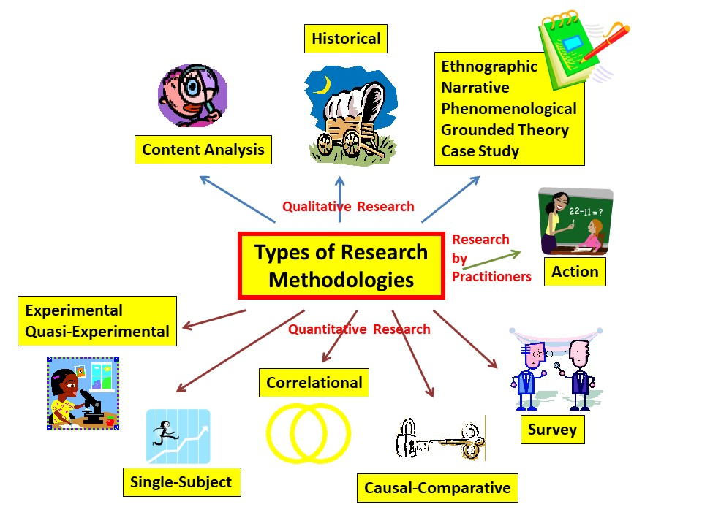

This figure shows the methods that can be used for research methodologies. These methods are necessary to create an appropriate research which includes the right data and elements for a proper research.

Do’s | Don’ts
Maintaining a good record of all your research activities and report your data as carefully and objectively as possible. | Fabrication, manipulation or misrepresentation of data.
Disclose financial or personal interests that may directly/indirectly affect your work. | Deceiving research sponsors, colleagues, or ethical committees by having bias in data interpretation, peer review, or personnel decisions.
Treat animals with care and respect when studying them in your research and adhere to ethical guidelines. | Use any external research data (published or unpublished) without permission.
Respect intellectual property, privacy, and confidentiality and give proper credit for any contributions from other researchers. | Support irresponsible publication practices. Your main goal should be to advance science and share your knowledge within the community.

Above, is a table which shows what to do and not to do when creating a research design. This is very important when creating a clear idea what the researcher wants to present.
Appendix 4: Any personal self-development activities that have been undertaken
Through this course I have learnt a very important key on how to create and develop a more in-depth research. Most of these activities have helped me on improving my key skills on positionality that I take on the society and not only, which has integrated on me a value of knowing where I stand and how my characteristics do not always define me and this can be changed and develop for better though gaining new experiences. When it comes to evaluate literature only in the past few years, I have learnt how important is to have and accurate information and how this can make a big difference when analysing I'm presenting data and information for a research. defining a research question was something that I suffered through MBA because I found it quite hard on working how to narrow a question And I realised that is very important to create a question which will contribute to knowledge and will have an impact later in life. My MBA dissertation did not have a very narrow question because I lacked the knowledge of how to address a problem which I'm learning now. I am still working on gaining knowledge on philosophical framework for research which I find it quite difficult and not so straight forward.
Research ethics and integrity is also a topic which I took it quite lightly. Ethics was something that I didn't focus much on as I believed that as long as you know how to differentiate right from wrong that's all that you need to know. During this course, when analysing the ethics and integrity I realised how important yes to show morals and ethics to not only participants but also to the gathering the right data which has made an impact on how I'm going to work on my next research.
This course was quite challenging for me because, I learned information which I didn't know before and I strongly believe that has personally developed me more in terms of writing a better research.
I am still yet, to learn more through this course and create a better understandment on how to create I research which will have impact not only to the public but also in my future career.

