

Workplace Culture and its Impact on Organisational Efficiency

BA(Hons) Leadership and Management Skills for the workplace

Workplace Culture and its impact on organisational efficiency
BMSW5105_LON
Klaudia Wiktoria Kolodziejek
ID:1916661

Table of Contents
Table of Contents
Task 1 4
LO 1: Assessing the culture and context of an organisation 4
Introduction 4
Company Background: 4
LO2: evaluating the organization within its broader environment using appropriate environmental and organizational techniques 5
Business environmental analysis tools: 5
LO 3: Appraising the cultural and ethical behaviour present in one or more organisations. 11
Organisational culture and external performance 11
Organisational culture and performance 13
Conclusion and Recommendations 14
Task 2 14
Individual Reflective 14
References 17

Executive Summary
Organisational culture is a set of values, norms, and assumptions shared by team members in the same organisation. This paper provides the analysis of organisational culture, management practices, group dynamics, and motivation and performance within Tesco Plc. Tesco is the largest British retail corporation offering food and non-food products, including fresh foods, bakery products, drinks, home appliances, entertainment products, toys and games, households, baby products, clothing, garden products, health and beauty products, pets, electronics, etc. It looks at the company's external environment, the various factors influencing business operations, and the role of the organisational culture in overcoming the challenges. Also, it evaluates the market environment within the industry and how the business has sustained a competitive advantage in the sector. This paper also compares the organisational culture and the performance of the organisation in both financial and non-financial ways. More importantly, how the covid-19 pandemic contributed to changes in the organisational culture and how the organisations responded. Lastly, it inspects the ethical dilemma surrounding contemporary businesses.

Task 1

LO 1: Assessing the culture and context of an organisation

Introduction
Organisational culture is a set of values, norms, and assumptions shared by team members in the same company. It is a collection of characters or traits that make a company the way it is. The values of an organisation inform the employees of the importance of the company, which helps to increase organisational effectiveness. Organisational culture we developed through regular and authentic behaviours by the management and the employees. It entails how decisions are made and how business activities are carried out. Crucial factors of an organisation's culture include the environment, history, leaders, and management. A great culture illustrates positive traits that result in growth and improved performance, while a dysfunctional culture exhibits qualities that hinder a company's success (Wong, 2021). A functional organisational culture increases employee contribution and harmony on strategic issues providing aligned standpoints between the company and individual objectives. Therefore, a crucial comprehensive synchronization of values, mission, practices, and goals leads to increased effectiveness. For this reason, this paper purposes of providing the analysis of organisational culture, management practices, group dynamics, and motivation and performance within Tesco Plc.

Company Background:
Tesco is the largest British retail corporation focusing on groceries, general produce, and food. The company offers a wide range of food and non-food products, including fresh foods, bakery products, drinks, home appliances, entertainment products, toys and games, households, baby products, clothing, garden products, health and beauty products, pets, electronics, etc. Tesco also offers retail banking and insurance services through Tesco Bank in the United Kingdom (Tesco Company Profile. 2020). The company was founded by Jack Edward Cohen in 1919 and is headquartered in Welwyn Garden City, Hertfordshire, in the United Kingdom and has its presence in the UK, across Europe, and worldwide. The company has extended its operations to China, Hungary, and Republic of Ireland, the Czech Republic, Malaysia, Japan, Poland, Thailand, South Korea, Turkey, and Slovakia in the past decade. The multinational enterprise has employed over 700,000 employees to render its services in over 3,400 shops to millions of Tesco customers worldwide (About Us, 2021). The foods and drinks retail segment is the largest in the UK market, and this has offered the company an opportunity to develop and contend with other international retail businesses. Tesco targets middle and low-class customers by offering quality products at reasonable prices, giving it a 24% overall market share (Tesco Company Profile. 2020). The company's culture of "sell it cheap and pile it high" has driven it to expand, placing it at a competitive advantage.

LO2: evaluating the organization within its broader environment using appropriate environmental and organizational techniques

Business environmental analysis tools:
The environmental analysis seeks to find out information about occurrences and relationships within the business environment, the knowledge that facilitates the company's management plan for the organisation's future. Environmental analysis entails dividing the external environment into sectors so that different tools can be used to scan the segments. It means analysing the forces that directly or indirectly affect the business operations. The external environment comprises micro and macro environments (Buye, 2021). The microenvironment includes all the factors that directly affect the business, while the macro environment entails general factors that affect the entire industry and not just a particular company. Various tools are used to scan the business environment, including PASTEL, Potter's Five Model, and cultural Web. PASTEL analysis is a tool used to analyse the macro factors that affect the business, including political, economic, social, technological, environmental, and legal factors. The Potters Five Forces Model analyse the company's competitive environment, such as the number of competitors, suppliers, customers, potential entrants, and the close substitutes in the market. The cultural web is a device used to plan a company's future by mapping the existing culture.

Pastel analysis of Tesco Plc.:
Political factors: Political factors affect business activities due to the changes in government policies and procedures. These factors vary in their significance for both local and international enterprises. The political ground enacts substantial influence due to the government regulations and the country's stability. Tesco abides by the directives issued by European Union and other countries it operates in (Shaw, 2021). Brexit came as a challenge to the company, where its food supplies from Northern Ireland changed due to the shifts in the trading arrangements. This increased the cost of importation and caused delays in the sensitive food industry. Consequently, brexit affected Tesco's supply chain cost and the warehouse time leading to low-profit margins.
Economic factors: This factor constitutes the global economy variations that directly or indirectly affect business operations. An increase in the overall economic status and the living standards offer encouraging prospects for businesses to make profits (Robinson & Pearce, 2015). Economists support that affirmative variations in economic activities provide the customers with high purchasing power creating an outstanding chance for businesses to promote their sales resulting from the increased demand for the goods and services. For example, Tesco Plc. has business operations in different regions and countries with different nations. Therefore, the fluctuations in the exchange rates and inflation in different countries affect its operations. A decrease in the pound's value gains other currencies makes the value of imports increase, and the company's profits from the imports go down. On the other hand, the exports lose value, and the business gains little profit from the goods sold in other countries.
Social factors: Social factors entail the social structure fluctuations likely to influence consumer behaviour. These elements include age, gender, language, religion, lifestyle, and social class. International companies have the challenge of understanding the population of a foreign market. It is more beneficial if the company management is able to develop strategies that sustain the business in both local and foreign markets (Rahman, 2020). For example, Tesco has a history of selling quality products at low prices and uses this strategy to address the social structure. This approach targets the middle and the low-class communities who make up the larger percentage of the total population. The company understands that low living standards deny the consumers the purchasing power. The low price strategy empowers the consumers to make more purchases and harvests more revenues. Additionally, Tesco studies the characteristics of the consumers in the intended foreign market, including their tastes and preferences, religion, and beliefs, so it stocks goods that fit the needs of the community.
Technological factors: Technological changes have a substantial effect on business strategies. These modifications allow the business to adopt new inventions and innovations (Rahman, 2020). Businesses that embrace new technology lower their cost of operation thus, companies lookout for relevant technological factors to remain competitive in the industry. The adoption of modern technology by Tesco Plc. has helped it boost the information system and facilitated its database management. The company has used the internet to increase its market share through online selling and marketing. Tesco has moved a step further to save time for the online buyers as they can order anything from anywhere and have it delivered at low facilitation fees.
Legal factors: Legal elements refer to the government-imposed laws and regulations. Legal frameworks differ with countries because government policies significantly impact businesses via regulatory bodies (Rahman, 2020). Every country has established independent institutions that govern the operations of every business and confirm compliance with the law. Additionally, some countries have imposed constitutional changes that affect how businesses operate. For example, Tesco must comply with the government's rules and regulations in the countries where it operates. The UK law competition law bans anti-competitive activities. Thus, Tesco cannot just merge with or buy another supermarket of its size (Rahman, 2020). Also, the company cannot employ underage individuals or pay workers below the minimum wages set by the government.
Environmental factors: Most governments are pressuring companies to address the environmental issue following concerns for climate change. Besides, the public is also concerned with pollution, mainly by emissions and waste from different businesses. According to Rahman (2020), Tesco has bowed to this pressure and vowed to eliminate plastic packaging and replace them with biodegradable products. The company is also committed to minimizing its carbon footprints.
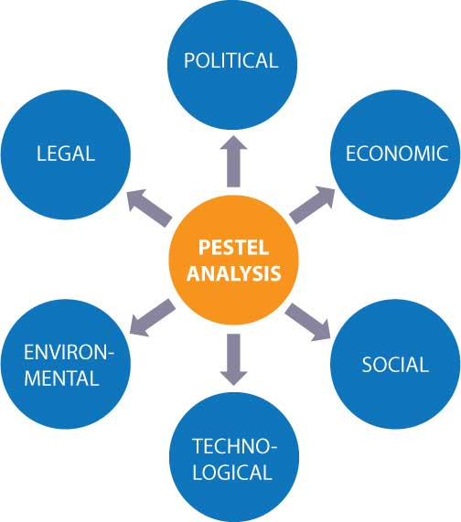
Figure showing PESTEL analysis

Tesco's industry analysis through Porter's Five Forces Model:
The Porter's five forces model is a structure that helps us understand the competitive environment and the retail industry. This analysis has helped Tesco Plc. build a sustainable competitive advantage in the retail industry. Managers at Tesco have used the Porter five forces to develop a strategic position within the retail industry and explore profitable opportunities in the entire consumer service sector.
Threats of competitors: The threat of new entrants in the market can force the existing companies to lower their prices and spend more on innovations in order to retain their customers. New entries bring new capabilities and pressure on costs (Rachapila and Jansirisak, 2013). Tesco has addressed the threat of new entrants by innovating new products that attract new customers and sustain existing ones. Also, the company builds economies of scale to lower the production cost in order to maintain the low pricing strategy. Also, the company builds more capacities and invests much in research and development so that new entrants cannot match its position and development level.
Bargaining power of buyers: Customers could be so powerful to force the company to lower the prices of its products, therefore, increasing their values. The buyer's bargaining power is larger when compared to the supply in the market, and the products are undifferentiated. Buyers demand a lot and want to buy the best offer available at the minimum cost (Rachapila and Jansirisak, 2013). Tesco has managed to build a large customer base to reduce the bargaining power of customers while creating a platform to streamline the company sales. Also, the company rapidly innovates new products to counter offers and discounts for the existing products to limit the bargaining power of customers.
Threat of substitute products/services: The industry profitability is affected when a new product meets the customer's needs in different ways. The threat of a substitute product is huge if it offers a unique value from the already existing products (Rachapila and Jansirisak, 2013). Tesco offers a large variety of products ranging from clothing to food, household, beauty products, electrical and electronic, furniture, etc., all with close substitutes. Besides, the company has managed to differentiate its products so that customers recognize them as high value and low priced. Besides, Tesco has invested so much in research development thus, it understands the core needs of the customers thus offers what the customers need, not just what they are buying.
Threat of competitors: Intense rivalry among the existing participants in the industry pushes the prices down and lowers the overall profitability of the entire industry (Dudovskiy, 2016). Tesco's retail sector is very competitive with giant competitors such as Morrisons, Asda, and Sainsbury's. However, the company has managed to maintain its profitability despite the stiff competition it faces. Tesco has built a strong differentiation strategy to create brands that stand out in the market. Moreover, the company collaborates with the competitor to increase the market size instead of competing for small markets. Although there are many players and competitors in the retail industry, Tesco has struggled to sustain its leadership position.
Bargaining power of suppliers: Powerful suppliers can use their bargaining power influence to hike the prices of their commodities or demand favourable terms from the competitors lowering the industry profitability. Supplies gain more power if they are few and /or high switching costs are involved (Dudovskiy, 2016). Tesco Plc. has built an efficient supply chain with hundreds of suppliers with minimum supplier switching costs in the supply chain. Also, the company has devised different materials that can be used as substitutes should the supplies increase the prices of their products, ensuring production and steady supply. Also, the company has maintained dedicated suppliers whose operations depend on the company to lower the bargaining power of the suppliers.
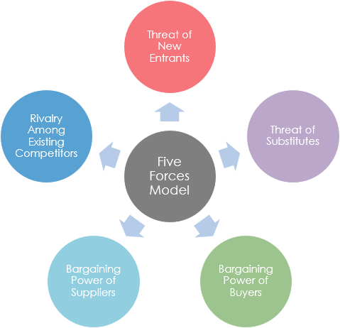
Figure showing Porter's Five Forces Model

Analysing the Organisational culture of Tesco through the Cultural WEB model
Organisational culture is a set of values, norms, and assumptions shared by team members in the same organisation. Organisational culture represents the personality of a company conforming to the values, beliefs, attitudes, visions used by the system. A coherent culture is a key to any organisation that wants to achieve a competitive advantage. The culture of Tesco PLC is mapped trough the cultural WEB. This is a tool used to plan an organisation's culture and brings out different elements that affect organisational culture. It consists of six factors:
Stories: This includes the past occasions and people referred to in the organisation. It is who and what the organisation chooses to immortalise that contributes so much to the organisational values and is professed as great behaviour (Tools hero, 2020). The company's history from when to be a market to stall and the milestones the business has taken to become the largest retailer globally set the culture of continuous growth in the organisation. The company managers envision far and must develop strategies that keep the company rolling higher and higher.
Rituals and routines: These are daily behaviours and people's actions that gesture acceptable behaviour. These aspects govern the expected behaviour and what the management considers appropriate (Tools hero, 2020). Tesco is committed to fulfilling employees' potential by the identification and nurturing of talents. The management spots talented individuals and supports them through training and development.
Symbols: These are the visual representations of a company, such as the logo, forma and informal dress codes, and the offices' luxury (Tools hero, 2020). The symbol of Tesco is doing little things that matter to customers and colleagues. This is a symbol of unity, service, and dedication, and it proliferates in Tesco-careets.com. Besides, the Tesco logo borrows greatly from the British flag where the red color symbolizes prosperity and happiness while blue represents excellence and trustworthiness.
Organisational structure: This entails the structure defined by the organisation chart and the unprinted lines of authority and influence that show the highly valued person's contribution (Tools hero, 2020). The structure of Tesco is divided into two. First is the board consisting of the chairman, two executive directors, and seven non-executive directors. The second is the executive committee comprising executive directors and senior executives from the countries in which the company operates.
The control system: This is how the organisation is controlled, including quality, finance reward, etc. (Tools hero, 2020). Tesco Plc. follows all the corporate governance codes in the countries where it operates.
Power structures: These dictate the people with the real power in the company and are mainly the key influencers in the decision-making process, strategic direction, and operations (Tools hero, 2020). At Tesco, the power structure is hierarchical, with the CEO being the authority figure.
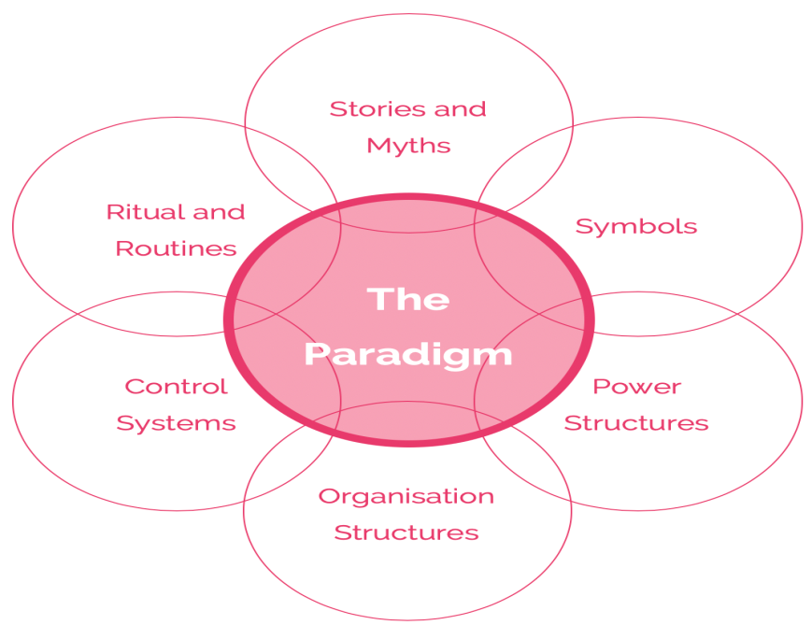
Figure showing cultural WEB model

LO 3: Appraising the cultural and ethical behaviour present in one or more organisations.

Organisational culture and external performance
External environments are factors that occur outside the organisation causes change inside the company however, the business has no control over them. They include covid-19 pandemic, technological, political, social, and economic factors. These factors influence current operations, growth, and long-term sustainability thus, they cannot be ignored. Therefore the company managers adjust the organisational structures so as to adapt to the changing outside world.
The Impact Covid-19 pandemic on Tesco organisational culture: The covid-19 pandemic struck in March 2020, crippling the world's economy in days. In response to the guiding principles issued by the World Health Organisation (WHO) containment measures, many rules were imposed that affected the operations of businesses. Tesco was not spared; the business observed major changes in a couple of months than it has done in a decade (ICAEW Insights, 2020). Due to the lockdowns and restricted movements, people resulted to online shopping and orders skewed towards the higher side. The company recruited 50,000 new temporary employees to support the delivery, distribution centres and shop floors (ICAEW Insights, 2020). This recruitment came as a response to the needs created by the covid-19 crisis and incurred a cost to the company, nevertheless, the cost was worth it.
At Tesco, employees at the office usually help their counterparts with shifts during the high-demand season usually the Christmas period. However, at the pandemic's peak, the management applied the same strategy to meet the surging demand. The social distancing rule made the office space not ideal for the workers, and the company had to devise measures to keep the work going on while adhering to the WHO guidelines. Therefore, the finance team shifted to working remotely, and collaborating with other teams worked seamlessly (ICAEW Insights, 2020). Consequently, the organizational changes associated with the pandemic helped the company to realize more sales and generate high profits.
Technological changes: Technology is observing major shifts, and so is Tesco. The technology keeps on advancing, challenging Tesco and its employees to keep up with the pace. Technology is a key factor in organisational behaviour as it has a huge contribution to the company's communication structure (Gold, 2017). Technology has totally changed the way of doing things, and Tesco must keep up with the new innovations in order to remain viable and relevant in the industry. Therefore, the company must adopt new methods of incorporating technology at every level of operation. For this reason, Tesco must invest more in research and increase the frequency of employee training to ensure they are up to date with the new technology to increase efficiency so that the company remains at the top position in terms of service delivery.
Economic factors: Tesco is affected by the fluctuations and exchange rates since it operates in different countries. These fluctuations sometimes increase the value of imports while that of export decreases (Robinson & Pearce, 2015). That means Tesco risks selling commodities at high prices in foreign markets in order to recover the expenses resulting from the fluctuations in the exchange rate. High prices place the company at the risk of losing customers to competitors. To stop this from happening, Tesco must change the suppliers to the ones with the most reasonable prices to make the final cost of the product or service affordable to the consumer.
Social factors: Tesco faces a challenge of understanding its new customers in a new market so as to offer goods and services that match their needs and purchasing power. The public perceives the company as the leading business with quality and low price products. Tesco must strive to maintain this in order to remain socially acceptable to the consumers. Also, increase customer relations to understand their needs and perception of quality (Shahzad et al ., 2012) Therefore, the management should increase the frequency of promotional activities to keep the customers encouraged to buy.
Political factors: Brexit came as a big challenge for Tesco. Britain's withdrawal from the EU increases the import rates for Tesco and other multinational companies( Harraf, 2019). The company resulted in changing some operations structures, including the suppliers, to comply with the new laws and still get raw materials at a reasonable price and enjoy the economies of scale.

Organisational culture and performance
The strong organizational culture is demonstrated by employee welfare, cohesiveness, commitment, and loyalty to the company. Thus culture is homely and provides a family-like working environment. This type of culture is characterised by growth, creativity, and variety seeking. Employees understand and respond to the culture, and goals are clear (Kaupa & Atiku, 2020). which means everybody understands their roles and executes them with the utmost honesty and integrity to increase the outcomes and productivity. Moreover, employees and customers exhibit consistency in behaviours, making it easy to predict and regulate.
Organisations exhibiting a strong culture have a strong medium of signalling employees and require minimal procedures and policies. Consequently, better deployment of the company resources and activities is effective and efficient. Thus a strong culture leads to high performance (Kaupa & Atiku, 2020). On the other hand, a weak culture has a negligible alignment to company values and employee behaviour, which is inconsistent with the organisational objectives. There is a need for procedures and bureaucracy in such organizations for easier control and effectiveness. Organisations with this type of culture take long to influence the culture change and thus, quick fixes cannot be implemented to increase the outcome. Therefore, organisational performance is slow and low.
Tesco uses a power culture characterised by a top-down structure where fewer individuals influence the decision-making process (Kapur, 2020). This culture is associated with an autocratic leadership style. This management style is perfect for a multinational company that operates differently because it speeds up the decision-making process. For example, the company has succeeded in opening new branches and operating a chain of retail shops while maintaining a large customer base and high profits.
Another example is that Tesco has managed to replace the old hierarchical way of decision making. The method has been replaced with the creation of teams. Teams encourage the flow of communication and include many people in the decision-making process (Kapur, 2020). That means employees can give their suggestions, which are later included in the organisation's culture and policies. Consequently, they own the company's processes, values, missions, and goals and work towards achieving them. Consequently, there is increased profitability, increasing its competitive advantage.

Ethical dilemma
An ethical dilemma is a puzzle that may come up when there are two or more options but is morally appropriate. Ethical dilemmas in contemporary businesses include data privacy, discrimination, and oppression of employees, sexual harassment, white-collar crimes, and romantic involvements. Whistleblowing, etc. The big question is, "is Tesco, an ethical company?" Tesco has been a target for many campaigns due to its business approach. According to Ethical consumer (2021), the company received the worst eating over its use of poisonous chemicals in electronic products. The company has vowed to have achieved zero discharge by 2020in agriculture and leather but failed to include electronics. Nevertheless, Tesco scored the best rating in 2019 for its supply management due to its approach to human rights and supplier code of conduct (Ethical consumer, 2021). As fate would have it, one of the suppliers was busted using slave labour, exposing modern slavery in the UK. However, the company said they did not know that their supplies were exploiting their workers.

Conclusion and Recommendations
Organisational culture is a set of values, norms, and assumptions shared by the team members working within the same company. Organisational culture is the company's mirror as it explains why the company is the way it is. Successful companies invest in building a strong culture that incorporates everyone to make them feel like part of the organisation. Functional and strong cultures result in strong performance, while dysfunctional cultures deter the organisation from achieving its objectives. Tesco Plc. has a functional organisational culture that incorporates group dynamics into the management practices to keep employees motivated and increase productivity and performance. Although the company has achieved a stable and strong organisational culture, it must put extra effort into innovation. This can be achieved through continuous appraisal of employees' talents and suggestions to develop new ways of conducting business operations to sustain its productivity and maintain the lead in the retail industry.

Task 2

Individual Reflective
This model has been carefully planned and formulated to equip the learners with the knowledge and skills employers are looking for in different organizations. Each company has its own goals and objectives, and employees' contribution is paramount to achieving the desired outcome. Most organisation's success results from their culture (Warric 2021). I look forward to becoming an executive manager in a multinational company leading many teams and influencing them towards change that increases performance. Therefore, this module has provided relevant information on the organisational culture and its relation to performance.
The knowledge that organisational culture is a set of values, norms, and assumptions shared by team members in the same company enlightens me on workplace behaviors, acceptable and not. Since organizational behaviour is what defines a company, I have learned the benefits of maintaining a strong culture. Also, managers add their traits to the organisational culture (Genç, 2013). This information motivates me to pursue leadership positions at any organisation with confidence that I will achieve the best results by applying this knowledge and skills. I understand that setting clear departmental goals, promoting diversity and inclusion, establishing an employee recognition programme, prioritizing respect, establishing a strict zero-tolerance, being flexible, and allowing humour are all key factors for an engaging and productive working culture.
Becoming a successful leader in an organisation requires a series of competencies and skills. Decision-making is perhaps the most significant skill for the managerial position. Managers plan and decide so many issues concerning the activities and operations in the company. These skills help the managers align their decisions with the organization's goals and plan in the company's best interest (Szczepańska-Woszczyna, 2015). The module has also outlined that communication skills are necessary for building a healthy and strong organisational culture. Transparency in communication allows for clarity of goals, a better understanding of the work activities, and healthy relationships between team members. It also encourages positive relations within and outside the company, such as customers encouraging them to purchase the company's products.
I have learnt that teamwork skills are vital in building a functional organisational culture. Every leader must be a team worker to demonstrate collaboration instead of competition. A culture of teamwork motivates workers to work together as a team while sharing the available resources determined to achieve the company's goals. Teamwork skills go hand in hand with problem-solving skills. As teams work together, they devise new ways of doing things resulting in innovations and cultural evolutions (Szczepańska-Woszczyna, 2015). Time management skills are equally important. Stressing on proper time management within the company improves the employee's performance and increases the capacity. This ensures increased efficiency, more output, increased productivity, high performance.
Conclusively, building a strong organisational culture is a product of leaders' and employees' combined efforts. Managers must work in harmony with employees to achieve the most strong and functional culture that acts as the organisation's mirror. Culture reflects what happens in the organisation and how the processes are carried out. Consequently, every leader must possess the right skills to facilitate proper relationships with employees and business processes to increase productivity and performance.

References
About Us. 2021. Tesco contols Inc. retrieved from https://tescocontrols.com/about-us/careers/your-career-join-in/company-culture/#
Buye, R. 2021. Organisational analysis tools and techniques: critical reflection on the PESTLE analysis and other related techniques. 10.13140/RG.2.2.27060.78727.
Dudovskiy, J. 2016. Tesco's Porter's five Forces analysis. Business Research Methodology. Retrieved from https://research-methodology.net/tesco-porters-five-forces-analysis/
Ethical Consumer. 2021, Tesco Plc. Retrieved from https://www.ethicalconsumer.org/company-profile/tesco-plc
Genç, K.Y., 2013. Culture as a strategic resource for organizations and an assessment on cultures of Turkish large firms. Procedia-Social and Behavioral Sciences, 75, pp.525-531.
Gold, S. 2017. Three external factors driving corporate cultural change today. Industry week.
Harraf, A., 2019. The Impact of the Brexit Vote on EU Multinational Companies (No. 9011291). International Institute of Social and Economic Sciences.
ICAEW Insights. 2020. Adapting to covid-19: the Tesco story. Retrieved from https://www.icaew.com/insights/interviews-and-profiles/2020/july-2020/adapting-to-covid19-the-tesco-story
Kapur, R., 2020. Meaning and significance of culture. Retrieved from https://www.researchgate.net/publication/347307596_Significance_of_Organizational_Culture
Kaupa, s., & Atiku, s., 2020. The impact of organisational culyute on performance: A case study of the Ministry of Publuc Service in Swaziland. International Journal of Science Research (IJSR) 9(5): 847-856.
Rachapila, T. and Jansirisak, S., 2013. Using Porter's Five Forces Model for analysing the competitive environment of Thailand's sweet corn industry. International Journal of Business and Social Research, 3(3), pp.174-184.
Rahman, M. 2020. PESTEL analysis of Tesco. Retrieved from https://howandwhat.net/pestel-analysis-tesco/
Robinson, R. & Pearce A. 2015. Effects of Global Business Environment for Manufacturing Companies. Thesis for the partial requirement for Doctor ofPhilosophy Degree at Cambridge University. Stoke-on-Trent: Cambridge University
Shahzad, F., Luqman, R.A., Khan, A.R. and Shabbir, L., 2012. Impact of organizational culture on organizational performance: An overview. Interdisciplinary Journal of Contemporary Research in Business.
Shaw, A., A. 2021. PESTLE analysis for Tesco. Retrieved from https://swotandpestleanalysis.com/pestle-analysis-of-tesco/
Szczepańska-Woszczyna, K., 2015. Leadership and organizational culture as the normative influence of top management on employee's behaviour in the innovation process. Procedia Economics and Finance, 34, pp.396-402.
Tesco Company Profile. 2020. Corporate watch. Retrieved from https://corporatewatch.org/tesco-company-profile/
Tools hero. 2020. Cultural web analysis. Retrieved from https://www.toolshero.com/management/cultural-web-analysis/
Warrick, D & Gardner, Donald. 2021. Leaders Build Cultures: Action Steps for Leaders to Build Successful Organizational Cultures. Journal of Leadership, Accountability and Ethics. 18. 2021.
Wong, K. 2021. Organizational culture: Definition, importance and development. Retrieved from https://www.achievers.com/blog/organizational-culture-definition/

