Task 1: Locating Sources
Identify and locate three different sources (a report, a journal article, and a website) related to the question
“What employability skills do university graduates need to succeed in the workplace?”
Show how you used keywords, search terms, and Boolean operators to find them, and explain how you know which type of source each one is and why it is appropriate for the research question.

Source Type & Why It Is Appropriate | URL/DOI | What search engine did you use? Google/Online Library/Library AI Assistant | Keywords/Boolean Operators Used
Report: it is a report because it presents research findings from employers, students and universities.  It is appropriate because it identifies the employability skills employers expect graduates to have. | Managers.org.uk  Knowledge and insights  Research  Building employability  skills | goggle | Graduate employability skills and employers and university
Journal Article:  It was published in an academic journal and has undergone scholarly review. | Doi:10.3390/educsci13121272 | Goggle scholar | Graduates employability skills and workplace
Website:  It is published in an organisation’s website rather than in a journal or report. | https://www.universitiesuk.ac.uk/latest/news/strong-demand-graduates-employers | goggle | Graduates and employability skills and employers

Task 2: Evaluating Information (CRAAP Test)
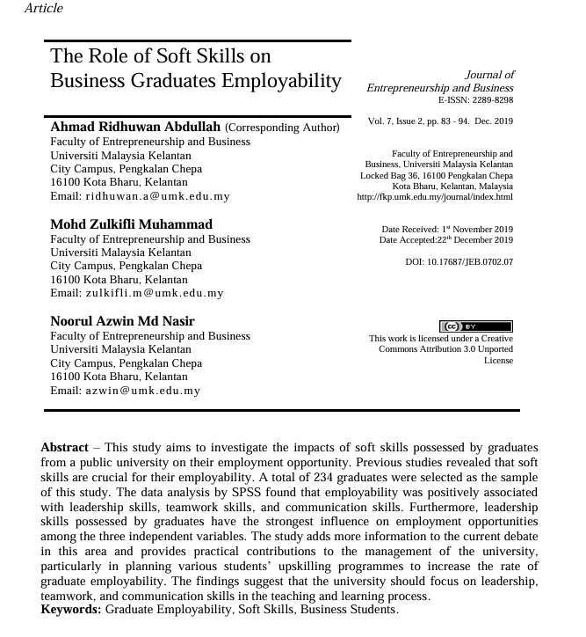
Your colleague has forwarded you a source from a peer reviewed journal, and they are not sure whether it is appropriate to use and has asked for your help. Your task is to evaluate the source by using the CRAAP Test to assess its appropriateness for the following question “What employability skills do business university graduates need to succeed in the workplace?”

CRAAP Test
Currency | It is not current because it was published 2019
Relevance | It is relevant because employability was positively related to leadership skills.  It is relevant because it focus on the skills university graduates need for employment.
Authority | Ahmed Ridhuwan Abdullah  Mohd Zulkiffi Muhammad  Nooral Azwin MD Nasir
Accuracy | It is accurate because the article is referenced
Purpose | To create awareness, inform and enlighten graduates what skills they need to succeed in modern workplace.
Task 3: Source Analysis
Your manager has provided you with a short extract from a source and has asked you to analyse the source by Identifying one strength, one weakness, and providing a brief explanation of the strength and weakness identified.
If you want to read the article online, please click the following link: https://www.universitiesuk.ac.uk/latest/news/strong-demand-graduates-employers

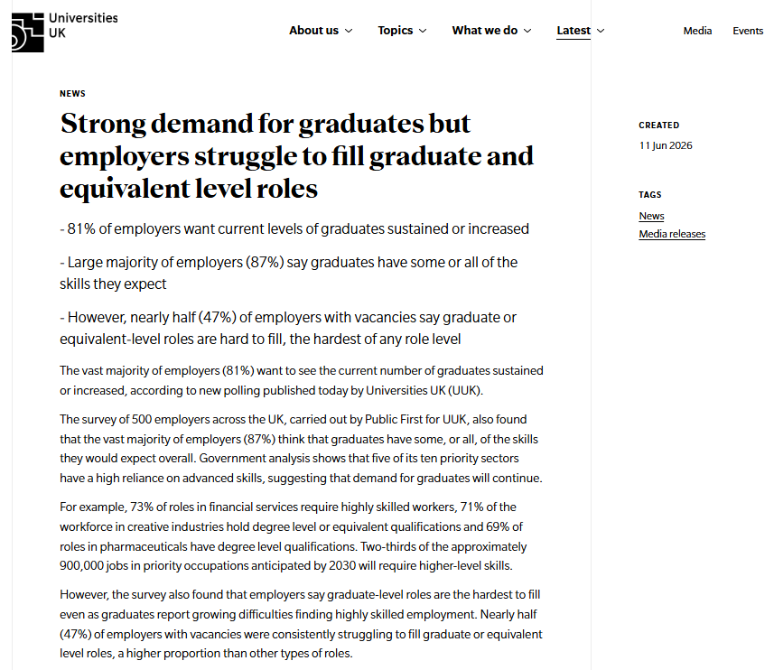
.

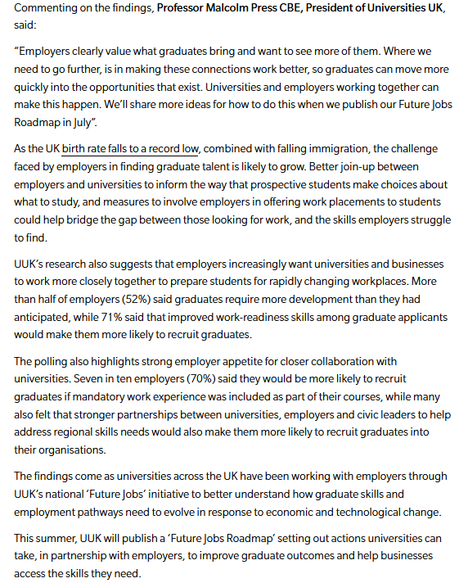

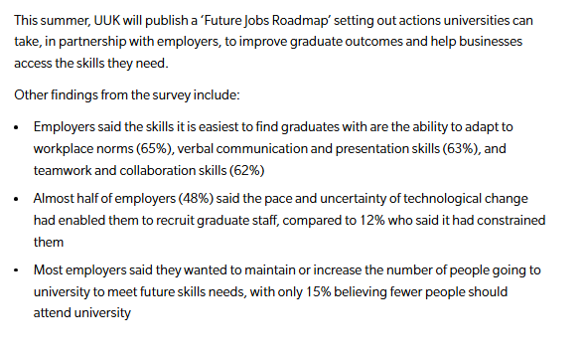

Strength of the Source: it uses facts and relevant to the topic, it has a clear purpose and is current information. It provides recent and relevant statistical evidence from a survey of 500 UK employers.

Weakness of the Source: change of technology creates uncertainty to recruit graduates.

